|  |  |  |
| --- | --- | --- |
|  | **SRI KRISHNA COLLEGE OF TECHNOLOGY**  **An Autonomous Institution | Accredited by NAAC with 'A' Grade**  **Affiliated to Anna University | Approved by AICTE**  **KOVAIPUDUR, COIMBATORE 641042** |  |

#### TITLE of the Project

**A PROJECT REPORT**

***Submitted by***

#### KAVINA A 727821TUEC107

**KANISHQ RAJ G 727821TUEC102**

**KISHOREKUMAR P 727821TUEC113**

**NIRMALRAJA GOPALAN M 727821TUEC159**

*in partial fulfilment for the award of the degree*

Of

#### BACHELOR OF ENGINEERING

**IN**

**SRI KRISHNA**

**COLLEGE OF TECHNOLOGY**

**JANUARY 2023**

***CERTIFICATE***

#### 

#### BONAFIDE CERTIFICATE

Certified that this project report **“Title”** is the Bonafide work of **XXXX**, **YYYY** and **ZZZZ** who carried out the project work under my supervision.

SIGNATURE SIGNATURE

XXXXX _____________

**HEAD OF THE DEPARTMENT SUPERVISOR**

Professor Assistant Professor

Department of ___________ Department of ____________

Sri Krishna College of Technology Sri Krishna College of Technology

Kovaipudur Kovaipudur

Coimbatore-42. Coimbatore-42.

Certified that the candidates were examined by us in the Project Work viva- voce examination held on ............................... at Sri Krishna College of Technology, Coimbatore -641 042.

**INTERNAL EXAMINER EXTERNAL EXAMINER**

***ACKNOWLEDGEMENT***

## ACKNOWLEDGEMENT

First and foremost, we thank the **Almighty** for being our light and for showering his gracious blessings throughout the course of this project.

We are grateful to our beloved Dean-Academics **Dr. Manju P &** Dean-Administration **Dr R Ramesh Kumar** for their tireless and relentless support.

We extend our sincere thanks to our Head of the Department **­­­______** for his/her encouragement and inspiration.

We are greatly indebted to our Industry Mentor ________ & Project guide **_______** Assistant Professor, Department of ___________ for their valuable guidance and suggestions in all aspects that aided us to ameliorate our skills.

We are thankful to all those who have directly and indirectly extended their help to us in completing this project work successfully.

### ABSTRACT

Library websites are the fundamental tool for the promotion of information to all users since it is difficult to access a library during times like lockdowns, holidays, etc, Research activities and academics plays a important role in these websites. This paper explains about our website which is created to meet the basic needs of a ordinary library website. Our website is created to enrich the learning experience of the users of our and to give a well organized website. During the covid-19 pandemic, a study was conducted to examine the content of the library websites to check if the content of the library websites meets the basic standards of a library which was conducted by the college libraries in Goa(India) .Out of forty college libraries taken for the study , only Twenty nine websites were actually been felt as existing by the users since other websites are not active or because of having poor content. So the other Twenty nine websites were taken for the study and found that the webites were not met the basic user needs like well-structured and well organized content especially during the pandemic situation. From this study it is evident that there is a necessity to develop a website which has a very good quality content that will provide a good quality library website for the academic users. From that study, it is also found that eleven libraries do not have their existence on the college website or on the internet. It is only because of bad content quality and accessibility. Our website will be a solution to it. Our library aims to serve the teaching and research needs of our college community. It serves all students and active members of the foundation and its partners to lead a successful education life. Academic library websites need evaluation to determine whether users can derive useful experiences while visiting them to perform tasks. This is more so because visiting an academic library website is by voluntary action rather than compulsion as is the case with university, polytechnic and college sites where students must conduct academic transactions that cannot be reasonably avoided. The result of such an evaluation provides signposts for improvement so that academic library websites can continue to be useful to their users.

Keywords: Library website, Content analysis, college libraries, library webpage, web accessibility, user community, Covid-19 Pandemic.

***LIST OF FIGURES***

|  |  |
| --- | --- |
| S.No | Figure Name |
|  |  |
|  |  |
|  |  |
|  |  |
|  |  |
|  |  |
|  |  |
|  |  |

***TABLE OF CONTENTS***

|  |  |  |
| --- | --- | --- |
| **Sl.No** | LIST OF TABLES | **TABLE DESCRIPTION** |
|  |  |  |
|  |  |  |
|  |  |  |
|  |  |  |

**CHAPTER – 1**

**INTRODUCTION**

This chapter describes the problem definition and the importance of

Library Websites. The overview of the project is also described.

#### PROBLEM DEFINITION

The library website is a reflective image of the library. The World Wide Web has made a tremendous impact on the functioning of academic libraries. In The temporary age of the Internet which ought about tremendous change in information technology. The functioning of the libraries has shifted from traditional functioning to use moderthe of n ICT (Information Communication Technology) and Artificial Intelligence. Researchers are depending on web-based resources for their academic and research activities. Many college library websites provide general and inadequate information on their webpage which makes them inaccessibility of or the user community since they are not updated regularly. The library website should be well-designed and well-structured that will provide the required, useful and adequate information for the academic user community.

Academic library websites are llibraries virtual presentation to the world. Beyond providing information about libraries and library services, academic library websites provide access to online catalogues, electronic databases, subject resources, library instruction/tutorials, and digital collections. Academic library Web pages are portals to knowledge that support faculty and student research and educational needs, in line with the institution's mission. A library website helps to build a long and strong relationship with the users by promoting library services. To build a credible relationship with the user library image needs to be projected through the library website, it is hard for any library to establish a credible relationship with the users. To establish strong relationships between the library and users the librarians have to reasonably and cautiously step towards setting up an effective library website so that it could not only it could help everyone to know about the library at a glance but also feel the effectiveness of web-based services. Present day’s library websites act as a main window to access library sources and services. It has become a starting point to access academic or scholarly information. The growth and use of online information sources increase its importance and the present generation is very much dependent on electronic journals, e-books and electronic databases. Usability analysis of libraries website is paramount because libraries’ website is taking more attention to serving primary sources of information for their users; and for many services and sources, library users depend on the library websites.

**1.2 OBJECTIVE**

Selection of information resources can be reflected on the Web through creating links to other relevant sites as well as creating links to full text electronic resources. In fact, many librarians are beginning to view Web "collection development" as a task equally important to traditional (print-based) collection building. It is in some ways more challenging, given the changing nature of Web resources. An excellent example of a library Web site that takes its role of selection seriously is at the University of California.

Organization of information resources can be reflected on the Web through proper classification of resources and links, collocation (placing similar resources together), and subject bibliographies of print resources. Some of this can be performed informally on a local level, while other pieces of this puzzle should be addressed at a higher and more formal level (e.g., the OCLC NetFirst project is a good example of formalized cataloging of Web resources). While the topic of metadata on the Web is somewhat beyond the scope of this paper, it is clearly a vital issue for libraries in the coming Internet-based information infrastructure.

Providing access to information can be reflected on the Web through the following: internal search engines, online reference service, stable links to other Internet sites, access to the online catalogue and other databases, basic information about the library (hours, staff, collections, etc.), and timely updates. Perhaps the most important of these is access to the online catalogue of the library's local collection(s). While many library Web sites provide a telnet-based connection to their online catalogue, a growing number are transitioning to a Web-based interface. A Web-based searchable online catalogue is preferable in several respects: it provides a consistent and standardized interface for the user, it avoids the necessity of a helper application on the client side, and (in many cases) it allows more flexibility for the user in manipulating data retrieved from the online catalogue.

**1.3 OVERVIEW**

Our motive is to create a far better website that gives all the necessary options and availability of the content in a orderly manner that gives information about various different views like e-journals, e-books, newspapers and other informations of the education and other articles . The role of the library Web site should be distinguished from its mission. The mission is more theoretical and is tied to the needs of the parent organization. The role of the library Web site, like the traditional role of librarians, should be one of selecting information resources, organizing information resources, and providing access to information resources. All types of librarians can benefit from incorporating the three-fold function of libraries into the library Web site. Application of these principles may look quite different from library to library, but the end result will help us bring the rich information resources on the Internet to our information-seeking users.

It should be clear to all of us that the mission of a library Web site is connected to the type of library represented. Thus, academic, public, and special library Web sites will all have different purposes. My own context is an academic library, so the mission of my Web site is tied to the three-fold mission of the academy: research, teaching, and public service. The academic library Web site can support research in higher education through providing access to Internet research tools and full text databases. It can support teaching through online full text reserves and other means. And it can support public service through allowing the general public to access its online resources, including the online public access catalog.

Public library Web sites serve different purposes. A typical public library might want to provide free and open access to information for all local residents, and this could be reflected in the library Web site through links to community information resources, links to job postings, access to the library's online catalog, etc. While a public library might want to give completely free access to its Web resources, licensing restrictions on some electronic databases may limit this scenario. Password protection (perhaps through a patron's barcode number) may be necessary in some cases.

Special libraries have still another mission when it comes to creating a Web site. Special libraries generally need to service their parent company or organization, and the library Web site will reflect this through focusing almost exclusively on the parent company's staff and clientele. Sometimes this will take the form of a heavily passworded Web site; other times it will preclude the library from even appearing on the publicly available Web page, restricting itself to a locally available Intranet. On occasion, the special library may wish to use its library Web site as a "loss leader" to attract more business to the company. Generally, however, the special library Web site will be an internal tool that will focus almost exclusively on staff.

**CHAPTER -2**

**HISTORY OF LIBRARIES**

The very earliest libraries are believed to have been built around five thousand years ago, with the first human efforts to organize collections of documents. These took the form of clay tablets in cuneiform script about an inch thick, in various shapes and sizes.Mud-like clay was placed in the wooden frames, and the surface was smoothed for writing and allowed to dry until damp. After being inscribed, the clay dried in the sun, or for a harder finish, was baked in a kiln.According to research, the word “library” originated in Latin, from the word Libraria, meaning “place storing books” and the Latin liber, meaning “book,” whereas a Latinized Greek word, bibliotheca, is the origin of the word for library in German, Russian, and the Romance languages.

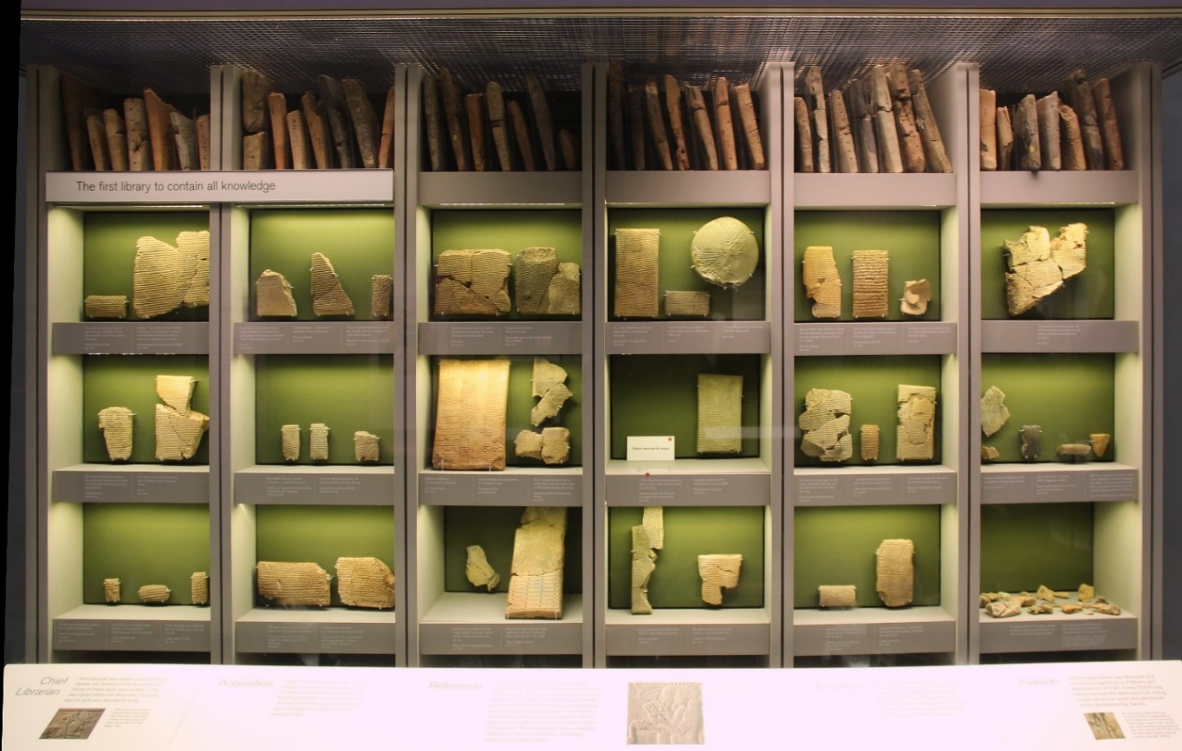

It is believed that the first libraries appeared five thousand years ago in Southwest Asia’s Fertile Crescent, an area that ran from Mesopotamia to the Nile. The world’s oldest known library is believed to be The Library of Ashurbanipal. which was founded sometime in the 7th century B.C. for the “royal contemplation” of the Assyrian ruler Ashurbanipal. Located in Nineveh in modern day Iraq, the site included a trove of some 30,000 cuneiform tablets organized according to subject matter. The library, named after Ashurbanipal, in fact the last great king of the Assyrian Empire, is a collection of more than 30,000 clay tablets and fragments containing contemporary texts of all kinds, including a number in various languages.

The texts themselves–from both Babylonia and Assyria–include a wide variety of documents, both administrative (legal documents such as contracts), and literary, including the famous Gilgamesh myth. Subject matter included Astronomy, Divinatory, Epics (Gilgamesh, Anzu myth, the Epic of Creation, literary myths about Ashurbanipal himself), Historical, Medicine, Lexical (syllabaries and archaic word lists, grammatical texts) and Religion.

The history of libraries began with the first efforts to organize collections of documents. The first libraries consisted of archives of the earliest form of the writings—the clay tablets in cuneiform script discovered in sumer, some dating back to 2600 BC. Private or personal libraries made up of written books appeared in classical Greece in the 5th century BC. In the 6th century, at the very close of the classical period, the great libraries of the Mediterranean world remained those of constantinophile and Alexandria.

The Fatimids (r. 909–1171) also possessed many great libraries within their domains. The historian Ibn Abi Tayyi describes their palace library, which probably contained the largest collection of literature on earth at the time, as a wonder of the world. Throughout history, along with bloody massacres, the destruction of libraries has been critical for conquerors who wish to destroy every trace of the vanquished community's recorded memory. A prominent example of this can be found in the Mongol massacre of the Nizaris at Alamut in 1256 and the torching of their library, "the fame of which", boasts the conqueror Juwayni, "had spread throughout the world".

The libraries of Timbuktu were established in the fourteenth century and attracted scholars from all over the world.

**2.1 ANCIENT STONE LIBRARIES**

By some historians, the creation of the first libraries marks the end of pre-history and the start of recorded human history. As ancient civilizations such as the Mesopotamians and Egyptians began to develop the earliest forms of writing—Mesopotamian Cuneiform and later the Egyptian hieroglyphs—scribes began to create archives of clay tablets that listed inventories and records of commercial transactions.

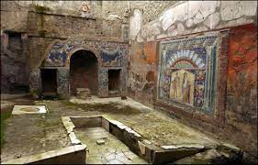

While these early documents might not sound exciting or philosophical, they were instrumental in growing knowledge and early human civilization. They often shared key pieces of information needed to build societies. From early medical diagnoses, to inventories of the yearly harvest surpluses, to the laws that governed city-states—such as the Code of Hummurabi—these ancient scribes accumulated documents so they could draw upon information as needed. For example, if the ancient Mesopotamian government needed to predict whether their harvest would be good or bad after a large flood, scribes could point officials towards records of earlier harvests to help them with planning.

In this way, ancient scribes forged the role of librarians—connecting people with knowledge by giving them access to recorded information.

**2.2 THE INVENTION OF PAPER DOCUMENTS**

As ancient civilizations developed techniques for producing paper, grand libraries were built to house the great collections of scrolls that governments and individuals began to develop.

These great ancient libraries included the Library of Alexandria and the Chinese Imperial Libraries created during the Han Dynasty. While these libraries were open to the public, they were not easy to browse. Scholars who intended to read specific texts or authors had to ask librarians to fetch specific scrolls for them (Krasner-Khait). Thus, librarians continued to be the players who connected scholars with critical recorded information.

The libraries established by the Han Dynasty were particularly exciting in the history of libraries, as Chinese librarian Liu Xin created the first library classification/formal catalog system (Frank). Moreover, ancient Chinese scribes invented important book printing technologies such as wood-block printing that enabled the first large-scale printing and mass dispersing of texts.

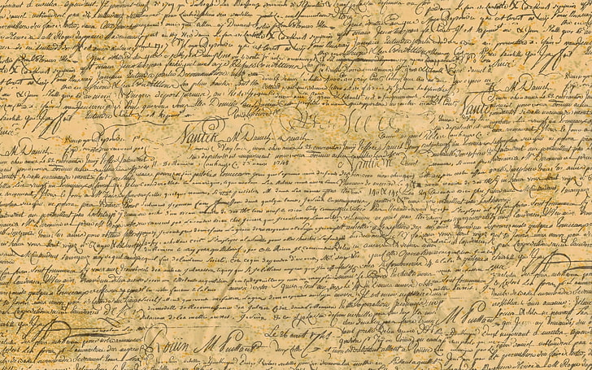

**2.3 RELIGIOUS LIBRARIES IN THE MIDDLE AGES AND EARLY PUBLIC LIBRARIES**

As antiquity ended with the fall of the Roman Empire, religious institutions began to take over the functions of ancient government and private libraries. In Western Europe, Catholic monks took an active role in collecting and creating written texts, and monasteries made up the main libraries.

In Muslim countries, Imams and other scholars used printing techniques developed by Chinese scholars to create collections of written texts. Early libraries were created to house Qur’anic texts, but also included important early developments in astronomy and mathematics by Arabic scholars.

As the Renaissance and later the Enlightenment movements spread throughout Europe, non-religious libraries began to pop-up. These libraries, such as the humanist, Bartolomeo Platina’s library and the Austrian National Library, served as institutional meeting places of scholars who collected and produced written texts on philosophy, mathematics, religion, and science. After the creation of the Gutenberg Printing Press, the libraries began to store not just valuable ancient texts, but modern books as well.

Although these libraries were independent, they were open only to card-holders usually from grand academic instructions or the aristocracy.

**2.4 THE DEVELOPMENT OF PUBLIC LIBRARIES**

By the 1800s there were libraries across the United States and Europe that were open to the public, but were not public libraries in the same sense that they are today.

While large university libraries and privately-owned libraries allowed individuals from outside of the institution to visit, these people had to pay for their entry. In the late 1800s and early 1900s the first true public libraries—in that they are funded by public taxes and therefore open to everyone—began to open.

This system is still in place today. Most universities, including private ones who receive federal funding, and municipal libraries are free and open to the public. The fact that libraries are open is of huge importance to the history of libraries, as it has forged a great role for libraries to help the general public access vital information—from medicine and science to public affairs and literary arts. Moreover, these libraries serve a critical function of connecting to other libraries. Most universities and municipal library systems have a mechanism for sharing materials and information.

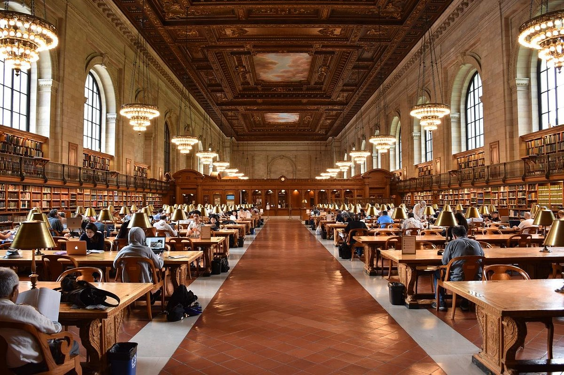

In this sense, librarians in public libraries serve a critical function in helping the general public access a vast collection of information. Whether it is an archive of news stories around a particular historical event, a rare unedited edition of a book, or a digitally published paper, libraries have a system for helping individuals find the materials they are looking for. For example, a librarian might not be a doctor, but they can help a young medical student track down a specific research study pertinent to their term paper research. This is also why knowing [how to cite](http://www.citethisforme.com/us/citation-generator/apa), where to look for information, [how to do an in text citation](http://www.citethisforme.com/us/bibliography-basics/what-is-a-citation/in-text), and other skills comes in handy. If you ever need additional information on a topic, you can read the bibliography, from either your own paper or someone else’s, and use it to discover additional resources at your library.

**CHAPTER – 3**

**HOW WILL LIBRARIES SURVEY IN THE DIGITAL AGE**

Libraries and the role of librarians will survive as digital tools take over printed material, the same way they have survived across millennia—by adapting to the modes of documentation and the needs of information seekers at the time.

As online databases continue to develop, librarians will still serve an active role in connecting people with the information they need. While a library might not need to house as many books and print archives for scholars and readers to sift through, it will still serve as a space for people to come to seek out knowledge.

People will still turn to libraries and librarians to connect them to the correct online tools they need to conduct their research.

**3.1 TECHNOLOGY HAS CHANGED THE WAY WE CONSUME MEDIA**

Libraries have always been at the heart of the communities they serve. They are accessible and safe spaces, providing access to huge resources of information and knowledge. There are an estimated 315,000 public libraries in the world, 73 per cent of them in developing and transitioning countries. The public library transcends national and cultural boundaries -- no matter where you are in the world, they are an essential part of creating and maintaining an educated and literate population.

But today, public libraries are at a turning point. The way we access and consume information has changed dramatically in the 21st century, and this presents major challenges and opportunities for public library systems across the world.

The advent of new technologies has changed some of our reading habits. But our need for shared, community-centred spaces to find information and connect with others is unlikely to change any time soon. To survive in the digital age and stay relevant, public libraries need to be brave and innovative. They must embrace both the physical and virtual.

**3.2 LIBRARIES MUST OFFER MORE THAN JUST BOOKS**

Regular visitors to libraries expect them to continue to provide the services they have provided for many years. And rightly so -- the ‘traditional’ library of books, journals and quiet reading spaces shouldn’t just disappear. But libraries also need to respond quickly to real changes in how people live their lives.

In the UK, with heightened pressure on public expenditure and lowering visitor numbers, the traditional library system has come under more scrutiny. Why maintain expensive-to-run ‘physical’ libraries when growing numbers of people can already access the information they need from any location? As a result, in recent years public libraries have been threatened with closure across all parts of the country.

But there has also been a major rethink in the UK as to how exactly the library should be serving the public, and what the library of the future could and should look like. Last year, the Arts Council England published a wide-ranging and detailed piece of research,envisioning library of the future aiming to answer these very questions. As well as emphasising the need for the physical and the digital to sit side by side, it finds that the 21st century public library service will be one in which “local people are more active and involved in its design and delivery.” A sense of community, always a defining feature of libraries, has renewed importance.

**3.3 LIBRARIES HAVE TO MODERNISE WHILE STAYING TRUE TO HEART OF WHAT THEY OFFER**

Like other library providers, the British Council has had to respond to lifestyle changes in the countries we work in. Our network of libraries has decreased in recent years, reflecting a global trend for fewer library visitors, with people more likely to read books and newspapers digitally, instead of on paper.

The concept of the library continues to hold a special place of importance in people’s hearts - and recent developments, like the reinvention of the [**Library of Birmingham**](http://www.libraryofbirmingham.com/) in the UK (which has two million visitors a year, and lends its digital collections to ten million people a year), have shown how a library can still be a huge source of pride.

Libraries remain central to the community and people access its services for various reasons – not just to source information, read or borrow books. **In the digital age, a public library can connect even the most remote community to networks of knowledge and information**.

**CHAPTER – 4**

**LITERATURE SURVEY**

**4.1 ABSTRACT**

Internet and Distributed Network System created scope for research in the area of information system and its related fields. Digital Library, one of the most recent development in Library and Information Science, which help its user to seek information through web browser. Digital Library is organized assortment of information, with its supported services and a place where the information is kept in digital format and can be retrieved over a networks. Since last one decade researchers are focusing on the users of Digital Library to develop more efficient and effective system to provide quality service to users. The aim of this paper is to provide literature on Digital Library with respect to its users that may be helpful for future research. The paper discusses about the users centric approach in the context of Digital Library. Researchers are working on the system upgradation by using wireless technology to connect with end users directly with libraries. Further, other areas such as user’s Perception, Attitude, Adoption and Satisfaction with respect to digital library are also discussed.

Key words: Digital Library, Users centric approach, Users satisfaction, Users perception; Digital library literature

**4.2 INTRODUCTION**

Significant changes seen by society through the transmission of information around the globe and it is accountable to the evolution of information technology. Now it is possible to archiving and accessing knowledge in the digitized form besides preservation of traditional knowledge due to use of information technology. Demand for electronic information increasing day by day and at the same time traditional format of library becoming more and more expensive and complex to maintain. Now it is time for libraries to capitalize these challenges and meet demands and expectations of digital users. Libraries has to redesign their services to create value addition to satisfy the user’s community.

**4.3 DIGITAL LIBRARY**

Digital Library is a source that rebuild the knowledge and supports of conventional library in digital form. Digital Library is organized assortment of information, with its supported services and a place where the information is kept in digital format and can be retrieved over a networks. It comprise of digital contents which interconnected by establishing link, metadata or simply query based relationship and software which may use basic pages in HTML or based on database management system. It can be interpreted on the basis of above definition that a single web page or huge collection mass digital information is not a digital library. Here, it is important to note that digital libraries are not going to replace conventional libraries but rather digital libraries are the future of conventional libraries (Seadle, 2007). Basically, digital library is required technological support to link the resources of many services that are disseminated to user. Collection of information is not restricted to document storage but it is extended to digital artefacts than can only be distributed in digital formats.

**4.4 REVIEW OF LITERATURE**

This section of the article discuss about the research related to user’s experience with digital library. This may be helpful to understand user’s opinion, attitude, satisfaction and service experiences with digital library which can be further considered for enhancing user’s satisfaction towards the use of digital library.

Ekere et al (2016) study the perception of users towards digital library facilities, resources and services and found that users are highly satisfied with it. Users are highly aware and satisfied about the digital library resources such and WWW, WIFI and search engines compare to online databases, portals, online abstract, video CDs, CD-ROMs, and online indexes and abstract. Asad Khan (2016) investigated the factors that influence the adoption of Digital Library among research students.

The findings revealed that Interface characteristics influence cognitive response which predict student’s intention of using digital library. Whereas navigation, individual differences and system characteristics significantly affected the ease of use. Usefulness is directly affected by system characteristics and system quality. Finally, it is found that usefulness have highest effects on digital library usage intention. Xianjin et al (2015) worked on Flow experience with respect to Mobile Library and try to compares perception of user’s with mobile libraries and web digital libraries with respect to flow experience.

Where flow experience defined as best experience about an activity that can be done by comparing perceived skills and perceived challenges. Study reveals that more users experienced flow in using web digital libraries than mobile libraries. Yuangen and Zeng (2014) worked with customer churn rate and it is the rate of customer discontinuation with digital library service. Study found that customer churn rate of the given library is very high and same with churn hazard in initial three months after customer’s registration on the web site of the library. Xianjin et al (2014) investigated the effects of user’s perception towards print and digital resources in terms of usage, usefulness and ease of use.

There is a significant effect of the characteristics of user’s such as gender, age field and experience on perception of users with respect to usefulness, usage and ease of use. Yalan et al (2014) examined quality of digital library which define as the quality of information quality of system and overall service quality of digital library. The compression of user’s perceptions towards virtual communities and digital libraries have been done understand the actual nature of e quality perceived by the users. Based on the user’s perception study found that digital libraries provide better information, system and service quality than virtual communities.

Ahmed (2013) study the usage pattern of digital information resources and satisfaction with university resources by the faculty members. It is found that faculty members are dissatisfied with current e-resources by the university. Service related issues are the main reason for dissatisfaction such as limited title and access to past issues, They identified limited number of titles, limited access to back issues, difficulty in finding information, inability to access from home, limited access to computers and slow download speed as major constraints.

However, poor infrastructure and limited access to these resources is the main reason for dissatisfaction. Chang (2013) study user’s behavior intention towards using mobile library application by applying unified theory of acceptance and usage of technology (UTAUT) with task technology fit model. Effort expectancy, social influence, facilitating conditions and performance expectancy influence the behavioral intention towards mobile library application. Task technology model have moderating effect on behavioral intention.

Ming-der et al (2012) research scholar are frequent users of digital resources of library in this regard this study investigated usage pattern, search behavior of graduate students and perception towards digital resources. Study reveals that students are using digital resources during thesis writing and science and technology student consider it as the most important for their research compare to other disciplines. Less number of students are using metasearch and alter services to collect update information.

Lorraine Paterson and Boon Low, (2011) found that students has higher acceptance of mobile library services. Anna (2008) indicated that user’s perception is defer by the institute to institute and the services they offered. Further, users have positive attitude towards digital library but at the same time most of them are unaware about various services offered by the digital library. It is also found that interface considered to be an important factor to use digital library. Nov and Ye (2008) employed technology acceptance model and support that TAM has explanatory power to predict intention. This study found that resistance to change is the important determinant of perceived ease of use.

Ahmed (2013) study the usage pattern of digital information resources and satisfaction with university resources by the faculty members. It is found that faculty members are dissatisfied with current e-resources by the university. Service related issues are the main reason for dissatisfaction such as limited title and access to past issues, They identified limited number of titles, limited access to back issues, difficulty in finding information, inability to access from home, limited access to computers and slow download speed as major constraints. However, poor infrastructure and limited access to these resources is the main reason for dissatisfaction.

Chang (2013) study user’s behavior intention towards using mobile library application by applying unified theory of acceptance and usage of technology (UTAUT) with task technology fit model. Effort expectancy, social influence, facilitating conditions and performance expectancy influence the behavioral intention towards mobile library application. Task technology model have moderating effect on behavioral intention. Ming-der et al (2012) research scholar are frequent users of digital resources of library in this regard this study investigated usage pattern, search behavior of graduate students and perception towards digital resources.

Study reveals that students are using digital resources during thesis writing and science and technology student consider it as the most important for their research compare to other disciplines. Less number of students are using metasearch and alter services to collect update information. Lorraine Paterson and Boon Low, (2011) found that students has higher acceptance of mobile library services. Anna (2008) indicated that user’s perception is defer by the institute to institute and the services they offered. Further, users have positive attitude towards digital library but at the same time most of them are unaware about various services offered by the digital library.

It is also found that interface considered to be an important factor to use digital library. Nov and Ye (2008) employed technology acceptance model and support that TAM has explanatory power to predict intention. This study found that resistance to change is the important determinant of perceived ease of use.

Conclusion

It is high time for libraries in India to shift from traditional model to digital model. This study provide the highlights about the key areas in which researcher are doing research with respect to Digital Library and user experience to provide future scope for further research in this area. Majority of studies, which included in this paper, are related to Adoption, Perception, Attitude and Satisfaction of user towards Digital Library services. Whereas, Flow Experience and Equality aspect of Digital Library has also been studied out by the researchers. Mobile library is emerging as a new concept and showing high rate of acceptance among users where libraries provide content browsing through mobile application

### CHAPTER - 5

**5.1 HOME PAGE**

A home page is the default or front page of a site. It is the first page that visitors see when they load a URL. Our Home page contains information about the library. It contains a descriptive representation of the complete details of library. It describes the prime motive of the library and also contains the statistical information of the books, reference materials and the audio-visual resources.

Components are independent and reusable bits of code. They serve the same purpose as JavaScript functions, but work in isolation and return HTML. Components are of two types. They are Class components and Function components. A class component is a JavaScript class that extends React.Component which has a render method, whereas a functional component is just a plain JavaScript function that returns JSX

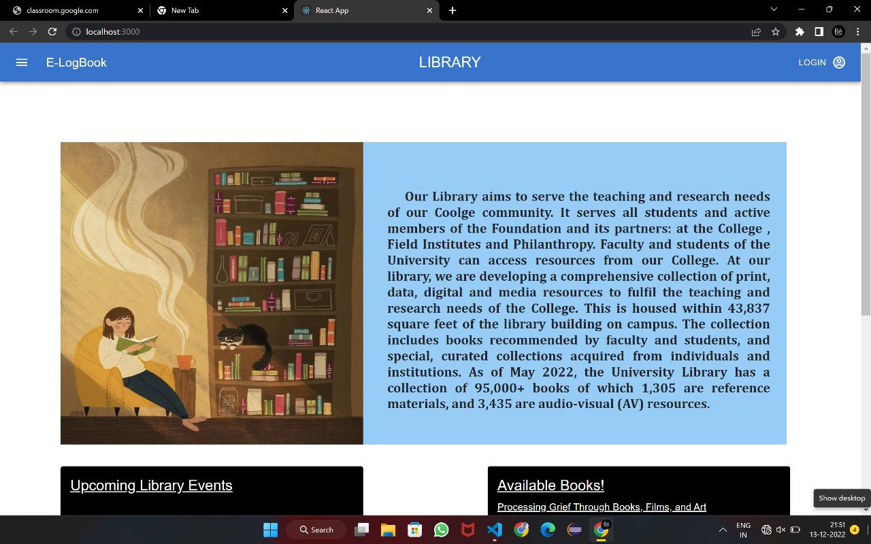

APPBAR:

Appbar is a component used to display action items in a bar. It can be placed at the top or bottom. The top bar usually contains the screen title, controls such as navigation buttons, menu button etc. The bottom bar usually provides access to a drawer and up to four actions. Our Home page consists of an appbar with the title “Library” and a co-title “E-LogBook”. It also consists of two buttons with each specification. A dropdown button with some functions to perform and for navigation and a Login button to enter into the Login page. When the Login button is clicked a dropdown box appears with two login options which are Student login and the Admin login.

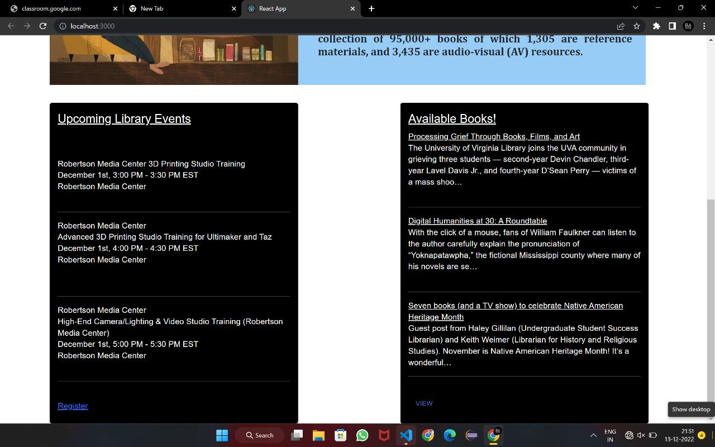

The Home page contains two cards in it. One to know the information about the Upcoming Library Events and the other to know some of the unique and trending books available in the library. Cards in React are components which are a content container. It incorporates options for images, headers and footers, a wide variety of content, contextual background colours and excellent display options. Users find it attractive when an information is displayed using card component. An option called Register is available in the first card of the Home page, by which when clicked , user will be able to open a google form. The google form helps the user to register for the upcoming webinars , Seminars and the Library events which will be innovative and useful for them. A View option is available in the second card which is in the link format. The users can click it and view the newly available books, top pickings and also the trendy books.

The Home page acts as the main page of the application. It plays the role of a root from which the other pages can be navigated easily.

**5.2 LOGIN PAGE:**

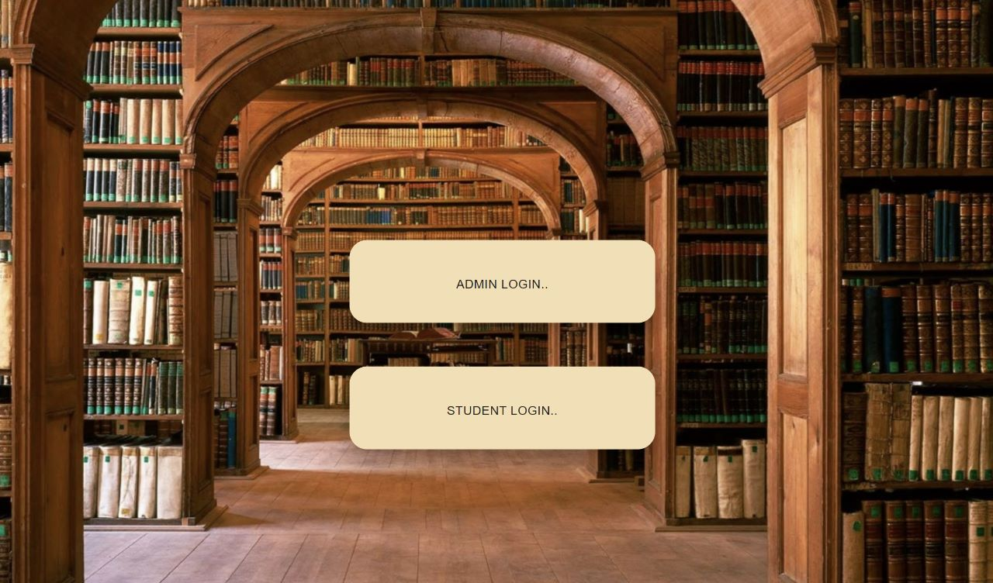

This Login page is used to select whether the user is an administrator or a student. When clicked both the options will direct the users to the respective pages where they login to the webpages for the further accessibilities.

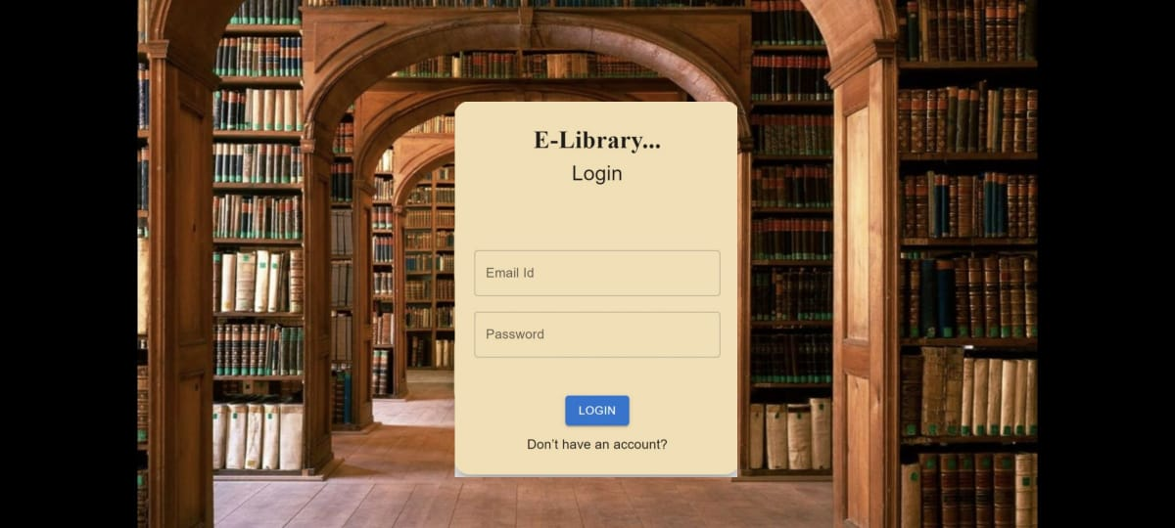

Login Page is very common among any type of secured applications and its widely used on the internet for authenticating the user before presenting the secured pages of the web applications. The user authentication is done through a special web page called Login Page. The Login page asks you to enter your credentials which is then validated by the application and after successful validation you are presented with the secured part of the application.   
Login Form is the page where you can login to the application or the page where the system will display the information you are going to enter for the application. For example, you can login to website and access the secured dynamic content.

Login page contains many uses. Some of them includes,

* Login Page is used to allow the users to login on the website and application.
* Applications/Websites identifies the users with their username and password.
* Login Page takes user input and passes the data to server-side program. The authentication is done by server-side program and authentication results (message) is displayed to user on the website site login form. If user is authenticated, they are forwarded to the secure section of the website.
* Login form also provides the link for the registration page. If website user is already not registered then he/she can register by visiting the registration section of the website.

This Login page consists of a background image of a library which indicates the main motive and the theme of the application. It consists of a card which contains two textboxes in it. One is for entering the E-mail of the user and the another one is for entering the password the respective user. It consists of a login button to perform the final action and it also has a button called ‘Don’t have an account?’ by which the user will be able to create an account if they do not possess any. After entering a valid a E-mail ID and the password and clicking in Login button, the user will be able to enter into the respective pages depending on whether the user is an administrator or a student.

**5.3 ADMIN PAGE**

Administrators should have the highest level of access to an account or a website. A general user will have the limited access to the website than the Administrators. The Admin login page consists of an Appbar with contents in it. It has a title called “Admin Page” with two buttons in it. Buttons allows users to take actions and make choices with a single tap. The Buttons in React communicate the actions that users can perform. The Button comes in 3 variants: **text (default), contained,** and **outlined.**

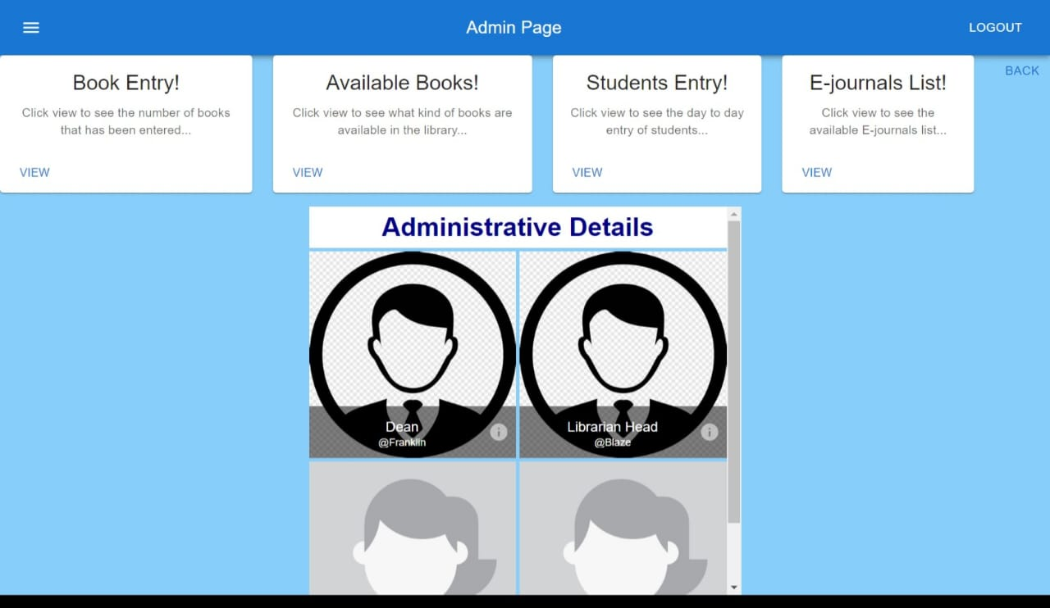

Text buttons are used for less-pronounced actions, including those in card dialogs. In cards, the text buttons will help us to maintain an emphasis on card content. Contained buttons are high-emphasis, distinguished by the use of elevation and fill. It contains actions which are primary used in our App. Outlined buttons are medium-emphasis buttons. They contain essential actions but not the main action in the app. Outlined buttons are the lower alternative to contain the buttons or a higher emphasis alternative to the text buttons.

The Admin Page consists a Logout button which is of the type text variant. It also contains a Dropdown button which when clicked, show some specific options and also some navigation options. The page contains of cards which are entitled as Book Entry , Available books , Students Entry and the E- Journals list. Each of the four cards has an option called view which when clicked , directs the user to a page regarding the title.

The page contains of an image list which consists of the images of important people of the library such as Dean and the Librarian head. The image lists in react are of many types and this page contains the Standard Image list. Standard image list has the speciality of every picture in the list are uniform in its resolution in an professional manner. The user have to scroll the image list to view all the images in it. A back button is also available in the page, which when clicked, takes the user to the previous login page.

**5.4 BOOK ENTRY:**

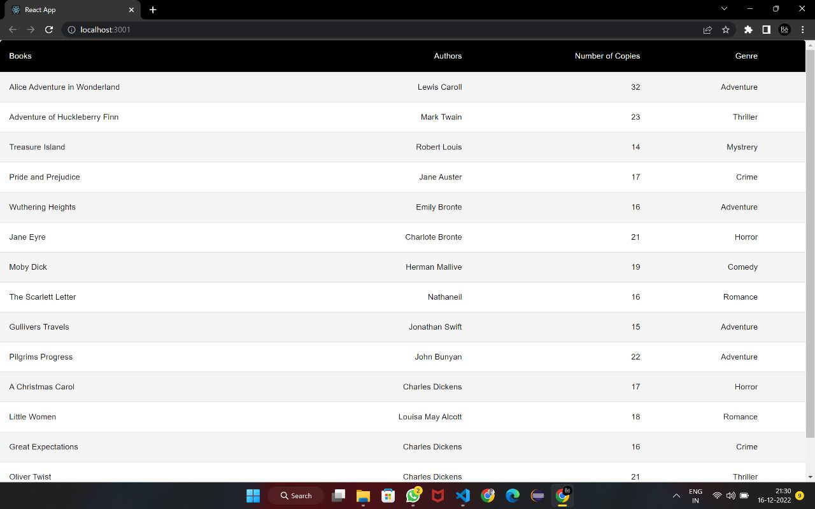

A library can be a helpful place to go to find books, do research, or gain access to other resources. Libraries contain massive amounts of information, but there are specific ways to find this information efficiently. One of such efficient ways is the book entry page. Thus keeping in mind the different approaches of the readers, the books that are available in the library, the number of available copies of each book and also the genre of the books are shown. The Authors of the books are displayed as in a sense that nowadays, most of the people are interested in choosing books of some of the specific authors. For example, Alice’s adventure in wonderland is one of the finest books of the author Lewis Caroll which is being displayed in the book entry page.

In simple words, the book entry page is e-catalogue of the library. A library catalogue is a list of books and other graphic material in a library arranged according to a recognized order and containing specific items of bibliographical information for the purpose of identification and location of the material catalogued.

**5.6 STUDENT ENTRY:**

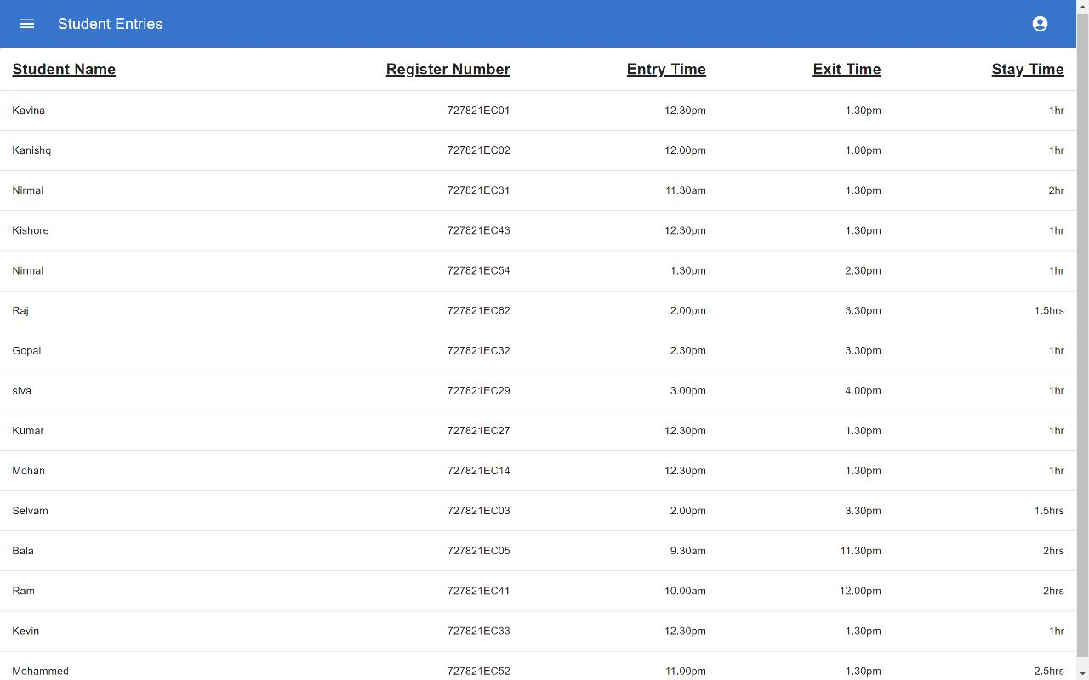

This Student Entry pages shows the information of the details about the students who enters the library with their name, register number, entry time, exit time and also the stay time. This is used by the administrators a statistical information and also the activities and interests of students in library. As these data are very important to maintain, these are updated everyday and stored in the server for later use.

**5.7 SAMPLE CODE**

**HOME PAGE**

function ButtonAppBar() {

return (

<Box sx={{ flexGrow: 1 }}>

<AppBar position="static">

<Toolbar>

<IconButton

size="large"

edge="start"

color="inherit"

aria-label="menu"

sx={{ mr: 2 }}

>

<MenuIcon />

</IconButton>

<Typography variant="h6" component="div" sx={{ flexGrow: 1 }}>

E-LogBook

</Typography>

<Typography variant="h5" component="div" sx={{ flexGrow: 1 }}>

LIBRARY

</Typography>

<Button color="inherit" >Login</Button>

<AccountCircleTwoToneIcon />

</Toolbar>

</AppBar>

   </Box>

  );

}

function BoxSx() {

return (

<div className='a'>

<Box style={{

backgroundColor:"lightskyblue"

}}

sx={{

width: 1200,

height: 500,

backgroundColor: 'primary.dark',

'&:hover': {

backgroundColor: 'primary.main',

opacity: [0.9, 0.8, 0.7],

},

}}

> <img src={img1} className="a1"/> <h6 className='v4'> &emsp; Our Library aims to serve the teaching and research needs of our Coolge community. It serves all students and active members of the Foundation and its partners: at the College , Field Institutes and Philanthropy.

Faculty and students of the University can access resources from our College.

At our library, we are developing a comprehensive collection of print, data, digital

and media resources to fulfil the teaching and research needs of the College. This is housed

within 43,837 square feet of the library building on campus.

The collection includes books recommended by faculty and

students, and special, curated collections acquired from individuals and institutions. As of May 2022,

the University Library has a collection of 95,000+ books of which 1,305 are reference materials,

and 3,435 are audio-visual (AV) resources.

</h6>

</Box></div>

  );

}

function MediaCard() {

return (

<div>

<Stack spacing ={7} direction="row">

<Card style={{

width:'500px', height:'645px'

}} sx={{ maxWidth: 800 }} className='a4'>

<CardContent style={{backgroundColor:'black'}}>

<Typography gutterBottom variant="h5" component="div" color="white">

<u>Upcoming Library Events</u><br/><br/>

</Typography>

<Typography variant="body2" color="white" fontSize={16}>

<br/>Robertson Media Center

3D Printing Studio Training<br/>

December 1st, 3:00 PM - 3:30 PM EST<br/>

Robertson Media Center<br/><br/><hr/>

Robertson Media Center<br/>

Advanced 3D Printing Studio Training for Ultimaker and Taz<br/>

December 1st, 4:00 PM - 4:30 PM EST<br/>

Robertson Media Center<br/><br/><br/><hr/>

Robertson Media Center<br/>

High-End Camera/Lighting & Video Studio Training (Robertson Media Center)<br/>

December 1st, 5:00 PM - 5:30 PM EST<br/>

Robertson Media Center<br/><br/><hr/><br/>

<a href="https://docs.google.com/forms/d/e/1FAIpQLSeejWA1Jat0FxlvM9QALrZ04mbeINF8xzCHN0OXbxpFkdTXTg/viewform?usp=pp_url ">Register</a><br></br>

</Typography>

</CardContent>

</Card>

<Card style={{

width:'500px',

}}sx={{ maxWidth: 800 }} className='a5'>

<CardContent style={{backgroundColor:'black'}}>

<Typography gutterBottom variant="h5" component="div" color="white">

<u>Available Books!</u>

</Typography>

<Typography variant="body2" color="white" fontSize={16}>

<u>Processing Grief Through Books, Films, and Art<br></br></u>

The University of Virginia Library joins the UVA community in grieving three students — second-year Devin Chandler, third-year Lavel Davis Jr., and fourth-year D’Sean Perry — victims of a mass shoo…

<br/><br/><hr/>

<u>Digital Humanities at 30: A Roundtable<br/></u>

With the click of a mouse, fans of William Faulkner can listen to the author carefully explain the pronunciation of “Yoknapatawpha,” the fictional Mississippi county where many of his novels are se…

<br/><br/><hr></hr>

<u>Seven books (and a TV show) to celebrate Native American Heritage Month<br/></u>

Guest post from Haley Gillilan (Undergraduate Student Success Librarian) and Keith Weimer (Librarian for History and Religious Studies). November is Native American Heritage Month! It’s a wonderful…

<br/><hr/><br/><Button size="small">View</Button> </Typography>

</CardContent>

</Card>

</Stack>

    </div>

);

**LOGIN PAGE**

export default class Page extends Component {

render() {

return (

<div>

<Grid style={ {backgroundImage:"url('../bg.jpg')",

height:'1334px',

marginTop:'0px',

marginBottom:'0px',

fontSize:'50px',

backgroundSize: 'absolute' ,

backgroundRepeat: 'no-repeat'}}>

<br/>

<div align="center" style={{marginTop:"250px",marginLeft:"110px"}} >

<Card align="center" elevation={20} style={{backgroundColor:"wheat", margin:"50px",width:"350px",padding:"25px",borderRadius:'20px'}}>

<Typography style={{fontFamily:"Poppins",fontStyle:"widetext",fontSize:"30px"}}><b>E-Library...</b></Typography>

<Typography style={{fontSize:"25px"}}>Login</Typography>

<br/>

<TextField fullWidth label="Email Id" placeholder='Email Id'></TextField>

<br/>

<TextField fullWidth label="Password" placeholder="password" type="password"/>

<Button variant="contained">Login</Button>

<br/>

<Typography>Don’t have an account? </Typography>

</Card>

</div>

</Grid>

</div>

    )

  }

}

export default class Page extends Component {

render() {

return (

<div>

<Grid style={ {backgroundImage:"url('../bg.jpg')",

height:'1334px',

marginTop:'0px',

marginBottom:'0px',

fontSize:'50px',

backgroundSize: 'absolute' ,

backgroundRepeat: 'no-repeat'}}>

<br/>

<div align="center" style={{marginTop:"250px",marginLeft:"110px"}} >

<Card align="center" elevation={20} style={{backgroundColor:"wheat", margin:"50px",width:"350px",padding:"25px",borderRadius:'20px'}}>

<Typography style={{fontFamily:"Poppins",fontStyle:"widetext",fontSize:"30px"}}><b>E-Library...</b></Typography>

<Typography style={{fontSize:"25px"}}>Login</Typography>

<br/>

<TextField fullWidth label="Email Id" placeholder='Email Id'></TextField>

<br/>

<TextField fullWidth label="Password" placeholder="password" type="password"/>

<Button variant="contained">Login</Button>

<br/>

<Typography>Don’t have an account? </Typography>

</Card>

</div>

</Grid>

</div>

    )

  }

}

**ADMIN PAGE**

export default class Page extends Component {

render() {

return (

<div>

<Grid style={ {backgroundImage:"url('../bg.jpg')",

height:'1334px',

marginTop:'0px',

marginBottom:'0px',

fontSize:'50px',

backgroundSize: 'absolute' ,

backgroundRepeat: 'no-repeat'}}>

<br/>

<div align="center" style={{marginTop:"250px",marginLeft:"110px"}} >

<Card align="center" elevation={20} style={{backgroundColor:"wheat", margin:"50px",width:"350px",padding:"25px",borderRadius:'20px'}}>

<Typography style={{fontFamily:"Poppins",fontStyle:"widetext",fontSize:"30px"}}><b>E-Library...</b></Typography>

<Typography style={{fontSize:"25px"}}>Login</Typography>

<br/>

<TextField fullWidth label="Email Id" placeholder='Email Id'></TextField>

<br/>

<TextField fullWidth label="Password" placeholder="password" type="password"/>

<Button variant="contained">Login</Button>

<br/>

<Typography>Don’t have an account? </Typography>

</Card>

</div>

</Grid>

</div>

    )

  }

}

function MediaCard() {

return (

<div>

<Stack spacing ={3} direction="row">

<Card sx={{ maxWidth: 350 }}cd >

<CardContent>

<Typography gutterBottom variant="h5" component="div">

Book Entry!

</Typography>

<Typography variant="body2" color="text.secondary">

Click view to see the number of books that has been entered...

</Typography>

</CardContent>

<CardActions>

<Button size="small">View</Button>

</CardActions>

</Card>

<Card sx={{ maxWidth: 350 }}>

<CardContent>

<Typography gutterBottom variant="h5" component="div">

Available Books!

</Typography>

<Typography variant="body2" color="text secondary">

Click view to see what kind of books are available in the library...

</Typography>

</CardContent>

<CardActions>

<Button size="small">View</Button>

</CardActions>

</Card>

<Card sx={{ maxWidth: 350 }}>

<CardContent>

<Typography gutterBottom variant="h5" component="div">

Students Entry!

</Typography>

<Typography variant="body2" color="text.secondary">

Click view to see the day to day entry of students...

</Typography>

</CardContent>

<CardActions>

<Button size="small">View</Button>

</CardActions>

</Card>

<Card sx={{ maxWidth: 350 }}>

<CardContent>

<Typography gutterBottom variant="h5" component="div">

E-journals List!

</Typography>

<Typography variant="body2" color="text.secondary">

Click view to see the available E-journals list...

</Typography>

</CardContent>

<CardActions>

<Button size="small">View</Button>

</CardActions>

</Card>

<div>

<Button className='b1'>Back</Button>

</div>

</Stack>

  </div>

);

}

function TitlebarImageList() {

return (

<div align="center"><ImageList sx={{ width: 500, height: 450 }}>

<ImageListItem key="Subheader" cols={2}>

<ListSubheader style={{fontWeight: "bold",fontSize:30,color:"Darkblue"}} component="div">Administrative Details</ListSubheader>

</ImageListItem>

{itemData.map((item) => (

<ImageListItem key={item.img}>

<img

src={`${item.img}?w=248&fit=crop&auto=format`}

srcSet={`${item.img}?w=248&fit=crop&auto=format&dpr=2 2x`}

alt={item.title}

loading="lazy"

/>

<ImageListItemBar

title={item.title}

subtitle={item.author}

actionIcon={

<IconButton

sx={{ color: 'rgba(255, 255, 255, 0.54)' }}

aria-label={`info about ${item.title}`}

>

<InfoIcon />

</IconButton>

}

/>

</ImageListItem>

))}

</ImageList>

   </div>

  );

}

**STUDENT ENTRY**

function createData(name, regno, time, xttime, stayhr) {

return {name, regno, time, xttime, stayhr };

}

const rows = [

createData('Alice Adventure in Wonderland', 'Lewis Caroll ', 32, 'Adventure'),

createData('Adventure of Huckleberry Finn', 'Mark Twain', 23, 'Thriller'),

createData('Treasure Island', 'Robert Louis', 14,'Mystrery'),

createData('Pride and Prejudice', 'Jane Auster', 17, 'Crime'),

createData('Wuthering Heights', 'Emily Bronte', 16, 'Adventure'),

createData('Jane Eyre', 'Charlote Bronte', 21, 'Horror'),

createData('Moby Dick', 'Herman Mallive', 19, 'Comedy'),

createData('The Scarlett Letter', 'Nathaneil ', 16, 'Romance'),

createData('Gullivers Travels', 'Jonathan Swift', 15, 'Adventure'),

createData('Pilgrims Progress','John Bunyan', 22, 'Adventure'),

createData('A Christmas Carol', 'Charles Dickens', 17, 'Horror'),

createData('Little Women', 'Louisa May Alcott', 18, 'Romance'),

createData('Great Expectations', 'Charles Dickens', 16,'Crime'),

createData('Oliver Twist', 'Charles Dickens', 21, 'Thriller'),

createData('Crime and Punishment', 'Fyodor Dostoyevsky', 15, 'Crime'),

];

export default function CustomizedTables() {

return (

<TableContainer component={Paper}>

<Table sx={{ minWidth: 700 }} aria-label="customized table">

<TableHead>

<TableRow>

<StyledTableCell>Books</StyledTableCell>

<StyledTableCell align="right">Authors</StyledTableCell>

<StyledTableCell align="right">Number of Copies</StyledTableCell>

<StyledTableCell align="right">Genre</StyledTableCell>

<StyledTableCell align="right"></StyledTableCell>

</TableRow>

</TableHead>

<TableBody>

{rows.map((row) => (

<StyledTableRow key={row.name}>

<StyledTableCell component="th" scope="row">

{row.name}

</StyledTableCell>

<StyledTableCell align="right">{row.calories}</StyledTableCell>

<StyledTableCell align="right">{row.fat}</StyledTableCell>

<StyledTableCell align="right">{row.carbs}</StyledTableCell>

<StyledTableCell align="right">{row.protein}</StyledTableCell>

</StyledTableRow>

))}

</TableBody>

</Table>

</TableContainer>

  );

}

**BOOK ENTRY**

function createData(name, Reg_No, Entrytime, ExitTime, StayTime) {

return { name, Reg_No, Entrytime, ExitTime, StayTime};

}

const rows = [

createData('Kavina', '727821EC01', '12.30pm', '1.30pm','1hr'),

createData('Kanishq', "727821EC02", '12.00pm', '1.00pm', '1hr'),

createData('Nirmal', '727821EC31', '11.30am', '1.30pm', '2hr'),

createData('Kishore', '727821EC43', '12.30pm', '1.30pm', '1hr'),

createData('Nirmal', '727821EC54', '1.30pm','2.30pm', '1hr'),

createData('Raj','727821EC62', '2.00pm', '3.30pm', '1.5hrs'),

createData('Gopal', '727821EC32', '2.30pm', '3.30pm', '1hr'),

createData('siva', '727821EC29', '3.00pm', '4.00pm', '1hr'),

createData('Kumar', '727821EC27', '12.30pm', '1.30pm' ,'1hr'),

createData('Mohan', '727821EC14', '12.30pm', '1.30pm', '1hr'),

createData('Selvam', '727821EC03', '2.00pm', '3.30pm', '1.5hrs'),

createData('Bala', '727821EC05', '9.30am', '11.30pm', '2hrs'),

createData('Ram', '727821EC41', '10.00am', '12.00pm', '2hrs'),

createData('Kevin', '727821EC33', '12.30pm', '1.30pm', '1hr'),

createData('Mohammed', '727821EC52','11.00pm', '1.30pm', '2.5hrs'),

];

export default function BasicTable() {

return (

<TableContainer component={Paper}>

<Table sx={{ minWidth: 650 }} aria-label="simple table">

<TableHead>

<TableRow>

<TableCell style={{

fontSize:'20px'

}}><b><u>Student Name</u></b></TableCell>

<TableCell align="right" style={{

fontSize:'20px'

}}><b><u>Register Number</u></b></TableCell>

<TableCell align="right" style={{

fontSize:'20px'

}}><b><u>Entry Time</u></b></TableCell>

<TableCell align="right" style={{

fontSize:'20px'

}}><b><u>Exit Time</u></b></TableCell>

<TableCell align="right" style={{

fontSize:'20px'

}}><b><u>Stay Time</u></b></TableCell>

</TableRow>

</TableHead>

<TableBody>

{rows.map((row) => (

<TableRow

key={row.name}

sx={{ '&:last-child td, &:last-child th': { border: 0 } }}

>

<TableCell component="th" scope="row">

{row.name}

</TableCell>

<TableCell align="right">{row.Reg_No}</TableCell>

<TableCell align="right">{row.Entrytime}</TableCell>

<TableCell align="right">{row.ExitTime}</TableCell>

<TableCell align="right">{row.StayTime}</TableCell>

</TableRow>

))}

</TableBody>

</Table>

</TableContainer>

  );

}

**CHAPTER-6**

**INTRODUCTION TO E-LIBRARY**

An e-library or [Digital library](https://www.lisedunetwork.com/digital-library/) is a physical site and/ or website that provide around the clock online access to [digitized](https://www.lisedunetwork.com/concepts-digitization-digital-library/) audio, video, and [written material](https://www.lisedunetwork.com/a-w-materials/). It provides free copies of books, [journals](https://www.lisedunetwork.com/e-journal/), etc. available to the users. Normally these materials are classics which have no copyright digital formats (as opposed to print, microform, or other media) and accessible by computers. The digital content may be stored locally, or accessed remotely via [computer networks](https://www.lisedunetwork.com/information-networks-digital-libraries/). A digital library is a type of information retrieval system. Digital Libraries are an increasingly popular research area that encompasses more than traditional information retrieval or database methods and techniques.



**6.1 FEATURES**

1. E-library is the easiest to use the available online research tool.
2. Standards searching help the educators to integrate the technology into the curriculum, by increasing the technology literacy.
3. Students can use the search by topic feature to retrieve a manageable amount of quality content, quickly and easily.
4. Public libraries need to offer an easy-to-use research solution to patrons.
5. Point-and-click functionality ensures all the users finding the information they need.
6. The reference desk gives integrated access to a dictionary, encyclopedia, almanacs, and much more.
7. Visually impaired people are no longer disabled in searching and surfing information on the digital library.

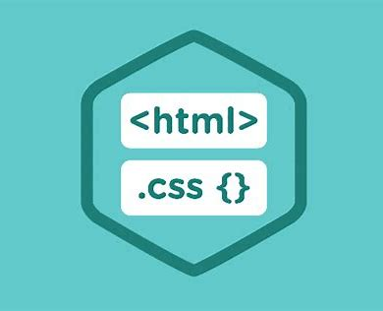

**6.2 FUNCTIONS AND TOOLS:**

The major tools and tags we have used are\

Tag:

1. <button>

2. <img>

3.<input>

4.<div>

5.<h1>

Functions:

1.OnClick

2.Class

3.Id

CSS Style:

1.Position

2. Background-color

3. Background-image

4. Text-align

5. Min-height

6. Min-width

7. Top

8. Background-size

9. Font-family

10. Font-size

11. Background-position

12. Color

13. Right

14. Left

15. Border

16. Box-shadow

17. Border-radius

18. Hover

19. Paddings

20. bottom

21. Cursor

22. Transition

23. Width

24. Height

25. Text-indent

**6.3 INNOVATIVE FEATURES**



1.No Physical Restrictions.

2.Multiple Access.

3.Easy-to-use.

4.Conservation and Preservation.

5.No Limitation of Space.

6.Scope of Improvement.

7.More than a Library.

8.Not Time-Bound

9.No Boundaries of Knowledge.

10.No Language Bar.

Multiple Access:

One main problem in traditional libraries is the restriction in using the same resource by multiple people simultaneously. It is not a problem in the case of digital libraries. Several individuals and institutions can access the same resource at the same time. Mintbook is one such digital library where resources are available to universities, training centers, banking, and even schools. It has a variety of content that matches everybody’s choice.

**6.4 MORE THAN A LIBRARY**

Another exciting feature of digital libraries is that it’s not just a library. Its spectrum is broader than the old school libraries. For instance, [digital libraries](https://mintbook.com/digital-library) engage with their clients via formal as well as informal mode.

No Language Bar:

Apart from having a wide variety of texts and books, a digital library also has texts in many languages. Language isn’t a hindrance to DLs.

The Various Functions of E-Library:

* **Access to a large amount of information –**It provides large amount of information to access the resources.
* **User-friendly interface –**It meet the demands of multiple users to access the system over the internet at the same time.
* **Client server architecture –**Digital libraries provide support to their clients which can be accessed with common desktop configuration and software.
* **Network accessibility –**Online library system is a collection of disparate system and resources connected through a network.
* **Access to primary information sources –**They provide a wide range of information to the users in digital form.
* **Support multimedia content –**This system supports the multimedia content.

**6.5 SYSTEM OBJECTIVES**



Improvement in control and performance. The system is developed to cope up with the current issues and problems of library. The system can add user, validate user and is also bug free. Save cost after computerized system is implemented less human force will be required to maintain the library thus reducing the overall cost.

Save time librarian is able to search record by using few clicks of mouse and few search keywords thus saving his valuable time.

**6.6 EXISTING VS PROPOSED SYSTEM**

1-Existing system does not have any facility of teachers login or student login where as proposed system will have a facility of student login as well as teacher’s login

2-Existing system does not have a facility of online reservation of books whereas proposed system has a facility of online reservation of books

3-Existing system does not have any facility of online notice board where description of workshops happening in our college as well as nearby colleges is being provided.

4-Existing system does not has any option of lectures notes uploaded by teachers whereas proposed system will have this facility.

5-Existing system does not have any facility to generate student reports as well book issue reports whereas proposed system provides librarian with a tool to generate reports.

6-Existing system does not has any facility for book request and suggestions where as in proposed system after logging in to their accounts student can request books as well as provide suggestions to improve library

7-Option of online Notice board librarian will be able to provide a detailed description of workshops going in the college.

**6.7 LOGBOOK:**

A [log](https://www.collinsdictionary.com/dictionary/english/log) book is a book in which [records](https://www.collinsdictionary.com/dictionary/english/record) [details](https://www.collinsdictionary.com/dictionary/english/detail) and [events](https://www.collinsdictionary.com/dictionary/english/event) relating to something are stored. A library logbook is one in which the details about the books in the library, the students who enters and leaves the library, the events that are happening regarding the library are stored. Since today belongs to the digital age, the idea of introducing E-logbook seems to be innovative and useful in many aspects for the users. Creating an application which acts as an E-logbook for the library is a creative idea. The application will be more user-friendly and it will be an attractive User-Interface.

E-logbook stores and record data about the happenings of the events and the entries of books and students. The users will be able to register for the events that are happening in the library. The following figure is an example of an eLogbook web application.

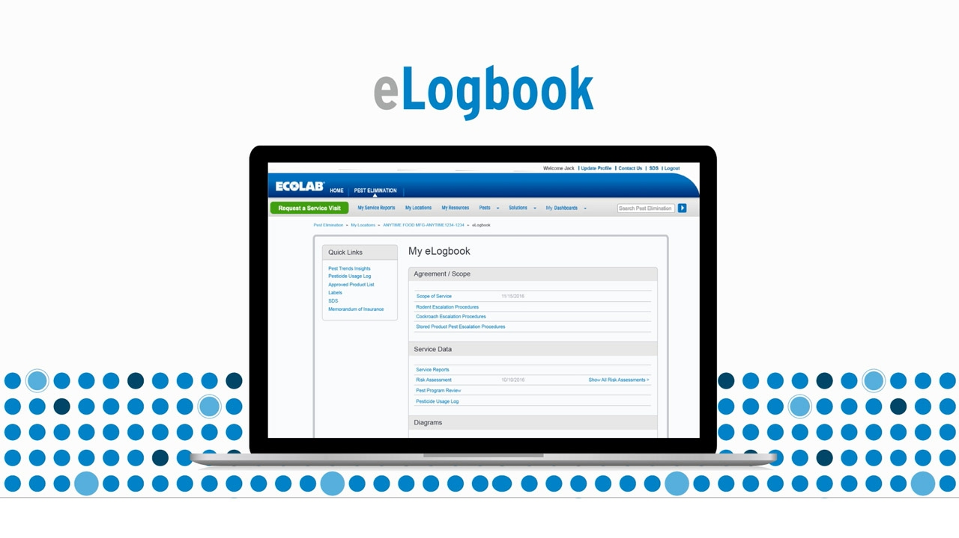

What Data do E-Logbook collects?

E-logbook collects a multitude of data for the library. Some of the information collected may include:

* Statistical information about library.
* Complete details of the available books.
* Students Entry and Exit time.
* Upcoming events in the library.
* List of e-journals.

**CHAPTER – 7**

**CONCLUSION & FUTURESCOPE**

This website provides a computerized version of library management system which will benefit the students as well as the staff of the library. It makes entire process online where student can search books, staff can generate reports and do book transactions. It also has a facility for student login where student can login and can see status of books issued as well request for book or give some suggestions. It has a facility of teacher’s login where teachers can add lectures notes and also give necessary suggestion to library and also add info about workshops or events happening in our college or nearby college in the online notice board. There is a future scope of this facility that many more features such as online lectures video tutorials can be added by teachers as well as online assignments submission facility, a feature of group chat where students can discuss various issues of engineering can be added to this project thus making it more interactive more user friendly and project which fulfills each users need in the best way possible.