Suicide Rates & Socioeconomic Factors Analysis

Overview:
This documentation focuses on analyzing suicide rates and their correlation with socioeconomic factors from the years 1990 to 2022 and build an ETL(Extract, Transform, Load) pipeline which transforms the data and derive meaningful insights.

Objectives:
- Data Collection
- ETL Process
- Predictive Modeling
- Fraud Detection
- Data Analysis
- Data Visualization

- Data Collection:
Two datasets will be used for this project which are sourced from Kaggle.
- age_std_suicide_rates_1990-2022.csv
- suicide_rates_1990-2022.csv
- ETL Process:
ETL using Python:
Used Python data analysis libraries numpy and pandas to perform ETL for the datasets.
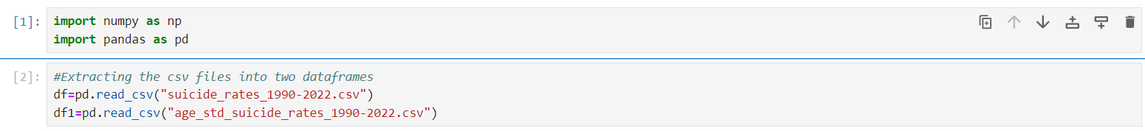
Importing necessary libraries and importing the datasets and initializing two dataframes df and df1 for those two datasets
Retrieving the information of dataframe df to see the schema

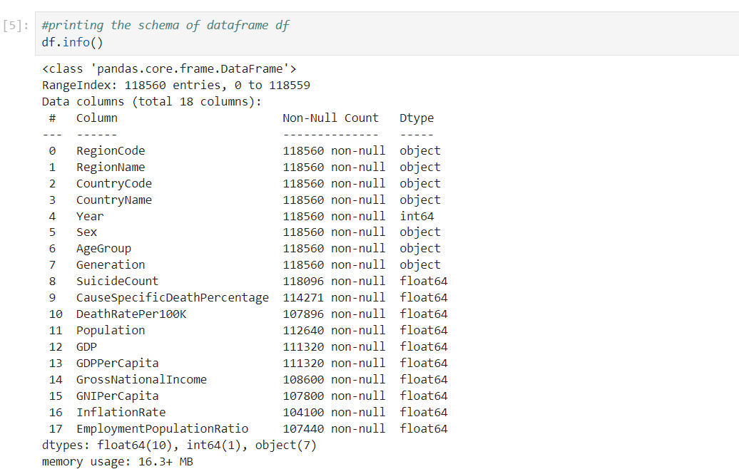

Retrieving total number of null values for the dataframe by each column
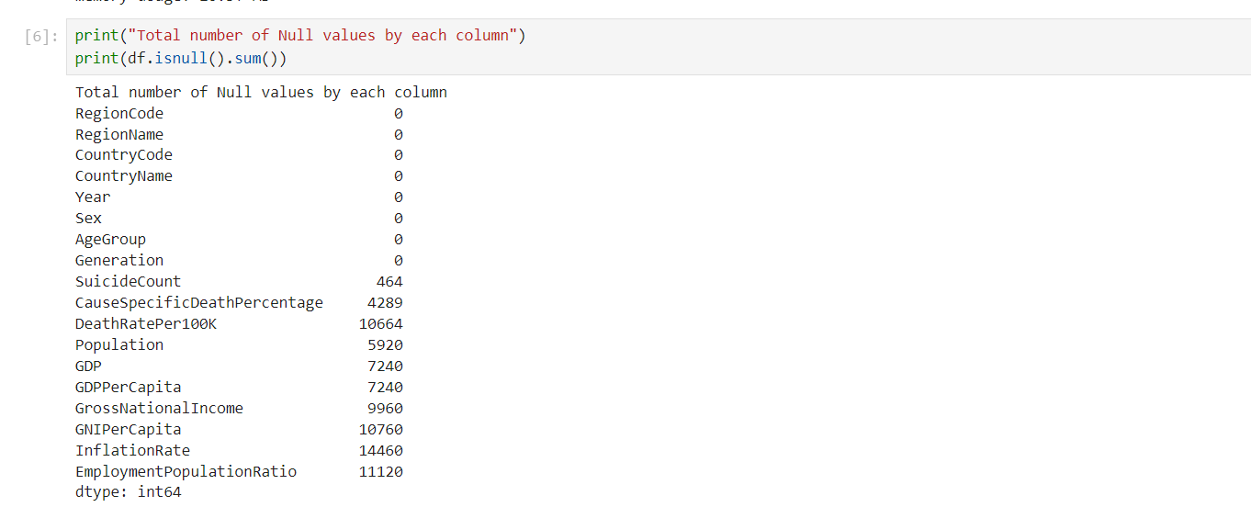
Dropping unnecessary columns and checking total number of records present in dataframe

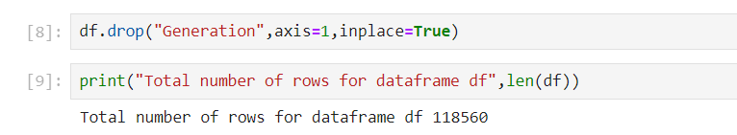
Dropping all the null values to improve data integrity and accuracy.

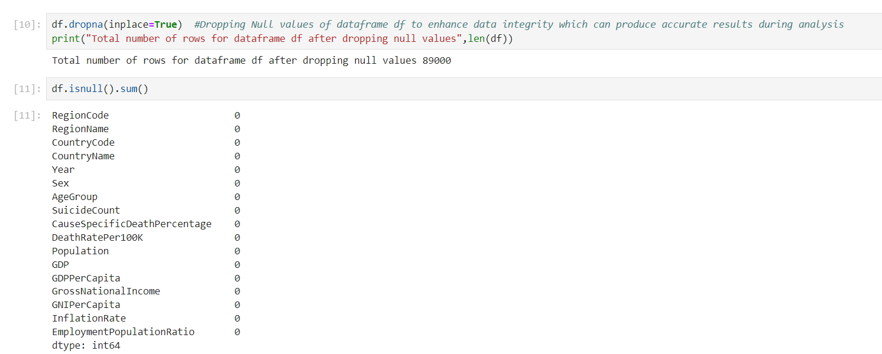

Removing duplicate rows from the dataset
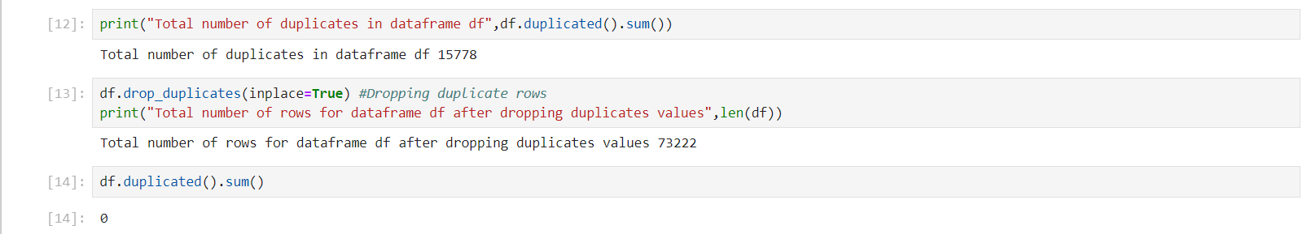

Retrieving schema for the second dataframe
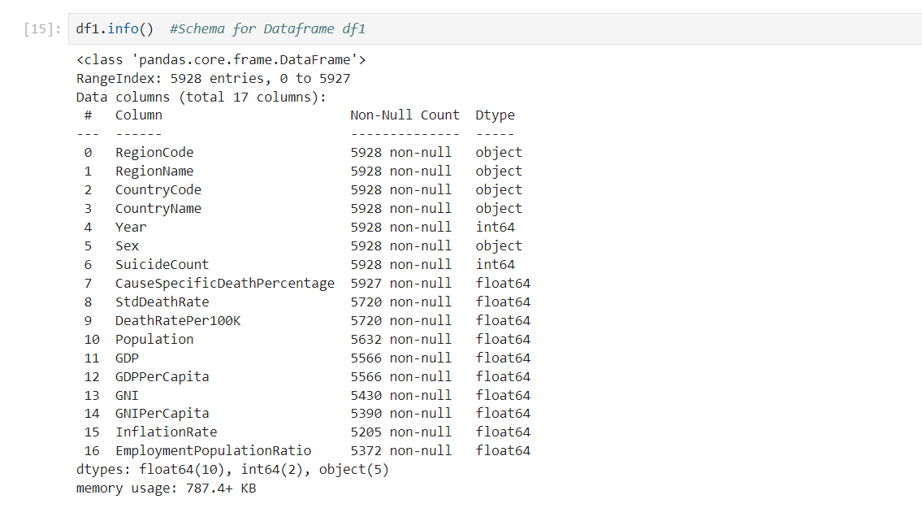
Checking null values by every column and removing them and dropping unnecessary columns
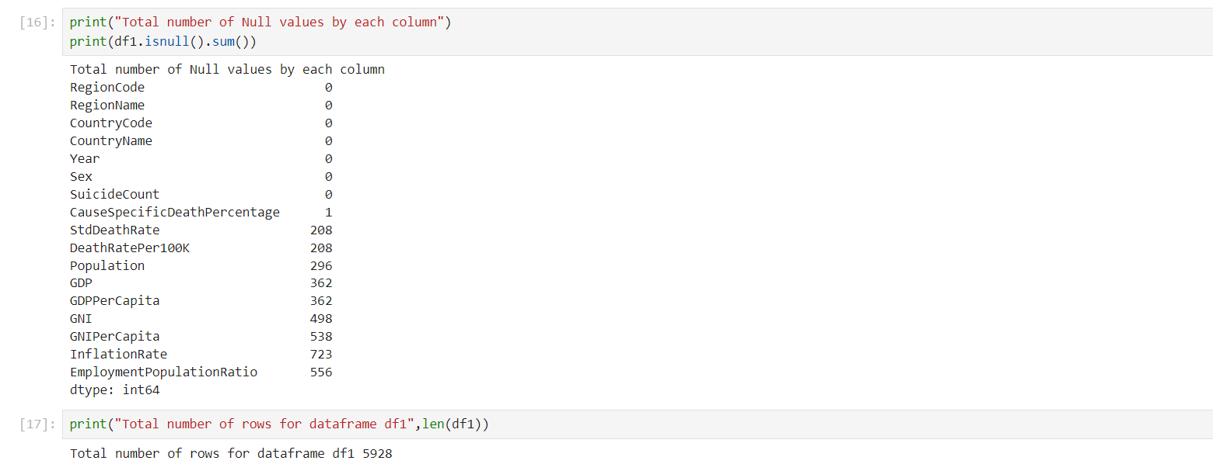
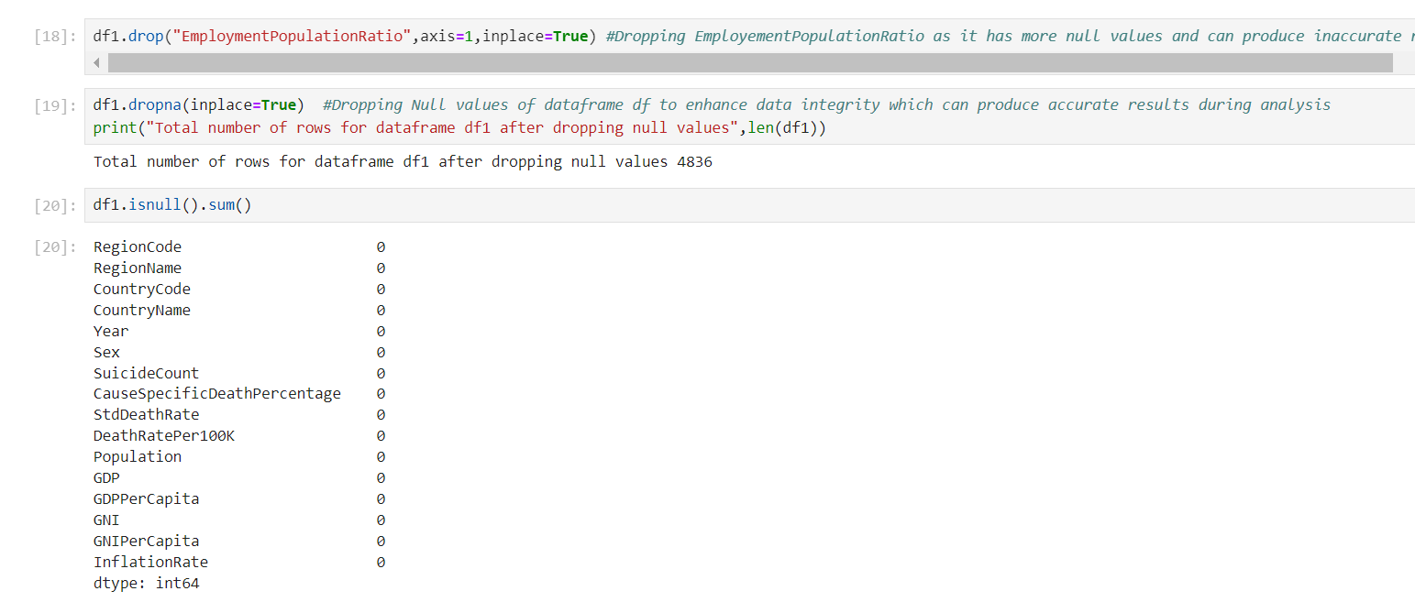

Exporting the transformed datasets as csv files.
ETL using SSIS:
Used SQL server Integration services for ETL of the datasets in visual studio 2022
Performing ETL on datasets to store raw data in SQL server database it will be stored in SQL server database suicide_analysis
As tables suicide_rates_raw and age_std_suicide_rates_raw
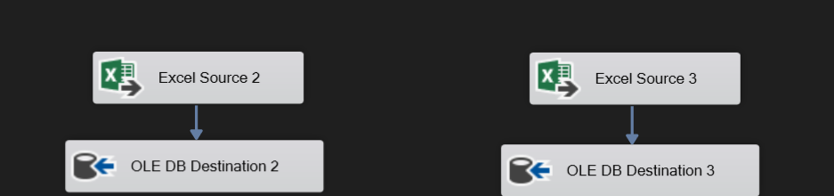
Performing ETL on suicide_rates_1990-2022.csv by removing duplicate values using sort and removing NULL values for every column using conditional splits and saving those transformed dataset as a table named suicide_rates_pro in SQL server database suicide_analysis using OLE DB Destination
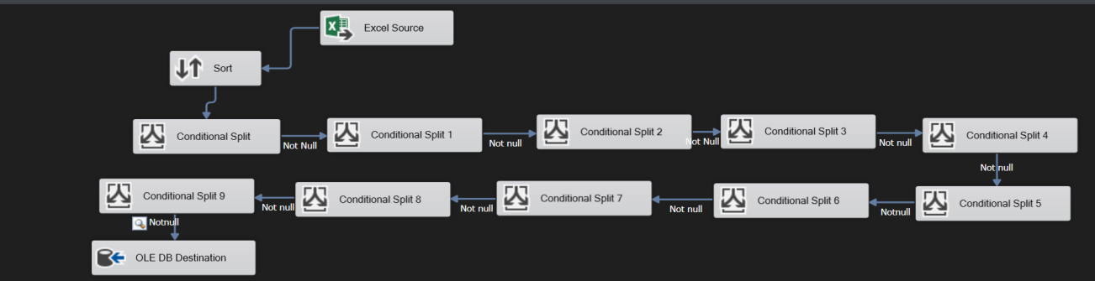
Performing ETL on age_std_suicide_rates_1990-2022.csv by removing NULL values for every column using conditional splits and saving those transformed dataset as a table named age_std_suicide_rates_pro in SQL server database suicide_analysis using OLE DB Destination.
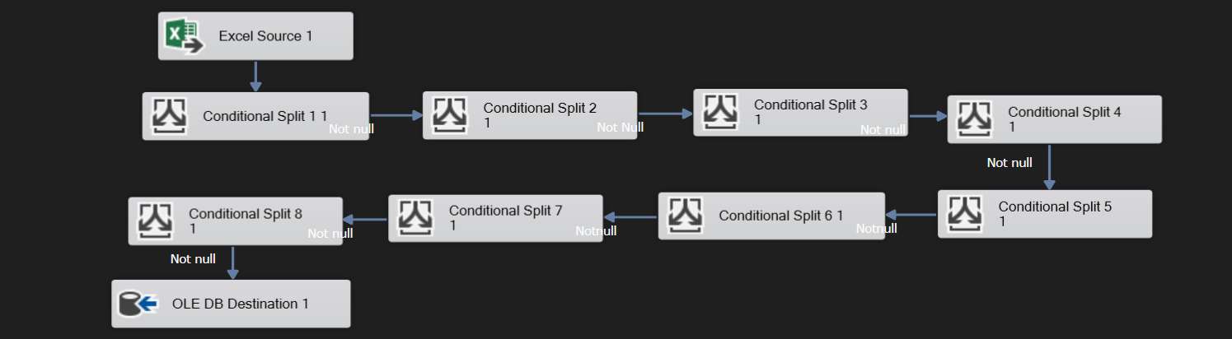
The transformed datasets are loaded into the suicide_analysis database and stores as 4 tables
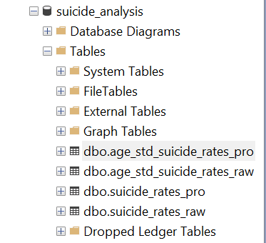

Suicide_rates_pro table schema:
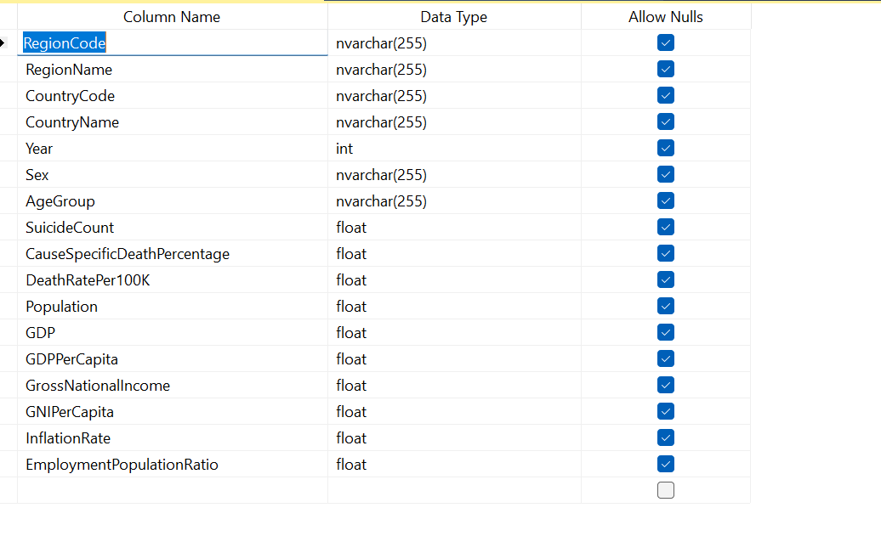
Age_std_suicide_rates_pro table schema:
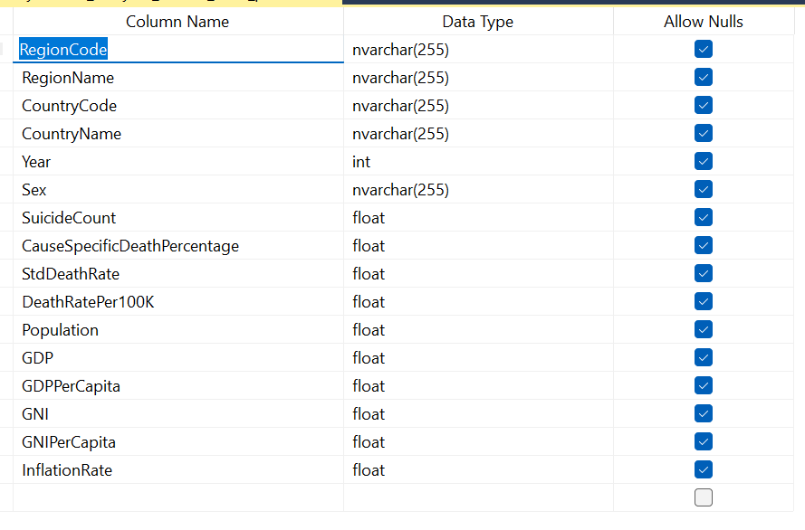
Checking whether the data is stored in table or not:
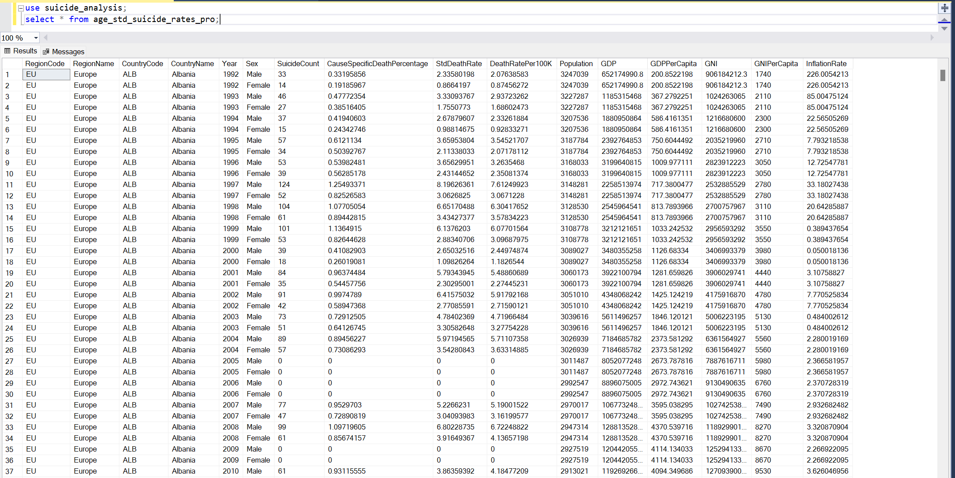

- Predictive Modeling:
Used Python libraries Scikit learn and tensorflow for predictive modeling which predicts future suicide rates for next 7 years using the socioeconomic factors and predicts inflation rate for next 5 years.
Importing necessary libraries and extracting the transformed datasets
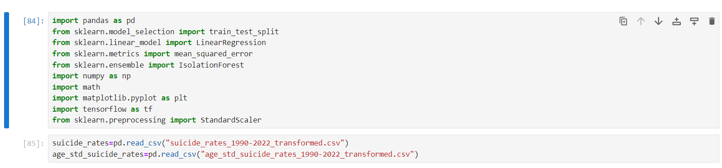
Converting the Year column as int and dropping unncessary columns to predict accurate suicide counts
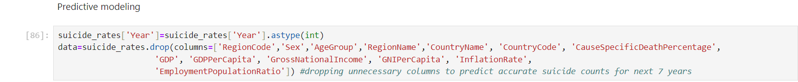\
Groupping the rows by year and getting the sum of other features and reshaping the year to numpy array into x variable and y is the target variable and splitting the data into training dataset and testing dataset for the input features and for the target variable where 20% of the data is used for testing and remaining 80% for the training.and random shuffling is applied to the data before splitting. Setting a random_state ensures reproducibility, meaning if you use the same value for random_state each time you run the code, you'll get the same split of data. It's helpful for debugging and sharing code because it produces consistent results. Here, random_state=42 is just an arbitrary value chosen to initialize the random number generator. It could be any integer value.
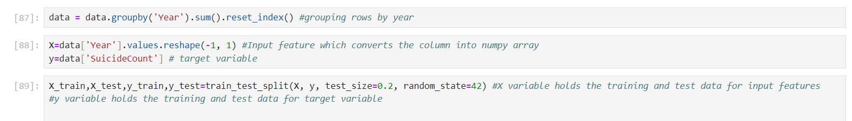
Creating a Linear regression model and fitting it to the training dataset this model can be used to generate output if we provide other data accurately because it has been trained on the training data, and creating a future_years dataset from year 2023 to 2029 to predict sucide rates for those years and predicting them using the trained model
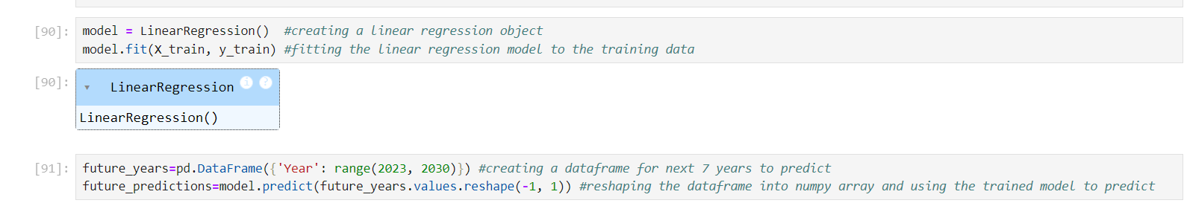
Displaying the future suicide rates from 2023 to year 2029
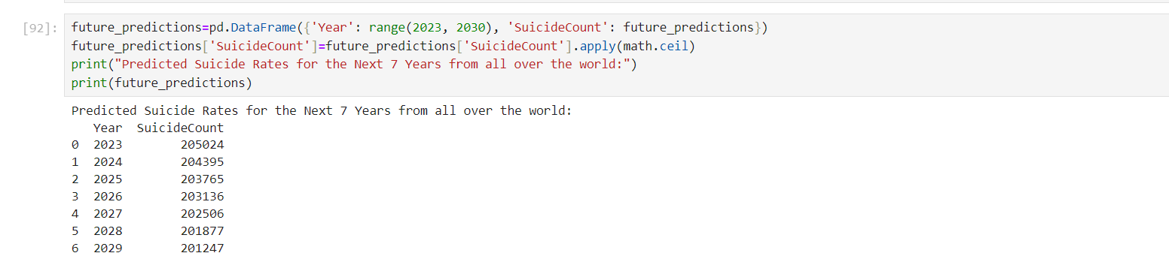

Selecting the relevant features to predict inflation rate and splitting them into training and testing datasets and creating a neural network with 3 dense layers using sequential model the Sequential API is simpler and more straightforward, suitable for most cases where the network consists of a single stack of layers and adding a densely-connected layer to the model. Each Dense layer represents a fully connected layer where each neuron is connected to every neuron in the previous layer.and it contains 64 layers
specifying the activation function used by the neurons in this layer. Relu stands for Rectified Linear Unit, a common activation function used to introduce non-linearity into the network.
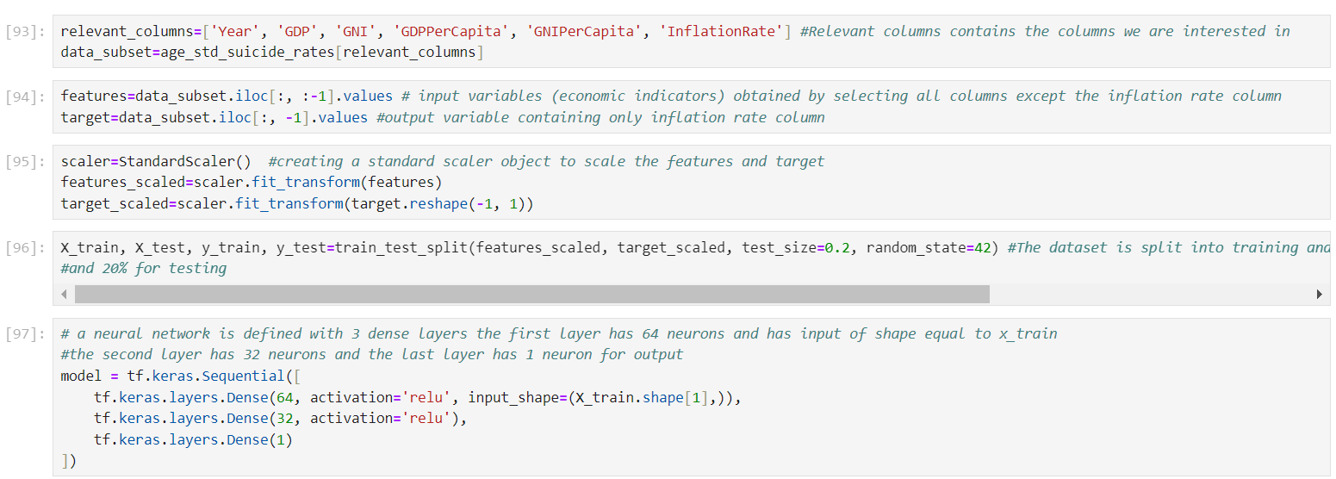
The model is now compiled with Adam optimizer and mean squared error loss function and the model is trained on training data for 50 epochs which is iterations over the entire training dataset to train the model. One epoch consists of one forward pass and one backward pass of all the training examples. With batch size of 32
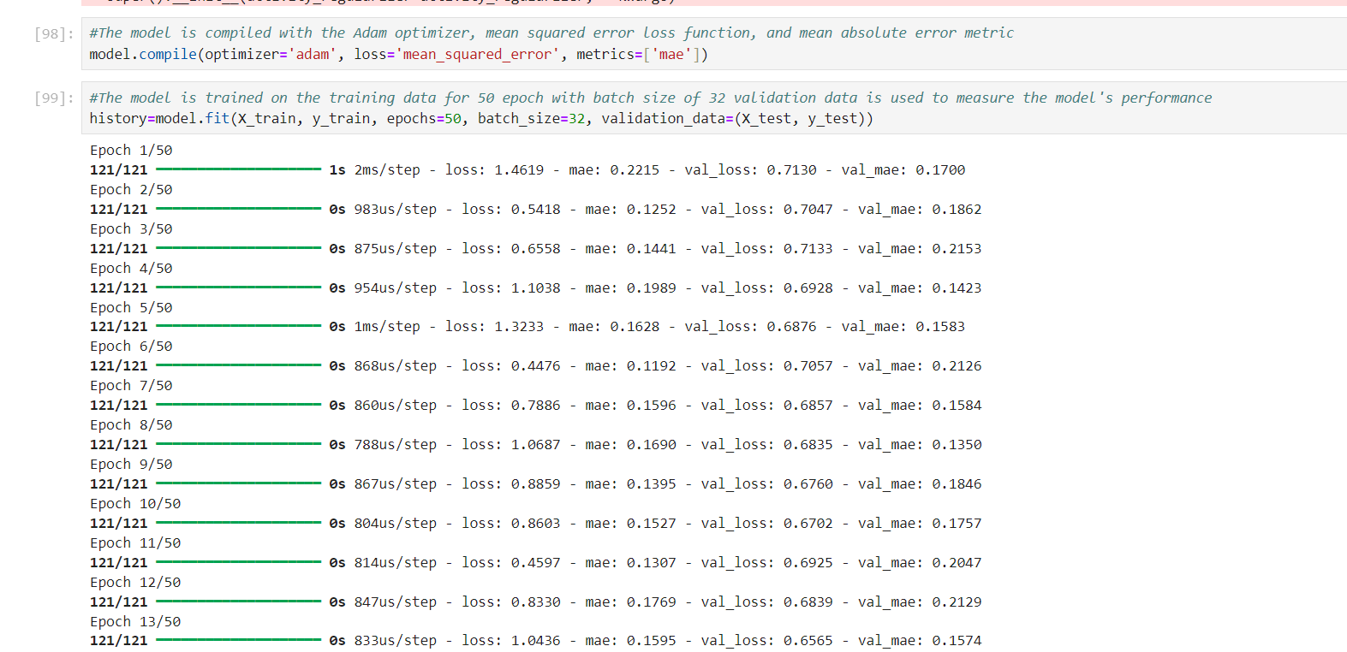

The features and target variable are standardized using StandardScaler() to ensure consistent scales across the dataset the target variable is reshaped to a single column and scaled accordingly data from a dataframe is converted to a NumPy array for numerical processing future years are generated using np.arange() and formatted into a numpy array economic indicators are initialized with zeros, except for years this data is then scaled using the previously fitted scaler finally, the machine learning model is utilized to predict inflation rates for the future years based on the scaled future data. This pipeline provides a structured approach to preprocess data and utilize a trained model for making predictions on unseen data, aiding in forecasting inflation trends for upcoming years.

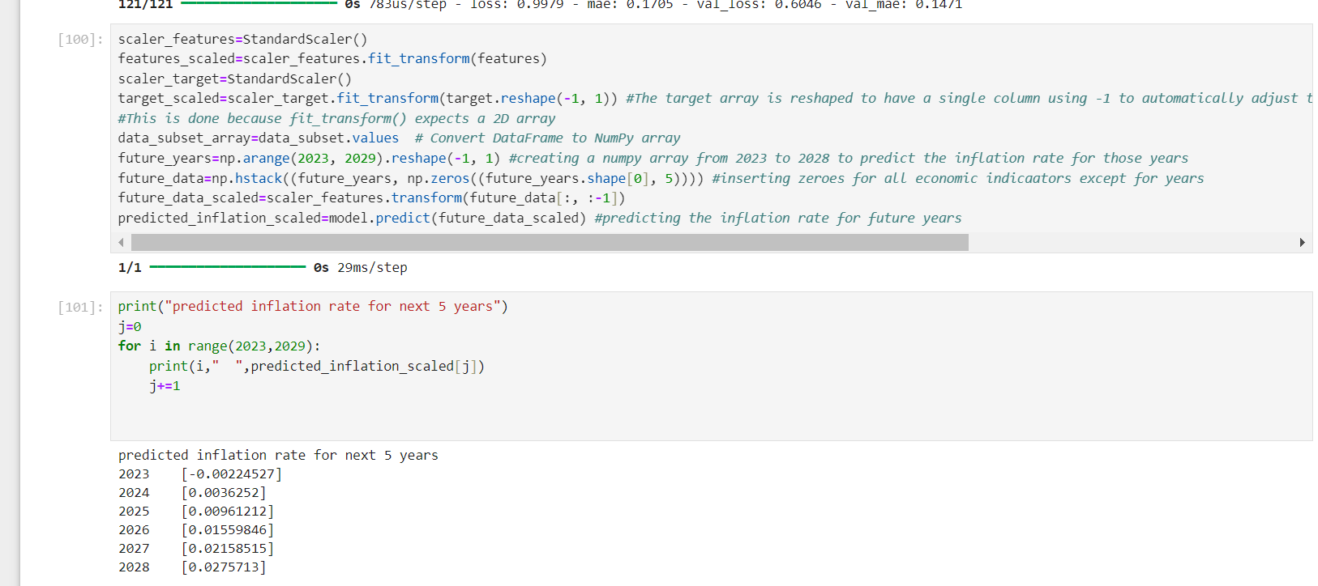

- Fraud Detection:
Used scikit learn isolation forests for outlier detection.
Iterating through a list of numerical column names, including SuicideCount, DeathRatePer100K, GDP, and GDPPerCapita. For each column, it computes the Z-scores, which measure how many standard deviations an observation is from the mean. The formula (value - mean) / standard deviation is applied to calculate the Z-scores observations with absolute Z-scores greater than 3, indicating they are more than 3 standard deviations away from the mean, are considered outliers. If any outliers are detected for a column, they are printed along with the name of the column. 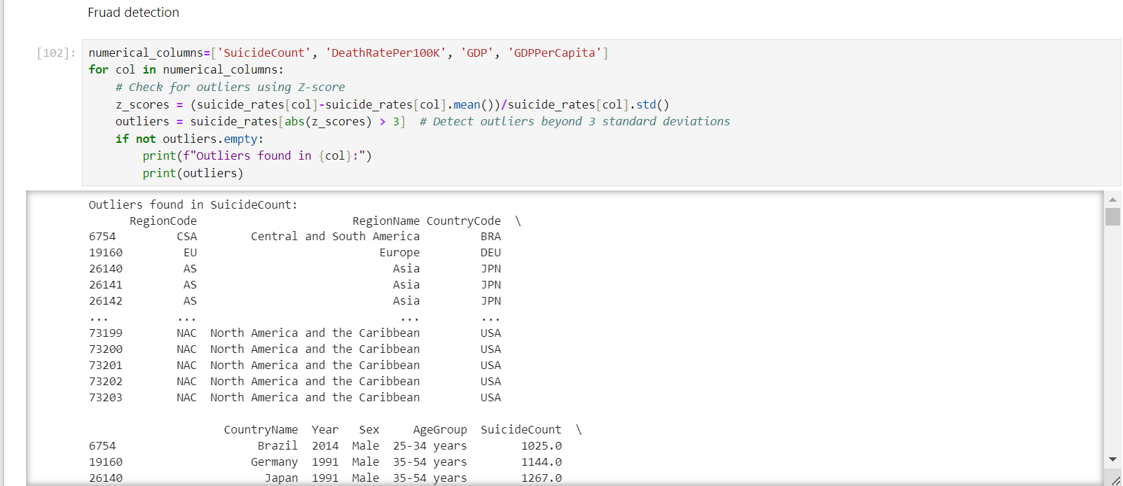
Using Isolation Forest, an anomaly detection algorithm, to identify outliers in a dataset comprising numerical columns related to suicide rates it initializes an isolation forest model with a contamination parameter set to 0.05, which can be adjusted based on the expected rate of outliers or anomalies in the data the model is then trained on the numerical columns of the dataset using the trained model, outlier predictions are made for each data point. These predictions are assigned to a new column outlier in the dataset subsequently, a scatter plot is generated, where each point represents a year's suicide count, with outliers highlighted using color coding the colorbar indicates the outlier status, with distinct colors denoting outliers this visualization aids in understanding the distribution of suicide counts over the years and identifying potential anomalies that deviate significantly from the normal, facilitating further investigation or analysis.

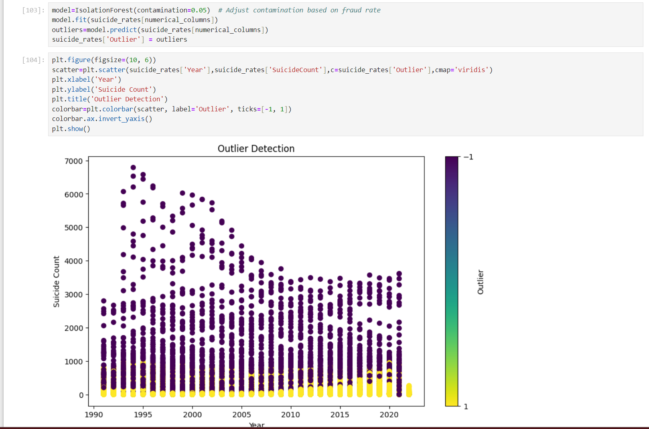

- Data Analysis:
Used SQL server management studio for data analysis and performed data analysis on data which was loaded from SSIS
Query to get Average suicide counts by each region
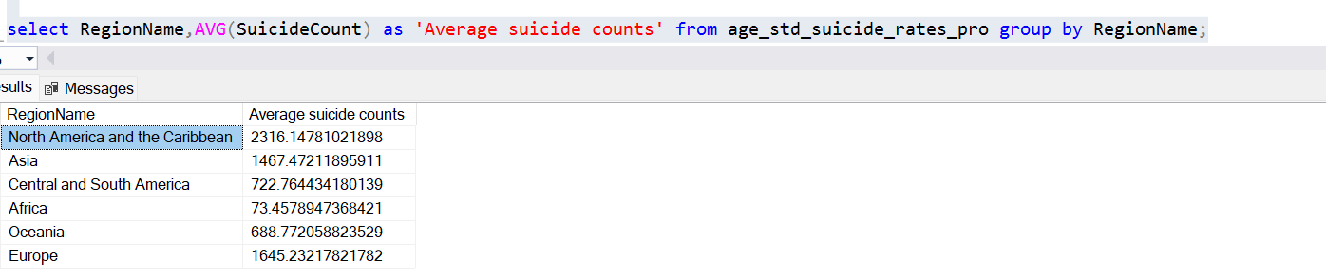
Query to get Total suicides by gender in America
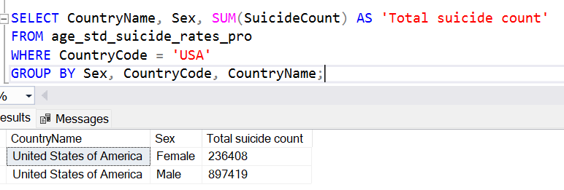

Query to get Highest inflation rate in year 2001
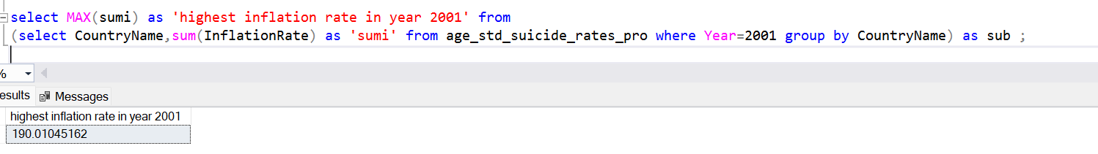
Query to get Age group with highest suicide counts in Europe
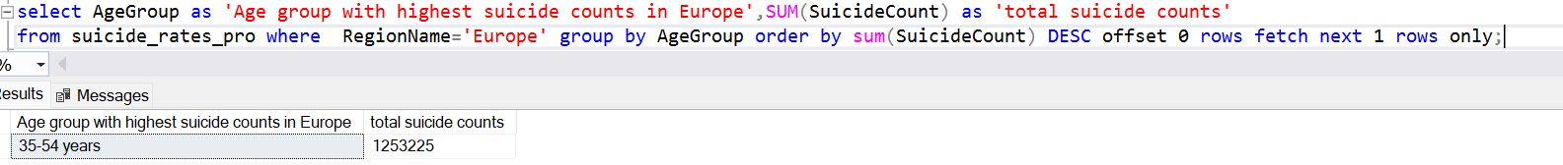
Query to get country with least GDP per capita in year 2011
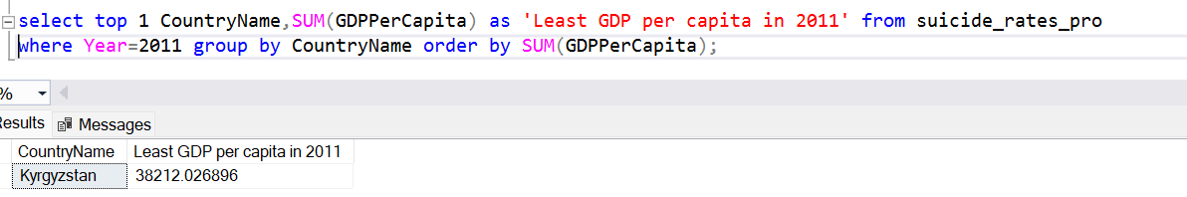

- Data Visualization:
Used PowerBi and Tableau to generate Dashboard and Reports and it contains analysis on suicide counts by gender and age group and it specifies the relationship between the suicide rates and socioeconomic factors like GDP and Inflation rate
PowerBi dashboard:

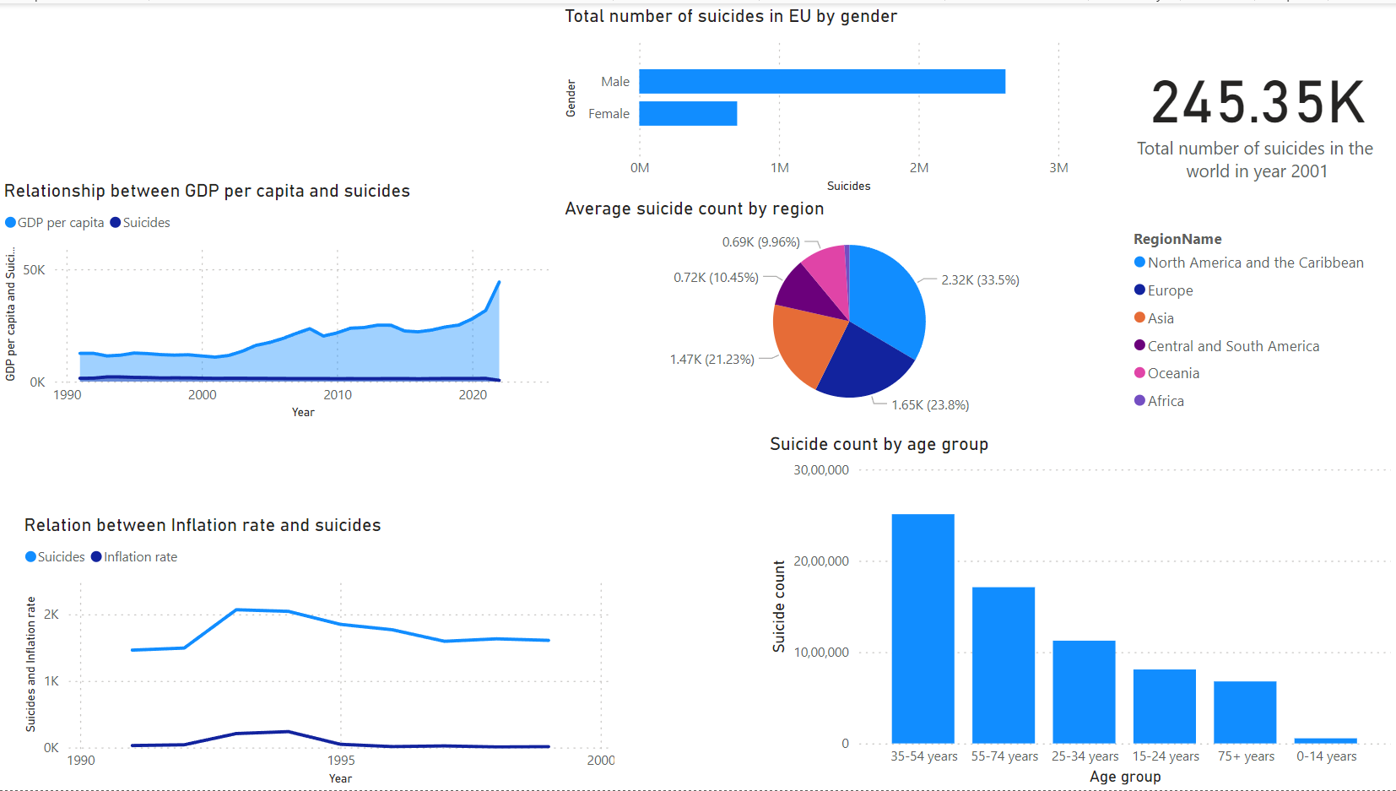

Tableau Report:
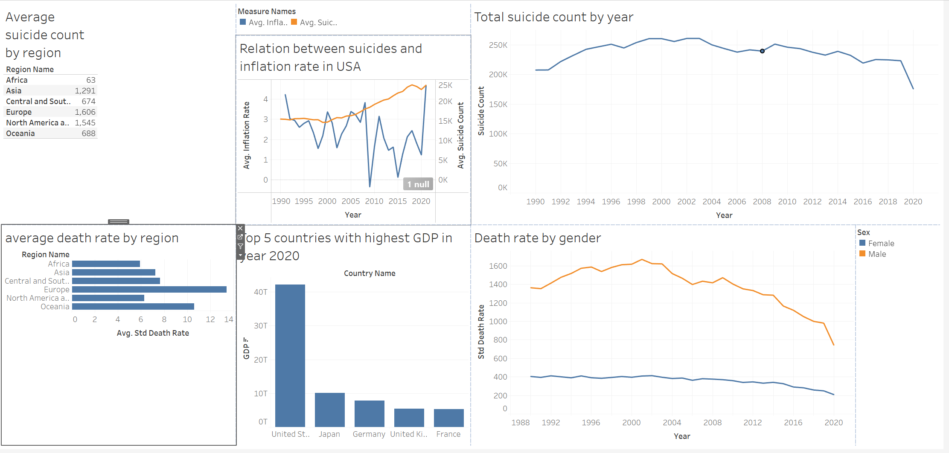

Conclusion:
In conclusion, this project aims to comprehensively analyze suicide rates and their association with socioeconomic factors spanning the years 1990 to 2022. Utilizing datasets sourced from Kaggle, the analysis will unveil trends in suicide rates over time and explore correlations with indicators such as GDP, Inflation rates. Employing a robust data warehousing solution coupled with ETL processes ensures efficient data handling, while the integration of advanced analytics tools facilitates predictive modeling and fraud detection. Leveraging technologies like Microsoft SQL, SSIS, Python, Tableau, and Power BI, this project endeavors to deliver actionable insights through interactive visualizations and customized reports.

