**Maths Test Chapter-1**

1. Give the definition of the following with examples. (Each 2M)
2. Cartesian Product of A and B
3. Relation, Domain, Co-domain, Range.
4. Functions
5. Types of Functions.
6. Special cases of Function.
7. Composition of function
8. Fill in the blanks. (Each 1M)
9. If n(A) = p, n(B) = q, then the total number of relations that exist between A and B is_________
10. A function is also called as ___________________.
11. The difference between relation and function is ____.
12. An onto function is also called a ________.
13. A one – one and onto function is also called a _________.
14. True of False (Each 1M)
15. A×B=Ǿ if and only if A = Ǿ or B = Ǿ
16. If n(A) = p and n(B) = q then n(A×B) =pq.
17. The range of a function is a subset of its co-domain.
18. If f : A ® B is an onto function then, the range of f = B That is, f(A) = B .
19. If n(A) = n(B), then f is a bijection from A to B.
20. All one – one functions are onto functions.
21. Composition of three functions is always associative.
22. Solve the following (Each 2M)
23. If A = {1,3,5} and B = {2,3} then

(i) find A×B and B×A.

(ii) Is A×B=B×A? If not why?

(iii) Show that n(A×B) = n(B×A) = n(A)× n(B)

1. Let A = {3,4,7,8} and B = {1,7,10}. Which of the following sets are relations from A to B?
2. R1 ={(3,7), (4,7), (7,10), (8,1)}
3. R2= {(3,7), (4,10), (7,7), (7,8), (8,11), (8,7), (8,10)}
4. A Relation R is given by the set {(x,y) /y=x +3, x ∈{0,1,2,3,4,5}}. Determine its domain and range.
5. Represent each of the given relations by (a) an arrow diagram, (b) a graph and (c) a set in roster form, wherever possible.

(i) {(x,y)|x = 2y, x ∈{2,3,4,5}, y ∈{1,2,3,4}

(ii) {(x,y)|y = x+3, x, y are natural numbers < 10}.

1. If X = {–5,1,3,4} and Y = {a,b,c}, then which of the following relations are functions from X to Y ?
2. R1 = {(–5,a), (1,a), (3,b)}
3. R2 = {(–5,a), (1,a), (3,b),(4,c),(1,b)}.
4. 
5. 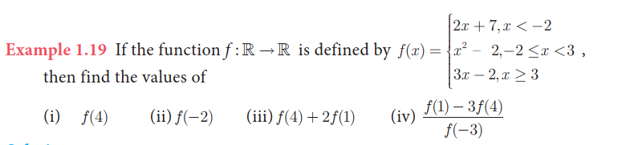
6. 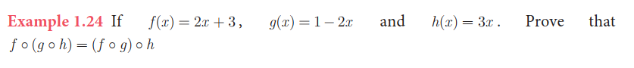
7. 

**All the Best**