**Maths Test Chapter-2**

1. **Define the following(2m)**
2. Generalised form of Euclid’s division lemma.
3. Arithmetic Progression
4. Geometric Progression
5. **Solve the following (3m)**
6. Find the greatest number that will divide 445 and 572 leaving remainders 4 and 5 respectively.
7. Find the HCF of 396, 504, 636.
8. Use Euclid’s Division Algorithm to find the Highest Common Factor (HCF) of 10224 and 9648.
9. A positive integer when divided by 88 gives the remainder 61. What will be the remainder when the same number is divided by 11?
10. Find the greatest number consisting of 6 digits which is exactly divisible by 24,15,36?
11. Find the least number that is divisible by the first ten natural numbers.
12. Find the remainders when 70004 and 778 is divided by 7.
13. 
14. 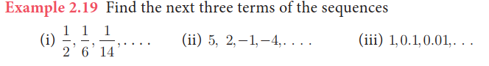
15. 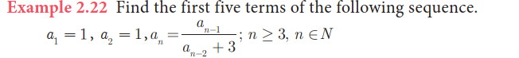
16. 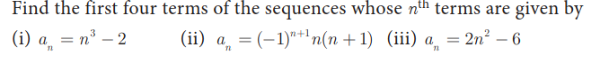
17. 
18. 
19. 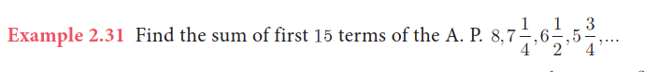
20. 
21. In a G.P. 729, 243, 81,… find t7 (7th Term).
22. 
23. How many terms of the series 1+ 4+ 16+ ☹ make the sum 1365?
24. Fill in the blanks.(11m)
    1. Two positive integers are said to be relatively prime or co prime if their Highest Common Factor is ____.
    2. Two integers a and b are congruent modulo n if _______.
    3. The nth term of the sequence 0,2,6,12,20,... can be expressed as _____.
    4. The difference between any two consecutive terms of an A.P. is always ________
    5. In general, the nth term of A.P can be written as ______.
    6. An Arithmetic progression having a common difference of zero is called a ____________.
    7. If a and l are first and last terms of an A.P. then the number of terms is given by n= ___________.
    8. If the first term a, and the last term l (nth term) are given then

Sum to n terms of A.P = ________.

* 1. In general, the nth term of G.P can be written as ______.
  2. In general, Sum to n terms is ________

1. True /False (3m)
   1. Two integers a and b are congruent modulo m, written as a mod m, if they not leave the same remainder when divided by m.
   2. All sequences are functions
   3. All functions are sequences.
   4. In A.P If every term is multiplied or divided by a non-zero number, then the resulting sequence is also in ______.
   5. Sum of first n natural numbers _________

**All the Best**