
Forest Fire Risk Prediction Using Random Forest
Mini Project Report
Abstract
Forest fires destroy vegetation, wildlife habitat and human property, and they are difficult to control once they spread. Predicting the fire risk of an area in advance can help forest departments take preventive measures such as patrolling, warnings and resource allocation. This project, "Forest Fire Risk Prediction Using Random Forest," aims to develop a machine learning system that predicts whether a forest area is likely to catch fire and estimates the fire risk level as Low, Moderate or High. The model uses features including temperature, relative humidity, wind speed, rainfall, and the Fire Weather Index components FFMC, DMC, DC, ISI, BUI and FWI. A Random Forest Classifier is trained using a dataset containing 500 records and evaluated using Accuracy, Precision, Recall, F1-score and the Confusion Matrix. The project also uses feature importance to identify the variables that contribute most to forest fire occurrence. The developed model can provide a quick fire risk estimate for a new set of weather values and demonstrates the practical application of Machine Learning in environmental monitoring and disaster prevention.

PROGRAM:
Import the Required Libraries
import os
import numpy as np
import pandas as pd
import matplotlib.pyplot as plt
import joblib
from sklearn.model_selection import train_test_split
from sklearn.ensemble import RandomForestClassifier
from sklearn.metrics import (accuracy_score, precision_score, recall_score,
f1_score, confusion_matrix, classification_report)

print("Libraries imported successfully!")
Load Dataset
DATA_PATH = "forest_fire_dataset.csv"

if not os.path.exists(DATA_PATH):
raise FileNotFoundError(
"forest_fire_dataset.csv was not found. "
"Keep the CSV in the same folder as this notebook."
)

df = pd.read_csv(DATA_PATH)
print("Dataset loaded successfully!")
print("Dataset shape:", df.shape)
print(df.head().to_string(index=False))
Check Dataset Information
print(df.info())
print("\nMissing values:")
print(df.isnull().sum())
Statistical Summary
print(df.describe().round(2).T[["mean", "min", "max"]])
Visualize Fire / No Fire Distribution
counts = df["fire"].value_counts().sort_index()
print(counts.rename({0: "No Fire", 1: "Fire"}))

plt.figure(figsize=(7, 5))
plt.bar(["No Fire", "Fire"], counts.values, color=["#4c9f70", "#d9534f"], edgecolor="black")
plt.title("Distribution of Forest Fire Classes")
plt.xlabel("Class")
plt.ylabel("Count")
plt.grid(axis="y", alpha=0.2)
plt.show()
Correlation Analysis
corr = df.corr(numeric_only=True)

plt.figure(figsize=(9, 7))
plt.imshow(corr, cmap="coolwarm", vmin=-1, vmax=1)
plt.colorbar(label="Correlation")
plt.xticks(range(len(corr.columns)), corr.columns, rotation=45, ha="right")
plt.yticks(range(len(corr.columns)), corr.columns)
for i in range(len(corr)):
for j in range(len(corr)):
plt.text(j, i, f"{corr.iloc[i, j]:.2f}", ha="center", va="center", fontsize=7)
plt.title("Correlation Heatmap")
plt.tight_layout()
plt.show()
Split Input and Output
X = df.drop(columns=["fire"])
y = df["fire"]

print("Input features:")
for feature in X.columns:
print("-", feature)

print("\nX shape:", X.shape)
print("y shape:", y.shape)
Train-Test Split
X_train, X_test, y_train, y_test = train_test_split(
X,
y,
test_size=0.20,
random_state=42,
stratify=y
)

print("Training data:", X_train.shape)
print("Testing data :", X_test.shape)
Train Random Forest Classifier
rf_model = RandomForestClassifier(
n_estimators=300,
max_depth=10,
random_state=42,
n_jobs=-1
)

rf_model.fit(X_train, y_train)
print("Random Forest model trained successfully!")
Make Predictions
y_pred = rf_model.predict(X_test)

comparison = pd.DataFrame({
"Actual": np.where(y_test.values[:10] == 1, "Fire", "No Fire"),
"Predicted": np.where(y_pred[:10] == 1, "Fire", "No Fire")
})
print(comparison.to_string(index=False))
Model Evaluation
accuracy = accuracy_score(y_test, y_pred)
precision = precision_score(y_test, y_pred)
recall = recall_score(y_test, y_pred)
f1 = f1_score(y_test, y_pred)

print(f"Accuracy : {accuracy:.4f}")
print(f"Precision: {precision:.4f}")
print(f"Recall : {recall:.4f}")
print(f"F1 Score : {f1:.4f}")
print(f"Accuracy in percentage: {accuracy * 100:.2f}%")
print("\nClassification Report:")
print(classification_report(y_test, y_pred, target_names=["No Fire", "Fire"]))
Confusion Matrix
cm = confusion_matrix(y_test, y_pred)
print(cm)

plt.figure(figsize=(6, 5))
plt.imshow(cm, cmap="Blues")
plt.colorbar()
plt.xticks([0, 1], ["No Fire", "Fire"])
plt.yticks([0, 1], ["No Fire", "Fire"])
for i in range(2):
for j in range(2):
plt.text(j, i, cm[i, j], ha="center", va="center", fontsize=14)
plt.xlabel("Predicted Class")
plt.ylabel("Actual Class")
plt.title("Confusion Matrix")
plt.tight_layout()
plt.show()
Feature Importance
importance_df = pd.DataFrame({
"Feature": X.columns,
"Importance": rf_model.feature_importances_
}).sort_values("Importance", ascending=True)

print(importance_df.sort_values("Importance", ascending=False).round(6).to_string(index=False))

plt.figure(figsize=(9, 5))
plt.barh(importance_df["Feature"], importance_df["Importance"])
plt.xlabel("Importance")
plt.ylabel("Feature")
plt.title("Feature Importance - Random Forest")
plt.tight_layout()
plt.show()
Predict Forest Fire Risk for New Conditions
def predict_fire_risk(temperature, humidity, wind_speed, rain,
ffmc, dmc, dc, isi, bui, fwi):
area = pd.DataFrame([{
"temperature": temperature,
"humidity": humidity,
"wind_speed": wind_speed,
"rain": rain,
"ffmc": ffmc,
"dmc": dmc,
"dc": dc,
"isi": isi,
"bui": bui,
"fwi": fwi
}])

probability = float(rf_model.predict_proba(area)[0][1]) * 100

if probability >= 70:
level = "High Risk"
elif probability >= 40:
level = "Moderate Risk"
else:
level = "Low Risk"

return round(probability, 2), level

# Hot, dry and windy day with no rain
prob, level = predict_fire_risk(
temperature=38, humidity=45, wind_speed=20, rain=0.0,
ffmc=90, dmc=45, dc=180, isi=4.5, bui=45, fwi=3.5
)
print("Fire Probability (%):", prob)
print("Fire Risk Level:", level)

# Cool, humid day with rain
prob, level = predict_fire_risk(
temperature=25, humidity=85, wind_speed=10, rain=6.0,
ffmc=60, dmc=8, dc=30, isi=0.3, bui=9, fwi=0.1
)
print("\nFire Probability (%):", prob)
print("Fire Risk Level:", level)
Save Trained Model
joblib.dump(rf_model, "forest_fire_random_forest.joblib")
print("Model saved successfully!")

OUTPUT:
Import the Required Libraries
Libraries imported successfully!
Load Dataset
Dataset loaded successfully!
Dataset shape: (500, 11)
temperature humidity wind_speed rain ffmc dmc dc isi bui fwi fire
33.2 82 15 0.2 77.2 14.3 26.0 2.2 14.8 1.2 0
28.0 86 13 0.0 75.9 17.5 70.2 1.6 17.3 0.9 0
34.9 61 14 0.0 85.6 29.2 144.8 2.2 36.3 0.4 1
35.6 53 17 0.0 89.8 21.4 74.1 3.6 23.6 0.8 1
24.6 57 16 0.0 75.1 30.7 119.4 1.1 30.5 1.0 0
Check Dataset Information
<class 'pandas.DataFrame'>
RangeIndex: 500 entries, 0 to 499
Data columns (total 11 columns):
# Column Non-Null Count Dtype
--- ------ -------------- -----
0 temperature 500 non-null float64
1 humidity 500 non-null int64
2 wind_speed 500 non-null int64
3 rain 500 non-null float64
4 ffmc 500 non-null float64
5 dmc 500 non-null float64
6 dc 500 non-null float64
7 isi 500 non-null float64
8 bui 500 non-null float64
9 fwi 500 non-null float64
10 fire 500 non-null int64
dtypes: float64(8), int64(3)
memory usage: 43.1 KB
None

Missing values:
temperature 0
humidity 0
wind_speed 0
rain 0
ffmc 0
dmc 0
dc 0
isi 0
bui 0
fwi 0
fire 0
dtype: int64
Statistical Summary
mean min max
temperature 31.95 22.2 42.0
humidity 71.46 37.0 90.0
wind_speed 15.49 7.0 24.0
rain 0.83 0.0 10.9
ffmc 76.53 50.2 94.5
dmc 25.84 0.7 55.1
dc 92.28 6.0 220.0
isi 1.24 0.0 6.0
bui 26.71 1.1 57.5
fwi 0.89 0.0 4.6
fire 0.58 0.0 1.0
Visualize Fire / No Fire Distribution
fire
No Fire 210
Fire 290
Name: count, dtype: int64
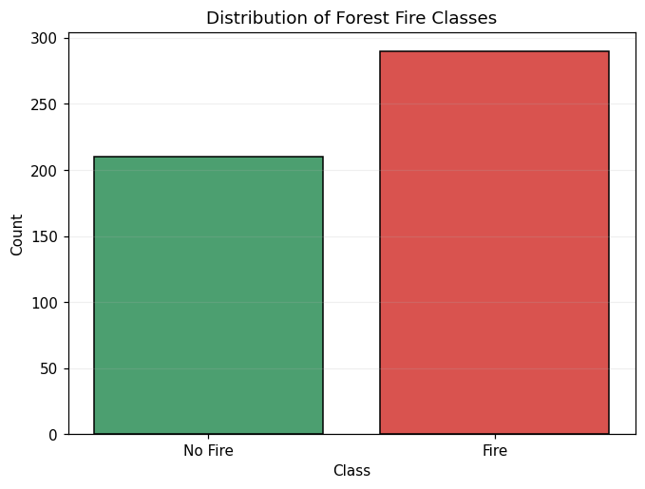
Correlation Analysis
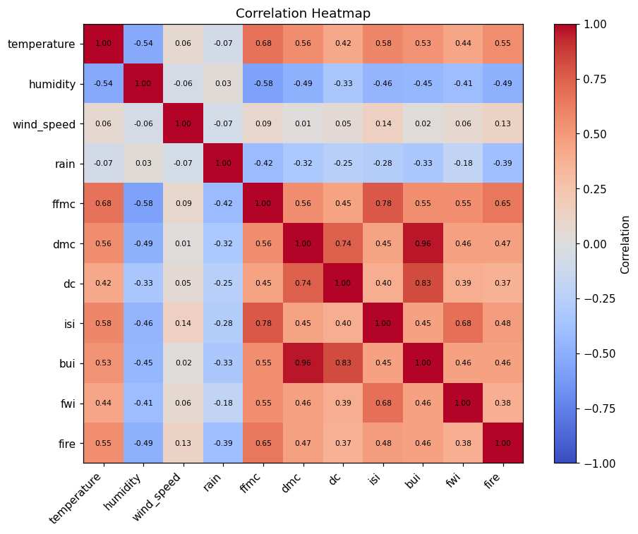
Split Input and Output
Input features:
- temperature
- humidity
- wind_speed
- rain
- ffmc
- dmc
- dc
- isi
- bui
- fwi

X shape: (500, 10)
y shape: (500,)
Train-Test Split
Training data: (400, 10)
Testing data : (100, 10)
Train Random Forest Classifier
Random Forest model trained successfully!
Make Predictions
Actual Predicted
Fire No Fire
Fire Fire
Fire Fire
No Fire No Fire
No Fire No Fire
Fire No Fire
No Fire Fire
Fire Fire
Fire Fire
Fire Fire
Model Evaluation
Accuracy : 0.8300
Precision: 0.8727
Recall : 0.8276
F1 Score : 0.8496
Accuracy in percentage: 83.00%

Classification Report:
precision recall f1-score support

No Fire 0.78 0.83 0.80 42
Fire 0.87 0.83 0.85 58

accuracy 0.83 100
macro avg 0.83 0.83 0.83 100
weighted avg 0.83 0.83 0.83 100
Confusion Matrix
[[35 7]
[10 48]]
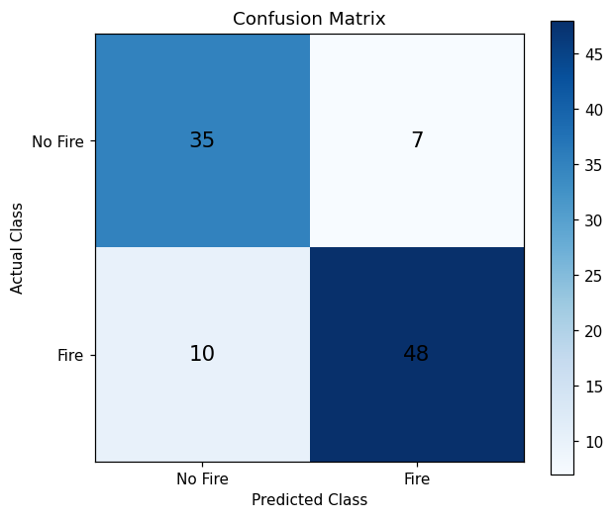
Feature Importance
Feature Importance
ffmc 0.287351
temperature 0.131480
humidity 0.120967
rain 0.092146
isi 0.078148
dmc 0.072084
bui 0.070669
dc 0.058022
fwi 0.049285
wind_speed 0.039848
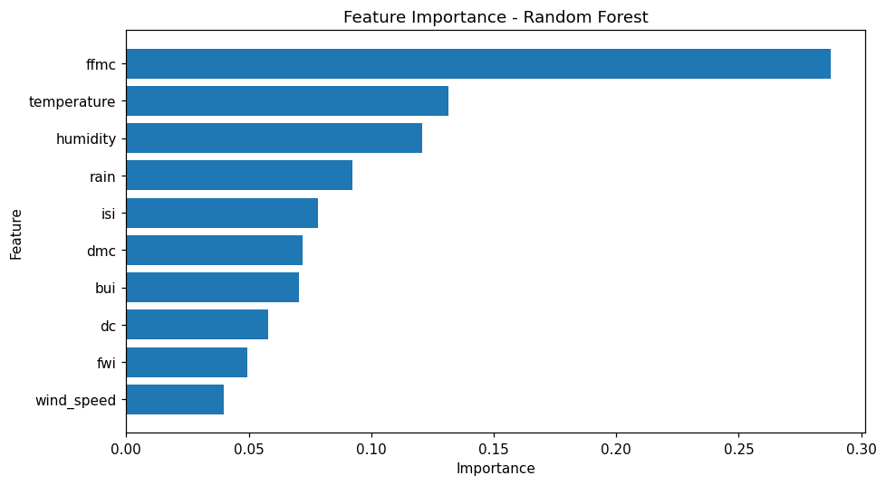
Predict Forest Fire Risk for New Conditions
Fire Probability (%): 98.67
Fire Risk Level: High Risk

Fire Probability (%): 1.67
Fire Risk Level: Low Risk
Save Trained Model
Model saved successfully!

