Online Retail Sales Analysis
Project Objective:
To clean, transform, and analyze the UK-based Online Retail transactional dataset in Excel, and to derive descriptive, diagnostic, predictive, and prescriptive insights into sales performance across countries, months, and products using PivotTables.
Dataset Description:
The dataset is the Online Retail dataset sourced from the UCI Machine Learning Repository, containing transactional records for a UK-based online retailer selling unique all-occasion gifts, covering the period December 2010 to December 2011. The raw file contained 541,909 rows and 8 columns. After cleaning (removing duplicates, cancelled orders, blank Description/CustomerID rows, and invalid prices) and adding 4 calculated columns, the final cleaned dataset contains 392,692 rows and 12 columns.
Column Description
Column Name | Description
InvoiceNo | Unique invoice number for each transaction (numbers starting with "C" indicate a cancelled order)
StockCode | Unique code identifying each product
Description | Name/description of the product
Quantity | Number of units sold in the transaction
InvoiceDate | Date and time the transaction took place
UnitPrice | Price per unit of the product, in GBP (£)
CustomerID | Unique identifier assigned to each customer
Country | Country where the customer is located
Sales | Calculated field: Quantity × UnitPrice, rounded to 2 decimals
Year | Year extracted from InvoiceDate
Month Name | Full month name extracted from InvoiceDate (e.g., December)
Quarter | Quarter of the year derived from InvoiceDate (Q1–Q4)

Data cleaning & transformation:
- Removed 5,268 fully duplicate rows using Data - Remove Duplicates.
- Removed 9,251 cancelled orders (InvoiceNo beginning with "C") using a Text Filter.
- Removed 1,454 rows with blank Description and 133,204 rows with blank CustomerID using blanks filters.
- Removed 40 rows with zero or negative UnitPrice.
- Standardized ID/text columns (InvoiceNo, StockCode, Description, CustomerID, Country) to Text format and applied TRIM() to remove extra spaces.
- Standardized InvoiceDate to DD/MM/YYYY, UnitPrice to 2 decimals, and Quantity to whole numbers.
- Added 4 calculated columns: Sales (=ROUND(Quantity×UnitPrice,2)), Year, Month Name, and Quarter, then converted formulas to fixed values.
- Verified final row count (392,692) using =COUNTA(A:A)-1 and spot-checked Sales calculations manually.
- Applied final formatting: bold header row, frozen top row, AutoFilter enabled, Arial font throughout.
Visualization and Insights Arrived with screenshot of visualization
Report/Dashboard screenshot:
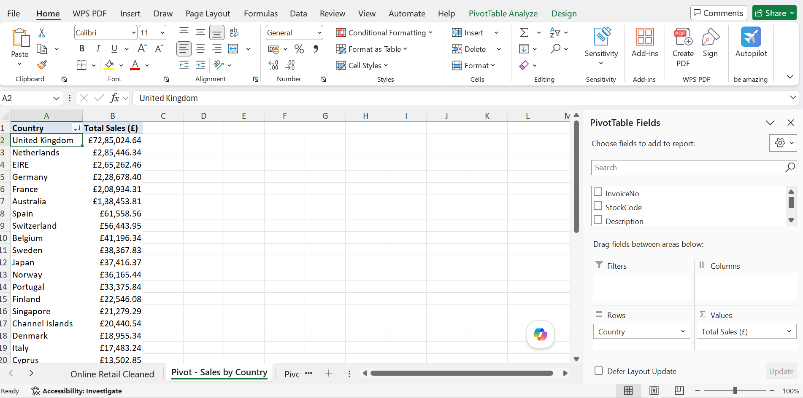
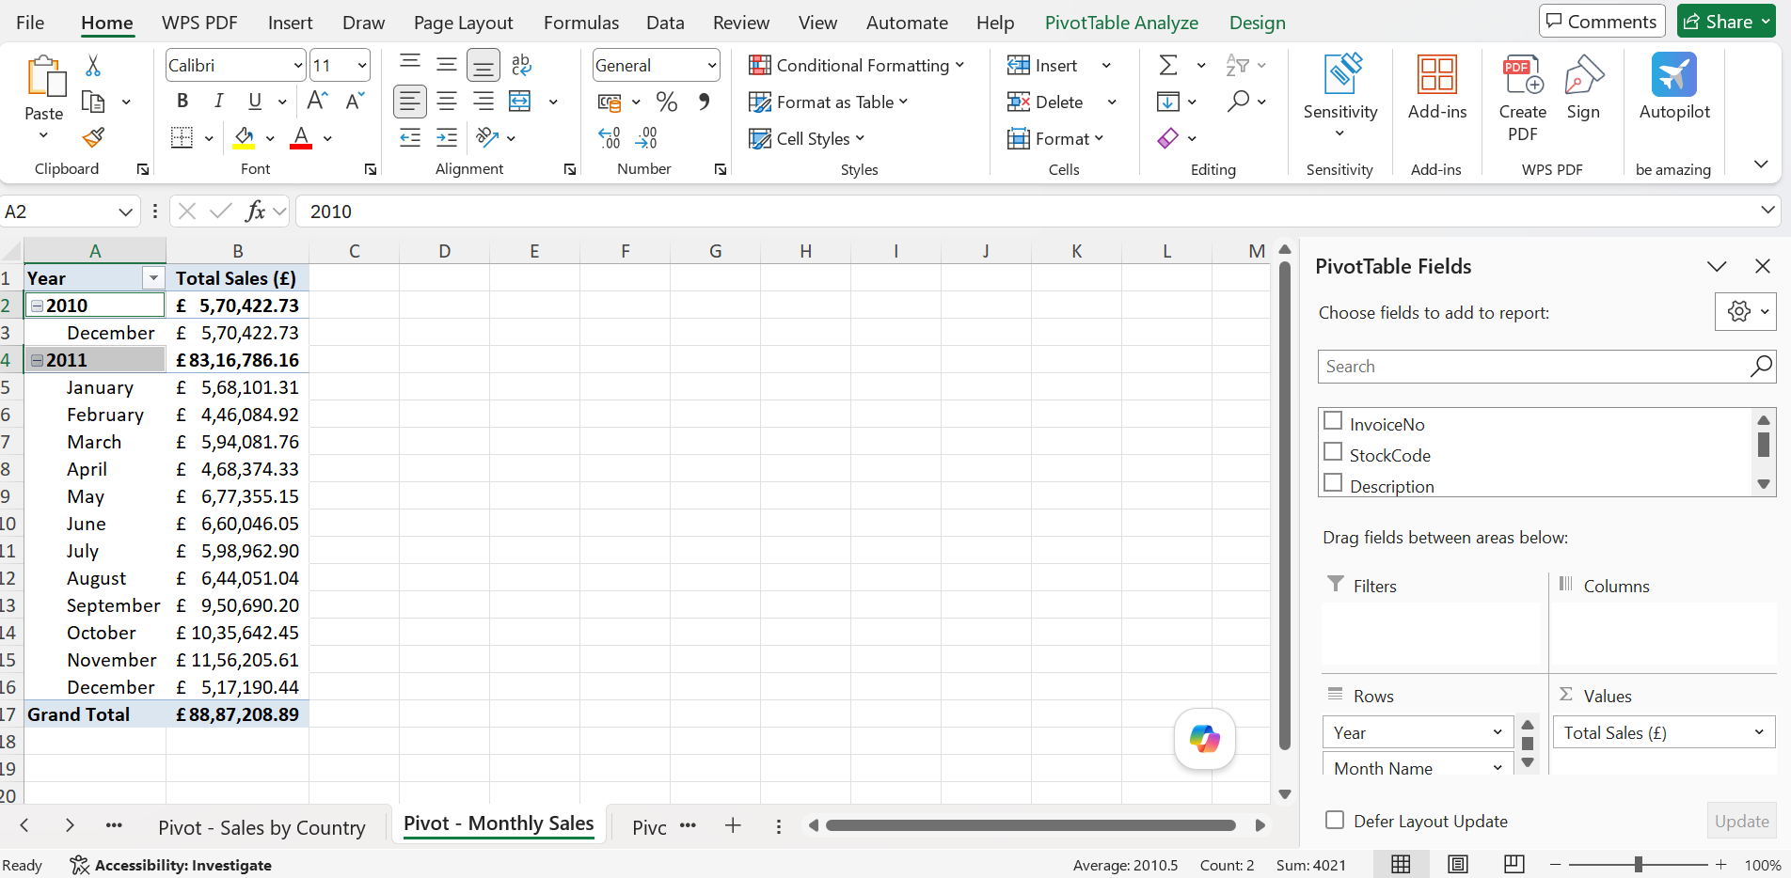
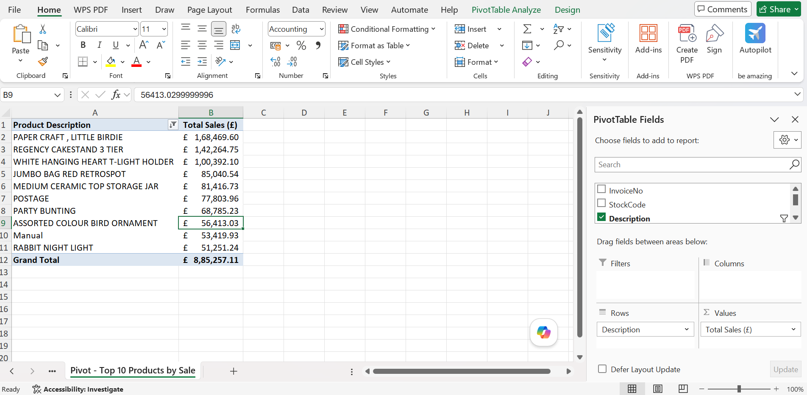
- Descriptive analysis:
  - United Kingdom is the dominant market, contributing the majority of total sales (~£7.3 million) across 37–38 countries served.
  - November 2011 was the highest-selling month (~£1.16 million), with sales showing a strong Q4 seasonal spike driven by holiday gifting.
  - "PAPER CRAFT, LITTLE BIRDIE" was the top-selling product by revenue (~£168,469.60).
- Diagnostic Analysis:
  - Sales are heavily UK-concentrated because the business is a UK-headquartered retailer with only secondary international wholesale demand.
  - The Q4 spike is explained by seasonal/holiday gift purchasing behavior, consistent across the monthly sales pivot.
  - A large share of raw data quality issues (missing CustomerID, cancellations) originated from wholesale/bulk order entries and order cancellations, which needed removal for accurate revenue reporting.
- Predictive Analysis:
  - Based on the recurring Q4 seasonality pattern, sales volumes are expected to rise again in the final quarter of future years, particularly November.
  - Top-performing products and countries (UK, Netherlands, EIRE, Germany, France) are likely to continue driving the majority of future revenue if current buying patterns persist.
- Prescriptive Analysis:
  - Increase inventory and marketing spend ahead of Q4 (October–November) to capitalize on the recurring seasonal demand spike.
  - Focus international expansion efforts on the next-best-performing countries (Netherlands, EIRE, Germany, France) rather than spreading resources thinly across all 37+ countries.
  - Continue promoting top-selling products such as "PAPER CRAFT, LITTLE BIRDIE" and bundle them with lower-performing items to lift overall basket value.
Conclusion:
The Online Retail dataset was successfully cleaned, transformed, and analyzed in Excel, reducing the raw file from 541,909 to 392,692 reliable transaction records. PivotTable analysis revealed that the UK market and Q4 holiday season drive the majority of sales, with a small set of countries and products accounting for most revenue. These insights support targeted inventory planning, seasonal marketing, and focused international growth strategies.

