**EDI Cloud Promotion Instructions**

Irvin Automotive 

Document Version v1.0

Date: 11 May 2018

Contents

Statement of Confidentiality 2

Document Versions 3

1. Summary 4

2. Previous tasks 6

3. XML backup 9

4. XML loading process for new XMLs 10

5. XML loading process for modified XMLs 11

6. LOG File 13

# Statement of Confidentiality

The information contained in this document is proprietary and confidential of QAD Inc., its subsidiaries, and affiliates.

No reproduction of this document may be made without the express written consent of QAD.

“QAD” and "MFG/PRO" are registered trademarks of QAD Inc.

# Document Versions

|  |  |  |  |
| --- | --- | --- | --- |
| Revision | Date | Author | Description |
| 1.0 | 11 May 2018 | InterOperability | Initial version of the document |
|  |  |  |  |

# Summary

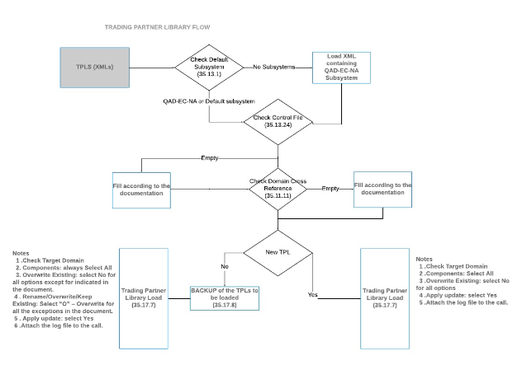

|  |  |  |
| --- | --- | --- |
| **Delivery Information** | **Component** | **Number** |
|  | XML files | 1 |

|  |  |  |  |
| --- | --- | --- | --- |
| **XML Information** | **File Name** | **eCommerce Domain** | **New** |
|  | D02-HONHCMEC09092302EDI-856-Outbound.xml | D02 | NO |
|  |  |  |  |
|  |  |  |  |

# Previous tasks

One of the previous steps to be completed before loading and installing the XMLs is the generation of the Cross Reference between the eCommerce and QAD domain.

The below Domain Cross References must exist, so they have to be generated in case are missing:

|  |  |
| --- | --- |
| eCommerce Domain | QAD Domain |
| D02 | D02 |

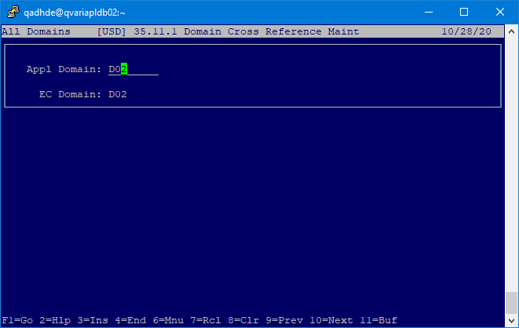

The second of the steps to be completed before of loading and installing the XMLs is the generated of the eCommerce Control.

The below Setup must exist, so it has to be generated in case is missing:

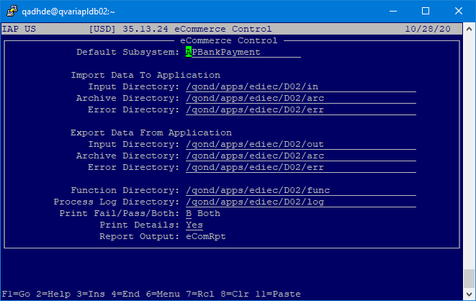

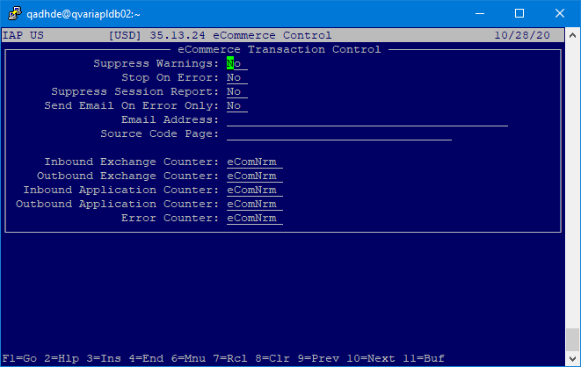

# XML backup

In order to have a backup, please, download the following trading partner and documents in the following list, using *35.17.8 Trading Partner Library Unload*.

This backup will allow the Cloud Team to reverse the process in case of issues.

|  |  |  |
| --- | --- | --- |
| Domain | Trading Partner | Document |
| D02 | D02-HONHCMEC09092302EDI-856-Outbound.xml | 856 |
|  |  |  |
|  |  |  |

|  |  |  |
| --- | --- | --- |
|  |  |  |
|  |  |  |

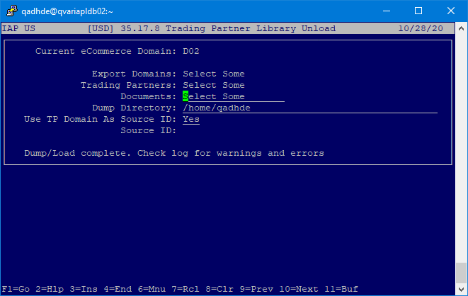

# XML loading process for new XMLs

N/A

# XML loading process for modified XMLs

This is the Section to be followed by the Cloud Team when the XML already exists in the environment and domain.

**eComerce Target Domain** is the domain where the TPL will be loaded, so check that it is correct.

**Components**: Select Some

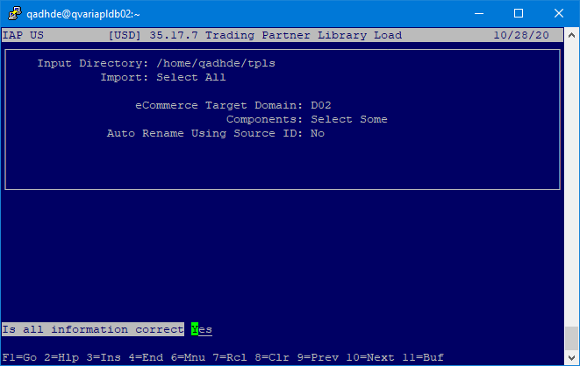

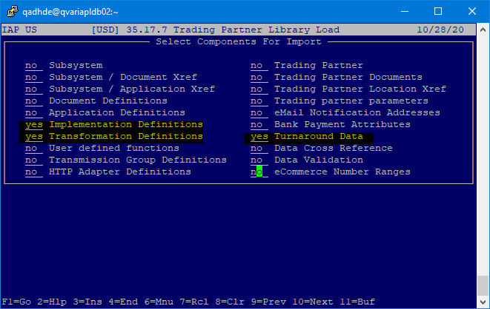

**Overwrite Existing**: select “Yes”.

**Rename/Overwrite/Keep Existing**: Select “O” – Overwrite for all the exceptions in the table above.

**Apply update**: select Yes

# LOG File

A log file will be created in the home directory, so please attach it to the call just for reference.

The log file *must* be validated by Cloud to confirm that all the data has been loaded as indicated in the document without issues.