NEWS APP

1.Abstract:

This project report covers the development of a categorized news app designed as an Android application using Flutter and Flask. The application offers users a platform to access real-time news in various categories, including General, Technology, Sports, Health, and Business. The app’s goal is to provide a simplified, organized, and secure means for users to engage with current events. By utilizing a public news API, the app retrieves the latest stories based on user-selected categories, keeping content relevant and up-to-date. A secure user authentication system is implemented using Flask and bcrypt to protect user credentials, while SQLAlchemy is used as an ORM to manage and store user data within a database. The app includes an intuitive navigation system with an app drawer for easy access to different news categories, contributing to an overall streamlined and enjoyable user experience. The combination of Flutter's UI capabilities and Flask's backend strength ensures that the app is both visually appealing and functionally robust.

2. Project Objectives
The primary goals and motivations for creating this app are centered on user accessibility, data security, and seamless functionality. The specific objectives include:
- Provide Easy and Organized Access to News: The app enables users to access and view news articles in an organized manner, with news stories grouped by categories such as Technology and Health. This arrangement allows users to focus on topics of personal interest, rather than sifting through an overwhelming amount of information.
- Ensure Data Security through Robust Authentication: A secure authentication system is a priority in this app, as it requires users to sign up or log in. By implementing bcrypt for password hashing, the app safeguards sensitive user information. SQLAlchemy is used to efficiently manage user data, further contributing to data privacy and security.
- Enable a User-Friendly and Intuitive Interface: Navigation in the app is designed to be straightforward, with an app drawer that lets users easily select and switch between news categories. This design minimizes the number of steps users need to take to reach their desired content.
- Efficient Content Loading and Display: Given that the app fetches data from an external API, it is essential to minimize load times and ensure that the news articles are presented in a timely fashion. Efficient API calls and state management have been incorporated to maintain a smooth user experience.
.

3. Functionalities
The core functionalities of the news app are built around four main areas: user authentication, news data fetching, navigation, and error handling.

a. User Authentication
- Login and Signup Screens: Users are provided with separate screens for login and signup, where they can either create a new account or log in to an existing one. The authentication process is essential for providing a personalized experience and protecting user data.
- Backend with Flask and Bcrypt Security: The app uses Flask as its backend framework, which handles the logic for authenticating users. The bcrypt hashing library is used to secure passwords, ensuring that even if unauthorized access were attempted, user passwords remain protected. This security feature is critical for building user trust and safeguarding sensitive data.
- Data Management with SQLAlchemy: SQLAlchemy serves as the ORM (Object-Relational Mapping) tool for managing user data. It enables secure storage and retrieval of user credentials and ensures that only authorized users can access specific functionalities within the app.

b. News Data Fetching and API Integration
- Integration with a Public News API: The app uses a public news API to pull real-time news articles for different categories. This external data source provides access to a wide variety of current news topics and updates, enhancing the app's relevance and usefulness to the user.
- Category-Based Data Fetching: Within the app, a controller function manages category-specific news fetching. This feature allows users to select a category (e.g., Sports or Business) from the app drawer, triggering a request to the API. The app then retrieves and displays only the news stories relevant to the chosen category, keeping the interface uncluttered and specific to user interests.
- Efficient Data Handling: Efficient data handling techniques, including state management, are used to update news content in real time without lag. The app is designed to handle large volumes of news data while keeping memory usage and load times optimized.

c. App Drawer and Navigation
- Category Selection Using the App Drawer: The app includes an app drawer on the home screen, where users can quickly navigate between news categories like General, Technology, Sports, Health, and Business. This drawer makes it easy for users to switch categories without returning to a main menu, thus enhancing the user experience.
- Smooth Transition and Content Refresh: When a category is selected, the app initiates a data fetch and dynamically refreshes the content displayed on the screen. This feature eliminates the need for manual page reloads and provides a seamless transition between categories, making for a more enjoyable and less disruptive experience.

d. Error Handling and Loading Indicators
- User-Friendly Error Messages: The app incorporates a user-friendly approach to error handling. If an error occurs while fetching news data (e.g., due to a network issue or an unavailable API), a message is displayed to the user. This error message is intended to provide transparency, informing users of the issue without causing confusion or frustration.
- Loading Indicators: While news data is being fetched, the app displays a loading indicator. This feedback is essential for enhancing the user experience, as it informs users that content is being loaded. The loading indicator also helps prevent users from clicking multiple times, which could result in redundant API calls or application errors.

4. Additional Requirements
In addition to core functionalities, the project includes several additional requirements to improve usability, security, and overall performance.

a. API Key Security
- Ensuring Safe Storage of the API Key: Since the app relies on an external news API, protecting the API key is crucial to prevent unauthorized usage. In a production environment, the API key should be stored securely (e.g., in environment variables or a secured server) to prevent unauthorized access. This security measure is critical for maintaining control over API usage and protecting the app from potential security breaches.

b. Responsive and Adaptive Design
- Device Compatibility: The app is designed with responsiveness in mind to ensure it functions well on different screen sizes and resolutions, making it accessible to a broader audience. Flutter’s adaptable UI components allow the app to deliver a consistent user experience on various devices, including both smartphones and tablets.
- User Interface and Accessibility: The interface elements, such as buttons, icons, and the app drawer, are optimized for accessibility and ease of use. By following design best practices, the app ensures that users of all abilities can navigate through the content without difficulty.

c. User Privacy and Data Security
- Secure Data Handling: Bcrypt hashing is implemented to ensure that passwords are securely stored, preventing unauthorized access to user accounts. This hashing method makes it challenging for anyone to decrypt user passwords, even if the data were compromised.
- SQLAlchemy ORM for Secure Database Operations: SQLAlchemy's ORM functionality allows for secure data handling, ensuring that user data is properly managed and protected. This data security is essential for building a secure platform, where users feel confident about the privacy of their information.

d. Smooth and Intuitive Navigation
- Streamlined User Journey: The app’s navigation design focuses on minimizing clicks and offering direct access to news categories. By keeping the user journey streamlined, the app reduces time to content and enhances the overall ease of use.
- Consistent User Experience: The design principles followed ensure a consistent user experience across different sections of the app. The simple, minimalistic interface, combined with effective error handling, contributes to a smooth user flow that keeps users engaged.

5.Program Implemention :
Main.dart
import 'package:flutter/material.dart';
import 'login_screen.dart';
import 'signup_screen.dart';

void main() {
runApp(MyApp());
}

class MyApp extends StatelessWidget {
@override
Widget build(BuildContext context) {
return MaterialApp(
debugShowCheckedModeBanner: false,
title: 'News App',
theme: ThemeData(
primarySwatch: Colors.blue,
),
home: SplashScreen(),
);
}
}

class SplashScreen extends StatefulWidget {
@override
_SplashScreenState createState() => _SplashScreenState();
}

class _SplashScreenState extends State<SplashScreen>
with SingleTickerProviderStateMixin {
late AnimationController _controller;
late Animation<double> _animation;

@override
void initState() {
super.initState();
_controller = AnimationController(
duration: const Duration(seconds: 2),
vsync: this,
)..repeat(reverse: true);

_animation = Tween<double>(begin: 0.8, end: 1.2).animate(_controller);

Future.delayed(Duration(seconds: 3), () {
Navigator.pushReplacement(
context,
PageRouteBuilder(
pageBuilder: (context, animation, secondaryAnimation) =>
LoginScreen(),
transitionsBuilder: (context, animation, secondaryAnimation, child) {
var begin = Offset(0.0, 1.0);
var end = Offset.zero;
var curve = Curves.easeInOut;
var tween =
Tween(begin: begin, end: end).chain(CurveTween(curve: curve));

return SlideTransition(
position: animation.drive(tween),
child: child,
);
},
),
);
});
}

@override
void dispose() {
_controller.dispose();
super.dispose();
}

@override
Widget build(BuildContext context) {
return Scaffold(
backgroundColor: Colors.white,
body: Center(
child: ScaleTransition(
scale: _animation,
child: Icon(
Icons.article,
size: 100,
color: Colors.blueAccent,
),
),
),
);
}
}

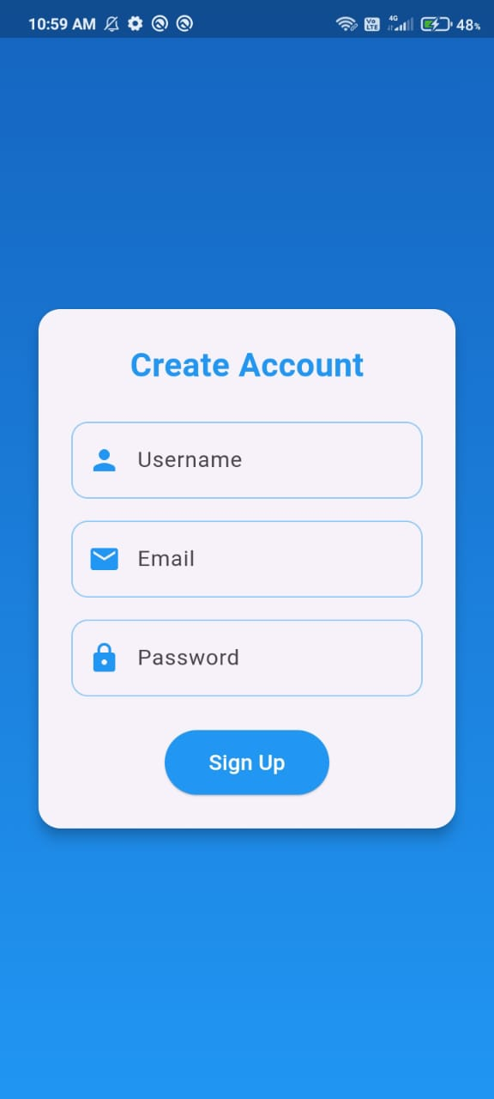
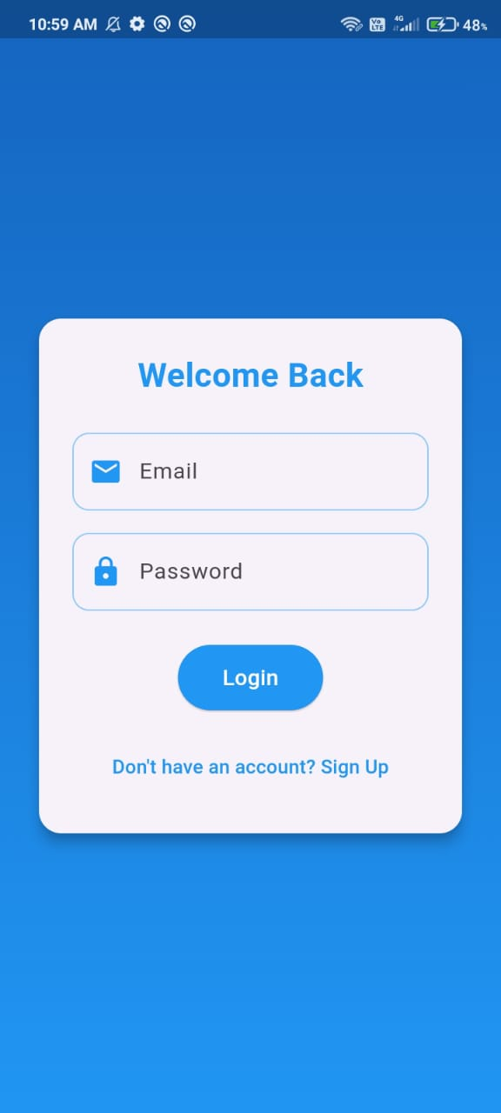

Figure 1: Sign in page Figure 2: Login page


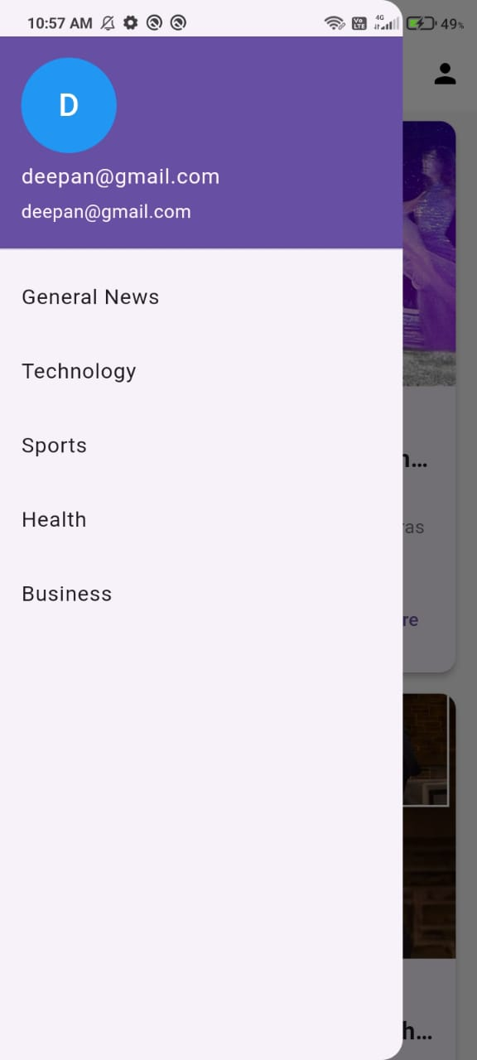

Figure 3: News categories Figure 4: News Feed

Conclusion:
In conclusion, this categorized news app, developed using Flutter for the front end and Flask for the backend, provides a practical, user-friendly platform for accessing real-time news across categories such as Technology, Health, Sports, and Business. By integrating a public news API, the app enables users to stay informed with the latest headlines while offering an organized, streamlined navigation through an intuitive app drawer. Secure user authentication is achieved using Flask and bcrypt, ensuring that sensitive data remains protected, while SQLAlchemy handles database operations efficiently to store and retrieve user information. This project showcases the synergy between Flutter’s responsive and visually appealing UI capabilities and Flask’s robust backend processing, highlighting best practices for mobile app security, API integration, and user-centered design. Overall, the app offers a seamless, secure experience for news consumption, with potential for future enhancements like personalized recommendations, additional news sources, and expanded content categories, making it a versatile and scalable platform for news access.

