**TASK BASED ON LIVE MASTER CLASS ON DOCKER**

**#TASK2.1:** The compose should deploy two services (web and DB), and each service should deploy a container as per details below:

**For web service:** --->> php:rc-apache

a. Container name must be php_web.

b. Use image php with any apache tag. Check here for more details https://hub.docker.com/_/php?tab=tags.

c. Map php_web container's port 80 with host port 6000 d. Map php_web container's /var/www/html volume with host volume /var/www/html.

**For DB service:**

a. Container name must be mysql_web.

b. Use image mariadb with any tag (preferably latest). Check here for more details https://hub.docker.com/_/mariadb?tab=tags.

c. Map mysql_web container's port 3306 with host port 3306

d. Map mysql_web container's /var/lib/mysql volume with host volume /var/lib/mysql.

e. Set MYSQL_DATABASE=database_web and use any custom user ( except root ) with some complex password for DB connections. After running docker-compose up you can access the app with curl command curl <server-ip or hostname>:6000/

**SOLUTION**

Create docker-compose.yml file using "vim" command. Edit the docker-compose file

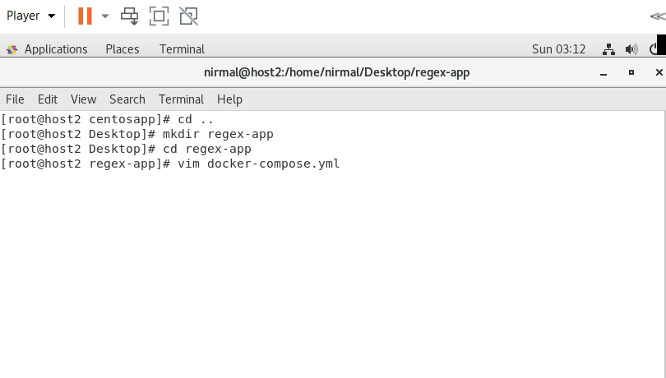**First section** to define will be the web portion of the stack and next section defines the database.

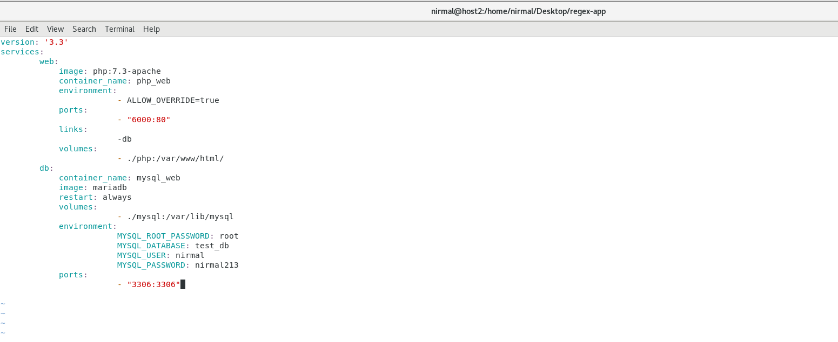

Create a directory named "php" under the previous directory. Create index.php file php directory. Edit index.php and add credentials for mysql access.

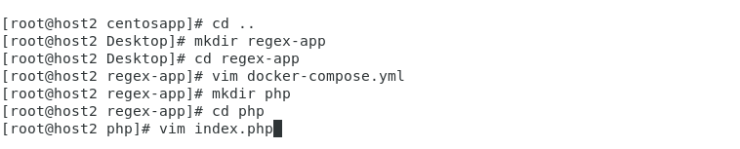

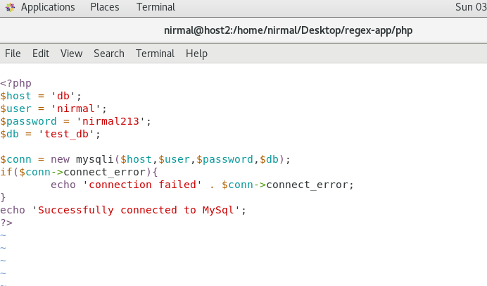

Create a Dockerfile using "vim" command. Edit that file put specific keywords that dictate how to build a specific image.

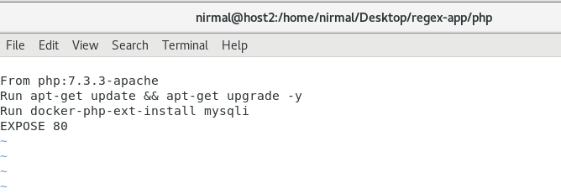

Install Docker compose.

[**sudo curl -L "https://github.com/docker/compose/releases/download/1.29.2/docker-compose-$(uname -s)-$(uname -m)" -o /usr/local/bin/docker-compose**](sudo%20curl%20-L%20%22https:/github.com/docker/compose/releases/download/1.29.2/docker-compose-$(uname%20-s)-$(uname%20-m)%22%20-o%20/usr/local/bin/docker-compose)

sudo chmod +x /usr/local/bin/docker-compose

docker-compose --version

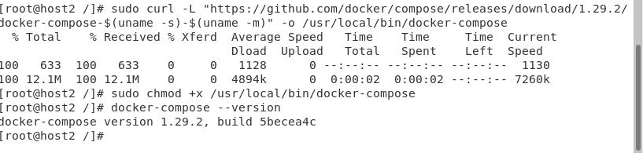

Build Docker Container.

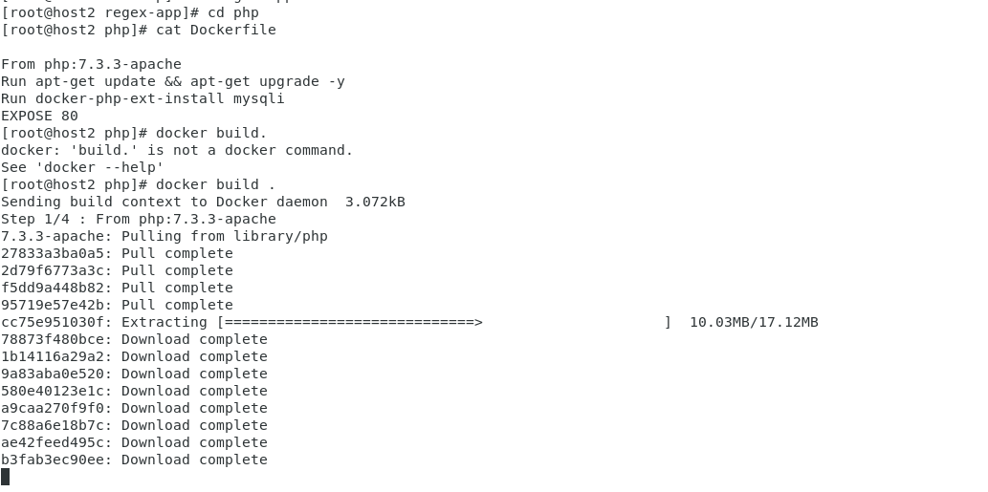

Use docker-compose up command to aggregate the output of each container

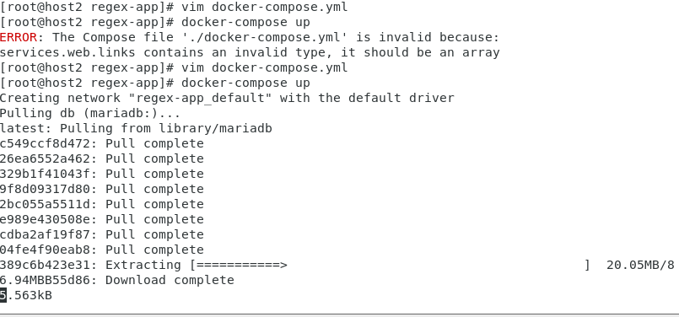

Use "docker-compose stop" command to Stop the docker-compose.

Use "docker-compose up -d" command for Detached mode: Run containers in the background.

Use "docker-compose ps" which only shows running containers.

Use "curl 192.168.29.22:6000" server-id with 6000 port number.

It will show output as "Successfuly Connected to MYSQL"

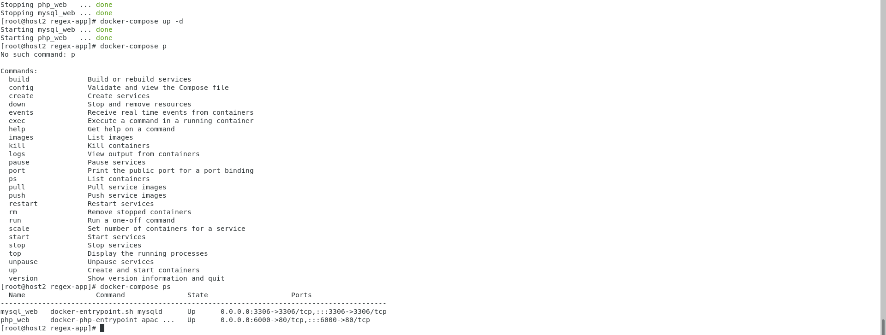

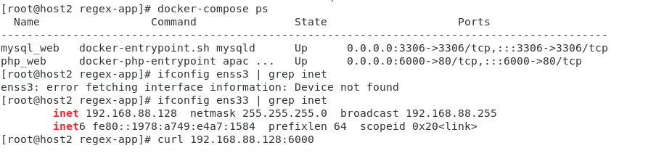

# 

# **#TASK2.2: Dockerfile** 1) Webserver 2) This is coming from Docker ---> Content 3) CentOS

# **SOLUTION**

Create a folder and create 3 files

-index.js

-package.json

-Dockerfile

# Index.js

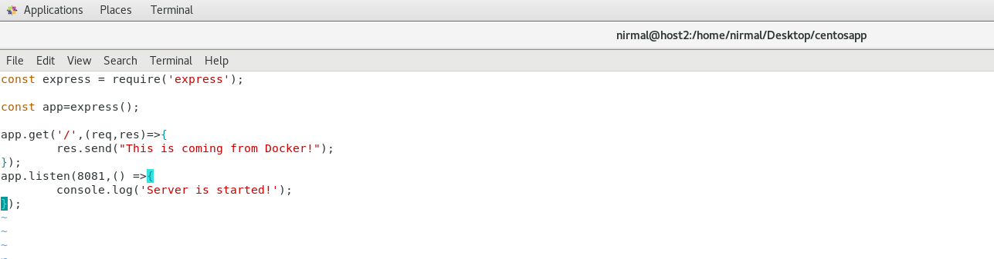

# Dockerfile

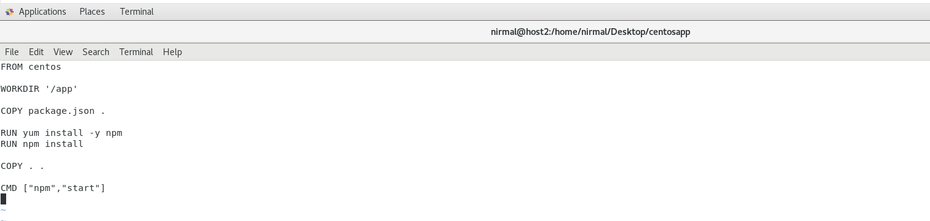

# Package.json

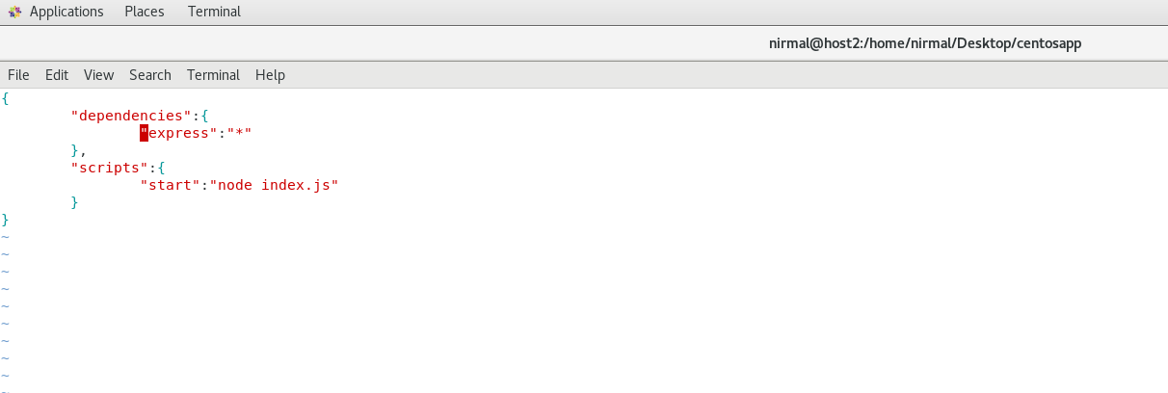

# Build an image

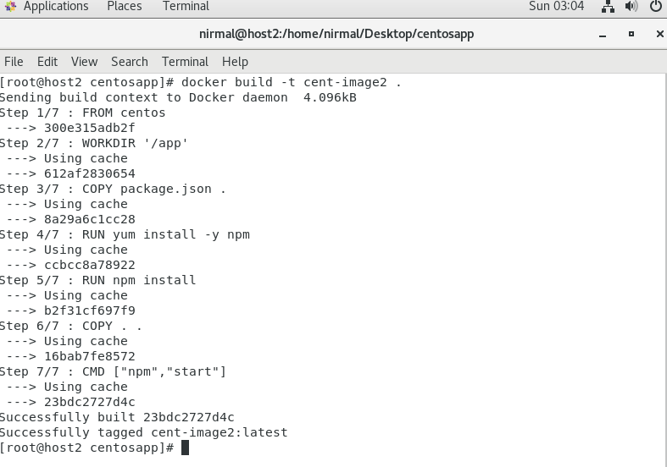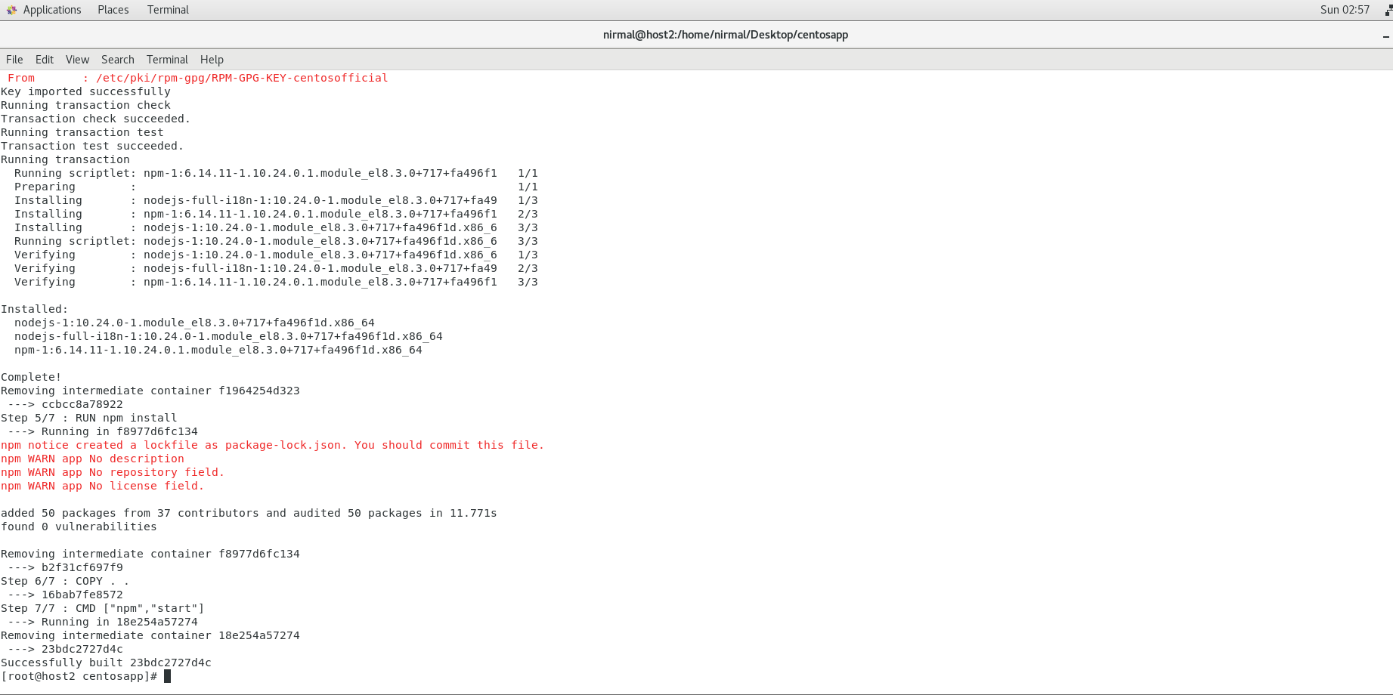

Use**"**docker run -p 30:8081 -dit cent-image2" to run the container.

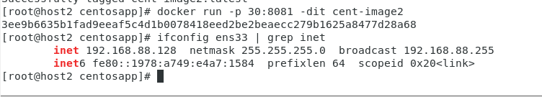

# Curl from ip

