SBA 930 - Evaluating LLMs for Financial Forecasting and Risk Analysis
Nirmala Sendilkumar
10/07/2026

Overview 2
Steps 3
Conclusion 11
Appendix 13

Overview
This project evaluates how well two large language models (LLMs), Claude and ChatGPT, can support financial forecasting and risk analysis. Acting as a financial data analyst, I gave both models the same prompts and the same data so that the comparison would be fair, and I did not allow web search so that each answer depended on the data supplied in the prompt.
I used two types of free, public data from FRED (Federal Reserve Bank of St. Louis), downloaded in October 2026: (1) historical stock prices, using the monthly S&P 500 index, and (2) economic indicators, using CPI inflation, real GDP growth, the federal funds rate, and the WTI crude oil price. Each model received data only through December 2024 and was asked to forecast 2025. I then compared the forecasts with the actual 2025 values.
The work follows the four parts of the assignment: (1) evaluating the two LLMs on three scenarios (economic policy and the stock market, commodity price trends, and economic indicators), (2) forecasting inflation and GDP growth and comparing the results with actual data, (3) identifying market volatility, credit and liquidity risks with mitigation strategies, and (4) optimizing a prompt and measuring whether the forecast improved. Every response was scored from 1 to 5 for accuracy, relevance and reliability.
Tools used: Claude (free plan), ChatGPT (free plan), FRED for data, and Google Sheets for calculations, charts and the scoring log.
Headline result: Claude was closer to the actual values in three of the five numeric tests and ChatGPT in two, but both models missed sudden changes (the fall in oil prices and the swings in GDP growth). Improving the prompt reduced the GDP forecast error for both models. This report is a class exercise and is not financial advice.

Steps

Step 1: Select the datasets and the LLMs
All data came from FRED (fred.stlouisfed.org), the economic data service of the Federal Reserve Bank of St. Louis. I downloaded each series as a CSV file starting in January 2022, imported it into a Google Sheets workbook named "SBA930 Results", and split it at December 2024. The LLMs only saw data through December 2024. The 2025 values were kept hidden and used afterwards as the answer key.
Table 1. Datasets. Source: FRED, downloaded October 2026.
Dataset | Series (FRED code) | Frequency | Used for
1. Historical stock prices | S&P 500 index (SP500) | Monthly average | Stock-market scenario, volatility risk
2. Economic indicators | CPI inflation, % change from a year ago (CPIAUCSL) | Monthly | Inflation forecast
2. Economic indicators | Real GDP, % change from preceding quarter, annualized (A191RL1Q225SBEA) | Quarterly | GDP forecast, optimization
2. Economic indicators | Federal funds effective rate (FEDFUNDS) | Monthly | Credit and liquidity risk
2. Economic indicators | WTI crude oil price, dollars per barrel (DCOILWTICO) | Monthly average | Commodity scenario
LLMs tested: Claude (Anthropic) and ChatGPT (OpenAI), both on their free plans. Each prompt was run in a new chat so earlier conversation could not influence the answer. Both models received the identical prompt and data, and both were told not to use web search.

Step 2: Design the prompts
I wrote five prompts. Prompts A and B are the two required scenarios, C covers the economic indicators, D covers risk analysis, and E is the optimized version of the GDP forecast. The full text of every prompt is in Appendix B.
Table 2. Prompts used.
ID | Scenario | Data supplied to the models | What the model was asked to do
A | Economic policy and the stock market | S&P 500 monthly change statistics and the federal funds rate path, 2022-2024 | Table of policy factors with impact, reasoning and confidence; forecast the S&P 500 change from Dec 2024 to Dec 2025 with low and high
B | Commodity price trends | Monthly WTI crude oil prices, Jan 2022 to Dec 2024 | Forecast each quarter of 2025 with low and high estimates, assumptions and confidence
C | Economic indicators | Monthly CPI inflation and quarterly GDP growth, 2022-2024 | Forecast CPI and GDP growth for each quarter of 2025 with low and high estimates
D | Risk analysis | S&P 500 volatility statistics and monthly federal funds rate | Rate market volatility, credit and liquidity risk (High/Medium/Low), justify with data, give two mitigations each
E | GDP forecast, optimized | Quarterly GDP plus summary statistics | Same task as C for GDP, with a role, a volatility warning, numbered steps and a self-check

Step 3: Part 1 - Scenario results
3a. Commodity price trends (Prompt B)
Both models summarized the 2022-2024 history correctly. For example, I checked Claude's statements that oil peaked at $114.84 in June 2022 and fell to $76.44 by December 2022 against the FRED data, and both matched. Both then forecast prices staying roughly flat in 2025.
Table 3. WTI crude oil, quarterly average in dollars per barrel. Absolute error = |forecast - actual|.
Quarter | Claude forecast | ChatGPT forecast | Actual average | Claude abs. error | ChatGPT abs. error
Q1 2025 | 71.50 | 74.00 | 71.84 | 0.34 | 2.16
Q2 2025 | 70.50 | 75.00 | 64.63 | 5.87 | 10.37
Q3 2025 | 70.00 | 77.00 | 65.74 | 4.26 | 11.26
Q4 2025 | 70.50 | 72.00 | 59.64 | 10.86 | 12.36
Average error |  |  |  | 5.33 (8.56%) | 9.04 (14.23%)
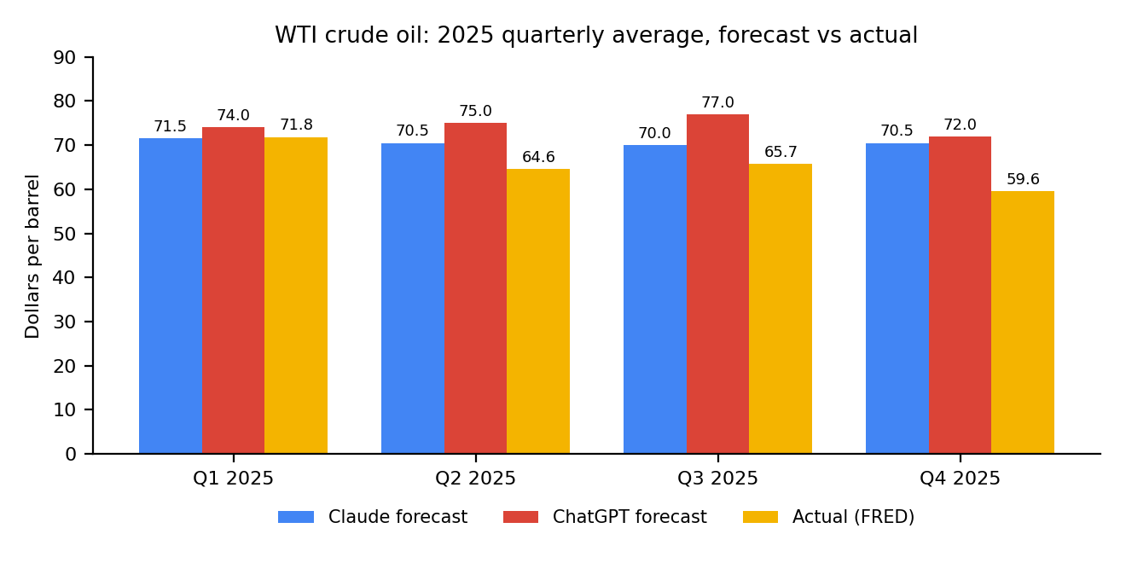
Figure 1. Oil price forecasts versus actual.
- Both models expected prices to stay near or above $70, but actual prices fell to about $59.64 by Q4 2025. Neither predicted the decline.
- Claude's average error was $5.33 per barrel (8.56%) compared with $9.04 (14.23%) for ChatGPT, and Claude was closer in every quarter.
- Claude's low-high ranges contained the actual price in all four quarters. ChatGPT's contained it only in Q1. ChatGPT also predicted a seasonal rise in Q3 that did not happen.
3b. Economic policy and the stock market (Prompt A)
Both models produced a table of policy factors (Federal Reserve rate cuts, inflation, rates staying higher for longer, lagged effects of the 2022-2023 rate hikes, and policy uncertainty) with an expected impact and a confidence level, and then forecast the change in the S&P 500 from December 2024 to December 2025.
Table 4. S&P 500 forecast versus actual. Actual change is calculated from the monthly average values in my dataset, so it is approximate.
Model | Forecast | Low to high range | Actual change | Error (points) | Actual in range?
Claude | +8% | -12% to +22% | +14.0% | 6.0 | Yes
ChatGPT | +9% | -10% to +20% | +14.0% | 5.0 | Yes
- Both models predicted the right direction (up) and both underestimated the gain. ChatGPT was one percentage point closer.
- Claude's reasoning was consistent with the data: compounding the +0.84% average monthly gain gives about 10.6% a year, and 3.45% monthly volatility scales to about 12% a year.
- ChatGPT cited outside "Federal Reserve research" even though the prompt said to use only the supplied data, listed several nearly identical easing scenarios as separate rows, and called the compounded average gain unrealistically large when it is a normal annual stock return.

Step 4: Part 2 - Economic trend forecasting
I gave both models the monthly CPI inflation rate (percent change from a year ago) and the quarterly real GDP growth rate (annualized) for 2022-2024 and asked for each quarter of 2025. October 2025 is missing in the FRED CPI data, so the Q4 2025 actual is the average of November and December.
Inflation (CPI, % change from a year ago)
Table 5. CPI inflation forecasts (percentage points).
Quarter | Claude forecast | ChatGPT forecast | Actual | Claude abs. error | ChatGPT abs. error
Q1 2025 | 2.9 | 2.6 | 2.72 | 0.18 | 0.12
Q2 2025 | 2.8 | 2.4 | 2.46 | 0.34 | 0.06
Q3 2025 | 2.7 | 2.3 | 2.90 | 0.20 | 0.60
Q4 2025 | 2.6 | 2.4 | 2.67 | 0.07 | 0.27
Average error |  |  |  | 0.20 | 0.27
GDP growth (original prompt)
Table 6. GDP growth forecasts (percentage points, annualized rate).
Quarter | Claude forecast | ChatGPT forecast | Actual | Claude abs. error | ChatGPT abs. error
Q1 2025 | 2.1 | 2.2 | 0.1 | 2.0 | 2.1
Q2 2025 | 2.0 | 2.3 | 4.0 | 2.0 | 1.7
Q3 2025 | 1.9 | 2.4 | 3.9 | 2.0 | 1.5
Q4 2025 | 1.9 | 2.3 | 0.2 | 1.7 | 2.1
Average error |  |  |  | 1.93 | 1.85
- Inflation forecasts were good. Average errors were 0.20 points for Claude and 0.27 for ChatGPT. Claude's ranges contained the actual value in all four quarters and ChatGPT's in three of four (it missed Q3 by 0.60). ChatGPT was closer in Q1 and Q2, and Claude was closer in Q3 and Q4.
- GDP forecasts were poor for both models. Both predicted a smooth growth rate near 2%, but actual growth swung from 0.1% to 4.0% and back to 0.2%. Average errors were about 1.9 points. Claude's ranges contained the actual value in one of four quarters and ChatGPT's in none.
- Lesson: the models handled the level and trend of a slow-moving series (inflation) much better than a volatile one (GDP growth), and they did not predict turning points.

Step 5: Part 3 - Risk identification and mitigation
I first measured volatility from the S&P 500 monthly data and gave those numbers, with the federal funds rate history, to both models (Prompt D).
Table 7. Market volatility statistics calculated in Google Sheets.
S&P 500 statistic (2022-2024) | Value | When
Volatility (standard deviation of monthly change) | 3.45%
Worst month | -7.99% | May 2022
Best month | +6.31% | August 2022
Average monthly change | +0.84%
The federal funds rate rose from 0.08% in January 2022 to 5.33% in August 2023, stayed at 5.33% until August 2024, and fell to 4.48% by December 2024.
Table 8. Risk ratings by each model.
Risk | Claude rating | ChatGPT rating | Evidence from the data
Market volatility | High | High | Monthly standard deviation of 3.45% against a +0.84% average gain; a 14.3-point spread between the worst (-7.99%) and best (+6.31%) months
Credit risk | Medium-High | High | Policy rate up 5.25 points in 19 months and held at 5.33% for 13 months, raising debt-service costs for floating-rate and refinancing borrowers; partial relief to 4.48% by Dec 2024
Liquidity risk | Medium | Medium | No direct liquidity data was supplied, so both models inferred it from the rate tightening and the -7.99% sell-off month
- Claude calculated a one-month 95% value-at-risk of about -4.9% (0.84% minus 1.65 times 3.45%), which is correct, and openly stated that its liquidity rating was an inference.
- ChatGPT rated credit risk High using the interest-rate path only and did not point out that the data contained no credit measures. Its liquidity reasoning (Medium because no extreme liquidity shock appears in the data) was sensible.
- The datasets contain market and interest-rate data only, so the credit and liquidity ratings are reasoned inferences rather than measured results.
Mitigation strategies
Table 9. Mitigation strategies.
Risk | Mitigation strategies (my recommendations, informed by both models)
Market volatility | Diversify across asset classes, sectors and regions. Set position-size and loss limits, such as a value-at-risk limit. Hedge part of the equity exposure with protective puts or index options. Rebalance regularly and stress-test for a one-month drop of about 8%, like May 2022.
Credit risk | Tighten underwriting for floating-rate and refinancing-dependent borrowers. Stress-test interest coverage at current rates. Avoid concentration in a few borrowers or loan types. Use interest-rate swaps or caps and hold loan-loss reserves.
Liquidity risk | Hold a buffer of cash and short-term Treasuries sized for several months of stressed outflows. Keep committed credit lines. Ladder maturities, diversify funding sources and run regular liquidity stress tests.
Relying on LLM output | Check every number against official sources. Require ranges and stated assumptions. Keep a human reviewer in the loop and compare more than one model.

Step 6: Part 4 - Optimization
The GDP forecast gave the weakest results, so I used it to test prompt optimization. Both models had predicted a smooth path near 2%, while real growth was volatile. The statistics from the 2022-2024 data (average 2.44%, standard deviation 1.51 points, lowest -1.0%, highest 4.5%) showed this volatility, so I added them to the prompt together with the techniques below (Prompt E).
Table 10. Optimization techniques.
Technique | What I added to the prompt
Role prompting | "You are a senior macroeconomic analyst with 15 years of experience forecasting US GDP."
Extra context | Summary statistics: average 2.44%, standard deviation 1.51, lowest -1.0%, highest 4.5%
Explicit warning | Quarterly GDP growth is volatile; do not forecast a smooth line near the average
Step-by-step structure | Step 1 describe the pattern, Step 2 forecast with low-high ranges of about 1.5 standard deviations, Step 3 present a table, Step 4 review the forecast
Structured output | A table with fixed columns: Quarter, GDP forecast, GDP low, GDP high
Self-check | The model must review its forecast for errors and say what it is least sure about
Table 11. GDP growth forecasts with the optimized prompt (percentage points).
Quarter | Actual | Claude optimized | Claude abs. error | ChatGPT optimized | ChatGPT abs. error
Q1 2025 | 0.1 | 1.4 | 1.3 | 2.0 | 1.9
Q2 2025 | 4.0 | 3.0 | 1.0 | 3.8 | 0.2
Q3 2025 | 3.9 | 2.4 | 1.5 | 2.3 | 1.6
Q4 2025 | 0.2 | 1.8 | 1.6 | 3.1 | 2.9
Average error |  |  | 1.35 |  | 1.65
Table 12. Before and after optimization.
Measure | Claude before | Claude after | ChatGPT before | ChatGPT after
Average absolute error (points) | 1.93 | 1.35 | 1.85 | 1.65
Actual value inside low-high range | 1 of 4 | 4 of 4 | 0 of 4 | 3 of 4
Average 2025 growth forecast (actual 2.05%) | 1.98 | 2.15 | 2.30 | 2.80
Shape of forecast | Flat near 2% | Up and down | Flat near 2% | Up and down
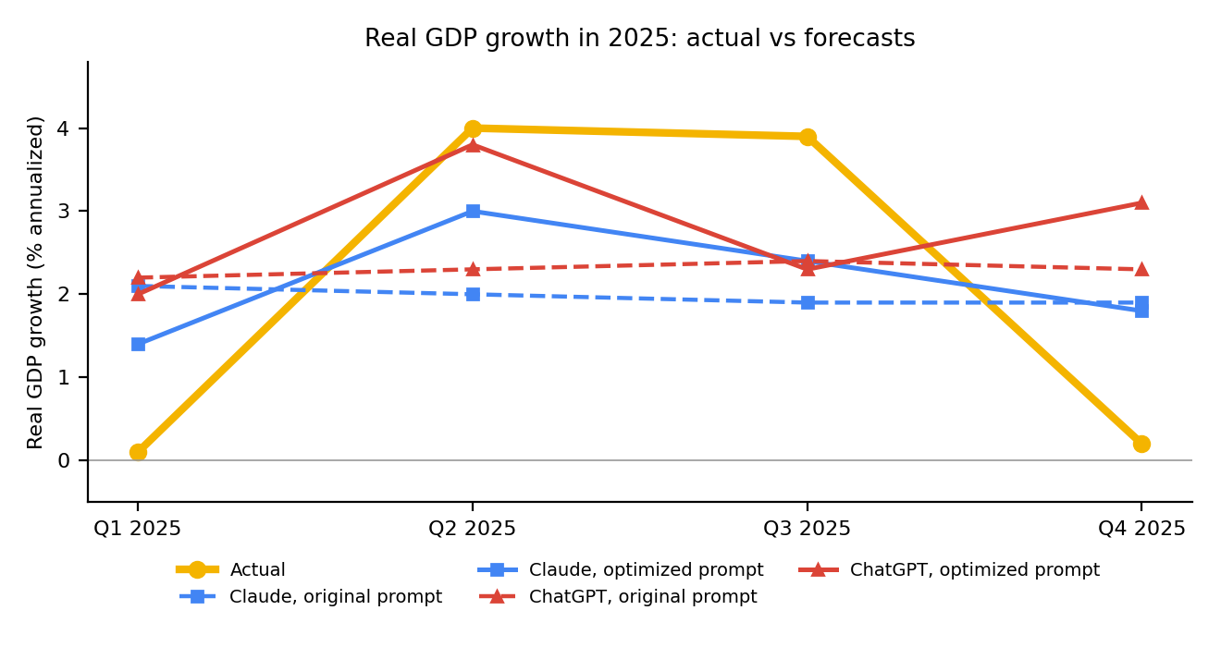
Figure 2. Actual GDP growth versus original and optimized forecasts.
- Claude's average error fell by 0.58 points (about 30%) and ChatGPT's by 0.20 points (about 11%). Both models now forecast an uneven path and gave wider ranges that caught more of the actual values.
- The overall level did not improve: the average growth forecast was already close to the actual 2.05%, and ChatGPT's moved higher. The gain came from capturing the swings, not from a better average.
- Timing of the swings is still guesswork. ChatGPT predicted a pickup in Q4 when growth actually slowed (error 2.9 points), and Claude itself said the timing of the weak and strong quarters could not be forecast from the data alone.
- Caution: this is one test with four quarterly values. Because 2025 has already happened, the models may also recall real outcomes (Claude's answer noted that the actual figures exist), so the result shows the effect of the prompt method and is not proof of true forecasting skill.

Step 7: Overall scoring of the two LLMs
I scored each response from 1 (poor) to 5 (excellent) on three measures. Accuracy: do the numbers match the data supplied and the actual 2025 values? Relevance: did the answer follow the instructions and use the supplied data? Reliability: did the model state assumptions and uncertainty, avoid unsupported claims, and give realistic ranges?
Table 13. Scores (1 to 5).
Prompt | LLM | Accuracy | Relevance | Reliability | Main reason
B - Oil forecast | Claude | 4 | 5 | 5 | Avg error $5.33; actual inside all four ranges
B - Oil forecast | ChatGPT | 3 | 5 | 3 | Avg error $9.04; unsupported Q3 rise; inside 1 of 4 ranges
C - Inflation and GDP | Claude | 3 | 5 | 4 | Good CPI, poor GDP; ranges 4/4 for CPI, 1/4 for GDP
C - Inflation and GDP | ChatGPT | 3 | 5 | 3 | Good CPI, poor GDP; ranges 3/4 for CPI, 0/4 for GDP
D - Risk analysis | Claude | 4 | 5 | 5 | Correct figures and VaR; flagged inference
D - Risk analysis | ChatGPT | 4 | 4 | 4 | Correct figures; more generic mitigations
A - Policy and stocks | Claude | 4 | 5 | 5 | +8% vs actual +14%; sound arithmetic
A - Policy and stocks | ChatGPT | 4 | 5 | 3 | +9% vs +14%; cited outside research, overlapping rows
E - GDP optimized | Claude | 4 | 5 | 5 | Error 1.35; actual inside 4 of 4 ranges
E - GDP optimized | ChatGPT | 3 | 5 | 4 | Error 1.65; wrong Q4 direction
Table 14. Average scores across the five prompts.
Average score | Accuracy | Relevance | Reliability
Claude | 3.8 | 5.0 | 4.8
ChatGPT | 3.4 | 4.8 | 3.4
Strengths and weaknesses
- Claude strengths: stated assumptions and uncertainty clearly, flagged what it was inferring, did the arithmetic correctly, and gave ranges that contained the actual value most often (oil 4 of 4, inflation 4 of 4). Weaknesses: its forecasts were still smooth and missed turning points, it made a small timing slip about the best and worst months, and its answers were long.
- ChatGPT strengths: concise, well-organized tables, used the supplied numbers correctly, and was slightly closer on early-2025 inflation and on the S&P 500 change. Weaknesses: narrower ranges that missed more often (oil 1 of 4, inflation 3 of 4, original GDP 0 of 4), a seasonal oil rise that the data did not support, citations of outside research against the instructions, overlapping scenarios, and weaker self-review.

Conclusion
What I found
- Neither LLM was consistently better. Claude was closer to the actual values in three of the five numeric tests (oil, inflation and the optimized GDP forecast) and ChatGPT in two (the original GDP forecast and the S&P 500 change), although the gaps were small in several tests. Claude scored higher on reliability (4.8 against 3.4).
- Both models were useful for describing history, listing policy factors and identifying risks, and they forecast slow-moving data such as inflation well (errors of 0.2 to 0.3 percentage points).
- Both models failed to predict sudden changes. They missed the fall in oil prices (about $60 by Q4 2025 against forecasts of $70 or more) and the swings in GDP growth.
- Prompt optimization helped. Adding a role, summary statistics, a volatility warning, numbered steps and a self-check cut GDP error by about 30% for Claude and 11% for ChatGPT and produced ranges that captured more of the actual values.
Recommendations
- Always include the relevant data in the prompt and tell the model not to use outside information, so results can be checked.
- Ask for a low-high range, the assumptions and a confidence level, and then check how often actual values fall inside the range.
- Give the model context about volatility (for example the standard deviation) so it does not forecast an unrealistically smooth line.
- Verify every figure and every cited source against official data such as FRED, the BEA or the BLS before using it.
- Keep a human reviewer in the loop and compare more than one model, because the two models disagreed and made different mistakes.
- Back-test any prompt on past data, as in this project, before relying on it for real decisions.
Limitations
- Each test used only four quarterly forecasts, and each prompt was run once per model, so the differences may partly be chance.
- The S&P 500 and oil values are monthly averages, so the S&P 500 change is approximate and daily volatility is higher than shown.
- 2025 has already happened, so the models may know the real outcomes. October 2025 CPI is missing in the source data.
- The 1 to 5 scores are my own judgment, the free model versions may differ from paid ones, and the datasets have no direct credit or liquidity measures, so those risk ratings are inferences.
This report is a class exercise on evaluating LLMs. It is not investment advice, and none of the forecasts should be used for financial decisions.

Appendix

A. Data sources
All data were downloaded in October 2026 from FRED, Federal Reserve Bank of St. Louis (fred.stlouisfed.org). Series codes: SP500 (S&P 500), CPIAUCSL (Consumer Price Index for All Urban Consumers: All Items, percent change from year ago), A191RL1Q225SBEA (Real Gross Domestic Product, percent change from preceding period, annualized), FEDFUNDS (Federal Funds Effective Rate), and DCOILWTICO (Crude Oil Prices: West Texas Intermediate). Daily and monthly series were converted to monthly values in FRED, and the one missing CPI month (October 2025) was left blank.

B. Full prompts
Where the prompts below show a bracketed note, the actual data table (copied from the Google Sheet, 2022-2024 only) was pasted at that point.
Prompt A - Economic policy and the stock market
You are a financial analyst. Below is background data.
S&P 500 monthly change statistics, Jan 2022 to Dec 2024: volatility (standard deviation of monthly change) 3.45%; worst month -7.99% (May 2022); best month +6.31% (August 2022); average monthly change +0.84%.
Federal funds rate: rose from 0.08% in January 2022 to 5.33% in August 2023, stayed at 5.33% until August 2024, then fell to 4.48% by December 2024.
Forecast the potential impact of recent economic policies, such as Federal Reserve interest rate decisions and inflation policy, on the stock market in 2025. Do not use web search.
Answer in a table with these columns: Policy factor, Expected impact on stocks (Positive, Negative or Neutral), Reasoning, Confidence (Low, Medium or High). Then predict the S&P 500's total percent change from December 2024 to December 2025, with a low and high estimate.
Prompt B - Commodity price trends
You are a financial analyst. Below is monthly WTI crude oil price data (dollars per barrel) from January 2022 to December 2024.
[Oil data, Jan 2022 to Dec 2024, pasted here]
Analyze the historical trend and predict the average price for each quarter of 2025 (Q1, Q2, Q3, Q4). Do not use web search. Base your forecast on this data and your general knowledge.
Answer in a table with these columns: Quarter, Forecast average price, Low estimate, High estimate. Then list your key assumptions and explain how confident you are.
Prompt C - Inflation and GDP
You are a financial analyst. Below are two US economic datasets.
DATASET 1: Monthly CPI inflation rate (percent change from a year ago), January 2022 to December 2024.
[CPI data pasted here]
DATASET 2: Quarterly real GDP growth (percent change from the preceding quarter, seasonally adjusted annual rate), Q1 2022 to Q4 2024.
[GDP data pasted here]
Forecast two things for each quarter of 2025 (Q1, Q2, Q3, Q4): (1) the average CPI inflation rate for the quarter, and (2) real GDP growth for the quarter. Do not use web search. Base your forecast on this data and your general knowledge.
Answer in a table with these columns: Quarter, CPI forecast, CPI low, CPI high, GDP forecast, GDP low, GDP high. Then list your key assumptions and explain how confident you are.
Prompt D - Risk analysis
You are a financial risk analyst. Below is US market data from January 2022 to December 2024.
S&P 500 monthly change statistics: volatility (standard deviation of monthly change) 3.45%; worst month -7.99% (May 2022); best month +6.31% (August 2022); average monthly change +0.84%.
Federal funds effective rate (monthly, percent):
[Federal funds data pasted here]
Identify three risks: (1) market volatility risk, (2) credit risk, and (3) liquidity risk. For each one, rate it High, Medium or Low, justify the rating by citing specific numbers from the data above, and suggest two mitigation strategies. Do not use web search. Answer in a table, then add a three-sentence summary.
Prompt E - GDP forecast (optimized)
You are a senior macroeconomic analyst with 15 years of experience forecasting US GDP.
Below is quarterly US real GDP growth (percent change from the preceding quarter, seasonally adjusted annual rate), Q1 2022 to Q4 2024.
[GDP data pasted here]
Summary statistics for 2022-2024: average 2.44%, standard deviation 1.51 points, lowest -1.0%, highest 4.5%.
Important: quarterly GDP growth is volatile and often swings by 2 points or more from one quarter to the next. Do not simply forecast a smooth line near the average.
Task: Forecast real GDP growth for each quarter of 2025 (Q1 to Q4). Do not use web search.
Step 1: Briefly describe the pattern in the data, including how much it swings from quarter to quarter.
Step 2: Give a forecast for each quarter that reflects that volatility, with a low and high estimate (use roughly plus or minus 1.5 standard deviations).
Step 3: Present a table with columns: Quarter, GDP forecast, GDP low, GDP high.
Step 4: Review your forecast for errors and say what you are least sure about.

C. Forecast values and ranges
The tables show each model's forecast with its low and high estimates. The complete text of every answer is saved in the Prompt Log tab of the Google Sheets workbook "SBA930 Results".
Oil price (dollars per barrel)
Quarter | Claude: forecast (low to high) | ChatGPT: forecast (low to high)
Q1 2025 | 71.50 (66 to 78) | 74 (68 to 81)
Q2 2025 | 70.50 (62 to 79) | 75 (68 to 83)
Q3 2025 | 70.00 (60 to 80) | 77 (69 to 85)
Q4 2025 | 70.50 (59 to 82) | 72 (63 to 82)
Inflation and GDP growth, original prompt (%)
Quarter | Claude CPI | ChatGPT CPI | Claude GDP | ChatGPT GDP
Q1 2025 | 2.9 (2.6 to 3.2) | 2.6 (2.2 to 3.0) | 2.1 (0.5 to 3.5) | 2.2 (1.2 to 3.2)
Q2 2025 | 2.8 (2.4 to 3.3) | 2.4 (2.0 to 2.9) | 2.0 (0.3 to 3.4) | 2.3 (1.3 to 3.3)
Q3 2025 | 2.7 (2.2 to 3.3) | 2.3 (1.9 to 2.8) | 1.9 (0.0 to 3.3) | 2.4 (1.4 to 3.4)
Q4 2025 | 2.6 (2.0 to 3.3) | 2.4 (2.0 to 2.9) | 1.9 (-0.3 to 3.3) | 2.3 (1.3 to 3.3)
GDP growth, optimized prompt (%)
Quarter | Claude: forecast (low to high) | ChatGPT: forecast (low to high)
Q1 2025 | 1.4 (-0.9 to 3.7) | 2.0 (-0.3 to 4.3)
Q2 2025 | 3.0 (0.7 to 5.3) | 3.8 (1.5 to 6.1)
Q3 2025 | 2.4 (0.1 to 4.7) | 2.3 (0.0 to 4.6)
Q4 2025 | 1.8 (-0.5 to 4.1) | 3.1 (0.8 to 5.4)
S&P 500 change, Dec 2024 to Dec 2025
Model | Forecast (low to high) | Actual
Claude | +8% (-12% to +22%) | +14.0%
ChatGPT | +9% (-10% to +20%) | +14.0%

D. Spreadsheet workbook
The calculations in this report were done in the Google Sheets workbook "SBA930 Results". Its tabs are: Prompt Log (prompts and full answers), Scores, Forecast vs Actual (oil), Econ Forecast (CPI and GDP, before and after optimization), Stock Data (S&P 500 and volatility statistics), CPI, GDP, FedFunds and Oil (source data from FRED).

