SBA 928 Project Report
Nirmala Sendilkumar
10/04/2026

Overview 2
Project goal 2
Requirements covered 2
Environment and tools 2
Summary of results 3
Steps 4
Step 1: Create the workspace folder 4
Step 2: Create the uv project 4
Step 3: Install the packages 4
Step 4: Create the project files and folders 5
Step 5: Write the helper modules 5
Step 6: Write the prompt templates 5
Step 7: Generate the dataset (guide Step 1) 6
Step 8: Write the scoring and model helpers 7
Step 9: Prompt engineering experiment (guide Step 2) 7
Step 10: Fine-tuning, run 1 (guide Step 3) 8
Step 11: Compare base and fine-tuned model (guide Step 4) 9
Step 12: Improvement experiment, run 2 10
Step 13: Check how trustworthy the scores are 11
Step 14: Bias and fairness audit (guide Step 5) 12
Step 15: Custom inference (guide Step 6) 13
Step 16: Automated tests and code quality 14
Step 17: Write the README report 14
Step 18: Publish to GitHub 14
Problems encountered and how they were fixed 15
Conclusion 16
What was achieved 16
Limitations 16
Recommended next steps 16
Appendix 17
A. Full command reference 17
B. File inventory 17
C. Result files 18
D. Prompt variants and scenario templates 18
E. Screenshots 19
F. Repository 20

Overview

Project goal
This report documents, step by step, how the SBA 928 project was built from the project guide: a market research assistant that reads a customer review and returns three labelled parts: the Positive feature, the Primary problem and a Recommendation. The work was done in VS Code on Windows using a uv Python project, a small pretrained language model (google/flan-t5-small), and a synthetic dataset of 600 reviews.
The report follows the order in which the work was actually carried out, including the errors that were hit and how each was fixed, so that the whole process can be repeated from scratch.

Requirements covered
Requirement | Where it is addressed | Outcome
1. Diverse AI prompt generation: dataset, prompts, variations | Steps 6, 7 and 9; Appendix D | 600-review synthetic dataset; five prompt variants plus three market research scenario templates
2. Fine-tuning a language model, and comparison with the original | Steps 10, 11, 12 and 13 | Two fine-tuning runs; base model scored token F1 0.176, run 2 scored 0.994 on the test set
3. Bias assessment and fairness strategies | Step 14; Conclusion | Data and model audit by region, category and rating; five fairness strategies tied to findings

Environment and tools
Item | Value
Operating system | Windows, with VS Code as the editor
Terminals used | VS Code integrated terminal (PowerShell, then Git Bash)
Project manager | uv 0.12.11
Python | CPython 3.13.15
Key libraries | torch 2.14.1 (CPU build), transformers 5.18.0, datasets, accelerate, sentencepiece, numpy
Developer tools | pytest 9.1.1, ruff 0.16.10, Git
Base model | google/flan-t5-small (trained on CPU, no graphics card)
Project location | C:\SBA_work\SBA_928 (kept outside OneDrive)
Repository | https://github.com/Nirmala-SK/SBA_928_Nirmala

Summary of results
All scores below are from the 60 held-out test reviews, with identical inputs and decoding for every model.
Metric | Base model | Run 1 (3 epochs) | Run 2 (8 epochs)
Token F1 | 0.176 | 0.809 | 0.994
Recommendation F1 | 0.0 | 0.282 | 0.974
Format adherence | 0.0 | 1.0 | 1.0
Grounding | 0.0 | 0.996 | 1.0
Exact match | 0.0 | 0.0 | 0.967

Important caveat. The dataset is synthetic and templated, and 38 of the 60 test reviews exactly duplicate a training review. These scores therefore show that the pipeline works, not how the model would perform on real customer reviews. See Step 13 and the Conclusion.

Steps

Step 1: Create the workspace folder
Goal: have a clean parent folder for the project, outside OneDrive.
- The first folder (C:\Users\nirma\OneDrive\Documents\SBA_work) was inside OneDrive. The project installs several gigabytes of packages into a hidden .venv folder, and OneDrive would try to sync every file, which causes slow installs and file errors.
- A new folder was created with mkdir C:\SBA_work, opened in VS Code with File > Open Folder, and a new terminal was opened with Terminal > New Terminal.
- The prompt then read PS C:\SBA_work>.
uv was checked before going on:
uv --version
Result: uv 0.12.11, so no installation was needed.

Step 2: Create the uv project
Goal: create the package layout the guide expects.
uv init --app --package SBA_928
cd SBA_928
- uv printed Initialized project sba-928 at C:\SBA_work\SBA_928.
- It created pyproject.toml, README.md, .python-version, .gitignore and src\sba_928\__init__.py.
- The outer project folder is SBA_928 (uppercase) and the Python package folder inside src is sba_928 (lowercase). This is correct and must not be renamed: Python imports use the lowercase name, and renaming it causes ModuleNotFoundError.
- The SBA_928 folder was then opened as the VS Code project root (File > Open Folder), so VS Code can find the project's Python environment.

Step 3: Install the packages
uv add torch transformers datasets accelerate sentencepiece numpy
uv add --dev pytest ruff
The first attempt failed while installing the tokenizers wheel:
error: Failed to install: tokenizers-0.23.2-cp310-abi3-win_amd64.whl
Caused by: failed to hardlink file ... (os error 396)
Cause. uv saves disk space by hard-linking files from its download cache. Windows refused because the cache is in a user folder managed by OneDrive (error 396, incompatible hardlinks).
Fix: tell uv to copy files instead of linking them. The setting was made permanent, then a new terminal was opened before retrying:
$env:UV_LINK_MODE = "copy" # this session only
setx UV_LINK_MODE copy # permanent; applies to new terminals
After retrying, uv add reported Checked 59 packages with no errors, and the testing tools installed afterwards. A check confirmed the libraries load:
python -c "import torch, transformers, datasets; print('All good', torch.__version__, transformers.__version__)"
Output: All good 2.14.1+cpu 5.18.0. The +cpu means training runs on the processor. pyproject.toml then listed accelerate, datasets, numpy, sentencepiece, torch and transformers as dependencies, and pytest and ruff under [dependency-groups].

Step 4: Create the project files and folders
All source files were created empty first, as the guide's file list requires, then filled one at a time. In Git Bash:
cd src/sba_928
touch step_01_generate_dataset.py step_02_prompt_engineering.py step_03_fine_tune.py
touch step_04_compare_models.py step_05_bias_audit.py step_06_custom_inference.py
touch prompts.py schema.py settings.py modeling.py metrics.py io_utils.py
cd ../..
mkdir config tests
Problem. A single long pasted command failed with bash: [200~cd: command not found. The stray [200~ is added by Git Bash when pasting. Fix: press Ctrl+C and paste the command in shorter pieces, one line at a time.
Result: 12 new files plus __init__.py in src/sba_928, and new config and tests folders.

Step 5: Write the helper modules
Three small modules were written and each was tested straight after pasting. They hold the rules and settings that every later step shares.
File | Purpose | Check run | Result
schema.py | Defines the required fields of a record and validate_record, which rejects bad records (empty fields, rating outside 1 to 5, wrong split name, missing answer labels) | Import validate_record | schema OK
io_utils.py | Reads and writes JSONL and JSON files, creates missing folders, and computes a SHA-256 fingerprint of a file | Write and read back 2 records | io OK 2
settings.py | Fixed seed (42), base model name, data and output paths, and the TrainConfig class that loads training settings from JSON (unknown keys raise an error) | Load config/default.json | settings OK google/flan-t5-small 3

config/default.json holds the run 1 training settings: 3 epochs, learning rate 5e-5, batch size 4 with 2 gradient-accumulation steps, maximum lengths 256 (input) and 96 (answer) tokens, seed 42.

Step 6: Write the prompt templates
prompts.py is the core of Requirement 1. It contains:
- Three instruction paraphrases for the same task, mixed into the training data so the model does not memorise one sentence.
- format_context and format_training_input, which define the single input layout used in training, testing and inference: the instruction, then Context:, then the product, rating and review. Using one layout everywhere is what makes the model comparison fair.
- Five prompt variants (minimal, structured, grounded, role-based, few-shot) that change only the wording, for the prompt-engineering experiment.
- Three market research scenario templates: consumer behavior, market trend and competitor analysis, which turn one review into different research questions.
Check: prompts OK 5 variants, 3 scenarios.

Step 7: Generate the dataset (guide Step 1)
Decision. The assignment allows either a public dataset (Kaggle, Google Dataset Search, UCI) or one the student creates. Fine-tuning needs a correct answer for every review, and real review datasets only have text and star ratings, so Option A was chosen: generate a labelled synthetic dataset with code, as the guide's Step 1 describes.
Option | Effort | Labels | Realism | Chosen
A: generate with code | Low | Built in and always correct | Lower (templated) | Yes
B: real Kaggle reviews | High | Must be written by hand | Higher | No

How the data is built
- 12 products in 7 categories (drinkware, electronics, apparel, food, beauty, fitness, home), each with two positive features and two problems, and each problem paired with a recommendation.
- Each review is one of three kinds: mixed (60%), positive only (20%) or negative only (20%). The answer is built from the same pieces as the review, so it is always supported by the text.
- Each record carries a region (5 regions) and category as metadata. Region is not part of the model input; it is kept only so the bias audit can compare groups.
- Region sizes were set deliberately uneven (34%, 26%, 20%, 12%, 8%) so the bias audit has real imbalance to examine.
- Records were shuffled with seed 42 and split 80/10/10 with no shared review IDs, and every record was checked with validate_record.
uv run python -m sba_928.step_01_generate_dataset
INFO train: 480 records -> data\processed\train.jsonl
INFO validation: 60 records -> data\processed\validation.jsonl
INFO test: 60 records -> data\processed\test.jsonl
Files created: data/raw/synthetic_market_reviews.csv, train.jsonl, validation.jsonl, test.jsonl and manifest.json (record counts and SHA-256 fingerprints). One record looks like this:
{"review_id": "SYN-0167", "product": "Protein Bars", "category": "food",
"region": "North America", "rating": 2,
"review": "I regret buying this. The texture is chalky.",
"target": "Positive feature: None reported. Primary problem: The texture is chalky.
Recommendation: Improve the texture of the recipe.", "split": "test"}

Step 8: Write the scoring and model helpers
metrics.py scores the model's answers without any extra library, so results can be stated as numbers and not as impressions. modeling.py loads a model and generates answers the same way for every experiment.
Metric | Question it answers
token_f1 | How many of the right words did the answer contain (0 to 1)?
positive_f1, problem_f1, recommendation_f1 | The same score for each of the three parts separately
format_adherence | Did the answer use all three labels, once each, in the right order?
grounding | Do the words in the positive-feature and problem fields appear in the review? (A low score means invented facts.)
exact_match | Is the answer identical to the reference?

subgroup_metrics averages a metric per group (such as region), reports each group's size and its gap from the overall mean, and flags any group with fewer than 10 examples as unreliable.
modeling.py picks the device (graphics card if present, otherwise CPU) and generates with do_sample=False, num_beams=1, so the same input always gives the same output. This is deliberate: random sampling would make base and fine-tuned models impossible to compare fairly.
Checks: metrics OK 1.0 1.0 0.0 (a perfect answer scores 1.0, an answer with no labels scores 0.0 for format) and modeling OK cpu.

Step 9: Prompt engineering experiment (guide Step 2)
Goal: test whether changing only the prompt wording can make the original, untrained model produce the required three-part answer. No model parameters are changed in this step.
uv run python -m sba_928.step_02_prompt_engineering --limit 12 --device cpu
Each of the five variants was run on the same 12 validation reviews (the test split stays untouched until Step 11). The first run downloaded google/flan-t5-small.
Variant | Token F1 | Format adherence | Grounding
minimal | 0.154 | 0.0 | 0.0
structured | 0.163 | 0.0 | 0.0
grounded | 0.171 | 0.0 | 0.0
role_based | 0.267 | 0.0 | 0.0
few_shot | 0.035 | 0.0 | 0.0

What the answers actually looked like
Reading the saved answers mattered more than the scores. For the review "I regret buying this. The battery dies within two weeks." (Wireless Mouse, 2/5):
Variant | Answer
minimal | The battery is not working properly.
structured | Negative feature
grounded | The battery is not working properly.
role_based | The negative feature is the primary problem, and the primary problem is the battery.
few_shot | Negative
Correct answer | Positive feature: None reported. Primary problem: The battery dies within two weeks. Recommendation: Extend battery life or add recharging.

Three more reviews showed the same pattern: one- or two-word answers ("Five Stars", "Positive", "Negative"), generic judgments such as "The product is not good for the skin" for a moisturizer review that praised how fast it absorbs, and, for role_based, a repeat of the label list from the prompt.
Finding. No variant produced the three-label format and none gave a recommendation. role_based had the highest token F1 (0.267) mainly because it copied the words "Positive feature, Primary problem, Recommendation" from the prompt, and the correct answers contain those same words. The metric rewards word overlap, so the answers had to be read too. Prompt wording changed how the model failed, not whether it did. This is the case for fine-tuning.

Step 10: Fine-tuning, run 1 (guide Step 3)
Goal: teach the model the answer format and task by training it on the 480 training examples. Unlike Step 9, model parameters change here.

How the script prepares and trains
- Data preparation: each record becomes an input (instruction + context, from format_training_input) and a label (the three-part answer). Both are tokenized and truncated at 256 and 96 tokens.
- Training: Seq2SeqTrainer from Hugging Face Transformers on the CPU, seed 42.
- Checkpoint choice: the model is evaluated on the validation split after every epoch and the best checkpoint (lowest validation loss) is kept.
- The test file is never opened during training.
- Outputs: the final model and tokenizer, the resolved settings and a training summary with per-epoch losses, under artifacts/models/flan-t5-sba-928/.
uv run python -m sba_928.step_03_fine_tune --config config/default.json
Setting | Run 1
Epochs | 3 (180 training steps)
Learning rate | 5e-5
Batch size / accumulation | 4 / 2
Training time | 398.9 seconds (6 min 39 s) on CPU
Average training loss | 1.851

Epoch | Training loss | Validation loss
2 | 1.306 | 0.4063
3 | 1.028 | 0.3629

Both losses fell from epoch 2 to epoch 3, so the model was still learning. (Epoch 1 values are stored in training_summary.json.) The script ended with Saved fine-tuned model to artifacts\models\flan-t5-sba-928\final. A notice about missing embed_tokens keys is routine and did not prevent the model from saving or generating.

Step 11: Compare base and fine-tuned model (guide Step 4)
The original and the run 1 model were given the same 60 test reviews, the same input layout and the same fixed decoding, and each answer was scored.
uv run python -m sba_928.step_04_compare_models --fine-tuned-model artifacts/models/flan-t5-sba-928/final --device cpu
Metric | Base | Run 1
Token F1 | 0.176 | 0.809
Positive feature F1 | 0.0 | 0.967
Problem F1 | 0.0 | 1.0
Recommendation F1 | 0.0 | 0.282
Format adherence | 0.0 | 1.0
Grounding | 0.0 | 0.996
Exact match | 0.0 | 0.0

Fine-tuning fixed what prompting could not: every answer used the three labels in order, and the positive feature and problem were found almost perfectly. Recommendations were the weak part. The four worst cases showed three kinds of result:
Review | Run 1 recommendation | Verdict
Desk lamp: loose switch | Improve the switch's design | Acceptable but vague; the metric penalises wording, not meaning
Yoga mat: smells of rubber | Improve the grip | Real error: the grip was the praised feature
Protein bars: price high for size (two reviews) | Improve the size of the bars | Real error: the complaint is price, not size

The model had learned a general pattern, "Improve the ___", but did not reliably tie the recommendation to the specific problem. Three short epochs were not enough.

Step 12: Improvement experiment, run 2
Goal: improve the recommendations. Validation loss was still falling at epoch 3, so two settings were changed together in a new config file, config/experiment2.json, with its own output folder so run 1 stayed intact.
Setting | Run 1 | Run 2
Epochs | 3 | 8
Learning rate | 5e-5 | 1e-4
Training steps | 180 | 480
Training time | 6 min 39 s | 24 min 17 s
Final validation loss | 0.3629 | 0.0034 (0.004205 at epoch 7)
Output folder | flan-t5-sba-928 | flan-t5-sba-928-run2

Because the comparison step overwrites its output, run 1's results were copied to artifacts/evaluation_run1 before run 2 was evaluated, and run 2's results to artifacts/evaluation_run2 afterwards.
cp -r artifacts/evaluation artifacts/evaluation_run1
uv run python -m sba_928.step_03_fine_tune --config config/experiment2.json
uv run python -m sba_928.step_04_compare_models --fine-tuned-model artifacts/models/flan-t5-sba-928-run2/final --device cpu
cp -r artifacts/evaluation artifacts/evaluation_run2
Model selection rule: the better run was chosen by validation loss, not test score, so the test set stays an unbiased check. Run 2 had far lower validation loss and was selected.
Metric (test set) | Base | Run 1 | Run 2
Token F1 | 0.176 | 0.809 | 0.994
Positive feature F1 | 0.0 | 0.967 | 1.0
Problem F1 | 0.0 | 1.0 | 1.0
Recommendation F1 | 0.0 | 0.282 | 0.974
Format adherence | 0.0 | 1.0 | 1.0
Grounding | 0.0 | 0.996 | 1.0
Exact match | 0.0 | 0.0 | 0.967

Limits of this comparison. Two settings changed at once, so the improvement cannot be credited to either one alone. A validation loss as low as 0.0034 also suggests the model learned the templates almost perfectly, which Step 13 examines.

Step 13: Check how trustworthy the scores are
Scores near 1.0 on a small, templated test set are a warning, not proof. Two checks were run.

Check 1: duplicate reviews between training and test
uv run python -c "... print('test reviews identical to a training review:', ...)"
Result: 38 of 60 test reviews (63%) were word-for-word copies of a training review. The split in Step 7 made the review IDs unique, as the guide requires, but with only 12 products and a few phrases per product, identical review texts occur often.

Check 2: score the seen and unseen reviews separately
Group | Reviews | Token F1 | Recommendation F1 | Exact match
Seen in training | 38 | 0.9947 | 0.9795 | 0.9737
Never seen | 22 | 0.9914 | 0.9646 | 0.9545

The scores are almost the same, so the model is not just recalling training answers: it handles new combinations of known phrases. Exact match is 37 of 38 and 21 of 22, which is one error in each group. With groups this small, one review moves exact match by about 4.5 points.

The two errors in run 2
Both non-exact test answers were Bluetooth Speaker reviews with the problem "the bass sounds muddy" (SYN-0371 and SYN-0081). The positive feature and problem were correct, but the recommendations were wrong: "Increase the bass volume" and "Extend the bass noise" instead of "Retune the low-frequency audio". These are real errors, not wording differences. That problem phrase appears in 11 of 480 training reviews (2.3%), close to the roughly 3.3% expected if all problem phrases were equally common, so rarity does not explain them. The cause is not established.
Remaining limitation. Both groups still share the same product and problem vocabulary, and 22 reviews is too few for firm conclusions. Neither group represents real customer wording.

Step 14: Bias and fairness audit (guide Step 5)
uv run python -m sba_928.step_05_bias_audit
The audit has two parts: a check of the training data, and a comparison of the model's scores across region, category and rating band for both models, with the size of every group. Outputs are artifacts/bias_audit/bias_audit.json and subgroup_metrics.csv.

Training data audit
Region | Share of training data | Average rating | Average review length (words)
North America | 36.7% | 2.90 | 13.07
Europe | 28.1% | 3.03 | 14.23
Asia-Pacific | 17.5% | 2.96 | 12.76
Latin America | 11.5% | 2.95 | 14.16
Middle East & Africa | 6.2% | 3.43 | 13.47

- Region imbalance is about six to one (36.7% against 6.2%).
- Category imbalance is also visible: apparel 18.8%, beauty 7.7%, fitness 7.1%.
- Middle East & Africa reviews are rated higher on average (3.43 against about 2.9 to 3.0).
- No loaded terms were found with the project word list, which is a weak check.

Model results (run 2, token F1)
Group | Reviews | Mean | Gap vs overall
Category: electronics | 10 | 0.9611 | -0.0324
Region: Middle East & Africa | 11 | 0.9646 | -0.0289
Rating: mid (3) | 21 | 0.9815 | -0.0120

Five groups had fewer than 10 test reviews and cannot be assessed reliably: fitness (3), beauty (6), drinkware (6), Latin America (6) and apparel (8).
Reading the gaps. The electronics and Middle East & Africa gaps come from the same two records (SYN-0371 and SYN-0081), so the data cannot separate a category effect from a region effect. The gaps are small, rest on two answers and are observations, not evidence of unfairness. The groups are synthetic labels, not real demographic evidence.

Fairness strategies tied to these findings
- Demographic diversity: stratify the splits by region and category, and add examples for the smallest groups (Middle East & Africa, fitness, beauty).
- Regional differences: include regional spelling, idiom and review length, and report scores per region with uncertainty once groups are large enough (about 30 or more reviews each).
- Industry context: report each category separately, because a prompt that works for electronics may not suit food or beauty.
- Prompt design: use neutral wording, keep demographic attributes out of prompts unless the research question needs them (region is already kept out of the model input here), and use grounded prompts.
- Process: extend the loaded-term list, have a person review samples of prompts and answers, re-audit after every retraining, and document remaining gaps.

Step 15: Custom inference (guide Step 6)
The saved run 2 model was used on reviews typed in by hand, formatted exactly as in training.
uv run python -m sba_928.step_06_custom_inference --model artifacts/models/flan-t5-sba-928-run2/final \
--product "Wireless Mouse" --rating 3 --review "The mouse is comfortable, but it disconnects several times each day." --device cpu
Review | Model answer | Verdict
Wireless Mouse, 3/5: comfortable, but disconnects several times each day | Positive: Is comfortable. Problem: It disconnects several times each day. Recommendation: Improve the wireless connection stability. | Correct and grounded
Wireless Mouse, 2/5: fits my hand nicely but the cursor freezes away from the laptop (new wording) | Positive: Fits my hand nicely. Problem: The cursor freezes whenever I move away from the laptop. Recommendation: Improve the cursor stability. | Correct, and the recommendation is new
Electric Kettle, 2/5: boils quickly, but handle too hot and lid flimsy (unseen product, two problems) | Positive: None reported. Problem: The handle gets too hot to touch. Recommendation: Keep the lid intact. | Failed: missed the positive and gave an unsuitable recommendation

The Kettle review was rerun with a rating of 4 to test whether the low rating caused the missed positive feature. The answer was identical, so the rating does not explain it. Candidate causes, none tested, are the bare opening sentence ("Boils quickly."), the two-problem structure and the unseen product.
Metric blind spot. The grounding score was 1.0 for the failed Kettle answer, because it only checks that the words in the first two fields appear in the review. It cannot detect omissions or irrelevant advice.

Step 16: Automated tests and code quality
Three test files were added in the tests folder: test_dataset.py (4 tests: split sizes, no ID overlap, reproducibility, answers supported by the review), test_prompts.py (3 tests) and test_metrics.py (5 tests).
uv run pytest
uv run ruff check .
Command | Result
uv run pytest | 12 passed in 0.25s
uv run ruff check . | All checks passed!

Step 17: Write the README report
README.md was rewritten to cover the reproduction commands, the dataset, the prompt variants, both fine-tuning runs, the comparison tables, the limitations and the bias audit with fairness strategies. Placeholder text was replaced with the real findings (prompt-variant observations, the two non-exact answers, the bias-gap explanation and the Kettle rerun). VS Code's search (Ctrl+F for [ADD) was used to confirm no placeholder was left.

Step 18: Publish to GitHub

Prepare .gitignore
Large and regenerable folders were excluded so GitHub would not reject the push:
.venv
artifacts/models/
tmp_test/
.pytest_cache/
.ruff_cache/
git check-ignore -v confirmed each folder is ignored, and git status --short | grep -E "venv|cache|artifacts/models|tmp_test" printed nothing, so none of them was staged. A warning that LF would be replaced by CRLF in .gitignore is a harmless Windows line-ending notice.

Choose the repository
The existing repository SBA_928_Nirmala_Sendilkumar already held two commits of earlier, unrelated work, so pushing to it would have been rejected. Rather than delete it (which cannot be undone), a new empty repository, SBA_928_Nirmala, was created with the README, .gitignore and licence options left unchecked.

Commit and push
git add .
git commit -m "Complete SBA 928 prompt engineering and fine-tuning project"
git add artifacts/evaluation_run2
git commit -m "Add run 2 evaluation results"
git branch -M main
git remote add origin https://github.com/Nirmala-SK/SBA_928_Nirmala.git
git push -u origin main
Commit | Content
314f2ff | 36 files, 5,052 insertions: source, tests, configs, data, small result files, README, uv.lock
6fd0abf | 2 files, 101 insertions: artifacts/evaluation_run2

The first commit's file list showed evaluation and evaluation_run1 but no evaluation_run2, which the README refers to, because the copy had not been made earlier. It was created, its numbers were checked (run 1 token F1 0.8087, run 2 token F1 0.9935), and it was added as the second commit before pushing.
The push uploaded 53 objects (186.66 KiB) and ended with [new branch] main -> main and branch 'main' set up to track 'origin/main'. The trained model checkpoints stay on the local machine in artifacts/models/; the README documents where they are.

Problems encountered and how they were fixed
Problem | Cause | Fix
Project path inside OneDrive | OneDrive syncs thousands of package files | Moved to C:\SBA_work
uv add failed with os error 396 | Hard-link to a cache folder managed by OneDrive | Set UV_LINK_MODE=copy (also with setx) and reopened the terminal
bash: [200~cd: command not found | Git Bash adds stray characters when pasting long commands | Ctrl+C, then paste shorter commands one at a time
Base model ignored the answer format | Small pretrained model cannot follow a custom format from instructions alone | Fine-tuning (Steps 10 to 12)
Run 1 gave unsuitable recommendations | Only 3 epochs and a low learning rate | Run 2 with 8 epochs and learning rate 1e-4
38 of 60 test reviews duplicated training reviews | Repeated phrases in the synthetic generator | Scored seen and unseen reviews separately and reported the limitation
Existing GitHub repository was not empty | It held earlier unrelated commits | Created a new empty repository, SBA_928_Nirmala
evaluation_run2 missing from first commit | The folder copy had not been made | Copied, verified the numbers, added as a second commit
Tied-weights and embed_tokens messages | Notices about how the checkpoint was saved | Harmless: outputs were correct, so they were ignored

Conclusion

What was achieved
- A complete, tested and published pipeline: dataset generation, prompt experiments, two fine-tuning runs, model comparison, bias audit and custom inference, with 12 passing tests and a clean ruff check.
- Prompt engineering alone did not work. Five prompt variants gave a format adherence of 0.0, so wording did not make the base model produce the three-part answer.
- Fine-tuning did. Token F1 rose from 0.176 to 0.809 (run 1) and 0.994 (run 2), with format adherence 1.0 and near-perfect grounding. Run 2's extra epochs and higher learning rate raised recommendation F1 from 0.282 to 0.974.
- The bias audit found real imbalance in the data (region shares from 36.7% to 6.2%, uneven categories, higher ratings in the smallest region), but the model's gaps were small and traced to two records.

Limitations
- Synthetic, templated data. 12 products and a small set of phrases. High scores show the pipeline works, not that the model understands real reviews.
- Test overlap. 38 of 60 test reviews duplicate training reviews. Unseen reviews scored almost the same (token F1 0.9914), but they share the same vocabulary and number only 22.
- Failure outside the templates. The Electric Kettle review (unseen product, two problems) missed the positive feature and gave an unsuitable recommendation, and the grounding metric did not catch it.
- Two settings changed at once in run 2, so the gain cannot be attributed to either.
- Small groups. Most region and category groups had fewer than 10 test reviews, so subgroup gaps are unstable and region labels are synthetic.

Recommended next steps
- Replace or extend the data with real public reviews (for example from Kaggle) and write or verify the labels, then re-run Steps 3 to 5.
- Split so that identical review texts never appear in both training and test, and stratify by region and category.
- Build a larger test set, aiming for at least 30 reviews per group, and report uncertainty.
- Change one training setting at a time to learn which of epochs or learning rate matters.
- Add a metric that detects missing fields and irrelevant recommendations, and have a person review a sample of answers.
- Test with harder inputs: unseen products, two or more problems, problem-first wording and other languages or spellings.

Appendix

A. Full command reference
# setup
uv init --app --package SBA_928
cd SBA_928
uv add torch transformers datasets accelerate sentencepiece numpy
uv add --dev pytest ruff
# pipeline
uv run python -m sba_928.step_01_generate_dataset
uv run python -m sba_928.step_02_prompt_engineering --limit 12 --device cpu
uv run python -m sba_928.step_03_fine_tune --config config/default.json
uv run python -m sba_928.step_03_fine_tune --config config/experiment2.json
uv run python -m sba_928.step_04_compare_models --fine-tuned-model artifacts/models/flan-t5-sba-928-run2/final --device cpu
uv run python -m sba_928.step_05_bias_audit
uv run python -m sba_928.step_06_custom_inference --model artifacts/models/flan-t5-sba-928-run2/final \
--product "Wireless Mouse" --rating 3 --review "..." --device cpu
# quality
uv run pytest
uv run ruff check .

B. File inventory
File | Purpose
src/sba_928/schema.py | Record fields and validation
src/sba_928/io_utils.py | JSON and JSONL helpers, file hash
src/sba_928/settings.py | Seed, paths, base model, TrainConfig
src/sba_928/prompts.py | Input format, five prompt variants, three scenario templates
src/sba_928/metrics.py | Token F1, field scores, format, grounding, subgroup metrics
src/sba_928/modeling.py | Device choice and deterministic generation
step_01_generate_dataset.py | Create and split the 600-review dataset
step_02_prompt_engineering.py | Compare prompt variants on the untrained model
step_03_fine_tune.py | Fine-tune FLAN-T5-small with Seq2SeqTrainer
step_04_compare_models.py | Compare base and fine-tuned models on the test split
step_05_bias_audit.py | Dataset audit and subgroup metrics
step_06_custom_inference.py | Run the saved model on one new review
config/default.json, experiment2.json | Run 1 and run 2 training settings
tests/ (3 files) | 12 automated tests
artifacts/ | Prompt results, evaluation_run1/2, bias audit (models folder stays local)

C. Result files
Folder | Contents
artifacts/prompt_baseline | prompt_predictions.jsonl (every prompt, answer and score), prompt_summary.json
artifacts/evaluation_run1 | Base vs run 1 test comparison
artifacts/evaluation_run2 | Base vs run 2 test comparison (selected model)
artifacts/bias_audit | bias_audit.json, subgroup_metrics.csv
artifacts/models/ (local only) | Run 1 and run 2 checkpoints, training summaries

D. Prompt variants and scenario templates
Variant | Technique | Best suited to
minimal | Bare task | Exploratory questions; shows the unguided baseline
structured | Required labels | Outputs that feed dashboards or tables
grounded | "Use only the review" | Claims that must be traceable
role_based | Analyst persona | Audience-specific summaries for a product team
few_shot | One worked example | Small models that need to see the format

Scenario | Question it asks of one review
consumer_behavior | What purchase motivation or frustration does this review reveal about the customer?
market_trend | If many customers in this category wrote reviews like this, what trend would it point to?
competitor_analysis | Which weakness could a competitor exploit, and what should the maker fix first?

E. Screenshots
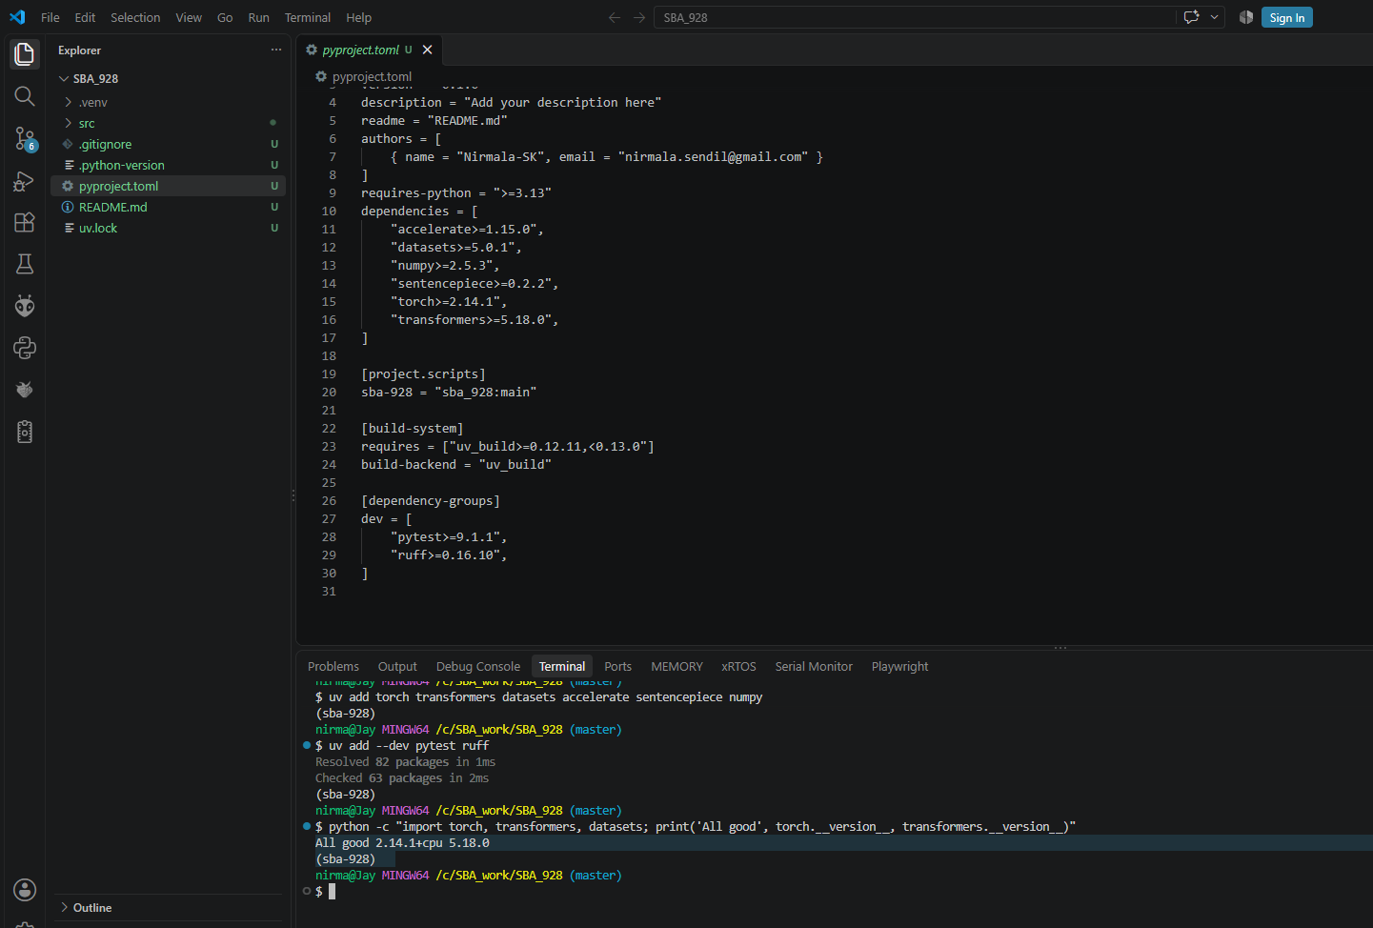
Figure 1: Dependencies in pyproject.toml and the library check printing 'All good 2.14.1+cpu 5.18.0'.
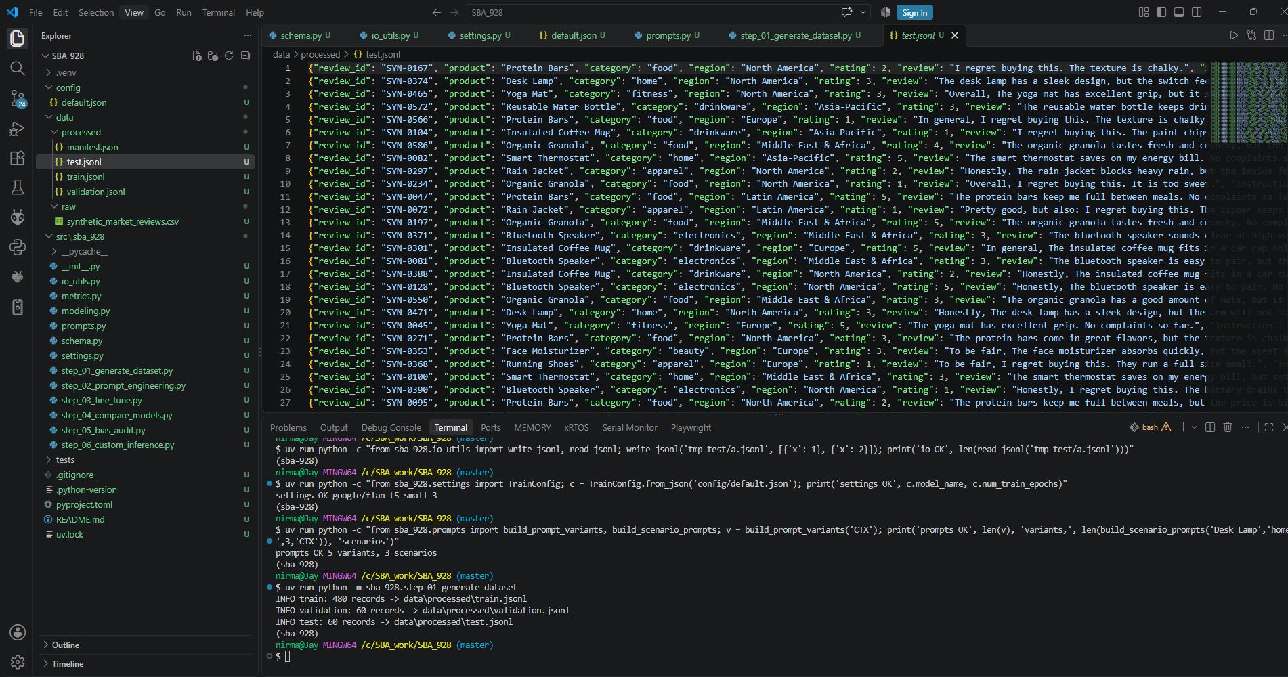
Figure 2: Dataset generation (480 / 60 / 60) and the data folders in the Explorer.
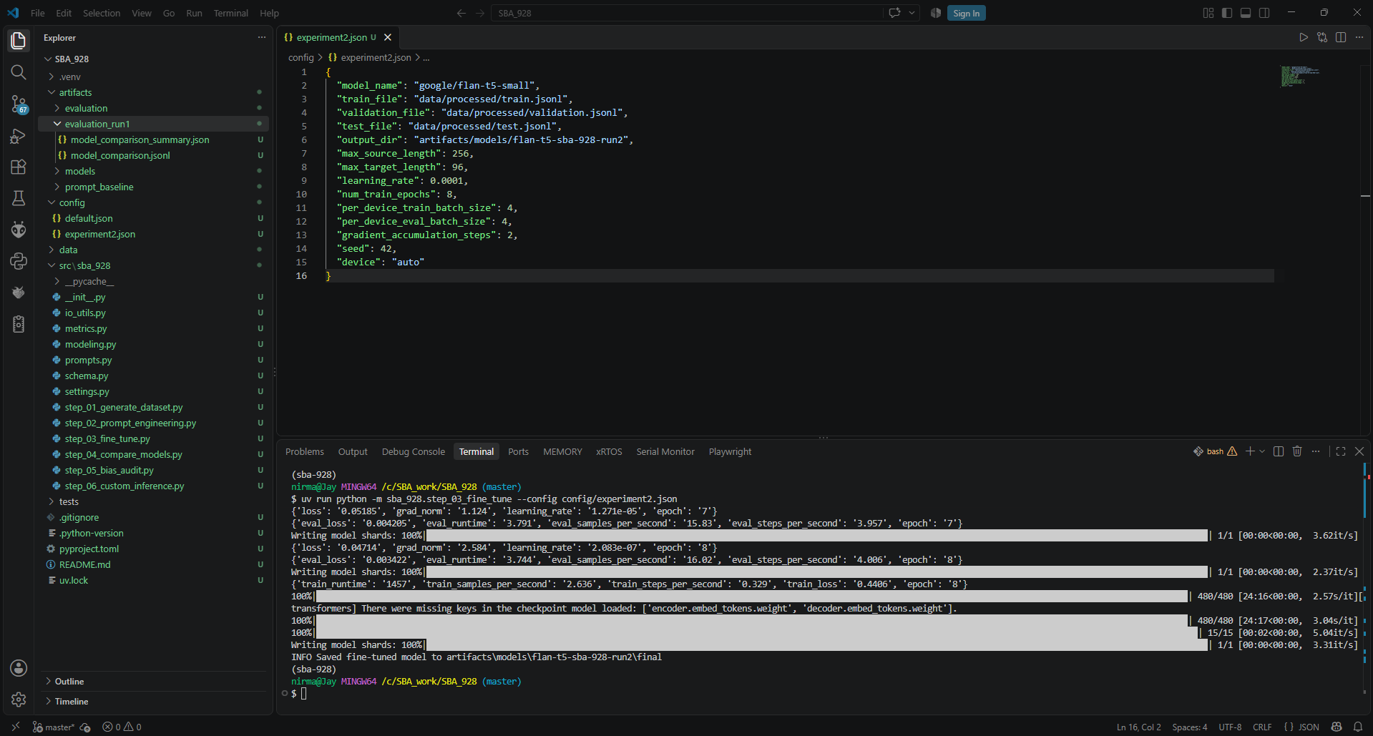
Figure 3: Run 2 training finished (480 steps) and the experiment2.json settings.
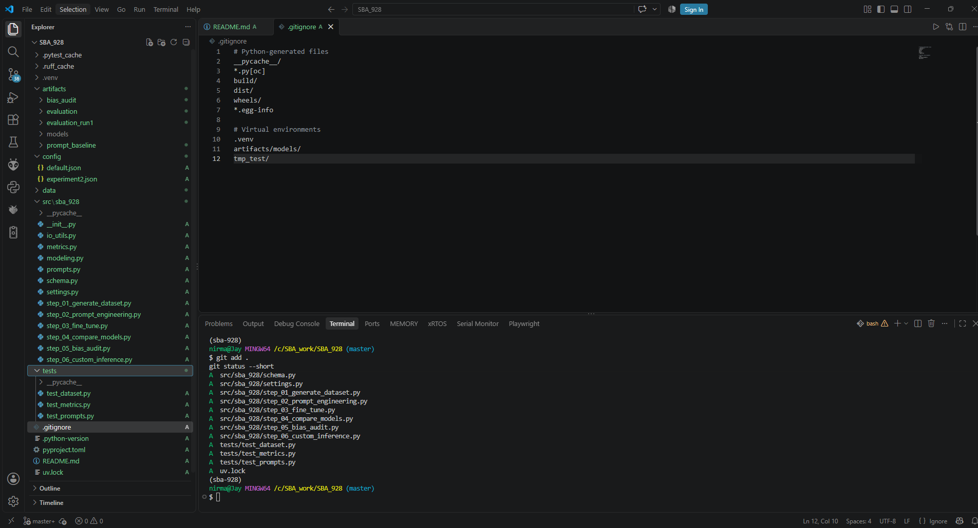
Figure 4: Files staged with git add before the first commit.

F. Repository
Code, data, configs, tests and result files: https://github.com/Nirmala-SK/SBA_928_Nirmala

