Report
SBA 928 Project Version 2
Nirmala Sendilkumar
10/20/2026

Overview 2
Project goal 2
Feedback addressed 2
Environment and tools 3
Summary of results 3
Steps 4
Step 1: Understand the feedback and plan the six task families 4
Step 2: Add the task builders (tasks.py) 4
Step 3: Fix the folder problem and preview the new records 5
Step 4: Update the record schema (schema.py) 5
Step 5: Build, mix and split the dataset (guide Step 1) 5
Step 6: Update the prompt templates (prompts.py) 6
Step 7: Update the scoring (metrics.py) 6
Step 8: Prompt engineering experiment (guide Step 2) 6
Step 9: Fine-tune on all six task families (guide Step 3) 7
Step 10: Compare base and fine-tuned model (guide Step 4) 7
Step 11: Improve customer segmentation 8
Step 12: Bias and fairness audit (guide Step 5) 9
Step 13: Custom inference (guide Step 6) 10
Step 14: Automated tests and code quality 11
Step 15: Update the README and add this report 11
Step 16: Publish version 2 to GitHub 11
Problems encountered and how they were fixed 12
Conclusion 13
What was achieved 13
Limitations 13
Recommended next steps 13
Appendix 14
A. Full command reference 14
B. Files changed or added in version 2 14
C. Result files 15
D. Task families, answers and rules 15
E. Screenshots 16
F. Repository 16

Overview

Project goal
This report documents, step by step, how version 2 of the SBA 928 project was built. Version 1 trained a model on one task: reading a customer review and returning the Positive feature, the Primary problem and a Recommendation. The project review asked for fine-tuning on several market research task families instead of one.
In version 2 the same small pretrained model (google/flan-t5-small) is fine-tuned on six task families, 100 records each: review insight (the version 1 task), consumer behavior, market trends, competitor analysis, product demand and customer segmentation. Everything else in the pipeline (prompt experiment, comparison with the base model, bias audit, custom inference, tests) was updated to cover all six families. The report follows the order in which the work was done, including the errors that were hit and how each was fixed.
Version 1 stays available on the v1 branch of the repository. Version 2 is on the v2 branch and is then merged into main.

Feedback addressed
Feedback from the project review | What was changed in version 2 | Where
Fine-tuning records were still mainly Positive feature, Primary problem, Recommendation. Train and evaluate on multiple task families (Consumer Behavior, Market Trends, Competitor Analysis, Product Demand, Customer Segmentation). | Five new task families were added next to the original one. Each has its own input format and its own labelled answer, computed by a fixed rule from the review data. The model is trained and tested on all six together. | Steps 1 to 6, 9 to 11; Appendix D
Prompt Diversity scored 18/20. | Five prompt variants (minimal, structured, grounded, role-based, few-shot) were written for each of the six families, each with its own labels and worked example. The prompt experiment now covers all families. | Steps 6 and 8
The professional report must be inside the repository, not only in Canvas. | This report is stored in the docs folder of the repository and linked from the top of README.md. | Steps 15 and 16
Keep the strong parts: documented limitations and the bias analysis. | Limitations were rewritten for the new design. The bias audit was extended to six task families and to the new region handling. | Steps 12 and 13; Conclusion

Environment and tools
Item | Value
Operating system | Windows, with VS Code as the editor
Terminal used | VS Code integrated terminal (Git Bash)
Project manager | uv (uv sync --group dev installs everything)
Python | CPython 3.13.15
Key libraries | torch (CPU build), transformers, datasets, accelerate, sentencepiece, numpy. Unchanged from version 1.
Developer tools | pytest 9.1.1, ruff, Git
Base model | google/flan-t5-small (trained on CPU, no graphics card)
Project folder | SBA_928 (kept outside OneDrive)
Repository | https://github.com/Nirmala-SK/SBA_928_Nirmala

Summary of results
All scores are from the 60 held-out test records (10 per task family), with identical inputs and decoding for both models. These scores are not comparable with the version 1 scores, because the task and the test set are different.
Metric | Base model | Fine-tuned (version 2)
Token F1 | 0.078 | 0.818
Format adherence | 0.0 | 1.0
Exact match | 0.0 | 0.267
Key-field accuracy | 0.0 | 0.683

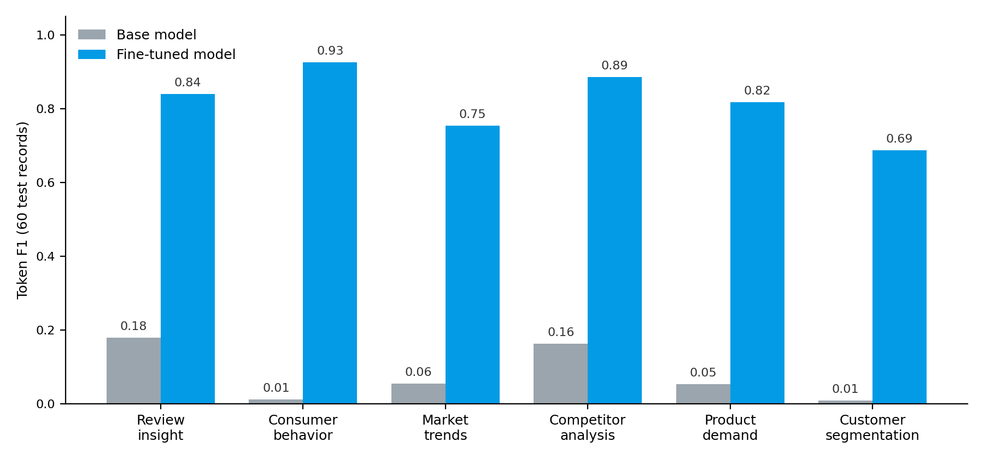
Figure 1. Token F1 on the 60 test records, by task family (10 records each).
Important caveat. The data is synthetic and the answers are produced by fixed rules. Each task family has only 10 test records, so one record moves a family's score by 10 points. The scores show that the pipeline works and in which direction the model improves, not how it would perform on real customer data. Customer segmentation (key-field accuracy 0.4) and product demand (0.6) are the weakest families.

Steps

Step 1: Understand the feedback and plan the six task families
Goal: decide what each new task looks like before writing any code.
- The review asked for training on multiple market research dimensions. The five families named in the feedback were used as they are, and the original review task was kept as a sixth family.
- Every answer must be computed from the input by a fixed rule, so the labels are always correct and the scores can be trusted.
- All families are built from the same pool of 600 synthetic reviews generated in version 1 (seed 42), so no new data source was needed.
- The data is split 80/10/10 inside every family, so train, validation and test each contain all six tasks.
Task family | Input given to the model | Answer labels
Review insight | One review | Positive feature, Primary problem, Recommendation
Consumer behavior | Four reviews of one product | Buying driver, Pain point, Sentiment
Market trends | Average rating by quarter for a category and region | Trend, Change, Implication
Competitor analysis | Two products in one category, 8 reviews each | Leader, Rating gap, Recommendation
Product demand | Reviews last month and average rating | Demand level, Reason, Recommendation
Customer segmentation | Counts and percentages of customers rated 4-5, 3 and 1-2 | Largest segment, Smallest segment, Recommendation

Step 2: Add the task builders (tasks.py)
Goal: write the code that creates the five new task families without touching the working version 1 code.
- A new file src/sba_928/tasks.py was created next to the step files. It holds one builder function per family, a list of instruction wordings per family, and generate_task_records, which builds 100 unique records per family.
- Each builder samples reviews from the 600-review pool and computes the answer by a rule (see Appendix D). For example, the competitor with the higher average rating is the leader, and demand is Low when fewer than 15 reviews arrived last month or the rating is below 2.8.
- A trend series for market trends (four quarterly average ratings) is generated from a seeded random trend, because the review pool has no dates.
- Records that pool several regions carry the region label "All regions", so the bias audit can tell them apart from records with one real region.

Step 3: Fix the folder problem and preview the new records
A small preview script printed two records from each family. It first failed:
ModuleNotFoundError: No module named 'sba_928'
Running uv sync --group dev then printed error: No pyproject.toml found. Both messages had the same cause.
Cause. The terminal was in the outer SBA_928 folder, but the project files (pyproject.toml, src, tests) are in the SBA_928 folder inside it. uv and Python only find the project from the inner folder.
Fix: move into the inner folder, move the preview script with it, and sync the project:
cd SBA_928
ls
mv ../preview_tasks.py .
uv sync --group dev
uv run python preview_tasks.py
uv sync reinstalled the project from the correct folder. A warning that VIRTUAL_ENV does not match the project environment is harmless and was ignored. The preview then printed sensible contexts and answers for all five new families. Example (product demand):
Product: Face Moisturizer. Category: beauty. Reviews last month: 80. Average rating: 2.1.
Demand level: Low. Reason: Weak ratings. Recommendation: Reduce inventory and review the marketing plan.

Step 4: Update the record schema (schema.py)
validate_record in version 1 required a non-empty review and required every answer to contain the three review labels, so it would have rejected every new record.
- A table TASK_TARGET_LABELS now lists the three labels each family's answer must contain.
- Records without a task_type are treated as review insight, so the version 1 tests and code keep working.
- The review field is only required for review insight. The new families keep their data in context.

Step 5: Build, mix and split the dataset (guide Step 1)
Two functions were added to the end of tasks.py: build_dataset (100 review-insight records plus 100 per new family) and split_by_task (shuffles each family with seed 42 and splits it 80/10/10). main in step_01_generate_dataset.py was replaced to use them and to validate every record.
uv run python -m sba_928.step_01_generate_dataset
INFO train: 480 records -> data\processed\train.jsonl
INFO validation: 60 records -> data\processed\validation.jsonl
INFO test: 60 records -> data\processed\test.jsonl
The sizes are the same as in version 1 (480, 60, 60), but each split now holds all six families, 80, 10 and 10 records of each.

Step 6: Update the prompt templates (prompts.py)
build_prompt_variants was hard-coded to the review labels. It now takes the task family as a second argument and builds the five variants (minimal, structured, grounded, role-based, few-shot) with that family's own labels and its own worked example. Old calls still work, because the default is review insight. The three scenario templates from version 1 (consumer behavior, market trend, competitor analysis) were kept.

Step 7: Update the scoring (metrics.py)
The version 1 scorer only understood the review labels, so every new answer would have scored 0. The new score_example reads the task family from the labels in the correct answer and scores against that family's labels.
- The three field scores (positive_f1, problem_f1, recommendation_f1) keep their names. They now mean the first, second and third labelled field of whichever family is being scored.
- A new metric, key_field_match, is 1 when the first labelled field is exactly right: the positive feature, buying driver, trend, leader, demand level or largest segment.
- The grounding score is only meaningful for review insight and consumer behavior. For numeric families the answer words ("Medium", "Rising") never appear in the input, so it is not used as a headline result.

Step 8: Prompt engineering experiment (guide Step 2)
Goal: test whether changing only the prompt wording makes the original model produce the required answers for all six families. No model parameters are changed.
step_02_prompt_engineering.py was changed to build each prompt for the record's own family, and to pick the validation records evenly across the six families (two each for --limit 12).
uv run python -m sba_928.step_02_prompt_engineering --limit 12 --device cpu
Variant | Token F1 | Format adherence
minimal | 0.086 | 0.0
structured | 0.050 | 0.0
grounded | 0.084 | 0.0
role_based | 0.089 | 0.0
few_shot | 0.228 | 0.167

Four of the five variants never produced the required labelled format. The few-shot prompt scored highest, and 2 of its 12 answers followed the format. Changing the wording of the prompt alone barely moves the base model, which is the case for fine-tuning.

Step 9: Fine-tune on all six task families (guide Step 3)
step_03_fine_tune.py needed no change, because it only reads the instruction, context and target fields. A new config file, config/experiment3.json, was created with its own output folder, so the version 1 models are not overwritten.
Setting | Version 1, run 2 | Version 2, run 3
Epochs | 8 | 10
Learning rate | 1e-4 | 1e-4
Max input length (tokens) | 256 | 384
Max answer length (tokens) | 96 | 128
Output folder | flan-t5-sba-928-run2 | flan-t5-sba-928-run3

The input and answer lengths were raised because the consumer behavior inputs list four reviews and the competitor answers are longer.
uv run python -m sba_928.step_03_fine_tune --config config/experiment3.json
The first multi-task run took 37 minutes 38 seconds on CPU (600 training steps). Validation loss fell at every epoch, so the model kept learning from all six families:
Epoch | Training loss | Validation loss
1 | 4.747 | 0.8664
2 | 1.644 | 0.3047
4 | 0.6416 | 0.1909
6 | 0.4794 | 0.1587
8 | 0.4099 | 0.1443
10 | 0.3704 | 0.1379

Step 10: Compare base and fine-tuned model (guide Step 4)
step_04_compare_models.py was changed to score the new families against their context, to record each record's task family, and to add a results table per family. It also got an --output-dir option, so the new results are saved in artifacts/evaluation_run3 and the version 1 results stay as they are.
uv run python -m sba_928.step_04_compare_models --fine-tuned-model artifacts/models/flan-t5-sba-928-run3/final --output-dir artifacts/evaluation_run3 --device cpu
First multi-task run, 60 test records:
Metric | Base | Fine-tuned
Token F1 | 0.078 | 0.792
Format adherence | 0.0 | 1.0
Exact match | 0.0 | 0.283
Key-field accuracy | 0.0 | 0.633

Task family | Token F1 | Exact match | Key field
Review insight | 0.179 to 0.840 | 0.0 to 0.2 | 0.0 to 1.0
Consumer behavior | 0.011 to 0.956 | 0.0 to 0.6 | 0.0 to 0.9
Market trends | 0.055 to 0.761 | 0.0 to 0.2 | 0.0 to 0.6
Competitor analysis | 0.162 to 0.885 | 0.0 to 0.1 | 0.0 to 0.7
Product demand | 0.053 to 0.817 | 0.0 to 0.6 | 0.0 to 0.6
Customer segmentation | 0.007 to 0.490 | 0.0 to 0.0 | 0.0 to 0.0

Every family improved over the base model and every answer used the required labels. Customer segmentation was clearly the weak family: key-field accuracy was 0.0.

Step 11: Improve customer segmentation
Goal: find out why one family failed and fix the cause, instead of just reporting the low score. The saved answers were read first:
Input (customers rated 4-5 / 3 / 1-2) | Correct answer | Model answer
Electronics, Asia-Pacific: 3 / 1 / 3 of 7 | Largest: Promoters (43%). Smallest: Passives. | Largest: Passives (50%). Smallest: Promoters.
Drinkware, North America: 4 / 6 / 8 of 18 | Largest: Detractors (44%). Smallest: Promoters. | Largest: Promoters (43%). Smallest: Passives.
Electronics, Latin America: 1 / 2 / 4 of 7 | Largest: Detractors (57%). Smallest: Promoters. | Largest: Promoters (47%). Smallest: Passives.

The model gave almost the same answer for every input and invented percentages, so it was not comparing the counts. Two causes were found in the task design, not in the model:
- The percentage had to be calculated, but the input only gave counts.
- Some groups had tied counts (for example 3 promoters and 3 detractors), so the correct answer was an arbitrary tie-break.
Fix: the input now lists the percentage next to each count, and the generator skips groups with tied counts. Only the segmentation records changed, so the other five families are comparable between runs. The few-shot example in prompts.py was updated to the new format, and then the dataset was regenerated, the prompt experiment re-run and the model retrained with the same config.
uv run python -m sba_928.step_01_generate_dataset
uv run python -m sba_928.step_02_prompt_engineering --limit 12 --device cpu
uv run python -m sba_928.step_03_fine_tune --config config/experiment3.json
uv run python -m sba_928.step_04_compare_models --fine-tuned-model artifacts/models/flan-t5-sba-928-run3/final --output-dir artifacts/evaluation_run3 --device cpu
Final results on the 60 test records, base model to fine-tuned model:
Task family | Token F1 | Exact match | Key field
Review insight | 0.179 to 0.840 | 0.0 to 0.2 | 0.0 to 1.0
Consumer behavior | 0.011 to 0.925 | 0.0 to 0.4 | 0.0 to 0.8
Market trends | 0.055 to 0.754 | 0.0 to 0.0 | 0.0 to 0.6
Competitor analysis | 0.162 to 0.885 | 0.0 to 0.1 | 0.0 to 0.7
Product demand | 0.053 to 0.817 | 0.0 to 0.6 | 0.0 to 0.6
Customer segmentation | 0.008 to 0.687 | 0.0 to 0.3 | 0.0 to 0.4
All 60 records | 0.078 to 0.818 | 0.0 to 0.267 | 0.0 to 0.683

Segmentation improved from token F1 0.490 to 0.687 and from key-field accuracy 0.0 to 0.4. It is still the weakest family: a small model only partly learns to compare three percentages from 80 training examples. Small changes in the other families (for example consumer behavior token F1 0.956 to 0.925) come from retraining on only 10 test records per family and are within the noise.

Step 12: Bias and fairness audit (guide Step 5)
step_05_bias_audit.py was rewritten for three reasons: 240 of the 480 training records pool all regions, the new families have an empty review field, and the new results are in evaluation_run3. Records without a single region are left out of the region comparison, review length and rating by region are compared on the 80 review-insight training records only, and a comparison by task family was added. The results go to artifacts/bias_audit_run3.
uv run python -m sba_928.step_05_bias_audit --eval-dir artifacts/evaluation_run3 --output-dir artifacts/bias_audit_run3

Training data audit (480 records)
- Task families are balanced (16.7% each). Categories: apparel 18.5%, home 18.1%, food 17.1%, electronics 15.8%, drinkware 15.2%, fitness 7.7%, beauty 7.5%.
- Region is a real attribute for 240 of the 480 records. Among those: North America 30.0%, Europe 24.2%, Asia-Pacific 18.8%, Latin America 15.0%, Middle East & Africa 12.1%.
- On the 80 review-insight records, average rating by region ranged from 2.75 (Middle East & Africa) and 2.79 (Asia-Pacific) to 3.27 (North America). These are small samples.
- No loaded terms were found with the project word list, which is a weak check.

Model results (fine-tuned, token F1)
Group | Test records | Gap vs overall
Category: electronics | 10 | -0.107
Category: apparel | 12 | +0.098
Rating: high (4-5) | 13 | +0.059

Groups with fewer than 10 test records cannot be assessed reliably: beauty (8), drinkware (8), fitness (4), food (9), home (9), every region (4 to 8 each) and rating 1-2 (5). Only 30 of the 60 test records have a single region, so no regional gap could be assessed.
Reading the gaps. The six task families differ in difficulty (family token F1 from 0.687 to 0.925), so a category's score can be affected by which families happen to fall in it. This was not tested. The gaps are observations on small samples, not evidence of unfairness or of its cause. Groups are synthetic labels, not real demographic evidence.

Fairness strategies tied to these findings
- Diversity: stratify the splits by region and category and add examples for the smallest groups (Middle East & Africa, fitness, beauty).
- Regional differences: make region a real attribute for every family, and report scores per region with uncertainty once groups have about 30 or more records.
- Industry context: report each task family and each category separately.
- Prompt design: keep region out of the model input (done here), use neutral wording and grounded prompts.
- Process: extend the loaded-term list, have a person review samples of answers, and re-audit after every retraining.

Step 13: Custom inference (guide Step 6)
step_06_custom_inference.py got a --task option. Review insight works as before with --product, --rating and --review. The other five families take the data text with --context, in the same format used in training.
uv run python -m sba_928.step_06_custom_inference --model artifacts/models/flan-t5-sba-928-run3/final --task product_demand --context "Product: Wireless Mouse. Category: electronics. Reviews last month: 62. Average rating: 3.9." --device cpu
Input | Model answer | Verdict
Review insight: Wireless Mouse, 3/5, "The mouse is comfortable, but it disconnects several times each day." | Positive feature: Is comfortable. Primary problem: It disconnects several times each day. Recommendation: Keep the current design. | Feature and problem correct. Recommendation wrong: "Keep the current design" is the training answer for reviews with no problem.
Product demand: Wireless Mouse, 62 reviews last month, average rating 3.9 | Demand level: Medium. Reason: Moderate review volume or ratings. Recommendation: Maintain current inventory. | Wrong. The rule gives High (40 or more reviews and rating 3.2 or higher). The model has trouble applying numeric thresholds.

Both are single examples that show where the model fails. The grounding score for the second answer was 0.0, which is expected: it only checks words that appear in the input, and the numeric families answer with words such as "Medium".

Step 14: Automated tests and code quality
The 12 version 1 tests still passed after the changes. A new file tests/test_tasks.py adds 6 tests: all six families are present, the dataset is reproducible, contexts are unique within each family, the split covers every family without ID overlap and passes validation, segmentation always has a clear largest segment, and a perfect answer scores 1.0 for every family.
uv run python -m pytest
uv run python -m ruff check .
uv run pytest failed with uv trampoline failed to canonicalize script path. This is a Windows quirk of how uv launches the pytest program directly. Running it through Python avoids it.
The first ruff run found 8 style findings: 5 unnecessary int() calls and 1 loop that should use .items() in tasks.py, one string-concatenation warning in step_05_bias_audit.py, and one file-opening warning in a scratch script. The code was corrected, the scratch scripts were deleted, and the results are below.
Command | Result
uv run python -m pytest | 18 passed
uv run python -m ruff check . | All checks passed!

Step 15: Update the README and add this report
README.md was rewritten for version 2: the six task families with their rules, the new commands, the prompt experiment, the final results by family, the customer segmentation iteration, the limitations and the updated bias analysis. Every number in it comes from the runs described in this report. A link to this report was added at the top of the README.
This report is saved in the docs folder of the project, so it is part of the repository as the project review requires.

Step 16: Publish version 2 to GitHub
The repository keeps both versions as branches, so the original submission is never lost:
- v1: the existing project, exactly as it was on main before the update.
- v2: the updated project with six task families, this report and the new README.
- main: receives version 2 after it has been checked on GitHub.
git branch v1
git push -u origin v1
git switch -c v2
git add .
git commit -m "SBA 928 version 2: six market research task families"
git push -u origin v2
# on GitHub: open a pull request from v2 into main and merge it
Model checkpoints stay out of Git (artifacts/models/ is in .gitignore), as in version 1. The README says where they are written.

Problems encountered and how they were fixed
Problem | Cause | Fix
No module named 'sba_928' | Terminal was in the outer SBA_928 folder, not the project folder | cd SBA_928, then uv sync --group dev
No pyproject.toml found | Same cause | Run commands from the inner SBA_928 folder
uv trampoline failed to canonicalize script path | Windows quirk when uv launches the pytest program | Use uv run python -m pytest
Customer segmentation key-field accuracy 0.0 | Percentages had to be calculated, and tied counts gave arbitrary answers | Percentages added to the input, ties excluded, dataset regenerated and model retrained
Review scorer scored every new answer 0 | metrics.py only knew the review labels | Scorer reads the labels of each task family
8 ruff findings | Unnecessary int(), loop style, string concatenation, scratch script | Fixed in tasks.py and step_05; scratch scripts deleted
VIRTUAL_ENV warning from uv | An old environment path is still set in the terminal | Harmless, ignored

Conclusion

What was achieved
- The model is now fine-tuned and tested on six market research task families instead of one, which answers the main point of the project review.
- Prompt engineering alone did not work. Four of five prompt variants gave a format adherence of 0.0, and the best (few-shot) gave 0.167.
- Fine-tuning did. Token F1 rose from 0.078 to 0.818 on the 60 test records, and format adherence from 0.0 to 1.0 on every record.
- A weak family was investigated and improved. Customer segmentation went from key-field accuracy 0.0 to 0.4 after two flaws in the task design were fixed.
- The pipeline is tested (18 tests) and passes the ruff style check. The report is stored in the repository.

Limitations
- Small test sets. Each family has 10 test records, so one record moves its score by 10 points.
- Synthetic, rule-based data. The answers come from fixed rules, so the scores say little about real customers or real reviews.
- Shared review pool. All families draw on the same 600 reviews, so a test record can reuse reviews that also appear in a training record. Contexts are unique within each family (tested), but overlap in the underlying reviews was not measured.
- Numeric reasoning is weak. Customer segmentation (0.4) and product demand (0.6) are the weakest families, and the custom product demand example was wrong.
- Market trend series are synthetic. They come from a seeded random trend, not from the review data.
- Bias audit. Only 30 of 60 test records have a single region, most groups have fewer than 10 records, and region labels are synthetic.

Recommended next steps
- Build a larger test set (about 30 or more records per family) and report uncertainty.
- Split so that the same underlying review never appears in both training and test, and measure the overlap.
- Use real public review data with verified labels for at least some families, and real dates for market trends.
- Give the model more training examples for the numeric families, or have the program compute the numbers and let the model write only the explanation.
- Add a metric that detects missing fields and unsuitable recommendations, and have a person review a sample of answers.

Appendix

A. Full command reference
# setup (from the inner SBA_928 folder)
uv sync --group dev
# checks
uv run python -m pytest
uv run python -m ruff check .
# pipeline
uv run python -m sba_928.step_01_generate_dataset
uv run python -m sba_928.step_02_prompt_engineering --limit 12 --device cpu
uv run python -m sba_928.step_03_fine_tune --config config/experiment3.json
uv run python -m sba_928.step_04_compare_models --fine-tuned-model artifacts/models/flan-t5-sba-928-run3/final --output-dir artifacts/evaluation_run3 --device cpu
uv run python -m sba_928.step_05_bias_audit --eval-dir artifacts/evaluation_run3 --output-dir artifacts/bias_audit_run3
uv run python -m sba_928.step_06_custom_inference --model artifacts/models/flan-t5-sba-928-run3/final --product "Wireless Mouse" --rating 3 --review "The mouse is comfortable, but it disconnects several times each day." --device cpu
uv run python -m sba_928.step_06_custom_inference --model artifacts/models/flan-t5-sba-928-run3/final --task product_demand --context "Product: Wireless Mouse. Category: electronics. Reviews last month: 62. Average rating: 3.9." --device cpu

B. Files changed or added in version 2
File | Change
src/sba_928/tasks.py | New. Builders for the five new task families, build_dataset, split_by_task
src/sba_928/schema.py | Labels per task family; review required only for review insight
src/sba_928/prompts.py | Prompt variants, labels and worked examples for six families
src/sba_928/metrics.py | Scoring by task family; new key_field_match metric
src/sba_928/step_01_generate_dataset.py | main builds and splits the six-family dataset
src/sba_928/step_02_prompt_engineering.py | Balanced sample across families; per-family prompts
src/sba_928/step_04_compare_models.py | Per-family results; --output-dir option
src/sba_928/step_05_bias_audit.py | Region handling, task-family comparison, input and output folders
src/sba_928/step_06_custom_inference.py | --task and --context options
config/experiment3.json | New. Training settings for version 2
tests/test_tasks.py | New. 6 tests for the multi-task dataset
README.md | Rewritten for version 2
docs/ | This report
src/sba_928/step_03_fine_tune.py | Unchanged

C. Result files
Folder | Content
artifacts/prompt_baseline | Prompt experiment: predictions and summary (12 validation records)
artifacts/evaluation_run3 | Base against fine-tuned comparison on the 60 test records, with a per-family summary
artifacts/bias_audit_run3 | Dataset audit and subgroup metrics
artifacts/models/flan-t5-sba-928-run3/final | Fine-tuned model (kept out of Git)
artifacts/evaluation_run1, evaluation_run2, bias_audit | Version 1 results, kept for reference

D. Task families, answers and rules
Task family | Answer rule
Review insight | Templated review text; the answer lists the positive feature, the problem and the matching recommendation
Consumer behavior | Most frequent feature and problem among 4 reviews. Sentiment from the average rating: 4.0 or more satisfied, 3.0 to 3.9 mixed, below 3.0 dissatisfied
Market trends | Change from first to last quarter: +0.3 or more Rising, -0.3 or less Falling, otherwise Stable
Competitor analysis | Higher average rating leads; equal averages are a Tie; the other product should fix its most common complaints
Product demand | Low if under 15 reviews or rating below 2.8; High if 40 or more reviews and rating 3.2 or higher; otherwise Medium
Customer segmentation | Customers rated 4-5 are Promoters, 3 Passives, 1-2 Detractors. Groups with tied counts are excluded. The recommendation follows the largest segment

E. Screenshots
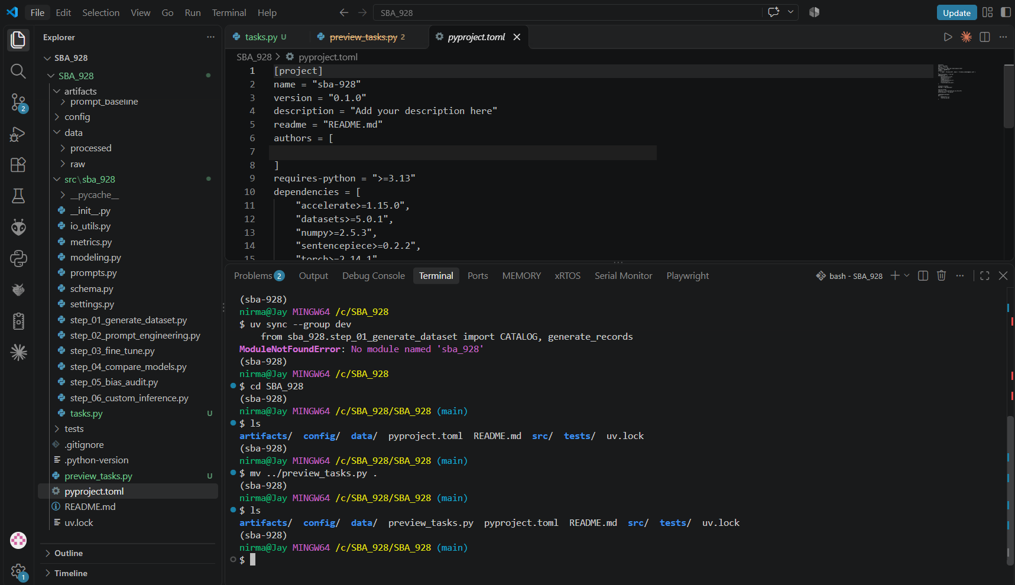
Figure 2. VS Code Explorer with the new tasks.py (marked U), and the terminal after moving into the inner SBA_928 folder (Step 3).

F. Repository
https://github.com/Nirmala-SK/SBA_928_Nirmala
Branches: v1 (original submission), v2 (this version) and main.

