1. **Create a Virtual Environment: DjangoAssignment**

1. **Activate the Virtual Environment**

1. **Install Django**

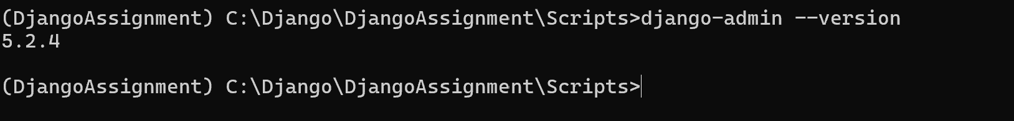

1. **Create a New Django Project: Login System**

1. **Create a New Django Application: “Loginify”**

**TASK-4**

1. **Setup Superuser**

