1.pwd

This Command prints the absolute path of current working directory

Eg:

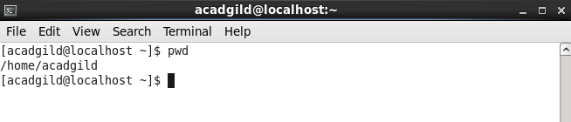

2.vi

This is an interactive text editor which is display oriented. Using vi v can insert text anywhere in the file very easily. Most of vi commands move the cursor forward and backward in units of characters,words,sentences, and paragraphs. Some of the operators like d for delete and c for change can be combined with the motion commands to make them operate on entire words, paragraphs etc, in a natural way

Eg:

vi filename

above command used to open a file. If file doesn’t exists the it will create a new file

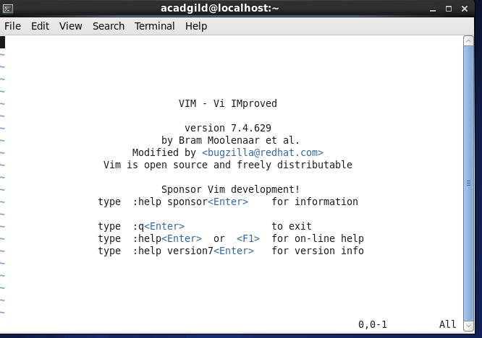

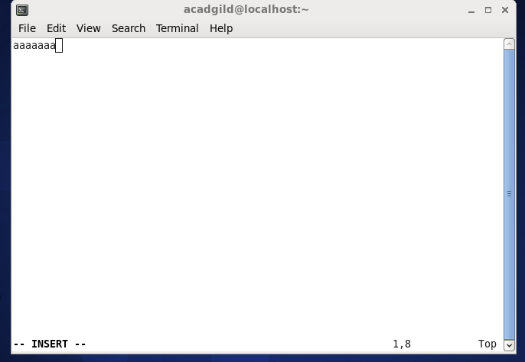

3.touch

The touch [command](http://www.linfo.org/command.html) is the easiest way to create new, empty [files](http://www.linfo.org/file.html). It is also used to change the timestamps (i.e., dates and times of the most recent access and modification) on existing files and [directories](http://www.linfo.org/directory.html).

touch's syntax is

touch [option] file_name(s)

When used without any [options](http://www.linfo.org/option.html), touch creates new files for any file names that are provided as [arguments](http://www.linfo.org/argument.html) (i.e., input data) if files with such names do not already exist. Touch can create any number of files simultaneously.

Thus, for example, the following command would create three new, empty files named file1, file2 and file3:

touch file1 file2

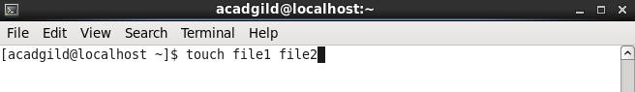

4.mkdir

To create a directory, the ‘mkdir’ command is used.

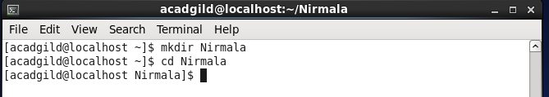

5.rm

This command is used to delete empty directories and files. If it is not empty directory then delete all files in it and then directory can be deleted.

rmdir deletes directory

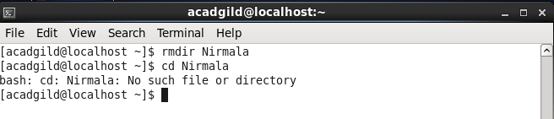

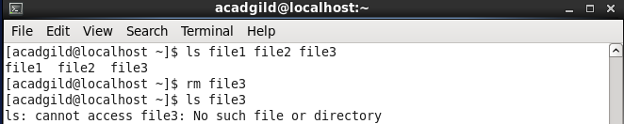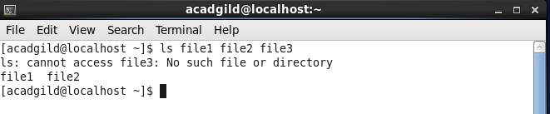

6:ls

ls lists files and directories

ex:



7:echo

The ‘echo’ command is used to display the values of  a variable. One such variable is ‘HOME’. To check the value of a variable precede the variable with a $ sign.

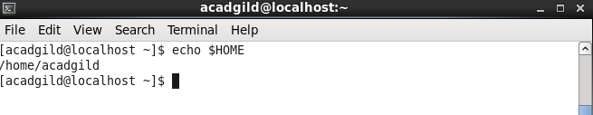

This command will echo whatever we provide it.

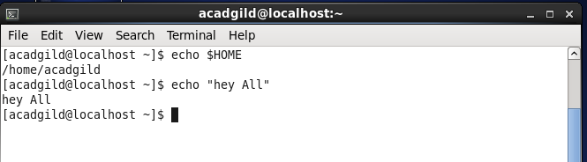

8:cat

The cat command is used for:

1. Display text file on screen
2. Read text file
3. Create a new text file
4. File concatenation
5. Modifying file

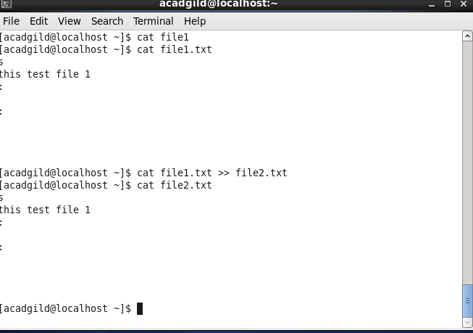

9.who

This command is useful to find out the following information:

1. Time of last system boot.
2. Current run level.
3. List of logged in users and more.

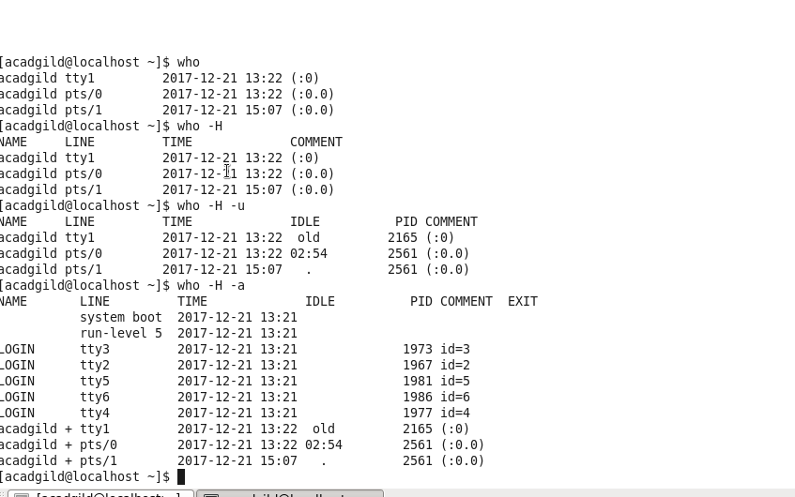

10.cd

Change the current working directory to the directory provided as argument. If no argument is given to ‘cd’, it changes the directory to the user's home directory. The directory path can be an absolute path or relative to current directory. The absolute path always starts with /.

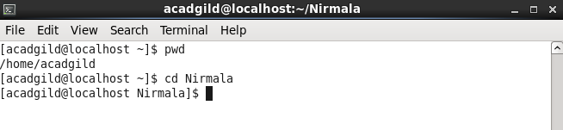

11.date

Displays current time and date.

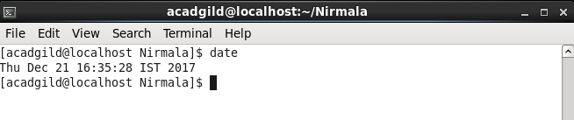

12.cal

Displays the calendar of the current month and also display calendar for the specified month and year.

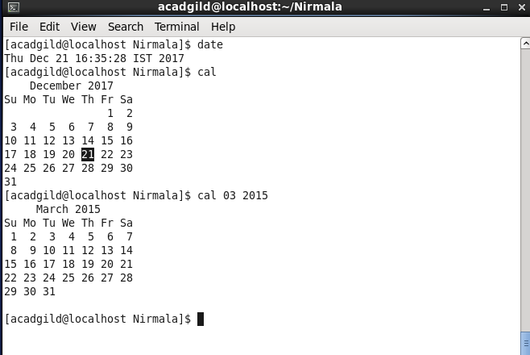

13.mv

The **mv** command moves, or [renames](https://www.computerhope.com/jargon/r/rename.htm), files and directories on your [filesystem](https://www.computerhope.com/jargon/f/filesyst.htm).

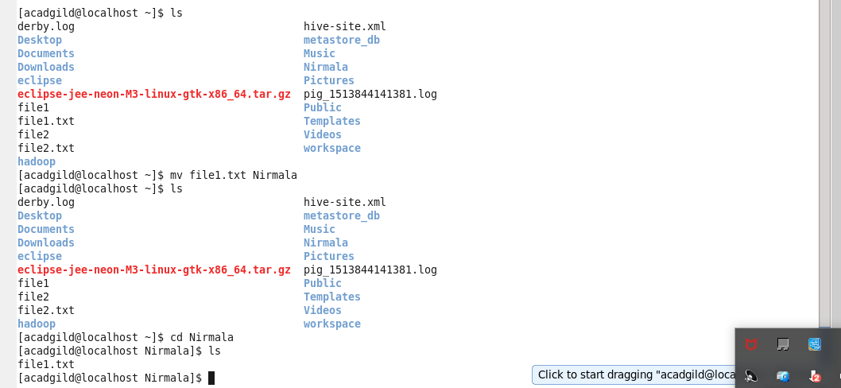

14.cp

Copy files and directories. If the source is a file, and the destination (file) name does not exit, then source is copied with new name i.e. with the name provided as the destination.

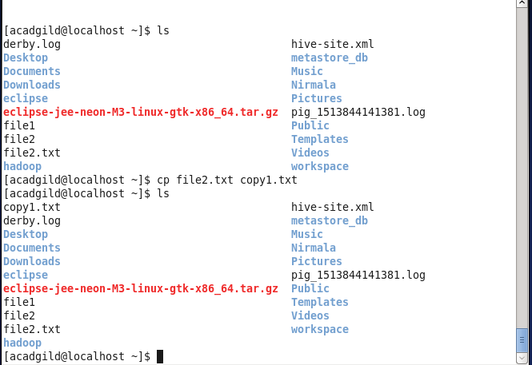

15.which

Locate the [executable file](https://www.computerhope.com/jargon/e/execfile.htm) associated with a given [command](https://www.computerhope.com/jargon/c/command.htm).

**which** returns the following value, depending on what occurred:

1. All *filename*s were found, and all were executable.
2. One or more filenames were not found, or were not executable.
3. An invalid option was specified.

