**Session 13: SCALA - SESSION II**

Assignment 13.1

Create a Scala application to find the GCD of two numbers.

Greatest Common Divisor (GCD) of two or more integers, which are not all zero, is the largest positive integer that divides each of the integers.

For example, the **gcd** of **8 and 12 is 4.**

In the below scala code, we are going to find the gcd of the two numbers 12 and 8.

Required Output

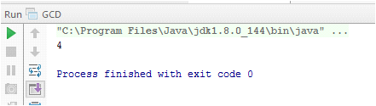

Screen Shot

