**ABSTRACT**

**Topic:** Kissan Kerala

Kissan Kerala is a web-based application where, agricultural enthusiast and farmers are main users. The main intension for Kissan Kerala is to automate farming technologies. One of the major drawback of existing system is the farmers have no opportunities to post advertisements for their product for sailing. And there is no options available to upload their valuable farm video tutorials.

The facilities provided by the proposed system includes farmers can post advertisements for their product for sales and also farmer can upload video tutorials for latest farming trends. The Kissan Kerala website system provides users and farmers to get online information about crops, agricultural information’s, schemes,apply new shemes,apply Insurance, fertilizers, application forms(pdf), farm news, exhibitions,email subscription,Post Questions for expert answers ,and a photo gallery.

**USERS of Kissan Kerala**

Kissan Kerala having 4 users.

1. Admin :

An administrator may be a dedicated staff whose responsibility is managing Kissan Kerala. The admin can access the entire system functionalities. The Admin can login to the system, can add/update/delete the farm news, manage exhibition details such as add new exhibition details, Edit exhibition details, delete exhibition details, manage gallery, manage districts such as add new districts and delete districts, add/delete product category. They may wish to Enable/disable any user accounts existing in the database. All users are under admin.

2. Farmers:

Farmer is any person who uses Kissan Kerala. They may want to know about various subsidies, loans and schemes those are available.And farmers can apply different loans and schemes. One of the major functionality of farmers include post their advertisements for their products for sailing and the farmer can view their product status and update it. Farmer have a chance to upload their valuable videos on to the site once the admin approves the video it can seen the public.

3 . Normal User:

Normal users can view various subsidies, loans and schemes those are available. And upcoming exhibition details and exhibition gallery. They get information about farm products for sales and purchase products also get information about fertilizers. Once the normal user registers this site who is enrolled as farmer and get extra privileges.

4. Officer Module:

The Officer can log into the system, can view the members (farmers). They can send notifications about specific schemes, products or subsidies. The officer can view the subsidy or scheme requests then he/she will be approved the request by checking accurate conditions. If there request is approved then a mail or notification is send to requested one. Officer can also update or delete his or her profile details.

**Functional Modules:**

1. Registration

The different users such as officer and common user/farmers have to register in the site by providing needed information. In the case of officer, at first admin Aprove the Officer registration. For the common user i.e. Farmers, they can choose the site for Post product details for sale, view different schemes and other statistical information’s. and can also apply for various schemes and subsidies .Before using these facilities he/she must register first.

2. Searching

Searching can be done based on different Products categories like food Products, horticulture products, cash crops etc. Officer can search persons or individual farmers based on their adhaar number. After searching, data’s like product information, subsidy details, scheme details farmers information etc. can be retrieved.

3. Scheme / Subsidy request

The farmers have an option for requesting schemes and subsidies. By this option they can make requests for available subsidies and schemes instead of visiting the office. If the request is acceptable, then officer will approve the request and send notification for inform the person who need the service.

4. Booking

Through this, the system provides an opportunity to farmers or normal users for purchasing the products based on their needs. Searching will help for selecting the product, if farmer is sure, he/she can make order of that particular product. If he needs more than one product, for this the cart option is too available.

5. Payment

The payment facility can be done by online. The users can have done their payment option through online.

6. Doubts and Reply

Registered user can send their doubts about cultivation or anything to the Public. Then the officer or other farmers will reply for the specific doubts

7. Insurance Listing and apply

Another facility for the Officers is having option for insurance listing. If he/she needs to know the insurance details. And apply for insurance.

**TABLE DESIGN**

**Database: kissankeraladb**

**1. Table Name: tbl_Login**

**Primary Key: Login_Id**

|  |  |  |  |
| --- | --- | --- | --- |
| **NAME** | **DATA** **TYPE** | **SIZE** | **DESCRIPTION** |
| Log_Id | Integer | 10 | Primary Key |
| Username | Varchar | 20 | Username |
| Password | Varchar | 20 | User Password |
| Status | Integer | 1 | Status |

1. **Table Name: tbl_Farmer**

**Primary Key: Farmer_id**

**Foreign Key:Log_Id(tbl_Login),District_Id(tbl_district),** **Ward_Id(tbl_Ward)**

|  |  |  |  |
| --- | --- | --- | --- |
| **NAME** | **DATA** **TYPE** | **SIZE** | **DESCRIPTION** |
| Farmer_Id | Integer | 10 | Primary Key |
| Log_Id | Integer | 10 | Foreign Key |
| First_name | Varchar | 20 | Farmer First Name |
| Last_name | Varchar | 20 | Farmer Last Name |
| Gender | Varchar | 15 | Gender of user |
| Adhar_no | Varchar | 20 | Farmer Aadhar No |
| Dob | Date |  | Farmer DOB |
| House_ name | Varchar | 30 | House Name |
| District_Id | Varchar | 20 | District Name (Foreign Key) |
| City | Varchar | 20 | City Name |
| Phone | Integer | 15 | Phone Number |
| Area_Land | Varchar | 10 | Total area of land |
| Panchayath | Varchar | 20 | Panchayath of user |
| Survey_No | varchar | 20 | Land survey number |
| Marital_Status | varchar | 15 | User Married or not |
| Ward_Id | varchar | 20 | User ward(foreign key) |
| Krishibhavan | varchar | 20 | Name of krishibhavan |
| Status | Integer | 2 | Status |

1. **Table Name: tbl_officer**

**Primary Key: Officer_Id**

**Foreign Key:Log_Id(tbl_Login)**

|  |  |  |  |
| --- | --- | --- | --- |
| **NAME** | **DATA** **TYPE** | **SIZE** | **DESCRIPTION** |
| Officer_Id | Integer | 10 | Primary Key |
| Log_Id | Integer | 10 | Foreign Key |
| Name | Varchar | 20 | Officer Name |
| Address | Varchar | 20 | Officer address |
| Adhar_no | Varchar | 20 | officer Aadhar No |
| Dob | Date |  | Farmer DOB |
| Gender | Varchar | 20 | Gender |
| Phone | Integer | 15 | Phone Number |
| Aprove | integer | 2 | Indicate approval of admin |
| Status | Integer | 1 | Status |

1. **Table Name: tbl_Product**

**Primary Key: Product_Id**

**Foreign Key: Farmer_id (tbl_register) ,** **Category_Id(tbl_productcategory)**

|  |  |  |  |
| --- | --- | --- | --- |
| **NAME** | **DATA** **TYPE** | **SIZE** | **DESCRIPTION** |
| Product_Id | Integer | 10 | Primary Key |
| Farmer_id | Integer | 10 | Foreign Key |
| Category_Id | Varchar | 20 | Product category Name |
| Quantity | Varchar | 30 | Quantity Of sale item |
| Price | Float | 5 | Item price |
| Location | Varchar | 20 | Item Location |
| Phone | Varchar | 15 | Phone Number |
| Path | Varchar | 100 | Product Picture Path |
| Status | Integer | 1 | Status |

1. **Table Name: tbl_Cart**

**Primary Key: Cart_Id**

**Foreign Key: Product_Id (tbl_Product)**

|  |  |  |  |
| --- | --- | --- | --- |
| **NAME** | **DATA** **TYPE** | **SIZE** | **DESCRIPTION** |
| Cart_Id | Integer | 10 | Primary Key |
| Product_Id | Integer | 10 | Foreign Key |
| Quantity | Varchar | 30 | Quantity Of products |
| Price | Float | 5 | Item price |
| Cart_date | Date |  | Carting date |
| Price | Varchar | 10 | Cart products price |
| Status | Integer | 1 | Status |

1. **Table Name: tbl_Purchase**

**Primary Key: Purchase_Id**

**Foreign Key: Cart_Id (tbl_Cart)**

|  |  |  |  |
| --- | --- | --- | --- |
| **NAME** | **DATA** **TYPE** | **SIZE** | **DESCRIPTION** |
| Purchase_Id | Integer | 10 | Primary Key |
| Cart_Id | Integer | 10 | Foreign Key |
| Cust_Name | Varchar | 30 | Name of customer |
| Address | Float | 5 | Delivery Address |
| Cart_date | Date |  | Carting date |
| Price | Varchar | 10 | Cart products price |
| Status | Integer | 1 | Status |

**7 . Table Name: tbl_exhibition**

**Primary Key: exid**

**Foreign Key: District_Id(tbl_district)**

|  |  |  |  |
| --- | --- | --- | --- |
| **NAME** | **DATA** **TYPE** | **SIZE** | **DESCRIPTION** |
| exid | Integer | 10 | Primary Key |
| Title | Varchar | 20 | Exhibition Title |
| District_Id | Varchar | 30 | Exhibition Location |
| Venue | Varchar | 30 | Exhibition Place |
| Date | Date |  | Exhibition Date |
| Time | Time |  | Exhibition Time |
| Phone | varchar | 15 | Phone Number |
| Status | Integer | 1 | Status |

**8. Table Name: tbl_district**

**Primary Key:** **District_Id**

|  |  |  |  |  |
| --- | --- | --- | --- | --- |
| **NAME** | **DATA** **TYPE** | **SIZE** |  | **DESCRIPTION** |
| District_Id | Integer |  | 10 | Primary Key |
| dname | Varchar |  | 30 | District Name |
| Status | Integer |  | 1 | Status |

**9. Table Name: tbl_news Primary Key: newsid**

|  |  |  |  |  |
| --- | --- | --- | --- | --- |
| **NAME** | **DATA** **TYPE** | **SIZE** |  | **DESCRIPTION** |
| newsid | Integer |  | 10 | Primary Key |
| title | Varchar |  | 100 | News title |
| date | Date |  |  | Date of news |
| path | Varchar |  | 100 | News pics path |
| Status | Integer |  | 1 | Status |

**10. Table Name: tbl_video**

### Primary Key: Video_Id

|  |  |  |  |
| --- | --- | --- | --- |
| **NAME** | **DATA** **TYPE** | **SIZE** | **DESCRIPTION** |
| Video_Id | Integer | 10 | Primary Key |
| path | Varchar | 100 | Video path |
| title | Varchar | 100 | Video title |
| description | Varchar | 500 | Video description |
| status | Integer | 1 | Status |
| adminstatus | Integer | 1 | Video aproval |

**11 .Table Name: tbl_gallery**

**Primary Key: Img_Id**

|  |  |  |  |  |
| --- | --- | --- | --- | --- |
| **NAME** | **DATA** **TYPE** | **SIZE** |  | **DESCRIPTION** |
| Img_Id | Integer |  | 10 | Primary Key |
| date | Date |  |  | System date |
| path | Varchar |  | 100 | Image path |
| status | Integer |  | 1 | Status |

**12. Table Name: tbl_productcategory**

**Primary Key: Category_Id**

|  |  |  |  |
| --- | --- | --- | --- |
| **NAME** | **DATA** **TYPE** | **SIZE** | **DESCRIPTION** |
| Category_Id | Integer | 10 | Primary Key |
| name | varchar | 100 | Category name |
| status | Integer | 1 | Status |

**13. Table Name: tbl_Questions**

**Primary Key: Ques_Id**

**Foreign Key: Farmer_Id (tbl_Farmers)**

|  |  |  |  |
| --- | --- | --- | --- |
| **NAME** | **DATA** **TYPE** | **SIZE** | **DESCRIPTION** |
| Ques_Id | Integer | 10 | Primary Key |
| Farmer_Id | Integer | 10 | Foriegn Key |
| Question | varchar | 100 | Doubts/Questions |
| status | Integer | 1 | Status |

**14. Table Name: tbl_Answers**

**Primary Key: Answ_Id**

**Foreign Key: Ques_Id (tbl_Questions)**

|  |  |  |  |
| --- | --- | --- | --- |
| **NAME** | **DATA** **TYPE** | **SIZE** | **DESCRIPTION** |
| Answ_Id | Integer | 10 | Primary Key |
| Ques_Id | Integer | 10 | Foriegn Key |
| Answer | varchar | 100 | Answer for the question |
| status | Integer | 1 | Status |

**15. Table Name: tbl_Schemes**

**Primary Key: Scheme_Id**

|  |  |  |  |
| --- | --- | --- | --- |
| **NAME** | **DATA** **TYPE** | **SIZE** | **DESCRIPTION** |
| Scheme_Id | Integer | 10 | Primary Key |
| Scheme_Name | Varchar | 50 | Name of the scheme |
| Description | varchar | 100 | Scheme description |
| status | Integer | 1 | Status |

**16. Table Name: tbl_Schemeapply**

**Primary Key: Aplication_Id**

**Foreign Key: Farmer_Id (tbl_Farmers),** **Scheme_Id(tbl_Schemes)**

|  |  |  |  |
| --- | --- | --- | --- |
| **NAME** | **DATA** **TYPE** | **SIZE** | **DESCRIPTION** |
| Aplication_Id | Integer | 10 | Primary Key |
| Farmer_Id | Integer | 10 | Foriegn Key |
| Scheme_Id | Integer | 10 | Foriegn Key |
| Agri_Land | double |  | Agricultural land area |
| Survey_No | varchar | 20 | Agricultural land survey number |
| Leased | varchar | 20 | Whether land is leased or not |
| Bankname | varchar | 20 | Name of the bank |
| Branch | varchar | 20 | Name of the branch |
| Account_No | varchar | 20 | Bank Account number |
| Land_cost | varchar | 20 | Land preparation cost |
| Labour | varchar | 20 | Labour charge |
| Fertilizer | varchar | 20 | Fertilizer Cost |
| Seed | varchar | 20 | Seed Cost |
| Date | Date |  | Scheme apply date |
| status | Integer | 1 | Status |

**17. Table Name: tbl_Applicationstatus**

**Primary Key: Status_Id**

**Foreign Key: Aplication_Id (tbl_Schemeapply)**

|  |  |  |  |
| --- | --- | --- | --- |
| **NAME** | **DATA** **TYPE** | **SIZE** | **DESCRIPTION** |
| Status_Id | Integer | 10 | Primary Key |
| Aplication_Id | Integer | 10 | Foriegn Key |
| Action | varchar | 100 | Application action |
| status | Integer | 1 | Status |

**18. Table Name: tbl_Machinebooking**

**Primary Key: Book_Id**

**Foreign Key: Farmer_Id (tbl_Farmers),** **Machine_Id(tbl_Machines)**

|  |  |  |  |
| --- | --- | --- | --- |
| **NAME** | **DATA** **TYPE** | **SIZE** | **DESCRIPTION** |
| Mbook_Id | Integer | 10 | Primary Key |
| Farmer_Id | Integer | 10 | Foriegn Key |
| Machine_Id | Integer | 10 | Foriegn Key |
| Area | varchar | 30 | Area of agricultural land |
| BookDate | Date |  | Machine delivery date |
| Fromtime | Time |  | Machine delivery time |
| Totime | Time |  | Machine return time |
| status | Integer | 1 | Status |

**19. Table Name: tbl_Machinecategory**

**Primary Key: Category_Id**

|  |  |  |  |
| --- | --- | --- | --- |
| **NAME** | **DATA** **TYPE** | **SIZE** | **DESCRIPTION** |
| Category_Id | Integer | 10 | Primary Key |
| Cat_Name | varchar | 10 | Machine name |
| status | Integer | 1 | Status |

**20. Table Name: tbl_Machinestock**

**Primary Key: Machine_Id**

**Foreign Key: Category_Id (tbl_Machinecategory)**

|  |  |  |  |
| --- | --- | --- | --- |
| **NAME** | **DATA** **TYPE** | **SIZE** | **DESCRIPTION** |
| Machine_Id | Integer | 10 | Primary Key |
| Category_Id | Integer | 10 | Foreign Key |
| Machine_Name | varchar | 10 | Machine name |
| Fuel | varchar | 10 | Fuel type |
| Cost | varchar | 10 | Cost per hour |
| status | Integer | 1 | Status |

**21. Table Name: tbl_Insurance**

**Primary Key: Insurance_Id**

|  |  |  |  |
| --- | --- | --- | --- |
| **NAME** | **DATA** **TYPE** | **SIZE** | **DESCRIPTION** |
| Insurance_Id | Integer | 10 | Primary Key |
| Name | varchar | 10 | Insurance name |
| Description | varchar | 20 | Insurance Description |
| status | Integer | 1 | Status |

**22. Table Name: tbl_Insurancereg**

**Primary Key: Reg_Id**

**Foreign Key: Insurance_Id (tbl_Insurance),** **Farmer_Id(tbl_Farmers),** **Crop_Id(tbl_crops)**

|  |  |  |  |
| --- | --- | --- | --- |
| **NAME** | **DATA** **TYPE** | **SIZE** | **DESCRIPTION** |
| Reg_Id | Integer | 10 | Primary Key |
| Farmer_Id | Integer | 10 | Foriegn Key |
| Insurance_Id | Integer | 10 | Foriegn Key |
| Agri_Land | double |  | Agricultural land area |
| Survey_No | varchar | 20 | Agricultural land survey number |
| Leased | varchar | 20 | Whether land is leased or not |
| Crop_Id | Integer | 10 | Foreign Key |
| Amount | varchar | 20 | Preminum Amount |
| challan | varchar | 20 | Preminum Amount Challan number |
| Date | Date |  | Date of challan |
| Duration | varchar | 15 | Insurance period |
| Bank | varchar | 20 | Name of the bank |
| Branch | varchar | 20 | Name of the branch |
| Account_No | varchar | 20 | Bank Account number |
| status | Integer | 1 | Status |

**23. Table Name: tbl_Crops**

**Primary Key: Crop_Id**

|  |  |  |  |
| --- | --- | --- | --- |
| **NAME** | **DATA** **TYPE** | **SIZE** | **DESCRIPTION** |
| Crop_Id | Integer | 10 | Primary Key |
| Farmer_Id | Integer | 10 | Foriegn Key |
| Name | varchar | 10 | Crop name |
| area | varchar | 20 | Area of agricultural |
| level | varchar | 20 | Crops current level |
| status | Integer | 1 | Status |

**24. Table Name: tbl_Applyinsure**

**Primary Key: Insurapply_Id**

**Foreign Key: Reg_Id (tbl_Insurancereg)**

|  |  |  |  |
| --- | --- | --- | --- |
| **NAME** | **DATA** **TYPE** | **SIZE** | **DESCRIPTION** |
| Insurapply_Id | Integer | 10 | Primary Key |
| Reg_Id | Integer | 10 | Foriegn Key |
| Date | Date |  | Date of destroy |
| Nature | varchar | 20 | Nature of agricultural destroy |
| Number | integer | 10 | No of crops destroyed |
| Pic1 | varchar | 100 | Picture path |
| Pic2 | varchar | 100 | Picture path |
| Pic3 | varchar | 100 | Picture path |
| Aproval | Integer | 2 | Offcer aproval |
| status | Integer | 1 | Status |

Level 0 DFD For Kissan Kerala

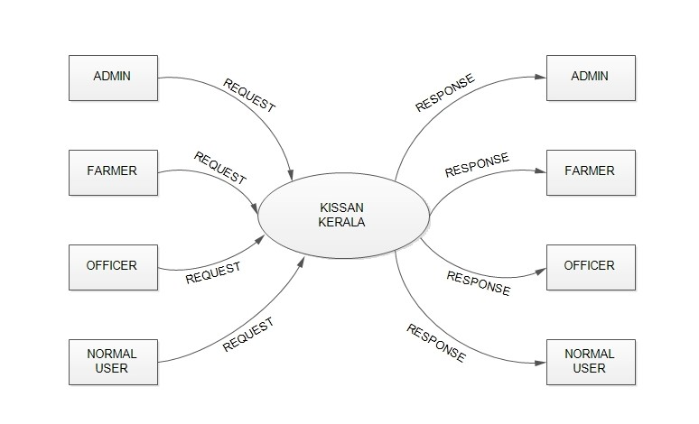

Level 1 DFD For Admin

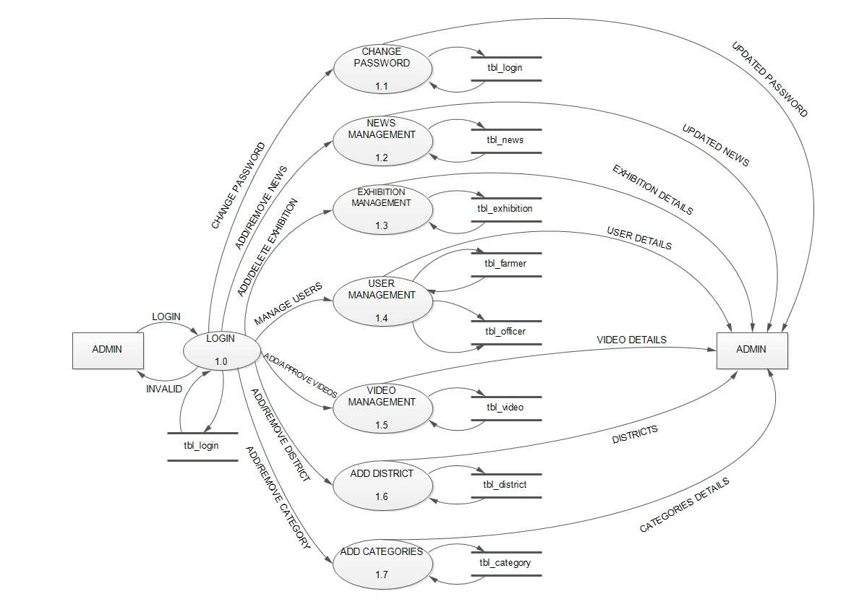

Level 1 DFD For Farmer

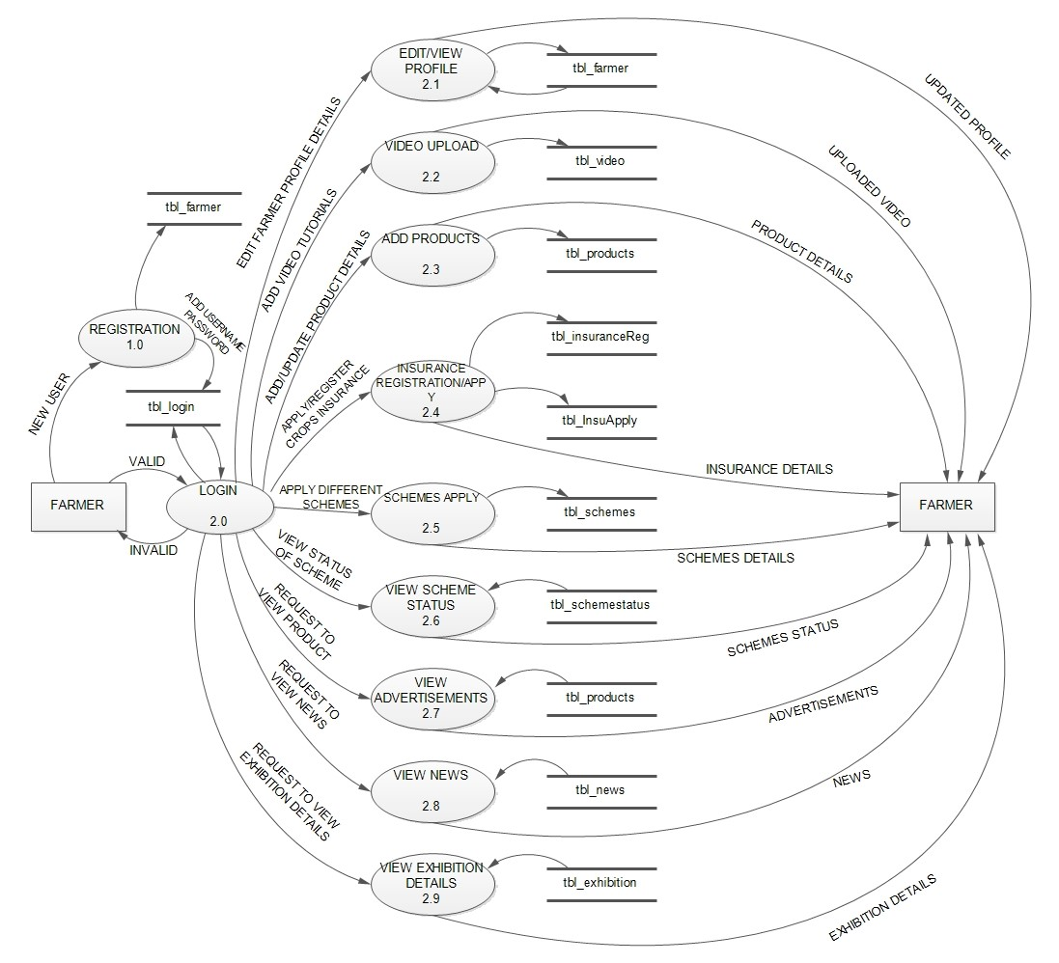

Level 1 DFD For Normal User

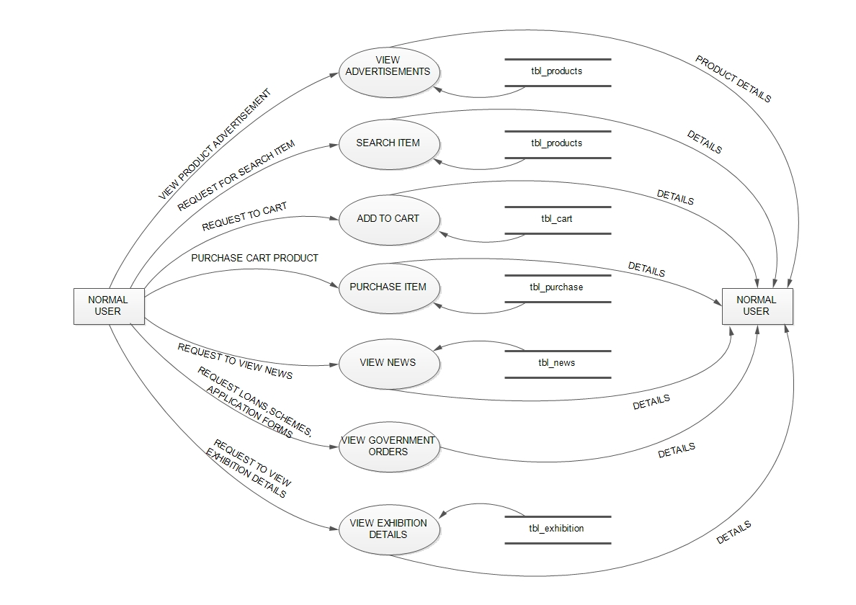

Level 1 DFD For Officer

