**Hacker Centre bot**

**Overview**

Hacker chat bot is a chat bot system for information retrieval system. We have developed the Hacker Centre Chatbot using Google DialogFlow as a natural language understanding engine to understand the text messages of the users. User can query to the chat bot to get the information related to hacker centres. Information like nearest hacker centre, details of hacker centre, seating capacity of hacker centre, address of the hacker centre etc.

When a user inputs a text message, the Chatbot processes the message to determine what is the intent behind the message. Our Chatbot can determine a user’s intent because we have trained it by providing example phases of how a user searching for information on ISS courses would ask their questions. After determining the intent, the Chatbot may request for more information from the user if this information was not provided in the text message

**Installation sets**

**Step number 1:**

Install nodejs. Go to the website <https://nodejs.org/en/download/> and download nodeJs according to the system and install it.

**Step number 2:**

Install all the dependency files for the bot framework UI. For doing that go to the folder UI.ai using cmd and run command npm install

**Step number 3:**

Add dialog flow api in the file config/api.js. Go to the UI.ai using cmd and run command **node bin/www**. Open the browser and provide the URL [**http://localhost:3000/**](http://localhost:3000/)

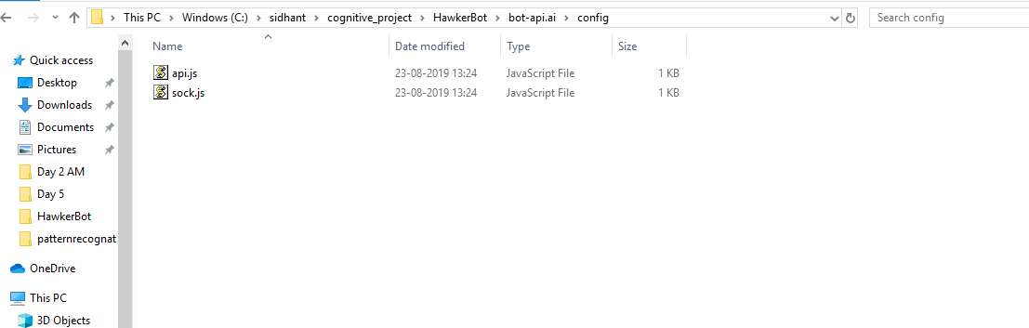

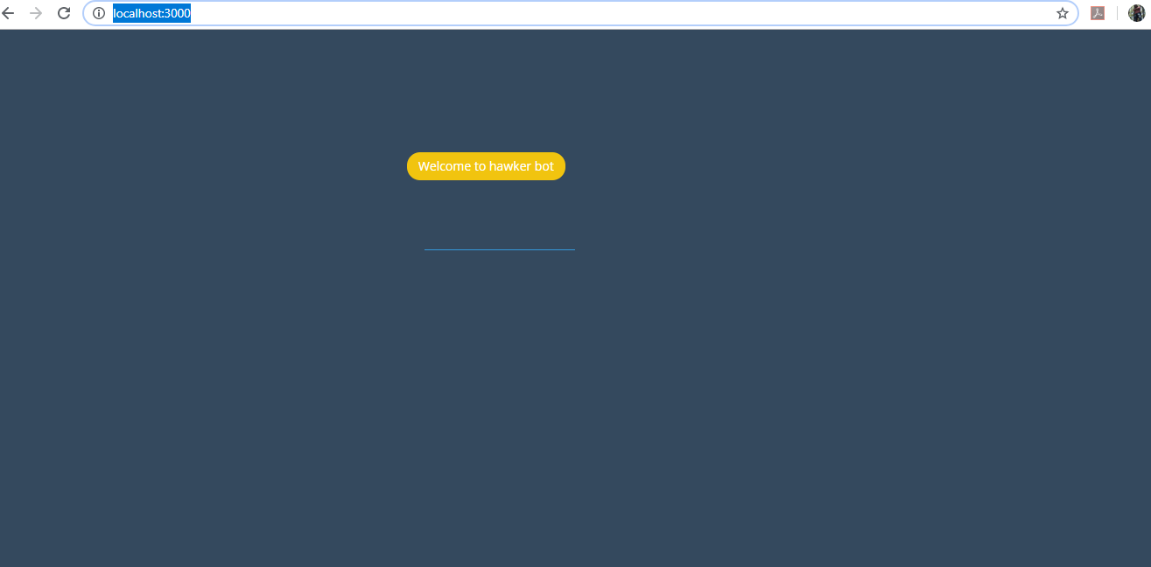

**Step number 4:**

Import the dialog flow zip file in the on the dialog flow.

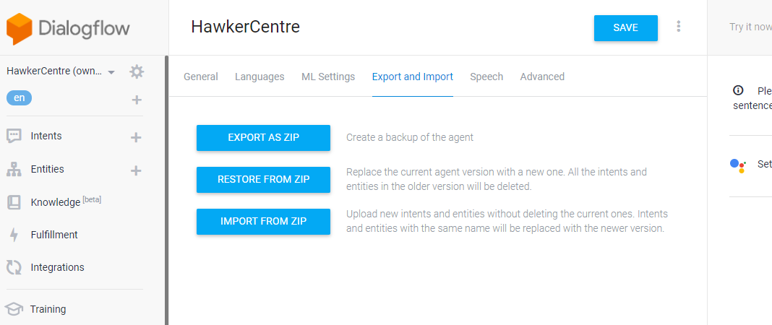

**Step number 5:**

For executing the backend, install all the dependencies in the python environment

* flask
* datetime
* json
* os
* googlesearch
* numpy
* nltk
* sklearn

**Step number 6:**

Download ngrok (<https://ngrok.com/download>) and run ngrok.exe after unzipping the downloaded file. Run the command in the ngrok command prompt **ngrok http 8800** and copy the https URL. Paste the copied URL in the dialog flow fulfilment and save it. Update the URL in the dialog flow whenever ngrok is rerun.

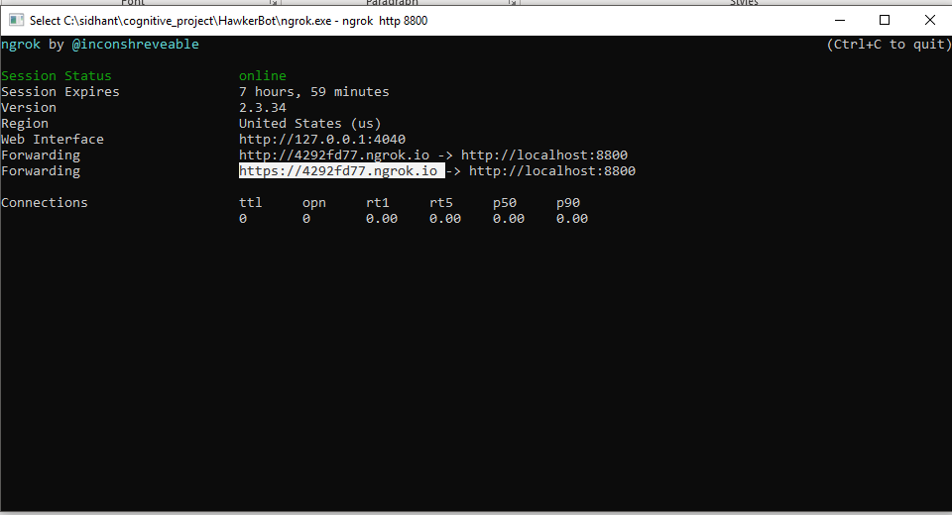

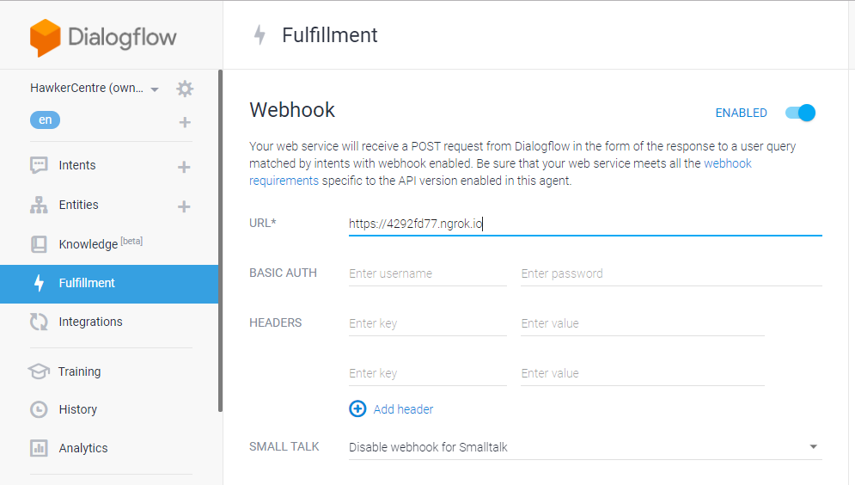

**Step number 7:**

Go to the location of app.py file using cmd and run command **python app.py**.

**Conversation with the Chatbot.**

You may start the conversation with a simple greeting and can ask the chat bot about the nearest hawker centre. It will ask for your current location. Provide the location and according to that it will output nearest hawker centres as selectable tiles. Click on of centre and proceed with your query/interaction. This is one of the flow, you can directly query by providing hawker centre name for eg - **information about clementi hawker centre**

