Waste Sorting

Nirmalendu Prakash

Table of Contents

Business Background & Problem Description 3

project Objective & Scope 3

Image Classification 3

Object Detection 4

Image Classification 4

Data Collection 4

Data Pre-processing 4

Training 4

Observation 7

Future Scope 7

Business Background & Problem Description

For easy sorting and recycling of waste, we have 3 types of bins in the NUS campus, as shown below:



In spite of the availability of bins, most of the recyclable waste ends up in the general bin or different types are mixed.

<https://www.channelnewsasia.com/news/commentary/ikea-sponsored-recycling-bins-for-recyclables-not-junk-singapore-11788898>

project Objective & Scope

Given the different types of items that end up in trash, the problem is approached in multiple steps:

Image Classification

Considering the scale of the problem and data requirement, as a first step, a classification solution is to be devised for following types of recyclable waste items-

1. Brochure
2. Cardboard
3. Paper receipt
4. A5 paper with written notes
5. Plastic bottle
6. Food container
7. Plastic wrapping for common food items such as snacks

Object Detection

Devising a solution to identify above objects and also any recyclable items from this list- <https://www.nea.gov.sg/docs/default-source/our-services/waste-management/list-of-items-that-are-recyclable-and-not.pdf> form images containing a mix of recyclable and non-recyclable items. The solution will identify items in the image, label them accordingly and any non-recyclable object to be tagged as “other”.

Image Classification

Data Collection

* Images are a mix of publicly available dataset (<https://www.kaggle.com/asdasdasasdas/garbage-classification>) as well as google image search
* Image size -384x512
* Images are placed in 3 folders-paper, plastic and can

Data Pre-processing

Some of the images are rotated and flipped to create more data and also to make the model learn robust features

Read the images in numpy array and saving in h5 format for easy transfer for running in colab and also to save processing time on rerun.

Available here- <https://drive.google.com/open?id=1VSnOt2sbgqt5PUzU2XuwNp3PG1SeyqNW>

Training

Starting with a 5 layer CNN with dropout and average pooling before dense layer:

Accuracy:



Loss:



Accuracy hovers around 70 %

Trying Resnet model with 3 residual blocks of 16,32,64 filters

Accuracy:

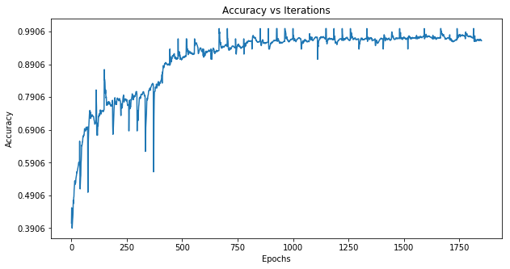

Loss:

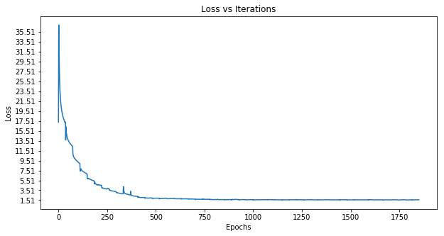

Autoencoder

Autoencoder model to identify images which do not belong to the categories considered

Train an auto encoder model to recreate training images. We can feed other images into this model and based on a threshold mean square error, we can classify images as “other” or “recyclable” and feed the recyclable images to Resnet model for further classification.

Observation

Images which contain lot of items such as mixture of food waste, gets classified as paper, because A5 paper in the training set has similar features and mixture of colours. Also, metal cans are misclassified as plastic, owing to their similarity with plastic bottles.

Future Scope

Considering above observations, a more comprehensive dataset is needed, as the items to be classified can have similar features. Also to be explored is testing the model with higher resolution images.

Once the model is able to learn different features for similar items such as plastic bottle and metal can, we could create dataset for object detection, containing mixture of the items and develop object detection models such as YOLO.