Executive Summary:
DIDPass is a Web3-based decentralized identity and credential verification tool designed to solve real-world problems such as fake identity, forged credentials, document tampering, weak password-based authentication, and unreliable audit records. Many organizations still verify documents through PDFs, screenshots, email attachments, and manual checks. These methods are not fully reliable because a document can be edited, a credential can be forged, and a password can be stolen.
The proposed system uses Public Key Infrastructure principles, decentralized identity, verifiable credentials, smart contracts, hashing, encryption, and tamper-evident audit logging. A trusted issuer, such as a university, company, or bank, can issue digital credentials to a user. Later, a verifier such as an employer or service provider can check whether the credential is genuine, unchanged, and not revoked.
DIDPass stores only proof on the blockchain, such as DID records, credential hashes, document hashes, revocation status, and audit hashes. The actual documents are stored off-chain in encrypted form to protect privacy and reduce blockchain storage cost. This design provides authentication, confidentiality, integrity, revocation control, and audit trust.
The tool is developed using free and open-source technologies such as Solidity, Hardhat, Node.js, React or Flutter, Ethers.js, IPFS or local storage, and cryptographic libraries. It can be demonstrated locally without paid subscriptions, real gas fees, or cloud services. Overall, DIDPass shows how Web3 and PKI can be used to build a future-ready digital trust platform for universities, companies, KYC systems, document approval, and compliance auditing.

Abstract
DIDPass is a Web3-based cryptographic tool designed to provide secure digital identity, credential verification, document integrity, confidentiality, and tamper-evident audit logging. The system addresses common problems such as forged certificates, fake identity claims, document modification, weak password-based verification, and poor audit reliability. It applies Public Key Infrastructure principles with decentralized identity, smart contracts, cryptographic hashing, encryption, digital signatures, and revocation checking.
The tool allows users to create a decentralized identity, allows trusted issuers to issue verifiable credentials, and allows verifiers to check whether a credential or document is real, unchanged, and not revoked. DIDPass stores only hashes and proof records on-chain, while actual documents and encrypted files are stored off-chain. This approach improves privacy, reduces blockchain storage cost, and supports trustworthy verification. The system is designed as a local demonstrable prototype using Solidity and Hardhat, making it suitable for university coursework and future real-world extension.
Keywords: DIDPass, Web3, decentralized identity, verifiable credentials, PKI, Solidity, smart contract, encryption, document integrity, audit logging.

Keywords:
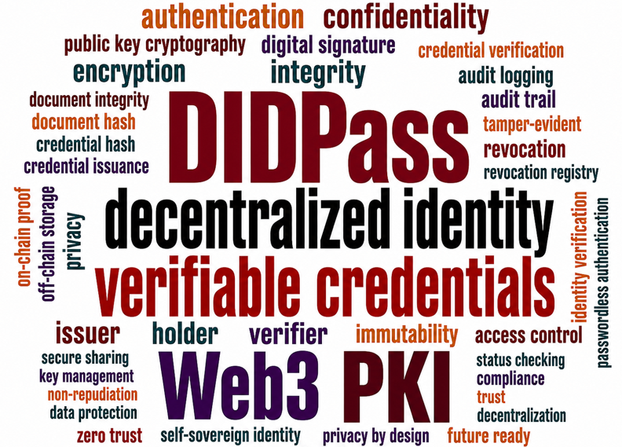

1. Introduction
Digital identity and document verification have become important requirements in modern organizations. Universities, companies, banks, and service providers frequently need to verify whether a person, credential, or document is genuine. However, many existing verification methods still depend on passwords, scanned documents, PDF certificates, screenshots, email attachments, and manual approval. These methods are weak because documents can be modified, credentials can be forged, and passwords can be stolen or reused.
The lack of cryptographic verification creates a trust problem. For example, an employer may receive a university certificate from a student, but the employer may not know whether the certificate was genuinely issued by the university or edited later. Similarly, a company may issue an employee credential, but without a secure verification mechanism, the credential can be copied or misused. This shows the need for a stronger system that can prove identity, validate credentials, protect document integrity, and record important actions in a tamper-evident way.
DIDPass is proposed as a Web3-based solution to this problem. It uses decentralized identity, public/private key ownership, trusted issuer verification, credential hashing, document hashing, encryption, smart contracts, and audit logging. The system does not store full documents on the blockchain. Instead, it stores only proof such as hashes and revocation status, while actual documents are stored off-chain. This makes the system more private, efficient, and suitable for real-world use.

1.1 Aim
The aim of this project is to design and develop DIDPass, a Web3-based decentralized identity and passwordless authentication tool that applies Public Key Infrastructure principles to solve real-world problems in digital identity, credential verification, document integrity, confidentiality, and audit trust. The tool mainly aims to allow trusted issuers, such as universities, companies, or banks, to issue verifiable digital credentials to users. It also allows verifiers, such as employers or service providers, to confirm whether a credential or document is genuine, unchanged, and not revoked. DIDPass further aims to protect sensitive documents using encryption, store only cryptographic proof on the blockchain, and keep actual documents off-chain for privacy and performance. Overall, the project aims to create a secure, future ready digital trust platform where identity, credentials, documents, and verification history can be trusted using cryptography, blockchain proof, and controlled access.

1.2 Objectives
The main objectives of DIDPass are:
- To provide secure digital identity and passwordless authentication by using public/private key cryptography so that users can prove their identity without depending only on weak password-based verification.
- To verify credentials and documents using cryptographic proof by allowing trusted issuers to issue verifiable credentials and allowing verifiers to check whether the credential or document is genuine, unchanged, and not revoked.
- To protect trust, confidentiality, and auditability by encrypting sensitive documents, storing only hashes/proofs on blockchain, keeping actual files off-chain, and maintaining tamper-evident audit records.
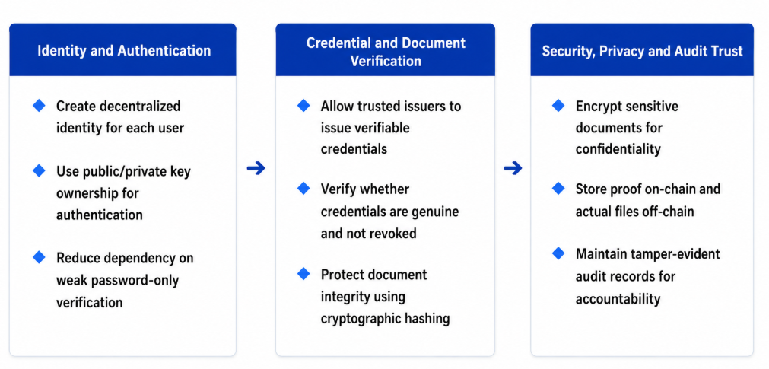
Figure 1: Objectives

2. Problem and Solution

2.1 Background of the Problem
Many organizations now depend on digital identity, online credential verification, and electronic document sharing. Universities issue digital certificates, companies verify employee records, and banks check KYC documents online. However, these processes still often rely on passwords, PDF files, screenshots, scanned documents, and manual checking, which can be forged, edited, stolen, or misused.
The main problem is the lack of strong cryptographic proof. A verifier may receive a certificate or document but may not know whether it was genuinely issued, modified later, or already revoked. DIDPass addresses this issue by using decentralized identity, trusted issuer verification, document hashing, encryption, smart contracts, and tamper-evident audit records to make identity and document verification more trustworthy.

2.2 Identified Issues
The current digital verification process has several weaknesses related to identity, credential trust, confidentiality, integrity, and auditability. These issues make it difficult for organizations to confirm whether a user, credential, or document is genuine. The following table highlights the main problems that DIDPass is designed to address.
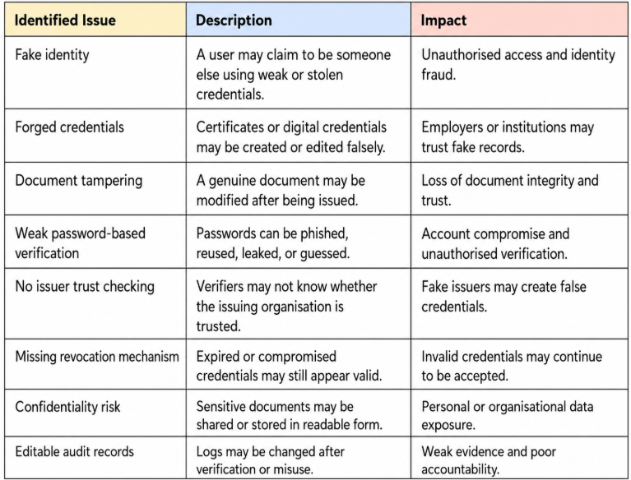

2.3 Proposed Solutions
DIDPass proposes a Web3-based cryptographic solution to reduce the weaknesses found in traditional identity, credential, and document verification systems. Instead of trusting only passwords, screenshots, PDF files, or manual checking, the system uses decentralized identity, public/private key ownership, trusted issuer verification, document hashing, encryption, revocation checking, and tamper-evident audit records. This ensures that a credential or document can be checked for authenticity, integrity, validity, and trust before it is accepted.
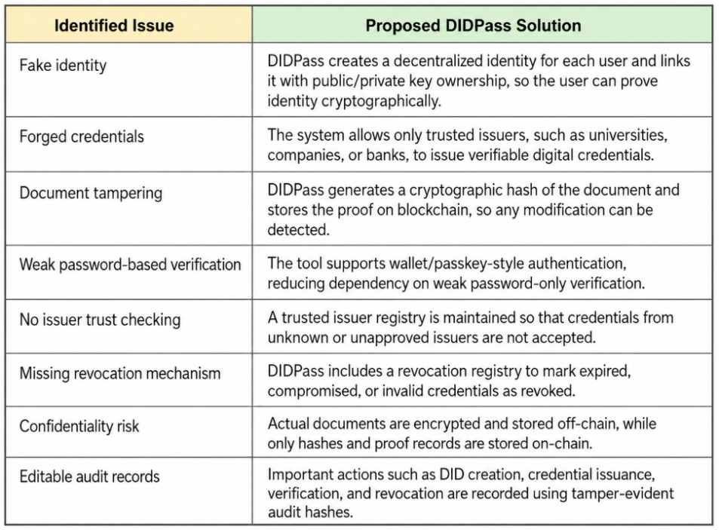
The proposed solution improves trust because DIDPass verifies identity, issuer, credential hash, document hash, revocation status, and audit records before accepting any proof. This makes the system suitable for real-world use cases such as university certificate verification, employee identity verification, KYC document checking, secure document approval, and compliance auditing.

3. Scope of the Project

3.1 In-scope
The scope of this project is as follows:
- Design and development of DIDPass as a Web3-based cryptographic tool that supports decentralized identity, credential verification, document integrity, confidentiality, and tamper-evident audit logging.
- Implementation of PKI-based identity ownership and authentication, where users prove identity using public/private key cryptography instead of relying only on weak password-based verification.
- Development of a trusted issuer and verifiable credential workflow, where approved issuers such as universities, companies, or banks can issue digital credentials that can later be verified by authorized verifiers.
- Protection of credentials and documents using cryptographic hashing and encryption, where document/credential hashes are stored as blockchain proof and actual files are stored off chain in encrypted form.
- Implementation of smart contract-based verification, revocation, and audit logging, where DID status, issuer trust, credential hash, document hash, revocation status, and audit records are checked before accepting a credential or document.

3.2 Out of Scope
The following areas are outside the scope of the current DIDPass prototype:
- Public blockchain mainnet deployment and use of real cryptocurrency gas fees, as the prototype will be demonstrated locally for coursework.
- Full enterprise production deployment for universities, banks, companies, or government systems.
- Paid third-party identity, KYC, or cloud service integration, such as enterprise identity providers or government digital identity systems.
- Hardware-based key protection, such as Hardware Security Modules, biometric devices, or production hardware wallet integration.
- Formal legal certification and third-party security audit, including legally approved e-signature compliance, full penetration testing, and external smart contract auditing.

