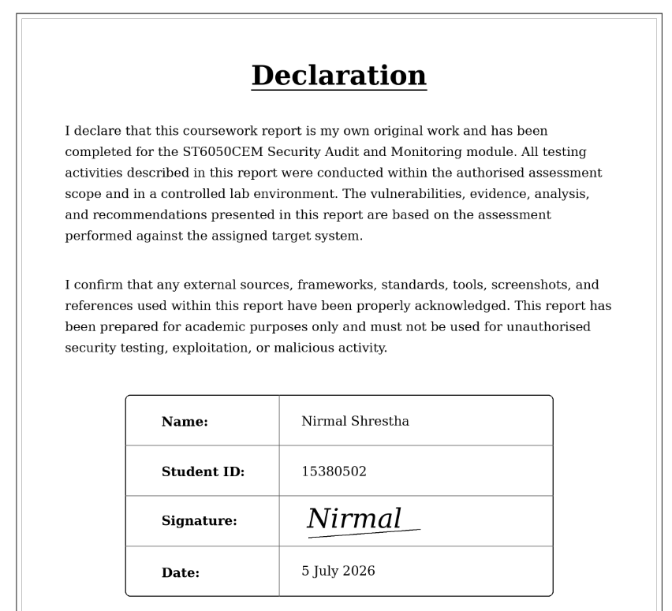

Executive Summary
This report evaluates the information security posture of Nepalaya Solutions Pvt. Ltd., a software development company based in Kathmandu that delivers digital solutions for sectors such as healthcare, fintech, and ecommerce. Due to the sensitive nature of the data handled by the organization, weaknesses in access control, system configuration, monitoring, or incident response could create serious operational and compliance risks. The assessment was performed as part of an ISO/IEC 27001:2022-aligned security audit, supported by technical VAPT activities on the assigned audit box and the development of an ITIL-based service management approach.
The audit combined governance review, compliance analysis, vulnerability assessment, penetration testing, and risk-based evaluation. During the technical assessment, several weaknesses were identified, including exposed credentials, insecure authentication behavior, sensitive information disclosure, outdated services, and privilege escalation opportunities. These issues demonstrated how multiple security gaps could be linked together by an attacker to move from initial discovery to unauthorized access and possible system compromise. The findings also showed that stronger logging, alerting, and continuous monitoring would be required to detect suspicious activity at an early stage.
Overall, the assessment shows that Nepalaya Solutions needs to improve both technical controls and security management practices. Priority actions include patching vulnerable components, rotating exposed credentials, enforcing least privilege, hardening configurations, and improving monitoring. These actions will help reduce risk, improve audit readiness, and support long-term security maturity.

1. Introduction

1.1 Organizational Background
Nepalaya Solutions Pvt. Ltd. is a software development company based in Kathmandu, Nepal. The company provides customized digital solutions for sectors such as healthcare, fintech, and ecommerce. As these industries depend heavily on secure data processing, Nepalaya Solutions is responsible for protecting sensitive customer, financial, and business information.
The organization’s growing digital operations increase its exposure to cybersecurity threats such as phishing, insecure APIs, weak system configuration, and unauthorised internal access. Because of this, information security must be managed through proper governance, technical controls, monitoring, and continuous improvement. The coursework scenario requires Nepalaya Solutions to conduct an ISO/IEC 27001:2022-aligned external audit, perform VAPT on the provided audit box, and develop an ITIL-based secure service management library

1.2 Purpose of the External Security Audit
The purpose of this external audit is to assess whether Nepalaya Solutions has appropriate security controls to protect its systems, data, and services. The audit helps identify weaknesses in governance, compliance, access control, system configuration, vulnerability management, monitoring, and incident response.
This assessment also supports management decision-making by showing how technical vulnerabilities can create business risks. Instead of only listing weaknesses, the audit explains their causes, impact, priority, and remediation requirements. This helps the organization improve audit readiness and reduce the likelihood of future security incidents.

1.3 Aim and Objectives
The aim of this report is to evaluate the information security posture of Nepalaya Solutions through an ISO 27001-aligned audit and controlled vulnerability assessment.
The main objectives are:
- To define an information security governance structure under the role of CISO.
- To identify relevant legal, regulatory, and contractual requirements.
- To apply recognised audit frameworks such as ISO 27001, NIST, COBIT, OWASP, and ITIL.
- To conduct VAPT on the provided audit box using ethical testing methods.
- To identify vulnerabilities, assess their risk, and map them to security controls.
- To recommend remediation actions with practical timelines.
- To develop ITIL-based policies for secure service management.

1.4 Scope and Boundaries of Assessment
The scope of this assessment was limited to the authorized virtual audit box provided for Nepalaya Solutions Pvt. Ltd. Testing focused on identifying and validating security weaknesses through controlled reconnaissance, scanning, enumeration, exploitation, post-exploitation, and remediation planning. The assessment was performed ethically within the lab environment and did not include live public systems, third-party infrastructure, or denial-of-service testing. The purpose was to evaluate risk and recommend security improvements, not to disrupt services.
Assessment boundaries included:
- Testing was restricted only to the assigned audit box and authorized services.
- No external systems, client networks, or third-party assets were targeted.
- Findings are based on the controlled lab environment and require management review before production implementation.

2. ISO 27001 Governance Framework

2.1 Information Security Governance Structure
For Nepalaya Solutions Pvt. Ltd., information security must be managed as a business-level responsibility rather than only a technical function. Since the company handles sensitive client data across healthcare, fintech, and ecommerce, a clear governance structure is required to define accountability, reporting lines, risk ownership, and monitoring responsibilities.
The governance model is led by the Chief Information Security Officer (CISO), who reports to senior management and provides independent oversight of security risks. This supports ISO 27001:2022 leadership expectations by ensuring that security objectives are aligned with business goals, legal obligations, and client requirements. The coursework also requires the governance structure to be developed under the role of CISO with responsibilities for Security Analyst, Risk Manager, Compliance Officer, and SOC Analyst roles.
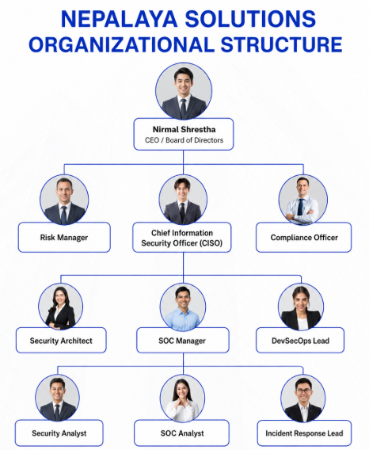
Figure 1: Organization Structure

2.2 Roles and Responsibilities
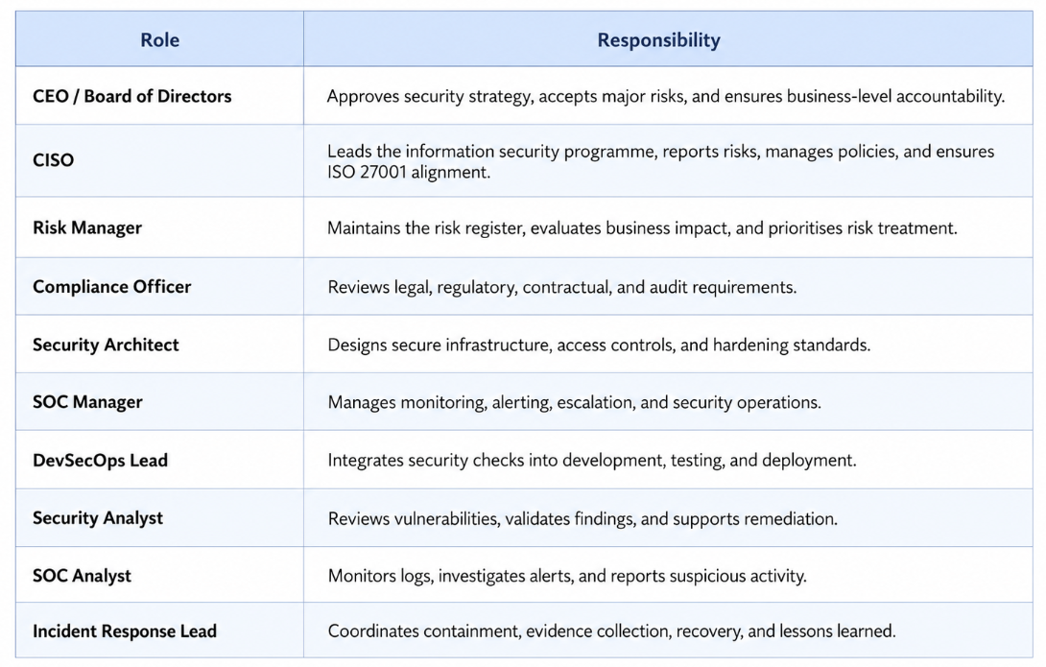
Table 1: Roles and Responsibilities

2.3 ISO 27001 Control Alignment
The proposed governance structure supports ISO/IEC 27001:2022 by assigning clear ownership for leadership, risk management, compliance, monitoring, incident response, and secure system development. This is important for Nepalaya Solutions because the organization handles sensitive client data and needs security responsibilities to be managed at both management and operational levels.
The CISO provides overall security direction, while the Risk Manager, Compliance Officer, Security Architect, DevSecOps Lead, SOC Manager, Security Analyst, SOC Analyst, and Incident Response Lead support risk treatment, legal compliance, secure configuration, monitoring, vulnerability management, and incident handling. This improves audit readiness, reduces weak accountability, and supports ISO 27001 principles of leadership, continual improvement, and risk-based security management.

2.4 ISO 27001 Annex Roles Justification
This presents how the proposed information security roles for Nepalaya Solutions Pvt. Ltd. support ISO/IEC 27001:2022 Annex A controls. The mapping shows that each role has a clear security purpose and contributes to governance, risk management, compliance, monitoring, secure development, and incident response.
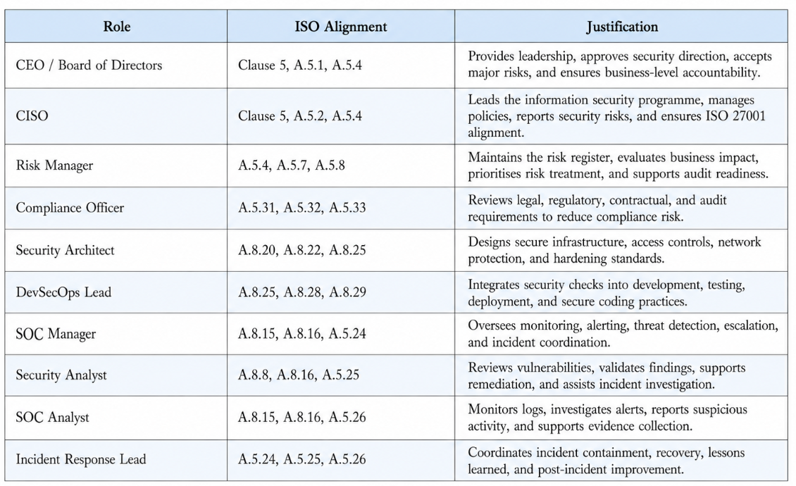
Table 2: Roles Justification

2.5 Security Governance Accountability and Escalation Model
Nepalaya Solutions requires a clear accountability and escalation model so that security decisions are not delayed or handled informally. The CISO acts as the central security authority and coordinates risk reporting between technical teams and senior management. Operational teams such as SOC analysts, security analysts, DevSecOps engineers, and incident response personnel identify and report risks, while the Risk Manager and Compliance Officer evaluate business, legal, and regulatory impact. Final approval for major security decisions, risk acceptance, budget allocation, and policy enforcement remains with the CEO and Board of Directors. This ensures that security governance supports ISO/IEC 27001:2022 leadership, accountability, risk ownership, and continual improvement expectations. ISO/IEC 27001 defines requirements for establishing, maintaining, and continually improving an information security management system.
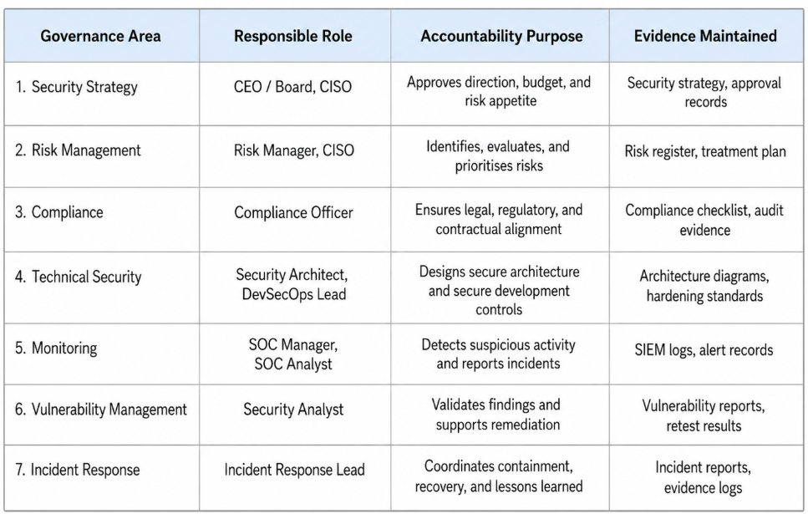
Table 3: Security Governance Accountability

2.6 RACI Matrix for Information Security Roles
A RACI matrix helps Nepalaya Solutions separate responsibility, accountability, consultation, and information-sharing duties. This reduces confusion during audits, incidents, vulnerability remediation, and policy enforcement. It also improves evidence quality because each activity has an assigned owner and reviewer.
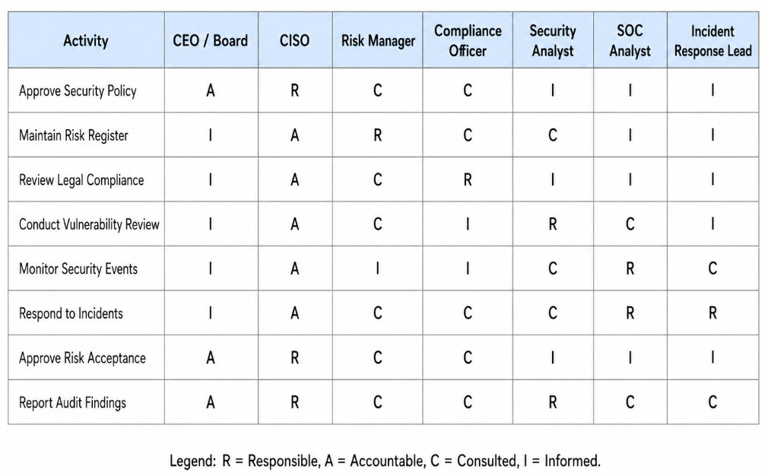
Table 4: RACI Matrix

3. Legal, Regulatory and Contractual Compliance

3.1 Legal and Regulatory Requirements
As Nepalaya Solutions Pvt. Ltd. is registered in Nepal, it must comply with relevant Nepalese laws, cybersecurity requirements, privacy expectations, and contractual obligations. These requirements define how organisational data should be collected, stored, processed, accessed, and protected. Since the audit identified weaknesses such as weak authentication, credential exposure, privilege escalation, and insecure service access, legal and contractual compliance is important for reducing risk and maintaining client trust.
- The Electronic Transactions Act 2006 is a key legal foundation for electronic records and cyber-related activities in Nepal. It supports the need to prevent unauthorised access, protect information, and maintain accountability if cyber incidents occur.
- The Privacy Act 2018 and related data protection requirements focus on protecting personal and sensitive information. Weak access control, exposed credentials, and poor monitoring could lead to privacy breaches, reputational damage, and compliance issues.
- Nepalaya Solutions should also consider relevant cybersecurity directives and organisational security policies to ensure systems are monitored, updated, and protected against misuse. Findings such as outdated services and insecure configurations show the need for continuous vulnerability management.
- For international clients, global privacy requirements such as GDPR should be considered where personal data is processed. GDPR expects strong authentication, access control, logging, monitoring, and breach response controls.
- Contractual requirements from clients must also be followed. These may include secure development practices, confidentiality, incident reporting, service availability, vulnerability remediation, and protection of client data.

3.2 Contractual and Client Security Obligations
Apart from legal requirements, Nepalaya Solutions must also meet the security obligations agreed with its clients, especially those from regulated sectors such as healthcare, fintech, and ecommerce. These obligations may include secure software development, protection of source code and client data, access control, vulnerability management, incident reporting, confidentiality, and regular security testing. The audit findings show that weaknesses such as exposed credentials, weak authentication, outdated services, or privilege escalation could lead to data exposure, service disruption, unauthorised administrative access, breach of service agreements, financial penalties, contract termination, and reputational damage.

3.3 Compliance Risk and Audit Readiness
The vulnerabilities identified during the assessment show that technical weaknesses can become compliance and audit risks. Issues such as credential exposure, privilege escalation, outdated services, and weak logging may cause unauthorised access, data exposure, and delayed incident detection. To improve audit readiness, Nepalaya Solutions should maintain updated policies, risk registers, patch records, incident logs, vulnerability reports, and remediation evidence aligned with legal, contractual, and ISO 27001 expectations.

3.4 Legal, Regulatory, and Contractual Compliance Mapping
The compliance assessment was mapped against relevant Nepalese laws, cybersecurity expectations, international privacy requirements, and client contractual obligations. This mapping ensures that technical findings from the audit are not treated only as system weaknesses, but also as possible legal, regulatory, and contractual risks. The Electronic Transactions Act, 2063 is relevant because it provides Nepal’s legal basis for electronic transactions and computer-related offences. The Privacy Act, 2075 is relevant because Nepalaya Solutions processes sensitive personal and client information. The National Cyber Security Policy, 2080 supports national-level cybersecurity expectations and strengthens the relevance of secure infrastructure, incident response, and cyber resilience.
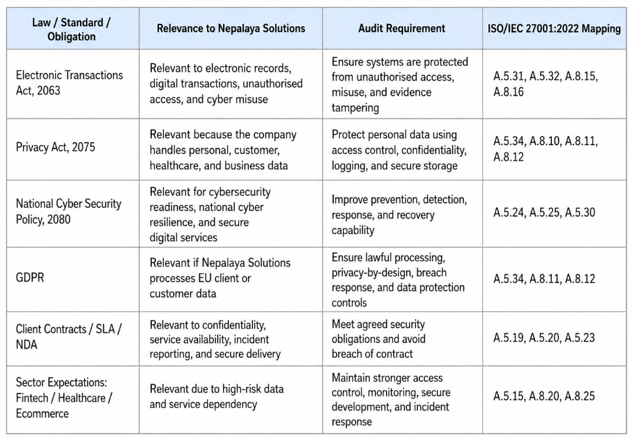
Table 5: Mapping

4. Audit Framework and Methodology

4.1 Integrated Audit Approach
The audit of Nepalaya Solutions was conducted using an integrated approach that combined governance review, compliance assessment, technical testing, risk analysis, and service management improvement. ISO/IEC 27001:2022 was used as the main framework because it supports risk-based information security management, control ownership, leadership accountability, and continual improvement.
Additional frameworks were also considered to strengthen the audit. NIST supported technical control review and risk assessment, COBIT supported governance and business alignment, OWASP supported web application security testing, and ITIL supported incident management, change management, monitoring, and business continuity. This combined approach ensured that the audit was not limited to technical vulnerabilities only, but also considered organizational risk, compliance, and operational resilience.

4.2 Audit Methodology
The audit methodology followed a simple risk-based process: planning, fieldwork, control testing, reporting, and follow-up. First, the audit scope, objectives, boundaries, and evidence requirements were defined. Then reconnaissance, scanning, enumeration, and evidence collection were performed on the authorized audit box. Identified weaknesses were validated through controlled testing, documented with risk ratings and business impact, and followed by remediation and retesting recommendations to support ISO 27001-aligned continuous improvement.

4.3 Audit Lifecycle
The audit lifecycle followed a structured process from planning to improvement. First, the audit scope, objectives, authorised environment, and testing boundaries were defined. Then the assessment moved into reconnaissance, scanning, enumeration, vulnerability validation, exploitation, and evidence collection. After the technical work, findings were analyzed using risk rating, business impact, and framework mapping. Finally, remediation actions and follow-up recommendations were prepared to support continuous improvement.
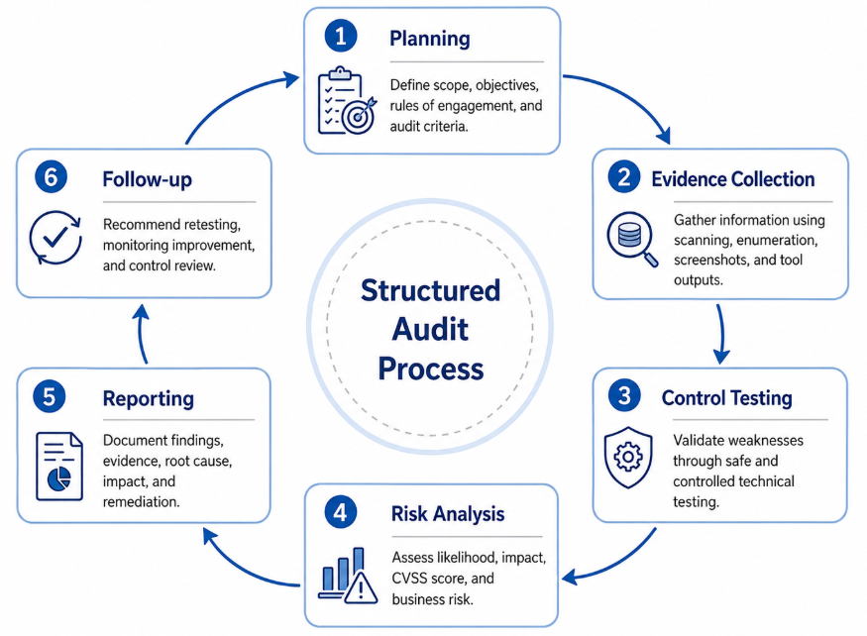
Figure 2: Audit Life Cycle

4.4 Framework Alignment and Control Validation
The audit used multiple frameworks to make the assessment complete and reliable. ISO/IEC 27001:2022 was used as the main framework for governance, leadership, risk management, and control alignment, while NIST supported technical control review, COBIT supported business governance, OWASP supported web application security testing, and ITIL supported incident management, change management, monitoring, and service continuity. This helped Nepalaya Solutions connect technical vulnerabilities with business risk, compliance expectations, control weaknesses, and remediation priorities.

4.5 Ethical and Controlled Testing
All testing activities were performed only within the authorised audit box provided for the coursework, and no live public systems, third-party infrastructure, client networks, or unauthorised assets were targeted. The purpose of testing was to safely validate security weaknesses, understand their possible impact, and collect evidence through screenshots, command outputs, scan results, and controlled exploitation proof. This ensured that the findings were accurate, reproducible, ethical, and suitable for remediation planning and retesting.

4.6 Framework Integration and Audit Application Matrix
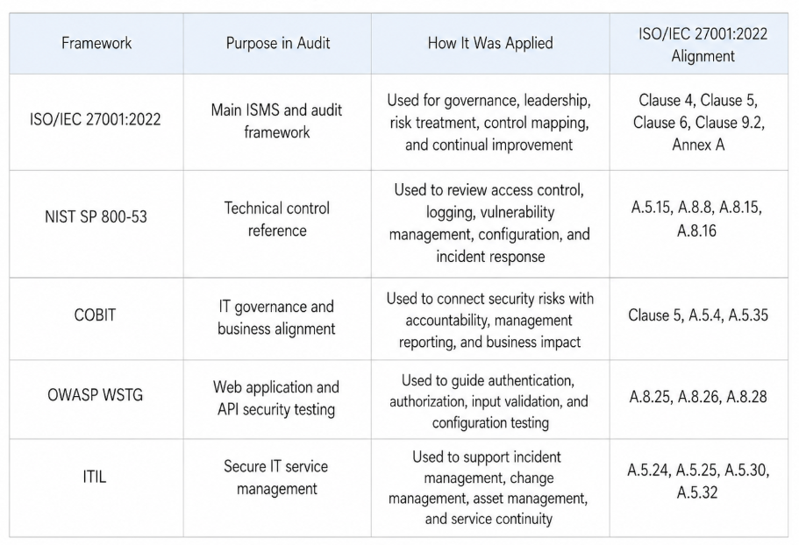
Table 6: Matrix

4.7 ISO 27001 Internal Audit Clause 9.2 Alignment
The audit methodology was aligned with ISO/IEC 27001:2022 Clause 9.2, which focuses on internal audit planning, audit criteria, scope, reporting, and follow-up. Although this assessment was performed as an external coursework audit, the same audit discipline was applied by defining the assessment scope, documenting the audit criteria, collecting evidence, validating findings, reporting risks, and recommending corrective actions. This approach ensures that the audit remains structured, repeatable, evidence-based, and useful for management decision-making.
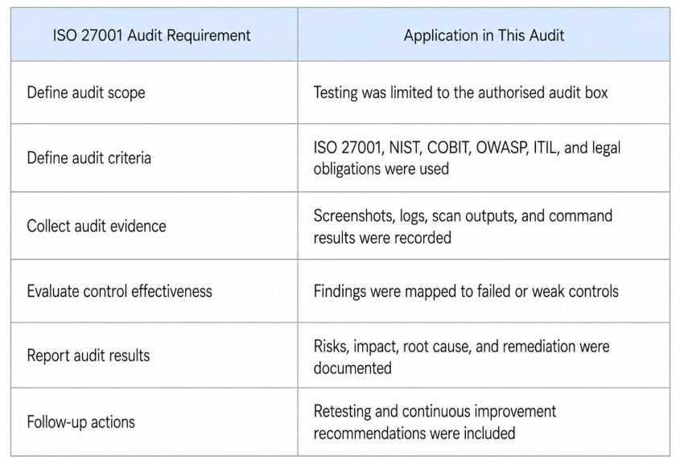
Table 7: Alignment

5. VAPT Tools, Techniques and Procedures

5.1 Testing Approach
The Vulnerability Assessment and Penetration Testing activity was performed on the authorised audit box provided for Nepalaya Solutions Pvt. Ltd. using a controlled black-box testing approach, where the tester initially had no internal knowledge of the target system. The purpose was to simulate how an external or unauthorised attacker could identify exposed services, enumerate resources, validate weaknesses, and chain vulnerabilities to gain system access. The testing combined automated scanning with manual validation to reduce false positives and confirm real-world impact. This approach aligns with the coursework requirement to demonstrate system and penetration testing using appropriate tools, techniques, and procedures. ISO/IEC 27001:2022 was used as the main governance and control reference for risk-based security management, while NIST SP 800-53 supported technical control review for access control, monitoring, configuration, vulnerability management, and incident response.
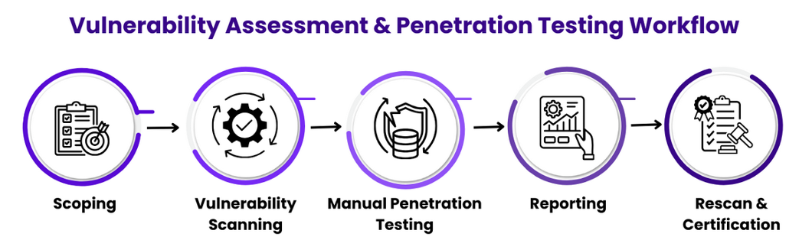
Figure 3: Testing Workflow

5.2 Scope and Testing Boundary
The scoping phase defined what was included and excluded from the assessment before any technical testing was performed. The VAPT activity was limited to the authorised audit box provided for Nepalaya Solutions Pvt. Ltd. and was conducted only inside the controlled lab environment. No public systems, third-party infrastructure, client networks, or denial-of-service testing were included. This ensured that the assessment remained ethical, controlled, and aligned with the approved coursework requirements.

5.3 Vulnerability Scanning
The Nmap scan identified exposed services including SSH on port 22, HTTP on port 80, and an additional web service on port 8082. These results were important because they showed that the target system had both remote access and web application services available for further testing. The SSH service later became relevant during credential compromise validation, while the web services supported directory enumeration and application-level vulnerability testing.
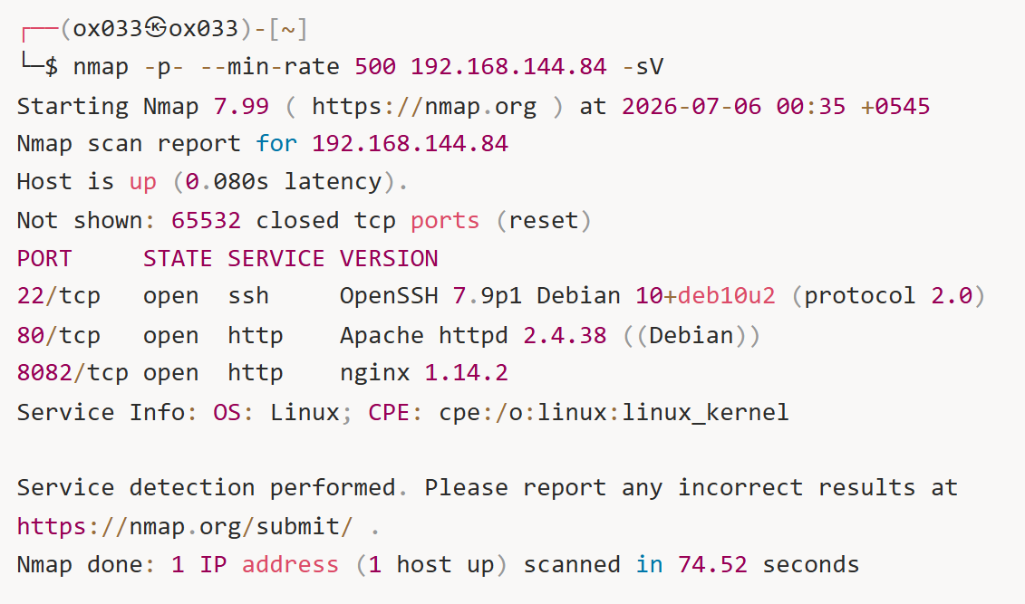
Figure 4: Nmap scan
The Feroxbuster scan identified multiple accessible web paths and resources. This confirmed that the web application had discoverable directories and files that could assist an attacker in understanding the application structure. These results supported later manual testing, including exposed file review, credential discovery, and application validation.

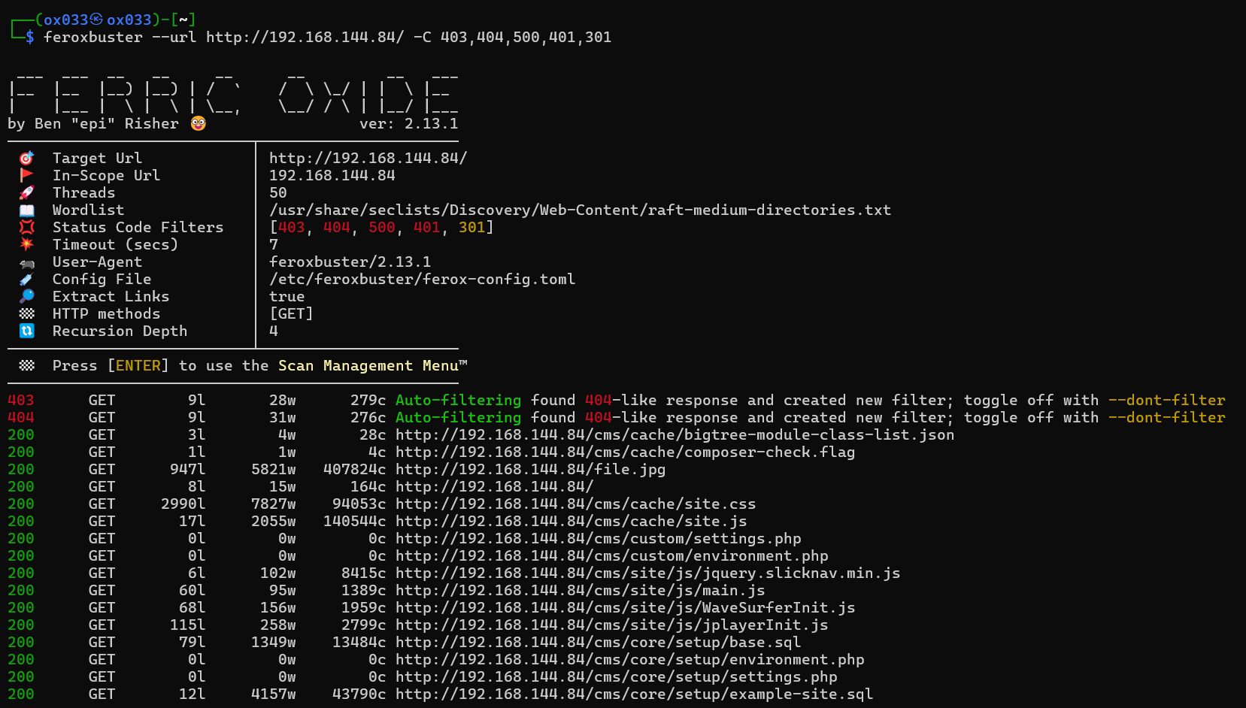
Figure 5: Fuzzing
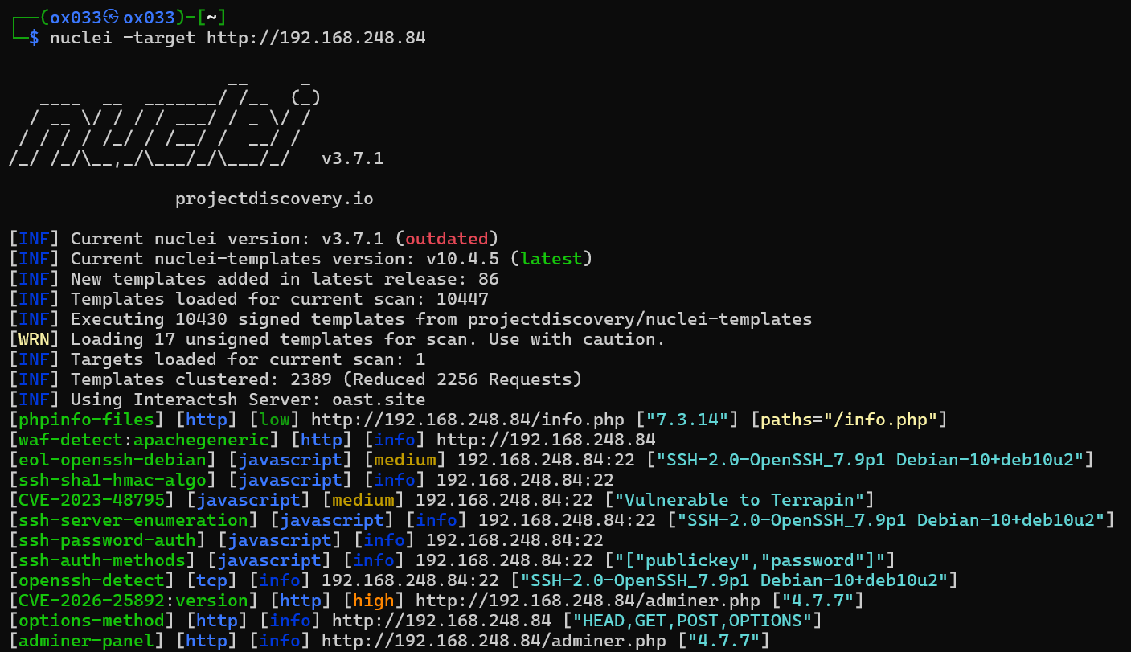
Figure 6: Nuclei vulnerability scanning

5.4 Manual Penetration Testing
Manual penetration testing was performed after scanning to confirm whether the identified weaknesses were exploitable. This step was important because automated scanning alone may produce false positives or may not fully explain business impact. Manual testing was used to validate insecure password reset behavior, exposed credentials, database access through Adminer, SSH credential compromise, and privilege escalation through insecure script permissions. Each test was performed only within the authorised audit box and evidence was collected through screenshots and command outputs.

5.5 Reporting
After scanning and manual validation, all confirmed findings were documented with affected asset, severity, CVSS score, evidence, impact, ISO/IEC 27001:2022 mapping, legal compliance relevance, and remediation guidance. The reporting phase converted technical results into business risk so Nepalaya Solutions could prioritize fixes, assign responsible owners, and plan retesting.

5.6 Tools Used
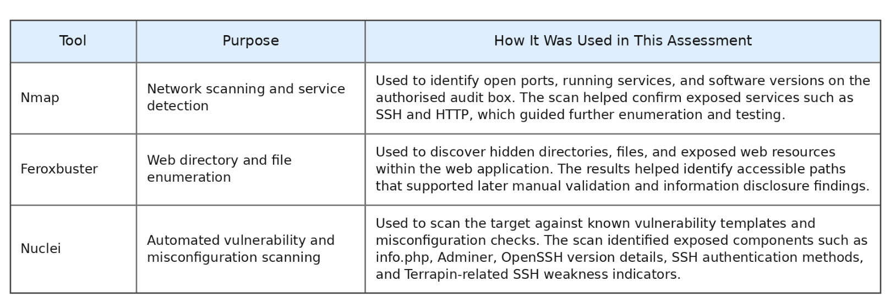
Figure 7: Tools used

6. Overview Of Findings
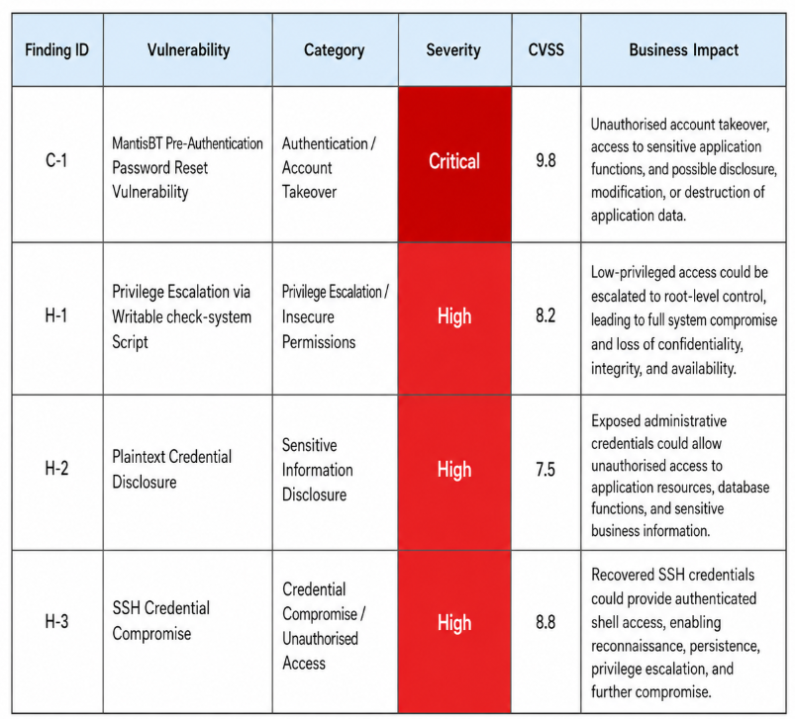
Table 8: Findings

7. Detailed Findings
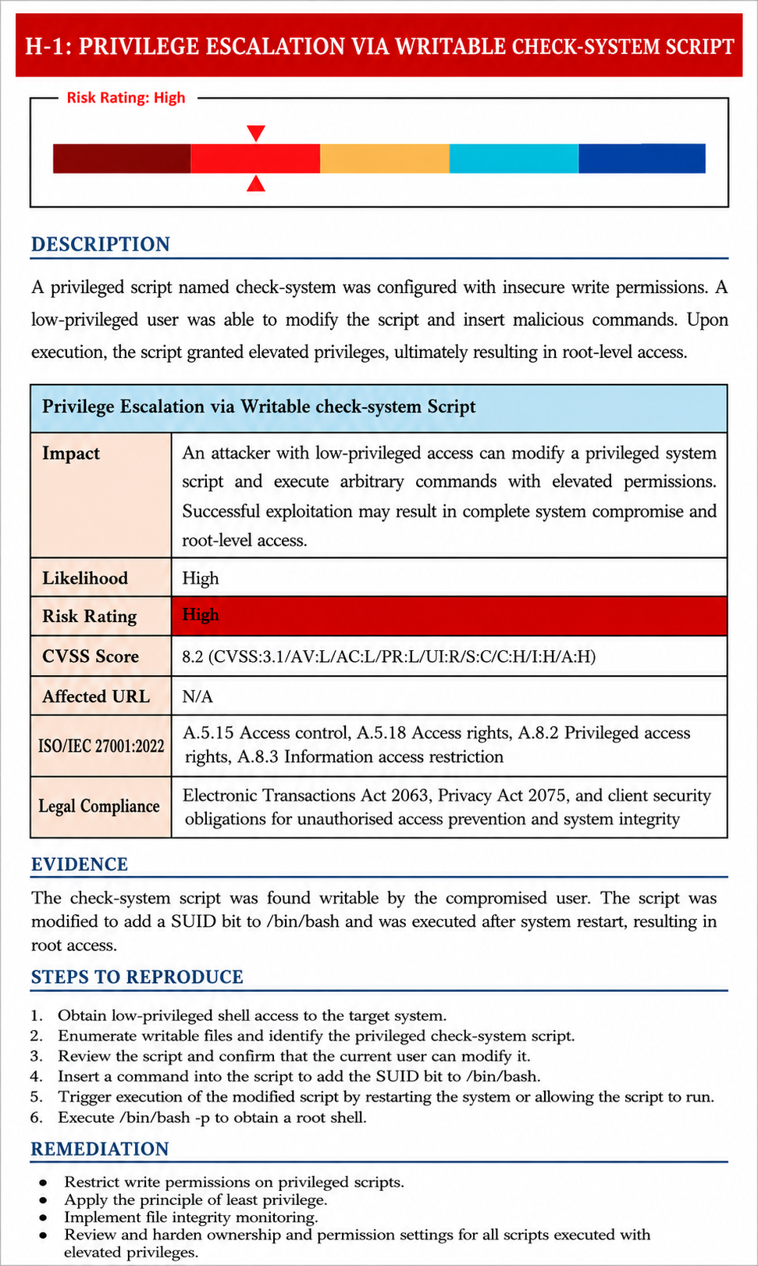
Figure 8: Privilege Escalation
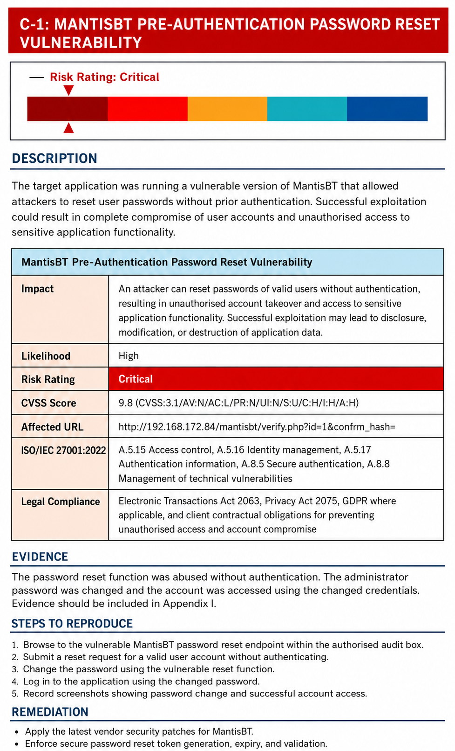
Figure 9: Pre-Auth Password Reset Vulnerability
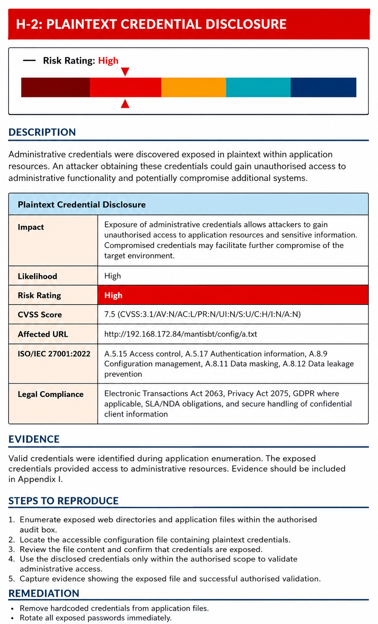
Figure 10: Credentials Disclosure
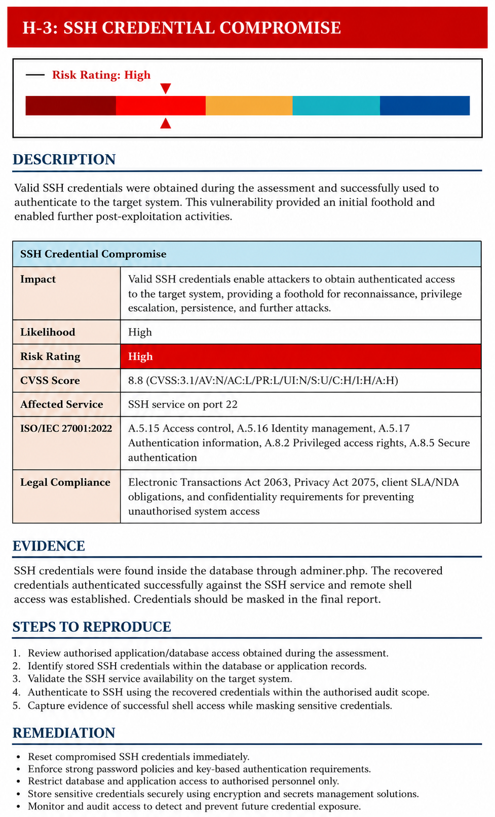
Figure 11: SSH compromise

8. Vulnerability Remediation and Management Response
The detailed findings show that Nepalaya Solutions faces high-risk weaknesses related to authentication, credential exposure, SSH access, and privilege escalation. Since these vulnerabilities can be chained together to support unauthorised access and possible full system compromise, remediation must be prioritized based on severity, business impact, and exploitability. The following remediation plan assigns clear owners, timelines, expected evidence, and company response requirements so that each issue can be tracked, fixed, retested, and formally closed.

8.1 Prioritized Remediation Action Plan
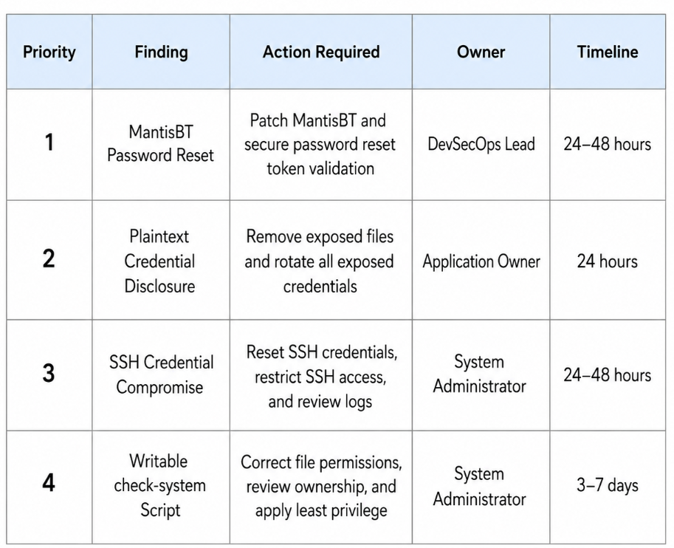
Table 9: Prioritized Action Plan

9. Framework Selection
Framework selection ensures the audit uses recognized standards to assess governance, technical controls, web security, risk ownership, and service management, making findings more reliable, structured, and remediation focused.
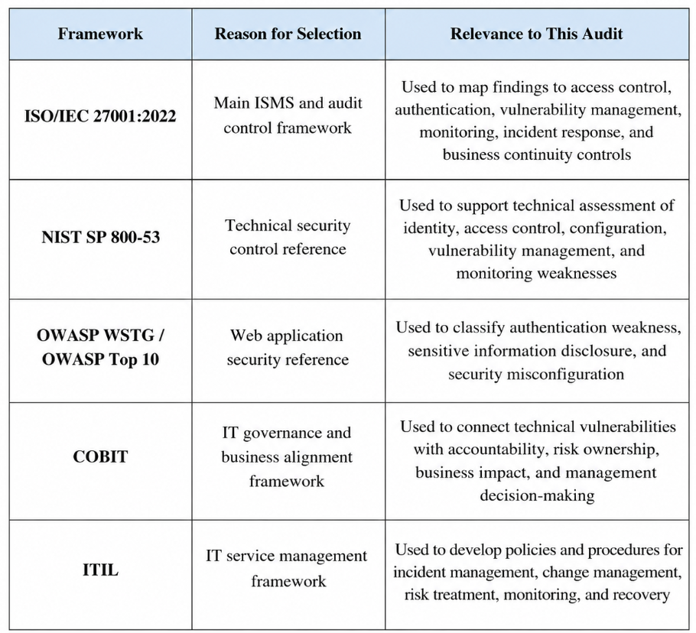
Table 10: Framework selection

9.1 Security Control Mapping
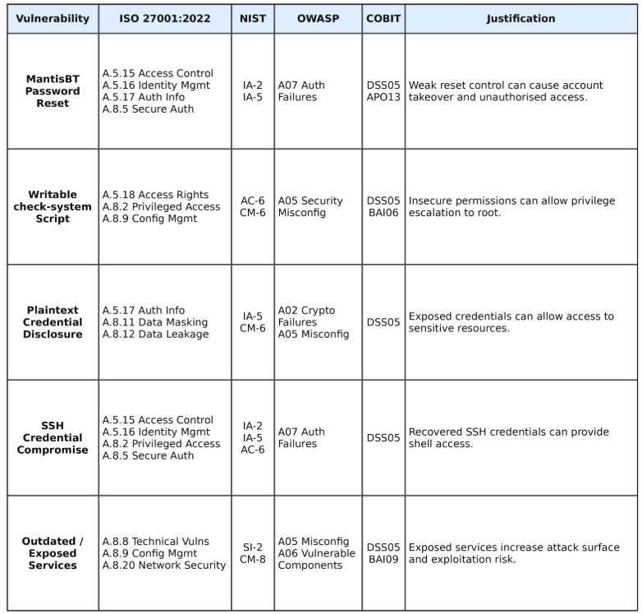
Table 11: Security Control Mapping

10. ITIL-Based Secure Service Management Library
This section presents an ITIL-based secure service management library for Nepalaya Solutions Pvt. Ltd. The library has been developed to convert the audit and VAPT findings into practical operational controls, policies, and procedures. The technical assessment identified weaknesses related to authentication, credential exposure, SSH access, privilege escalation, and monitoring. Therefore, the ITIL library focuses on improving incident handling, change control, access management, risk treatment, monitoring, logging, and business continuity. This supports long-term security improvement by ensuring that vulnerabilities are not only fixed technically but also managed through repeatable service management processes.
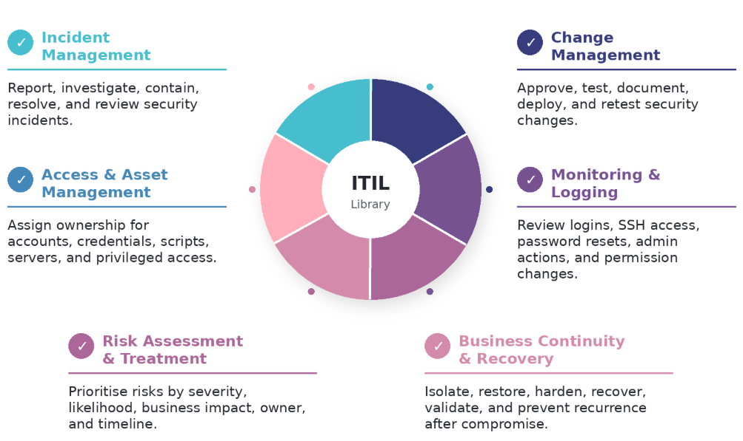
Figure 12: ITIL Secure Service Management Service

9.1 ITIL Library Coverage
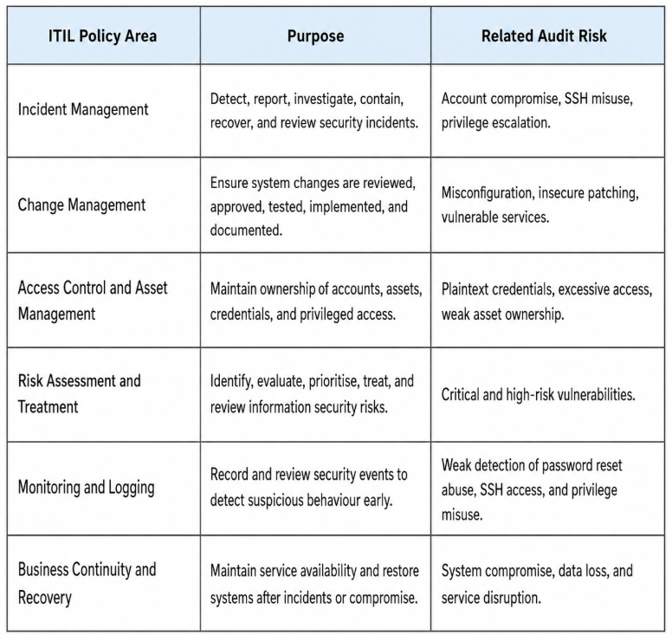
Table 12: ITIL coverage

