Experiment: 1
Aim: Sort a given set of n integer elements using Selection Sort method and compute its time complexity.
Objective:
- Run the program for varied values of n> 5000 and record the time taken to sort.
- Plot a graph of the time taken versus n.
- The elements can be read from a file or can be generated using the random number generator.
- Demonstrate how the brute force method works along with its time complexity analysis: worst case, average case and best case.
Theory:
Brute Force Method: Selection Sort -
Selection Sort is a brute-force sorting algorithm that systematically finds the smallest element and places it in the correct position in a step-by-step manner. It is simple but inefficient for large datasets due to its O(n²) complexity.
1. Working of Selection Sort
- Find the Minimum Element: Traverse the array to find the smallest element.
- Swap with the First Unsorted Element: Swap the minimum element with the first element of the unsorted portion.
- Repeat: Move the boundary between sorted and unsorted portions one step forward and repeat the process until the array is sorted.

Example Execution Given Input:
arr = [64, 25, 12, 22, 11]
Step-by-Step Execution:
  - Find the smallest element (11), swap with first element:
[11, 25, 12, 22, 64]
  - Find the smallest in the remaining subarray (12), swap with second element:
[11, 12, 25, 22, 64]
  - Find the smallest in the remaining subarray (22), swap with third element:
[11, 12, 22, 25, 64]
  - Find the smallest in the remaining subarray (25), swap with fourth element:
[11, 12, 22, 25, 64] 5. Array is now sorted. 2. Time Complexity Analysis Worst Case (O(n²)):
- Occurs when the input array is sorted in reverse order.
- Every element must be compared with every other element.
The number of comparisons in each pass decreases as sorting progresses. Comparisons per pass: (n−1)+(n−2)+...+2+1=n(n−1)2=O(n2) Example: [9, 8, 7, 6, 5, 4, 3, 2, 1] Best Case (O(n²)):
- Occurs when the input is already sorted.
- Even in this case, Selection Sort still makes the same number of comparisons as in the worst case.
- Example: [1, 2, 3, 4, 5, 6, 7, 8, 9]
Average Case (O(n²)):
- Happens when the input is random.
- Selection Sort does not depend on the input order and always makes the same number of comparisons.
- Example: [3, 1, 4, 5, 2, 9, 7, 8, 6]

Comparison Table:
Case | Scenario | Comparisons | Swaps | Complexity
Best Case | Already Sorted | O(n2) | O(n)) | O(n²)
Worst Case | Reverse Sorted | O(n2) | O(n) | O(n²)
Average Case | Random Order | O(n2) | O(n) | O(n²)
3. Program:
#include <stdio.h>
#include <stdlib.h>
#include <time.h>

void selection_sort(int arr[], int n) { int i, j, min_idx, temp; for (i = 0; i < n - 1; i++) { min_idx = i;
for (j = i + 1; j < n; j++) { if (arr[j] < arr[min_idx]) { min_idx = j;
} } temp = arr[i]; arr[i] = arr[min_idx]; arr[min_idx] = temp;
}
}
void generate_random_numbers(int arr[], int n, int lower, int upper) { for (int i = 0; i < n; i++) { arr[i] = (rand() % (upper - lower + 1)) + lower; }
} int main() { int n_values[] = {6000, 7000, 8000, 9000, 10000, 11000, 12000,
13000, 14000, 15000}; int num_tests = sizeof(n_values) / sizeof(n_values[0]); srand(time(0));
printf("No. of Input \t Time Taken \n"); for (int i = 0; i < num_tests; i++) { int n = n_values[i];
int *arr = (int *)malloc(n * sizeof(int));
if (arr == NULL) { printf("Memory allocation failed for n = %d\n", n); continue;
}
generate_random_numbers(arr, n, 1, 100000); clock_t start_time = clock(); selection_sort(arr, n); clock_t end_time = clock();
double time_taken = ((double)(end_time - start_time)) /
CLOCKS_PER_SEC; printf("%d \t - \t %.4f \n", n, time_taken); free(arr);
} return 0;
} /*
OUTPUT:
No. of Input Time Taken
6000 - 0.0310
7000 - 0.0510
8000 - 0.0750
9000 - 0.0840
10000 - 0.0880
11000 - 0.1580
12000 - 0.1400
13000 - 0.1680
14000 - 0.2090
15000 - 0.2180
*/

- Experimental Results
The following times were recorded for sorting randomly generated integers:
No. of Elements (n) | Time Taken  (seconds) |  | No. of Elements (n) | Time Taken  (seconds)
6000 | 0.0310 |  | 11000 | 0.1580
7000 | 0.0510 |  | 12000 | 0.1400
8000 | 0.0750 |  | 13000 | 0.1680
9000 | 0.0840 |  | 14000 | 0.2090
10000 | 0.0880 |  | 15000 | 0.2180
- Graph Interpretation
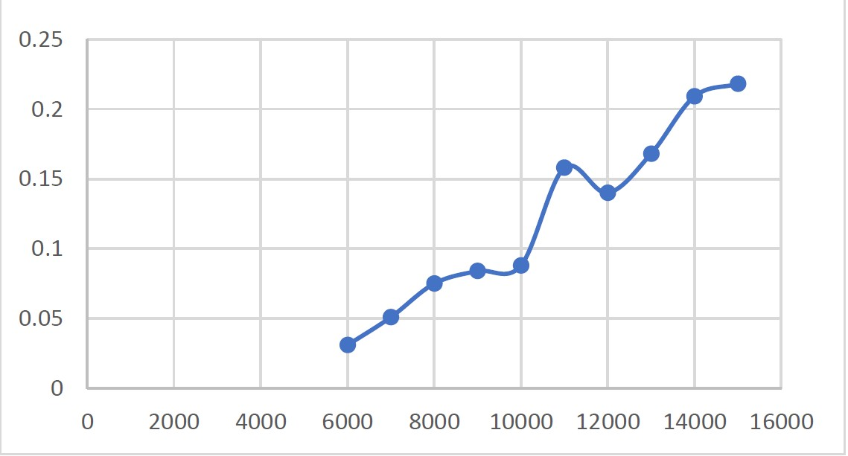
- The graph shows a quadratic increase in sorting time as n increases.
- This confirms the O(n²) complexity of Selection Sort. • Selection Sort is inefficient for large values of n (> 10,000).

- Why is Selection Sort Considered Brute Force?
  - Inefficient Comparisons: Every element is compared with every other element, leading to redundant operations.
  - Doesn’t Adapt to Sorted Inputs: Even in the best case (sorted input), it performs O(n²) comparisons.
  - Fixed Number of Swaps: It always performs exactly n swaps, even when unnecessary.
  - Lack of Divide-and-Conquer: Unlike Merge Sort or Quick Sort, Selection Sort doesn’t reduce the problem size efficiently.

- Optimized Alternatives
If sorting large datasets, consider:
- Merge Sort (O(n log n)) – Stable, useful for linked lists.
- Quick Sort (O(n log n) average case) – Efficient, in-place sorting. • Heap Sort (O(n log n)) – Good for priority queue applications.

Experiment: 2
Aim: Sort a given set of n integer elements using Quick Sort method and compute its time complexity.
Objective:
- Run the program for varied values of n> 5000 and record the time taken to sort.
- Plot a graph of the time taken versus n.
- The elements can be read from a file or can be generated using the random number generator.
- Demonstrate how the devide-and-conquer method works along with its time complexity analysis: worst case, average case and best case.
Theory:
Quick Sort –
Quick Sort is a highly efficient sorting algorithm based on the Divide and Conquer paradigm. It works by selecting a pivot element, partitioning the array into two subarrays (one with elements smaller than the pivot and another with elements greater than the pivot), and then recursively sorting the subarrays.
Algorithm Steps:
- Choose a Pivot – Select an element as the pivot (commonly the last, first, or a random element).
- Partitioning – Rearrange elements such that:
  - Elements smaller than the pivot are placed to the left.
  - Elements greater than the pivot are placed to the right.
- Recursive Sorting – Apply the same process to the left and right subarrays recursively. 4. Base Case – When the subarray has one or zero elements, recursion stops.

- Complexity Analysis:
Case | Time Complexity | Explanation
Best Case | O(nlogn) | When the pivot divides the array into equal halves recursively.
Average Case | O(nlogn) | On average, the array is partitioned into balanced subarrays.
Worst Case | O(n2) | Occurs when the pivot is always the smallest or largest element (e.g., sorted/reverse sorted array).
- Program:
#include <stdio.h>
#include <stdlib.h>
#include <time.h>

// Function to swap two elements void swap(int *a, int *b) { int temp = *a; *a = *b;
*b = temp;
}

// Partition function for QuickSort int partition(int arr[], int low, int high) {
int pivot = arr[high]; // Choosing the last element as pivot int i = (low - 1);

for (int j = low; j < high; j++) { if (arr[j] < pivot) { i++;
swap(&arr[i], &arr[j]);
} }
swap(&arr[i + 1], &arr[high]); return (i + 1);
}

// QuickSort function
void quickSort(int arr[], int low, int high) { if (low < high) {
int pi = partition(arr, low, high); quickSort(arr, low, pi - 1); quickSort(arr, pi + 1, high);
}
}

// Function to generate an array of random numbers void generateRandomNumbers(int arr[], int n) { for (int i = 0; i < n; i++) {
arr[i] = rand() % 100000; // Random numbers between 0 and
99999
}
}

// Function to write results to a file void writeResultsToFile(int n, double time_taken) { FILE *fp = fopen("quick_sort_results.csv", "a"); if (fp == NULL) {
printf("Error opening file!\n"); exit(1);
}
fprintf(fp, "%d,%f\n", n, time_taken); fclose(fp);
}
int main() {
FILE *fp = fopen("quick_sort_results.csv", "w"); if (fp == NULL) {
printf("Error opening file!\n"); return 1;
}
fprintf(fp, "n,Time (seconds)\n"); fclose(fp);

srand(time(0));
printf("No. of Input \t Time Taken \n");
for (int n = 5000; n <= 50000; n += 5000) { // Running for varied values of n
int *arr = (int *)malloc(n * sizeof(int)); if (arr == NULL) {
printf("Memory allocation failed\n"); return 1;
}
generateRandomNumbers(arr, n);

clock_t start = clock(); quickSort(arr, 0, n - 1); clock_t end = clock();

double time_taken = ((double)(end - start)) / CLOCKS_PER_SEC;
writeResultsToFile(n, time_taken);
printf("%d \t - \t %.4f \n", n, time_taken);

free(arr);
}
printf("Results saved to quick_sort_results.csv\n"); return 0;
}

/*
OUTPUT:
No. of Input Time Taken
5000 - 0.0010
10000 - 0.0010
15000 - 0.0020
20000 - 0.0020
25000 - 0.0040
30000 - 0.0050
35000 - 0.0040
40000 - 0.0070
45000 - 0.0140
50000 - 0.0080
Results saved to quick_sort_results.csv
*/
4. Performance Analysis:
- Space Complexity: O(logn) (for recursive calls in balanced partitions).
- In-Place Sorting: Requires only a small extra space for recursion.
- Not Stable: Elements with the same values may change their relative order. • Faster in Practice: Due to efficient cache usage and less overhead than Merge Sort.

5. Graph Interpretation
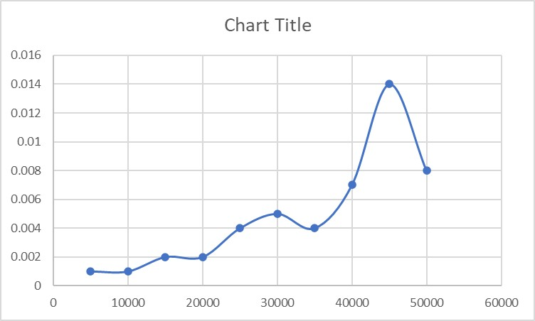
- The X-axis represents the number of input elements (ranging from 5000 to 50000).
- The Y-axis represents the time taken (in seconds) to sort the elements using Quick Sort.
- The plotted line shows variations in sorting time as the input size increases.

6. Observations:
- Initial Stability: For smaller input sizes (5000 to 15000), the execution time remains quite low and stable (~0.0010 to 0.0020 seconds).
- Gradual Increase: From 20000 to 35000 elements, the sorting time increases steadily, indicating the expected O(nlogn) complexity of Quick Sort.
- Fluctuations: Some minor inconsistencies in the pattern (e.g., a dip at 35000) may be due to system execution conditions, cache behavior, or the distribution of input data. 4. Sharp Peak: At around 45000 elements, there is a significant spike (~0.0140 seconds), suggesting that Quick Sort may have encountered a near-worst-case scenario (e.g., already sorted or reverse sorted data).
5. Drop at 50000: The time decreases to 0.0080 seconds, likely because of more balanced partitions in Quick Sort.

7. Optimizations:
- Randomized Quick Sort: Select a random pivot to reduce the likelihood of the worst-case scenario.
- Median-of-Three: Choose the median of three elements (first, middle, last) as the pivot to improve performance.
- Hybrid Approach: Use Insertion Sort for small subarrays (typically when n<10n < 10n<10) to optimize sorting.

8. Conclusion:
- Quick Sort generally follows an O(nlogn) time complexity, but certain cases can trigger near O(n2) behavior, as seen around 45000 elements.
- Execution time is influenced by pivot selection, system performance, and memory handling.
- To mitigate worst-case scenarios, randomized Quick Sort (choosing a random pivot) can improve performance consistency.

Experiment: 3
Aim: Sort a given set of n integer elements using Merge Sort method and compute its time complexity.
Objective:
- Run the program for varied values of n> 5000 and record the time taken to sort.
- Plot a graph of the time taken versus n.
- The elements can be read from a file or can be generated using the random number generator.
- Demonstrate how the divide-and-conquer method works along with its time complexity analysis: worst case, average case and best case.
Theory:
Merge Sort –
Merge Sort is a Divide and Conquer sorting algorithm that follows a recursive approach. It splits the array into two halves, sorts each half independently, and then merges them to obtain a sorted array. It is highly efficient and guarantees a worst-case time complexity of O(nlogn), making it suitable for sorting large datasets.
- Algorithm Steps:
  - Divide: If the array has more than one element, split it into two halves (left and right).
  - Conquer: Recursively apply Merge Sort on both halves. 3. Combine: Merge the sorted halves into a single sorted array.

- Complexity Analysis:
Case | Time Complexity | Explanation
Best Case | O(nlogn) | Occurs when the array is already sorted.
Average Case | O(nlogn) | Merge Sort consistently divides the array and merges efficiently.
Worst Case | O(nlogn) | Happens even when the array is in reverse order.

- Program:
#include <stdio.h>
#include <stdlib.h>
#include <time.h>

// Function to merge two subarrays
void merge(int arr[], int left, int mid, int right) { int n1 = mid - left + 1; int n2 = right - mid; int L[n1], R[n2];

for (int i = 0; i < n1; i++) L[i] = arr[left + i]; for (int j = 0; j < n2; j++) R[j] = arr[mid + 1 + j];

int i = 0, j = 0, k = left;
while (i < n1 && j < n2) { if (L[i] <= R[j]) { arr[k] = L[i]; i++; } else { arr[k] = R[j]; j++; } k++;
}
while (i < n1) { arr[k] = L[i]; i++; k++;
}
while (j < n2) { arr[k] = R[j]; j++; k++;
}
}

// Merge Sort function
void mergeSort(int arr[], int left, int right) { if (left < right) {
int mid = left + (right - left) / 2; mergeSort(arr, left, mid); mergeSort(arr, mid + 1, right); merge(arr, left, mid, right);
}
}

// Function to generate random numbers void generateRandomNumbers(int arr[], int n) { for (int i = 0; i < n; i++) { arr[i] = rand() % 100000;
}
}

// Function to write results to a file void writeResultsToFile(int n, double time_taken) { FILE *fp = fopen("merge_sort_results.csv", "a"); if (fp == NULL) {
printf("Error opening file!\n"); exit(1); }
fprintf(fp, "%d,%f\n", n, time_taken); fclose(fp);
} int main() {
FILE *fp = fopen("merge_sort_results.csv", "w"); if (fp == NULL) {
printf("Error opening file!\n"); return 1;
}
fprintf(fp, "n,Time (seconds)\n"); fclose(fp);

srand(time(0));
printf("No. of Input \t Time Taken \n"); for (int n = 5000; n <= 50000; n += 5000) { int *arr = (int *)malloc(n * sizeof(int)); if (arr == NULL) {
printf("Memory allocation failed\n"); return 1;
}
generateRandomNumbers(arr, n);

clock_t start = clock(); mergeSort(arr, 0, n - 1); clock_t end = clock();

double time_taken = ((double)(end - start)) / CLOCKS_PER_SEC;
writeResultsToFile(n, time_taken);
printf("%d \t - \t %.4f \n", n, time_taken);

free(arr);
}
printf("Results saved to merge_sort_results.csv\n"); return 0;
} /*
Output:
No. of Input Time Taken
5000 - 0.0020
10000 - 0.0010
15000 - 0.0020
20000 - 0.0040
25000 - 0.0040
30000 - 0.0050
35000 - 0.0070
40000 - 0.0090
45000 - 0.0080
50000 - 0.0110
Results saved to merge_sort_results.csv
*/
4. Performance Analysis:
- Space Complexity: O(n)O(n)O(n) (extra space required for merging).
- Stable Sorting: Maintains relative order of equal elements.
- Suitable for Linked Lists: Can efficiently sort linked lists due to its non-reliance on random access.
- Not In-Place: Requires additional memory for temporary arrays during merging.
5. Graph Interpretation
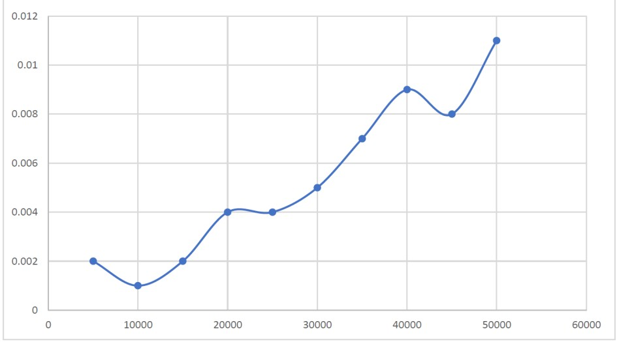

- The graph shows an increasing trend in the time taken as the input size (n) increases, which is expected for Merge Sort with a time complexity of O(nlogn).
- The fluctuations in the time values are likely due to system performance variations, memory management, and cache efficiency

6. Observations:
- Initial Values (5000 - 10000 elements): The time taken is very small, and there is a minor drop at 10000 elements. This could be due to CPU optimizations or variations in memory allocation.
- Steady Growth (15000 - 40000 elements): A clear increasing pattern is visible, aligning with the theoretical complexity O(nlogn).
- Small Dip at 45000 Elements: A minor dip at 45000 elements indicates momentary system efficiency, possibly due to efficient memory access or background processes.
- Significant Increase at 50000 Elements: The last point shows a jump, which aligns with the growing complexity as n increases.

7. Optimizations:
- Bottom-Up Merge Sort: Uses an iterative approach instead of recursion.
- Hybrid Approach: For small subarrays (e.g., n<10n < 10n<10), switching to Insertion Sort can improve efficiency.

8. Conclusion:
- The graph validates the theoretical complexity of Merge Sort (O(nlogn)).
- Minor fluctuations can be attributed to system-specific factors like CPU load and cache performance.
- Merge Sort is consistent and efficient for large inputs, making it suitable for sorting large datasets where stability is required.

Experiment: 4
Title: Minimum Cost Spanning Tree using Kruskal’s Algorithm with Union-Find Objective:
To implement Kruskal's algorithm using the Union-Find data structure to find the Minimum Cost Spanning Tree (MST) of a given connected undirected graph.

Theory:
A Minimum Cost Spanning Tree (MST) of a connected, undirected graph is a subset of its edges that:
1. Connects all vertices with the minimum possible total edge weight. 2. Contains no cycles, forming a tree structure.

1. Kruskal's Algorithm:
- Sort all edges in non-decreasing order of weight.
- Pick the smallest edge and check if it forms a cycle using Union-Find.
- If it does not form a cycle, add it to the MST.
- Continue this process until (V - 1) edges are included in the MST (where V is the number of vertices).

- Union-Find Data Structure:
  - Used to detect cycles efficiently.
  - Uses two main functions:
    - Find(u): Determines the root representative of a set.
    - Union(u, v): Merges two subsets if they belong to different sets.
- Implemented with Path Compression (to optimize Find) and Union by Rank (to optimize Union).

3. Flowchart:

S
tart

Sort Edges by Weight

Initialize MST & Union Find

Pick Next Edge

Find
root of
u
,v
(
Union Find
)

u
=
=
v

Discard Edge

Add edge t
o MST
& Union (u, v)

Next Edge

E===V
-
1

Output MST

End

True

False

3. Algorithm:
- Input: A graph with V vertices and E edges.
- Sort all edges in ascending order of weight.
- Initialize parent and rank arrays for Union-Find.
- For each edge, check if its vertices belong to different sets using Find.
- If different, add the edge to the MST and perform Union.
- Repeat until V - 1 edges are selected.
- Output the MST and its total cost.

4. Program:
#include <stdio.h>
#include <stdlib.h>

#define MAX 100

// Structure for an edge typedef struct { int src, dest, weight;
} Edge;

// Structure for a graph typedef struct { int V, E; Edge edges[MAX];
} Graph;

// Structure to represent subsets in Union-Find typedef struct { int parent, rank;
} Subset;

// Compare function for sorting edges by weight int compareEdges(const void *a, const void *b) { return ((Edge *)a)->weight - ((Edge *)b)->weight;
}

// Find function with path compression int find(Subset subsets[], int i) { if (subsets[i].parent != i)
subsets[i].parent = find(subsets, subsets[i].parent); return subsets[i].parent;
}

// Union function using rank
void unionSets(Subset subsets[], int x, int y) { int rootX = find(subsets, x); int rootY = find(subsets, y);

if (subsets[rootX].rank < subsets[rootY].rank)
subsets[rootX].parent = rootY;
else if (subsets[rootX].rank > subsets[rootY].rank) subsets[rootY].parent = rootX; else {
subsets[rootY].parent = rootX; subsets[rootX].rank++;
}
}

// Kruskal's Algorithm void kruskalMST(Graph *graph) { Edge result[MAX]; int e = 0, i = 0;

// Sort edges by weight
qsort(graph->edges, graph->E, sizeof(Edge), compareEdges);

// Allocate memory for subsets
Subset *subsets = (Subset *)malloc(graph->V * sizeof(Subset)); for (int v = 0; v < graph->V; ++v) { subsets[v].parent = v; subsets[v].rank = 0;
}

// Pick edges one by one
while (e < graph->V - 1 && i < graph->E) {
Edge nextEdge = graph->edges[i++]; int x = find(subsets, nextEdge.src); int y = find(subsets, nextEdge.dest);

if (x != y) { result[e++] = nextEdge; unionSets(subsets, x, y);
}
}

// Print MST
printf("Edges in Minimum Cost Spanning Tree:\n"); int minCost = 0; for (i = 0; i < e; ++i) {
printf("%d -- %d == %d\n", result[i].src, result[i].dest, result[i].weight);
minCost += result[i].weight;
}
printf("Total Minimum Cost: %d\n", minCost);

free(subsets);
}

// Main function int main() { Graph graph;
printf("Enter number of vertices and edges: "); scanf("%d %d", &graph.V, &graph.E);

printf("Enter edges (src dest weight):\n"); for (int i = 0; i < graph.E; i++)
scanf("%d %d %d", &graph.edges[i].src, &graph.edges[i].dest,
&graph.edges[i].weight);

kruskalMST(&graph); return 0; }
Example Input/Output:
Input:
Enter number of vertices and edges: 4 5 Enter edges (src dest weight):
0 1 10
0 2 6
- 3 5
- 3 15
- 3 4
Output:
Edges in Minimum Cost Spanning Tree:
2 -- 3 == 4
0 -- 3 == 5
0 -- 1 == 10
Total Minimum Cost: 19

10

5

1
5

6

5

4

10

- Graph
- MST 4

8. Result:
The given C program successfully finds the Minimum Cost Spanning Tree (MST) of a connected undirected graph using Kruskal’s Algorithm with the Union-Find data structure.

Experiment: 5
Title: Write a C program to find the Minimum Cost Spanning Tree (MST) of a given connected undirected graph using Prim's Algorithm. Objective:
To implement Prim’s algorithm in C to find the Minimum Cost Spanning Tree (MST) for a given connected, undirected graph..

Theory:
A Minimum Cost Spanning Tree (MST) of a graph is a spanning tree whose sum of edge weights is minimized. Prim’s algorithm is a greedy approach that builds the MST by adding the lowest weight edge that connects a new vertex to the growing spanning tree.
- Steps of Prim’s Algorithm:
  - Start with an arbitrary node and mark it as part of the MST.
  - Find the smallest edge that connects a node in the MST to a node outside the MST.
  - Add this edge and the new node to the MST.
  - Repeat until all vertices are included in the MST.

- Algorithm
  - Initialize a visited[] array to track included vertices.
  - Set the key[] array to store minimum edge weights (initialized to a large value, except the first vertex).
  - Start from any vertex (usually vertex 0).
  - For the selected vertex, update the key values of its adjacent vertices.
  - Select the vertex with the smallest key value that has not yet been included.
  - Repeat until all vertices are included in the MST.

- Program:
#include <stdio.h>
#include <limits.h>
#define V 5 // Number of vertices

// Function to find the vertex with the minimum key value int minKey(int key[], int visited[])
{
int min = INT_MAX, min_index; for (int v = 0; v < V; v++) if (visited[v] == 0 && key[v] < min) min = key[v], min_index = v; return min_index;
}

// Function to print the MST
void printMST(int parent[], int graph[V][V])
{
printf("Edge \tWeight\n"); for (int i = 1; i < V; i++)
printf("%d - %d \t%d\n", parent[i], i, graph[i][parent[i]]);
}

// Function to find the MST using Prim's Algorithm void primMST(int graph[V][V])
{
int parent[V]; // Stores MST int key[V]; // Key values
int visited[V]; // To track visited vertices

for (int i = 0; i < V; i++) key[i] = INT_MAX, visited[i] = 0;
key[0] = 0; parent[0] = -1;

for (int count = 0; count < V - 1; count++)
{
int u = minKey(key, visited); visited[u] = 1;
for (int v = 0; v < V; v++)
{
if (graph[u][v] && visited[v] == 0 && graph[u][v] < key[v])
parent[v] = u, key[v] = graph[u][v];
} }
printMST(parent, graph);
} int main() {
int graph[V][V] = { {0, 2, 0, 6, 0},
{2, 0, 3, 8, 5},
{0, 3, 0, 0, 7},
{6, 8, 0, 0, 9},
{0, 5, 7, 9, 0}};

printf("Minimum Cost Spanning Tree (Prim's Algorithm):\n"); primMST(graph);

return 0;
}

4. Sample Input/Output Input:
The program uses the following adjacency matrix representation of a graph:
0 2 0 6 0
2 0 3 8 5
0 3 0 0 7
6 8 0 0 9
0 5 7 9 0

Output:
Minimum Cost Spanning Tree (Prim's Algorithm):
Edge Weight
- - 1 2
- - 2 3
1 - 4 5
0 - 3 6
5
.
Graph

6
.
MST

0

2

3

5

8

1

6

7

9

2

3

4

0

2

3

5

1

6

2

3

4

- Result
The program successfully finds the Minimum Cost Spanning Tree (MST) of the given graph using Prim’s algorithm.

- Conclusion
Prim’s algorithm efficiently finds the MST of a given connected undirected graph using a greedy approach. The implemented C program correctly identifies the minimum spanning tree by incrementally adding the lowest weight edge that connects to the growing MST.

Experiment: 6
Title: Dijkstra’s Algorithm for Finding Shortest Path in a Weighted Graph. Objective:
To implement Dijkstra’s Algorithm to find the shortest paths from a given vertex to all other vertices in a weighted, connected graph.

Theory:
Dijkstra’s Algorithm is a greedy algorithm that finds the shortest path from a single source vertex to all other vertices in a weighted graph. It maintains a set of visited vertices and iteratively selects the vertex with the minimum distance, updating the distances of its neighbours.
- Steps Algorithm:
  - Assign an initial distance of 0 to the source vertex and infinity to all other vertices.
  - Mark all vertices as unvisited.
  - Pick the unvisited vertex with the minimum distance.
  - Update the distances of its adjacent vertices if a shorter path is found.
  - Mark the current vertex as visited.
  - Repeat until all vertices are visited.

- Time Complexity:
• O(V²) for an adjacency matrix implementation. • O((V + E) log V) if implemented using a priority queue (not used here).

- Algorithm Implementation
  - Use an adjacency matrix to represent the graph.
  - Initialize the distances and visited status of each vertex.
  - Select the vertex with the minimum distance and update its neighbors.
  - Repeat until all vertices are processed.
  - Print the shortest distances from the source.

- Program:
#include <stdio.h>
#include <limits.h>

#define V 10 // Maximum number of vertices (adjustable)
// Function to find the vertex with minimum distance value int minDistance(int dist[], int visited[]) { int min = INT_MAX, min_index = -1; for (int v = 0; v < V; v++) { if (!visited[v] && dist[v] <= min) { min = dist[v], min_index = v;
} }
return min_index;
}

// Function to print the shortest path distances
void printSolution(int dist[], int n) { printf("Vertex \t Distance from Source\n"); for (int i = 0; i < n; i++) { printf("%d \t %d\n", i, dist[i]);
}
}

// Dijkstra's Algorithm
void dijkstra(int graph[V][V], int src, int n) { int dist[V]; // Distance from source to each vertex int visited[V]; // 1 if vertex is included in shortest path tree

// Initialize all distances as INFINITE and visited[] as false for (int i = 0; i < n; i++) { dist[i] = INT_MAX, visited[i] = 0;
}
dist[src] = 0; // Distance from source to itself is 0

// Find shortest path for all vertices for (int count = 0; count < n - 1; count++) {
int u = minDistance(dist, visited); // Pick the minimum distance vertex visited[u] = 1;

// Update dist[v] if it's not visited and there's a shorter path
for (int v = 0; v < n; v++) {
if (!visited[v] && graph[u][v] && dist[u] != INT_MAX && dist[u] + graph[u][v] < dist[v]) { dist[v] = dist[u] + graph[u][v];
}
}
}

// Print the result printSolution(dist, n);
}

// Main function int main() { int n, src;

printf("Enter the number of vertices: "); scanf("%d", &n);

int graph[V][V];

printf("Enter the adjacency matrix (use 0 for no edge):\n"); for (int i = 0; i < n; i++) for (int j = 0; j < n; j++) scanf("%d", &graph[i][j]);

printf("Enter the source vertex: "); scanf("%d", &src);

dijkstra(graph, src, n);

return 0;
}
5. Input/Output: Input:
- Number of vertices
- Adjacency matrix representation of the graph
- Source vertex

Output:
- Shortest distance from the source to all other vertices

Example Execution:
Input:
Enter the number of vertices: 5
Enter the adjacency matrix (use 0 for no edge):
0 10 20 0 0
10 0 5 1 0
20 5 0 2 3
0 1 2 0 15
0 0 3 15 0
Enter the source vertex: 0 Output:
Vertex Distance from Source
6
.
Graph

0

10

5

1

1

3

15

2

3

4

20

2

- 0
- 10
- 13
- 11 4 16

7. Conclusion:
- Dijkstra’s Algorithm successfully finds the shortest paths in a weighted, connected graph.
- It ensures that the shortest path to each vertex is found using a greedy approach. • The implemented program correctly calculates and displays the shortest path distances.

EXPERIMENT 7: KNAPSACK PROBLEM USING GREEDY METHOD
OBJECTIVE
To implement the Fractional Knapsack Problem using the Greedy Method in C.
THEORY
The Knapsack Problem is an optimization problem where we aim to maximize the total value of items placed in a knapsack of limited capacity.
There are two types of knapsack problems:
- 0/1 Knapsack Problem – Items cannot be broken; we either take an entire item or leave it.
- Fractional Knapsack Problem – Items can be broken into smaller pieces, allowing us to take fractions of an item.
The Greedy Method is applicable for the Fractional Knapsack Problem where we:
- Sort items based on the profit-to-weight ratio (profit/weight).
- Select items with the highest ratio first.
- If the knapsack has remaining capacity, we take a fraction of the next item until the knapsack is full.
ALGORITHM (GREEDY APPROACH FOR FRACTIONAL KNAPSACK)
- Input: o The number of items, their profits, and weights.
  - The total capacity of the knapsack.
- Sort items in decreasing order of their profit-to-weight ratio.
- Iterate through sorted items: o If the entire item fits in the knapsack, take it completely.
  - If not, take the fraction that fits and break the loop.
- Output the maximum profit obtained.
PROGRAM (C CODE IMPLEMENTATION)
#include <stdio.h> struct Item { int weight, profit; float ratio; };
// Function to sort items in decreasing order of profit/weight ratio void sortItems(struct Item items[], int n) { struct Item temp; for (int i = 0; i < n - 1; i++) { for (int j = 0; j < n - i - 1; j++) { if (items[j].ratio < items[j + 1].ratio) { temp = items[j]; items[j] = items[j + 1];
items[j + 1] = temp;
}
}
}
}
// Function to calculate maximum profit using the greedy method float fractionalKnapsack(struct Item items[], int n, int capacity) { float totalProfit = 0.0;
int i;
// Sorting items based on their profit/weight ratio sortItems(items, n);

for (i = 0; i < n; i++) { if (items[i].weight <= capacity) { totalProfit += items[i].profit;
capacity -= items[i].weight;
} else {
totalProfit += items[i].profit * ((float)capacity / items[i].weight); break; // Knapsack is full
}
}

return totalProfit;
}
int main() {
int n, capacity;

// Input number of items printf("Enter number of items: "); scanf("%d", &n);

struct Item items[n];

// Input item weights and profits
printf("Enter weight and profit of each item:\n"); for (int i = 0; i < n; i++) {
scanf("%d %d", &items[i].weight, &items[i].profit); items[i].ratio = (float)items[i].profit / items[i].weight;
}

// Input knapsack capacity printf("Enter knapsack capacity: "); scanf("%d", &capacity)
float maxProfit = fractionalKnapsack(items, n, capacity); printf("Maximum profit: %.2f\n", maxProfit); return 0;
}
EXAMPLE EXECUTION
Input:
Enter number of items: 3
Enter weight and profit of each item:
10 60
20 100
30 120
Enter knapsack capacity: 50
OUTPUT:
Maximum profit: 240.00
TIME COMPLEXITY ANALYSIS
- Sorting the items based on profit-to-weight ratio: O(n log n) (if using quicksort or mergesort).
- Iterating through the items: O(n).
Thus, the overall complexity is O(n log n).
CONCLUSION
- The Greedy Method efficiently solves the Fractional Knapsack Problem by maximizing profit using profit-to-weight ratio.
- It is not applicable to the 0/1 Knapsack Problem, where dynamic programming is preferred.

Experiment No: 8(a)
Title: Write a C program to solve All-Pairs Shortest Paths problem using Floyd's algorithm.

Objective:
To implement Floyd-Warshall algorithm in C for finding the shortest paths between all pairs of vertices in a weighted directed graph, and analyze its time complexity.

Theory:
The Floyd-Warshall algorithm is a classical dynamic programming approach used to find the shortest distances between every pair of vertices in a graph.
It works with both positive and negative edge weights, provided there are no negative cycles.
It uses the idea that the shortest path between two vertices i and j either:
- Goes directly from i to j, or
- Passes through an intermediate vertex k.
Let dist[i][j] represent the shortest distance from i to j. The recursive relation is: dist[i][j] = min(dist[i][j], dist[i][k] + dist[k][j]) We perform this check for every pair (i, j) and for every vertex k as intermediate.

Algorithm Steps:
- Initialize the distance matrix dist with given edge weights.
- For all vertices k from 0 to V-1:
o For all vertices i from 0 to V-1:
  - For all vertices j from 0 to V-1:
  - Update dist[i][j] = min(dist[i][j], dist[i][k] + dist[k][j]) 3. After all iterations, dist[i][j] contains the shortest path from i to j.

C Program:
#include <stdio.h>
#define V 4
#define INF 99999

void floydWarshall(int graph[V][V]) { int dist[V][V];

// Initialize the solution matrix same as input graph for (int i = 0; i < V; i++) for (int j = 0; j < V; j++) dist[i][j] = graph[i][j];

// Adding all vertices one by one as intermediate for (int k = 0; k < V; k++) { for (int i = 0; i < V; i++) { for (int j = 0; j < V; j++) {
if (dist[i][k] + dist[k][j] < dist[i][j]) dist[i][j] = dist[i][k] + dist[k][j]; }
}
}

// Print final shortest distance matrix
printf("All Pairs Shortest Paths (Floyd-Warshall):\n"); for (int i = 0; i < V; i++) { for (int j = 0; j < V; j++) { if (dist[i][j] == INF) printf("%7s", "INF"); else
printf("%7d", dist[i][j]);
}
printf("\n");
}
} int main() {
int graph[V][V] = { {0, 5, INF, 10},
{INF, 0, 3, INF},
{INF, INF, 0, 1},
{INF, INF, INF, 0}
};
floydWarshall(graph); return 0;
}
Sample Output:
All Pairs Shortest Paths (Floyd-Warshall):
0 5 8 9
INF 0 3 4
INF INF 0 1 INF INF INF 0

Time Complexity:
• O(V³)
(Where V is the number of vertices) Space Complexity: • O(V²) for the distance matrix.

Limitations: • Cannot handle negative weight cycles (will give incorrect results).

Conclusion:
The Floyd-Warshall algorithm is an efficient way to compute shortest paths between all pairs of vertices using dynamic programming. Its cubic time complexity makes it suitable for dense graphs of moderate size.

Experiment No: 8(b)
Title: Write a program to solve Travelling Sales Person (TSP) problem using Dynamic Programming.

Objective:
To implement a Dynamic Programming approach to solve the Travelling Sales Person
Problem (TSP) and find the minimum cost tour that visits each city exactly once and returns to the starting city.

Theory:
The Travelling Sales Person (TSP) is a classic combinatorial optimization problem.
Given a set of n cities and the cost matrix (distance/cost between each pair), the goal is to: • Start from a city,
- Visit all other cities exactly once, and
- Return to the starting city, with minimum total cost.
Why Dynamic Programming?
TSP can be solved using Dynamic Programming with Bitmasking to represent the set of visited cities.
Let dp[mask][i] denote the minimum cost to reach city i from the starting city (say 0), having visited cities represented by the bitmask mask.

Algorithm Steps:
- Represent visited cities using bitmasking.
- Initialize dp[mask][i] with INF except for the starting point.
- Recursively compute the minimum path by trying all unvisited cities from current state.
- Base case: when all cities are visited.
- Finally, return to the starting city to complete the tour.

C Program:
#include <stdio.h>
#include <limits.h>
#define MAX 10
#define INF 99999
int n; int dist[MAX][MAX];
int dp[1 << MAX][MAX]; // dp[mask][i] int visited_all;

int tsp(int mask, int pos) { if (mask == visited_all)
return dist[pos][0]; // Return to starting point

if (dp[mask][pos] != -1) return dp[mask][pos]; int ans = INF;

for (int city = 0; city < n; city++) { if ((mask & (1 << city)) == 0) {
int newAns = dist[pos][city] + tsp(mask | (1 << city), city);
if (newAns < ans) ans = newAns;
}
}
return dp[mask][pos] = ans;
}
void initializeDP() {
for (int i = 0; i < (1 << n); i++) for (int j = 0; j < n; j++) dp[i][j] = -1;
} int main() {
printf("Enter number of cities: "); scanf("%d", &n);

printf("Enter cost adjacency matrix:\n"); for (int i = 0; i < n; i++) for (int j = 0; j < n; j++) scanf("%d", &dist[i][j]);

visited_all = (1 << n) - 1; initializeDP();

int min_cost = tsp(1, 0); // Start at city 0, only city 0 is visited
printf("Minimum TSP tour cost = %d\n", min_cost);

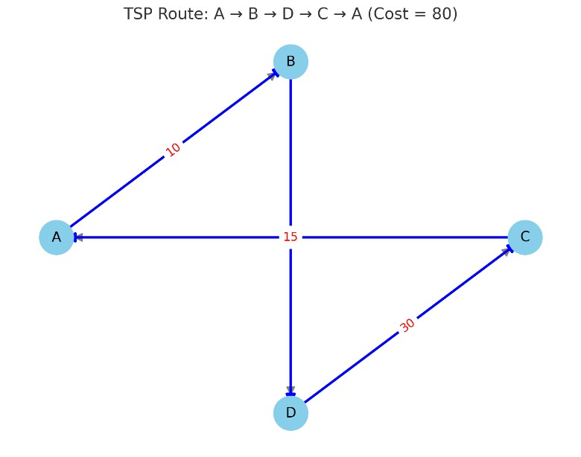
return 0;
25

}

Sample Input & Output:
Input:
Enter number of cities: 4 Enter cost adjacency matrix:
0 10 15 20
10 0 35 25
15 35 0 30
20 25 30 0 Output:
Minimum TSP tour cost = 80
(Tour: A → B → D → C → A)

Time Complexity: • O(n² × 2ⁿ) Where n is the number of cities. Efficient for n ≤ 16.

Space Complexity: • O(n × 2ⁿ) Due to the dp table.

Limitations:
• Not suitable for large values of n due to exponential growth. • The problem is NP-Hard, so exact solutions are costly for large inputs.

Conclusion:
The Dynamic Programming solution for TSP significantly reduces the brute-force complexity (O(n!)) to O(n² × 2ⁿ), making it feasible for moderate-sized inputs. It is a powerful example of optimization using state-space reduction and bitmasking.

Experiment No: 8(c)
Title: Write a program to solve 0/1 Knapsack Problem using Dynamic Programming method.

Objective:
To implement the Dynamic Programming approach for solving the 0/1 Knapsack Problem, maximizing total profit without exceeding the knapsack’s weight capacity.

Theory:
The 0/1 Knapsack Problem is a classic combinatorial optimization problem in which:
- You're given a set of n items, each with a weight w[i] and profit p[i].
- You must choose a subset of these items to put into a knapsack of maximum capacity W.
- Goal: Maximize the total profit such that the total weight does not exceed W.
- Each item can be either taken once (1) or not taken at all (0) — hence 0/1. Dynamic Programming Approach:
Let dp[i][w] be the maximum profit attainable using the first i items and with a knapsack capacity of w. Recurrence Relation: dp[i][w] = max(
dp[i-1][w], // Exclude item i dp[i-1][w - weight[i]] + profit[i] // Include item i (if it fits) )
Algorithm Steps:
- Create a 2D DP table dp[n+1][W+1].
- Initialize first row and column with zeros.
- Use the recurrence relation to fill the table.
- The bottom-right value in the table is the maximum achievable profit. 5. (Optional) Backtrack to find which items were selected.

C Program:
#include <stdio.h>

int max(int a, int b) { return (a > b) ? a : b;
} int main() { int n, W;
printf("Enter number of items: "); scanf("%d", &n);

int weight[n+1], profit[n+1];

printf("Enter weights of items:\n"); for (int i = 1; i <= n; i++) scanf("%d", &weight[i]);

printf("Enter profits of items:\n"); for (int i = 1; i <= n; i++) scanf("%d", &profit[i]);

printf("Enter knapsack capacity: "); scanf("%d", &W);

int dp[n+1][W+1];

// Build DP table for (int i = 0; i <= n; i++) { for (int w = 0; w <= W; w++) { if (i == 0 || w == 0) dp[i][w] = 0; else if (weight[i] <= w)
dp[i][w] = max(profit[i] + dp[i-1][w - weight[i]], dp[i-1][w]); else
dp[i][w] = dp[i-1][w];
}
}
printf("Maximum profit = %d\n", dp[n][W]);

// (Optional) Print selected items printf("Selected items (item index): "); int w = W;
for (int i = n; i > 0 && w > 0; i--) { if (dp[i][w] != dp[i-1][w]) { printf("%d ", i); w -= weight[i];
}
}
return 0;
}

Sample Input & Output:
Input:
Enter number of items: 4
Enter weights: 2 3 4 5
Enter profits: 3 4 5 6 Enter knapsack capacity: 5 Output:
Maximum profit = 7
Selected items (item index): 2 1

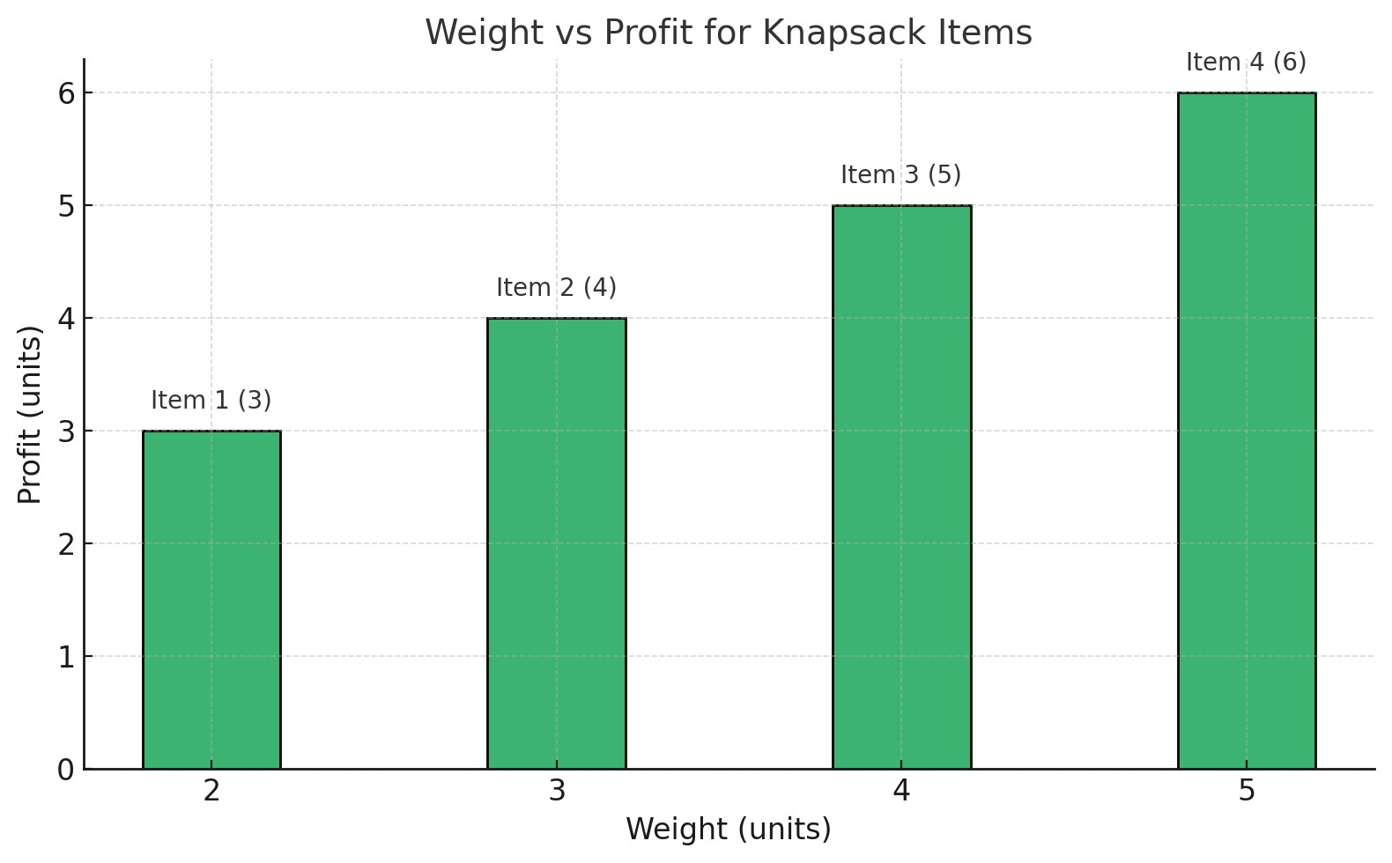
Time Complexity: • O(n × W)
Where n is the number of items, and W is the knapsack capacity.

Space Complexity:
• O(n × W) for the full DP table. • Can be reduced to O(W) using a 1D DP array in optimized versions.

Conclusion:
The Dynamic Programming method solves the 0/1 Knapsack Problem optimally in polynomial time, avoiding the exponential complexity of brute-force recursive methods. It is one of the best examples of overlapping subproblems and optimal substructure.

Experiment No: 9
Title: Subset Sum Problem using Backtracking / Dynamic Programming (C++/Java)

Objective:
To implement a backtracking or dynamic programming algorithm to find all subsets of a given set S whose sum is equal to a target value d.

Theory:
The Subset Sum Problem is a well-known NP-Complete problem in computer science. Given a set of positive integers, the goal is to find a subset whose elements add up to a specific value d.

Approach Used: Backtracking
• We explore each subset recursively:
o Include or exclude the current element. o Track the partial sum during recursion. o Backtrack when partial sum exceeds d.

Algorithm Steps:
- Start from the first element in the set.
- At each step, choose or skip the current element.
- If at any point the sum of chosen elements equals the target d, print the subset.
- If no subset found, display a message.

C++ Program:
#include <iostream> #include <vector> using namespace std;

void findSubsets(vector<int>& set, vector<int>& subset, int
index, int sum, int target, bool &found) { if (sum == target) { found = true; cout << "Subset: "; for (int num : subset) cout << num << " "; cout << endl; return;
}
for (int i = index; i < set.size(); i++) { if (sum + set[i] <= target) { subset.push_back(set[i]);
findSubsets(set, subset, i + 1, sum + set[i], target, found);
subset.pop_back(); // backtrack }
}
} int main() { int n, d;
cout << "Enter number of elements in the set: "; cin >> n;

vector<int> set(n);
cout << "Enter elements of the set:\n"; for (int i = 0; i < n; i++) cin >> set[i];

cout << "Enter the target sum (d): "; cin >> d;

vector<int> subset; bool found = false;

cout << "Subsets with sum " << d << " are:\n"; findSubsets(set, subset, 0, 0, d, found);
if (!found)
cout << "No subset found with the given sum.\n";

return 0;
}

Sample Input & Output:
Input:
Enter number of elements: 5
Enter elements: 1 2 5 6 8
Enter target sum: 9 Output:
Subsets with sum 9 are:
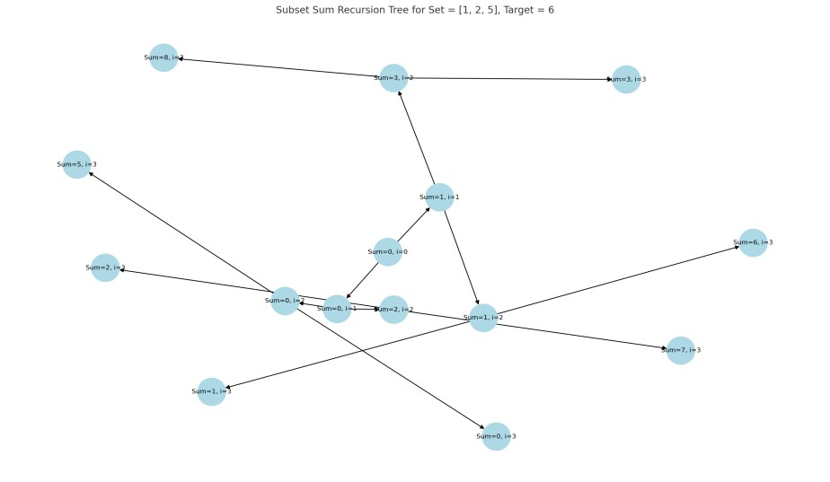
Subset: 1 2 6 Subset: 1 8

Time Complexity:
- Worst Case: O(2ⁿ) due to all possible subsets.
- Efficient for small n, but for large sets, optimization with memoization or pruning is recommended.

Space Complexity: • O(n) for recursive stack and subset vector.

Conclusion:
The Subset Sum Problem demonstrates backtracking effectively. This approach ensures all valid subsets are found, and the solution highlights how recursive depth-first search can be used for combinatorial problems.

Java Program: Subset Sum using Recursion + Backtracking
import java.util.*;

public class SubsetSum { static boolean found = false;

public static void findSubsets(List<Integer> set, List<Integer> subset, int index, int currentSum, int target) { if (currentSum == target) { found = true;
System.out.println("Subset: " + subset); return;
}
for (int i = index; i < set.size(); i++) { int element = set.get(i); if (currentSum + element <= target) { subset.add(element); // choose
findSubsets(set, subset, i + 1, currentSum + element, target);
subset.remove(subset.size() - 1); // backtrack
}
}
}
public static void main(String[] args) { Scanner sc = new Scanner(System.in);

System.out.print("Enter number of elements: "); int n = sc.nextInt();

List<Integer> set = new ArrayList<>();
System.out.print("Enter the elements of the set: "); for (int i = 0; i < n; i++) set.add(sc.nextInt());

System.out.print("Enter target sum (d): "); int target = sc.nextInt();

System.out.println("Subsets with sum " + target + ":"); findSubsets(set, new ArrayList<>(), 0, 0, target);

if (!found)
System.out.println("No subset found with the given sum.");

sc.close();
}
}
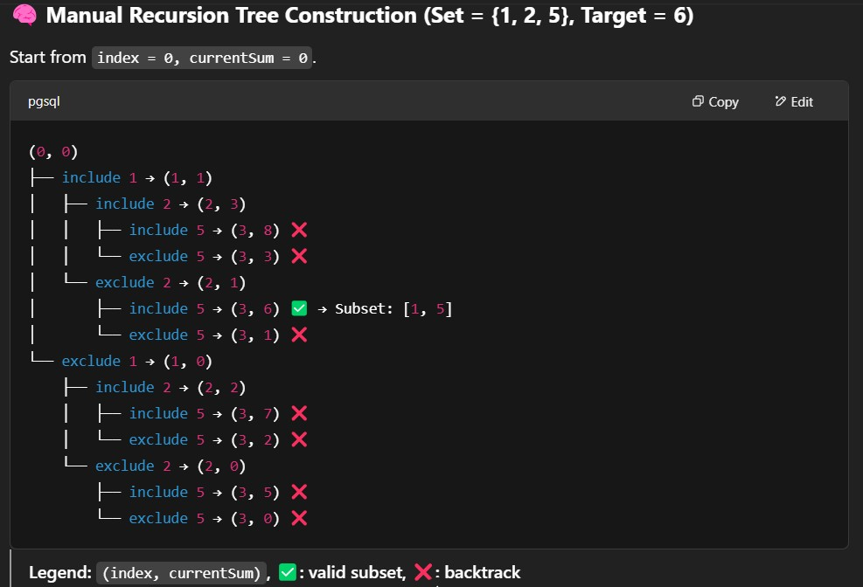

Experiment No: 10
Experiment Title
Design and implement a program to find all Hamiltonian Cycles in a connected undirected Graph G of n vertices using Backtracking Principle.

Objective
To implement a backtracking algorithm that finds all possible Hamiltonian cycles in a given connected undirected graph with n vertices. A Hamiltonian cycle visits every vertex exactly once and returns to the starting vertex.

Theory
- A Hamiltonian Cycle is a closed loop that visits every vertex exactly once and returns to the starting point.
- The problem is NP-complete, and no polynomial-time solution exists for arbitrary graphs.
- Backtracking is used to generate and explore all possible permutations of the graph's vertices to check if a valid cycle exists. • A graph is represented using an adjacency matrix graph[V][V].

Algorithm Steps (Backtracking)
- Initialize the path with the starting vertex 0.
- Recursively add vertices to the path one-by-one:
o Check if the vertex can be added (i.e., is adjacent and not already visited).
- If all vertices are in the path and the last vertex connects to the first, a cycle is formed.
- Backtrack and try alternate vertices.
- Repeat until all Hamiltonian cycles are found.

Input
- Number of vertices V
- Adjacency matrix graph[V][V]

C Program Code
#include <stdio.h>
#include <stdbool.h>

#define V 5 // Adjust for your graph size

int path[V];

// Check if current vertex can be added to the Hamiltonian Cycle bool isSafe(int v, bool graph[V][V], int pos) {
// Check if this vertex is adjacent to the previous vertex if (!graph[path[pos - 1]][v]) return false;

// Check if the vertex has already been included for (int i = 0; i < pos; i++) if (path[i] == v) return false;

return true;
}

// Recursive function to find all Hamiltonian cycles void hamiltonianCycleUtil(bool graph[V][V], int pos) { if (pos == V) {
// Check if there is a return edge to starting vertex if (graph[path[pos - 1]][path[0]]) { for (int i = 0; i < V; i++) printf("%d ", path[i]);
printf("%d\n", path[0]); // Closing the cycle
} return;
}
for (int v = 1; v < V; v++) { if (isSafe(v, graph, pos)) { path[pos] = v;
hamiltonianCycleUtil(graph, pos + 1);

// Backtrack path[pos] = -1;
}
}
}
void findHamiltonianCycles(bool graph[V][V]) { for (int i = 0; i < V; i++) path[i] = -1;

path[0] = 0; // Start at vertex 0

printf("Hamiltonian Cycles:\n"); hamiltonianCycleUtil(graph, 1);
} int main() { bool graph[V][V] = { {0, 1, 0, 1, 0},
{1, 0, 1, 1, 1},
{0, 1, 0, 0, 1},
{1, 1, 0, 0, 1},
{0, 1, 1, 1, 0}
};
findHamiltonianCycles(graph); return 0; }
Sample Output
Hamiltonian Cycles:
0 1 2 4 3 0
0 1 4 2 3 0
...
Test Case Graph: V = 5 Edges:
(0-1), (0-3), (1-2), (1-3), (1-4), (2-4), (3-4)

Time Complexity
• Worst Case: O(n!) – where n is the number of vertices (since we explore every permutation).

Conclusion
The backtracking algorithm correctly finds all Hamiltonian cycles in the graph. Although computationally expensive, it's efficient for small graphs and demonstrates recursive state space exploration.

