This document provides detailed documentation for the provider’s patient dashboard, covering patient-related functionalities, workflow descriptions, and the database schema used for storing relevant data.

1. Overview of Functionalities
The provider’s patient dashboard enables doctors to view booked appointments, record procedure details, and review patient insurance information. Key capabilities include:
- Viewing booked appointments assigned to the doctor.
- Adding procedure details for patients after visits.
- Viewing ongoing medical procedures.

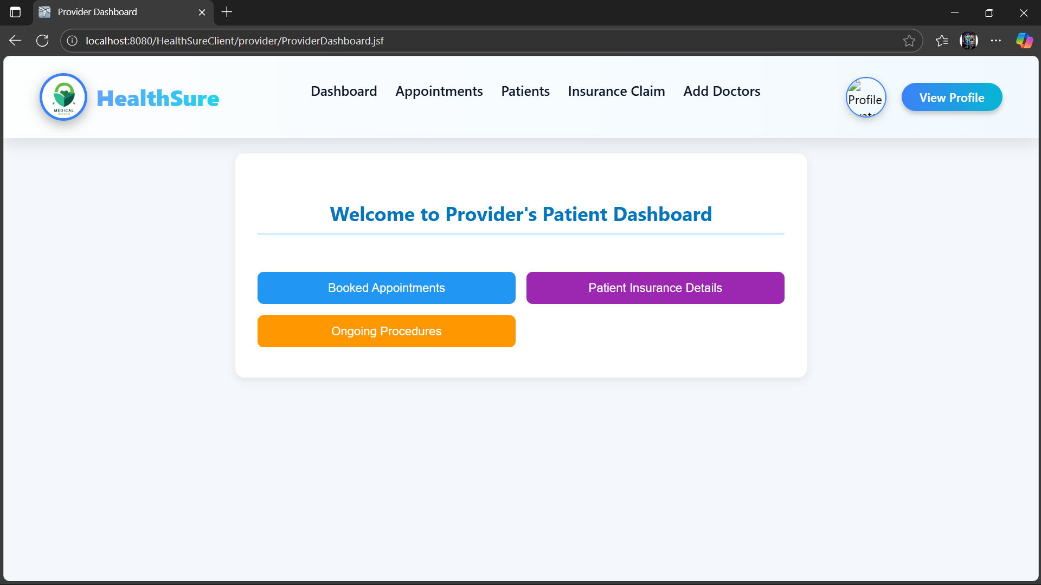

This is the provider’s patient dashboard that contains patient related functionalities.
Here the doctor can see the booked appointments under him,add procedure details for them and see the insurance details of his patients
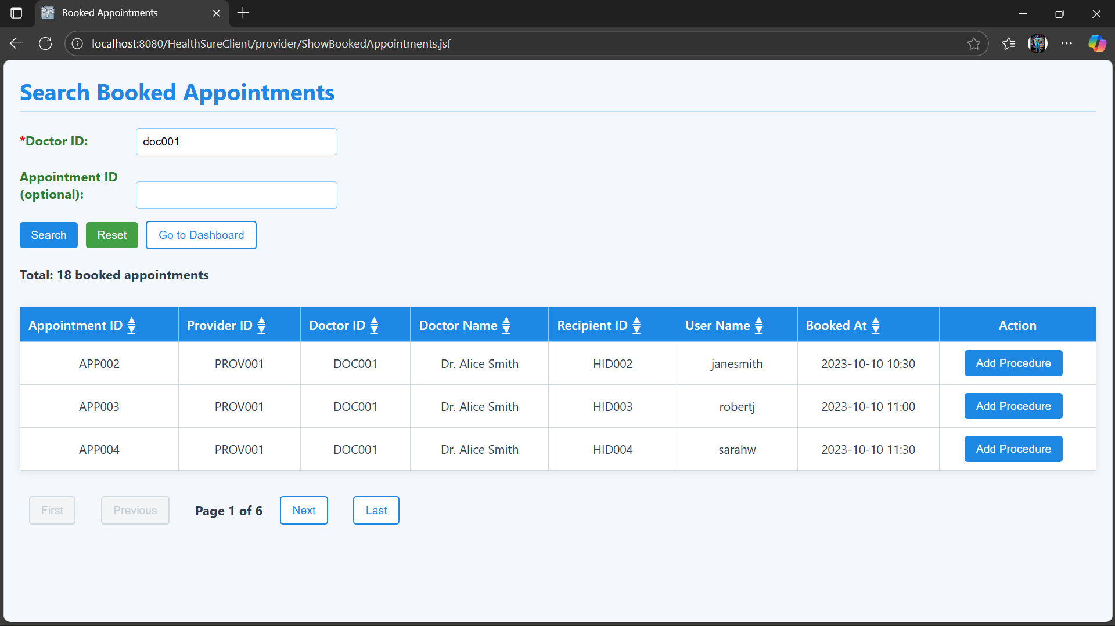

These are the booked appointments under the doctor for which he can add theprocedure details for the appointment after the patient is visited .

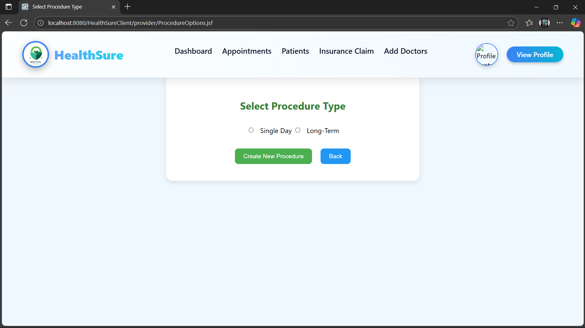

2. Procedure Types
Procedures can be classified into two types:
1. Single-Day: The medical condition is resolved in a single visit, requiring no further check-ups (e.g., fever, cold). The `procedure_date` field is populated, while `from_date` and `to_date` remain NULL.
2. Long-Term : The medical condition requires multiple visits for diagnosis and treatment. The `from_date` records the start date of the procedure, and `to_date` records the completion date.

3. Table: medical_procedure
The `medical_procedure` table stores detailed information about medical procedures performed on patients, including procedure type, status, and diagnosis details.
SQL Definition:
CREATE TABLE medical_procedure (
procedure_id VARCHAR(20) PRIMARY KEY,
appointment_id VARCHAR(20) NOT NULL,
h_id VARCHAR(20) NOT NULL,
provider_id VARCHAR(20) NOT NULL,
doctor_id VARCHAR(20) NOT NULL,
procedure_date DATE,
from_date TIMESTAMP DEFAULT CURRENT_TIMESTAMP,
to_date TIMESTAMP,
diagnosis TEXT NOT NULL,
recommendations TEXT,
procedure_type ENUM('SINGLE_DAY','LONG_TERM'),
procedure_status ENUM('IN_PROGRESS', 'COMPLETED'),
created_at TIMESTAMP DEFAULT CURRENT_TIMESTAMP,
FOREIGN KEY (appointment_id) REFERENCES Appointment(appointment_id),
FOREIGN KEY (h_id) REFERENCES Recipient(h_id),
FOREIGN KEY (provider_id) REFERENCES Providers(provider_id),
FOREIGN KEY (doctor_id) REFERENCES Doctors(doctor_id)
);

4. Table: prescription
The `prescription` table stores prescription records associated with a specific medical procedure, including prescribing doctor details, prescription duration, and relevant notes.
The prescribed by field stores the doctor who has prescribed that prescription.
It is useful for long term procedures in case the doctor who started the procedure is not available.
Any other doctor with same specialization can perform the diagnosis under his absence.

SQL Definition:
CREATE TABLE prescription (
prescription_id VARCHAR(20) PRIMARY KEY,
procedure_id VARCHAR(20) NOT NULL,
h_id VARCHAR(20) NOT NULL,
provider_id VARCHAR(20) NOT NULL,
doctor_id VARCHAR(20) NOT NULL,
prescribed_by VARCHAR(20) NOT NULL,
written_on TIMESTAMP DEFAULT CURRENT_TIMESTAMP,
start_date TIMESTAMP,
end_date TIMESTAMP,
notes TEXT,
created_at TIMESTAMP DEFAULT CURRENT_TIMESTAMP,
FOREIGN KEY (procedure_id) REFERENCES medical_procedure(procedure_id),
FOREIGN KEY (h_id) REFERENCES Recipient(h_id),
FOREIGN KEY (provider_id) REFERENCES Providers(provider_id),
FOREIGN KEY (doctor_id) REFERENCES Doctors(doctor_id),
foreign key(prescribed_by) REFERENCES Doctors(doctor_id)
);

5. Table: prescribed_medicines
The `prescribed_medicines` table stores detailed information about medicines prescribed under a specific prescription, including dosage, duration, and type.
Medicine type represents the type of medicine given.
Dosage specifies how many dose to take per day.
Start date represents from which date to start taking that particular medicine,as there can be multiple medicines under a prescription it specifies to take the medicines in correct order if they are related.
Duration specifies for how many days to take that particular medicine.

**SQL Definition:**
CREATE TABLE prescribed_medicines (
prescribed_id VARCHAR(20) PRIMARY KEY,
prescription_id VARCHAR(20) NOT NULL,
medicine_name VARCHAR(255) NOT NULL,
medicine_type ENUM('tablet', 'syrup','injection', 'drop') NOT NULL,
dosage VARCHAR(100),
duration VARCHAR(100),
notes TEXT,
start_date TIMESTAMP,
end_date TIMESTAMP,
created_at TIMESTAMP DEFAULT CURRENT_TIMESTAMP,
FOREIGN KEY (prescription_id) REFERENCES prescription(prescription_id)
);

6. Table: prescribed_tests
The `prescribed_tests` table stores medical test details prescribed by doctors under a given prescription, including test name, date, and result summary.
**SQL Definition:**
CREATE TABLE prescribed_tests (
test_id VARCHAR(20) PRIMARY KEY,
prescription_id VARCHAR(20) NOT NULL,
test_name VARCHAR(100) NOT NULL,
test_date DATE NOT NULL,
result_summary TEXT,
created_at TIMESTAMP DEFAULT CURRENT_TIMESTAMP,
FOREIGN KEY (prescription_id) REFERENCES prescription(prescription_id)
);
It is the table to store the test details prescribed by the doctor

7. Table: procedure_daily_log
The `procedure_daily_log` table stores daily logs of patient progress during long-term procedures, including vitals, notes, and the healthcare provider who entered the log.
**SQL Definition:**
CREATE TABLE procedure_daily_log (
log_id VARCHAR(20) PRIMARY KEY,
procedure_id VARCHAR(20) NOT NULL,
logged_by VARCHAR(20) NOT NULL,
log_date TIMESTAMP DEFAULT CURRENT_TIMESTAMP,
vitals TEXT, -- optional (BP, temp, pulse)
notes TEXT, -- e.g., "Patient stable", "No new meds today"
created_at TIMESTAMP DEFAULT CURRENT_TIMESTAMP,
FOREIGN KEY (procedure_id) REFERENCES medical_procedure(procedure_id)
);
The procedure_daily_log table is used to store records of a patient’s ongoing medical procedure. Each record captures vital information such as health details of the patient.
This table helps maintain a log history of patient health data during a procedure.

