**Adviti Pvt. Ltd.: HR Analytics Project**

**Background**

Adviti Pvt. Ltd. is a multifaceted consulting firm with a presence across various industry domains. The company prides itself on leveraging data-driven insights to inform strategic decisions and improve organizational efficiency. In line with this vision, the HR department has initiated an analytics project to delve into the workforce data and uncover actionable insights that will contribute to enhanced employee engagement and optimized operational practices.

### Problem Statement 1: Identify Factors Influencing Employee Attrition

* **Objective**: To pinpoint the underlying causes of employee turnover and propose data-backed strategies to bolster retention.

**Data Cleaning and Preparation**

1. Checked for missing values. No missing values or NA values found.
2. Next checked the data types of all the important features and rectified data types
   1. Changed the data type of employee_id from text string to varchar.
   2. Changed the data type of Distance_from_work from ‘int’ to ‘double’.
3. Rectified the gender column by replacing the F and M word by Female and Male resp.
4. The AccountExecutive column was in multiple format so changed it into a common name in order to maintain the uniqueness.
5. Encoded education level in 4 levels 1 being the Diploma , 2 being Bachelors , 3 being Masters, and 4 being PhD
6. Encoded Promotion column given yes and no to binary 1 and 0 respctively.

**Analysis and Insights**

Firstly a broader level analysis is done by analysing the relationships between the attrition and the different factors and have a overall picture of the attrition.

1. After querying in MySQL , the attrition rate was calculated to be 50.13 percentage. That is almost 50 percent of the employees are leaving the company.



1. Now to see the relationship between factors and attrition we filter the data by yes attrition and created a temporary table ‘Attrition Table’ for this subset.

Also kept aside the Interns from data as they are more likely to leave the company after the duration. So they need not to be included in the analysis.

So now the total no of employees who left the company came down to 260.

1. **Years of Service – wise Attrition Rates**

Now we categorized the attrition table in 4 partitions of years of service as 0-10,

11- 20, 21-30,31+ to calculate the percentages of employee attrition for each service year category.

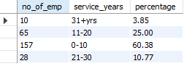

* It is observed that almost 60 % of employees leaving the company falls in the 0-10 years of service bracket.
* 25 % people falls in 11-20 years of bracket and almost 10 % people falls in the bracket 21 – 30
* It seems like people having 31+ years of experience are having lowest attrition rates.

1. **Salary wise Attrition Rates**

Here salary has been categorized equally into 10 parts ranging from 3 lakh to 99 lakh. We calculate the percentage of employee attrition for each salary bracket.

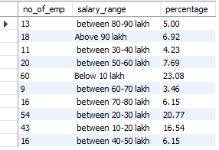

* From the table it is observed that significant no of people **(23%)**having salary less than 10 lakh are leaving the company followed by people having salary between 20 and 30 lakh and so on.
* The major attrition rates can be observed in the three salary range viz below 10 lakh bucket**(23.08%),** between 10 – 20 lakh bucket**(16.54%)** and between 20-30 lpa bucket**(20.77%).**
* So basically people having salary upto 30 lakh are more prone to leaving the company and rest are not significant in numbers.

1. **Department wise Attrition Rates**

Here the percentages of each departments attrition rates has been calculated.

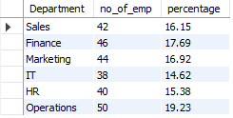

* It is observed that Operations department has the highest attrition rates(19.23) and IT department has the lowest attrition rates.
* There is no significant difference in the attrition rates of each department so department might not be a underlying factor for attrition rates.

1. **Position Wise Attrition Rates**

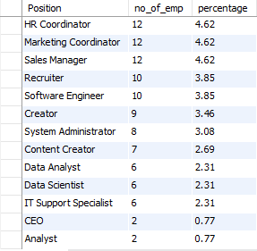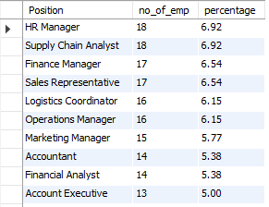Here the position wise attrition rates are calculated.

* From the above table we can observe that **HR manager** and **Supply Chain Analyst** has high attrition rates **(6.92 %).** Immediate attention is to be given to these positions as to what is the reason behind its high attrition Rates.
* **CEO and Analyst roles** has the least attrition rates(**0.77 %**) . This might be due to the higher job stability and employees find this role to be quite impactful in their career and growth.
* Multiple positions like **Finance Manager and Sales representative** have the same no of employees attritioned so there might be multifactor underlying causing the attrition.
* Interestingly, the HR Manager has a higher attrition rate (6.92%) compared to the HR Cordinator(4.62%), suggesting that the level in the hierarchy could be a factor in job stability.

1. **Gender Wise Attrition rate**



It is observed that males have higher attrition rates**(53.46%)** while female has comparatively lower attrition rates**(46.54%).**

1. 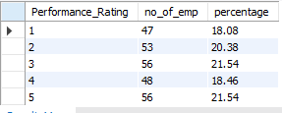**Performance rating wise Attrition rate**

There is a 5 scale performance rating and it is observed that there is not much significant difference among the distribution of employees with performance rating. We can say that performance rating is not influencing as a underlying factor to employee attrition rates.

1. **Promotion wise Attrition Rate**



It is observed that majority of the attrition is seen among those employees who are not given promotion. It is obvious though that employees look for promotion while working at a organisation for a longer run. So this might be a underlying factor in attrition of employees.

1. **Relationship between promotion and years of service**

So we have partitioned service of years in 4 parts of experience

Viz intern, freshers, intermediate, experience and leader.

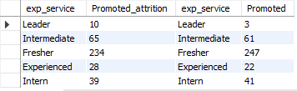Then we calculated the no of employess who are promoted and left the company (Promoted_attrition) and those who are promoted but did not leave.

* We can observe that the no of people promoted is equal to the no of people not promoted in the analysis.
* It is observed that there is a significant no of freshers **(234)** who are promoted but then left the company. This maybe due to other factors related to work which made them leave. While also there is a significant of number of freshers**(247)** who are promoted and stayed in the company.
* Followed by Intermedate experience level people who got promoted and also attritioned **(65)** and promoted and stayed (61).
* It is obvious that freshers are promoted more so number is more and reaching at the higher hierarchy there is no room for promotion.
* Also Interns any ways come as a contractual so they don’t contribute in full time employment thus irrespective of they are given promotion or not they are going to leave.
* Over all promotion has no significant impact on the underlying factor for attrition rates.

1. **Overall Comparison**



* The total employees(750) are divided in such a way that number of employees(376) leaving are almost similar to the number of people staying(374). This indicates that proper investigation is to be done for this high number of attritions.
* Interestingly average age of people leaving(35.7) is comparatively more than the people staying(34.6).
* It is observed that average salary of people(25 lakhs approx) leaving is significantly more than the average salary of people(23 lakhs approx) staying. This is quite intriqueing as though the average salary is more then also employees are leaving. So salary might not be the case for attrition.
* Employees who left have an average experience of 7.5 yrs while employees who stayed have an average experience of 6.3 yrs. This indicates that people after having an average of 7 yrs choose to switch to different companies.
* There is not much significant difference between average performance and average work time of the employees attritioned and retained. So performance and work time may not be underlying factors.
* It is a matter of concern that people leaving the company have more average commute distance compared to the people staying the company. So commute distance might be a underlying factor when employee choose to leave the company.
* It is also observed that people leaving the company have undergone more training hours that people retaining.
* It is quite confusing as to what would be the reason for having more satisfaction score among people who attritioned. That is people who left the company are not concerned with the work satisfaction.

## Problem Statement 2: Optimize Employee Training Programs

* **Objective**: To evaluate the current training initiatives' effectiveness and suggest improvements for fostering skill development and enhancing performance.

1. Effectiveness of training programmes: Training hours X Avg performance rating

To understand the current training initiatives we first try to find the no of employees who have gone through certain hours of training and their performances in the role.

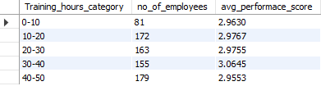

* Here it is observed that employees undergoing around 30 to 40 hours of training has yield better performance compared to others.
* It is also quite noticeable that giving excessive training (40-50 hours)to employees may exhaust them thus making them underperforming (2.95)
* There doesn’t seem to have direct correlation between performance and training hours and also linear increase can be seen upto training hours of 40 hours , post that performance decreased.

1. Promotions x Training Hours

Now we are to analyze whether after rigorous training hours employees are getting promoted or not .

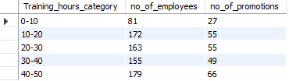

* From the above table it is observed that with increase in training hours employees are more often getting promotions.
* It is quite interesting that employees getting training hours between 10 hours to 20 hours are quite high in number(172) but they have not got much promotions (55).Proper investigation has to be done as to what is the reason behind it.
* It is observed that highest number of people have got 40 hours to 50 hours of training and also most of them have got promotions.

**Recomendation**

* Given the high attrition rates in the Finance and Operations departments, targeted retention programs may be effective. This could include mentorship programs, work-life balance initiatives, and career development plans.
* Employees with 0-10 years followed by 10 to 20 years of service are leaving at high rates. For newer employees, improved onboarding and mentorship could help. For veterans, new career growth opportunities or skill diversification may be beneficial.
* Surprisingly, employees in higher salary brackets are leaving more frequently. This could indicate that the issue is not salary but other factors like work culture, growth opportunities, or job satisfaction. A comprehensive review could help understand this counterintuitive trend.
* Employees with higher performance ratings are also leaving. Ensure that high performers are adequately recognized and have clear paths for career progression.
* While job satisfaction is generally high, employees are still leaving. Regular surveys and one-on-one meetings could help identify and address hidden issues.
* The number of training hours doesn't necessarily correlate with better performance. The focus should be on the quality and relevance of the training programs.
* Recommendations include focusing on training quality, tailoring training programs, and linking training to career progression.
* Further scope of the analysis would be in depth analysis of the employees of each department and user engagments.