Report On
Real-Time Patient Vital Monitoring System

By
Sakshi Falak - 02
Hirdhay Jadhwani - 03
Siddharth Jogi - 04
Sumanyu Joshi - 05
Nirmay Kadam - 06

Under the Guidance of
Mrs Vidya Pujari


Department of Computer Engineering
Vivekanand Education Society's Institute of Technology
2026-27

Table Of Contents

1. Problem Definition

2. Data Description
3. Proposed Solution and Methodology
4. Evaluation Plan
1. Problem Definition
The project addresses the delay and difficulty of monitoring repeated vital-sign readings across multiple patients. A clinician or operator needs a timely way to detect readings outside defined normal ranges, identify the patient and affected metric, and review both the latest state and the stored history. The project demonstrates this workflow with a distributed streaming-data stack; it is an educational prototype and does not make clinical diagnoses.
The system accepts heart rate, systolic and diastolic blood pressure, body temperature, respiration rate, and oxygen saturation (SpO2). Its task is to ingest readings continuously, apply explicit threshold rules, classify deviations as warnings or critical alerts, and make results available for live viewing and later analysis.
2. Data Description
The primary input is data/patient_vitals_3nights.csv, included with the project. It contains 43,200 synthetic readings for 10 patients, recorded once every 30 seconds over three simulated nights. The CSV is approximately 2.07 MB and contains patient ID, six vital measurements, and a simulated timestamp. The producer converts each row to JSON and adds an event timestamp when it is sent. No external download is required for this vital-sign file.
A separate patient master file, data/patients.csv, is described in the project README as 500,000 synthetic demographic records (name, age, ward, phone, and address) and is configured as an input to Spark for alert enrichment. That file is referenced by the pipeline but is not present in the supplied data folder at report preparation time; it must be added for the broadcast join and patient details to work. Without it, vitals ingestion and threshold processing can still be described, but enrichment is incomplete.
The vital-sign CSV is replayed as a stream. Kafka carries JSON messages; Spark writes vitals as date-partitioned Parquet and alerts as CSV to HDFS. Hive exposes SQL tables over those files, while HBase stores the latest reading and recent alerts for fast patient lookup. This gives the project structured CSV, JSON, Parquet, and key-value data representations.
3. Proposed Solution and Methodology
The producer reads the CSV and publishes keyed messages to the Kafka topic patient-vitals at a configurable rate (20 messages per second by default). Kafka buffers the stream and allows the Spark job, dashboard, and HBase writer to consume it independently.
Spark Structured Streaming processes the topic in five-second micro-batches. It parses messages against a fixed schema, converts event timestamps, and checks each vital against the project thresholds: heart rate 50 to 110 bpm, systolic pressure 80 to 150 mmHg, diastolic pressure 50 to 95 mmHg, temperature 95.0 to 100.4 degrees F, respiration 8 to 24 breaths/min, and SpO2 93.5 to 100%. Each out-of-range metric creates its own alert. A deviation more than 5% beyond the relevant boundary is classified CRITICAL; other violations are WARNING. These are rule-based thresholds, not a trained machine-learning model.
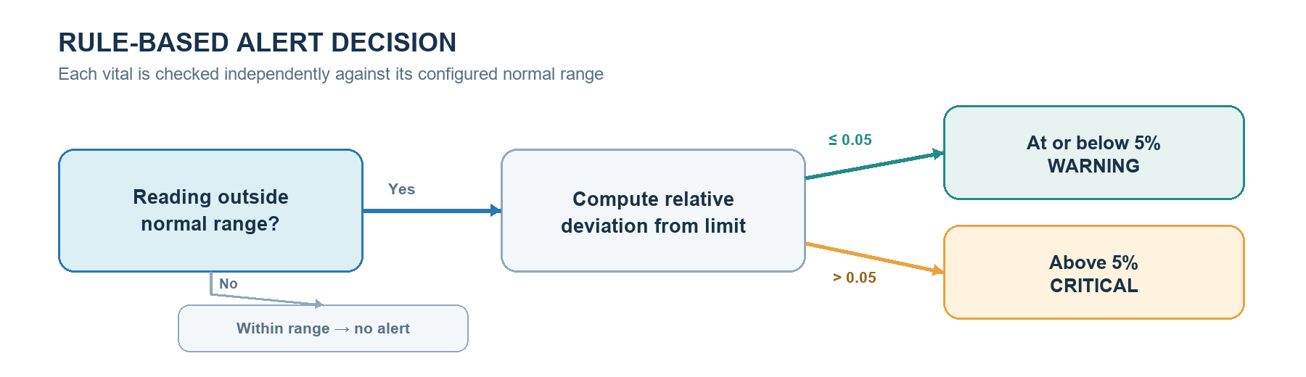
Figure 1. Rule-based alert severity decision
For each batch, Spark appends raw readings to HDFS in Parquet partitioned by date. Alerts are enriched with patient metadata using a broadcast join, written to HDFS as CSV, and published to patient-alerts in Kafka. A separate writer stores the latest reading and alert history in HBase. Hive external tables support SQL analysis over HDFS, and the Streamlit dashboard displays live readings, alerts, stored-data summaries, and patient lookups.
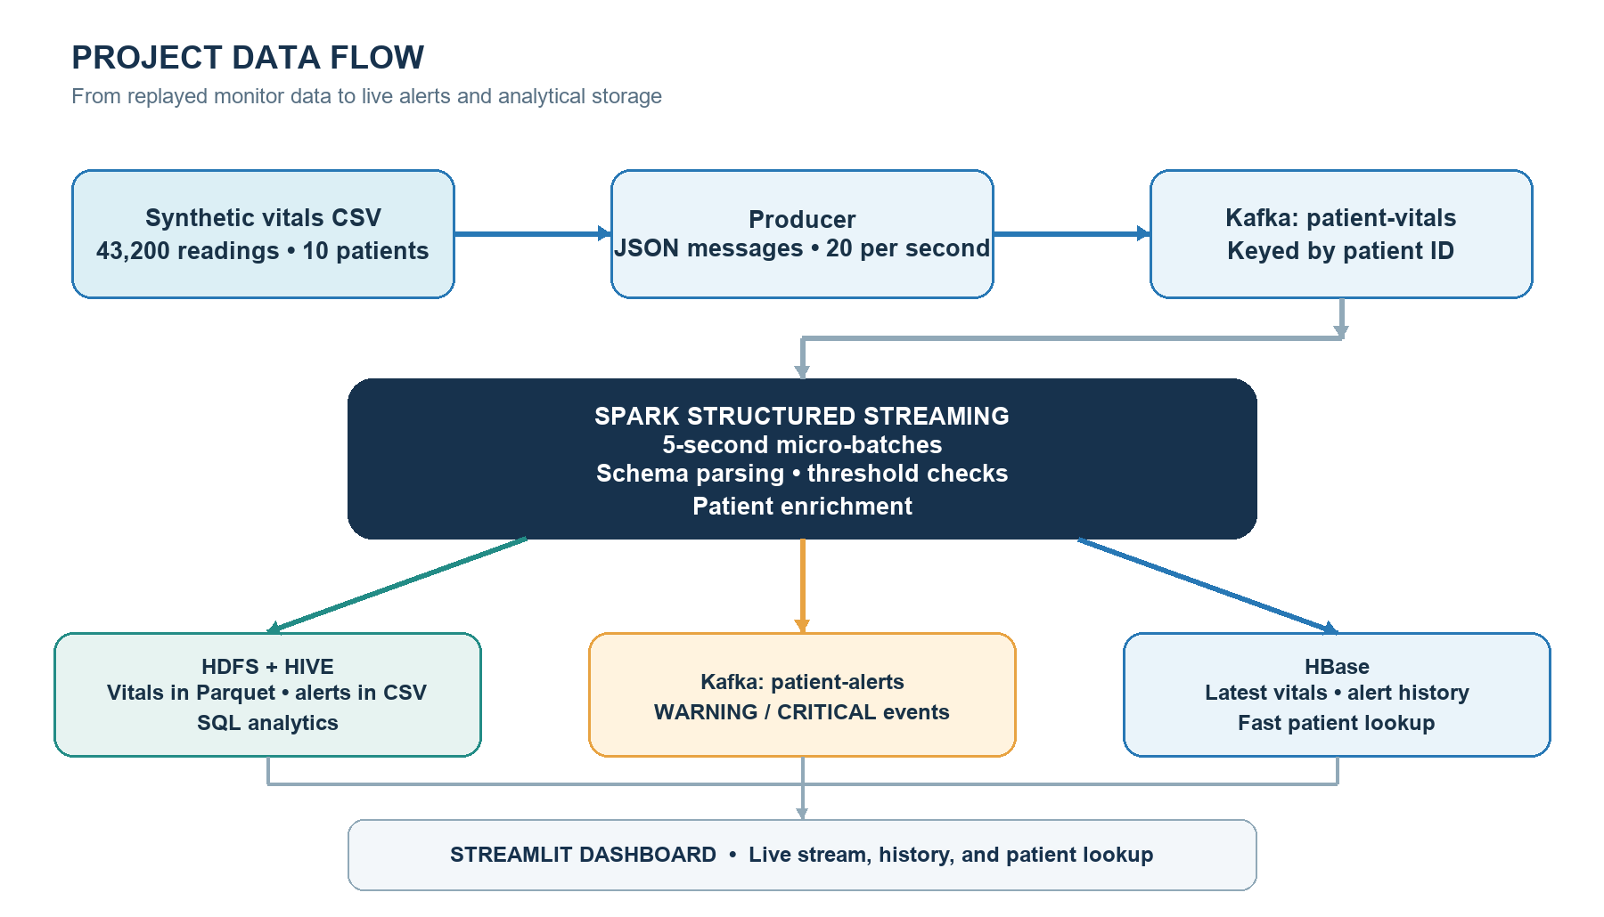
Figure 2. End-to-end project architecture
The current deployment is a local Docker Compose stack. The design can scale by increasing Kafka partitions and consumer parallelism, running Spark on a multi-node cluster, and configuring HDFS replication and HBase for cluster operation. The current single Kafka partition, local[2] Spark mode, single-node HDFS, and standalone HBase are suitable for a demonstration but limit throughput and fault tolerance. The five-second trigger sets a processing cadence, not a guaranteed end-to-end latency.
4. Evaluation Plan
Evaluation will use repeatable input batches with known expected outcomes. A small hand-checked test set should include values just inside each threshold, exactly at each boundary, just outside each boundary, and deviations on both sides of the 5% criticality rule. Expected alerts can then be compared with emitted alerts by patient, metric, direction, and severity. This provides an independent check of the implementation, including Fahrenheit temperature handling and missing or malformed fields.
For alert detection, calculate precision, recall, and F1 against the hand-checked expected alerts; report false positives and false negatives as counts as well. Compare the streaming rules with a simple offline baseline that applies the same documented thresholds to the same readings, then verify that both produce matching alert records. Because the baseline uses the same rule specification, agreement checks implementation consistency rather than clinical validity. No clinician-labeled ground truth is currently supplied, so clinical accuracy cannot be claimed.
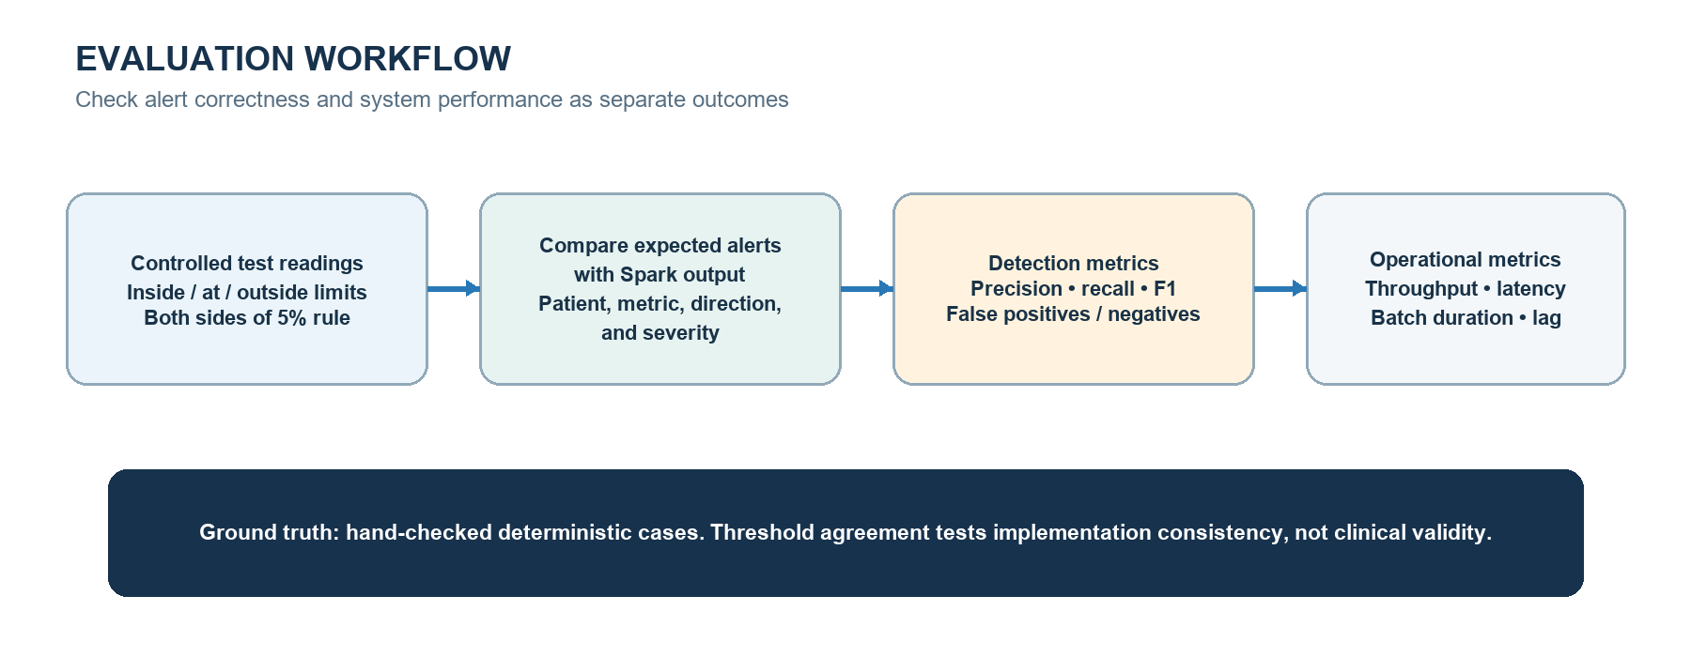
Figure 3. Proposed evaluation workflow
Measure operational performance separately: input throughput in messages per second, time from producer event timestamp to dashboard-visible alert, per-batch processing duration, and output counts in Kafka/HDFS/HBase. Repeat runs at increasing replay rates and record resource usage to identify when the local stack falls behind. Also check that Hive queries return the expected aggregate counts and that HBase lookups return the newest reading and alerts for selected patients.
Success means that all deterministic boundary cases yield the expected alert records, offline and streaming outputs agree on the same test inputs, the pipeline sustains the configured replay rate without growing lag during a run, and the stored/query results reconcile with the input and alert counts. Results should include the test-set size, replay rate, measured latency, and any missing-input or infrastructure limitations.

