California House Price Prediction — Project Report
Nov 6, 2026 · @Nirmay Kadam

Abstract
A tuned XGBoost model predicts the median house value of California census block groups with a test R² of 0.860 (RMSE $42,736, MAE $28,219). That is a 37% lower error than an ordinary least-squares Linear Regression (R² 0.647).
The project uses the 1990 California Housing dataset of 20,640 block groups. The workflow covers data acquisition, a data-quality audit, missing-value treatment, categorical encoding, univariate and bivariate exploratory analysis, correlation analysis, outlier detection and feature engineering. A held-out test set and 5-fold cross-validation validate every model.
Five models are compared: a mean baseline, Linear Regression (solved by hand from the normal equations and checked against scikit-learn), Linear Regression on a log target, Random Forest, and XGBoost trained on an NVIDIA RTX 3050 GPU. XGBoost beats Random Forest on every fold (paired t-test p < 0.001).
Residual analysis exposes two weaknesses. Linear Regression has the wrong functional form and predicts negative prices for 54 test blocks. Every model under-predicts the 4.7% of blocks whose value is capped at $500,001. Spatial cross-validation, which holds out whole regions, lowers the tree models' R² to about 0.71. Random K-fold therefore overstates accuracy for unseen areas.
Median income, location and ocean proximity are the dominant predictors. The best model is deployed in a Streamlit map application whose own measured accuracy is R² 0.827. The report closes with the ethical risks of location-based valuation: proxy discrimination, feedback loops and privacy.

1. Introduction and objectives
House prices depend on a few measurable traits of a neighbourhood: its income, its location, and the size and age of its homes. A model that learns these relationships can estimate values, explain what drives them, and show where estimates should not be trusted. This project builds such a model for California and treats validation and interpretation as seriously as accuracy.

1.1 Problem statement
Given the census attributes of a California block group, predict its median house value in US dollars. The task is supervised regression on independent observations. Accuracy is measured with MAE, RMSE and R² on data the model has never seen.

1.2 Objectives
- Acquire a real public dataset and document its source and structure.
- Assess data quality and treat missing values, categories and outliers with evidence, not by default.
- Explore the data with univariate, bivariate and correlation analysis.
- Engineer features that carry more signal than the raw columns.
- Fit a least-squares Linear Regression and verify the solution from first principles.
- Compare it with Random Forest and XGBoost using cross-validation and a held-out test set.
- Diagnose errors through residual analysis and interpret the most important predictors.
- Deploy the model in an interactive application and measure its real accuracy.
- Discuss the limitations and the ethical issues of location and property data.

1.3 Coverage of the brief
Requirement of the DMBI brief | Where it is addressed
Data acquisition from a public dataset | Section 2
Data cleaning and transformation | Sections 3, 5, 8
Descriptive and exploratory analysis | Section 6
At least 4 meaningful visualisations | 12 figures, Sections 3–13
A technique beyond basic EDA | Least-squares optimisation, Isolation Forest, ensembles, spatial cross-validation
Quantitative evaluation (MAE, RMSE, R²) | Section 11
Appropriate validation (K-fold, held-out test) | Sections 4, 11
Comparison of at least two methods | IQR vs Isolation Forest; drop vs impute; Linear Regression vs Random Forest vs XGBoost
Interpretation of errors and limitations | Sections 12, 15
Dashboard or decision summary | Sections 14, 16
Ethical issues in location and property data | Section 15

2. Dataset and data acquisition
The data is the California Housing dataset: 20,640 rows and 10 columns from the 1990 U.S. Census, loaded from housing.csv with pandas.

2.1 Source
- Original compilation: R. Kelley Pace and Ronald Barry, "Sparse Spatial Autoregressions", Statistics & Probability Letters 33 (1997), pages 291–297. Distributed through the StatLib repository at Carnegie Mellon University.
- Version used: the edition published with A. Géron, Hands-On Machine Learning with Scikit-Learn, Keras and TensorFlow. It adds the categorical column ocean_proximity and deliberately removes 207 values of total_bedrooms to teach missing-value handling. It is mirrored on Kaggle as camnugent/california-housing-prices.

2.2 Unit of observation
Each row is one census block group, the smallest area for which the Census publishes sample data. A block group typically holds 600 to 3,000 people. A row is therefore a neighbourhood summary, not a single house. Counts such as total_rooms are block totals, and the target is the block's median value. This shapes both how the results can be used and the ethical discussion in Section 15.

2.3 Variables
Variable | Type | Meaning | Unit
longitude | numeric | east–west position | degrees
latitude | numeric | north–south position | degrees
housing_median_age | numeric | median age of houses in the block | years
total_rooms | numeric | total rooms in the block | count
total_bedrooms | numeric | total bedrooms in the block | count
population | numeric | residents of the block | count
households | numeric | households in the block | count
median_income | numeric | median household income | tens of thousands of USD
ocean_proximity | categorical | distance class to the coast (5 levels) | category
median_house_value | numeric, target | median house value | USD

3. Data-quality assessment
The data is complete and consistent except for 207 missing bedroom counts. Its main quality problem is censoring: the target and two features were capped by the original collectors.
Check | Finding | Consequence
Missing values | total_bedrooms only: 207 rows (1.0%) | Treated in Section 5
Duplicate rows | 0 | None
Impossible values | No zero or negative counts; coordinates all inside California | None
Censored target | 965 rows (4.7%) at exactly $500,001 | True values above $500k are unknown; expensive areas will be under-predicted
Censored age | 1,273 rows (6.2%) at 52 years | Older stock cannot be distinguished
Censored income | 49 rows (0.2%) at 15.0001 | Negligible
Rare category | ISLAND has 5 rows; the other classes have 2,290–9,136 | Its effect cannot be estimated reliably
Skewed counts | Skewness 3.4–4.9 for rooms, bedrooms, population, households | Log transform for the linear model
The censoring spike is the single most important quality finding. A model trained on this target can never predict well above $500k, and the errors on capped rows are partly unknowable. Section 12 measures how large those errors are.
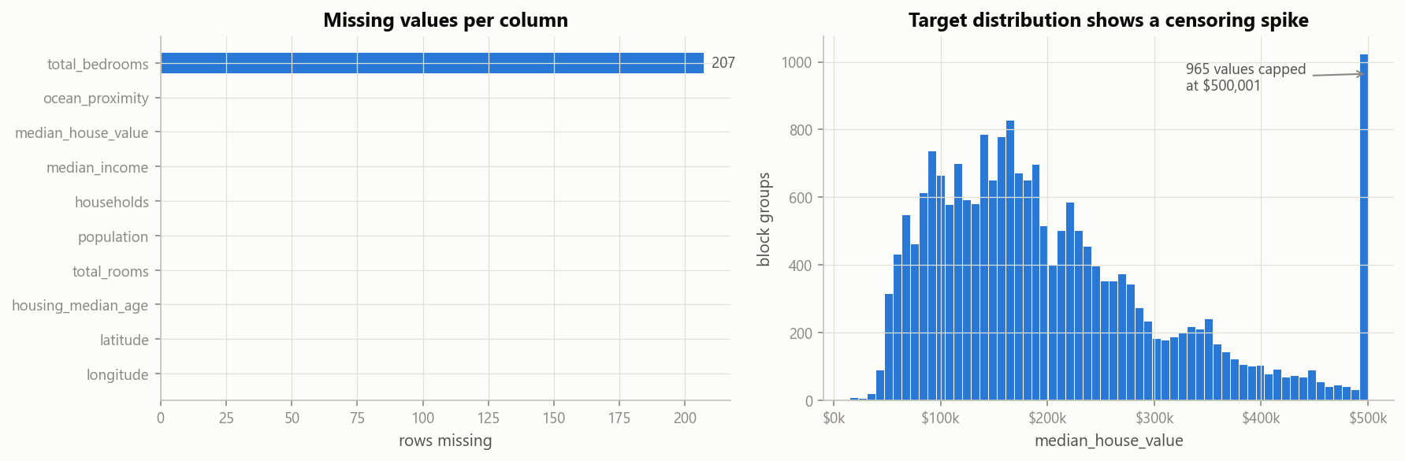
Figure 1. Only total_bedrooms has missing values (left); 965 target values sit at the $500,001 cap (right).

3.1 Categories of ocean proximity
Category | Rows | Share
<1H OCEAN | 9,136 | 44.3%
INLAND | 6,551 | 31.7%
NEAR OCEAN | 2,658 | 12.9%
NEAR BAY | 2,290 | 11.1%
ISLAND | 5 | 0.02%

4. Methodology and workflow
Every transformation lives inside one scikit-learn Pipeline, and the data is split before any of it is learned. This prevents leakage and guarantees that the deployed app transforms inputs exactly as training did.

4.1 Workflow
- Load the raw CSV and audit its quality.
- Split 80/20 into training and test sets, stratified by income band.
- Explore the data and decide treatments for missing values, categories and outliers.
- Build the pipeline: feature engineering, imputation, encoding, and (linear model only) log transform and scaling.
- Tune the tree models with randomized search and 5-fold cross-validation on the training set.
- Compare all models with the same 5 folds, then score each once on the test set.
- Run spatial cross-validation, residual analysis and permutation importance.
- Save the best pipeline and use it in the Streamlit app.

4.2 Train-test split
The data is split 80/20 with random_state=42: 16,512 training rows and 4,128 test rows. The split is stratified on five income bands (0–1.5, 1.5–3, 3–4.5, 4.5–6 and above 6, in $10k), because income is the strongest predictor. Mean income is 3.876 in training and 3.850 in test.
The split happens before imputation, scaling or tuning. Medians, scaling parameters and hyper-parameters are therefore learned from training rows only. The test set is used exactly once, for the final scores in Section 11.

4.3 One pipeline for training and deployment
The shared module housing_features.py defines the feature engineering and the preprocessing. Each model is wrapped as features → preprocessing → estimator and saved as a single object. The app passes raw values to that object. The earlier version of this project applied a log transform in training but not in the app, so every app prediction was wrong; the single pipeline removes that class of bug.

4.4 Tools and hardware
Component | Choice
Language | Python 3.11 in a project virtual environment
Data handling | pandas 2.2, NumPy 1.26
Modelling | scikit-learn 1.6, XGBoost 2.1
Statistics | statsmodels 0.14, SciPy 1.13
Visualisation | Matplotlib 3.9, Seaborn 0.13
Application | Streamlit 1.41, Folium
Hardware | NVIDIA RTX 3050 Laptop GPU (6 GB) for XGBoost; multi-core CPU for Random Forest

5. Missing-value treatment and categorical encoding
Median imputation inside the pipeline was chosen over dropping rows: both score within 1%, but imputation keeps every row and can score new inputs. ocean_proximity is one-hot encoded, with a reference category for the linear model.

5.1 Drop rows or impute?
The two strategies were compared with the same Linear Regression pipeline and 5-fold cross-validation on the training set.
Strategy | Training rows used | CV RMSE | CV R²
A. Drop incomplete rows | 16,354 | $67,088 | 0.664
B. Median imputation in the pipeline | 16,512 | $67,831 | 0.656
The difference is about 1%, because only 1% of rows are affected. The comparison is not perfectly like for like: strategy A simply excludes the 158 incomplete training rows from its folds. Strategy B was chosen for three reasons:
- It keeps all data.
- It can still score a new property whose bedroom count is unknown, which deletion cannot.
- The imputer is part of the pipeline, so its median is re-learned on each training fold and never sees validation or test rows.
total_bedrooms correlates about 0.93 with total_rooms. A regression imputer using rooms would be a natural refinement, but the gain is bounded by the 1% of rows affected.

5.2 Categorical encoding
ocean_proximity has five unordered levels, so label encoding (0–4) would impose a false order. It is one-hot encoded with OneHotEncoder(handle_unknown="ignore"), which turns each level into a 0/1 column and tolerates an unseen level at prediction time.
- Linear Regression: the first level, <1H OCEAN, is dropped as the reference. Keeping all five dummies alongside the intercept would make the design matrix rank-deficient (the dummy-variable trap). Each remaining coefficient reads as the difference from <1H OCEAN, holding the other features fixed.
- Tree models: all five dummies are kept. Trees have no intercept and are unaffected by collinear dummies.
The earlier version of the project dropped ocean_proximity entirely. Section 13 shows it is among the four most important predictors for both tree models.

6. Exploratory data analysis
Income is the strongest single predictor of value (r = 0.69), location acts in a strongly non-linear way, and the raw count columns are skewed and highly collinear.

6.1 Univariate analysis
Variable | Mean | Median | Skewness
total_rooms | 2,636 | 2,127 | 4.15
total_bedrooms | 538 | 435 | 3.46
population | 1,425 | 1,166 | 4.94
households | 500 | 409 | 3.41
median_income ($10k) | 3.87 | 3.53 | 1.65
housing_median_age (years) | 28.6 | 29.0 | 0.06
median_house_value (USD) | 206,856 | 179,700 | 0.98
- Count columns are strongly right-skewed: mean well above median, with a long tail of very large block groups. A log transform makes them roughly symmetric, which helps the linear model; trees do not need it.
- Median income is moderately skewed and top-coded at 15.
- The target is right-skewed with a spike at the $500,001 cap (Figure 1).
- Latitude is bimodal, with peaks at the Bay Area (about 37.8°N) and Los Angeles (about 34°N).
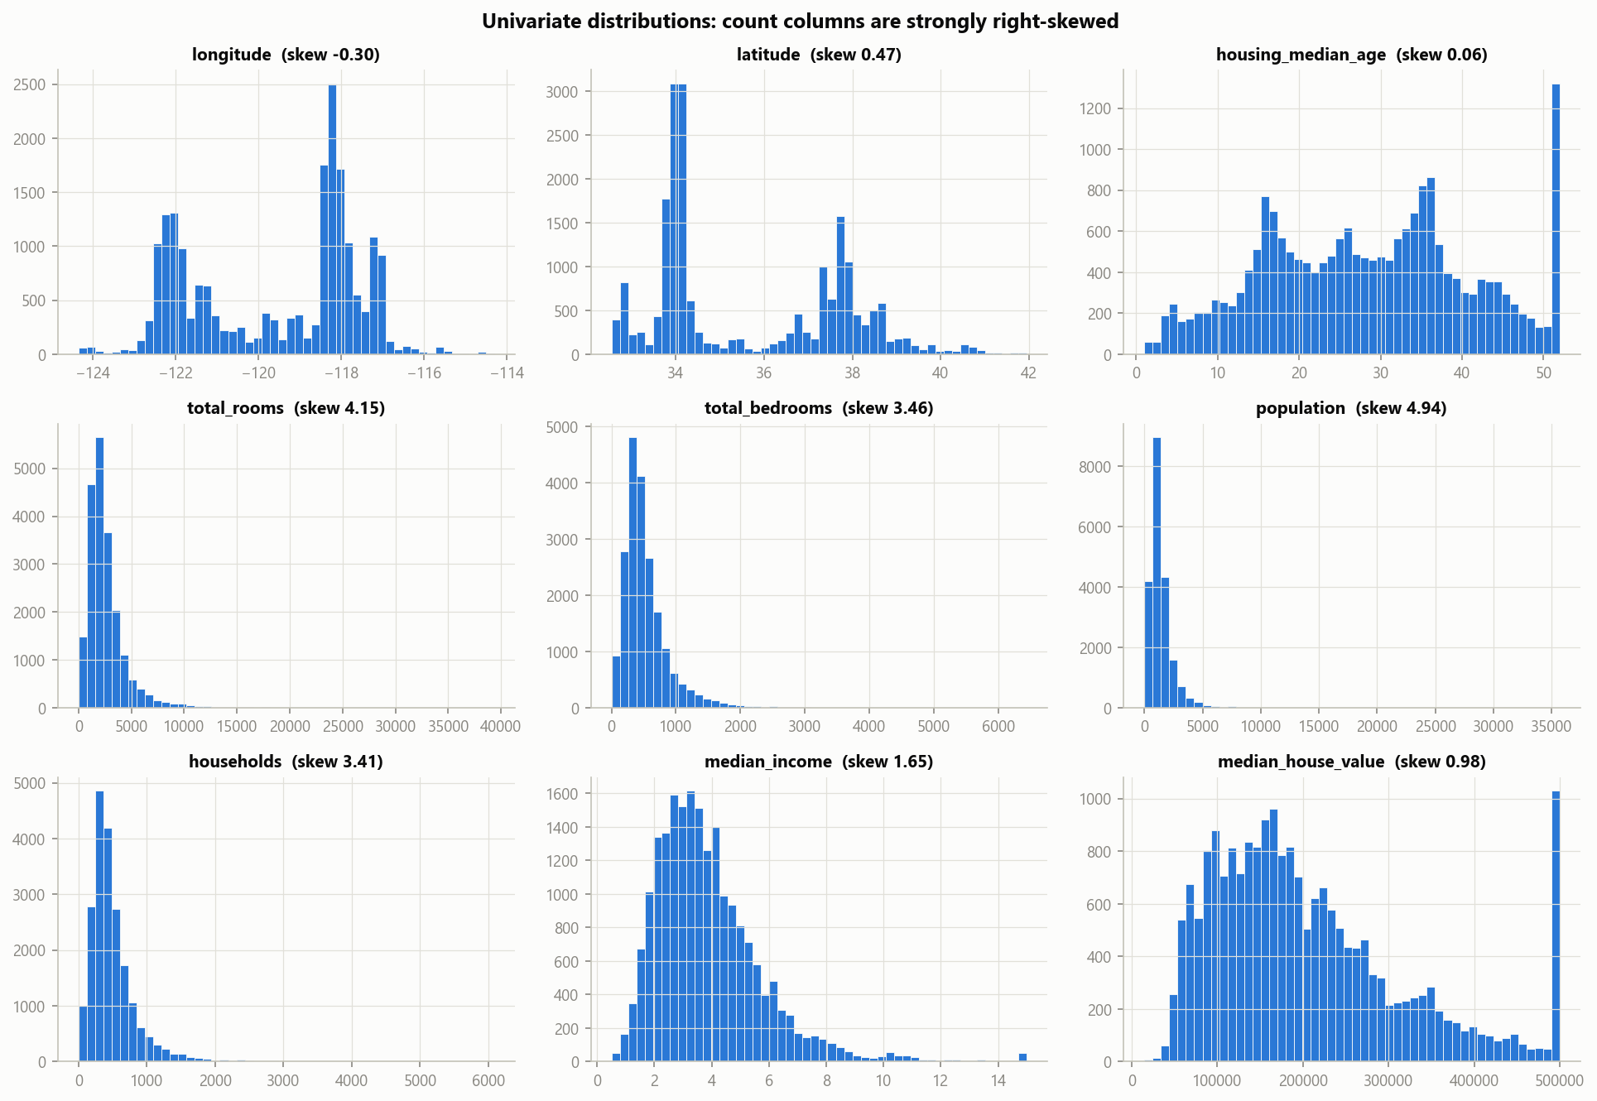
Figure 2. Univariate distributions: the count columns are strongly right-skewed.

6.2 Bivariate analysis
- Income vs value: a clear positive relationship whose spread widens as income rises (heteroscedasticity). Values pile up along a hard ceiling at $500k.
- Value by ocean proximity: INLAND blocks have a median of about $108k, against about $215k–$235k for the coastal categories. This is a large categorical effect.
- Geography: the price map shows expensive clusters along the Bay Area, Los Angeles and San Diego coasts, and cheaper values inland. A straight line in latitude and longitude cannot describe this pattern; tree models can partition the map into regions.
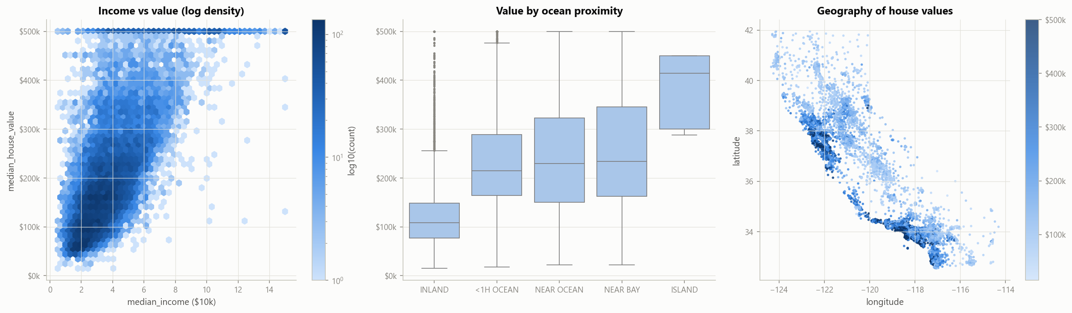
Figure 3. Value rises with income and hits a ceiling at $500k (left); inland blocks are far cheaper (centre); expensive blocks cluster on the coast (right).

6.3 Correlation analysis
Pearson (linear) and Spearman (rank) correlations were computed for all numeric and engineered features.
Feature | Pearson r with value
median_income | +0.688
bedrooms_per_room (engineered) | −0.256
rooms_per_household (engineered) | +0.152
latitude | −0.144
total_rooms | +0.134
housing_median_age | +0.106
households, total_bedrooms, population | −0.03 to +0.07
Two findings shape the modelling:
- The raw counts barely relate to price but correlate above 0.85 with each other. That is a multicollinearity warning for the linear model, confirmed by the VIF analysis in Section 9.
- Spearman exceeds Pearson for income, so the relationship is monotonic but not perfectly linear. A model that can bend, like a tree ensemble, should do better.
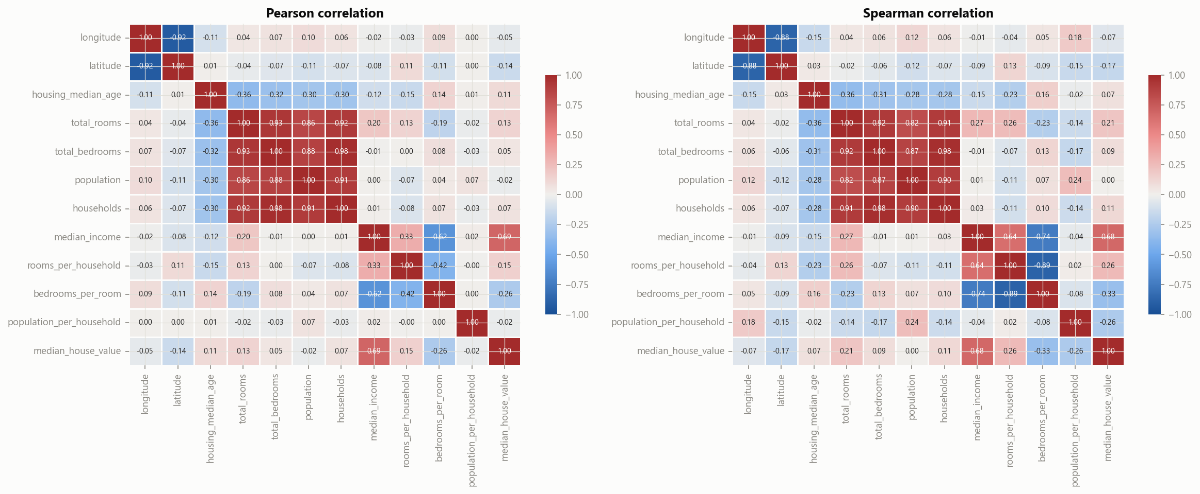
Figure 4. Pearson and Spearman correlation matrices: income dominates, and the raw counts correlate strongly with each other.

7. Outlier identification
The IQR rule and Isolation Forest agree on most flagged rows, but neither finds data errors, so all rows were kept and their influence controlled through transformation and robust models.

7.1 Two methods
- IQR rule (univariate): a value is an outlier if it lies below Q1 − 1.5·IQR or above Q3 + 1.5·IQR, where IQR = Q3 − Q1. A row is flagged if any of its 11 numeric features is an outlier.
- Isolation Forest (multivariate): random trees split the feature space; points that are isolated in few splits are anomalous. Its contamination was set to the IQR flag rate, so the two methods flag the same number of rows and can be compared on which rows they choose.

7.2 Results
Method | Rows flagged | Median value of flagged rows
IQR rule (any feature) | 3,938 (19.1%) | $188,400
Isolation Forest | 3,938 (19.1%) | $187,500
Flagged by both | 2,899 | $205,000
The Jaccard overlap (rows flagged by both ÷ rows flagged by either) is 0.58. IQR flags most often on the count columns: 1,306 rows on total_bedrooms, 1,287 on total_rooms, 1,220 on households and 1,196 on population. It flags none on latitude, longitude or age.
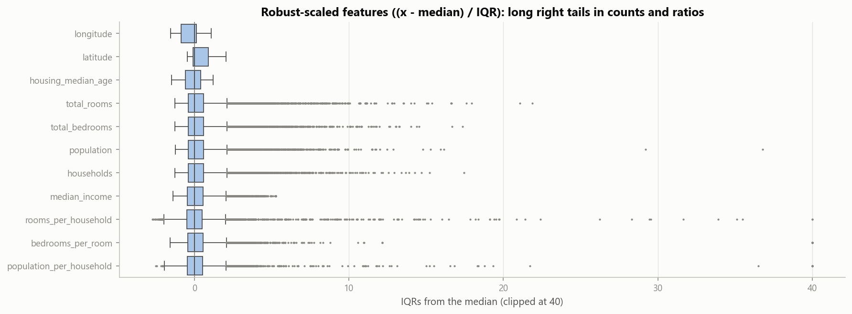
Figure 5. Features scaled as (x − median) / IQR: counts and ratios have long right tails.

7.3 Interpretation and decision
A univariate rule applied to 11 heavy-tailed columns over-flags: one in five rows cannot all be anomalies. Most IQR flags are simply large block groups. Isolation Forest agrees on most rows but also picks rows that are unusual in combination, such as many rooms per household with few residents (holiday homes and resort areas), even when no single column is extreme.
Decision: keep every row. None of the flagged rows is a data-entry error, and removing them would delete exactly the unusual neighbourhoods a deployed model must handle. Their influence is controlled in two ways instead:
- A log transform compresses the long tails for the linear model.
- Tree ensembles split on ranks, so extreme values cannot pull their predictions far.
The censored targets are a different problem, not outliers, and are treated as a limitation (Sections 12 and 15).

8. Feature engineering
Three per-household ratios replace the raw block totals as carriers of signal; in the final model the ratios matter and the raw totals contribute almost nothing.

8.1 Rationale
A block total such as total_rooms mostly measures how big the block group is, not what its homes are like. Two blocks with 3,000 rooms can be 300 large houses or 1,000 small flats. Dividing by the number of households turns totals into descriptions of a typical home.
Feature | Formula | Meaning | Pearson r with value
rooms_per_household | total_rooms / households | average home size | +0.152
bedrooms_per_room | total_bedrooms / total_rooms | layout; higher means smaller homes | −0.256
population_per_household | population / households | crowding | −0.024

8.2 A correction to the earlier version
The earlier notebook log-transformed the counts first and then divided them. That produced quantities such as log(bedrooms) / log(rooms), which have no meaning. The ratios are now computed from the raw counts; the log transform, where used, is applied afterwards.

8.3 Preprocessing by model family
Step | Linear Regression | Random Forest and XGBoost
Add the three ratios | yes | yes
Median imputation | yes | yes
log(1 + x) on skewed counts and ratios | yes | no
Standardisation (zero mean, unit variance) | yes | no
One-hot ocean_proximity | yes, <1H OCEAN dropped | yes, all levels kept
Trees split on thresholds, so monotonic transforms such as logs and scaling change nothing for them.

8.4 Evidence the features help
population_per_household has a near-zero linear correlation, yet it is the strongest engineered feature in both tree models: shuffling it raises test RMSE by $19.0k (Random Forest) and $12.6k (XGBoost). Crowding acts non-linearly, which correlation cannot see. Meanwhile each raw total raises RMSE by less than $1k once the ratios exist (Section 13).

9. Least-squares regression
The least-squares coefficients solved by hand match scikit-learn to within 1.4 × 10⁻⁶. The fitted model explains 65.9% of training variance, but severe multicollinearity makes several of its coefficients uninterpretable.

9.1 The optimisation problem
Ordinary least squares (OLS) chooses the coefficient vector β that minimises the residual sum of squares between observed values y and predictions Xβ, where X is the design matrix with a leading column of ones for the intercept:
\hat{\beta} = \arg\min_{\beta} \lVert y - X\beta \rVert^2
Setting the gradient −2Xᵀ(y − Xβ) to zero gives the normal equations, whose solution is unique when XᵀX is invertible:
X^\top X \, \hat{\beta} = X^\top y \quad\Rightarrow\quad \hat{\beta} = (X^\top X)^{-1} X^\top y

9.2 Verification from first principles
The transformed training matrix (16,512 rows × 15 features, plus the intercept) was solved in two ways and compared with scikit-learn's LinearRegression.
Method | Max absolute difference from scikit-learn
Normal equations, np.linalg.solve(XᵀX, Xᵀy) | 1.4 × 10⁻⁶
np.linalg.lstsq (SVD-based) | 2.6 × 10⁻⁹
The SVD route is more accurate because it avoids forming XᵀX, which squares the matrix's condition number. The training residual sum of squares is 7.53 × 10¹³.

9.3 Statistical inference
A statsmodels OLS fit gives R² = 0.659 (adjusted 0.659) and F = 2,128 (p < 0.001). Coefficients are per one standard deviation of the transformed feature; dummies are relative to <1H OCEAN.
Term | Coefficient | p-value
Intercept | +$218,500 | < 0.001
median_income | +$74,610 | < 0.001
latitude | −$61,670 | < 0.001
longitude | −$59,270 | < 0.001
housing_median_age | +$15,380 | < 0.001
ocean_proximity = INLAND | −$31,460 | < 0.001
ocean_proximity = ISLAND | +$108,400 | 0.023
households | +$536,900 | < 0.001
population | −$354,500 | < 0.001
total_rooms | −$144,100 | < 0.001
bedrooms_per_room | +$31,370 | < 0.001
Nearly every term is significant, largely because n ≈ 16,500 makes even small effects detectable. Significance does not show that the linear form is right; the residuals in Section 12 show it is not.

9.4 Multicollinearity
Feature | Variance inflation factor
total_rooms | 4,536
households | 4,383
population | 771
rooms_per_household | 540
population_per_household | 104
total_bedrooms | 84
bedrooms_per_room | 14
latitude / longitude | 10.2 / 9.6
median_income | 2.7
housing_median_age | 1.2
A VIF above 10 signals problematic collinearity; here it reaches 4,500. After the log transform each ratio is an exact linear function of the counts, since log(a/b) = log a − log b. The symptoms are visible in Section 9.3: huge opposite-signed coefficients for households (+$537k) and total_rooms (−$144k), and a positive coefficient for bedrooms_per_room although its raw correlation with value is negative.
Predictions are unaffected, because the cancelling coefficients still combine correctly. Interpretation must rely on the low-VIF terms: income, location, age and ocean proximity.

10. Models and hyper-parameter tuning
Five models span the range from no learning to boosted ensembles; the two tree models were tuned by randomized search with 5-fold cross-validation, XGBoost on the GPU.

10.1 Models compared
Model | Why it is included | Hardware
Baseline (predict the training mean) | The floor every model must beat | CPU
Linear Regression | Interpretable least-squares reference (Section 9) | CPU
Linear Regression on log(price) | Tests whether modelling log(value) fixes skew and heteroscedasticity | CPU
Random Forest | Averages many deep trees on bootstrap samples; captures non-linearity and interactions | CPU, all cores
XGBoost | Gradient boosting: trees added one at a time, each fitting the previous ensemble's errors, with shrinkage and regularisation | GPU (CUDA)

10.2 Tuning procedure
RandomizedSearchCV sampled hyper-parameter settings and scored each by 5-fold cross-validated RMSE on the training set. The full pipeline was tuned, so imputation was re-fitted inside every fold.
Setting | Random Forest | XGBoost
Settings sampled | 20 | 30
Fits (settings × 5 folds) | 100 | 150
Search space | trees 200–500; depth 20, 30 or none; min leaf 1–4; features per split 0.33–1.0 | trees 400–1,200; depth 4–8; learning rate 0.03–0.1; row and column subsampling 0.6–1.0; min child weight 1–5; L2 penalty 1–5
Best setting | 500 trees, max depth 30, max features 0.5, min samples per leaf 1 | 1,200 trees, max depth 8, learning rate 0.03, subsample 0.7, column sample 0.6, min child weight 1, L2 penalty 5
Best CV RMSE | $49,153 | $45,053
Search time (last run) | about 5 minutes | about 5 minutes
The XGBoost optimum combines many trees with a small learning rate and strong subsampling. That is the classic recipe for boosting that generalises: each tree contributes a little, and randomness decorrelates the trees.

10.3 What the GPU contributed
XGBoost was trained with device="cuda" on the RTX 3050. A helper function falls back to the CPU automatically, so the notebook runs on any machine.
On this dataset, one fit of the best XGBoost configuration took 5.8 seconds on the GPU and 3.6 seconds on a multi-core CPU. With only 16,500 rows × 16 features, the cost of moving data to the GPU and launching kernels outweighs the parallel speed-up. The GPU still kept the 150-fit search to about 5 minutes without occupying the CPU. GPU training pays off clearly at hundreds of thousands of rows or more.
Random Forest ran on the CPU because scikit-learn has no GPU backend and RAPIDS cuML does not run on native Windows.

11. Validation and model comparison
XGBoost is the best model on every metric: test R² 0.860, RMSE $42,736 and MAE $28,219, with cross-validated and test scores in close agreement.

11.1 Metrics
- MAE (mean absolute error): the average size of an error in dollars. Easy to explain and robust to a few large misses.
- RMSE (root mean squared error): squares errors before averaging, so large misses weigh more. Always at least as large as MAE.
- R² (coefficient of determination): the share of variance in value explained by the model. 0 means no better than the mean; 1 means perfect.

11.2 Cross-validation and test results
All models used the same five folds of the training set, so their fold scores can be compared pair by pair. Each model was then refitted on the whole training set and scored once on the 4,128 test rows.
Model | CV RMSE (mean ± std) | CV R² | Test MAE | Test RMSE | Test R² | Train R²
Baseline (mean) | $115,699 ± 1,068 | 0.000 | $90,807 | $114,165 | 0.000 | 0.000
Linear Regression | $67,831 ± 742 | 0.656 | $50,542 | $67,807 | 0.647 | 0.659
Linear Regression, log target | $66,027 ± 972 | 0.674 | $44,974 | $79,670 | 0.513 | 0.678
Random Forest | $49,153 ± 877 | 0.819 | $31,111 | $46,826 | 0.832 | 0.976
XGBoost | $45,053 ± 964 | 0.848 | $28,219 | $42,736 | 0.860 | 0.983
The fold standard deviations are about 2% of the mean, so the ranking is stable. Test scores sit close to the CV estimates for every model except the log-target variant, discussed below.
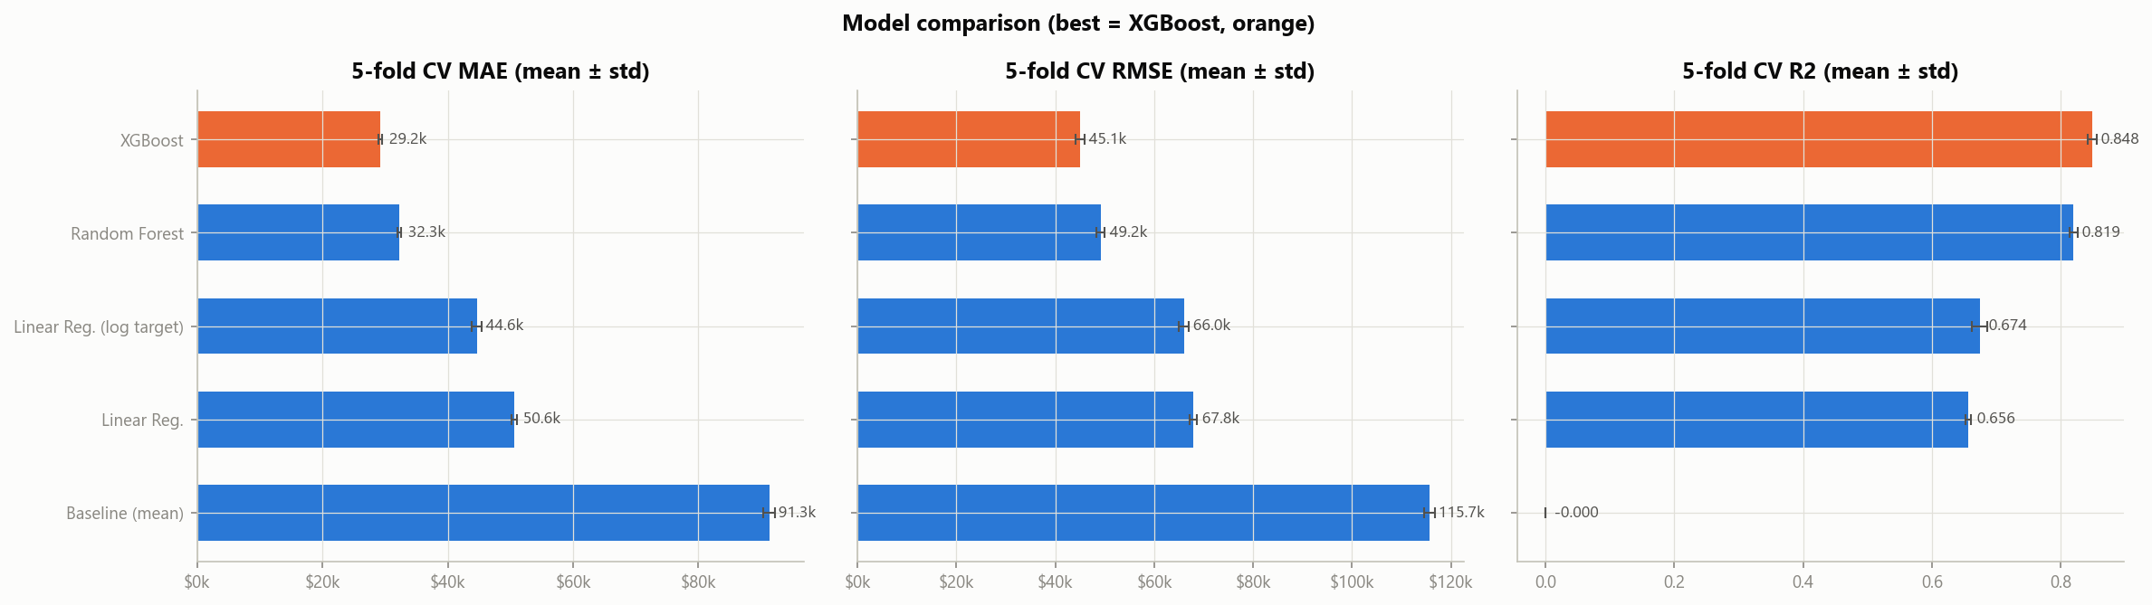
Figure 6. Cross-validated MAE, RMSE and R² (mean ± standard deviation over 5 folds); XGBoost highlighted.

11.3 Why the tree models win
- Non-linearity. Value curves with income and saturates at the cap, and location acts as a patchwork of coastal clusters. A linear model in latitude and longitude cannot represent either.
- Interactions. The same income buys far less house inland than on the coast. Trees model income × location interactions automatically; OLS would need hand-made interaction terms.
- The log target is not the fix. Modelling log(value) lowers Linear Regression's MAE from $50.5k to $45.0k, but its test RMSE worsens to $79.7k. Converting predictions back with exp() inflates a few extreme predictions, and RMSE punishes them heavily. The problem is the functional form, not just the scale of the target.
- Bias against variance. Linear Regression barely overfits (train–test R² gap 0.012): it underfits. The trees fit training data almost perfectly, with gaps of 0.144 (Random Forest) and 0.123 (XGBoost), yet their test errors are far lower. The extra variance is worth paying for.

11.4 Random Forest against XGBoost
Fold | 1 | 2 | 3 | 4 | 5
Random Forest RMSE | $48,458 | $49,395 | $49,222 | $50,615 | $48,077
XGBoost RMSE | $44,539 | $45,891 | $44,794 | $46,365 | $43,677
XGBoost wins on all five folds. A paired t-test on the fold RMSEs gives t = 23.5, p < 0.001. Because training folds overlap, the test is indicative rather than exact, but the consistent margin of about $4,000 per fold is clear.

11.5 Spatial cross-validation
Neighbouring block groups are very similar. With random folds, almost every validation block has a near-identical neighbour in training, so the score partly measures interpolation. GroupKFold on 0.5° grid cells (169 groups) holds out whole regions at once.
Model | Random K-fold R² | Spatial GroupKFold R² | RMSE increase
Linear Regression | 0.656 | 0.604 | +3%
Random Forest | 0.819 | 0.716 | +21%
XGBoost | 0.848 | 0.710 | +33%
The tree models lose far more than Linear Regression when whole regions are unseen, and XGBoost's lead over Random Forest disappears. Part of their advantage is local interpolation from neighbours. For genuinely new areas, R² of about 0.71 is the honest expectation; the trees still clearly beat Linear Regression.

12. Residual analysis
Residuals confirm that Linear Regression has the wrong functional form, show that XGBoost's errors are unbiased except on capped blocks, and locate the largest errors on the expensive coast. A residual is the actual value minus the predicted value; positive means the model under-predicted.

12.1 Linear Regression
- Funnel shape: the spread of residuals grows with the predicted value. This is heteroscedasticity, which violates the constant-variance assumption behind OLS inference.
- Curvature: residuals bend systematically across the range of predictions instead of scattering evenly around zero, a sign that the relationship is not linear.
- Impossible predictions: the model predicts a negative price for 54 of the 4,128 test blocks, because a straight line extrapolates past zero for cheap areas.

12.2 XGBoost
- Residuals scatter around zero with no visible trend across the predicted range.
- There are no negative predictions. 34 predictions exceed $500,001, which is plausible because the true values of capped blocks lie above the cap.
- The Q-Q plot shows heavy tails: large errors are more frequent than a normal distribution would imply. Interval estimates based on normal errors would be too narrow.
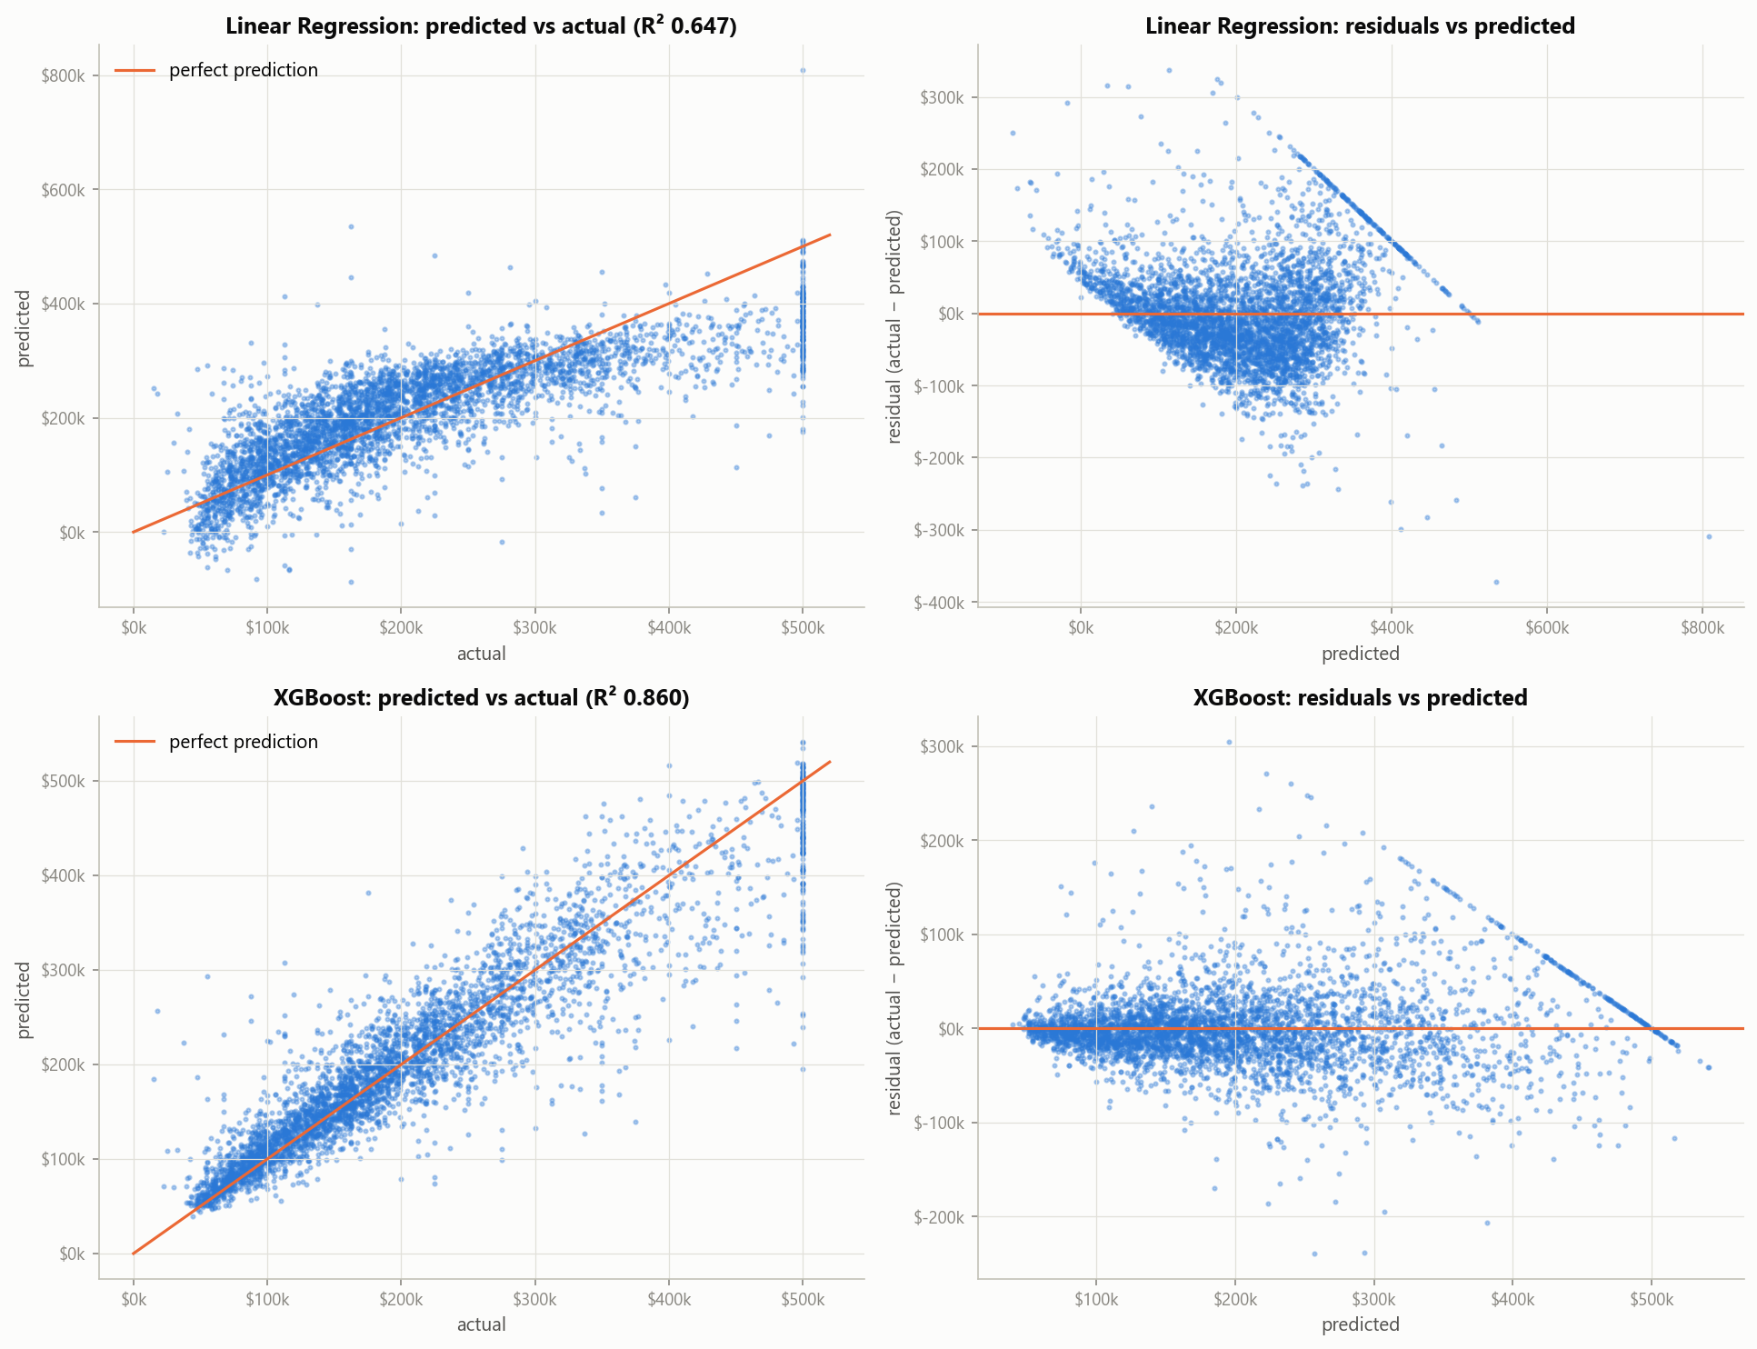
Figure 7. Top: Linear Regression shows a funnel and a curve. Bottom: XGBoost residuals scatter around zero. Both show the diagonal band of capped blocks.
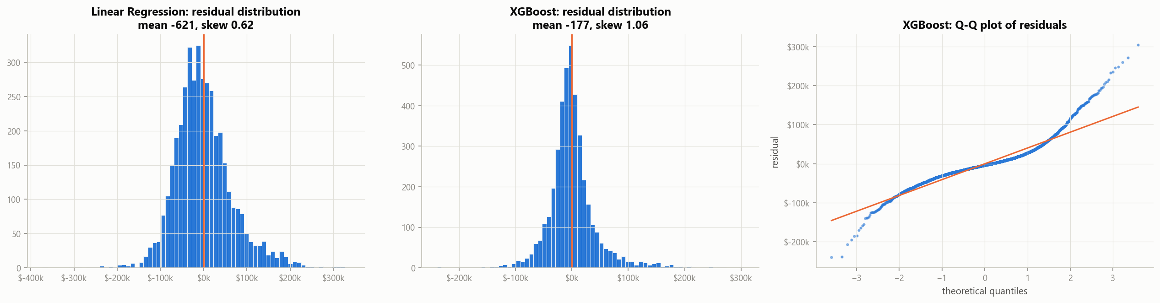
Figure 8. Residual distributions for both models and the XGBoost Q-Q plot, whose tails are heavier than normal.

12.3 The censored target
Model | Test subset | Rows | MAE | RMSE | Mean residual
Linear Regression | uncapped | 3,949 | $46,884 | $61,961 | −$6,428
Linear Regression | capped at $500,001 | 179 | $131,255 | $146,055 | +$127,485
XGBoost | uncapped | 3,949 | $26,825 | $39,910 | −$2,684
XGBoost | capped at $500,001 | 179 | $58,973 | $83,533 | +$55,127
On the 179 capped test blocks, XGBoost's MAE more than doubles and it under-predicts by $55k on average. These errors are partly unknowable: the recorded value is a floor, so the true error may be larger still. Both residual plots show this as a diagonal band of points at actual = $500,001. Metrics on that subset should not be trusted, and the model should not be used for high-value areas.

12.4 Where the errors are
A map of XGBoost's test residuals shows the largest errors clustered on the coast, in the Bay Area and Los Angeles. There, prices vary sharply from block to block and many targets are capped. Inland errors are small. The model is most reliable exactly where prices are lowest and most homogeneous.
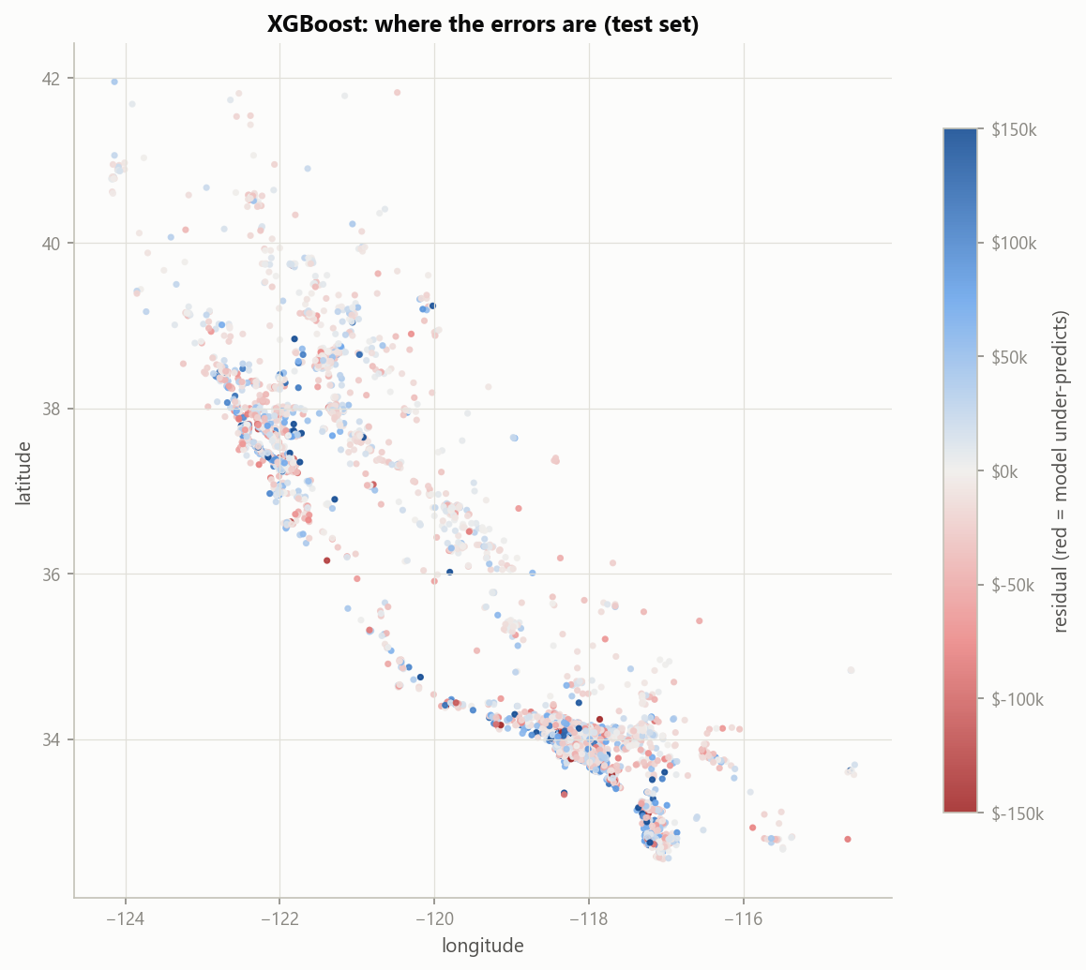
Figure 9. XGBoost test residuals by location; red marks under-prediction. The largest errors cluster in the Bay Area and Los Angeles.

13. Interpretation of important predictors
Income and location drive house value in every model, followed by ocean proximity and crowding; the raw block totals contribute almost nothing once the per-household ratios exist.

13.1 Three views of importance
- Standardised OLS coefficients: direction and size of each linear effect, per standard deviation of the feature (Section 9.3).
- Built-in tree importance: how much each feature reduces error inside the trees' splits (gain).
- Grouped permutation importance: how much test RMSE rises when one feature is randomly shuffled, breaking its link to the target. Shuffling happens after feature engineering, so shuffling total_rooms does not also break the ratios built from it. The five one-hot columns of ocean_proximity are shuffled together as one feature. Because it is measured on the test set and works for any model, this is the most reliable of the three.
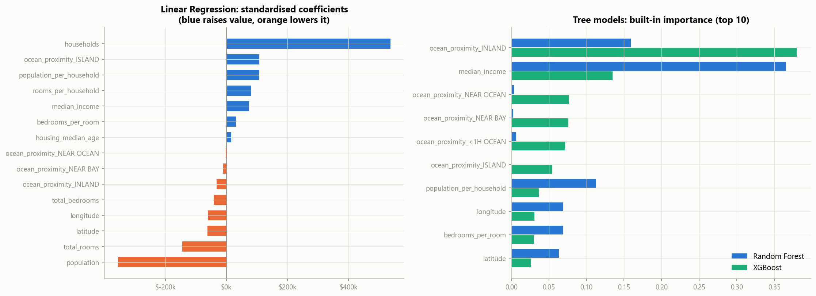
Figure 10. Standardised Linear Regression coefficients (left) and built-in gain importance of the two tree models (right).

13.2 Permutation importance
Feature | Random Forest | XGBoost | Linear Regression
longitude | +$17.6k | +$36.9k | +$40.2k
latitude | +$16.9k | +$36.2k | +$42.6k
median_income | +$48.5k | +$31.4k | +$56.4k
ocean_proximity | +$22.5k | +$16.8k | +$2.6k
population_per_household | +$19.0k | +$12.6k | +$95.4k
housing_median_age | +$6.6k | +$5.5k | +$3.2k
rooms_per_household | +$3.0k | +$5.7k | +$63.1k
bedrooms_per_room | +$3.5k | +$4.1k | +$12.9k
Raw totals (rooms, bedrooms, population, households) | < $0.3k each | < $1k each | +$23k to +$708k
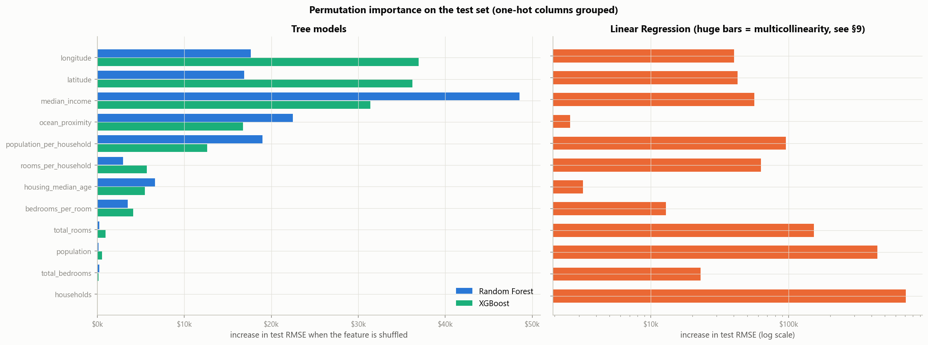
Figure 11. Grouped permutation importance on the test set. Linear Regression is on a log scale; its huge bars reflect multicollinearity.

13.3 Interpretation
- Income and location dominate. Random Forest ranks income first. XGBoost spreads credit across longitude, latitude and income: it uses fine-grained location to capture neighbourhood price levels, which overlap with income.
- Ocean proximity matters to the trees (+$17k to +$22k). By gain, INLAND is XGBoost's single most-used split feature (importance 0.38). In OLS, an inland block is worth about $31k less than an otherwise similar block within an hour of the ocean.
- Crowding lowers value. population_per_household is the strongest engineered feature for both trees.
- Age adds a little. Older housing stock is associated with slightly higher values, consistent with established central neighbourhoods.
- Raw totals add nothing once the ratios exist, which justifies the feature engineering of Section 8.

13.4 A warning about Linear Regression
Shuffling households raises Linear Regression's RMSE by about $708,000, which is absurd as a measure of importance. The model balances the collinear log counts with huge opposite-signed coefficients (VIF ≈ 4,500), and shuffling one of them destroys the balance. This is the multicollinearity of Section 9.4 made visible. Its meaningful drivers are income (+$56k) and location (+$40k each).

13.5 Why the importance measures disagree
Gain counts how much the trees use a feature to split; permutation measures how much accuracy depends on it. A feature can be split on often yet be replaceable by a correlated one, as INLAND is partly replaceable by latitude and longitude. For interpretation, permutation importance on held-out data is the more trustworthy measure.

14. Deployment: the Streamlit application
The best pipeline is deployed in a Streamlit map app whose measured accuracy, with inputs guessed from the location, is R² 0.827 and MAE $31,410.
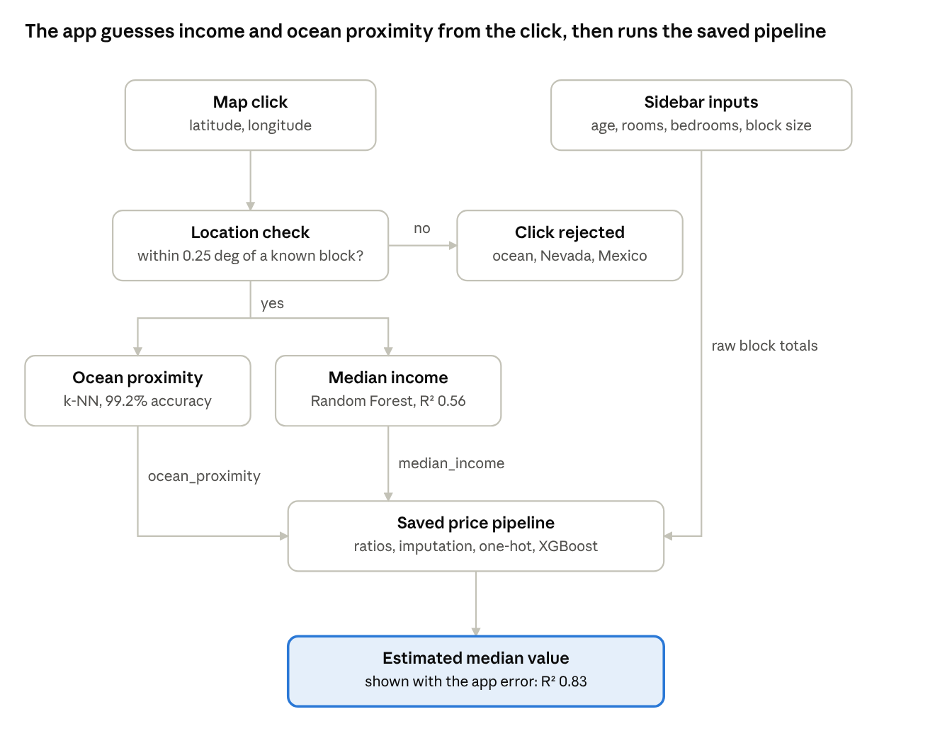
Streamlit app data flow · 2 helper models, 1 saved pipeline
A user clicks a location and enters a few details. Two helper models estimate what the user would not know, and the saved pipeline turns the raw row into a price.

14.1 Helper models
The price model needs median_income and ocean_proximity, which an ordinary user does not know. Two helpers, trained in Trainer_helper_model.ipynb on the same training split, estimate them from latitude and longitude.
Helper | Task | Candidates (5-fold CV) | Chosen | Test score
Ocean proximity | 5-class classification | k-NN with k = 1, 3, 5, 7, 9, 15; uniform or distance weights | k-NN, k = 3, distance-weighted | accuracy 0.992
Median income | Regression | k-NN regressor (R² 0.505), Random Forest (R² 0.565), XGBoost (R² 0.491) | Random Forest | R² 0.561, MAE $8,650
Ocean proximity is a purely geographic label, so neighbouring blocks almost always share it. Income varies between neighbouring blocks, so location explains only about 56% of it.

14.2 Input handling
- Location check: the ocean helper's nearest-neighbour distance rejects any click more than 0.25° from a known block. This blocks the ocean, Nevada (including Las Vegas) and Mexico, which the earlier rectangular bounding box let through.
- Neighbourhood size: three presets set the block's households and population from the dataset's quartiles: 280, 409 or 605 households.
- Raw row: rooms and bedrooms per house are multiplied by the number of households to give block totals, exactly as in the training data. The pipeline then applies all transformations itself.

14.3 Honest accuracy of the app
The test set was re-scored with the true median_income and ocean_proximity replaced by the helpers' guesses.
Inputs | MAE | RMSE | R²
True values (notebook) | $28,219 | $42,736 | 0.860
Guessed by the helpers (app) | $31,410 | $47,516 | 0.827
The loss is smaller than the income helper's weak R² suggests, because the price model already sees latitude and longitude. The location-driven part of income is redundant; only block-to-block variation is lost. The test still flatters the app, since real users give rough room counts and preset populations. The app therefore shows its measured error beside every prediction.

14.4 Functional test
Test | Result
Click San Jose, default inputs | $300,663, <1H OCEAN, estimated income $71,936
Click Fresno, default inputs | $124,861, INLAND, estimated income $42,121
Raise rooms per house from 5 to 8 (San Jose) | $255,342 to $279,957
Click the Pacific Ocean | rejected with the clicked coordinates
Click Las Vegas | rejected

15. Limitations and ethical issues
The model is suitable for teaching and exploratory analysis, not for decisions about individual people or properties: its data is old and censored, and location-based valuation carries real risks of discrimination.

15.1 Limitations
Limitation | Effect on the results
Data from 1990 | Absolute prices are decades out of date; the model learns relative patterns, not today's values
Block-group aggregates | Predicting one house from a neighbourhood median ignores its size, condition and features (an ecological inference)
Censored target, age and income | Values above $500,001 cannot be learned; capped blocks are under-predicted by about $55k on average
Spatial dependence | Random K-fold overstates accuracy for unseen regions: R² 0.86 falls to about 0.71
Chained inputs in the app | Guessed income and ocean proximity lower R² to 0.83, and rough user inputs lower it further
Missing variables | No data on schools, crime, transport, amenities or house condition, all of which affect price
Multicollinearity in the linear model | Individual coefficients for the count features cannot be interpreted

15.2 Ethical issues in location and property data
Proxy discrimination and digital redlining. In the United States, residential segregation and the historical practice of redlining tied location closely to race and ethnicity. A model that prices by latitude, longitude and income can reproduce that discrimination even though no protected attribute appears in the data. If such valuations feed lending, insurance or rents, the harm falls on the same communities again.
Feedback loops. Automated valuations can shape the market they measure. If a model under-values a neighbourhood, lenders offer less credit there, owners invest less, and prices stay low. The next model trained on those prices then confirms the original under-valuation.
Privacy. Census data is published at block-group level precisely so that individuals cannot be identified. Joining fine-grained location and income with other sources, such as property records or online listings, can re-identify households in small areas. Any extension of this work should keep data aggregated and avoid such linkage.
Uneven reliability. The model's errors are not spread evenly. They are largest in expensive coastal areas and on capped blocks, and the model is systematically biased downwards there. Reporting a single average accuracy hides who bears the error.
Transparency and accountability. People affected by an automated valuation should be able to see what drove it and contest it. This project reports permutation importance (Section 13), shows the app's measured error beside every estimate, and states its limitations in the app itself.
Appropriate use. Suitable for education, exploratory market analysis and demonstrating data science methods. Not suitable for mortgage approval, insurance pricing, tax assessment, rental decisions or any decision about an individual.

16. Dashboard summary and conclusions
A tree ensemble, not a linear model, should be used to estimate these prices: XGBoost cuts the error by 37% and its residuals show no structural bias outside the capped range.

16.1 Key figures
Measure | Value
Best model | XGBoost (GPU-trained)
Test R² / RMSE / MAE | 0.860 / $42,736 / $28,219
Linear Regression test R² | 0.647
RMSE reduction against Linear Regression | 37%
R² on unseen regions (spatial CV) | 0.710
R² in the app (guessed inputs) | 0.827
Strongest predictors | location, median income, ocean proximity, crowding
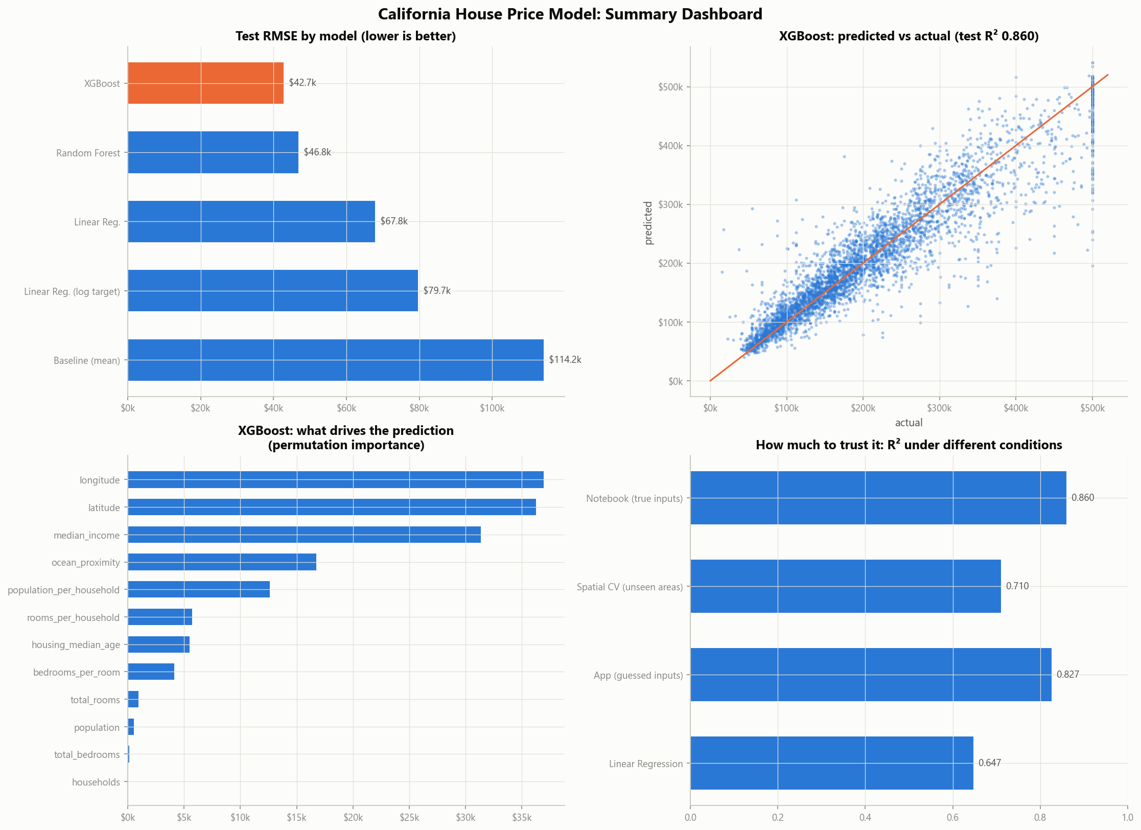
Figure 12. Summary dashboard: test RMSE by model, XGBoost predicted against actual, what drives its predictions, and R² under different conditions.

16.2 Decisions supported by the evidence
- Use a tree ensemble for price estimation. It beats Linear Regression on every metric and every fold, and the linear model's residuals show it has the wrong functional form.
- Prefer XGBoost to Random Forest for interpolation within known areas. It wins on all five folds. For unseen regions the two are equivalent (R² 0.71), so either is acceptable there.
- Expect lower accuracy outside the training conditions: for expensive coastal blocks, for regions far from training data, and in the app where income is guessed.
- Do not use the model for decisions about individuals, given the redlining, feedback-loop and privacy risks of Section 15.

16.3 Conclusions
The project met every objective of Section 1.2. The data-quality audit found censoring to be the defining weakness of the dataset. Evidence, not defaults, decided the treatment of missing values and outliers. Engineered per-household ratios replaced raw totals as carriers of signal. The least-squares solution was verified from first principles, and its multicollinearity was diagnosed and explained.
Two validation choices proved essential. Cross-validation on shared folds made model comparisons statistically meaningful. Spatial cross-validation revealed that random K-fold overstates accuracy for new regions by about 0.14 of R², a gap invisible to standard validation.

16.4 Future work
- Model the censored target directly, for example with a Tobit-style or quantile approach, instead of treating $500,001 as an exact value.
- Add spatial features such as distance to major cities or the coastline, or neighbourhood averages, and tune with spatial cross-validation.
- Report prediction intervals, for example with quantile regression, so the app can show a range instead of a single number.
- Replace the median imputer with a regression on total_rooms.
- Retrain on recent data to give current prices, and audit predictions for disparities across neighbourhoods.

References
- Pace, R. K. and Barry, R. (1997). Sparse Spatial Autoregressions. Statistics & Probability Letters, 33(3), 291–297.
- Géron, A. (2019). Hands-On Machine Learning with Scikit-Learn, Keras and TensorFlow, 2nd ed. O'Reilly Media. Chapter 2 and its California Housing dataset.
- Nugent, C. California Housing Prices. Kaggle dataset camnugent/california-housing-prices.
- Breiman, L. (2001). Random Forests. Machine Learning, 45, 5–32.
- Chen, T. and Guestrin, C. (2016). XGBoost: A Scalable Tree Boosting System. Proceedings of the 22nd ACM SIGKDD Conference, 785–794.
- Liu, F. T., Ting, K. M. and Zhou, Z.-H. (2008). Isolation Forest. Proceedings of the 8th IEEE International Conference on Data Mining, 413–422.
- Pedregosa, F. et al. (2011). Scikit-learn: Machine Learning in Python. Journal of Machine Learning Research, 12, 2825–2830.
- Roberts, D. R. et al. (2017). Cross-validation strategies for data with temporal, spatial, hierarchical, or phylogenetic structure. Ecography, 40(8), 913–929.

Appendix A. Reproducibility
Step | Command or file | Approximate time
Create environment | python -m venv .venv, then pip install -r requirements.txt | a few minutes
Train helper models | run all cells of Trainer_helper_model.ipynb | about 1 minute
Full analysis and main model | run all cells of DMBI_Project_v2.ipynb | 12–20 minutes
Launch the app | streamlit run app.py | seconds
All random processes use random_state=42. Three complete runs of the main notebook produced identical metrics. XGBoost uses the GPU when one is available and the CPU otherwise.

Appendix B. Project files
File or folder | Contents
housing.csv | The dataset
housing_features.py | Shared feature engineering, preprocessing, split and GPU detection
Trainer_helper_model.ipynb | Helper models for the app
DMBI_Project_v2.ipynb | Full analysis, 17 sections
app.py | Streamlit application
figures/ | The 12 figures in this report
reports/ | Model comparison, spatial validation and permutation importance tables; all metrics in JSON
models/ | Saved pipeline and helper models, plus app metadata

Appendix C. List of figures
Figure | Title | Section
1 | Missing values and the censored target | 3
2 | Univariate distributions | 6.1
3 | Income, ocean proximity and geography against value | 6.2
4 | Pearson and Spearman correlation matrices | 6.3
5 | Robust-scaled feature box plots | 7.2
6 | Cross-validated model comparison | 11.2
7 | Predicted against actual, and residuals against predicted | 12.2
8 | Residual distributions and Q-Q plot | 12.2
9 | Map of XGBoost residuals | 12.4
10 | Coefficients and built-in importance | 13.1
11 | Permutation importance | 13.2
12 | Summary dashboard | 16.1
— | App data-flow diagram | 14

