DEPARTMENT OF INFORMATION TECHNOLOGY
RESEARCH METHODOLOGY AND IPR LAB

EXPERIMENT 2
Research Planning and Methodology Design

Group No | Roll No. | Div | Name of the students
 |  |  | Hirdhay Jadhwani
 |  |  | Siddharth Jogi
 |  |  | Sumanyu Joshi
 |  |  | Nirmay Kadam

1. Aim
Formulate objectives, hypothesis, research methodology, workflow diagram, experimental plan, timeline, and expected contribution.

2. Research Topic
Research Problem / Topic | Validating model-based option-mispricing trading signals on NSE NIFTY 50 index options under realistic Indian market frictions: a correction audit
Research Gap Identified in Experiment 1 | Studies report pricing accuracy or simulated profits of option-pricing models, but none audits whether a model-versus-market mispricing signal on NIFTY 50 options stays profitable after pricing artifacts, execution timing, contract marking and full Indian statutory costs are corrected, with trade-level uncertainty and a hedged test of the signal itself.

3. Research Objectives
Write clear and specific objectives (min 4) that describe what the proposed research intends to achieve.
1. Reproduce the original +49.57% result exactly and quantify, one correction at a time, how much of it each backtest fix removes (correction waterfall).
2. Rebuild a full NIFTY 50 option chain for January 2021 – June 2024 from NSE Bhavcopy files and re-test the frozen strategies with independent per-period backtests from fresh capital.
3. Measure trade-level performance (net return on premium with bootstrap confidence intervals, profit factor, return without the largest trade) against a matched puts-only random baseline.
4. Test the mispricing signal separately from the strategy with a delta-hedged next-bar test compared with the round-trip trading cost.
5. Make every reported number reproducible from one script that records configuration, code version and input-data hashes.

4. Hypothesis
If applicable, state the expected relationship, effect, or outcome that will be investigated.
Null Hypothesis (H₀) | After correcting pricing artifacts and execution mechanics, the mispricing strategy's mean net return per trade is not greater than zero in any period, and the delta-hedged excess of undervalued puts after a next-bar fill does not exceed the round-trip cost.
Alternative Hypothesis (H₁) | The mean net return per trade is greater than zero (bootstrap 95% CI above zero) in at least three of the four periods, and the hedged excess after a next-bar fill exceeds the round-trip cost.
Variables / Parameters to be considered | Independent: pricing model (PDE / closed-form / Black-76), fill timing, contract marking, cost multiplier, strategy (Pure, Hybrid, Retail, random), period, India VIX regime.  Dependent: net return, return on premium per trade, win rate, profit factor, Sharpe ratio, maximum drawdown, delta-hedged P&L.  Controlled: capital INR 1 lakh, 50 units per trade, 35% stop / 60% target, entry threshold 1.5 × round-trip cost, strikes within 150 points of spot.

5. Research Methodology
Describe how the research problem will be investigated. Mention the main methods, techniques, tools, data/dataset, and evaluation approach.
Research Approach / Method | Quantitative, experimental (empirical backtesting) with a correction audit and hypothesis testing.
Data / Dataset / Input | NSE F&O Bhavcopy daily files (860 sessions, 2021–2024) for every NIFTY option; NIFTY 50 index closes and India VIX (Yahoo Finance); original 180-session panel for the audit.
Tools / Technologies | Python 3.11, NumPy, pandas, SciPy, PyArrow, Matplotlib; Git for version control; LaTeX (IEEEtran) for the paper.
Proposed Method / Technique | Black-76 pricing with an ATM put-call-parity forward, implied volatilities from traded CLOSE prices, a natural cubic-spline smile, and mispricing = market − model; strategies trade the signal under a cost-based entry threshold.
Evaluation / Performance Measures | Net return, mean / median net return on premium with bootstrap 95% CI, win rate, profit factor, Sharpe (RBI repo-rate hurdle), maximum drawdown, percentile vs random baseline, delta-hedged P&L vs cost.
Expected Methodology Steps | 1. Reproduce the original result. 2. Apply corrections one at a time (waterfall). 3. Rebuild the full chain. 4. Run independent period backtests. 5. Compare with baselines. 6. Run the hedged signal test. 7. Freeze outputs and write the paper.

6. Workflow Diagram
Draw the proposed research workflow showing the major steps from problem definition to expected results.
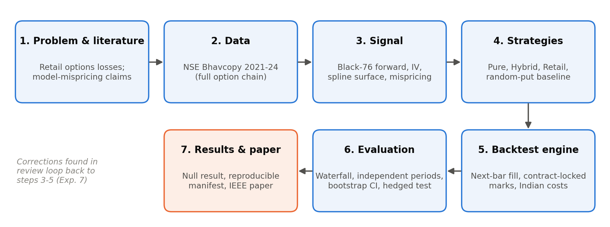
Figure: Proposed Research Workflow

7. Experimental Plan
Briefly specify how the proposed methodology will be implemented and tested.
Sr. | Experimental Activity / Step | Details / Expected Output
1 | Reproduce the original pipeline | Original +49.57% (S0) and closed-form +36.63% (S1) reproduced exactly
2 | Correction waterfall on 180 sessions | Return, trades and Sharpe after each correction (S0–S6)
3 | Rebuild the full option chain from Bhavcopy | 980,653 contract-days; 35,076-row multi-expiry signal panel
4 | Independent period backtests + random baseline | 12 strategy-period cells with trade-level CIs and percentile vs 500 random draws
5 | Delta-hedged signal test; stress and VIX tests | Hedged P&L of undervalued / rich / all puts vs round-trip cost; results under 1–3× costs and by VIX regime

8. Timeline
Prepare a simple timeline for completing the proposed research activities.
Activity | Start Date | End Date | Status / Remarks
Literature / Problem Finalization/Objectives | 11-04-2026 | 19-08-2026 | Completed — project repository started as an analytics app; research question finalised in Aug 2026 (git history)
Methodology Design | 20-08-2026 | 21-08-2026 | Completed — PDE pipeline, cost model and first paper draft
Implementation / Experiment | 20-08-2026 | 11-10-2026 | Completed — corrected pipeline (commit 58d248e outputs; tag paper-audit-v1)
Data Collection / Analysis | 11-10-2026 | 11-10-2026 | Completed — 860 Bhavcopy files rebuilt into the full chain
Result Evaluation | 11-10-2026 | 11-10-2026 | Completed — waterfall, period results and signal test frozen
Final Documentation | 11-10-2026 | 12-10-2026 | Completed — paper rewritten as a correction audit; lab records

9. Expected Contribution
State what the research is expected to contribute or improve compared with existing approaches.
1. A quantified correction waterfall showing how much apparent profit each common backtest artifact creates in an options mispricing strategy.
2. Independent, trade-level evidence on NIFTY 50 options over 2021–2024 with full Indian statutory costs, compared with a matched random baseline instead of zero.
3. A direct, delta-hedged test that separates the value of the mispricing signal from the directional and time-decay risk of the trade.
4. A fully reproducible research package (one script, recorded configuration and data hashes) that other students and researchers can re-run.

