DEPARTMENT OF INFORMATION TECHNOLOGY
RESEARCH METHODOLOGY AND IPR LAB

EXPERIMENT 4
Implementation and Experimental Validation

Group No | Roll No. | Div | Name of the students
 |  |  | Hirdhay Jadhwani
 |  |  | Siddharth Jogi
 |  |  | Sumanyu Joshi
 |  |  | Nirmay Kadam

1. Aim:
Implement the proposed methodology, perform experiments, compare with baseline techniques, and record observations.
2. Implementation of proposed methodology
- Programming Language/Technology: Python 3.11
- Software/Tools Used: NumPy, pandas, SciPy, PyArrow, Matplotlib, python-docx; Git; LaTeX (IEEEtran)
- Hardware/Platform Used: Intel Core i5-12450H (8 cores / 12 threads), 16 GB RAM, Windows 11
- Dataset/Input Used: NSE F&O Bhavcopy files (NIFTY options) Jan 2021 – Jun 2024; NIFTY 50 and India VIX closes
- Number of Samples/Records: 860 sessions; 980,653 contract-days; 35,076 signal-panel rows; 406 trades across 12 strategy-period runs
- Important Parameters: Capital INR 1 lakh; 50 units; stop 35%, target 60%; ε = 1.5 × cost; ±150 points; signal expiry ≥ 14 DTE; 5-session hold
Implementation Procedure:
- 1. Build the full chain and signal panel from the Bhavcopy cache (research/data/build_3_5_year_dataset.py --from-cache).
- 2. Compute forward, implied volatilities, spline surface and mispricing per expiry; flag the signal expiry (≥ 14 DTE).
3. Run the Pure, Hybrid and Retail strategies with next-bar fills and contract-locked marks (research/run_3_5y_experiments.py, RobustBacktestStrategy).
4. Book costs per trade with the Indian friction model (date-dependent STT) and mark equity daily (research/backtest/engine.py).
5. Repeat each strategy independently in periods A–D from fresh capital; compute trade-level statistics and the matched random baseline (research/analysis/trade_stats.py).
6. Reproduce the original pipeline and apply corrections one at a time on 180 sessions (research/analysis/waterfall.py).
7. Run the delta-hedged signal test (research/analysis/signal_test.py).
8. Regenerate all tables, figures and numbers with a manifest (research/reproduce_all.py).
3. Experiments Performed
Describe the experiments conducted to evaluate the proposed methodology.
E1 – Correction waterfall: On the original 180 sessions, the headline +49.57% was reproduced and corrections were added one at a time (closed-form pricing, forward-consistent pricing, next-bar fill, contract lock, stale-price removal and daily marking, full-chain data).
E2 – Independent period backtests: Pure, Hybrid and Retail were each run in periods A–D from INR 1 lakh (12 cells), with trade-level statistics.
E3 – Random baseline: For every cell, 500 draws of random near-ATM puts with the same fills, exits and costs and a matched trade count.
E4 – Delta-hedged signal test: 4,995 put observations; hedged P&L from the signal close and after a next-bar fill, compared with round-trip cost.
E5 – Robustness: Costs scaled 1–3× (entry threshold fixed or scaled) and results by India VIX regime.
4. Comparison with Baseline Techniques

Period / method (trades) | Net return (%) | Mean RoP % [95% CI] | Return without largest trade (%) | Win rate (%)
A (2021): Proposed – Pure Mispricing (40) | -43.0 | -5.2 [-27.2, 21.5] | -64.5 | 27.5
A (2021): Baseline – Retail RSI/MACD (54) | -96.3 | -11.9 [-27.9, 5.6] | -75.5 | 29.6
A (2021): Baseline – random puts (mean of 500) | -27.7 | — | — | —
B (2022): Proposed – Pure Mispricing (40) | +5.7 | -2.2 [-21.9, 20.4] | -34.4 | 37.5
B (2022): Baseline – Retail RSI/MACD (64) | -17.6 | -1.8 [-17.3, 14.6] | -41.6 | 37.5
B (2022): Baseline – random puts (mean of 500) | +3.7 | — | — | —
C (Jan-Sep 2023): Proposed – Pure Mispricing (24) | -36.2 | -22.8 [-33.3, -10.4] | -32.3 | 20.8
C (Jan-Sep 2023): Baseline – Retail RSI/MACD (44) | -49.3 | -13.4 [-29.3, 4.2] | -60.2 | 29.5
C (Jan-Sep 2023): Baseline – random puts (mean of 500) | -16.1 | — | — | —
D (Oct 2023-Jun 2024): Proposed – Pure Mispricing (29) | -44.4 | -6.7 [-24.8, 14.2] | -9.3 | 34.5
D (Oct 2023-Jun 2024): Baseline – Retail RSI/MACD (50) | +2.1 | -0.5 [-18.8, 18.4] | -17.9 | 38.0
D (Oct 2023-Jun 2024): Baseline – random puts (mean of 500) | -37.3 | — | — | —

Graphical Representation: Present the experimental results using appropriate graphs.
Note: Suggested graphs- Accuracy vs. Method, Error vs. Method, Compression Ratio vs. Method, Execution Time vs. Method, or Memory Usage vs. Method.
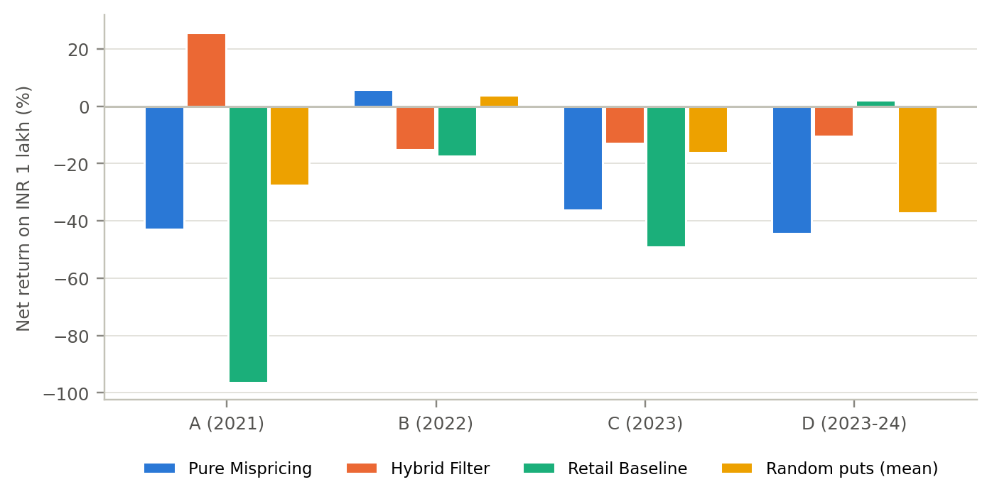
Figure 1: Net return vs method, per period (independent backtests).
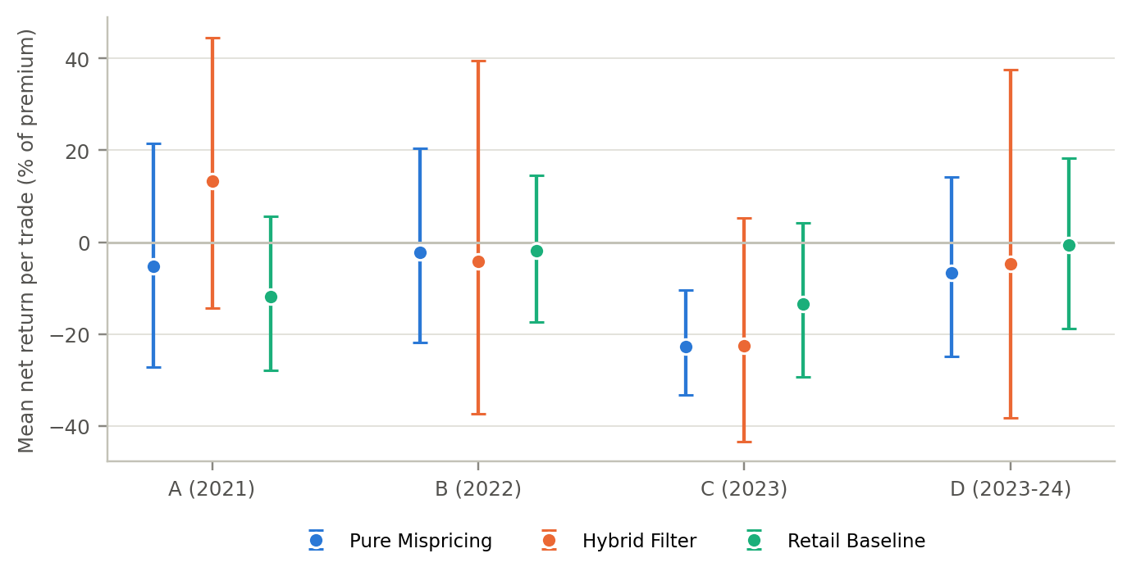
Figure 2: Mean net return per trade with bootstrap 95% CI vs method.
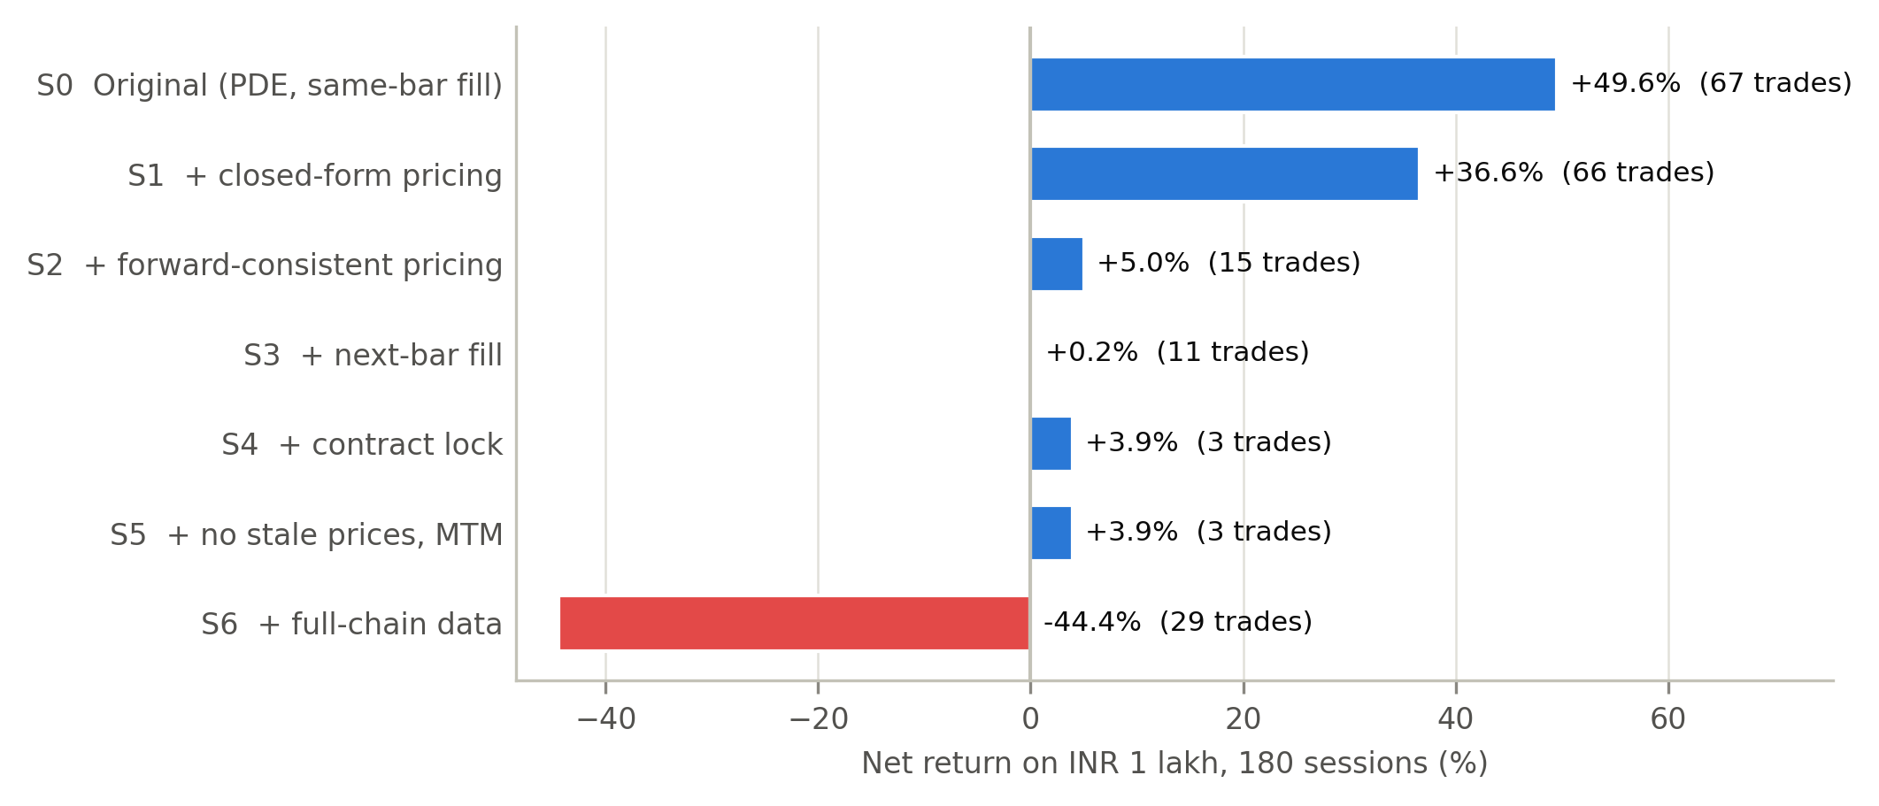
Figure 3: Correction waterfall on the original 180 sessions.
5. Record Observations
Write the important observations obtained from the experiments.
1. The original +49.57% was reproduced exactly; closed-form pricing alone reduced it to +36.63%, and forward-consistent pricing to +5.01% on 15 trades — the zero-dividend carry bias created most of the profit.
2. Only 3 of the 12 strategy-period cells were profitable, and 0 had a per-trade confidence interval entirely above zero.
3. The Pure Mispricing strategy lost money in 3 of 4 periods; its per-trade CI lay entirely below zero in Period C (upper bound -10.4%).
4. Results depend heavily on single trades: Hybrid in 2021 fell from +25.7% to +4.3% without its largest trade; Pure in Period D moved from -44.4% to -9.3% without its largest loss (INR 35,133, election-result day).
5. The random-put baseline also lost money in most cells, so comparing strategies against zero overstates how bad they are; none was consistently better than chance.
6. Every Pure and Hybrid trade was a put (133 and 61 trades): with consistent pricing the spline reproduces call prices, so calls carry no signal.

