DEPARTMENT OF INFORMATION TECHNOLOGY
RESEARCH METHODOLOGY AND IPR LAB

EXPERIMENT 5
Data Analysis and Visualization

Group No | Roll No. | Div | Name of the students
 |  |  | Hirdhay Jadhwani
 |  |  | Siddharth Jogi
 |  |  | Sumanyu Joshi
 |  |  | Nirmay Kadam

1. Aim:
Analyze experimental results using statistical methods, prepare graphs, tables, confusion matrices, and performance comparisons.

2. Experimental Data Analysis
The experimental results obtained from the proposed system were analyzed using appropriate statistical methods. The results should be organized in the form of tables and graphs to facilitate interpretation and comparison. Wherever applicable, a confusion matrix should be prepared to evaluate the classification performance of the proposed system.
The experimental data obtained from the implemented system should be collected and analyzed using suitable statistical measures.
Data analysed: 406 trades from the 12 independent strategy-period backtests (Pure 133, Hybrid 61, Retail 212) and 4,995 near-ATM put observations from the delta-hedged signal test. The unit of analysis is the trade (net return on premium) or the option-day (hedged P&L), which avoids the capital-path effects of portfolio returns.

3. Statistical Analysis
The experimental results should be analyzed using appropriate statistical methods and tabulated as below:

Table 1: Statistical Analysis

Parameter | Mean | Median | Variance | Standard Deviation | Minimum | Maximum
Net return on premium per trade, Pure Mispricing (%) (n=133) | -7.82 | -34.75 | 4186.7 | 64.70 | -76.84 | 349.08
Net return on premium per trade, Hybrid Filter (%) (n=61) | -0.74 | -33.60 | 5132.8 | 71.64 | -70.10 | 262.92
Net return on premium per trade, Retail Baseline (%) (n=212) | -6.49 | -39.31 | 4081.0 | 63.88 | -79.67 | 182.74
Hedged P&L after fill, undervalued puts (INR/unit) (n=346) | -0.28 | -4.37 | 698.4 | 26.43 | -105.95 | 136.85
Hedged P&L after fill, all near-ATM puts (INR/unit) (n=4978) | -2.48 | -5.23 | 637.1 | 25.24 | -183.23 | 385.52
Period return, Pure Mispricing (%), 4 periods (n=4) | -29.48 | -39.62 | 563.4 | 23.74 | -44.41 | 5.71

The experimental results should be organized in tabular form for systematic analysis and comparison.
Table 2: Pooled trade-level results over the four independent periods.
Strategy | Trades | Win rate (%) | Profit factor | Mean RoP % [95% CI]
Pure Mispricing | 133 | 30.8 | 0.69 | -7.8 [-18.1, 3.5]
Hybrid Filter | 61 | 36.1 | 0.92 | -0.7 [-17.6, 18.4]
Retail Baseline | 212 | 34.0 | 0.79 | -6.5 [-14.8, 2.3]

4. Graphical Representation
Graphs should be prepared to visualize the experimental results and identify differences and trends among the evaluated methods.
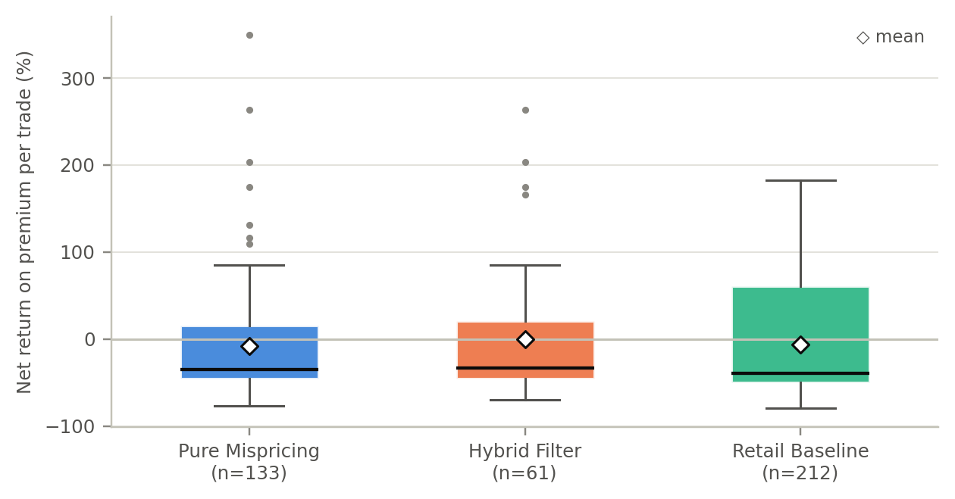
Figure 1: Distribution of net return on premium per trade, by strategy.
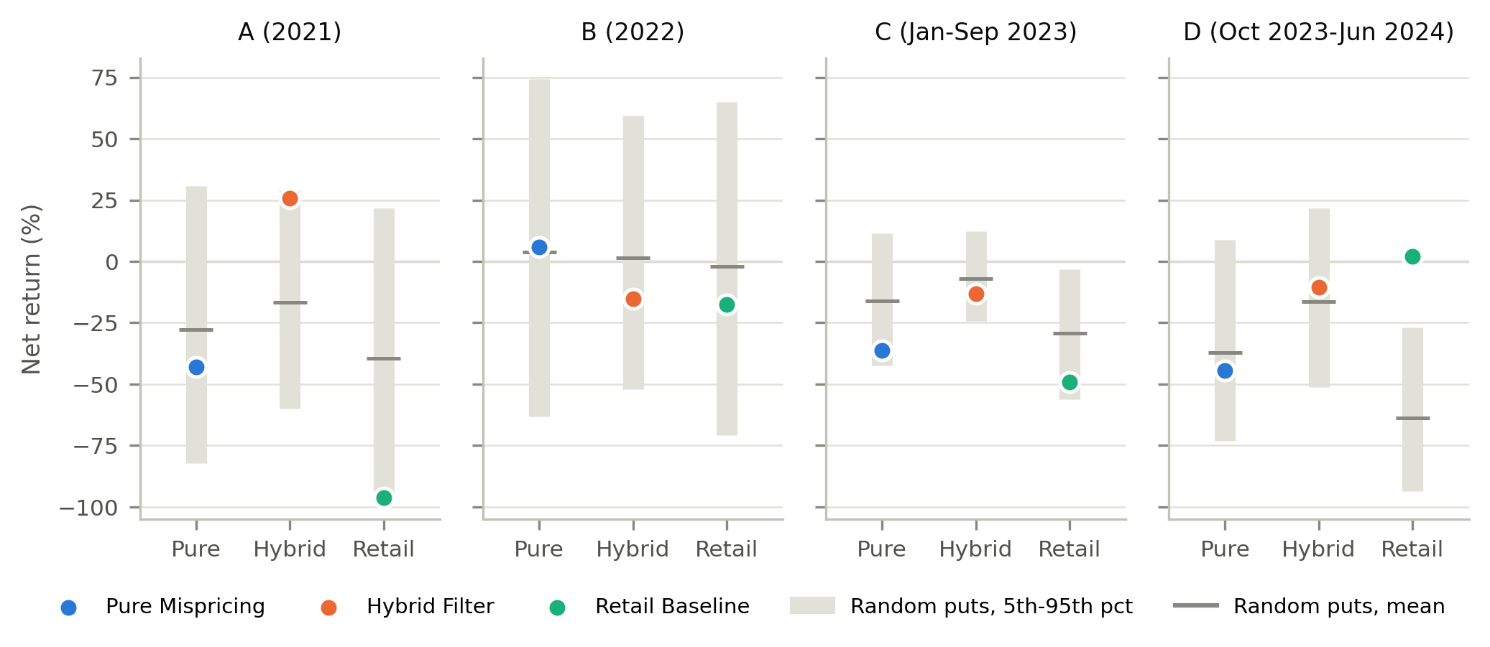
Figure 2: Period returns vs the matched random-put baseline.
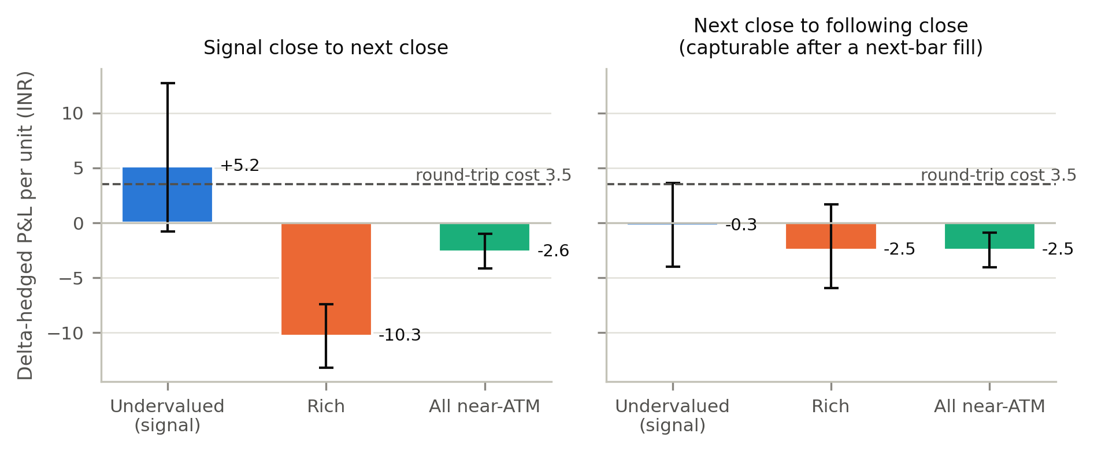
Figure 4: Delta-hedged P&L of the signal (all periods, 95% CI).

5. Confusion Matrix
For classification-based experiments, a confusion matrix should be prepared to evaluate the classification results.
The confusion matrix consists of:
- True Positive (TP)
- True Negative (TN)
- False Positive (FP)
- False Negative (FN)
Our study is not a classifier, so the confusion matrix treats the mispricing signal as one. Population: 4,978 near-ATM signal-expiry put observations. Predicted positive: the put is flagged undervalued (mispricing < −ε). Actual positive: after a next-bar fill, its delta-hedged P&L beats the same-day average of all near-ATM puts by more than its round-trip cost, i.e. a trade would have earned its costs back on relative value (695 of 4,978 observations, 14.0%).

Figure 3: Confusion Matrix
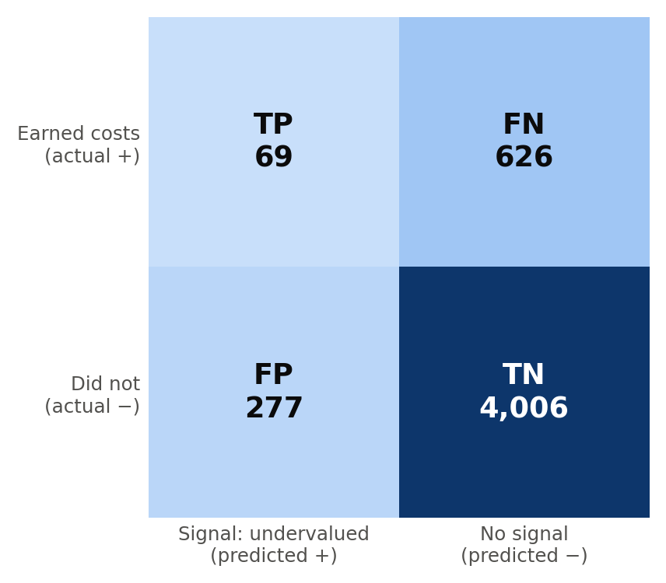
Figure 3: Confusion matrix of the proposed method.

6. Performance Comparison
The performance of the proposed method should be compared with the selected baseline methods using appropriate performance measures.

Table 3: Performance Comparison

Performance Measure | Proposed (mispricing signal) | Baseline 1 (random flag, same rate) | Baseline 2 (flag every put)
Accuracy | 81.9% | 81.0% | 14.0%
Precision | 19.9% | 14.0% | 14.0%
Recall | 9.9% | 7.0% | 100.0%
F1-Score | 0.133 | 0.093 | 0.245
Error (1 − accuracy) | 18.1% | 19.0% | 86.0%
Execution time (4-period backtest) | 0.06 s (Pure strategy) | 0.03 s (random-put strategy) | — (no model)
Baseline 1 and 2 values are expected counts for the same population. Accuracy is high for every rule because only 14.0% of observations are positives, so precision and F1 are the informative measures. Measured from the signal close instead (not tradeable), the same signal reaches precision 39.6% and F1 0.256.

Observations
Based on the statistical analysis, tables, graphs, confusion matrix, and performance comparison, the following observations should be made:
- The proposed method achieved weak performance: after a next-bar fill, 19.9% of flagged puts earned their costs back on relative value, against 14.0% for a random flag.
- The statistical analysis showed that the mean net return per trade is Pure -7.8%, Hybrid -0.7%, Retail -6.5%, with standard deviations of 65%, 72%, 64%; outcomes are dominated by dispersion and single trades rather than by any edge.
- The proposed method performed better than the random flag (Baseline 1) with respect to precision and F1 (0.133 vs 0.093), but not better than flagging every put (Baseline 2) on F1 (0.245).
- The confusion matrix indicates poor classification performance: of 346 flagged puts, 69 were true positives and 277 false positives, and the signal missed 626 of the 695 profitable opportunities.
- The graphical analysis shows that undervalued puts do revert relative to other puts from the signal close to the next close (+7.77 INR/unit), but after a next-bar fill the excess is 2.20 INR/unit, below the 3.54 INR round-trip cost.
- The overall performance of the proposed method was not economically better compared with the baseline methods: 3 of 12 strategy-period cells were profitable and 0 had a per-trade confidence interval above zero.

7. Conclusion
The experimental results were analyzed using statistical methods and presented using tables and graphs. A confusion matrix was used where applicable to evaluate classification performance. The proposed method was compared with baseline techniques using suitable performance measures. The analysis indicates that the proposed method contains a small, short-lived relative-value signal but provides no tradeable edge after realistic fills and Indian transaction costs; the large profits reported earlier were produced by pricing artifacts and backtest mechanics.

