DEPARTMENT OF INFORMATION TECHNOLOGY
RESEARCH METHODOLOGY AND IPR LAB

EXPERIMENT 6
Technical Paper Preparation
Group No | Roll No. | Div | Name of the students
 |  |  | Hirdhay Jadhwani
 |  |  | Siddharth Jogi
 |  |  | Sumanyu Joshi
 |  |  | Nirmay Kadam

1. Aim:
Write the research paper in IEEE conference/journal format using LaTeX or MS Word, including Abstract, Introduction, Methodology, Results, and References.

2. Paper Details
Item | Details
Title | How an Apparent Options Alpha Disappears: A Correction Audit of a Model-Mispricing Strategy on NIFTY 50 Index Options
Authors | Hirdhay Jadhwani, Siddharth Jogi, Sumanyu Joshi, Nirmay Kadam; Dipti Karani [role / affiliation to be confirmed]
Format | IEEE Transactions style (IEEEtran class, journal + compsoc options), 10 pt, two-column, written in LaTeX
Source file | research/paper/main.tex (repository tag paper-audit-v1)
Length / elements | 10 sections, 3 figures, 7 tables, 14 references
Numbers | Every result is a LaTeX macro generated by research/reproduce_all.py (output/paper/numbers.tex); tables are \input from generated files, so no number in the paper is typed by hand
Compilation | pdflatex/Overleaf (no TeX distribution on the development machine; compile on Overleaf with the research/output/paper folder uploaded alongside main.tex)

3. Abstract
An earlier version of this study reported that buying NIFTY 50 options priced below a Crank-Nicolson fair value returned +49.57% after Indian transaction costs over 180 sessions (Sharpe 2.07). We audit that result. Applying one correction at a time on the same sessions, closed-form pricing removes the finite-difference grid error and cuts the return to +36.63%. A forward-consistent price that removes the zero-dividend carry bias leaves +5.01% on 15 trades. Next-bar fills leave +0.17%, and marking each position on its own contract leaves 3 trades. We then rebuild a full NIFTY option chain for January 2021 to June 2024 from NSE Bhavcopy files and re-run the Pure Mispricing, Hybrid and RSI/MACD strategies with independent backtests in four periods. Only 3 of the 12 strategy–period cells are profitable, the bootstrap confidence interval for the mean net return per trade lies above zero in 0 of them, and several headline period returns hinge on a single trade. A delta-hedged test of the signal itself finds that undervalued puts do recover against the cross-section from the signal close to the next close. After a next-bar fill, however, the remaining excess is INR 2.20 per unit, below the INR 3.54 round-trip cost. The apparent alpha came from pricing artifacts and backtest mechanics, not from tradeable mispricing.
Index Terms: Backtest validation, option pricing, Crank-Nicolson, volatility surface, put-call parity, transaction costs, NIFTY 50, Indian derivatives, null result.

4. Structure of the Paper
No. | Section | Content
1 | Introduction | Context (SEBI study on retail F&O losses), the earlier +49.57% claim, why it is audited, and four contributions.
2 | Related Work | Finite-difference option pricing, backtest overfitting and multiple testing, indicators as a retail benchmark, Black's model.
3 | The Original Method | Spline volatility surface, mispricing definition, Indian cost model and entry threshold, the three frozen strategies (with the Retail rule as actually coded).
4 | Data | 180-session original sample; 860-session full chain rebuilt from Bhavcopy; periods A–D.
5 | What Was Wrong | Grid error as the call signal (Spearman -0.9997), carry bias as the put signal (parity residual INR 15.84), same-bar fills, wrong-contract marking, exit-only accounting, price field and stale prices, STT.
6 | The Correction Waterfall | S0 +49.57% → S1 +36.63% → S2 +5.01% → S3 +0.17% → S4 3 trades → S6 full chain.
7 | Corrected Results, 2021–2024 | 12 independent cells; 3 profitable, 0 with CI above zero; single-trade dependence; VIX and cost stress.
8 | Testing the Signal Itself | Delta-hedged test: excess 7.77 INR from the signal close, 2.20 INR after a fill vs 3.54 INR cost.
9 | Limitations | Daily closes, partial circularity of the surface, fixed rules, fixed sizing, sample.
10 | Conclusion | The apparent alpha came from pricing artifacts and backtest mechanics.

5. Figures and Tables
Element | File (generated) | Shows
Fig. 1 | fig1_correction_waterfall | Return after each cumulative correction (180 sessions)
Fig. 2 | fig2_period_returns_vs_random | 12 cells vs matched random baseline
Fig. 3 | fig3_hedged_signal_test | Hedged P&L of the signal, two horizons, vs cost
Table 1 | tab_waterfall
Table 2 | tab_period_results
Table 3 | tab_trade_breakdown
Table 4 | tab_vix
Table 5 | tab_stress
Table 6 | tab_signal_test_v2
Table 7 | tab_signal_test_legacy

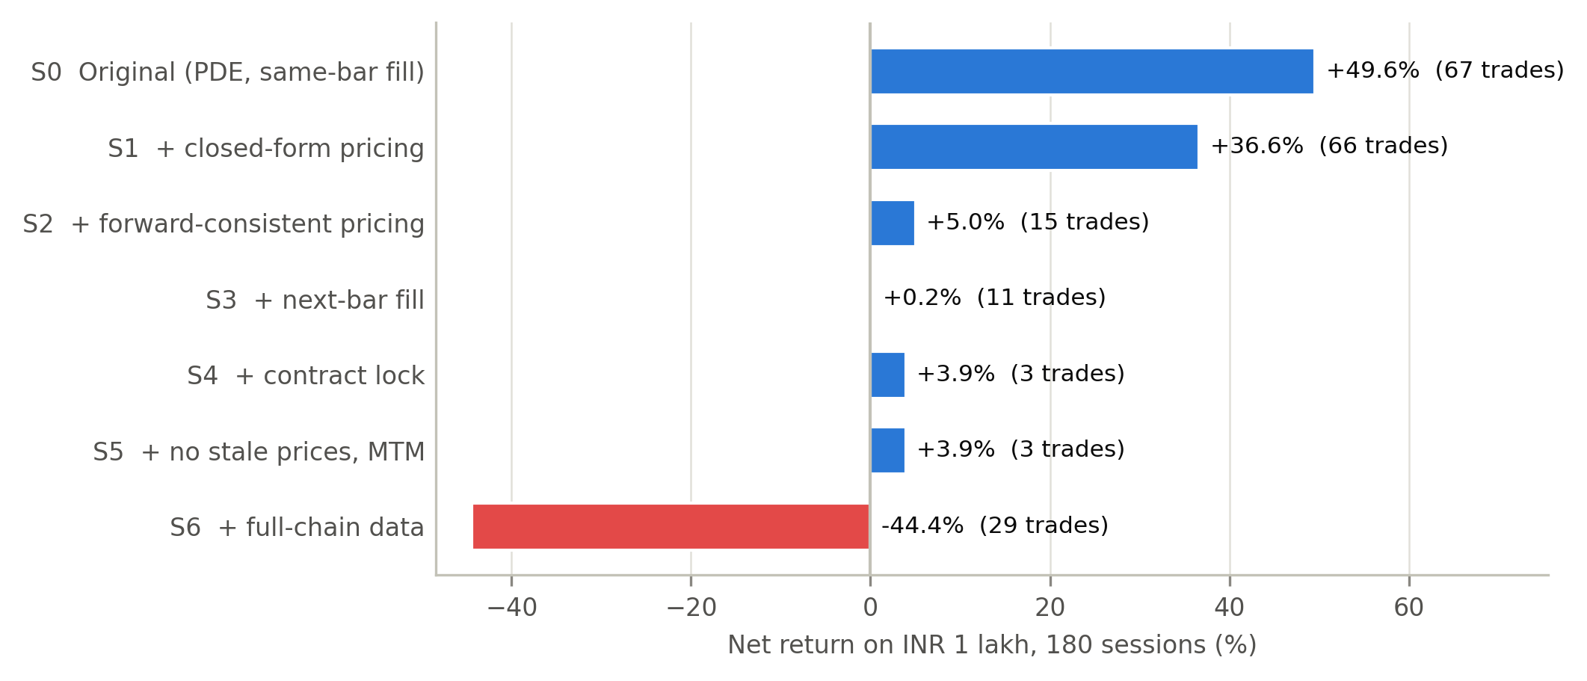
Figure 1 of the paper: correction waterfall.

6. Procedure Followed
1. Chose the IEEEtran journal template (compsoc) and kept the original bibliography style (IEEEtran, numbered).
2. Re-framed the paper from a performance claim to a correction audit after the review in Experiment 7.
3. Wrote sections in the order Method → Data → What Was Wrong → Waterfall → Results → Signal test → Limitations, then Introduction, Abstract and Conclusion last.
4. Generated all tables, figures and numbers with research/reproduce_all.py and linked them with \input and \newcommand macros, so a re-run updates the paper without hand edits.
5. Checked mechanically that every macro used in main.tex is defined and every input/figure file exists.
6. Marked facts only the authors can supply with \fillin{} so they are visible until resolved.

7. Pending Author Inputs
The following \fillin markers remain in main.tex and must be resolved by the authors before submission:
1. authors: state D. Karani's role and affiliation, e.g.\ faculty supervisor, and the institution name
2. authors: state the actual reason
3. authors: state how κ = 1.5 was chosen
4. authors: state whether 35%/60% were fixed before any backtest or chosen after looking at results

8. Conclusion
The research paper was prepared in IEEE format using LaTeX with Abstract, Introduction, Related Work, Method, Data, Results, Limitations, Conclusion and References. All quantitative content is generated from the frozen research outputs, which keeps the paper consistent with the code and data.

