DEPARTMENT OF INFORMATION TECHNOLOGY
RESEARCH METHODOLOGY AND IPR LAB

EXPERIMENT 10
Research Dissemination and Innovation Showcase
Group No | Roll No. | Div | Name of the students
 |  |  | Hirdhay Jadhwani
 |  |  | Siddharth Jogi
 |  |  | Sumanyu Joshi
 |  |  | Nirmay Kadam

1. Aim:
Submit the paper to a conference/journal (or prepare the submission package) and present the work through a research poster, demonstration, and innovation pitch.

2. Target Venues
Venue | Type | Why it fits | Status
Journal of Financial Research — P-Rex (re-examination track) | Journal | Registration-based track for re-examining prior claims; suits a correction audit | [check if currently open]
IEEE CIFEr (Computational Intelligence for Financial Engineering and Economics) | IEEE conference | Computational finance with empirical validation | 2027 edition (IEEE SSCI, 14–17 Feb 2027) deadline passed; target the next call
arXiv preprint (q-fin.CP / q-fin.TR) | Preprint | Immediate, citable dissemination with code link | Ready after the PDF is compiled
[institute / department research symposium] | Internal | Required presentation to the internal committee | [date]

3. Submission Package
Item | Location | Status
Manuscript (IEEE LaTeX) | research/paper/main.tex | Ready; compile to PDF on Overleaf
Generated tables, figures, numbers | research/output/paper/ | Ready (manifest at commit 58d248e)
Code and data availability | Repository tag paper-audit-v1 | Ready
Cover letter | Section 4 below | Drafted
Similarity report | Experiment 7 | Pending — run institute tool
Author details, Dipti Karani's role, \fillin items | main.tex | Pending — authors
Copyright / licence form of the venue | Venue portal | At acceptance

4. Cover Letter (Draft)
Dear Editor,
We submit the manuscript “How an Apparent Options Alpha Disappears: A Correction Audit of a Model-Mispricing Strategy on NIFTY 50 Index Options” for consideration.
An earlier version of our study reported that a Crank-Nicolson mispricing strategy on NIFTY 50 options returned +49.57% after Indian transaction costs. This manuscript audits that claim. Applying corrections one at a time, we show that the profit came from finite-difference grid error, a zero-dividend carry bias, same-bar fills and positions marked against the wrong contract. On a rebuilt full option chain for 2021–2024, 3 of 12 independent strategy-period cells are profitable and 0 has a per-trade confidence interval above zero; a delta-hedged test shows the signal reverts overnight but too little remains after a realistic fill to cover costs.
We believe the paper is useful to researchers and practitioners as a documented example of how backtest artifacts create apparent options alpha. All code and data, and a script that regenerates every number, are available. The manuscript is not under consideration elsewhere.
Sincerely,
Hirdhay Jadhwani, Siddharth Jogi, Sumanyu Joshi, Nirmay Kadam

5. Research Poster
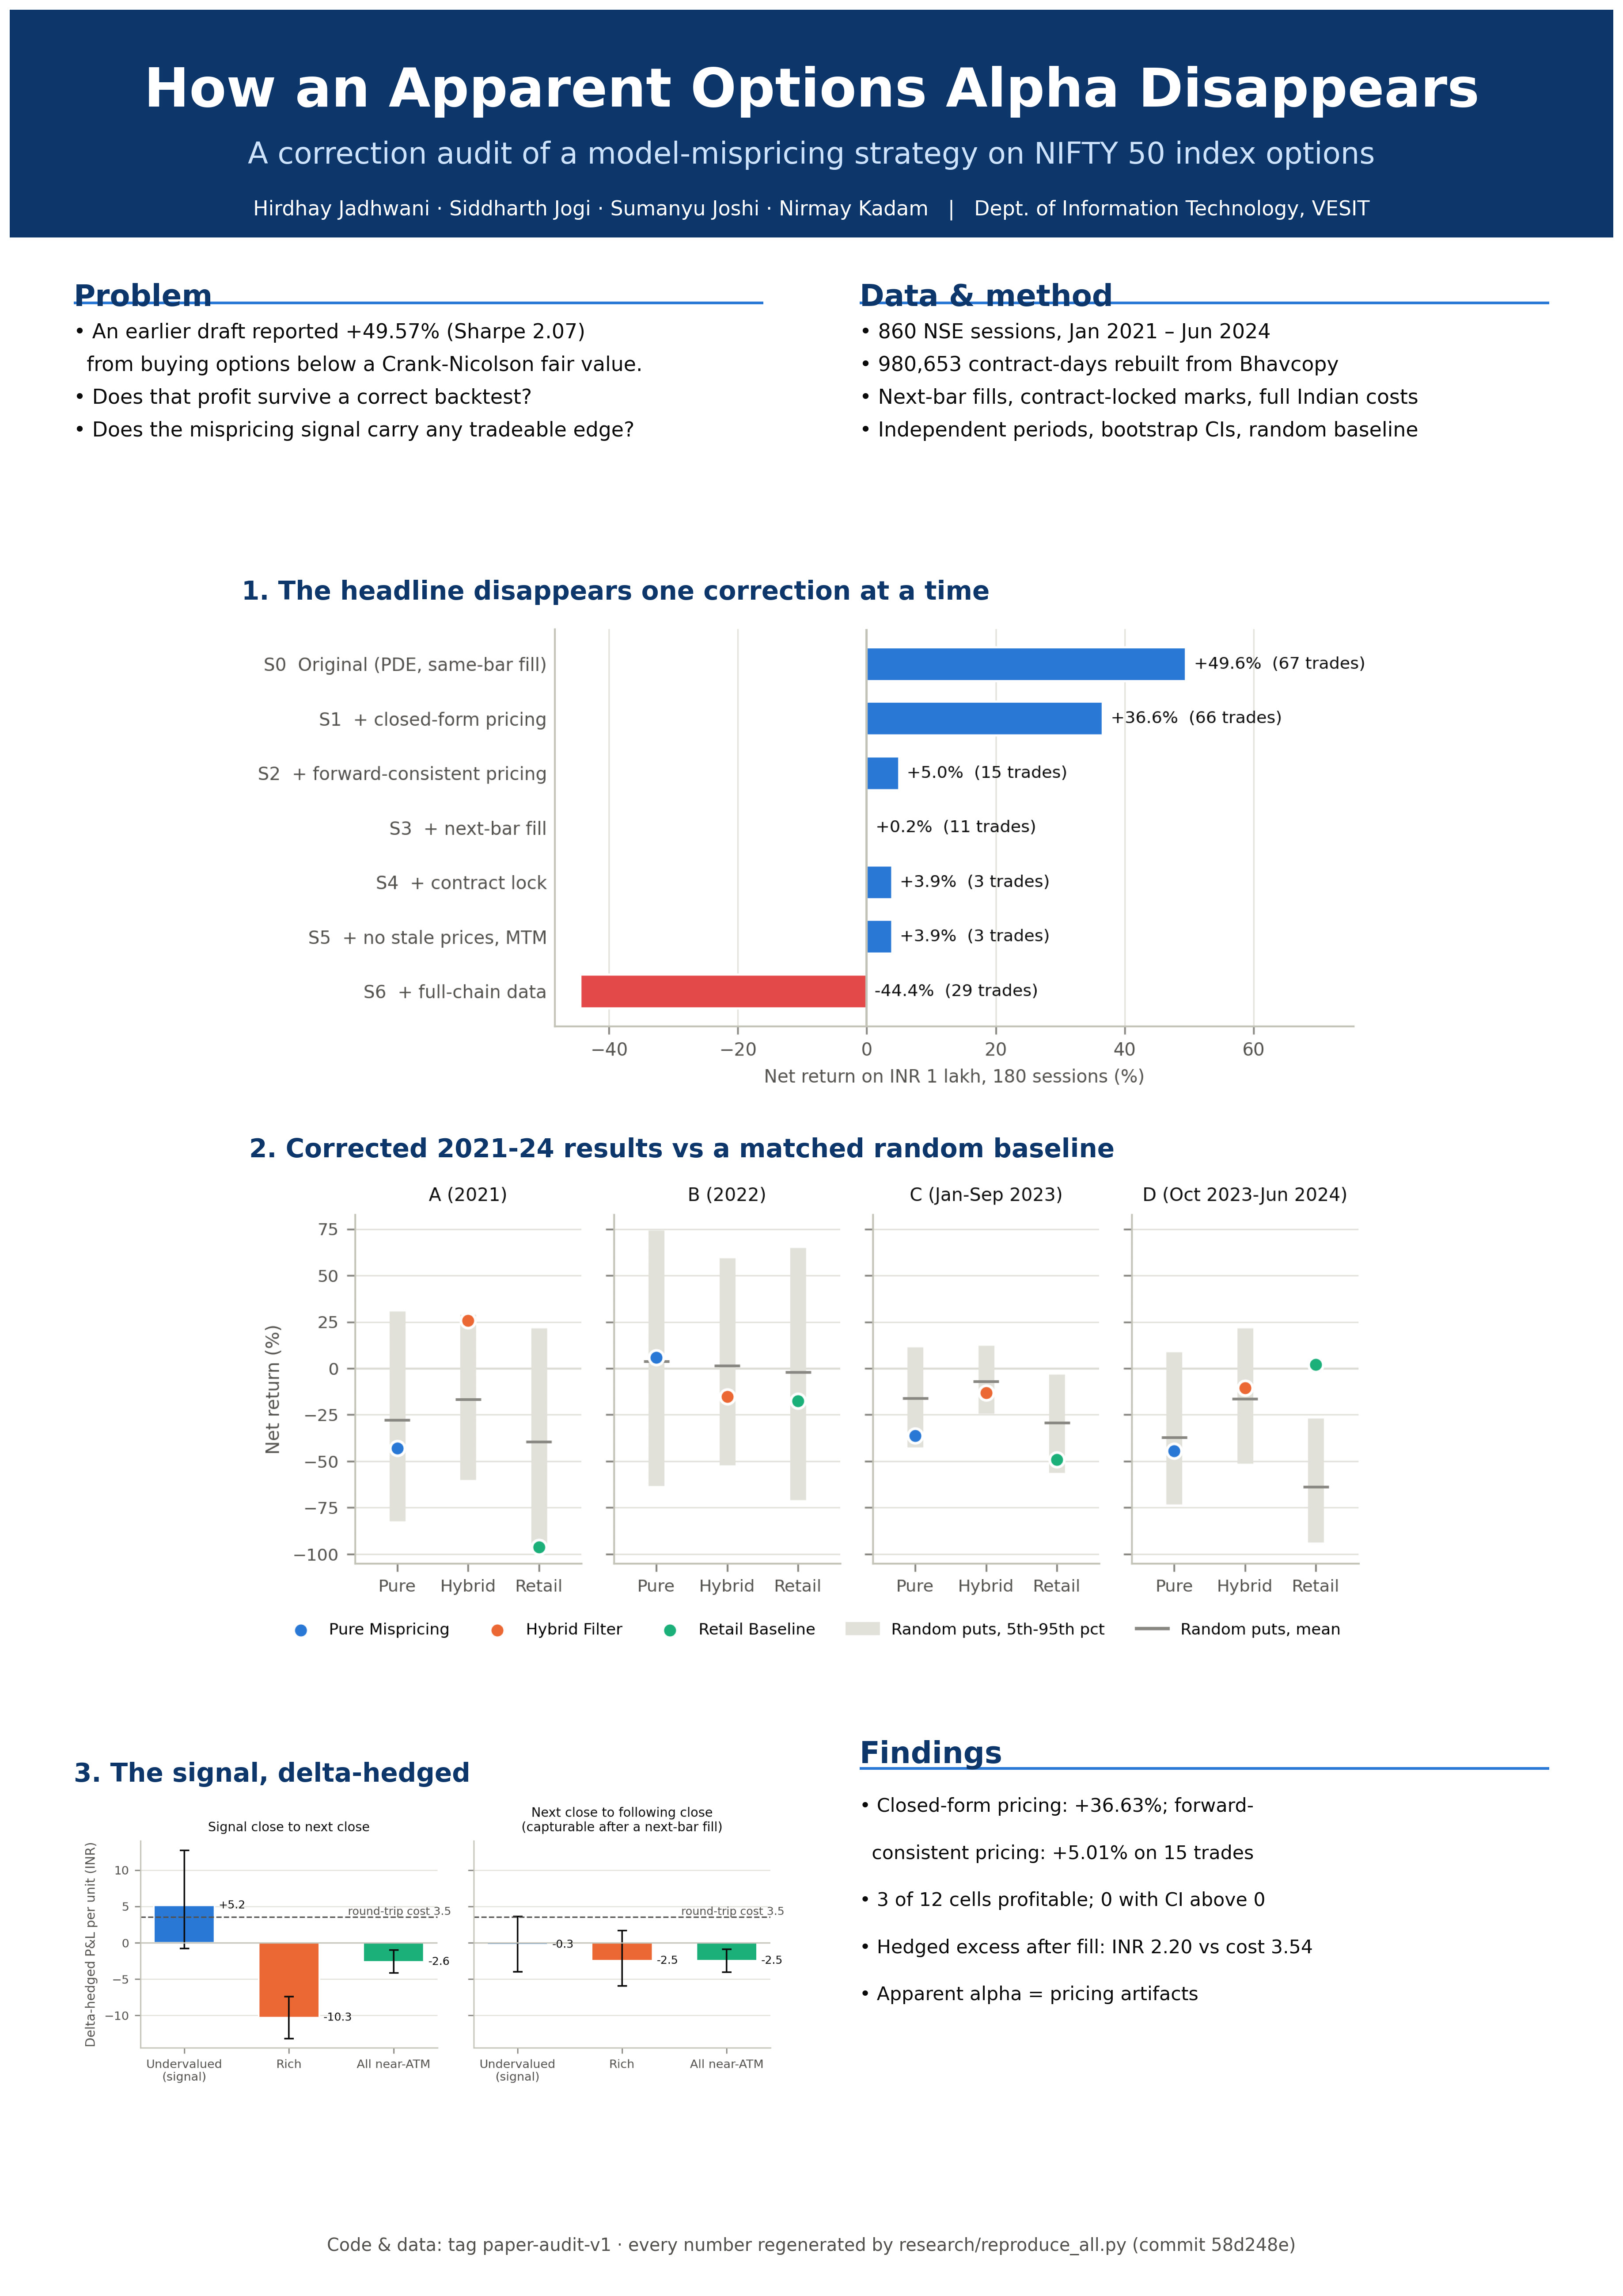
Research poster (A2 portrait; PNG in docs/lab_experiments/figures/exp10_poster.png).
Design: one question per block (problem, data/method), three result panels in reading order (waterfall → period results vs chance → hedged signal), and a findings box with the numbers a visitor should remember; colours follow a colour-blind-safe palette.

6. Demonstration Plan
1. Show the repository at tag paper-audit-v1 and the manifest (commit, configuration, data hashes).
2. Run `python research/reproduce_all.py --tables-only` live (seconds) to regenerate tables, figures and numbers.
3. Walk through the waterfall: reproduce +49.57%, then remove it correction by correction.
4. Open the 4 June 2024 trade in the data to show how one fill drives a period's result.
5. Optional: show the Shani dashboard (option chain, Greeks, technicals) as the product the research grew from.

7. Innovation Pitch (3 minutes)
Time | Content
0:00–0:30 | Hook: most Indian retail options traders lose money; model-based 'mispricing' strategies promise an edge. Our first backtest showed +49.57%.
0:30–1:15 | The twist: we audited our own result. Grid error, a carry bias, same-bar fills and wrong-contract marking created the profit — it falls to +5.01% with consistent pricing.
1:15–2:00 | Proof at scale: 860 sessions rebuilt from NSE data; 3 of 12 independent tests profitable, 0 with a per-trade confidence interval above zero; the hedged signal is real but smaller than costs.
2:00–2:40 | Innovation: a reproducible audit toolkit — correction waterfall, matched random baselines, hedged signal tests, one-command regeneration with a manifest — usable on any trading claim.
2:40–3:00 | Ask: feedback on extending the toolkit to intraday data and other strategies; venue suggestions.

8. Conclusion
The submission package, poster, demonstration and pitch were prepared. Target venues were identified (a re-examination journal track, an IEEE computational-finance conference and an arXiv preprint), with deadlines to be confirmed by the students; the remaining steps are compiling the PDF, the similarity check and the author details.

