**Home Work -2**

**\*Compatible Browser :** Internet Explorer.

**\*Link to the Website :** [**http://cs-server.usc.edu:1428/**](http://cs-server.usc.edu:1428/)

**\*Aim :** To apply UI design principles to the website already created.

**\*Design Principles Used:** In-order to make the website look appealing and to make easy for users to use the website, I have made changes to the CSS and I have implemented the following design principles.

*Law of Proximity.

*Line Gestalts.

*Frames.

*Contrast.

*Text Gestalt – Typographical rule.

*Conventions.

*Graphical Representation.

*Steve Krug’s First Law Of Usability.

*No Happy Talk or Instructions.

**\* Law of Proximity :**

**Definition:**Objects that are close to each other are perceived as belonging to each other.

**Example from my website** : In form 3 , as shown below the textbox1 and First Name are close to each other and the textbox2 and Last Name are close to each other.So,First Name and the textbox1 are perceived as belonging together.

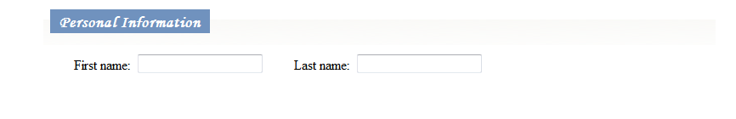

**\*Line Gestalt :**

**Definition :** Aligned items are perceived as belonging together.

**Example from my website:** In form 1 as shown below,the Cream Toppings field has three check box values aligned in a line where multiple values can be selected.This can be cited as an example for Line Gestalt.

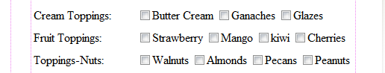

**\*Contrast:**

**Defintion :** Larger text stands out or usage of 3D text

**Example From my website:** Headings are in a separate font and color which secludes them from rest of the content below them.

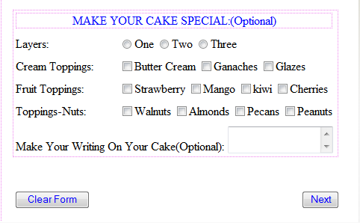

\***Frames :**

**Defintion** : Frames can be used to make clear distinction between areas.

**Example from my website:**

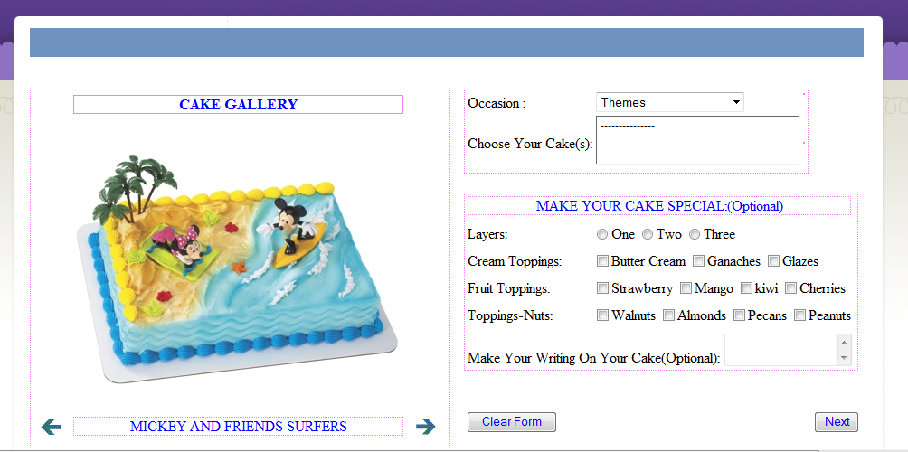

**\*Conventions:**

**Usage :** Use of conventions keeps the users from getting confused or misinterpretation.

**Example from my website:**

Convention Used : Usage of * to represent the Error Fields.

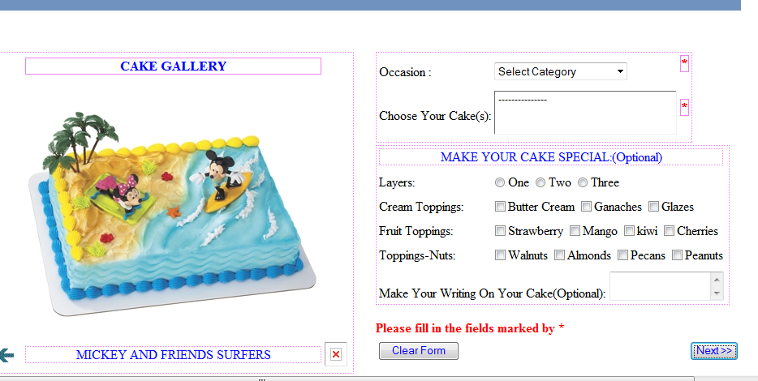

**\* Graphical Representation:**

**Use:**Lets the users do a mindless work.

**Example from my website:** Cakes are represented graphically as shown below.

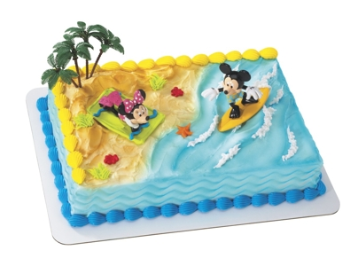

* **Steve Krug’s First Law Of Usability:**

**Definition:**Make it obvious for users as to what to be clicked on.

**Example from my website:**The buttons are kept in a place where there is not much visual noise and they clearly imply what they intend to do.

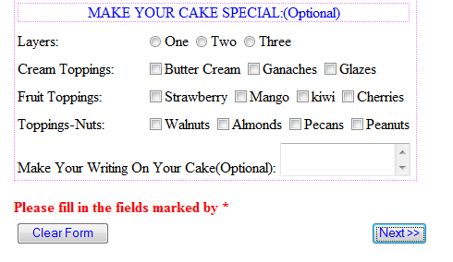

\***Text Gestalt – Typographical Rule:**

The website used slightly larger fonts and different colors for the headings so that the user can easily differentiate between the form content and the headings.

\***No Happy Talk or Instructions:**

Clearly the website has no happy talk or instructions

\***OTHER CHANGES:**

-> I have added an extra form so that the visual noise on any single page can be reduced there by making it easy for the users to use the website.

->I have changed the background image so that it can blend with the image gallery that I have added in-order improve user experience.