

Department of Information Technology

Academic Year: 2019-20 Name of Student: Nirmit dagli
Semester: VIII Student ID:16104013
Class / Branch: IT Date of Performance:14/01/2020
Subject: DevOps Lab Date of Submission:147/01/2020
Name of Instructor: Prof. Vishal Badgujar

Experiment No. 01
Aim: Case study on devops in terms of code, build, test, configure and monitor phase.
1. What is DevOps?
DevOps (development and operations) is an enterprise software development phrase used to mean a type of agile relationship between development and IT operations. The goal of DevOps is to change and improve the relationship by advocating better communication and collaboration between these two business units.
The term DevOps is a combination of two words namely Development and Operations. DevOps is a practice that allows a single team to manage the entire application development life cycle, that is, development, testing, deployment, operations.

2.Life cycle of DevOps
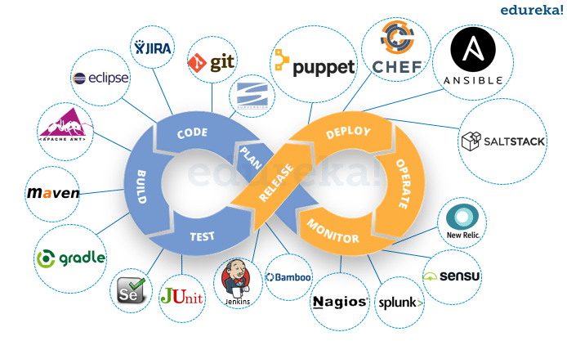
3.Phase of DevOps
DevOps is a software development approach through which superior quality software can be developed quickly and with more reliability. It consists of various stages such as continuous development, continuous integration, continuous testing, continuous deployment, and continuous monitoring.
1. Development
In this DevOps stage the development of software takes place constantly. In this phase, the entire development process is separated into small development cycles. This benefits DevOps team to speed up software development and delivery process.
2. Testing
QA team use tools like Selenium to identify and fix bugs in the new piece of code.
3. Integration
In this stage, new functionality is integrated with the prevailing code, and testing takes place. Continuous development is only possible due to continuous integration and testing.

4. Deployment
In this phase, the deployment process takes place continuously. It is performed in such a manner that any changes made any time in the code, should not affect the functioning of high traffic website.
5. Monitoring
In this phase, operation team will take care of the inappropriate system behavior or bugs which are found in production.
4.Recent devops tool with functionality.
1.Jenkins
Jenkins a DevOps tool for monitoring execution of repeated tasks. It helps to integrate project changes more easily by quickly finding issues.
Function:
- It increases the scale of automation
- Jenkins requires little maintenance and has built-in GUI tool for easy updates.
- It offers 400 plugins to support building and testing virtually any project.
- It is Java-based program ready to run with Operating systems like Windows, Mac OS X, and UNIX
2.Splunk
Splunk is a tool to make machine data accessible, usable, and valuable to everyone. It delivers operational intelligence to DevOps teams. It helps companies to be more productive, competitive, and secure.
Function
- Data drive analytics with actionable insights
- Next-generation monitoring and analytics solution
- Delivers a single, unified view of different IT services
- Extend the Splunk platform with purpose-built solutions for security

5.usecase of devops

[Paste your screenshots here]

