Game Design Document

Fill up the following document

1. Write the title of your project.

Marathon Runner Championship

1. What is the goal of the game?

To cross the finishing line and win the game in minimum time

1. Write a brief story of your game.

First, the game will start and players that are controlled by the

computer and player controlled by us will run and try to reach the

finishing line in minimum time without being affected by the obstacles

on the track and try to win the game.

1. Which are the playing characters of this game?

* Playing characters are the ones who respond to the user based on the input from the user.
* Cars, monkeys, dinos, wizards, etc., are the playing characters in the game.

|  |  |  |
| --- | --- | --- |
| Number | Character Name | What can this character do? |
| 1 | Mickey Mouse that is controlled by me | Run and move left, right, up and down |
| 2 | The other six characters like Chota Bheem, Minnie Mouse, Goofy, Sonic, Jerry, Doremon that are controlled by other players | Run and move up and down |

1. Which are the Non-Playing Characters of this game?

* Non-Playing characters are the ones that don't have an action or behavior when the user interacts with the game.
* Hurdles, stones, bananas, coins, etc., are non-playing characters in the game.

|  |  |  |
| --- | --- | --- |
| Number | Character Name | What can this character do? |
| 1 | Spiders | Moves up and down and reduce speed of character |
| 2 | Mouse | Moves up and down and reduce speed of character |
| 3 | Energy booster | Boosts player’s energy and increases its speed |

1. Draw your imagination of this game. What does this game look like?

* Draw the game either on your computer or on paper.
* Add images of the game scenes to show each of the playing and non-playing characters at least once.

­­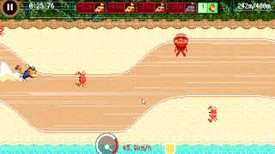

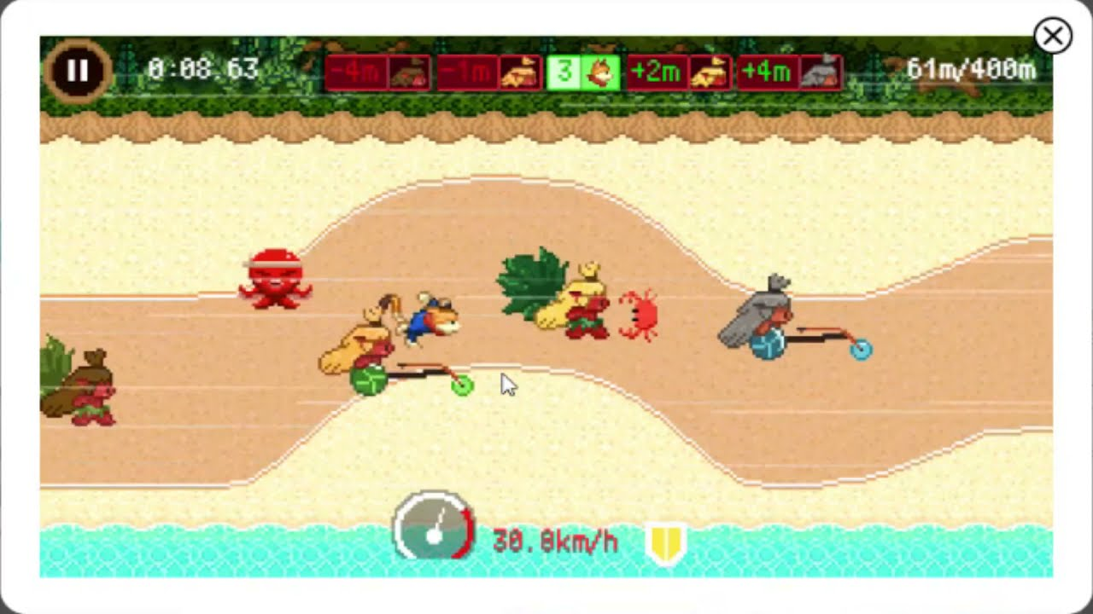­

1. How do you plan to make your game engaging?

This game is multiplayer game. When the game is started, each player gets

one character. Each player tries to reach the finishing line in minimum time.

If the player touches other player or any obstacle then its score gets

decreased.If the player touches any energy booster its score increases

and its speed also increases.