HERO-S:QPU-AwareEnergy-Latency
OrchestrationforAIoTIntrusionDetection
AuthorName(s)OmittedforReview
InstitutionOmittedforReview
Abstract—AIoT | intrusion-detection | workflows | increasingly | scale proxyresults from smallQiskitquantum-kernel feasibil-ityruns.
spanedgegateways,cloudAIaccelerators,andoptionalremote quantumservices.Thepracticalsystemsquestioniswhether

eachsecuritytaskshouldremainattheedge,escalatetocloud inference,orenteraQPU-capablepathunderlatency,queue-time,andenergyconstraints.ThispaperpresentsHERO-S, aQPU-awareedge-cloudorchestrationframeworkforAIoT intrusiondetection.HERO-Sannotatestaskswithalertseverity, assetcriticality,uncertainty,responsedeadline,backendqueue time,routeconfidence,andenergyestimates,thenappliesa constrainedroutingutility.WeevaluateHERO-SonTONIoT, NSL-KDD,CICIDS2017,andIoT-23over30seeds.Thecloud modelremainstheupper-qualityreferencebutviolatesa2.5 ms/sampleaveragegatewaybudget.Underthatbudgetand250 msQPUqueuetime,HERO-SimprovesF1overedge-onlyand overaclosestclassicaluncertainty-cascadebaselineonthethree nontrivialdatasets,maintainsnear-perfectedgeperformanceon IoT-23,andreducesenergyby71.7–98.0%relativetocloud-only routing. At 250 ms QPU queue time, HERO-S assigns all samples toedge/cloudroutes,illustratingexplicitqueue-awarecontrolof remoteacceleratoruse.
IndexTerms—AIoTsecurity,intrusiondetection,edge-cloud orchestration,QPU-awarescheduling,energy-awarerouting.
I.INTRODUCTION
AIoTsecuritypipelinescombinelocaltelemetrycol-lection,edgefiltering,cloud-basedmachinelearning,and specializedaccelerators.Edge-computingandmobile-edge-computingstudiesmotivatesplittinglatency-sensitivecompu-tationacrossdevices,gateways,andcloudresources[1],[2]. Near-termQPUsaddapossibleremoterouteforquantum kernelsandvariationalmethods[3]–[6].Thiscreatesaroute-selectionproblem:thedefendermustdecidewhenaremote quantum-capablepathisworthitsaddeddelayandenergy.
HERO-Saddressesthisroute-selectionlayer.CurrentQPU-compatibleclassifiersareevaluatedascandidateroutes,and everyrouteisscoredbyexpectedquality,deadline,backend queue time, confidence, and energy. This framing separates the upper-qualitycloudIDSreferencefromthefeasiblepolicies thatmustsatisfyagatewaylatencybudget.
The | contributions | are: | (1) | an | AIoT | edge-cloud-QPU

II.THREATAND WORKLOAD MODEL
A.DeploymentModel
HERO-SassumesanAIoTedge-cloudcontinuum.IoT devicesproducepacketorflowtelemetry,edgegateways perform normalization and low-cost filtering, cloud CPU/GPU resources run stronger IDS models, and a remote QPU service isavailable asanoptionalpath.The QPUisnotplaced onthe IoT device; it is a scarce remote service with queue time, shot budget,executionlatency,andmodeledinfrastructureenergy.
ThedeploymentiscompatiblewithcommonAIoTdata planes.Sensorsandgatewaysmayexportflowsummaries throughMQTT,CoAP,HTTP,orasite-localmessagebro-ker.Theorchestratorconsumesnormalizedflowrecordsand backend state, not raw packet payloads. Edge devices therefore remainlightweightwhilecloudandQPU-capableroutesare usedonlywhentheirexpectedsecurityutilityjustifiesaddi-tionaldelayandenergy.
B.Attacker,Defender,andMetadata
ThedefenderobservesflowtelemetryfromAIoTdevices andgateways.Theattackermaygeneratedenial-of-service, scanning,brute-force,botnet,backdoor,infiltration,orweb-attack traffic. Each task node records model and security meta-datausedbythescheduler:severityraisespriorityforlikely attacks, asset criticality distinguishes controllers from low-risk devices,uncertaintytriggersescalationwhenedgeinference isambiguous,confidencecheckswhetherthetargetrouteis reliableenough,deadlinespenalizeslowroutes,queuetime capturesremote-backenddelay,andenergypreventsexpen-siverouteswithoutexpectedutilitygain.Intheexperiments, severity is derived from the edge attack probability, uncertainty isoneminusedgeconfidence,assetcriticalityisassignedon a1–5scaletorepresentheterogeneousdevices,anddeadlines aresampledfromrepresentativeedge-responseclasses.

intrusion-detection | formulation; | (2) | HERO-Scheduler, | a | III.HERO-S ARCHITECTUREAND SCHEDULER

security-awareroute-selectionpolicyusingseverity,assetcrit-icality,uncertainty,confidencegates,deadlines,queuetime, and energy estimates; (3) a 30-seed evaluation on four real IDS datasets;(4)quantitativecomparisonwithaclosestclassical uncertainty-cascadebaseline,includingroute-callrates,SLA violations,energy,andenergy-delayproduct(EDP);and(5)a transparentQPU-proxymethodologythatseparatesscheduler-

Fig.1showsthesystemarchitecture.HERO-Shasan ingestionlayer,anedgepreprocessingandlightweightIDS layer,acloudAIlayer,aQPU-capableanalysispath,anda telemetry/schedulercontrolplane.

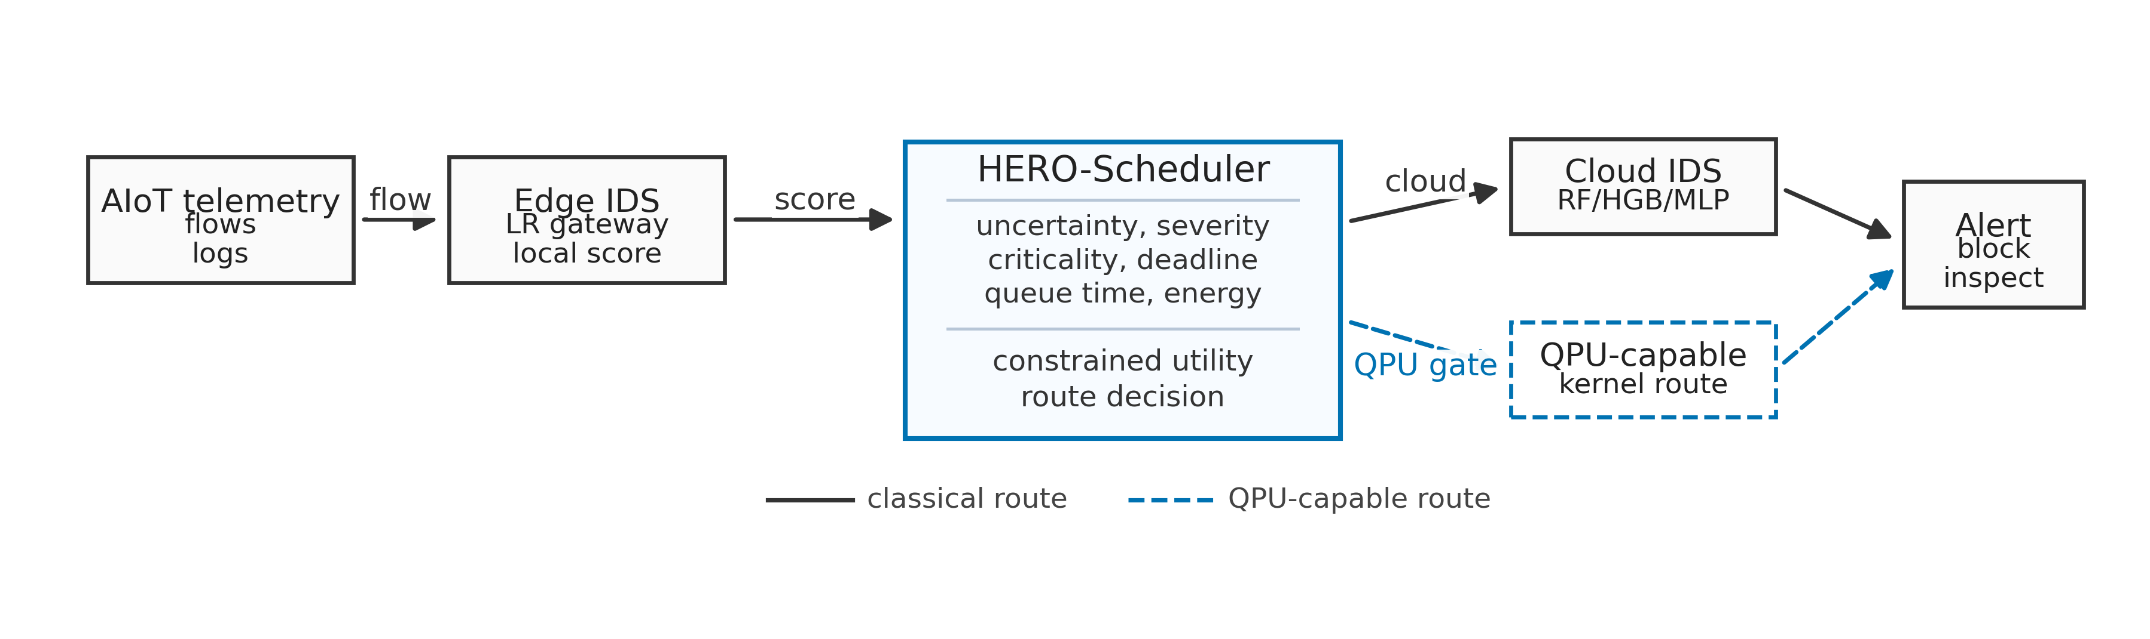
Fig.1.HERO-Sedge-cloud-QPUarchitecture.Flowtelemetryisfirsthandledbytheedge;uncertainorhigh-riskcasesmaybeescalatedtocloudinference oraQPU-capableroutedependingondeadline,confidence,queuetime,andenergy.
A.UtilityFunction | TABLEI
For each ready task v, HERO-Scheduler evaluates candidate | DATASETSUSEDINTHE 30-SEEDEVALUATION.
routerby | Dataset | Samples | Feat. | Normal | Attack | Ratio

score(r, v) = αQ(v, r) + βR(v) −γE(v, r) −δL(v, r) −ηW(r) −ζS(v, r), | (1)
whereQisexpectedqualitygain,Rissecurityrisk,Eis energy,Lislatency,Wisqueuetime,andSispredicted SLAviolation.Securityriskisseveritytimesassetcriticality and false-negative cost. Unless otherwise stated, HERO-S usesα=2.0,β=1.5,γ=0.001,δ=0.015,η=0.01, andζ=1.0.Thesevaluesarefixedacrossdatasetsandset qualityandsecurityriskasdominantterms,whileenergy, latency,queuetime,andSLAviolationsactaspenalties.The scheduler uses edge routes for high-confidence or budget-tight samples,cloudroutesforstrongerclassicalinferencewhen confidenceandlatencypermit,andQPU-capableroutesonly whenuncertainty,risk,queuetime,andconfidencejustifythe additionalcost.
HERO-Salsoappliestwosafetygates.First,cloudesca-lationrequiresedgeuncertaintyatleast0.08andcloud-route confidence at least 0.70, followed by an average 2.5 ms/sample latency-budgetcheck.Second,aQPU-capableroutemustwin theutilityscoreandmusthaveaconfidencemarginover theedge/cloudalternatives;otherwisethetaskfallsbackto thebestfeasibleclassicalroute.Thesegatesmakefallback behavioranexplicitpartofthealgorithm.
B.BaselinesandComplexity
WecompareHERO-Swithfourroutingpolicies.Edge-onlyperformsminimum-energygatewayinferencewithno escalation.Cloud-onlyistheupper-qualityclassicalreference butviolatestheaveragebudget.StaticQPUisastress-test baselinethatalwaystakestheQPU-capableroute.Theclosest classicalbaselineisanuncertaintycascade:itfirstrunsthe edgemodelandescalatestocloudwhenedgeuncertaintyis atleast0.25;ithasnosecuritymetadata,QPUawareness, queueterm,orenergyterm.
HERO-Schedulerprocessesreadytasksindependencyor-der, filters infeasible routes, estimates each route’s quality gain

TONIoT | 20,000 | 40 | 10,000 | 10,000 | 0.500
NSL-KDD | 7,000 | 41 | 3,500 | 3,500 | 0.500
CICIDS2017 | 40,000 | 78 | 25,818 | 14,182 | 0.355
IoT-23 | 10,035 | 15 | 7,200 | 2,835 | 0.283
andcostfromthetelemetrystate,scoresallfeasibleroutes, dispatches the task, and updates backend state. The scheduling passcostsO(|V ||R|)timeandO(|R|)per-taskmemoryfor |V |tasksand|R|routes.Intheevaluatedsystem|R|=3 (edge,cloud,QPU-capable),sotheschedulerislightweight relativetoIDSinferenceandremotebackenddelay.
IV.EXPERIMENTAL METHODOLOGY
A.DatasetsandSampling
TableIsummarizesthedatasets.TONIoTandIoT-23 provideIoT/IIoTtraffic[7],[8];CICIDS2017providesa modernIDSbenchmark[9],[10];NSL-KDDisretainedas areproduciblelegacybaseline[11].TONIoTisstratified-sampledto20,000rows.CICIDS2017issampledfromall eightdailyparquetfileswithupto5,000rowsperfile,pre-servingcoverageacrossbenign,DDoS,portscan,infiltration, web attack, botnet, and brute-force traffic. NSL-KDD uses the standardtrain/testfileswithstratifiedcaps.IoT-23dropsIP, UID,detailedlabel,andscenariofieldstoreduceleakage; becausetheselectedsubsetiseasy,itistreatedasvenue-alignmentvalidationratherthanthehardestbenchmark.
B.IDSModelsandQPU-CompatibleRoute
Classical IDS baselines are Logistic Regression, RBF-SVM, RandomForest,HistogramGradientBoosting,andMLP.The edgerouteusesLogisticRegressionbecauseithasacompact lineardecisionruleandsmallmemoryfootprintsuitablefor gatewayinference,whilethecloudrouteusesRandomForest asastrongerensemblereferencewithlargermodelstate; TableIIIreportsthefullcomparison.Scheduler-scaleQPU behavior is represented by a four-feature reduced-kernel proxy.

TABLEII
ROUTE-COSTANDTELEMETRYASSUMPTIONS.
Route | Lat. | Energy | Source
EdgeCPU | 1.2ms | 0.0227J | RAPLifavailable;fallback
modelotherwise.
CloudCPU/GPU | 6.0ms | 1.296J | NVML/RAPLifavailable;
fallbackmodelotherwise.
QPU-capable | 75–325ms | 1800J | Modeledinfrastructuresen-
sitivityonly.
The proxy represents the feature-reduced interface that a QPU-
compatible kernel path would occupy in the routing graph. We
alsorunsmallQiskitquantum-kernelsubsetsonTONIoT
andNSL-KDDusing16trainingsamples,8testsamples,256

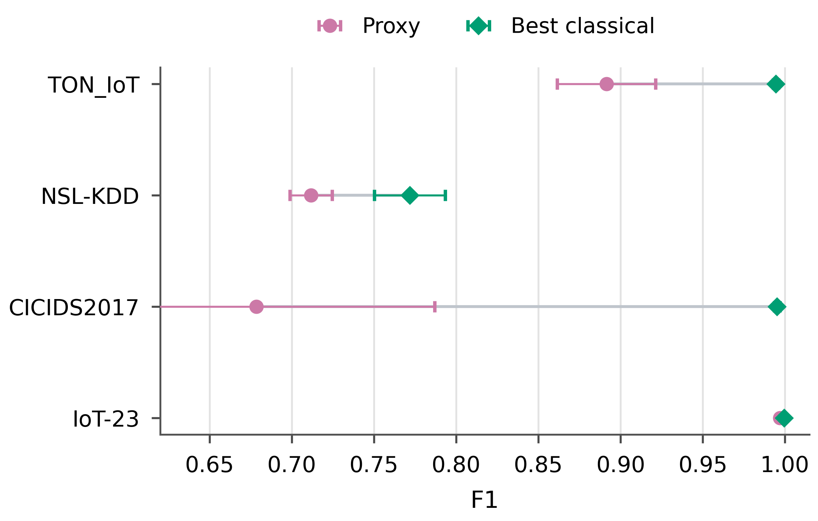

shots,and3seeds[12],[13]. | Fig.2. | F1scoresforthebestclassicalIDSmodelandthereduced-kernel
TheproxyexercisestheroutethatafutureQPUkernel
 | proxy.
implementationwouldoccupyintheorchestrationgraph.

Whenitsexpectedutilityisbelowclassicalinference,HERO-Sfallsbacktoedgeorcloudexecutionandpreservesscarce backendcapacity.
C.Metrics,Energy,andStatisticalTests
Metricsincludeaccuracy,precision,recall,F1,ROC-AUC, PR-AUC,FPR,FNR,latency/sample,energy/sample,EDP, route-callrates,sampled-deadlineviolationrate,andaverage-budgetviolation.Wereportmeanandstandarddeviation over30seedsandusepairedWilcoxonsigned-ranktestsfor HERO-S versus edge-only and versus the uncertainty cascade. The2.5ms/sampleconstraintisarepresentativeaverage gatewaycomputebudgetusedtostress-testlatency-sensitive edgeoperation.Edge-computingandMECsurveysmotivate pushing latency-sensitive services toward nearby resources for highly responsive operation [14], [15]; we also report sampled-deadlineviolationrateswithper-flowdeadlinesdrawnfrom 5–100msresponseclasses.
CPU/GPUenergyusesRAPL/NVMLcounterswhenavail-ableandotherwisealabeledfallbackmodel.QPUinfras-tructureenergyismodeledforschedulingsensitivitybecause directfacilitytelemetryisoutsidethecurrentartifact.Static QPU routing is therefore reported as a stress-test baseline. The modeledroutecostsare1.2msand0.0227JforedgeCPU, 6.0msand1.296JforcloudCPU/GPU,and75–325msplus 1800JfortheQPU-capablepathdependingonqueuetime.

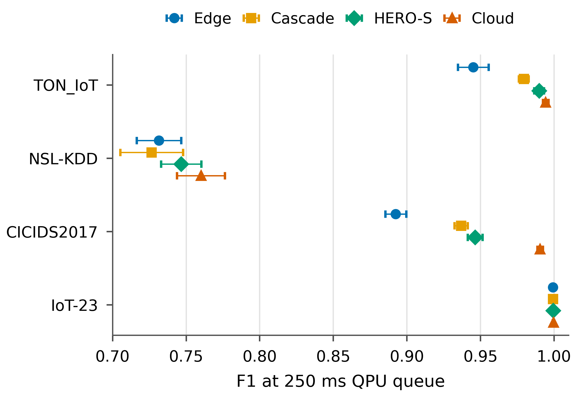
Fig.3. Closest-baselinecomparisonat250msQPUqueuetime.HERO-S improvesoveredge-onlyandtheuncertaintycascadewhileremainingbelow theaveragelatencybudget.
selecteduncertain/high-riskcasesatlowqueuetimeandfalls backtoclassicalrouteswhenconfidence,queue,orlatency conditionsareunfavorable.
B.Closest-BaselineSchedulerComparison
TableIVaddressesthemainorchestrationquestionunder deadlineandqueueconstraints.Underanunconstrainedset-

V.RESULTS ting,cloud-onlyroutinggivesthestrongestF1onTONIoT,

A.IDSQualityandProxyLimits
TableIIIgivesthecompleteclassicalbaselinecomparison over30seeds.Strongclassicalmodels,especiallyRFand HGB, are the best quality references on the evaluated datasets. TheseresultsmotivateQPU-awarerouteadmission:QPU-capableexecutionisselectedonlywhenitsexpectedutility exceedstheedgeandcloudalternatives.
Thereduced-kernelproxyisweakestandleaststableon CICIDS2017(F10.679±0.108),whereasIoT-23isnearly saturated.Thisinstabilitymotivatesconfidence-gatedQPU-capablerouting.HERO-Sthereforeusestheproxyroutefor

NSL-KDD, and CICIDS2017. Under a 2.5 ms/sample average gateway budget, however, cloud-only routing at 6.0 ms/sample isinfeasible.At250msQPUqueuetime,HERO-Ssatisfies theaveragebudget,avoidsQPUcalls,improvesF1overboth edge-onlyandtheuncertaintycascadeonthethreenontrivial datasets, and achieves only marginal additional F1 on the near-saturatedIoT-23setting.
NSL-KDDillustratesalimitationoffixeduncertaintycas-cades:the0.25ruleescalatesasmallsubsetwhosecloud predictionsdonotconsistentlyimprovetheedgedecision,so cascadeF1canfallbelowedge-onlyeventhoughthecloud modelisstrongeronaverage.Thecascadethresholdisa

TABLEIII
IDSBASELINECOMPARISONOVER 30SEEDS.VALUESAREMEANS; PROXY F1ALSOREPORTSSTANDARDDEVIATIONBECAUSETHEREDUCED-KERNEL ROUTEISUSEDINTHESCHEDULER-SCALEAUDIT.
Dataset | Model | Acc. | F1 | Recall | FPR | FNR | ROC-AUC | PR-AUC
TONIoT | LR | 0.944 | 0.945 | 0.966 | 0.079 | 0.034 | 0.991 | 0.991
 | RBF-SVM | 0.973 | 0.973 | 0.968 | 0.022 | 0.032 | 0.982 | 0.986
 | RF | 0.994 | 0.994 | 0.996 | 0.007 | 0.004 | 1.000 | 1.000
 | HGB | 0.995 | 0.995 | 0.995 | 0.006 | 0.005 | 1.000 | 1.000
 | MLP | 0.978 | 0.978 | 0.968 | 0.012 | 0.032 | 0.994 | 0.994
 | Proxy | 0.889 | 0.891±0.030 | 0.906 | 0.128 | 0.094 | 0.916 | 0.899
NSL-KDD | LR | 0.772 | 0.732 | 0.620 | 0.076 | 0.380 | 0.858 | 0.876
 | RBF-SVM | 0.789 | 0.747 | 0.622 | 0.044 | 0.378 | 0.893 | 0.908
 | RF | 0.801 | 0.760 | 0.630 | 0.027 | 0.370 | 0.961 | 0.956
 | HGB | 0.809 | 0.772 | 0.646 | 0.027 | 0.354 | 0.952 | 0.946
 | MLP | 0.789 | 0.755 | 0.652 | 0.075 | 0.348 | 0.873 | 0.889
 | Proxy | 0.763 | 0.712±0.013 | 0.586 | 0.061 | 0.414 | 0.829 | 0.874
CICIDS2017 | LR | 0.888 | 0.892 | 0.929 | 0.153 | 0.071 | 0.944 | 0.934
 | RBF-SVM | 0.906 | 0.911 | 0.956 | 0.143 | 0.044 | 0.960 | 0.944
 | RF | 0.991 | 0.991 | 0.990 | 0.009 | 0.010 | 0.999 | 0.998
 | HGB | 0.995 | 0.995 | 0.996 | 0.005 | 0.004 | 0.999 | 0.999
 | MLP | 0.952 | 0.953 | 0.973 | 0.068 | 0.027 | 0.989 | 0.987
 | Proxy | 0.744 | 0.679±0.108 | 0.567 | 0.078 | 0.433 | 0.804 | 0.840
IoT-23 | LR | 0.999 | 0.999 | 0.999 | 0.001 | 0.001 | 1.000 | 0.999
 | RBF-SVM | 1.000 | 0.999 | 0.999 | 0.000 | 0.001 | 1.000 | 1.000
 | RF | 1.000 | 1.000 | 0.999 | 0.000 | 0.001 | 1.000 | 1.000
 | HGB | 1.000 | 1.000 | 0.999 | 0.000 | 0.001 | 1.000 | 1.000
 | MLP | 0.999 | 0.999 | 0.998 | 0.000 | 0.002 | 0.999 | 0.999
 | Proxy | 0.997 | 0.997±0.001 | 0.994 | 0.000 | 0.006 | 1.000 | 1.000
TABLEIV
DEADLINE-CONSTRAINEDSCHEDULERCOMPARISONAT 250MS QPUQUEUETIME. F1VALUESARE 30-SEEDMEANS; HERO-S F1ALSOREPORTS STANDARDDEVIATION.CLOUD-ONLYISANUPPER-QUALITYREFERENCEBUTVIOLATESTHE 2.5MS/SAMPLEAVERAGEBUDGET.
Dataset | EdgeF1 | CascadeF1 | HERO-SF1 | CloudF1 | HEROlat. | HEROenergy | EDP | Edge/Cloud/QPU | Deadl.viol. | pvsCascade
TONIoT | 0.945 | 0.979 | 0.990±0.003 | 0.994 | 1.878ms | 0.203J | 0.383 | 0.859/0.141/0.000 | 0.021 | 1.86 × 10−9
NSL-KDD | 0.732 | 0.727 | 0.747±0.014 | 0.760 | 1.541ms | 0.113J | 0.175 | 0.929/0.071/0.000 | 0.011 | 3.54 × 10−8
CICIDS2017 | 0.892 | 0.937 | 0.946±0.005 | 0.991 | 2.498ms | 0.367J | 0.917 | 0.730/0.270/0.000 | 0.040 | 4.66 × 10−8
IoT-23 | 0.999 | 0.999 | 1.000±0.001 | 1.000 | 1.211ms | 0.0256J | 0.031 | 0.998/0.002/0.000 | 0.00045 | 1.60 × 10−2

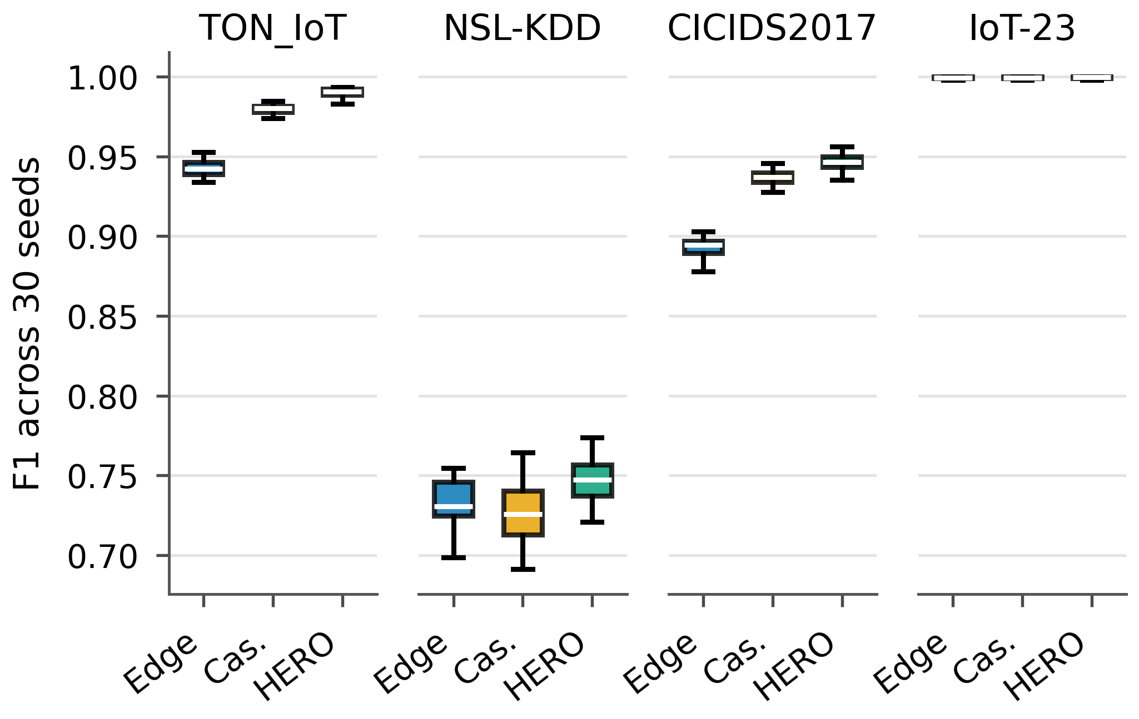
Fig.4.Thirty-seedF1distributionsforedge-only,uncertaintycascade,and HERO-Sat250msQPUqueuetime.
reasonableclassicaldesignchoice,butitdoesnotconsider cloudconfidence,securityrisk,orbackendstate.HERO-S usesaloweruncertaintytrigger(0.08)onlytogetherwitha cloud-confidencegate(≥0.70),security-riskweighting,and anaverage-budgetcheck,soloweruncertaintyalonedoesnot guaranteecloudescalation.Route-callratesinTableIValso identifywherethegainsoriginate.At250msqueuetime, QPUcallrateiszeroonalldatasetsbecausetheproxyhas lowerexpectedutilitythantheclassicalalternativesunderthe queue and latency budget. The quality gains come from selec-tiveedge-cloudrouting:HERO-Ssends14.1%ofTONIoT

samples,7.1%ofNSL-KDDsamples,27.0%ofCICIDS2017 samples, and 0.2% of IoT-23 samples to cloud inference. Fig. 4 showsthatthe30-seeddistributionsfollowthesamepattern. OnIoT-23,allpoliciesarealreadynearperfect;thenumerical F1differenceisoperationallynegligible,andHERO-Skeeps theroutemixalmostentirelyattheedge.
C.Energy-LatencyTradeoff
Edge-onlyremainsthelowest-energybaseline.HERO-S tradesadditionaljoulesforrecovereddetectionqualitywhile satisfyingtheaveragelatencybudget.Comparedwithcloud-only routing, HERO-S reduces energy by 84.4% on TONIoT, 91.3%onNSL-KDD,71.7%onCICIDS2017,and98.0%on IoT-23.ItsEDPremainsfarbelowcloud-only:0.383,0.175, 0.917,and0.031versus7.776forcloud-only.StaticQPU routinghasEDP5.85 × 105at250msqueuetimeandserves asthestress-testbaseline.
D.QPUQueueSensitivity
Fig.7showsthatQPUusechangeswithbackendqueue time.Atzeroqueue,HERO-SinvokestheQPU-capablepath for0.001ofTONIoTsamples,0.010ofNSL-KDDsamples, 0.000ofCICIDS2017samples,andalmostnoneonIoT-23. At an intermediate 50 ms queue, these rates drop to 0.0005 on TONIoT,0.0037onNSL-KDD,andzeroornearlyzeroon theotherdatasets.At250ms,QPUcallsdroptozeroonall datasets.Thismonotonicresponsefollowsdirectlyfromthe queueterm:whentheproxyroutelackssufficientconfidence orqueueconditionsarepoor,HERO-Sselectstheedgeor cloudroute.

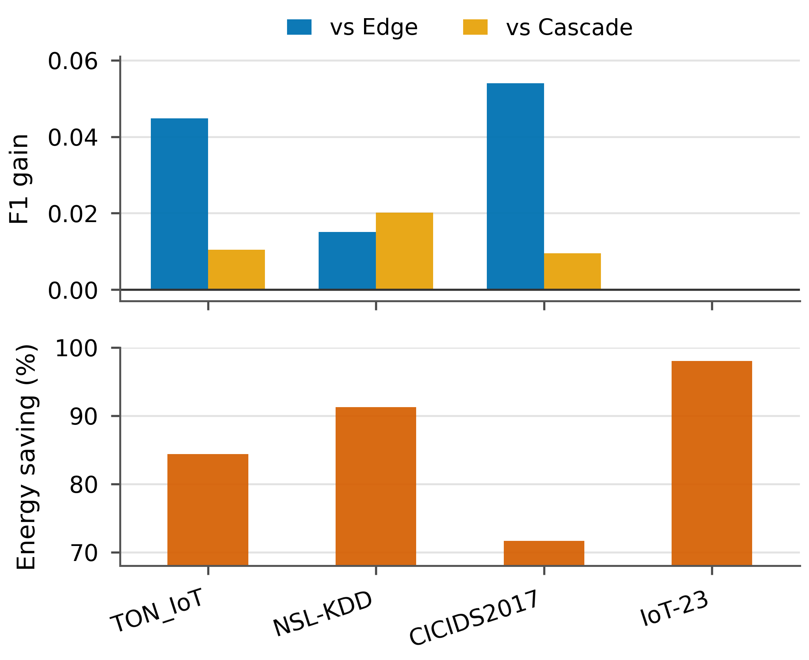
Fig.5. F1gainandenergysavingsunderthedeadline-constrainedsetting. HERO-Spaysmoreenergythanedge-onlybutremainsfarbelowcloud-only energy.
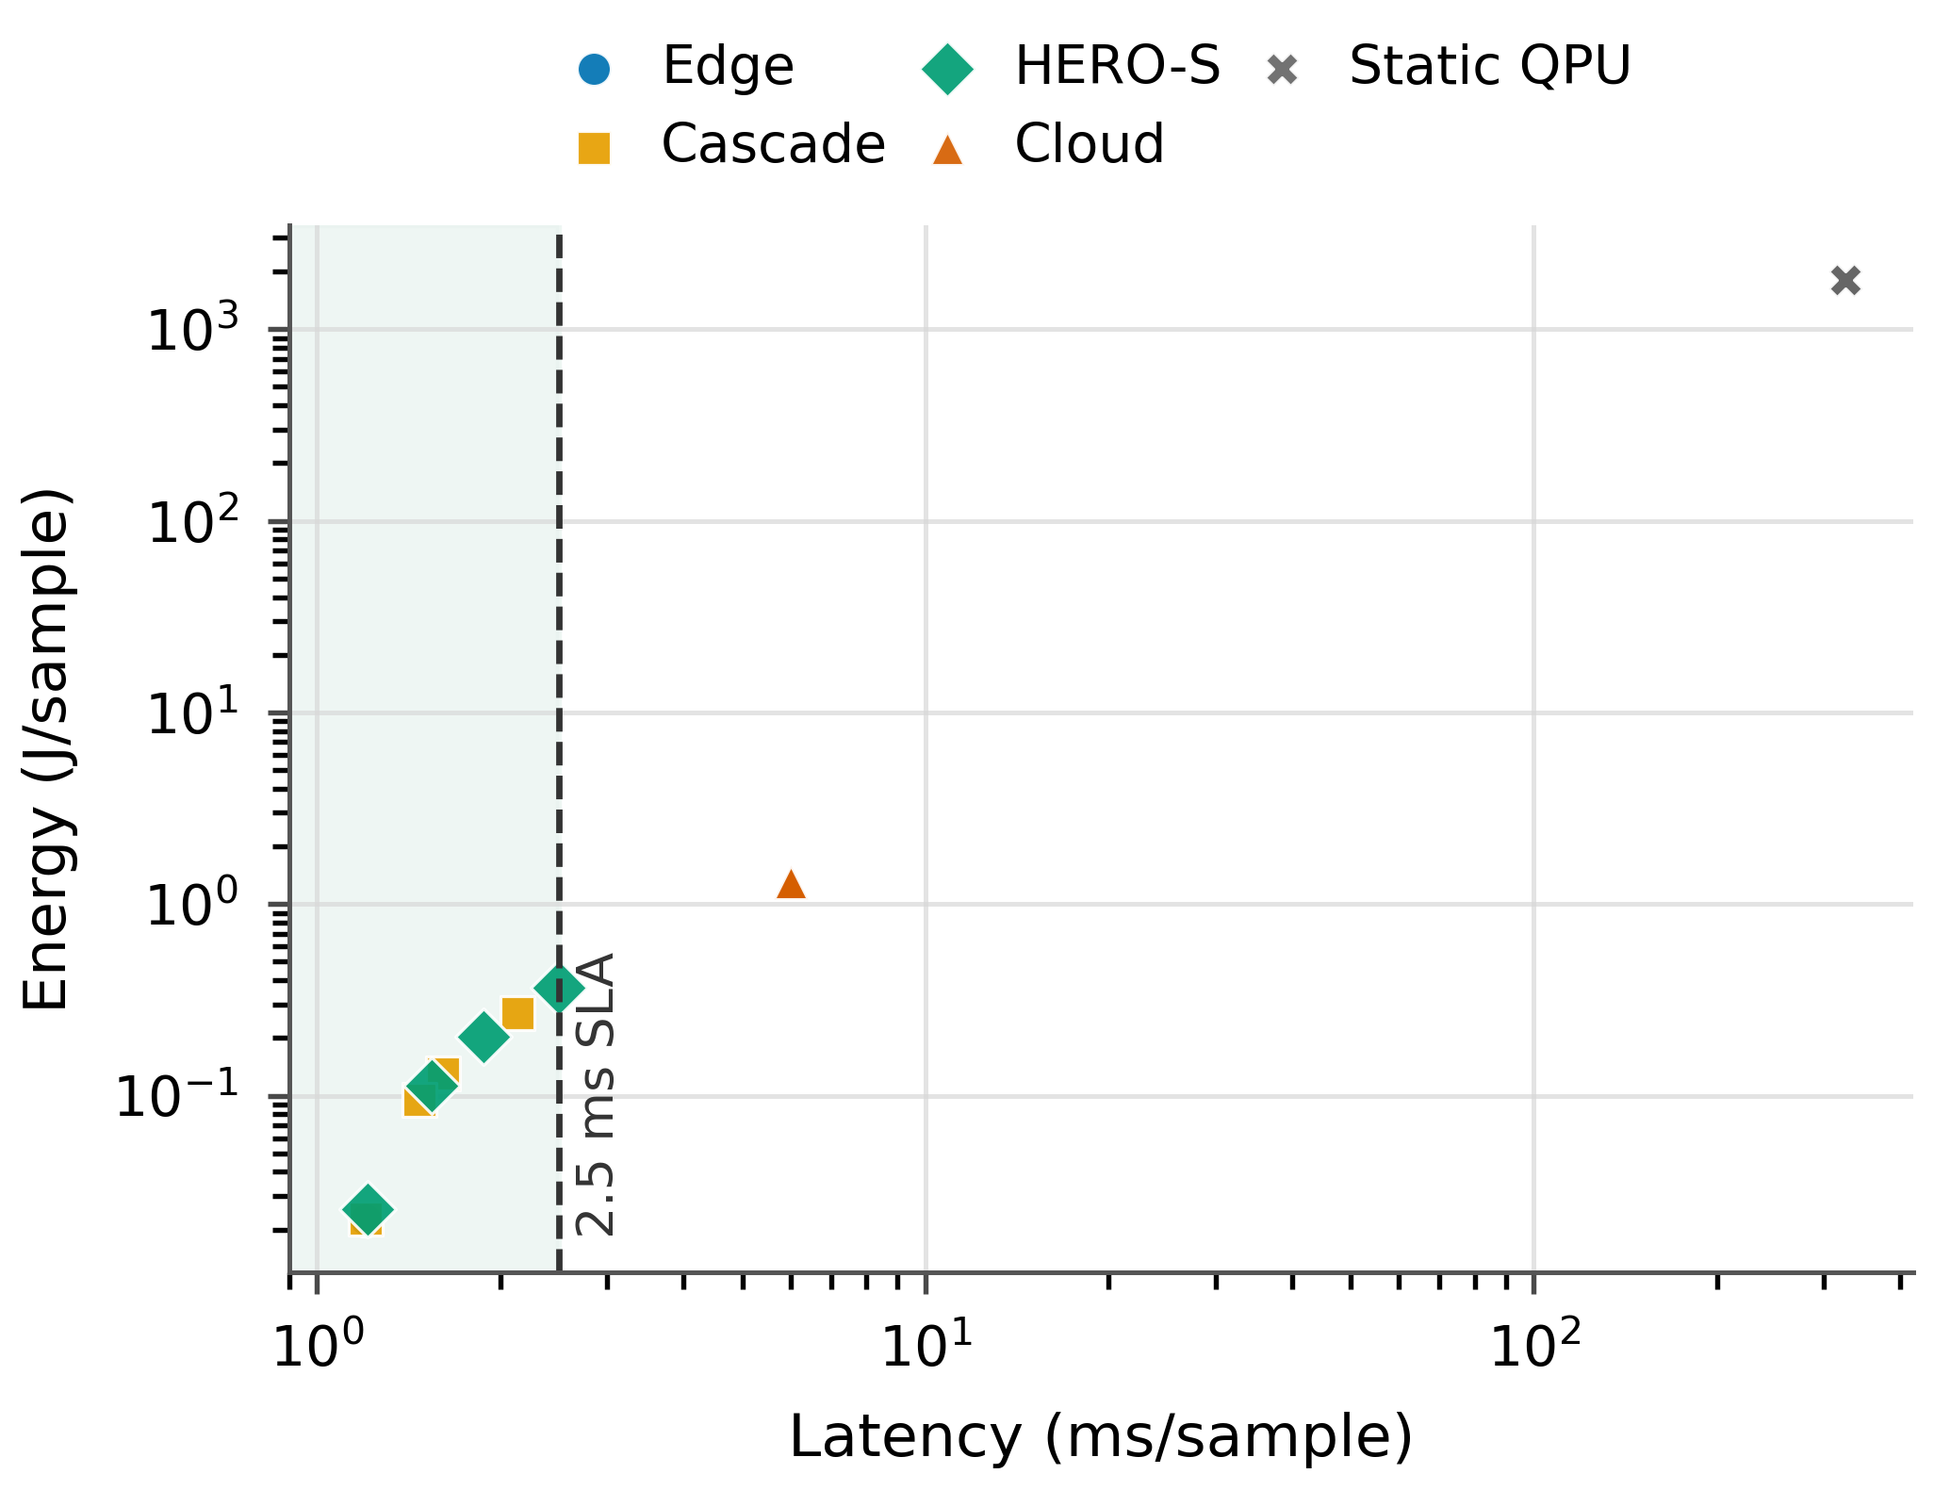
Fig.6. Energy-latencypolicytradeoff.Thedashedlinemarksthe2.5 ms/sampleaveragebudget.
This behavior clarifies how HERO-S differs from static QPU routing. Static QPU routing is insensitive to queue time, so its latency and EDP grow directly with the assumed wait. HERO-S uses queue time inside the score function and changes route decisionsbeforethewaitdominatesthetask.Evenwithlower modeledQPUenergy,a250msbackendqueuewouldexceed the2.5msaveragegatewaybudget,soqueuelatencyaloneis sufficienttoshiftthesetaskstoclassicalroutes.

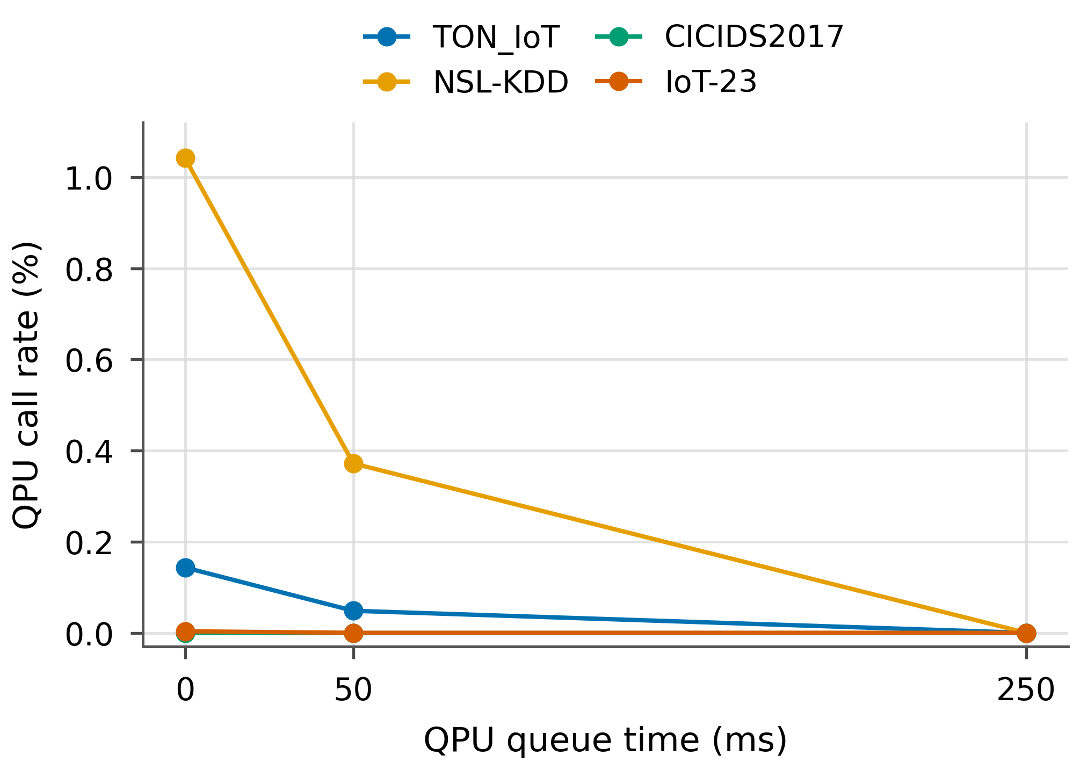
Fig. 7.Queue-time sensitivity. HERO-S reduces QPU-capable routing as wait timeincreases.
TABLEV
QISKITQUANTUM-KERNELSUBSETVALIDATION.
Dataset | Variant | Train/test | Acc. | F1 | Runtime(s)
TONIoT | noiseless | 16/8 | 0.833±0.072 | 0.804±0.120 | 10.38±0.52
TONIoT | noisylow | 16/8 | 0.833±0.072 | 0.804±0.120 | 4.23±0.17
NSL-KDD | noiseless | 16/8 | 0.833±0.072 | 0.821±0.062 | 10.90±0.31
NSL-KDD | noisylow | 16/8 | 0.833±0.072 | 0.821±0.062 | 4.41±0.08
forbothdatasetseventhoughF1differsbyclass-errormix. Theidenticalnoiselessandlow-noiselabelsonthesetiny subsetsindicatethattheinjectedsimulatornoisedidnotflip thefinalSVMdecisionforthesampledpoints.Theequality istreatedasasmall-sampleartifact;accuracyandefficiency assessmentofQPUroutesrequireslargerhardware-backed quantum-kernelstudies.
VI.DISCUSSION
HERO-SprovidesconstrainedrouteselectionforanAIoT securitypipeline.Theempiricalresultconcernsscheduling behavior:underanaveragegateway-latencybudget,HERO-Simprovesovertheclosestuncertaintycascade,adaptsto backendqueuetime,andallocateslower-utilityQPU-capable taskstoclassicalroutes.Cloud-onlyinferenceremainsthe upper-qualityreferencefordeploymentsthatcantolerateits latencyandenergycost.At250msqueuetime,theutility model assigns zero traffic to the QPU-capable path because the proxy quality and queue cost make classical routes preferable; atzeroqueue,Fig.7showsnonzeroQPU-capableroutingon TONIoTandNSL-KDD.Thesameutilityandconfidence gatescanadmitimprovedQPUkernelsorshorterbackend queueswithoutchangingtheorchestrationinterface.
Fordeployment,theschedulercanrunatanedgegateway

E.QiskitSubset or site controller because it requires only normalized flow fea-

TheQiskitsubsetservesasanimplementation-feasibility check.Accuracyisquantizedbecauseeachrunusesonly eightbalancedtestsamples;thesame6/7/7-correctpattern acrossthreeseedsyieldstheidentical0.833±0.072accuracy

tures, model confidence, metadata, and backend telemetry. The policyisalsoauditable:eachescalationcanbeexplainedby uncertainty,alertseverity,assetcriticality,confidencemargin, queuetime,andremaininglatencybudget.Thisisimportant

forAIoTsecurityoperationswhereacontrolleralert,botnet flow, and low-risk sensor event should not consume accelerator resourcesinthesameway.Thefixedweightsandgatesused hereareintentionallykeptconstantacrossdatasets,sothe reportedgainsarenotproducedbyper-datasetretuning.Ina productionsystem,thoseweightscouldbecalibratedagainst operatorcostsforfalsenegatives,falsepositives,cloudusage, andremoteacceleratoraccess.
Theenergymodelusesafixedroute-costtable.Edgeand cloudenergyaremeasuredwhenRAPL/NVMLcountersare availableandotherwiseusethelabeledfallbackroutemodel; inthispapertheper-routevaluesarefixedstress-testcosts ratherthandataset-specificpowertraces.QPUinfrastructure energy is modeled because per-job facility telemetry is unavail-able.Thesevaluesstress-testrouteselectionunderremote-acceleratorassumptionsinwhichfrequentQPUcallswould beimpracticalforAIoTdeployment.
The | current | implementation | has | limits. | The | QPU-
compatiblerouteisareduced-kernelproxyatschedulerscale; theQiskitsubsetissmall;IoT-23iscomparativelyeasyafter leakage-fieldremoval;andrealper-jobQPUfacilityenergy isunavailable.Theselimitsmotivatefutureworkwithlarger hardware-backedquantum-kernelruns,onlinetrafficreplay, anddeploymentonanedgegatewayconnectedtocloud inferenceandlivequantumbackends.Theartifactisintended tosupportsuchextensions:therouteinterfaceonlyrequires predicted quality, confidence, latency, energy, and queue state, soadditionaldetectorsorhardwarebackendscanbeadded withoutchangingtheschedulerabstraction.
Arepresentativeoperationalpathisasfollows.Agateway firstnormalizesaflowrecordandrunstheedgeLRdetector. Iftheedgemodelisconfidentandtheassetislowcriticality, HERO-Skeepsthetasklocalandavoidsremotecost.Ifthe sameuncertaintyoccursonahigh-criticalitycontrolleroran alertwithhighfalse-negativecost,theschedulerevaluates cloudandQPU-capableroutes.Thecloudrouteisadmitted onlywhentheRFconfidenceandaverage-latencybudget remainfeasible.TheQPU-capableroutemustalsoovercome queue, energy, and confidence penalties; otherwise it is explic-itlybypassed.Thispathisintentionallysimpletoaudit:every nonlocal decision can be traced to a small set of numeric fields ratherthananopaqueservice-placementrule.
Thisstructurealsoseparatesorchestrationpolicyfromclas-sifierchoice.Theedgemodelcouldbereplacedbyacompact tree,linearSVM,ortinyneuraldetector;thecloudroute coulduseadeeperensembleorGPUmodel;andtheQPU-capableroutecouldbeupgradedfromthereduced-kernel proxytoahardware-backedkernel.Ineachcase,HERO-S needsthesameroutecontract:estimatedconfidence,latency, energy,queuestate,andexpectedqualitygain.Thereported experimentsthereforeevaluatetheschedulinginterfaceunder currentproxyquality,whileleavingaclearpathforstronger detectorsandbackends.

VII.RELATED WORK
IDS datasets and metrics. AIoT intrusion detection requires datasetsandmetricsbeyondaccuracybecausefalsenegatives andfalsepositiveshavedifferentoperationalcosts.Recent AIoTandindustrialIoTsecuritysurveysemphasizehetero-geneous devices, edge analytics, and AI-based defenses as de-ployment concerns [16], [17]. TONIoT, IoT-23, CICIDS2017, andNSL-KDDcovercomplementaryIoT,botnet,enterprise-flow,andlegacybenchmarksettings[7]–[9],[11].HERO-S usesthesedatasetstoevaluateroutingpoliciesratherthana singleclassifier,andreportsFPR,FNR,PR-AUC,route-call rates,latency,andenergyinadditiontoF1.
Deep-learningandIoTIDS.DeepIDSsurveysshowthat neuralandensemblemodelscanperformwellbutmustbe benchmarkedagainststrongclassicalbaselines[18].Online andIoT-specificsystemssuchasKitsuneandN-BaIoTuse autoencoder-styleanomalydetectionfornetworktrafficand botnetdetection[19],[20].Software-defined,federated,and cloud-edgeIoTIDSworkstudiesmulti-stageanddistributed detectionpipelines[21]–[24].HERO-Sisorthogonaltothese classifiers:itcanrouteanydetectorfamily,butevaluates whetherstrongerroutesjustifyextradelayandenergy.
Edge-cloudorchestration.Edgecomputing,MEC,and
computation-offloading | studies | motivate | placing | latency-
sensitivecomputationneardevicesandescalatingselectively tocloudresources[1],[2],[14],[15].Edge-intelligence, energy-awarescheduling,andMLenergy-accountingstudies furthermotivatereportingqualitytogetherwithcostmet-rics[25]–[27].Existingorchestratorstypicallyoptimizeser-viceplacement,resourceutilization,orcommunicationdelay. HERO-Sfocusesonasecurity-specificlayerabovethose systemsbycombiningIDSuncertainty,alertseverity,asset criticality,false-negativerisk,acceleratorenergy,andQPU queuetimeinonerouteutility.
Quantum-aware | security | workflows. | Hybrid | quantum-
classicallearningstudiesmotivatequantumfeaturemaps, quantumkernels,andvariationalworkflows[4]–[6];earlyse-curitystudiesexplorequantummachinelearningforintrusion detectionbutremainlimitedinscale[28].HERO-Streats thesemethodsasoptionalcandidaterouteswhoseusemust be justified by security utility, latency, queue time, confidence, andmodeledenergy.Queue-awarefallbackforalow-quality QPUproxyisthereforepartoftheroute-selectionpolicy.
VIII.CONCLUSION
HERO-SisaQPU-awareenergy-latencyorchestration framework for AIoT intrusion detection. The evaluation shows thatunconstrainedcloudIDSremainsthebestqualityrefer-ence, while HERO-S is effective under gateway budgets where cloud-onlyexecutionisinfeasible.At250msQPUqueue time,HERO-Simprovesoveredge-onlyandoveraclosest uncertainty-cascadebaselineonTONIoT,NSL-KDD,and CICIDS2017,maintainsthenear-perfectIoT-23edgeresult, reducesenergyrelativetocloud-onlyexecution,andassigns QPU-capabletaskstoclassicalrouteswhenqueueandutility conditionsfavorthatchoice.Thecentralcontributionisan

auditableschedulingpolicyfordecidingwhenQPU-capable executionisused,deferred,oravoided.

[22]T. D. Nguyen, S. Marchal, M. Miettinen, H. Fereidooni, N. Asokan, and A.-R.Sadeghi,“D¨IoT:Afederatedself-learninganomalydetectionsys-
tem for iot,” in 2019 IEEE 39th International Conference on Distributed

REFERENCES  [1]W.Shi,J.Cao,Q.Zhang,Y.Li,andL.Xu,“Edgecomputing:Vision andchallenges,”IEEEInternetofThingsJournal,vol.3,no.5,pp. 637–646,2016. | ComputingSystems,2019,pp.756–767.  [23]V.Mothukuri,R.M.Parizi,S.Pouriyeh,Y.Huang,A.Dehghantanha, andG.Srivastava,“Asurveyonsecurityandprivacyoffederated learning,”FutureGenerationComputerSystems,vol.115,pp.619–640, 2021.

[2]P.MachandZ.Becvar,“Mobileedgecomputing:Asurveyonarchi-tectureandcomputationoffloading,”IEEECommunicationsSurveys& Tutorials,vol.19,no.3,pp.1628–1656,2017.
[3]J.Preskill,“QuantumcomputingintheNISQeraandbeyond,”Quan- tum,vol.2,p.79,2018.
[4]V.Havliceketal.,“Supervisedlearningwithquantum-enhancedfeature

[24]R. Yang, H. He, Y. Xu, B. Xin, Y. Wang, Y. Qu, and W. Zhang, “Efficient intrusion detection toward iot networks using cloud-edge collaboration,”ComputerNetworks,vol.228,p.109724,2023.
[25]Z.Zhou,X.Chen,E.Li,L.Zeng,K.Luo,andJ.Zhang,“Edge intelligence:Pavingthelastmileofartificialintelligencewithedge computing,”ProceedingsoftheIEEE,vol.107,no.8,pp.1738–1762,

spaces,”Nature,vol.567,no.7747,pp.209–212,2019. 2019.
[5]M.SchuldandN.Killoran,“Quantummachinelearninginfeature [26]C.Chenetal.,“Energy-awareschedulingforhigh-performancecom-
hilbertspaces,”PhysicalReviewLetters,vol.122,no.4,p.040504, putingsystems:Asurvey,”Energies,vol.16,no.2,p.890,2023.
2019. [27]E.Strubell,A.Ganesh,andA.McCallum,“Energyandpolicyconsid-
[6]M.Cerezoetal.,“Variationalquantumalgorithms,”NatureReviews erationsfordeeplearninginNLP,”inProceedingsofthe57thAnnual
Physics,vol.3,no.9,pp.625–644,2021. MeetingoftheAssociationforComputationalLinguistics,2019,pp.
[7]A.Alsaedi,N.Moustafa,Z.Tari,A.N.Mahmood,andA.Anwar, 3645–3650.

“TONIoTtelemetrydataset:Anewgenerationdatasetofiotandiiot fordata-drivenintrusiondetectionsystems,”IEEEAccess,vol.8,pp. 165 130–165 150,2020.
[8]S.Garcia,A.Parmisano,andM.J.Erquiaga,“IoT-23:Alabeled datasetwithmaliciousandbenigniotnetworktraffic,”Zenodo,2020.
[Online].Available:https://zenodo.org/records/4743746
[9]I. Sharafaldin, A. H. Lashkari, and A. A. Ghorbani, “Toward generating a newintrusiondetectiondatasetandintrusiontrafficcharacterization,”in Proceedings of the 4th International Conference on Information Systems SecurityandPrivacy,2018,pp.108–116.
[10]——,“AdetailedanalysisoftheCICIDS2017dataset,”inInformation SystemsSecurityandPrivacy,ser.CommunicationsinComputerand Information Science.Springer International Publishing, 2019, pp. 172–188.
[11]M.Tavallaee,E.Bagheri,W.Lu,andA.A.Ghorbani,“Adetailed analysisoftheKDDCUP99dataset,”in2009IEEESymposiumon Computational Intelligence for Security and Defense Applications, 2009, pp.1–6.
[12]Qiskitcontributors,“Qiskit:Anopen-sourceframeworkforquantum computing,”Zenodo,2019.[Online].Available:https://zenodo.org/ records/2562111
[13]QiskitAercontributors,“Qiskitaer:Highperformancesimulator forquantumcircuits,”GitHubrepository.[Online].Available:https: //github.com/Qiskit/qiskit-aer
[14]M.Satyanarayanan,“Theemergenceofedgecomputing,”Computer, vol.50,no.1,pp.30–39,2017.
[15]Y.Mao,C.You,J.Zhang,K.Huang,andK.B.Letaief,“Asurvey onmobileedgecomputing:Thecommunicationperspective,”IEEE CommunicationsSurveys&Tutorials,vol.19,no.4,pp.2322–2358, 2017.
[16]S.I.Siam,H.Ahn,L.Liu,S.Alam,H.Shen,Z.Cao,N.Shroff,and B.Krishnamachari,“Artificialintelligenceofthings:Asurvey,”ACM TransactionsonSensorNetworks,vol.21,no.1,pp.1–75,2025.
[17]B. Alotaibi, “A survey on industrial internet of things security: Require-ments,attacks,ai-basedsolutions,andedgecomputingopportunities,”Sensors,vol.23,no.17,p.7470,2023.
[18]M.A.Ferrag,L.Maglaras,S.Moschoyiannis,andH.Janicke,“Deep learning for cyber security intrusion detection: Approaches, datasets, and comparativestudy,”JournalofInformationSecurityandApplications, vol.50,p.102419,2020.
[19]Y.Mirsky,T.Doitshman,Y.Elovici,andA.Shabtai,“Kitsune:An ensembleofautoencodersforonlinenetworkintrusiondetection,”in Proceedings of the Network and Distributed System Security Symposium, 2018.
[20]Y.Meidan,M.Bohadana,Y.Mathov,Y.Mirsky,D.Breitenbacher, A.Shabtai,andY.Elovici,“N-BaIoT:Network-baseddetectionofiot botnetattacksusingdeepautoencoders,”IEEEPervasiveComputing, vol.17,no.3,pp.12–22,2018.
[21]J.Li,Z.Zhao,R.Li,andH.Zhang,“AI-basedtwo-stageintrusion detectionforsoftwaredefinediotnetworks,”IEEEInternetofThings Journal,vol.6,no.2,pp.2093–2102,2019.

[28]M.KalininandV.Krundyshev,“Securityintrusiondetectionusing quantummachinelearningtechniques,”JournalofComputerVirology andHackingTechniques,vol.19,no.1,pp.125–136,2023.

