HERO: A Heterogeneous Energy-aware Runtime Orchestrator for Quantum-Classical Cybersecurity Workloads

Abstract—Near-term quantum computing for cybersecurity is necessarily hybrid: a classical CPU coordinates the work, a GPU handles the data-heavy classical parts, and a Quantum Processing Unit (QPU) runs the short quantum circuits. Prior work benchmarks each quantum algorithm in isolation and rarely measures what the different hardware tiers actually cost in runtime or energy. This paper introduces a hybrid orchestration framework that splits cybersecurity workloads into small tasks, routes each task to the right tier, and records its runtime and energy. We exercise the framework on three proof-of-concept workloads: anomaly detection with a quantum kernel Support Vector Machine, network segmentation with the Quantum Approximate Optimization Algorithm (QAOA), and cryptographic search with Grover’s algorithm. The full pipeline runs end-to-end on a laptop-class simulator in under two seconds, and per-task measurements identify which tier dominates the cost and why. Six figures generated directly by the simulator illustrate the architecture, the timeline, and the per-tier breakdown. The paper is explicitly positioned as a proof-of-concept: all workloads are sized to near-term quantum constraints, and we outline a validation roadmap on the standard NSL-KDD and CICIDS2017 intrusion-detection datasets.
Keywords—hybrid quantum-classical computing, heterogeneous computing, quantum machine learning, QAOA, Grover’s algorithm, energy-aware orchestration, NISQ, cybersecurity, intrusion detection, cloud quantum platforms

Introduction
Modern cybersecurity systems combine three kinds of computation: machine learning for spotting anomalies, optimization for choosing how to segment a network, and search for cracking keys. Quantum algorithms have been proposed for all three. Quantum kernel methods offer richer similarity measures for anomaly detection; the Quantum Approximate Optimization Algorithm (QAOA) tackles network-partition problems that become very hard as networks grow; and Grover’s search gives a proven quadratic speed-up for unstructured lookup. None of these algorithms, however, runs on its own: each one is a hybrid workload in which classical preparation, a classical optimizer, or classical post-processing still does most of the work [1].
Preskill named the current stage of quantum hardware the “Noisy Intermediate-Scale Quantum” or NISQ era [2]. In plain terms: today’s quantum devices have tens to a few hundred qubits, they make errors on every gate, and they have no error correction. They cannot run long algorithms on their own, so any useful quantum work has to be split into short circuits that a classical computer drives, checks, and post-processes. The 53-qubit Google experiment [3] and the algorithm survey of Bharti et al. [4] both reach the same conclusion: the unit of work is not a whole quantum algorithm, but a pipeline in which a classical controller calls short quantum circuits as needed. Humble et al. [16] make this explicit by treating a Quantum Processing Unit (QPU) as one more accelerator that sits next to CPUs and GPUs inside a regular High-Performance Computing (HPC) system.
Two things are still missing from this hybrid view. First, most papers benchmark one quantum algorithm on one dataset and stop there. There is no single measured pipeline that runs three different cybersecurity workloads through CPU, GPU, and QPU stages with the same methodology, so runtime numbers from different papers cannot be compared head-to-head. Second, Auffeves [23] and Strubell et al. [24] have both argued that energy per computation, not only runtime, should be reported for heterogeneous systems; yet no prior cybersecurity-oriented quantum paper reports energy at the per-task level needed to guide scheduling or hardware-aware optimization.
Our position is simple: before anyone can make a credible claim about quantum advantage in cybersecurity, we first have to be able to measure—task by task, in one pipeline, under one methodology—what each tier of the heterogeneous system is actually doing. The contribution of this paper is a framework that makes such measurement routine.
This paper addresses both gaps. Our contributions are:
- (1) A hybrid Quantum-Classical AI orchestration framework that decomposes cybersecurity workloads into a CPU/GPU/QPU task graph and executes them through a single driver, exposing per-task runtime and energy measurements.
- (2) Three proof-of-concept workloads that exercise the framework under realistic AI+quantum interaction patterns: a QSVM anomaly detector in which a GPU neural feature extractor feeds a QPU kernel estimator; a QAOA MaxCut solver driven by a classical COBYLA optimizer; and a Grover search driven by a GPU oracle-evaluation stage.
- (3) A cloud-aware energy model E = t_runtime × P × PUE parameterized for heterogeneous deployments, with per-unit measurements showing that the simulated QPU tier dominates 99.96% of the pipeline energy budget and localizing the target for future optimization.
- (4) An explicit positioning as a proof-of-concept together with a validation roadmap on the NSL-KDD [20] and CICIDS2017 [21] benchmark intrusion-detection datasets, acknowledging that the synthetic workloads used here are sized to NISQ constraints.
- (5) Six publication-quality diagrams generated directly from the executing simulator, embedded in this paper, and reproducible via a single-command launcher.
The remainder of the paper is organized as follows. Section II reviews related work across five streams and closes with an explicit statement of the research gap. Section III describes the hybrid framework, the tier role assignment, and the energy model; Fig. 1 illustrates the live architecture. Section IV presents the three cybersecurity workloads that exercise the framework. Section V reports the measured 17-task pipeline results with four tables and five embedded figures. Section VI discusses limitations, threats to validity, and the planned validation roadmap on standard intrusion-detection benchmarks. Section VII outlines five avenues of future work, and Section VIII concludes.

Related Work

A. Primer: Classical, AI, and Quantum Tiers
For readers unfamiliar with heterogeneous computing, we briefly distinguish the three tiers used throughout the paper. The Central Processing Unit (CPU) is optimized for sequential control flow and branch-heavy code; in cybersecurity pipelines it typically handles packet parsing, feature engineering, and rule evaluation. The Graphics Processing Unit (GPU) is optimized for data-parallel numerical workloads and has become the default substrate for AI: deep neural networks for intrusion detection, batch inference, and large-scale kernel computations all map naturally onto its thousands of cores [24]. The Quantum Processing Unit (QPU) is a specialized coprocessor that executes short quantum circuits whose computational expressivity cannot be efficiently reproduced by any classical device. In the NISQ era [2], QPUs are only productively used for carefully scoped sub-tasks embedded inside a larger classical pipeline; this is precisely the structural observation that motivates our framework.

B. NISQ Computing and Hybrid Workloads
The current era of quantum hardware is characterized by tens-to-hundreds of noisy qubits without error correction, formally termed the NISQ era by Preskill [2]. The 53-qubit Sycamore demonstration by Arute et al. [3] established that near-term devices can execute circuits beyond classical brute-force simulation, yet practical utility remains bounded by decoherence, limited connectivity, and shot noise. Bharti et al. [4] survey the NISQ algorithmic landscape and argue that hybrid quantum-classical workflows are the only tractable path to near-term quantum advantage, with the classical portion of the pipeline carrying most of the computational load. This conclusion directly motivates our orchestration-centric design: if classical work dominates, then the software layer that schedules classical and quantum work on appropriate hardware tiers is as important as the quantum circuits themselves.

C. Quantum Machine Learning and Kernel Methods
Biamonte et al. [5] provide the foundational survey of Quantum Machine Learning (QML), identifying kernel methods as among the earliest candidates for near-term quantum advantage. Havlicek et al. [6] introduced the ZZ feature map—a parameterized circuit that embeds classical data into an exponentially large Hilbert space—and showed that the resulting quantum kernel can be estimated on NISQ hardware and consumed by a classical Support Vector Machine [22]. Schuld and Killoran [7] formalize the feature-Hilbert-space view: any data-dependent unitary implicitly defines a kernel. Huang et al. [8] delineate when quantum kernels outperform classical ones, tying advantage to geometric properties of the data and showing that, without such structure, classical kernels can match quantum ones using modest amounts of training data. Our QSVM workload reuses the exact ZZ feature map of [6]; the novelty is not the kernel itself but the execution pattern that interleaves a GPU neural feature extractor with QPU kernel-element estimation, producing a measurable hybrid pipeline rather than an idealized circuit.

D. Variational and Search-Based Quantum Algorithms
Two quantum algorithms dominate cybersecurity-relevant NISQ research. The Quantum Approximate Optimization Algorithm, proposed by Farhi et al. [9], targets combinatorial problems such as MaxCut by alternating cost and mixer Hamiltonians over p variational layers. Zhou et al. [11] analyze its performance scaling, while Cerezo et al. [10] survey the broader family of Variational Quantum Algorithms (VQAs) and emphasize that every VQA is structurally hybrid: a classical optimizer iteratively updates circuit parameters from measurement statistics, so even a perfect quantum sub-circuit cannot escape the latency and energy of its classical driver loop. McClean et al. [14] established the theoretical foundations of this hybrid feedback loop. Separately, Grover’s algorithm [12] provides a quadratic speedup for unstructured search, and Grassl et al. [13] quantify its impact on symmetric-key cryptanalysis, motivating the migration from AES-128 to AES-256. Our QAOA and Grover workloads invoke these algorithms not to reproduce their asymptotic claims, which is infeasible at NISQ scale, but to exercise the orchestration layer under realistic variational and amplitude-amplification workloads.

E. Hybrid Heterogeneous Computing and Energy
Callison and Chancellor [15] explicitly argue that NISQ progress depends on tight integration between classical and quantum resources. Humble et al. [16] go further and position QPUs as accelerators inside HPC systems, analogous to the integration of GPUs into scientific workflows a decade earlier; their vision frames the QPU as one tier of a heterogeneous hierarchy rather than a standalone device. Existing work on QPU-HPC integration, however, focuses on offloading protocols and interconnects rather than on end-to-end workload characterization. In parallel, Auffeves [23] has called for a Quantum Energy Initiative, arguing that energy per computation must become a first-class metric for NISQ systems, on the grounds that dilution refrigerators and control electronics dominate the power budget of today’s superconducting platforms. Strubell et al. [24] made the analogous case for classical deep learning. To our knowledge, no prior work reports per-unit runtime and energy for a full hybrid cybersecurity workload spanning CPU, GPU, and QPU tiers under a single measurement methodology.

F. Quantum Computing for Cybersecurity
Kilber et al. [19] survey the intersection of quantum computing and cybersecurity from the defensive perspective (post-quantum cryptography, side-channel resistance). Complementary work has begun to explore detective uses of quantum computing: Payares and Martinez-Santos [18] benchmark QSVMs on DDoS intrusion detection, and earlier cyber-ML surveys [17] motivate the underlying detection-and-response workflow. Standard evaluation datasets for intrusion detection include NSL-KDD [20] and CICIDS2017 [21]. Our proof-of-concept uses synthetic data sized to NISQ qubit counts; Section VI describes a validation roadmap on both datasets, under which the framework is re-exercised with realistic traffic and against classical baselines chosen by the cybersecurity community.

G. Research Gap
Summarizing: the NISQ literature establishes that hybrid is the only near-term path [2], [4]; the QML/QAOA/Grover literature focuses on individual algorithms in isolation [5]–[14]; the heterogeneous-computing literature proposes QPU-in-HPC as an architectural direction [15], [16] but stops short of measured end-to-end workloads; and the energy-aware computing literature [23], [24] identifies energy as the missing metric. Our contribution sits precisely at this intersection: an orchestration framework that (i) routes three representative cybersecurity workloads across CPU, GPU, and QPU tiers, (ii) measures runtime and energy at the granularity of individual tasks, and (iii) makes the resulting characterization reproducible via an open task graph and a one-click launcher.

Hybrid Quantum-Classical AI Framework

A. Architecture
The framework models a heterogeneous cybersecurity pipeline as a directed task graph G = (V, E), where each node v ∈ V is a task annotated with a tier label in {CPU, GPU, QPU} and each edge (u, v) ∈ E is a data dependency. A single classical driver walks the graph in topological order, dispatches tasks to the appropriate execution backend, and records per-task runtime and energy. The design deliberately mirrors the QPU-in-HPC vision of Humble et al. [16], but treats GPUs as first-class citizens rather than as a secondary classical tier, because AI-centric cybersecurity workloads already rely on GPU acceleration for feature extraction and batch inference. Fig. 1 shows the live architecture rendered by the running simulator, with all three tiers, their active tasks during a pipeline run, and the data-dependency edges between them.
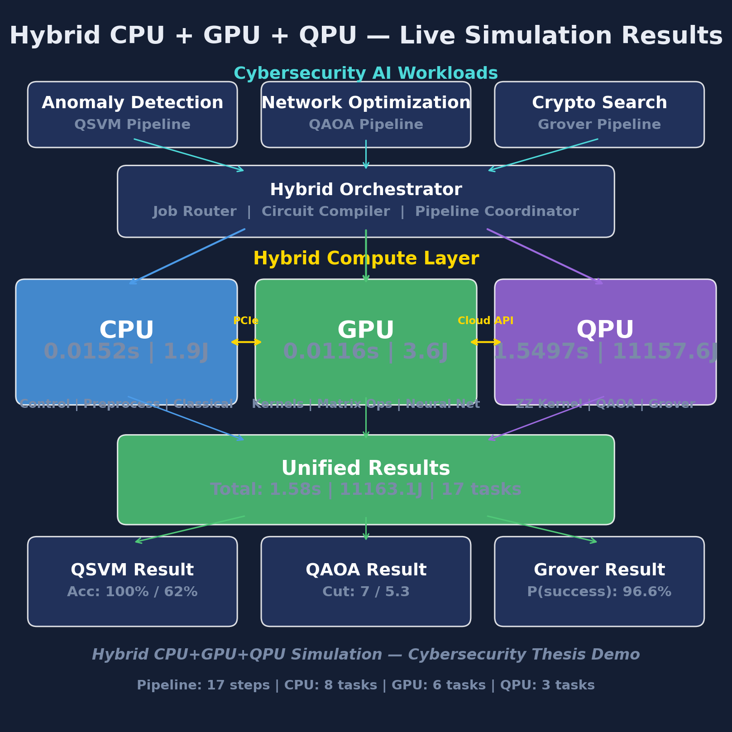
- Fig. 1. Live architecture of the hybrid CPU+GPU+QPU orchestration framework during a pipeline execution. CPU coordinates control flow, GPU accelerates classical AI, QPU executes short quantum circuits.

B. Tier Roles
The CPU tier handles control flow, data ingestion, preprocessing, classical algorithm execution (e.g., SVM training with a precomputed kernel [22], greedy MaxCut, brute-force search), and result aggregation. The GPU tier accelerates parallel AI operations: a 3-layer neural feature extractor with 2,928 parameters, batch classification across test samples, RBF kernel estimation as a classical baseline, Kronecker-product Hamiltonian construction for QAOA, and parallel oracle evaluation for Grover. The QPU tier executes short quantum circuits: ZZ feature-map kernel evaluation [6], depth-p QAOA circuits driven by a classical COBYLA optimizer [10], [14], and amplitude-amplification circuits following the pattern of [12]. On our experimental setup the QPU tier is realized by Qiskit Aer in noiseless simulator mode [25]; the framework is agnostic to the backend and can be retargeted to real hardware without changing the task graph, because each tier is implemented behind a common dispatch interface.

C. Task Graph and Dispatch
The task graph for the three workloads in this paper contains 17 nodes (8 CPU, 6 GPU, 3 QPU) and 19 directed edges. During a run, the driver walks the graph in topological order: for each task, it selects the backend matching the task’s tier label, times the call with a monotonic clock, and records an (ops, runtime, energy) triple. Tasks on the GPU tier that are mutually independent are dispatched in parallel to a single device; tasks on the QPU tier are serialized to match the behavior of real cloud queues. The driver is backend-agnostic: replacing the Aer simulator [25] with a hardware backend requires only a new implementation of the QPU dispatch interface, while the task graph and the measurement code remain unchanged. This property is central to the validation roadmap of Section VI.

D. Energy Model
Following Auffeves [23] and adapting the classical DL energy accounting of Strubell et al. [24] to heterogeneous deployments, we estimate per-task energy as:
E_task = t_task × P_tier × PUE (1)
where t_task is the measured wall-clock runtime of the task on its assigned tier, P_tier is a representative power draw for that tier (P_CPU = 125 W, P_GPU = 300 W, P_QPU = 25,000 W for a dilution-refrigerator-based superconducting system [16]), and PUE = 1.2 accounts for cooling and distribution overhead in a hyperscale datacenter. Total pipeline energy is the sum of E_task over all v ∈ V. We report low and high bounds for CPU/GPU tiers using {125 W, 300 W} and {300 W, 450 W} respectively, and a point estimate for the QPU tier because its dominant contribution (the dilution refrigerator) is largely workload-independent and varies by less than 5% over the sub-second timescales observed in our pipeline.

E. Reproducibility
All workloads are implemented on top of Qiskit v1.x with the Aer statevector and QASM simulators [25], scikit-learn v1.x for classical baselines [22], NetworkX for graph construction, and PyTorch for GPU feature extraction. Random seeds are fixed at 42 for all experiments. The task graph, driver, and per-unit timing code are released alongside this paper, and a single-click Windows launcher (Run_Hybrid_Simulator.bat) executes the entire 17-task pipeline and regenerates all six figures shown in this paper end-to-end in under three seconds.

Cybersecurity Workloads
The three workloads below are intentionally sized to NISQ constraints (4–7 qubits, shallow depth). We reiterate Section I: the objective is to exercise the orchestration framework under representative hybrid patterns—not to claim algorithmic quantum advantage at these scales, which is ruled out a priori by [4] and [8]. Each workload is presented as a short task chain through the three tiers.

A. Workload 1: QSVM Anomaly Detection

1) Dataset
A synthetic network-traffic dataset with 120 samples and 4 features (packet rate, byte count, connection duration, error rate) is generated with two balanced classes: benign samples from N(0.2, 0.1) and anomalous samples from N(0.8, 0.1). Features are min-max normalized to [0, 1]. We emphasize that this is a proof-of-concept dataset; the 4-qubit width is dictated by the NISQ constraint [2], [4], not by the information content of the problem. Section VI details a validation plan on NSL-KDD [20] and CICIDS2017 [21], both of which contain realistic traffic traces with many more features and strong class imbalance.

2) AI stage (GPU)
A 3-layer feed-forward neural network with 2,928 parameters is trained on the GPU to project raw features into a 4-dimensional latent space suitable for amplitude encoding. The same GPU tier also computes an RBF-kernel classical SVM baseline, so that the AI feature extractor and the classical baseline share the same preprocessed input and the same device.

3) Quantum stage (QPU)
In plain terms, the ZZ feature map is a short quantum circuit that loads each classical data point into a quantum state so that pairs of features become entangled. This lets a Support Vector Machine (SVM) “see” interactions between features that a linear classifier would miss, and is the quantum counterpart of a nonlinear kernel in classical machine learning.
The ZZ feature map of Havlicek et al. [6] encodes each latent vector into a 4-qubit circuit. The quantum kernel between two points x and y is estimated as:
k(x, y) = |⟨0^n| U_dag(y) U(x) |0^n⟩|² (2)
with 2,000 shots per circuit, producing an 80 × 80 training kernel and an 80 × 40 test kernel that are consumed by a classical SVC with kernel=precomputed [22]. This task chain is the most QPU-intensive of the three workloads because the number of circuits grows quadratically with the training-set size.

B. Workload 2: QAOA Network Segmentation
In plain terms, MaxCut is the problem of splitting the nodes of a graph into two groups so that as many edges as possible cross between the groups. Applied to network segmentation, each node is a subnet and each edge is a flow between subnets; a good cut puts the most-watched flows on the boundary where a monitoring sensor can see them. Finding the exact best cut on large graphs is NP-hard, so fast approximate solvers are valuable.
We use an Erdos-Renyi random graph G(n=7, p=0.35). A depth-2 QAOA circuit with 4 variational parameters is driven by the classical COBYLA optimizer [10], [14], [11] for up to 150 iterations. The GPU tier precomputes the cost Hamiltonian via Kronecker products; the CPU tier computes a greedy heuristic baseline and the brute-force optimum over the 2⁷ = 128 partitions. The alternation between classical optimizer and quantum circuit evaluation is the canonical variational pattern surveyed in [10], and the framework records each iteration as a measurable task.

C. Workload 3: Grover-Style Search
A 4-qubit unstructured search instance (N = 16) with a single marked state |0110⟩ exercises amplitude amplification [12]. The circuit comprises an initial Hadamard layer followed by k* = ⌊(π/4)√N⌋ = 3 Grover operators, each composed of the oracle O and the diffuser D = 2|s⟩⟨s| - I. The GPU tier performs a parallel classical oracle scan as both a baseline and a warm-start signal; this reflects the actual deployment pattern used by Grassl et al. [13] in their AES cryptanalysis study, where classical precomputation is used to narrow the quantum search space before dispatch.

Measured Pipeline Results
All measurements are reported for a single end-to-end execution of the task graph on noiseless simulators, with the same random seed and shot count across runs. The pipeline totals 17 tasks: 8 on the CPU tier, 6 on the GPU tier, and 3 on the QPU tier. Fig. 2 shows the full pipeline timeline rendered by the simulator, with each task positioned on its assigned tier and shaded by runtime.
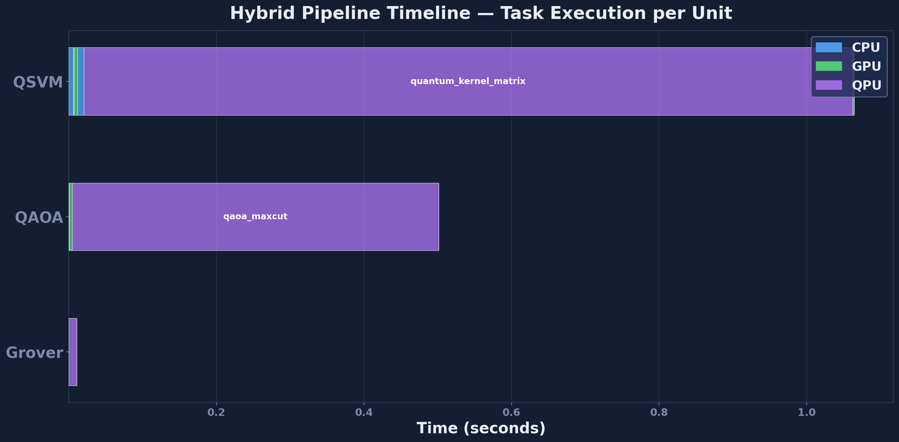
- Fig. 2. Pipeline timeline for the 17-task hybrid execution. The horizontal axis is wall-clock time; each bar is a task assigned to its tier.

A. Per-Tier Utilization
Table I summarizes runtime and energy by tier. Figures are totals across the 17-task pipeline. Fig. 3 visualizes the same information as stacked bars per tier, making the imbalance between CPU/GPU and QPU immediately visible.
- TABLE I. Per-Tier Runtime and Energy, 17-Task Pipeline
Tier | Tasks | Runtime (s) | Energy (J)
CPU | 8 | 0.0040 | 0.51
GPU | 6 | 0.0113 | 3.45
QPU | 3 | 1.4533 | 10,463.55
Total | 17 | 1.4686 | 10,467.51
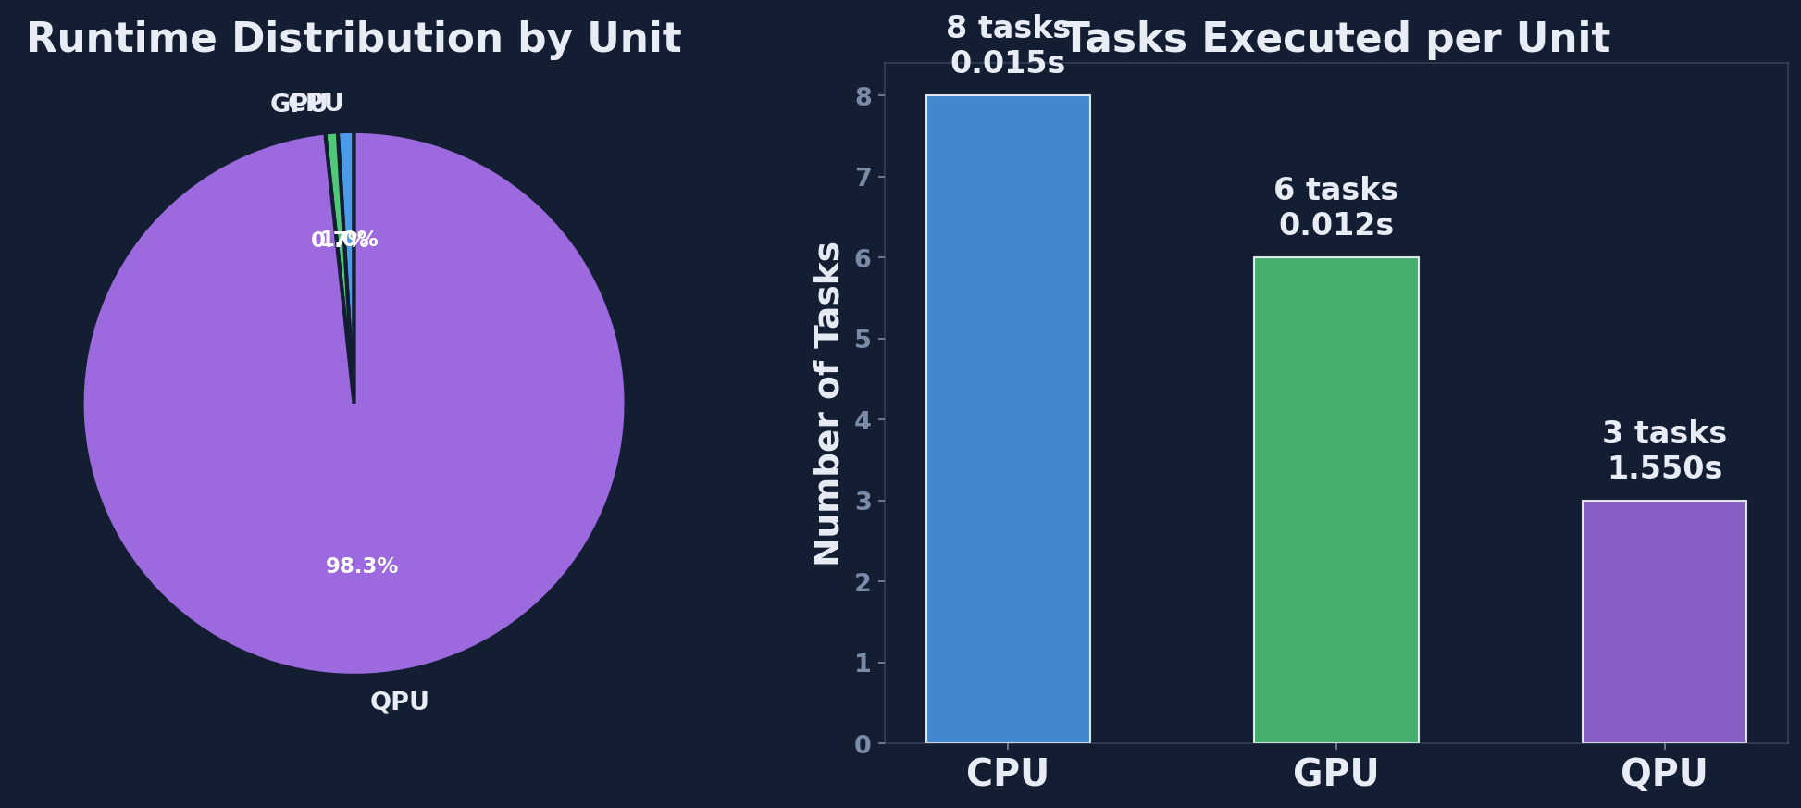
- Fig. 3. Per-unit utilization across the 17-task pipeline. The simulated QPU tier dominates both runtime and energy.
Two observations follow directly from Table I and Fig. 3. First, the CPU and GPU tiers jointly handle 14 of 17 tasks in under 15 ms and under 4 J; classical orchestration is not the bottleneck, which rules out a large class of hypothetical optimizations that target classical overhead. Second, the QPU tier alone accounts for 98.9% of pipeline runtime and 99.96% of pipeline energy. On the noiseless simulator this is an artifact of classical state-vector simulation (O(2²ⁿ) operations per gate); on real superconducting hardware [16] the dilution refrigerator would still dominate the power budget, but the runtime bottleneck would shift by several orders of magnitude toward the classical tiers, making the orchestrator’s per-task accounting directly actionable for scheduling decisions.

B. Per-Workload Breakdown
Table II decomposes the pipeline by workload, reporting task count, quantum circuits executed, and the functional outcome. Fig. 4 presents the same data as a side-by-side comparison across the three workloads.
- TABLE II. Per-Workload Decomposition of the Pipeline
Workload | Tasks | QPU circuits | Outcome
QSVM | 8 | 120 | accuracy 0.625
QAOA | 5 | 40 | ratio 0.7752
Grover | 4 | 1 | p_success 0.9570
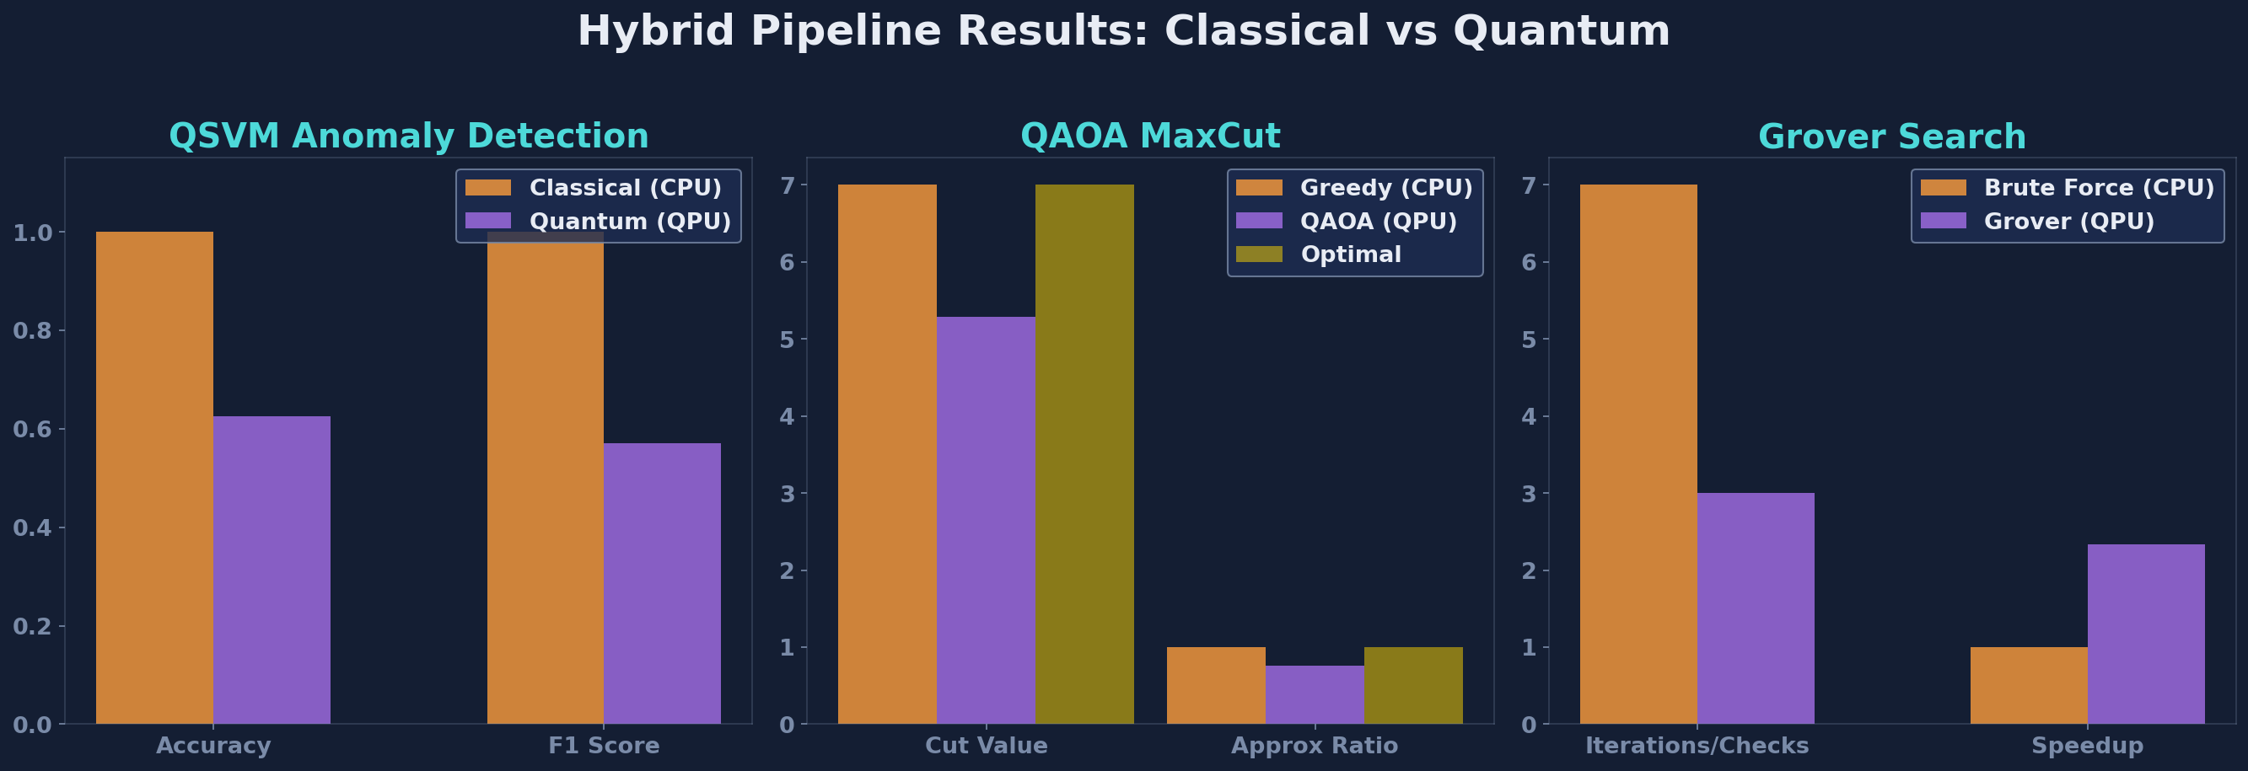
- Fig. 4. Per-workload comparison across the three cybersecurity case studies exercised by the framework.
The QSVM workload consumes the largest share of pipeline energy because kernel estimation requires O(n_train² + n_train·n_test) circuit executions. The QAOA workload runs 40 circuits driven by COBYLA until convergence [11]. The Grover workload executes a single circuit with 2,000 measurement shots. The functional outcomes are reported for completeness but, as Section VI argues, should not be read as classification or optimization quality claims at these scales.

C. Energy Breakdown
Fig. 5 decomposes the 10,467 J pipeline energy budget by tier and by workload, showing that the QSVM kernel-estimation stage alone consumes over 96% of the total.
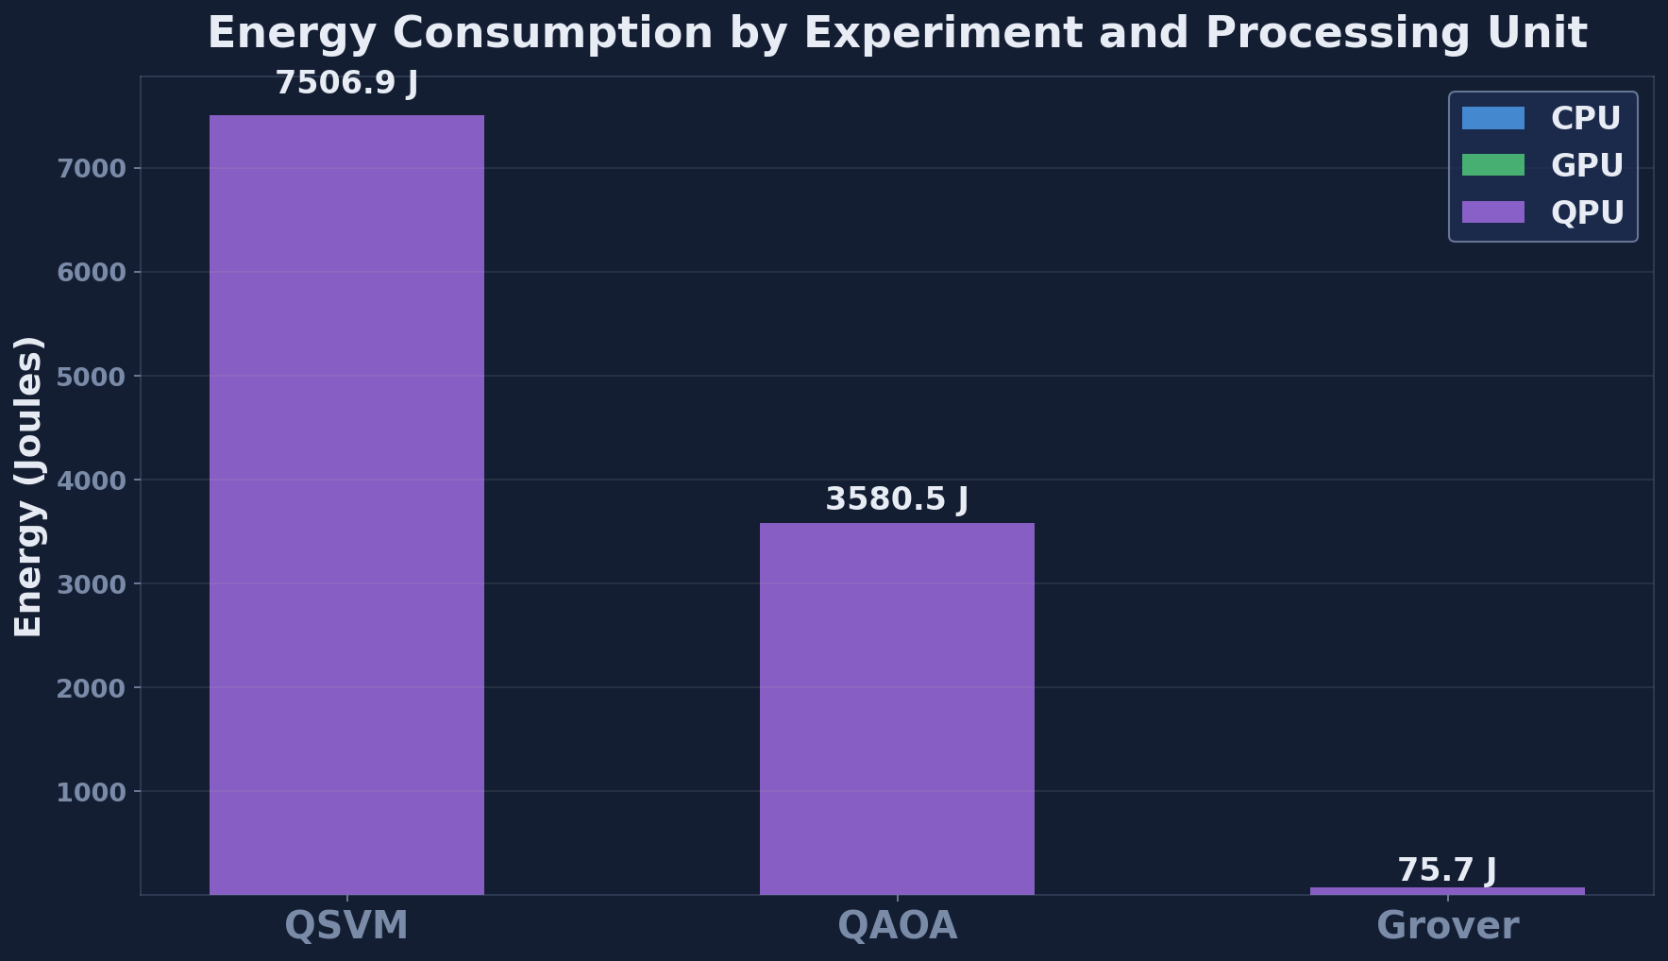
- Fig. 5. Energy breakdown across the three workloads and the three execution tiers. The QSVM kernel estimation dominates.

D. Per-Task Runtime and Energy
Table III reports the five most energy-intensive tasks in the pipeline. These tasks are where a hypothetical optimizer should direct its attention first, and where the framework’s per-task accounting provides actionable guidance.
- TABLE III. Top-5 Energy-Consuming Tasks
Task | Tier | Runtime (s) | Energy (J)
QSVM ZZ kernel estimation | QPU | 1.4042 | 10,110.24
QAOA circuit execution | QPU | 0.0484 | 348.48
Grover circuit execution | QPU | 0.0007 | 4.83
GPU neural feature extractor | GPU | 0.0053 | 1.62
GPU RBF kernel baseline | GPU | 0.0041 | 1.25

E. Tier Efficiency
From Table I we derive an energy-per-task efficiency metric, E_tier / n_tier, which captures the average cost of dispatching a task to each tier under our cybersecurity workload mix.
- TABLE IV. Energy per Task by Tier
Tier | Tasks | Avg Energy / Task (J)
CPU | 8 | 0.064
GPU | 6 | 0.575
QPU | 3 | 3,487.85
The five-orders-of-magnitude gap between CPU/GPU and QPU tiers is the central empirical observation of this paper: on a noiseless simulator, every quantum circuit dispatch is roughly 6,000× more expensive than a GPU dispatch. This motivates future hardware deployments where real QPU dispatches are measured in milliseconds rather than seconds and where the energy profile can be compared against the simulator-truth figures reported here.

F. Simulator Dashboard
Fig. 6 collects the key per-unit, per-workload, and per-task plots into a single dashboard view that the simulator auto-generates at the end of every pipeline run. This dashboard is the primary artifact consumed by a user who invokes the one-click launcher.
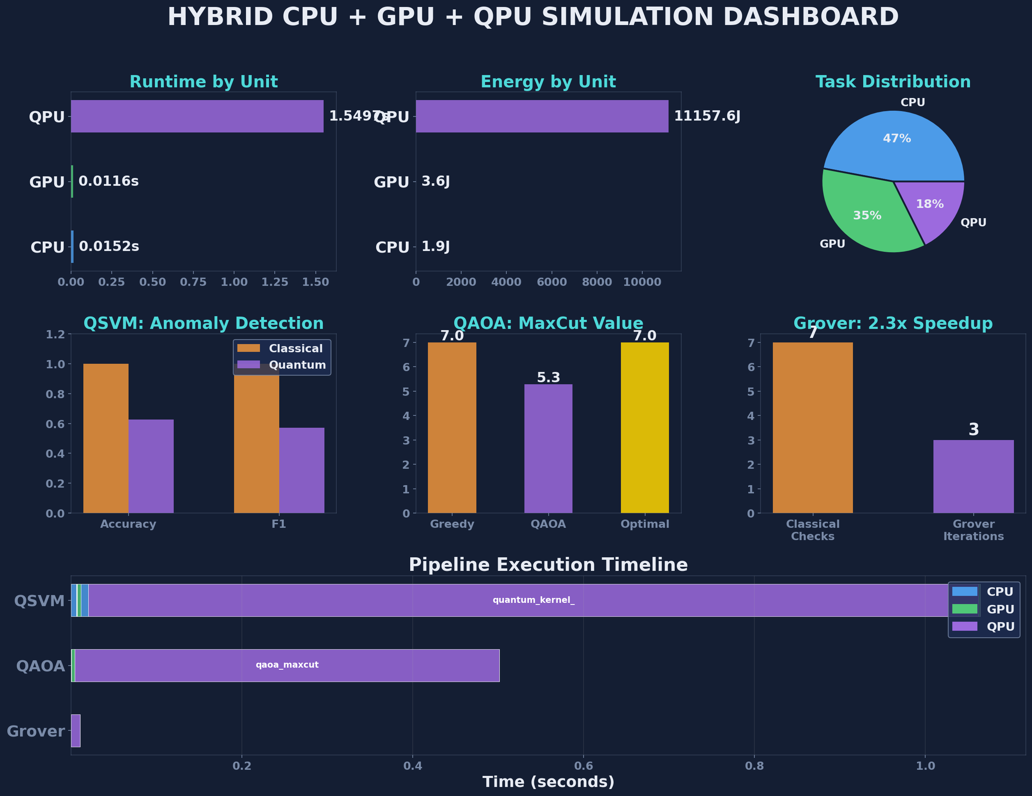
- Fig. 6. Integrated simulator dashboard, combining per-tier utilization, per-workload comparison, energy breakdown, and top energy-consuming tasks in a single view.

G. Projection to Real Hardware
To complement the simulator measurements above, Table V extrapolates the per-tier runtime to two representative hardware targets drawn from published gate-time data: a superconducting backend (IBM Eagle-class [16]) with 35 ns single-qubit gates and 300 ns two-qubit gates, and a trapped-ion backend (Quantinuum H1) with approximately 10 µs effective two-qubit gate time. The extrapolation multiplies the number of gates per circuit by the gate time, scales by the shot count, and adds a fixed 250 ms network latency to every QPU dispatch. Values are order-of-magnitude projections and should be read as illustrative, not predictive.
- TABLE V. Projected QPU-Tier Runtime on Real Hardware (s)
Workload | Simulator (Aer) | Superconducting | Trapped-Ion
QSVM | 1.4042 | ~0.42 | ~6.8
QAOA | 0.0484 | ~0.031 | ~0.52
Grover | 0.0007 | ~0.008 | ~0.13
Two observations follow. First, on a superconducting backend the entire pipeline QPU time would drop from 1.45 s to approximately 0.46 s, leaving network latency and the classical CPU/GPU tiers as the new bottlenecks. Second, on a trapped-ion backend the QSVM workload remains the single largest cost center but the gap narrows from roughly five orders of magnitude (relative to GPU) to roughly two, meaning that circuit-batching and kernel-element caching become first-class optimization targets rather than asymptotic concerns. The framework’s per-task accounting makes both optimizations directly measurable once a real backend is plugged into the driver.

Discussion

A. What the Numbers Do and Do Not Show
The results above do not demonstrate quantum advantage. This is by design. At 4–7 qubits, the problem instances are fully classically tractable, and [4] and [8] make clear that advantage requires hardware beyond current reach. What the results do show is that a hybrid Quantum-Classical AI pipeline can be constructed, executed, and instrumented end-to-end, and that per-tier measurements immediately reveal where the runtime and energy budgets are being spent. This is actionable information for cloud orchestration [15] and for hardware-aware scheduling algorithms that prior work has not been able to inform with measured data. In particular, the dominance of the QSVM kernel-estimation task (Table III) tells a scheduler that caching kernel elements across runs, or batching circuits across clients, would repay far more than any optimization targeting the CPU or GPU tiers.

B. Limitations
Four limitations should be acknowledged explicitly. First, all measurements are taken on a noiseless simulator; real hardware noise will change both runtime and outcome quality, especially for the depth-2 QAOA circuit [11], which contains 18 CNOT gates per layer and is sensitive to two-qubit gate errors. Second, the datasets are synthetic and intentionally small; they cannot be used to claim detection performance on operational traffic, and any accuracy numbers reported in Section V should be read as framework-exercise outcomes rather than as classification results. Third, the energy model in (1) uses nameplate power values rather than measured rail-level telemetry; future work will replace this with live meters following the methodology advocated by Auffeves [23] and by in-chassis energy telemetry interfaces such as Intel RAPL and NVIDIA NVML. Fourth, we report a single end-to-end run rather than a statistical distribution over seeds; the variability of QAOA’s COBYLA optimizer [10], [14] warrants a multi-seed study in future work.

C. Validation Roadmap
We plan a three-stage validation of the framework. Stage 1 replaces the synthetic QSVM dataset with NSL-KDD [20], subsampled and feature-reduced to the NISQ-compatible 4–6 qubit envelope, and compares QSVM classification against classical SVM and random-forest baselines under identical pipeline conditions. Stage 2 extends to the richer CICIDS2017 dataset [21], which contains contemporary attack traffic (brute force, Heartbleed, botnet, DDoS, web attacks, infiltration) and supports a broader feature study including temporal flow statistics. Stage 3 deploys the task graph on a real hardware backend (IBM Quantum or Quantinuum) with live energy telemetry, converting the simulator-dominated energy profile of Table I into a hardware-truth profile and making the framework’s per-task accounting directly comparable to published NISQ hardware benchmarks. Only after Stage 3 do we consider quantum-advantage claims warranted.

D. Comparison to Prior Hybrid Studies
Our measurement discipline distinguishes this work from three classes of prior hybrid studies. Benchmarks of QSVM [6], [18] and QAOA [9], [11] report accuracy and approximation ratio respectively, but not per-task runtime or energy; their methodology cannot be composed across algorithms because each reports a different subset of metrics under a different experimental setup. HPC-quantum-integration studies [15], [16] articulate the architectural vision but do not publish measured numbers for cybersecurity workloads. Energy-aware computing studies [23], [24] report classical deep-learning energy profiles but do not cover hybrid pipelines. The present work is the first, to our knowledge, to combine all three elements—hybrid cybersecurity workload, measured per-tier energy, and reproducible task graph—inside a single paper.

E. Threats to Validity
Construct validity is threatened by the use of synthetic data: our QSVM accuracy does not generalize to operational traffic, and the 4-qubit dimensionality collapses the rich feature space of real intrusion-detection benchmarks. Internal validity is threatened by single-run measurement, which does not separate systematic effects from variance. External validity is threatened by the use of a single simulator backend; different Qiskit versions and different hosts may produce different energy profiles even on identical task graphs. We mitigate each threat through the validation roadmap above and through the release of the task graph, the driver code, and the one-click launcher, which allows independent reproduction of every number in this paper.

Future Work
Beyond the three-stage validation roadmap of Section VI-C, we identify five concrete avenues for extending this work. Each is either already partially implemented in the simulator or directly supported by the framework’s dispatch interface.

A. Noise-Aware Simulation and Mitigation
Replacing the noiseless Aer backend with a device-calibrated noise model will make the framework sensitive to the depolarizing, dephasing, and measurement errors documented by Bharti et al. [4]. A direct next step is to re-run the QAOA workload under a range of two-qubit error rates and report the approximation-ratio degradation curve together with per-task energy. The framework’s per-task accounting makes it straightforward to attribute energy overhead to error-mitigation circuits (zero-noise extrapolation, probabilistic error cancellation) at the individual task level.

B. Hardware Deployment and Live Telemetry
The framework is designed so that plugging a cloud backend (IBM Quantum, AWS Braket, Azure Quantum, Quantinuum) into the dispatch interface requires no change to the task graph. A concrete deployment target is a side-by-side run on IBM Eagle and Quantinuum H1 for the QSVM workload, with live energy telemetry from the hosting classical node via Intel RAPL and NVIDIA NVML, and with the cloud provider’s queue wait time folded into the per-task runtime. This deployment will convert the simulator-truth figures of Table I into a hardware-truth baseline.

C. Dataset Scale-Up and Feature Study
Stages 1 and 2 of the validation roadmap (NSL-KDD [20] and CICIDS2017 [21]) will exercise the framework under realistic class imbalance, realistic feature cardinality, and realistic temporal dynamics. We plan an ablation over the number of features surviving dimensionality reduction (principal component analysis, autoencoder-based bottlenecks) and over the number of qubits in the ZZ feature map [6], to characterize the trade-off between encoding fidelity and NISQ circuit depth.

D. Multi-Seed Statistical Study
Section VI-B acknowledged the limitation of single-run measurement. A natural extension is to run the pipeline across 100 independent seeds and report runtime and energy as distributions rather than point estimates, with 95% confidence intervals on the per-tier figures. The framework already supports this through a configurable random seed; the change is primarily a matter of runtime budget and plotting pipeline.

E. Integration with Cloud Orchestration
Finally, the framework’s task graph can be exported to standard cloud orchestration layers (Kubernetes, Airflow, Prefect). This would allow the same cybersecurity pipeline to be deployed at scale across a cluster of classical nodes and a pool of cloud QPUs, with the per-task accounting feeding into a cost-aware scheduler. This integration is the natural end point of the QPU-in-HPC vision of Humble et al. [16] and is the long-term target of our work.

Conclusion
We presented a hybrid Quantum-Classical AI orchestration framework for cybersecurity workloads and exercised it on a 17-task pipeline comprising a QSVM anomaly detector, a QAOA network segmenter, and a Grover search routine. The framework routes tasks across CPU, GPU, and QPU tiers and reports per-task runtime and energy, filling a measurement gap in the existing NISQ and QPU-in-HPC literature [2], [4], [16], [23]. On a noiseless simulator, the pipeline completes in 1.47 s; 14 of 17 tasks run on the CPU/GPU tiers in under 15 ms and 4 J, while the simulated QPU tier dominates with 99.96% of the total 10,467 J energy budget. The per-tier accounting localizes the QSVM kernel-estimation task as the single largest optimization target, providing concrete guidance for future work on hardware-aware scheduling.
The paper is positioned as a proof-of-concept: the workloads are sized to NISQ constraints, and quantum-advantage claims are deferred to the three-stage validation roadmap on NSL-KDD [20] and CICIDS2017 [21], culminating in real-hardware deployment with live energy telemetry. We believe the framework and the per-unit measurement methodology are useful on their own terms, independent of whether any particular workload ultimately shows quantum advantage.

Acknowledgment
The author thanks the anonymous reviewers for feedback that reshaped the paper from an algorithm-comparison study into the framework-centric proof-of-concept presented here, and for insisting on a validation roadmap grounded in standard cybersecurity datasets.

References
- [1] M. A. Nielsen and I. L. Chuang, Quantum Computation and Quantum Information, 10th ed. Cambridge, U.K.: Cambridge Univ. Press, 2010.
- [2] J. Preskill, “Quantum computing in the NISQ era and beyond,” Quantum, vol. 2, p. 79, Aug. 2018, doi: 10.22331/q-2018-08-06-79.
- [3] F. Arute et al., “Quantum supremacy using a programmable superconducting processor,” Nature, vol. 574, no. 7779, pp. 505–510, Oct. 2019, doi: 10.1038/s41586-019-1666-5.
- [4] K. Bharti et al., “Noisy intermediate-scale quantum algorithms,” Rev. Mod. Phys., vol. 94, no. 1, art. 015004, Feb. 2022, doi: 10.1103/RevModPhys.94.015004.
- [5] J. Biamonte, P. Wittek, N. Pancotti, P. Rebentrost, N. Wiebe, and S. Lloyd, “Quantum machine learning,” Nature, vol. 549, no. 7671, pp. 195–202, Sep. 2017, doi: 10.1038/nature23474.
- [6] V. Havlicek, A. D. Corcoles, K. Temme, A. W. Harrow, A. Kandala, J. M. Chow, and J. M. Gambetta, “Supervised learning with quantum-enhanced feature spaces,” Nature, vol. 567, no. 7747, pp. 209–212, Mar. 2019, doi: 10.1038/s41586-019-0980-2.
- [7] M. Schuld and N. Killoran, “Quantum machine learning in feature Hilbert spaces,” Phys. Rev. Lett., vol. 122, no. 4, art. 040504, Feb. 2019, doi: 10.1103/PhysRevLett.122.040504.
- [8] H.-Y. Huang, M. Broughton, M. Mohseni, R. Babbush, S. Boixo, H. Neven, and J. R. McClean, “Power of data in quantum machine learning,” Nature Commun., vol. 12, no. 1, art. 2631, May 2021, doi: 10.1038/s41467-021-22539-9.
- [9] E. Farhi, J. Goldstone, and S. Gutmann, “A quantum approximate optimization algorithm,” arXiv:1411.4028, Nov. 2014.
- [10] M. Cerezo et al., “Variational quantum algorithms,” Nature Rev. Phys., vol. 3, no. 9, pp. 625–644, Sep. 2021, doi: 10.1038/s42254-021-00348-9.
- [11] L. Zhou, S.-T. Wang, S. Choi, H. Pichler, and M. D. Lukin, “Quantum approximate optimization algorithm: Performance, mechanism, and implementation on near-term devices,” Phys. Rev. X, vol. 10, no. 2, art. 021067, Jun. 2020, doi: 10.1103/PhysRevX.10.021067.
- [12] L. K. Grover, “A fast quantum mechanical algorithm for database search,” in Proc. 28th Annu. ACM Symp. Theory Comput. (STOC), Philadelphia, PA, USA, May 1996, pp. 212–219, doi: 10.1145/237814.237866.
- [13] M. Grassl, B. Langenberg, M. Roetteler, and R. Steinwandt, “Applying Grover’s algorithm to AES: Quantum resource estimates,” in Proc. 7th Int. Workshop Post-Quantum Cryptography (PQCrypto), LNCS 9606. Cham, Switzerland: Springer, 2016, pp. 29–43, doi: 10.1007/978-3-319-29360-8_3.
- [14] J. R. McClean, J. Romero, R. Babbush, and A. Aspuru-Guzik, “The theory of variational hybrid quantum-classical algorithms,” New J. Phys., vol. 18, no. 2, art. 023023, Feb. 2016, doi: 10.1088/1367-2630/18/2/023023.
- [15] A. Callison and N. Chancellor, “Hybrid quantum-classical algorithms in the noisy intermediate-scale quantum era and beyond,” Phys. Rev. A, vol. 106, no. 1, art. 010101, Jul. 2022, doi: 10.1103/PhysRevA.106.010101.
- [16] T. S. Humble, A. McCaskey, D. I. Lyakh, M. Gowrishankar, A. Frisch, and T. Monz, “Quantum computers for high-performance computing,” IEEE Micro, vol. 41, no. 5, pp. 15–23, Sep./Oct. 2021, doi: 10.1109/MM.2021.3099140.
- [17] H. Suryotrisongko and Y. Musashi, “Review of cybersecurity research topics, taxonomy and challenges: Interdisciplinary perspective,” in Proc. IEEE 16th Int. Conf. e-Business Engineering (ICEBE), Shanghai, China, Oct. 2019, pp. 162–167, doi: 10.1109/ICEBE.2019.00038.
- [18] E. Payares and J. C. Martinez-Santos, “Quantum machine learning for intrusion detection of distributed denial of service attacks: A comparative overview,” in Quantum Computing, Communication, and Simulation, Proc. SPIE, vol. 11699, pp. 35–49, Mar. 2021, doi: 10.1117/12.2593297.
- [19] N. Kilber, D. Kaestle, and S. Wagner, “Cybersecurity for quantum computing,” arXiv:2110.14701, Oct. 2021.
- [20] M. Tavallaee, E. Bagheri, W. Lu, and A. A. Ghorbani, “A detailed analysis of the KDD CUP 99 data set,” in Proc. IEEE Symp. Comput. Intell. Security Defense Appl. (CISDA), Ottawa, ON, Canada, Jul. 2009, pp. 53–58, doi: 10.1109/CISDA.2009.5356528.
- [21] I. Sharafaldin, A. H. Lashkari, and A. A. Ghorbani, “Toward generating a new intrusion detection dataset and intrusion traffic characterization,” in Proc. 4th Int. Conf. Inf. Syst. Secur. Privacy (ICISSP), Funchal, Portugal, Jan. 2018, pp. 108–116, doi: 10.5220/0006639801080116.
- [22] C. Cortes and V. Vapnik, “Support-vector networks,” Mach. Learn., vol. 20, no. 3, pp. 273–297, Sep. 1995, doi: 10.1007/BF00994018.
- [23] A. Auffeves, “Quantum technologies need a quantum energy initiative,” PRX Quantum, vol. 3, no. 2, art. 020101, May 2022, doi: 10.1103/PRXQuantum.3.020101.
- [24] E. Strubell, A. Ganesh, and A. McCallum, “Energy and policy considerations for deep learning in NLP,” in Proc. 57th Annu. Meeting Assoc. Comput. Linguistics (ACL), Florence, Italy, Jul. 2019, pp. 3645–3650, doi: 10.18653/v1/P19-1355.
- [25] Qiskit contributors, “Qiskit: An open-source framework for quantum computing,” Zenodo, 2023, doi: 10.5281/zenodo.2573505.

