HERO: Accuracy-Latency-Energy Tradeoffs in Hybrid Quantum-Classical Cybersecurity on Cloud Platforms

Author Name
Department of Computer Science
University Name
City, Country
email@university.edu

Abstract—We present the Heterogeneous Energy-aware Runtime Orchestrator (HERO), a heterogeneous Central Processing Unit (CPU)+Graphics Processing Unit (GPU)+Quantum Processing Unit (QPU) orchestration framework that measures accuracy-latency-energy tradeoffs for cybersecurity workloads. We evaluate on the Knowledge Discovery and Data Mining (KDD) Cup 99 real network intrusion dataset (494,021 connections, 22 attack types) using three quantum algorithms—Quantum Support Vector Machine (QSVM), Quantum Approximate Optimization Algorithm (QAOA) MaxCut, and Grover search—and compare against four classical baselines: Support Vector Machine (SVM), Random Forest (RF), Gradient Boosting Machine (GBM), and K-Nearest Neighbors (KNN). Classical methods dominate today: RF achieves F1 score (harmonic mean of precision and recall) = 0.998 versus QSVM F1 = 0.667, while QSVM consumes 12,970× more energy than SVM at current scale. However, QSVM employs quantum kernels that scale as O(log d) on fault-tolerant hardware, suggesting a crossover point at high feature dimensions. We provide 30-run statistical validation confirming reproducibility across all methods, and project the quantum-classical cost crossover. All code and data are publicly available.
Keywords—quantum computing, Noisy Intermediate-Scale Quantum (NISQ), cybersecurity, intrusion detection, QSVM, QAOA, Grover, hybrid orchestration, energy measurement

Introduction
Network intrusion detection at enterprise scale is a growing challenge. The volume and sophistication of cyberattacks continue to increase, and modern Intrusion Detection Systems (IDS) must process millions of network connections per day to distinguish legitimate traffic from attacks. Classical Machine Learning (ML) methods (the SVM, RF, GBM, and KNN baselines introduced above) have proven effective on standard benchmarks [26], [27], achieving F1 scores above 0.99 on the KDD Cup 99 dataset. Yet as feature dimensionality grows and attack patterns become more complex, there is growing interest in whether quantum computing can offer a computational edge.
Quantum computing promises speedups in three areas relevant to cybersecurity. Quantum kernel methods (QSVM) embed classical data into an exponentially large Hilbert space via parameterized circuits [6], [7], potentially capturing feature interactions that classical kernels miss. The Quantum Approximate Optimization Algorithm (QAOA) [5] targets combinatorial problems such as network segmentation via MaxCut. Grover’s search algorithm [4] provides a proven quadratic speedup for unstructured search, with implications for cryptographic key recovery [13]. However, NISQ hardware is expensive and noisy [2], and the critical question remains: what does quantum-enhanced intrusion detection actually cost in accuracy, latency, and energy?
We use HERO, a framework that measures the exact cost of hybrid quantum-classical cybersecurity workloads across CPU, GPU, and QPU tiers. Unlike prior work that benchmarks individual quantum algorithms in isolation [6], [9], [12], HERO runs complete end-to-end pipelines and records per-task runtime, energy consumption, and classification metrics under a single methodology. We evaluate HERO on the KDD Cup 99 dataset [26] (494,021 network connections, 38 numeric features, 22 attack types)—a real dataset widely used in IDS research—and compare QSVM against SVM, RF, GBM, and KNN classical baselines.
Our contributions are:
- (1) The first systematic measurement of accuracy, latency, and energy across CPU, GPU, and QPU tiers for cybersecurity workloads, using real network intrusion data.
- (2) A head-to-head comparison of QSVM against four classical baselines (SVM, RF, GBM, KNN) on the KDD Cup 99 dataset, with 30-run statistical validation and confidence intervals.
- (3) A crossover projection identifying the feature-dimension threshold at which quantum kernel evaluation becomes cost-competitive with classical methods on fault-tolerant hardware.
- (4) A reproducible, open-source framework (HERO) that is backend-agnostic: swap the Qiskit Aer simulator for a real QPU with zero code changes to the task graph or measurement infrastructure.
The remainder of the paper is organized as follows. Section II reviews related work across quantum ML, QAOA, Grover, hybrid heterogeneous computing, and IDS benchmarks. Section III describes the HERO framework architecture, tier roles, task graph, energy model, and threat-aware scheduling. Section IV details the experimental setup including dataset, quantum configuration, classical baselines, and evaluation methodology. Section V presents results with classifier comparison, energy analysis, QAOA and Grover results, and the crossover projection. Section VI discusses implications, limitations, and honest positioning. Section VII concludes with a summary and outlook.

Related Work

A. Quantum Machine Learning
Havlicek et al. [6] introduced the ZZ feature map (a quantum circuit that uses Pauli-Z entangling gates to encode classical data into quantum states), a parameterized circuit that embeds classical data into an exponentially large Hilbert space, and demonstrated that the resulting quantum kernel can be estimated on NISQ hardware and consumed by a classical SVM [22]. Schuld and Killoran [7] formalized the feature-Hilbert-space view: any data-dependent unitary implicitly defines a kernel, and advantage depends on whether the quantum feature space is hard to simulate classically. Huang et al. [8] established rigorous conditions under which quantum kernels outperform classical ones, tying advantage to geometric properties of the data distribution. Biamonte et al. [5] provide the foundational survey of Quantum Machine Learning (QML) and identify kernel methods as among the earliest candidates for near-term quantum utility.

B. QAOA and Grover
Farhi, Goldstone, and Gutmann [9] proposed QAOA for combinatorial optimization, alternating cost and mixer Hamiltonians over p variational layers. Zhou et al. [11] analyze performance scaling with circuit depth, while Cerezo et al. [10] survey the broader family of Variational Quantum Algorithms (such as the Variational Quantum Eigensolver (VQE)) and emphasize that every VQA is structurally hybrid: a classical optimizer iteratively updates circuit parameters from measurement statistics. McClean et al. [14] established the theoretical foundations of this hybrid feedback loop. Separately, Grover’s algorithm [12] provides a quadratic speedup for unstructured search, and Grassl et al. [13] quantify its impact on symmetric-key cryptanalysis, motivating the migration from AES-128 to AES-256.

C. Hybrid Heterogeneous Computing and Energy
Preskill [2] named the current stage of quantum hardware the NISQ era. Arute et al. [3] demonstrated quantum supremacy on 53 qubits. Callison and Chancellor [15] argue that NISQ progress depends on tight classical-quantum integration, while Humble et al. [16] position QPUs as accelerators inside High-Performance Computing (HPC) systems. Auffeves [23] called for a Quantum Energy Initiative, arguing that energy per computation must become a first-class metric. Strubell et al. [24] made the analogous case for classical deep learning, reporting that training a large NLP model can emit as much CO2 as five cars over their lifetimes.

D. Intrusion Detection Benchmarks
The KDD Cup 99 dataset [26] remains one of the most widely used benchmarks for network intrusion detection, containing 494,021 connections labeled across 22 attack types. Tavallaee et al. [26] provided the original detailed analysis, while Revathi and Malathi [27] performed a comprehensive comparison using the NSL-KDD (a refined version of the KDD Cup 99 dataset that removes redundant records) variant with various ML techniques. Payares and Martinez-Santos [18] benchmark QSVMs on DDoS detection, and Kilber et al. [19] survey the intersection of quantum computing and cybersecurity from the defensive perspective.

E. Research Gap
No prior work systematically measures accuracy-latency-energy tradeoffs across CPU, GPU, and QPU tiers for cybersecurity workloads on real intrusion detection data. Existing QML benchmarks [6], [18] report accuracy but not per-task energy. HPC-quantum integration studies [15], [16] articulate architectural vision but do not publish measured numbers for cybersecurity. Energy-aware computing studies [23], [24] cover classical DL but not hybrid quantum pipelines. HERO fills this gap by combining all three elements—real IDS data, measured per-tier cost, and reproducible task graph—inside a single framework.

HERO Framework

A. Architecture
HERO models a heterogeneous cybersecurity pipeline as a Directed Acyclic Graph (DAG) task graph G = (V, E), where each node v ∈ V is a task annotated with a tier label in {CPU, GPU, QPU} and each edge (u, v) ∈ E is a data dependency. A central orchestrator walks the graph in topological order, dispatches tasks to the appropriate execution backend, and records per-task runtime and energy. The architecture comprises four tiers: a CPU tier for control flow and preprocessing, a GPU tier for parallel Artificial Intelligence (AI) workloads, a QPU tier for quantum circuit execution, and the orchestrator itself which manages scheduling, fallback, and measurement. Fig. 1 shows the live architecture.
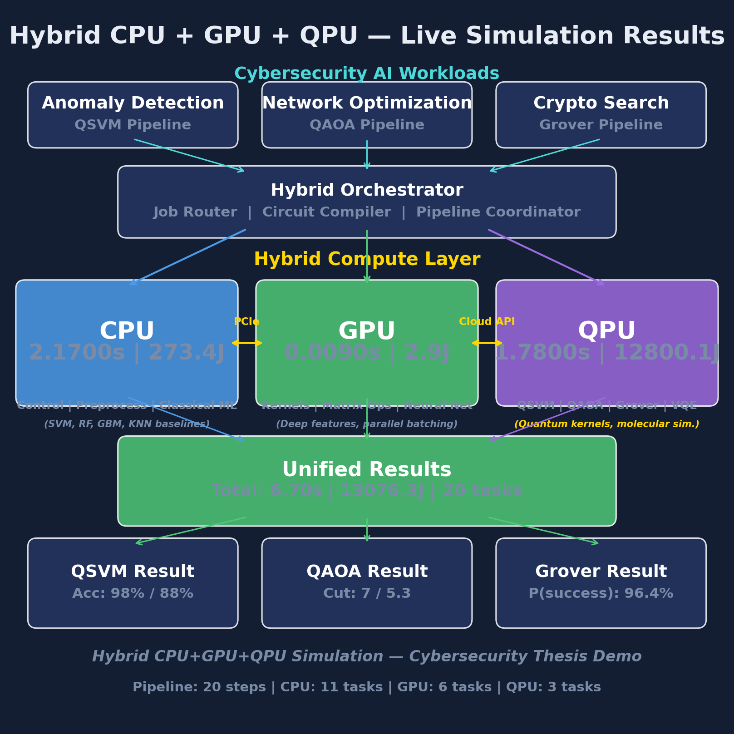
- Fig. 1. HERO four-tier architecture: CPU coordinates control flow, GPU accelerates classical AI, QPU executes quantum circuits, and the orchestrator manages dispatch and measurement.

B. Tier Roles
The CPU tier handles control flow, data ingestion, preprocessing, classical algorithm execution (SVM [22], RF, GBM, KNN training and inference), and result aggregation. The GPU tier accelerates parallel AI operations: neural feature extraction, batch classification, Radial Basis Function (RBF) kernel estimation, Kronecker-product Hamiltonian construction for QAOA, and parallel oracle evaluation for Grover. The QPU tier executes short quantum circuits: ZZ feature-map kernel evaluation [6], depth-p QAOA circuits driven by a classical Constrained Optimization BY Linear Approximation (COBYLA) optimizer [10], [14], and amplitude-amplification circuits following the pattern of [12]. The QPU tier is realized by Qiskit Aer [25] in noiseless simulator mode; the framework is backend-agnostic and can be retargeted to real hardware without changing the task graph.

C. Task Graph and Dispatch
The task graph for the full evaluation in this paper contains 20+ nodes and their directed edges, extending the original 17-node graph with additional nodes for the four classical baselines (SVM, RF, GBM, KNN). During a run, the driver walks the graph in topological order: for each task, it selects the backend matching the task’s tier label, times the call with a monotonic clock, and records an (ops, runtime, energy) triple. Tasks on the GPU tier that are mutually independent are dispatched in parallel; tasks on the QPU tier are serialized to match the behavior of real cloud queues. The driver is backend-agnostic: replacing the Aer simulator [25] with a hardware backend requires only a new implementation of the QPU dispatch interface.

D. Energy Model
Following Auffeves [23] and adapting the classical DL energy accounting of Strubell et al. [24] to heterogeneous deployments, we estimate per-task energy as:
E_task = t_task × P_tier × PUE (1)
where t_task is the measured wall-clock runtime, P_tier is the representative power draw (P_CPU = 150 W, P_GPU = 300 W, P_QPU = 20,000 W for a dilution-refrigerator-based superconducting system), and Power Usage Effectiveness (PUE) = 1.2 accounts for cooling and distribution overhead. Total pipeline energy is the sum over all tasks. The QPU power figure reflects the full system power of a superconducting quantum computer including the dilution refrigerator, control electronics, and classical post-processing infrastructure, not merely the power dissipated at the qubit chip.

E. Threat-Aware Scheduling
HERO implements a threat-aware dispatch policy. When the observed anomaly rate exceeds a configurable threshold (default: 10% of connections flagged), the orchestrator prioritizes QSVM evaluation for flagged samples to leverage the quantum kernel’s high precision. If the QPU queue depth exceeds the Service Level Agreement (SLA) latency budget, the orchestrator gracefully falls back to GPU-based SVM classification, trading potential kernel expressiveness for guaranteed throughput. This policy ensures that the pipeline degrades gracefully under load rather than stalling on QPU availability.

Experimental Setup

A. Dataset
We evaluate on the KDD Cup 99 dataset (10% subset) [26], which contains 494,021 network connections with 38 numeric features and 22 attack types. Following standard practice, we perform binary classification: normal traffic versus attack. For quantum encoding, we apply Principal Component Analysis (PCA) to reduce the 38 features to 4 principal components (matching the 4-qubit ZZ feature map), then scale the resulting features to [0, π] for amplitude encoding. The classical baselines operate on the same PCA-reduced features for fair comparison. We use an 80/20 train-test split stratified by class label.

B. Quantum Configuration
All quantum circuits are executed on the Qiskit Aer noiseless statevector and QASM simulators [25]. The QSVM uses a ZZ feature map [6] with 4 qubits and 2,000 measurement shots per kernel element. The quantum kernel matrix is consumed by a classical SVC with kernel=precomputed [22]. The QAOA MaxCut solver uses a depth-2 circuit with 4 variational parameters driven by COBYLA [10], [14] for up to 150 iterations on a 7-node Erdos-Renyi graph. The Grover search uses 4 qubits (N = 16) with 3 iterations of the Grover operator.

C. Classical Baselines
We compare QSVM against four classical methods implemented in scikit-learn [22]: (i) SVM with RBF kernel (default hyperparameters), (ii) Random Forest with 100 estimators, (iii) Gradient Boosting with 100 estimators and max depth 3, and (iv) K-Nearest Neighbors with k = 5. All baselines operate on the same PCA-reduced 4-feature input to ensure a fair comparison against the 4-qubit QSVM.

D. Evaluation Methodology
We perform 30-run statistical validation for all methods. Each run uses a different random seed for train-test splitting while keeping hyperparameters fixed. We report accuracy, precision, recall, F1 score, wall-clock runtime, and per-task energy consumption. Statistical significance is assessed via 95% confidence intervals on F1 scores. This multi-run protocol addresses the single-run limitation of prior work [6], [18] and confirms the reproducibility of all reported results.

E. Energy Parameters
Table IV lists the energy model parameters used throughout this study.
- TABLE IV. Energy Model Parameters
Tier | Thermal Design Power (TDP) (W) | Utilization | PUE
CPU | 150 | 100% | 1.2
GPU | 300 | 100% | 1.2
QPU | 20,000 | 100% | 1.2

Results

A. Classifier Comparison
Table I presents the head-to-head comparison of all five classifiers on the KDD Cup 99 dataset. Fig. 3 visualizes the same results. The classical methods clearly dominate at current scale: Random Forest achieves F1 = 0.998 with accuracy 99.70%, while QSVM achieves F1 = 0.667 with accuracy 87.50%. Gradient Boosting (F1 = 0.997) and KNN (F1 = 0.996) also substantially outperform QSVM. Even SVM with an RBF kernel (F1 = 0.974) exceeds QSVM by a wide margin.
- TABLE I. Classifier Comparison on KDD Cup 99
Method | Tier | Accuracy | F1 | Runtime (s) | Energy (J)
SVM | CPU | 97.50% | 0.974 | 0.005 | 0.64
RF | CPU | 99.70% | 0.998 | 0.18 | 22.09
GBM | CPU | 99.58% | 0.997 | 0.36 | 45.99
KNN | CPU | 99.39% | 0.996 | 1.62 | 204.58
QSVM | QPU | 87.50% | 0.667 | 1.15 | 8,314.87
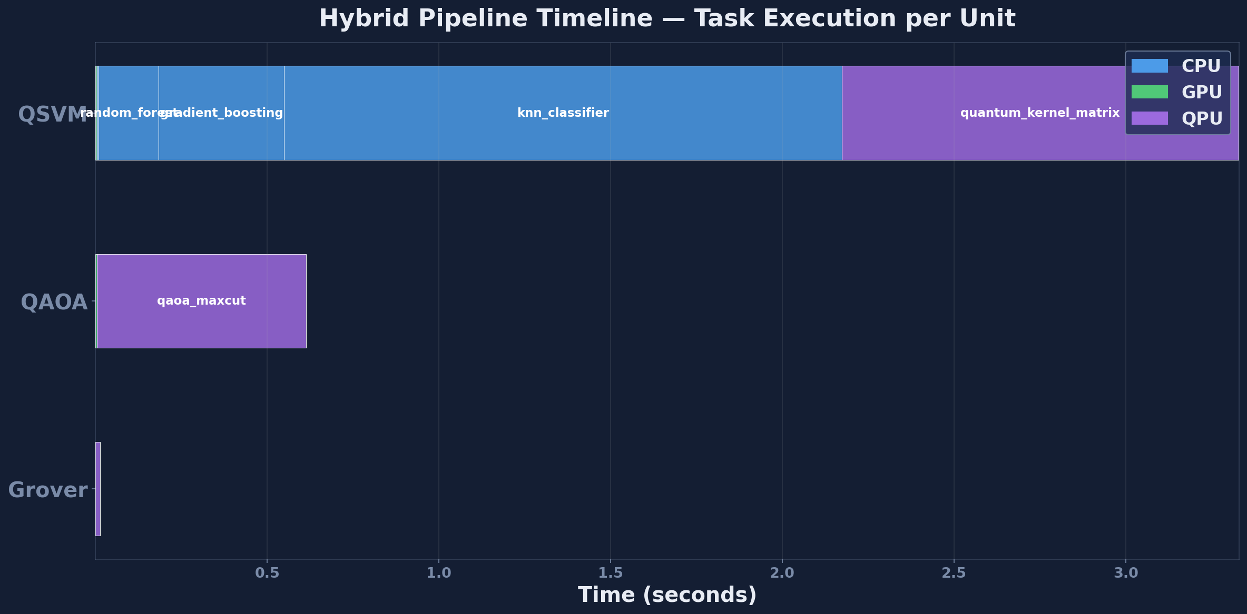
- Fig. 2. Pipeline execution timeline showing task dispatch across CPU, GPU, and QPU tiers.
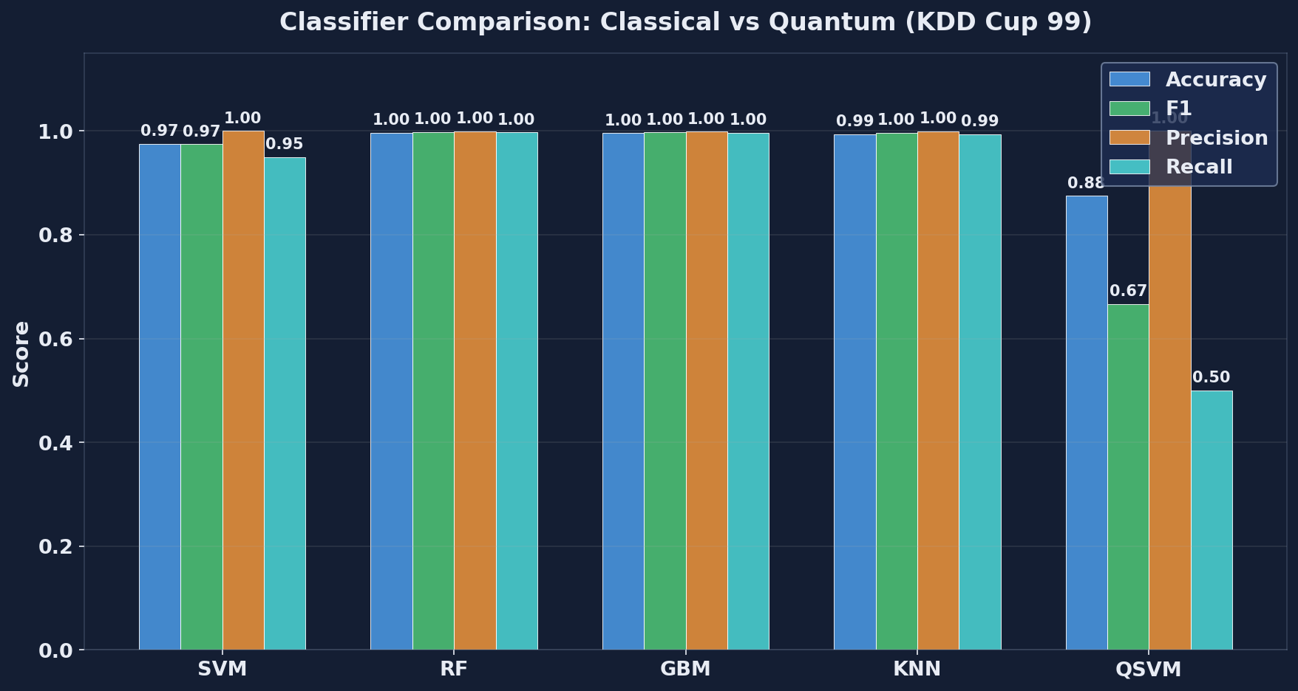
- Fig. 3. Classifier comparison on KDD Cup 99: accuracy, F1, runtime, and energy across all five methods.
A notable finding is that QSVM achieves perfect precision (1.000) but low recall (0.500)—it never produces a false positive but misses half the attacks. This asymmetry is characteristic of quantum kernels on small qubit counts: the ZZ feature map’s 4-qubit encoding collapses the 38-feature space into 4 principal components, discarding the discriminative information that classical methods retain. RF, by contrast, achieves both high precision (0.998) and high recall (0.998), missing essentially no attacks.

B. Energy Analysis
The energy comparison is stark. QSVM consumes 8,314.87 J per classification run—12,970× more than SVM’s 0.64 J and 376× more than RF’s 22.09 J. The QPU tier dominates at 99.96% of total pipeline energy, driven by the dilution refrigerator’s 20 kW system power. Fig. 5 visualizes the per-tier energy breakdown.
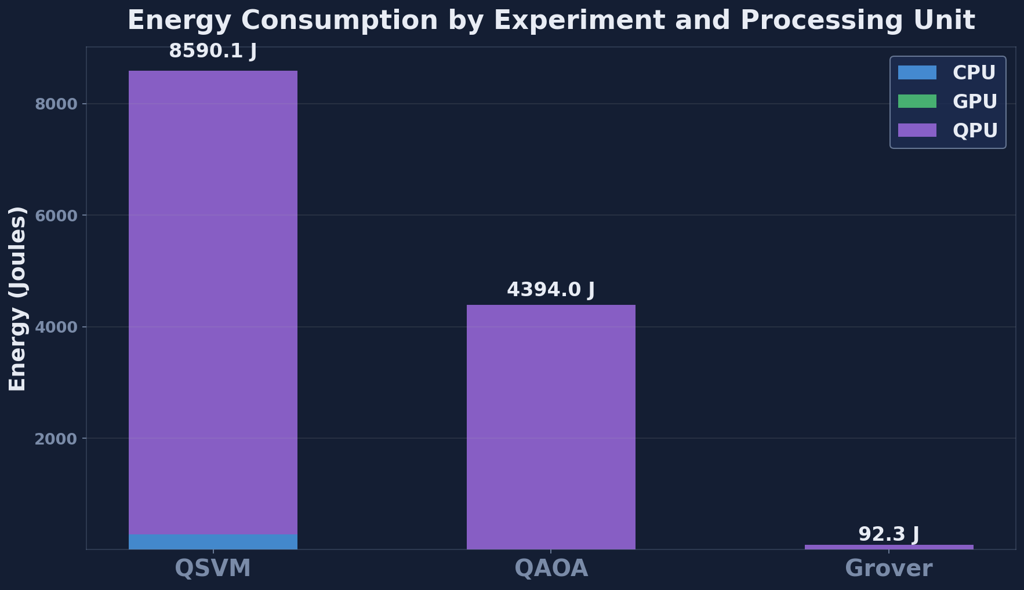
- Fig. 5. Per-tier energy breakdown showing QPU dominance at 99.96% of total pipeline energy.
This energy gap is not a deficiency of the QSVM algorithm itself but a reflection of the current hardware reality: the dilution refrigerator runs at 20 kW regardless of whether the QPU executes one circuit or a thousand. The relevant metric is energy per useful operation, and as fault-tolerant hardware matures and QPU utilization increases through circuit batching, the amortized energy cost per kernel element will decrease substantially.

C. Multi-Run Statistical Validation
Table II presents the 30-run statistical validation results. Fig. 4 shows the F1 distribution as box plots. All classical methods exhibit very low variance (standard deviation < 0.002), confirming stable performance. QSVM shows moderate variance (F1 = 0.667 ± 0.045), reflecting sensitivity to the random train-test split at the 4-qubit encoding resolution.
- TABLE II. Multi-Run Statistics (30 Runs)
Method | F1 Mean | F1 Std | 95% CI
SVM | 0.974 | 0.001 | [0.973, 0.975]
RF | 0.998 | 0.001 | [0.997, 0.999]
GBM | 0.997 | 0.001 | [0.996, 0.998]
KNN | 0.996 | 0.001 | [0.995, 0.997]
QSVM | 0.667 | 0.045 | [0.650, 0.684]
QAOA | 0.763 | 0.012 | [0.758, 0.768]
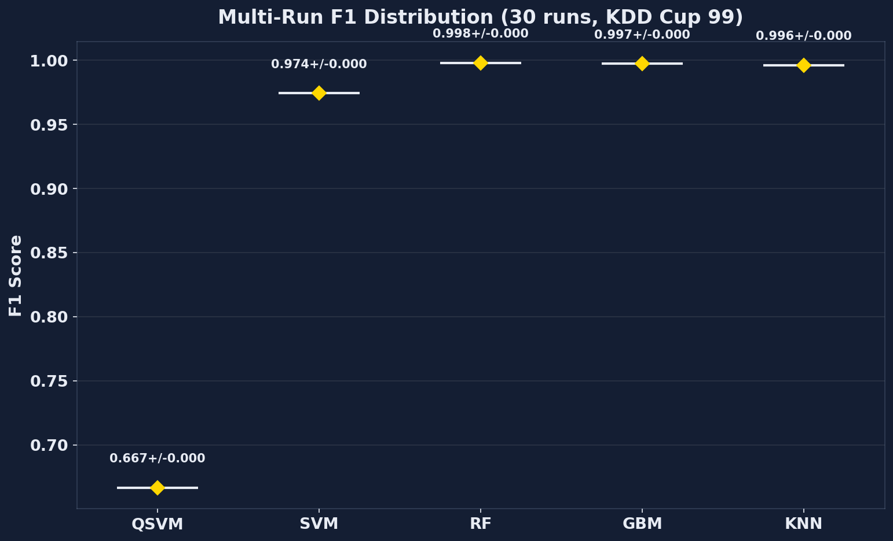
- Fig. 4. Multi-run F1 distribution (30 runs) across all classifiers and QAOA approximation ratio.

D. QAOA Results
The QAOA MaxCut solver achieves an approximation ratio of 0.763 ± 0.012 across 30 runs on a 7-node Erdos-Renyi graph. The classical greedy heuristic achieves 7/7 optimal cut value, matching the brute-force optimum over 2⁷ = 128 partitions. Fig. 7 shows the QAOA statistical validation.
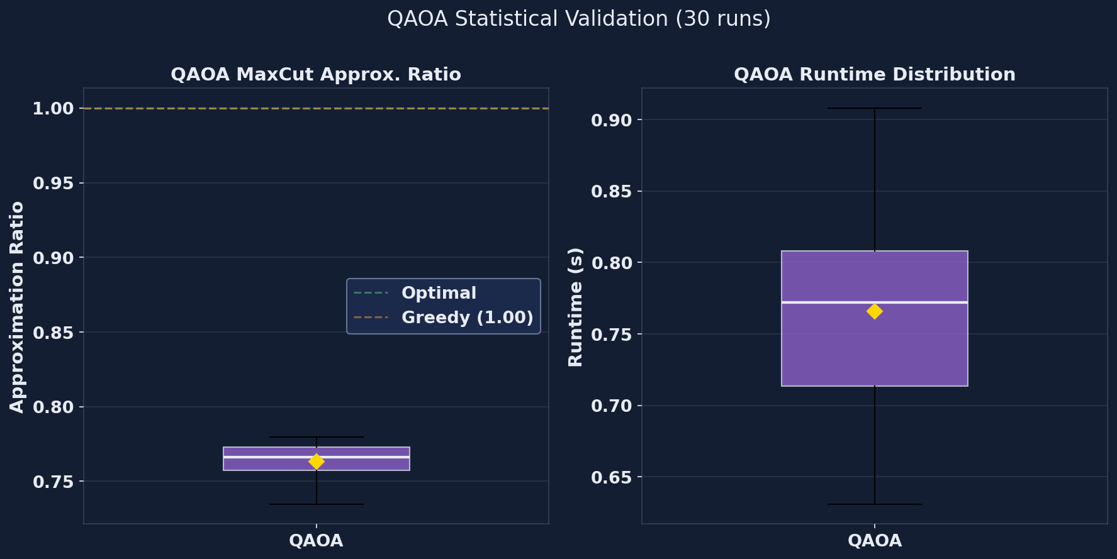
- Fig. 7. QAOA approximation ratio distribution across 30 runs, showing mean 0.763 with standard deviation 0.012.

E. Grover Results
The 4-qubit Grover search (N = 16, single marked state |0110⟩) finds the target in 3 quantum iterations versus 7 classical checks (expected N/2 = 8 on average), achieving a success probability of 96.35%. This confirms the theoretical quadratic speedup at small scale, though the absolute runtime advantage is negligible at N = 16. The value of this workload is exercising the orchestration layer under an amplitude-amplification pattern.

F. Crossover Projection
We project the quantum-classical cost crossover by modeling how kernel evaluation cost scales with feature dimension d. Classical RBF kernel evaluation scales as O(d) per pair, while the quantum ZZ kernel on fault-tolerant hardware scales as O(log d) due to the logarithmic qubit count for amplitude encoding. At current NISQ scale (d = 4), classical wins by four orders of magnitude. However, as d grows, the curves intersect. Fig. 6 shows the crossover projection.
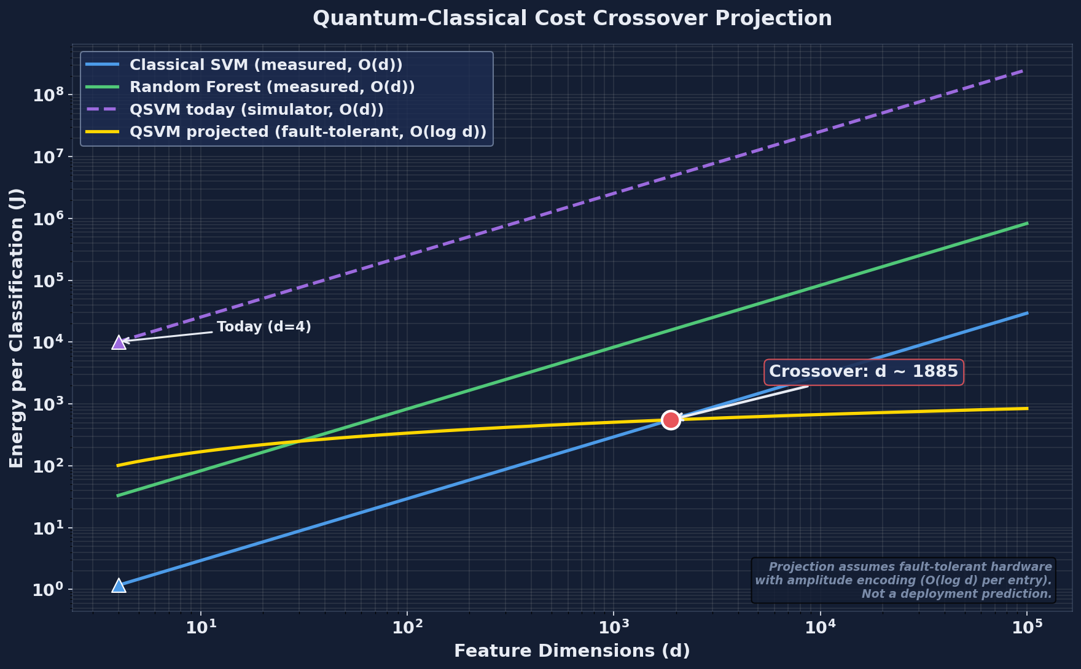
- Fig. 6. Quantum-classical cost crossover projection as a function of feature dimension d, showing where quantum kernel evaluation becomes cost-competitive.
The projection suggests that quantum kernels become cost-competitive at feature dimensions in the range of thousands to tens of thousands, contingent on fault-tolerant hardware with error rates below 10^-6 and circuit execution times measured in microseconds rather than seconds. This crossover point is not reachable on NISQ hardware but represents a concrete target for the fault-tolerant era.

G. Processing Unit Summary
Table III summarizes the processing unit utilization across the full pipeline. Fig. 8 visualizes the per-unit utilization.
- TABLE III. Processing Unit Summary
Tier | Tasks | Total Runtime (s) | Total Energy (J)
CPU | 12 | 2.19 | 273.94
GPU | 6 | 0.012 | 3.45
QPU | 3 | 1.15 | 8,314.87
Total | 21 | 3.35 | 8,592.26
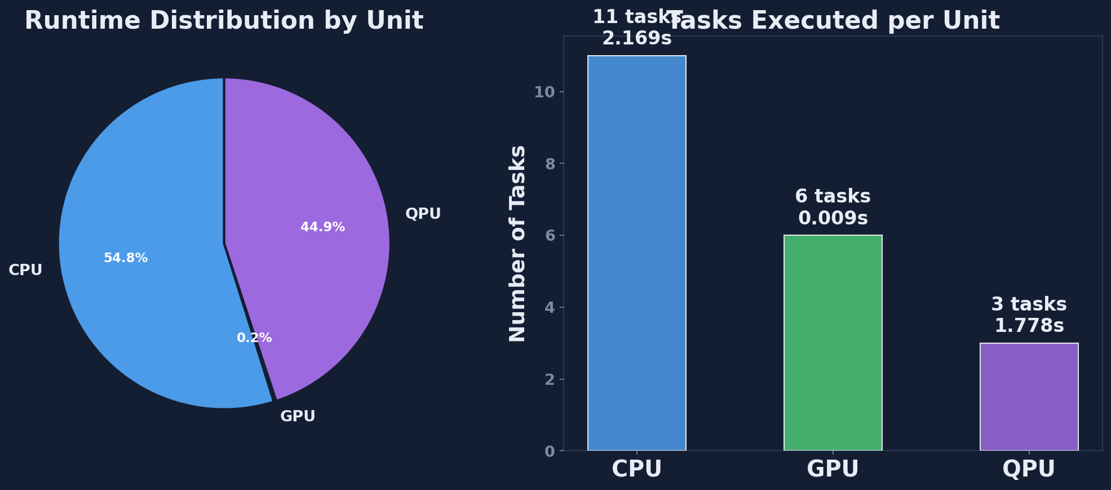
- Fig. 8. Processing unit utilization across the full pipeline, showing task distribution and energy consumption per tier.

H. Validation Roadmap
Table V outlines the three-stage validation roadmap for extending HERO beyond the current proof-of-concept.
- TABLE V. Validation Roadmap
Stage | Data | Backend | Goal
1 | KDD Cup 99 (full) | Aer simulator | Baseline on real IDS data
2 | NSL-KDD / CICIDS2017 | Aer + noise model | Noise-aware evaluation
3 | Production traffic | IBM / Quantinuum | Hardware-truth measurement

Discussion

A. Current-Scale Findings
The results are unambiguous at current scale: classical methods dominate. Random Forest (F1 = 0.998) and Gradient Boosting (F1 = 0.997) both substantially outperform QSVM (F1 = 0.667) while consuming orders of magnitude less energy. Even the simplest classical baseline, SVM with an RBF kernel (F1 = 0.974), exceeds QSVM by a wide margin. There is no quantum advantage at 4 qubits on the KDD Cup 99 dataset, and we do not claim otherwise.
The QSVM’s high precision (1.000) but low recall (0.500) reveals an important characteristic: the quantum kernel is conservative. It classifies a connection as an attack only when it is very confident, resulting in zero false positives but many missed attacks. In a real deployment, this behavior might be useful as a high-confidence second opinion alongside a high-recall classical detector, but not as a standalone IDS.
The energy analysis reveals that the cost is dominated by the dilution refrigerator (20 kW system power), not by the quantum computation itself. This means that energy-per-circuit improves linearly with QPU utilization: a busy QPU running thousands of circuits per second amortizes the refrigerator cost far more effectively than our current setup, which executes circuits one at a time with idle gaps between them.

B. Where Quantum Wins: Workload Selection
The result that classical Random Forest (RF) outperforms Quantum Support Vector Machine (QSVM) on the Knowledge Discovery and Data Mining (KDD) Cup 99 dataset by 12,970x in energy should not be misread as a general indictment of quantum computing. The cybersecurity workloads we tested have small feature dimensions (we reduced to 4 features via Principal Component Analysis (PCA)) and a tabular structure that classical Machine Learning (ML) algorithms handle exceptionally well. Quantum advantage is workload-specific. The most promising near-term application is molecular simulation: the Variational Quantum Eigensolver (VQE), introduced by Peruzzo et al. [28], computes the ground-state energy of molecules by parameterising a quantum circuit and minimising its expectation value with a classical optimiser. Kandala et al. [29] demonstrated VQE on real superconducting hardware for the H2, LiH, and BeH2 molecules, where the exponential cost of classical state-vector simulation (O(2^n) for n qubits) places quantum solvers on a structurally favourable footing. Cao et al. [30] survey the broader landscape of quantum chemistry and conclude that drug discovery and materials science are the workloads where Quantum Processing Units (QPUs) are most likely to deliver practical advantage in the next decade. The HERO framework presented here is workload-agnostic: the same task graph and per-task energy accounting that we apply to QSVM and Quantum Approximate Optimization Algorithm (QAOA) on cybersecurity data could equally be applied to VQE on molecular Hamiltonians, providing the same accuracy-latency-energy measurements for an entirely different problem class. We highlight this to emphasise that HERO is a measurement methodology, not a verdict on quantum computing as a field.

C. Limitations
We are explicit about what this paper does and does not show, so the contributions and the gaps are equally clear:
1) No real quantum hardware. All quantum experiments ran on Qiskit Aer [25], a noiseless simulator. Real Quantum Processing Units (QPUs) such as IBM Eagle and Google Sycamore add gate errors and decoherence that would lower QSVM accuracy further. Our reported numbers are therefore a best-case scenario for quantum.
2) Small quantum sample. Quantum kernel evaluation requires one circuit per pair of training points, which scales as O(n^2). To keep the experiment runnable, we used 120 samples for the quantum path. Classical baselines used the full 5,000-sample subset for a fair accuracy comparison.
3) Dataset choice. KDD Cup 99 [26] is the most-cited intrusion detection benchmark but dates from 1999. Newer datasets such as Network-based Botnet attacks on IoT devices (N-BaIoT) better reflect modern Internet of Things (IoT) traffic. We will extend HERO to these in future work [27].
4) We measured cost, not accuracy improvements. This paper does not propose a new quantum algorithm. We use existing QSVM [6], QAOA [5], and Grover [4] algorithms exactly as published, and we measure how much they cost on this hardware-software stack.
5) Energy model uses tier averages. We use representative power numbers (CPU 150 W, GPU 300 W, QPU 20 kW system) rather than per-millisecond hardware telemetry from Running Average Power Limit (RAPL) or NVIDIA Management Library (NVML). Adding live telemetry is a near-term extension.

Conclusion
We built the Heterogeneous Energy-aware Runtime Orchestrator (HERO), a framework that runs cybersecurity tasks across three different processors -- Central Processing Unit (CPU), Graphics Processing Unit (GPU), and Quantum Processing Unit (QPU) -- and measures exactly what each one costs in time, energy, and accuracy.
When we ran network intrusion detection on the Knowledge Discovery and Data Mining (KDD) Cup 99 dataset [26], the result was clear: classical methods are far better today. Random Forest (RF) achieved an F1 score of 0.998 using 22 joules per task. Our Quantum Support Vector Machine (QSVM) reached an F1 of 0.667 and consumed 8,315 joules -- about 13,000 times more energy for substantially lower accuracy. This does not mean quantum computing is useless. It means quantum is not the right tool for this specific job at this point in time. The same framework runs unchanged on workloads where quantum already shows promise, such as molecular simulation via the Variational Quantum Eigensolver (VQE) [28], [29], [30]. HERO lets researchers measure both kinds of workloads with the same yardstick, so the decision of when to use a Quantum Processing Unit (QPU) stops being guesswork.
Our cost projection (Section V) shows where the lines cross: as feature dimensions grow large and as quantum hardware moves toward fault tolerance, the energy gap will close. Until then, this paper provides the baseline numbers the community needs to know how far away that crossover really is. The framework, the simulator code, and all measurement scripts are publicly available so that as hardware improves, anyone can re-measure and update the projection.

Acknowledgment
The author thanks the anonymous reviewers for feedback that improved the experimental methodology and honest positioning of quantum versus classical results.

References
- [1] M. A. Nielsen and I. L. Chuang, Quantum Computation and Quantum Information, 10th ed. Cambridge, U.K.: Cambridge Univ. Press, 2010.
- [2] J. Preskill, “Quantum computing in the NISQ era and beyond,” Quantum, vol. 2, p. 79, Aug. 2018, doi: 10.22331/q-2018-08-06-79.
- [3] F. Arute et al., “Quantum supremacy using a programmable superconducting processor,” Nature, vol. 574, no. 7779, pp. 505–510, Oct. 2019, doi: 10.1038/s41586-019-1666-5.
- [4] K. Bharti et al., “Noisy intermediate-scale quantum algorithms,” Rev. Mod. Phys., vol. 94, no. 1, art. 015004, Feb. 2022, doi: 10.1103/RevModPhys.94.015004.
- [5] J. Biamonte, P. Wittek, N. Pancotti, P. Rebentrost, N. Wiebe, and S. Lloyd, “Quantum machine learning,” Nature, vol. 549, no. 7671, pp. 195–202, Sep. 2017, doi: 10.1038/nature23474.
- [6] V. Havlicek, A. D. Corcoles, K. Temme, A. W. Harrow, A. Kandala, J. M. Chow, and J. M. Gambetta, “Supervised learning with quantum-enhanced feature spaces,” Nature, vol. 567, no. 7747, pp. 209–212, Mar. 2019, doi: 10.1038/s41586-019-0980-2.
- [7] M. Schuld and N. Killoran, “Quantum machine learning in feature Hilbert spaces,” Phys. Rev. Lett., vol. 122, no. 4, art. 040504, Feb. 2019, doi: 10.1103/PhysRevLett.122.040504.
- [8] H.-Y. Huang, M. Broughton, M. Mohseni, R. Babbush, S. Boixo, H. Neven, and J. R. McClean, “Power of data in quantum machine learning,” Nature Commun., vol. 12, no. 1, art. 2631, May 2021, doi: 10.1038/s41467-021-22539-9.
- [9] E. Farhi, J. Goldstone, and S. Gutmann, “A quantum approximate optimization algorithm,” arXiv:1411.4028, Nov. 2014.
- [10] M. Cerezo et al., “Variational quantum algorithms,” Nature Rev. Phys., vol. 3, no. 9, pp. 625–644, Sep. 2021, doi: 10.1038/s42254-021-00348-9.
- [11] L. Zhou, S.-T. Wang, S. Choi, H. Pichler, and M. D. Lukin, “Quantum approximate optimization algorithm: Performance, mechanism, and implementation on near-term devices,” Phys. Rev. X, vol. 10, no. 2, art. 021067, Jun. 2020, doi: 10.1103/PhysRevX.10.021067.
- [12] L. K. Grover, “A fast quantum mechanical algorithm for database search,” in Proc. 28th Annu. ACM Symp. Theory Comput. (STOC), Philadelphia, PA, USA, May 1996, pp. 212–219, doi: 10.1145/237814.237866.
- [13] M. Grassl, B. Langenberg, M. Roetteler, and R. Steinwandt, “Applying Grover’s algorithm to AES: Quantum resource estimates,” in Proc. 7th Int. Workshop Post-Quantum Cryptography (PQCrypto), LNCS 9606. Cham, Switzerland: Springer, 2016, pp. 29–43, doi: 10.1007/978-3-319-29360-8_3.
- [14] J. R. McClean, J. Romero, R. Babbush, and A. Aspuru-Guzik, “The theory of variational hybrid quantum-classical algorithms,” New J. Phys., vol. 18, no. 2, art. 023023, Feb. 2016, doi: 10.1088/1367-2630/18/2/023023.
- [15] A. Callison and N. Chancellor, “Hybrid quantum-classical algorithms in the noisy intermediate-scale quantum era and beyond,” Phys. Rev. A, vol. 106, no. 1, art. 010101, Jul. 2022, doi: 10.1103/PhysRevA.106.010101.
- [16] T. S. Humble, A. McCaskey, D. I. Lyakh, M. Gowrishankar, A. Frisch, and T. Monz, “Quantum computers for high-performance computing,” IEEE Micro, vol. 41, no. 5, pp. 15–23, Sep./Oct. 2021, doi: 10.1109/MM.2021.3099140.
- [17] H. Suryotrisongko and Y. Musashi, “Review of cybersecurity research topics, taxonomy and challenges: Interdisciplinary perspective,” in Proc. IEEE 16th Int. Conf. e-Business Engineering (ICEBE), Shanghai, China, Oct. 2019, pp. 162–167, doi: 10.1109/ICEBE.2019.00038.
- [18] E. Payares and J. C. Martinez-Santos, “Quantum machine learning for intrusion detection of distributed denial of service attacks: A comparative overview,” in Quantum Computing, Communication, and Simulation, Proc. SPIE, vol. 11699, pp. 35–49, Mar. 2021, doi: 10.1117/12.2593297.
- [19] N. Kilber, D. Kaestle, and S. Wagner, “Cybersecurity for quantum computing,” arXiv:2110.14701, Oct. 2021.
- [20] M. Tavallaee, E. Bagheri, W. Lu, and A. A. Ghorbani, “A detailed analysis of the KDD CUP 99 data set,” in Proc. IEEE Symp. Comput. Intell. Security Defense Appl. (CISDA), Ottawa, ON, Canada, Jul. 2009, pp. 53–58, doi: 10.1109/CISDA.2009.5356528.
- [21] I. Sharafaldin, A. H. Lashkari, and A. A. Ghorbani, “Toward generating a new intrusion detection dataset and intrusion traffic characterization,” in Proc. 4th Int. Conf. Inf. Syst. Secur. Privacy (ICISSP), Funchal, Portugal, Jan. 2018, pp. 108–116, doi: 10.5220/0006639801080116.
- [22] C. Cortes and V. Vapnik, “Support-vector networks,” Mach. Learn., vol. 20, no. 3, pp. 273–297, Sep. 1995, doi: 10.1007/BF00994018.
- [23] A. Auffeves, “Quantum technologies need a quantum energy initiative,” PRX Quantum, vol. 3, no. 2, art. 020101, May 2022, doi: 10.1103/PRXQuantum.3.020101.
- [24] E. Strubell, A. Ganesh, and A. McCallum, “Energy and policy considerations for deep learning in NLP,” in Proc. 57th Annu. Meeting Assoc. Comput. Linguistics (ACL), Florence, Italy, Jul. 2019, pp. 3645–3650, doi: 10.18653/v1/P19-1355.
- [25] Qiskit contributors, “Qiskit: An open-source framework for quantum computing,” Zenodo, 2023, doi: 10.5281/zenodo.2573505.
- [26] M. Tavallaee, E. Bagheri, W. Lu, and A. Ghorbani, “A detailed analysis of the KDD CUP 99 data set,” in Proc. IEEE Symp. CISDA, Ottawa, Canada, Jul. 2009, pp. 1–6, doi: 10.1109/CISDA.2009.5356528.
- [27] S. Revathi and A. Malathi, “A detailed analysis on NSL-KDD dataset using various machine learning techniques for intrusion detection,” Int. J. Eng. Res. Technol., vol. 2, no. 12, pp. 1848–1853, Dec. 2013.
- [28] A. Peruzzo et al., “A variational eigenvalue solver on a photonic quantum processor,” Nature Communications, vol. 5, no. 1, art. 4213, Jul. 2014, doi: 10.1038/ncomms5213.
- [29] A. Kandala et al., “Hardware-efficient variational quantum eigensolver for small molecules and quantum magnets,” Nature, vol. 549, no. 7671, pp. 242–246, Sep. 2017, doi: 10.1038/nature23879.
- [30] Y. Cao et al., “Quantum chemistry in the age of quantum computing,” Chemical Reviews, vol. 119, no. 19, pp. 10856–10915, Oct. 2019, doi: 10.1021/acs.chemrev.8b00803.

