PROJECT REPORT
Mental Health Condition Predictor
A Machine Learning Approach to Predicting Mental Health Conditions from Lifestyle and Psychological Indicators
Submitted by
[ Name]
[SRMCEM / BTECH CSE(AIML)]
July 2026

1. Abstract
Mental health is a foundational component of overall well-being, yet early signs of conditions such as anxiety, depression, and burnout often go unnoticed until they significantly affect daily life. This project presents an end-to-end machine learning pipeline that predicts a person's likely mental health condition from everyday lifestyle and psychological indicators, including sleep patterns, academic or work pressure, social media usage, stress, mood, and social support. A Random Forest Classifier was trained on a structured dataset of 500 individuals and evaluated after data cleaning on 293 complete records, achieving a test accuracy of approximately 94.9% across four classes: Normal, Anxiety, Burnout, and Depression. The trained model was deployed through an interactive Streamlit web application that allows a user to enter their own lifestyle details through sliders and dropdowns and receive an instant, human-readable prediction. This report documents the problem motivation, dataset, methodology, model performance, deployment architecture, and directions for future improvement.

2. Introduction
The World Health Organization identifies mental health as an integral and essential component of health, not merely the absence of mental disorder. Rising academic pressure, demanding work schedules, and increased screen and social media exposure have been widely linked to elevated stress, anxiety, and burnout, particularly among students and young professionals. Traditional mental health screening relies on clinical interviews or self-reported questionnaires administered by a professional, which can be time-consuming, costly, and inaccessible to many people, especially in the early stages when symptoms are mild and easy to dismiss.
This project explores whether a data-driven approach can offer a lightweight, accessible first step toward self-awareness. By training a supervised classification model on everyday lifestyle and psychological indicators, the system can flag a probable mental health condition, encouraging the user to seek appropriate support rather than replacing professional diagnosis.

2.1 Problem Statement
Given a set of measurable lifestyle and psychological attributes for an individual, such as sleep quality, stress level, and social support, the objective is to build a classification model that accurately predicts which of four mental health categories the individual is likely to fall into: Normal, Anxiety, Burnout, or Depression, and to expose that model through an interactive, easy-to-use interface.

2.2 Objectives
- Collect and clean a structured dataset of demographic, lifestyle, and psychological features relevant to mental health.
- Engineer and encode features appropriately for a supervised machine learning model.
- Train and evaluate a classification model capable of distinguishing between Normal, Anxiety, Burnout, and Depression classes.
- Analyze which lifestyle factors contribute most strongly to the model's predictions.
- Deploy the trained model behind an interactive Streamlit web application for real-time use.

3. Dataset Description
The dataset, mental_health_prediction.csv, contains 500 records and 18 columns describing an individual's demographics, lifestyle habits, and psychological scores, along with the resulting mental health outcome. Table 1 summarizes the feature groups used for prediction.
Category | Features | Type
Demographics | age, gender, occupation | Numeric / Categorical
Lifestyle | sleep_hours, sleep_quality, social_media_hours, physical_activity_days | Numeric
Psychological scores | stress_level, anxiety_score, depression_score, mood_score, concentration_level | Numeric (1-10)
Environment | academic_work_pressure, work_life_balance, social_support | Numeric (1-10)
Target | mental_health_condition (Normal / Anxiety / Burnout / Depression) | Categorical
Table 1. Feature groups in the mental health dataset.
Two additional columns, severity and treatment, were present in the raw data but were deliberately excluded from the feature set. These fields are only known after a mental health condition has already been diagnosed, so including them would leak the answer into the model and produce an unrealistically optimistic, unusable predictor. This is a key data-leakage safeguard applied during preprocessing.
After removing rows with missing values, 293 of the original 500 records remained for training and evaluation. The class distribution is reasonably balanced across the four outcomes, as shown in Figure 1, which reduces the risk of the model becoming biased toward a majority class.
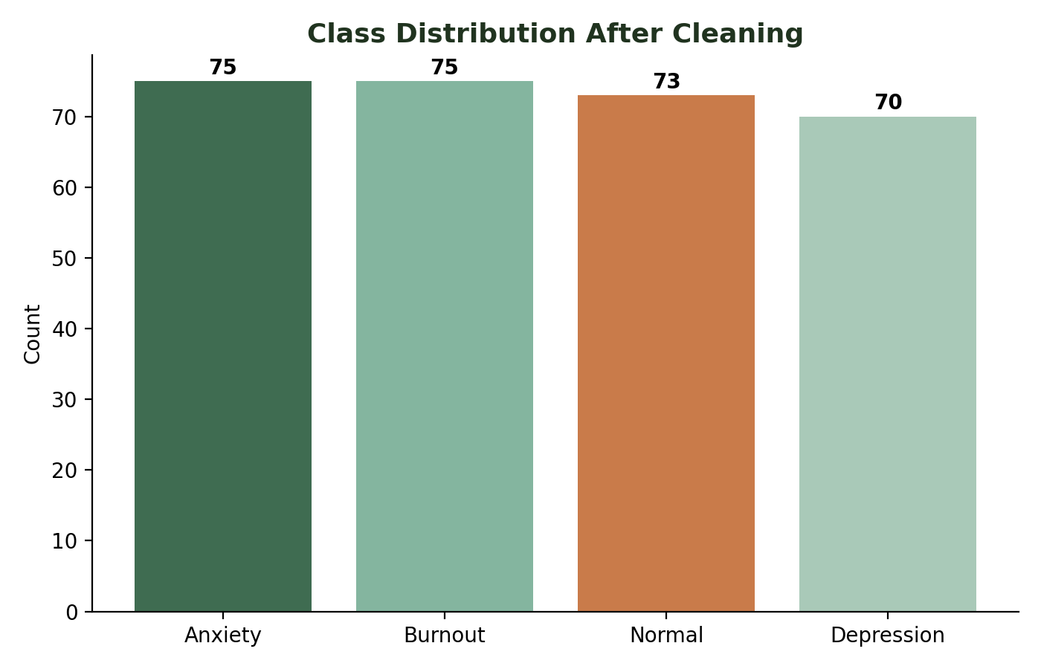
Figure 1. Class distribution of the cleaned dataset (293 records).

4. Methodology

4.1 System Architecture
The project follows a standard supervised machine learning workflow, moving from raw data to a deployed prediction interface. The pipeline consists of four stages: data preparation, model training, model persistence, and application deployment. Figure 4 illustrates the full data flow, from the raw CSV file through to the live Streamlit prediction.
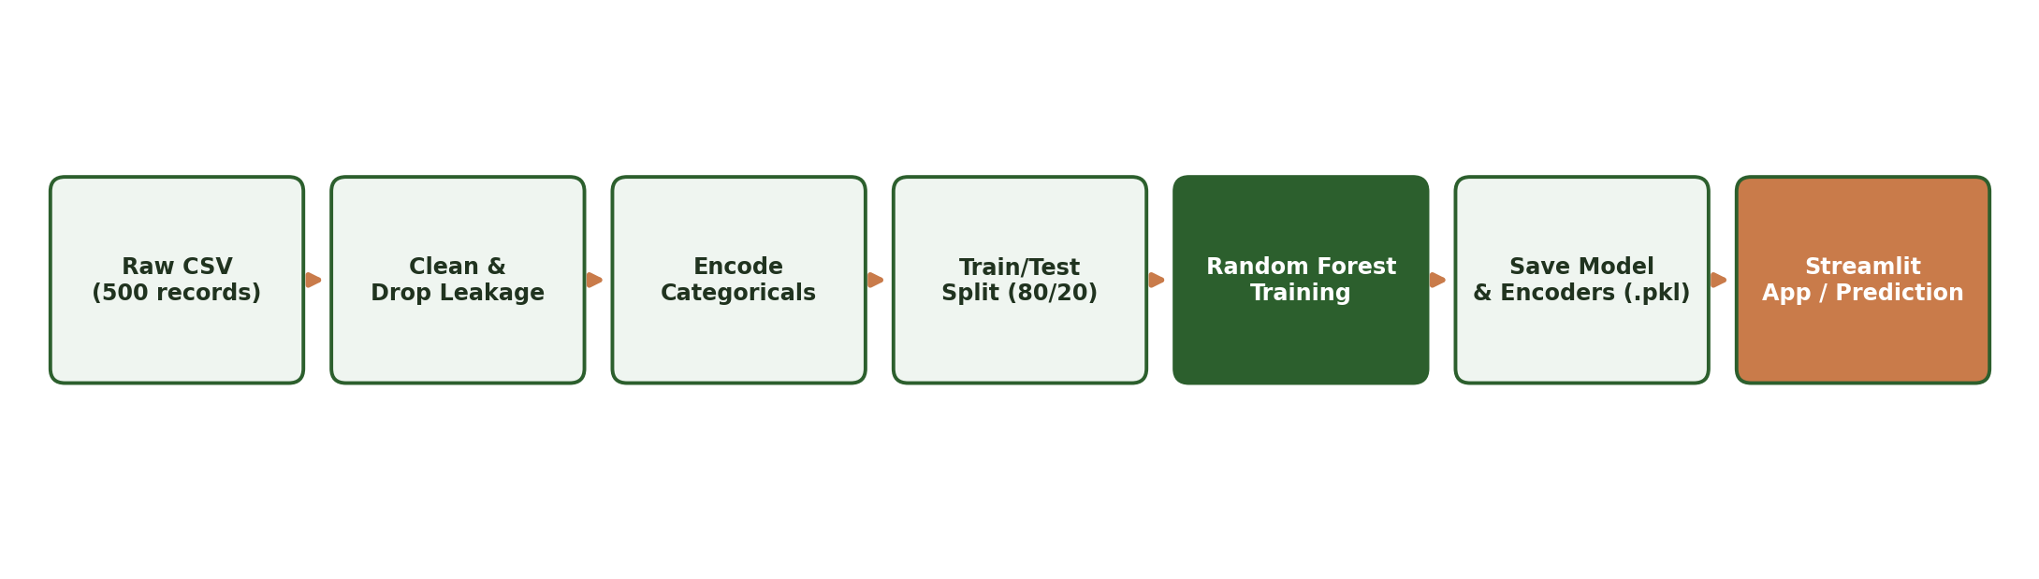
Figure 4. End-to-end pipeline from raw data to live prediction.
The repository is organized into clearly separated concerns: a data/ folder for the raw dataset, a notebooks/ folder holding the training and app-generation notebooks, a models/ folder containing the serialized Random Forest model and its three label encoders, app.py as the Streamlit entry point, and a tests/ folder for automated checks run through pytest and GitHub Actions on every commit.
Stage | Description
1. Data Preparation | Load CSV, drop missing rows, remove leakage columns (severity, treatment), encode categorical features
2. Train / Test Split | 80% training, 20% testing, with a fixed random seed for reproducibility
3. Model Training | Random Forest Classifier trained on 15 input features
4. Model Persistence | Model and label encoders serialized to .pkl files using pickle
5. Deployment | Streamlit application loads the artifacts and serves real-time predictions
Table 2. End-to-end pipeline stages.

4.2 Data Preprocessing
- Rows containing any missing values were dropped using dropna(), reducing the dataset from 500 to 293 clean records.
- The leakage-prone columns severity and treatment were removed prior to feature/target separation.
- Categorical fields gender and occupation were converted to numeric codes using scikit-learn's LabelEncoder.
- The target column mental_health_condition was label-encoded into four numeric classes for training and decoded back to text for the user-facing prediction.
- The final feature set consists of 15 ordered columns: age, gender, occupation, sleep_hours, sleep_quality, social_media_hours, academic_work_pressure, physical_activity_days, stress_level, anxiety_score, depression_score, work_life_balance, mood_score, concentration_level, and social_support.

4.3 Model Selection
A Random Forest Classifier was chosen as the core predictive model. Random Forests build an ensemble of decision trees on bootstrapped samples of the training data and aggregate their votes, which typically yields strong performance on structured, tabular data with a mix of numeric and categorical features, while remaining robust to noise and requiring minimal hyperparameter tuning. The model was trained using scikit-learn's RandomForestClassifier with a fixed random_state of 42 to ensure reproducible results, and the data was split into an 80% training set and a 20% testing set.

5. Results and Evaluation
The trained Random Forest model was evaluated on the held-out 20% test split (59 records). It achieved a training accuracy of 100% and a test accuracy of approximately 94.9%, indicating that the model fits the training data very closely while still generalizing well to unseen examples. Table 3 presents the detailed classification metrics per class.
Class | Precision | Recall | F1-score | Support
Anxiety | 0.86 | 0.92 | 0.89 | 13
Burnout | 0.94 | 1.00 | 0.97 | 15
Depression | 1.00 | 0.86 | 0.92 | 14
Normal | 1.00 | 1.00 | 1.00 | 17
Weighted Average | 0.95 | 0.95 | 0.95 | 59
Table 3. Classification report on the test set.
The confusion matrix in Figure 2 shows that the model correctly classifies the large majority of test samples. The most notable confusion occurs between Anxiety and Depression, two conditions that naturally share overlapping symptoms such as low mood, poor concentration, and disrupted sleep, which is consistent with clinical understanding of symptom overlap between the two conditions.
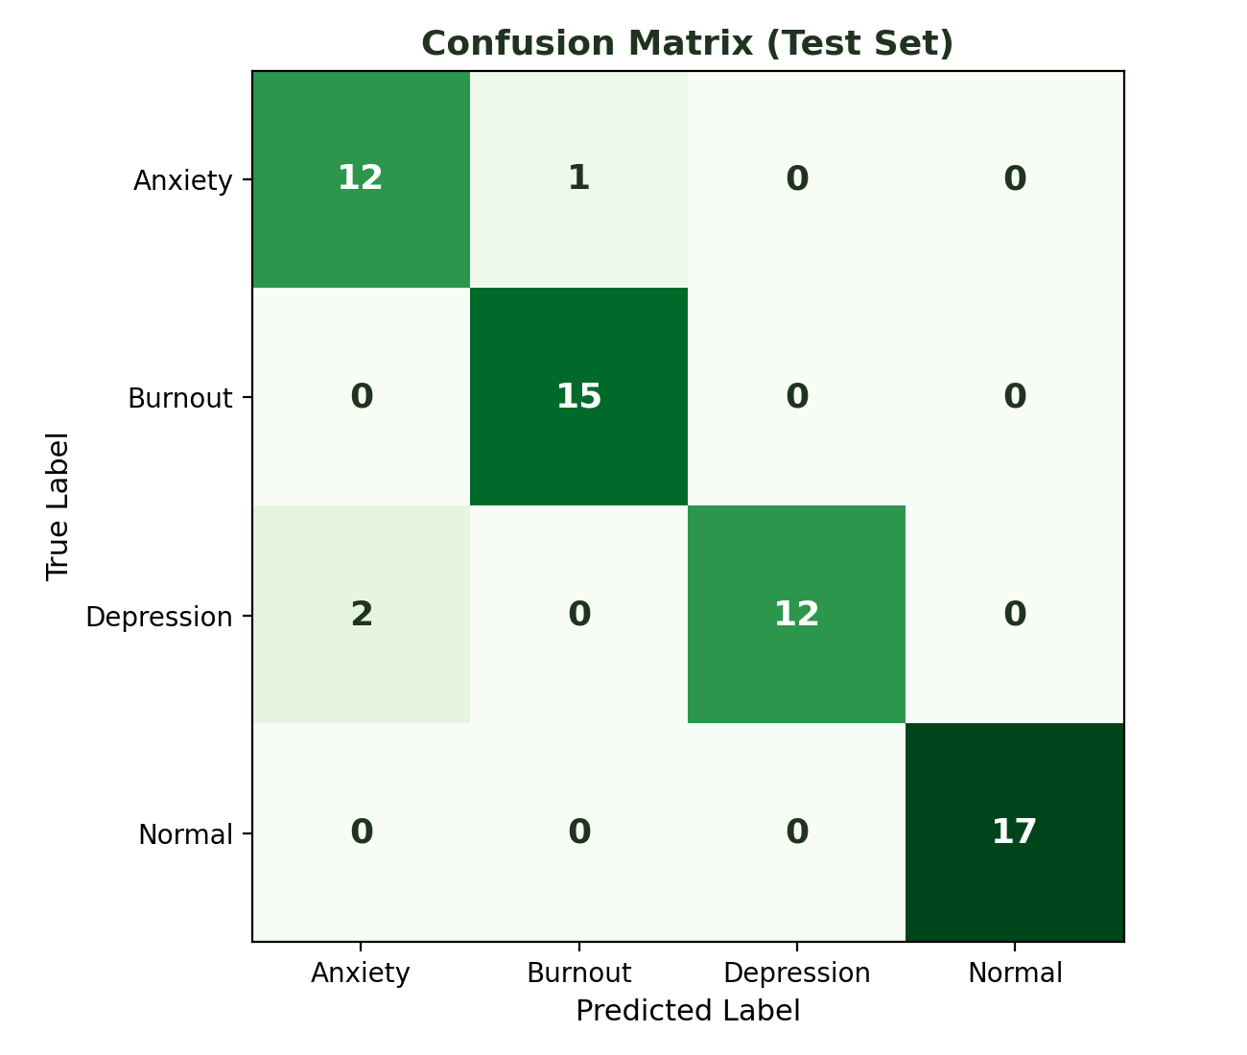
Figure 2. Confusion matrix on the 59-sample test set.

5.1 Feature Importance
Random Forest models provide a built-in measure of feature importance based on how much each feature reduces impurity across all trees in the ensemble. Figure 3 ranks the 15 input features by their contribution to the model's predictions.
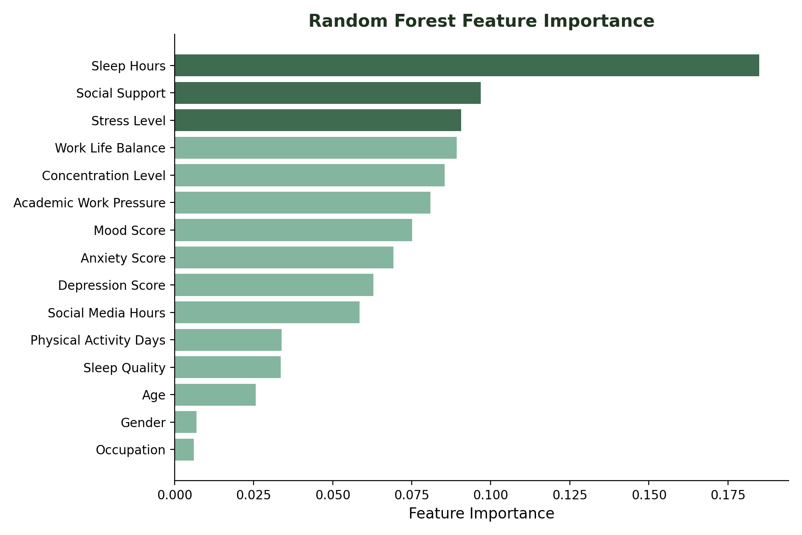
Figure 3. Feature importance ranking from the trained Random Forest.
Sleep hours emerged as the single strongest predictor, followed by social support, stress level, work-life balance, and concentration level. This aligns with established mental health research, which consistently links insufficient or poor-quality sleep to elevated risk of anxiety, depression, and burnout. Demographic attributes such as age, gender, and occupation contributed comparatively little to the model's decisions, suggesting that day-to-day lifestyle and psychological state are far more predictive of mental health outcomes than static demographic traits in this dataset.

6. Deployment: Interactive Web Application
The trained model and its label encoders were serialized using Python's pickle module and loaded into a Streamlit web application (app.py). The interface presents the user with sliders and dropdown menus for each of the 15 input features: an age slider, gender and occupation dropdowns, and ten-point scaled sliders for sleep quality, stress, anxiety, depression, mood, concentration, work-life balance, and social support, along with sliders for sleep hours, social media hours, and physical activity days.
When the user clicks the 'Predict' button, the application encodes the categorical inputs using the saved encoders, assembles all 15 features into the exact order expected by the model, and returns a decoded, human-readable prediction such as 'The predicted mental health condition is: Anxiety'. The application can be launched locally with a single command, streamlit run app.py, and opens automatically in the browser at http://localhost:8501.
Component | Technology
Model training | scikit-learn (RandomForestClassifier, LabelEncoder)
Data handling | pandas, NumPy
Web interface | Streamlit
Model persistence | pickle (.pkl files)
Testing | pytest
CI/CD | GitHub Actions
Table 4. Technology stack used across the project.

6.1 Sample Prediction Walkthrough
To illustrate the end-to-end flow, Table 5 shows an example set of inputs a user might enter into the application, representing someone with poor sleep, high pressure, and low social support.
Feature | Example Value
Age | 21
Gender | Female
Occupation | Student
Sleep Hours | 4.5
Sleep Quality | 3
Social Media Hours | 6.5
Academic / Work Pressure | 9
Physical Activity (days/week) | 1
Stress Level | 9
Anxiety Score | 8
Depression Score | 6
Work-Life Balance | 3
Mood Score | 3
Concentration Level | 3
Social Support | 2
Table 5. Example input values submitted through the Streamlit interface.
Given this combination of low sleep quality, high pressure, high stress, and low social support, the trained model would be expected to predict Anxiety or Burnout rather than Normal, consistent with the strong influence that sleep_hours, social_support, and stress_level exert on the model, as shown earlier in Figure 3. The application returns this prediction instantly as plain text, e.g. 'The predicted mental health condition is: Anxiety', without requiring the user to understand any of the underlying model mechanics.

7. Conclusion and Future Scope

7.1 Conclusion
This project demonstrates that a relatively simple, interpretable ensemble model, a Random Forest Classifier, can predict mental health conditions from everyday lifestyle and psychological indicators with high accuracy (94.9% on held-out test data). Careful preprocessing, in particular the removal of leakage-prone fields such as severity and treatment, was essential to ensuring the model reflects a realistic prediction scenario rather than an artificially inflated one. The feature importance analysis further confirms that sleep, social support, stress, and work-life balance are the dominant drivers of predicted mental health outcomes, offering an interpretable and actionable takeaway alongside the prediction itself. Packaging the model inside a Streamlit application makes the tool immediately usable by a non-technical person, turning a machine learning experiment into a practical, interactive self-awareness aid.

7.2 Limitations
- The dataset is relatively small (293 usable records after cleaning), which limits how confidently the reported accuracy generalizes to a broader population.
- The tool is intended purely as a self-awareness aid and is not a substitute for a clinical diagnosis by a qualified mental health professional.
- Missing-value rows were dropped rather than imputed, which further reduced the usable sample size.

7.3 Future Improvements
- Introduce SHAP (SHapley Additive exPlanations) values so the app can explain why a specific prediction was made for an individual user, not just which features matter globally.
- Expand and diversify the dataset across age groups, cultures, and occupations to improve generalizability.
- Connect a lightweight database to track a user's predictions over time and visualize trends.
- Containerize the application with Docker and deploy it to a public cloud endpoint for wider access.
- Experiment with additional algorithms (Gradient Boosting, XGBoost, Logistic Regression) and cross-validation for a more rigorous model comparison.

8. References
1. Pedregosa, F. et al. (2011). Scikit-learn: Machine Learning in Python. Journal of Machine Learning Research, 12, 2825-2830.
2. Breiman, L. (2001). Random Forests. Machine Learning, 45(1), 5-32.
3. Streamlit Documentation. https://docs.streamlit.io
4. World Health Organization. Mental health: strengthening our response. https://www.who.int
5. Project source code and dataset: mental_health_prediction.csv, Mental_Health_Prediction.ipynb, app.py (project repository).

