Mobile Game Marketing Performance
Synthetic portfolio report for August 2025
This report evaluates fictional paid acquisition campaigns by cost, player quality, retention and monetization. It demonstrates the analytical method without exposing any employer, client or production data.

Executive summary
The synthetic portfolio acquired 1,527 players and generated 13.0% return on ad spend. D7 retention was 8.7%. Store Intent produced the strongest D7 retention, while Playable Broad produced the lowest cost per D7 retained player.
Acquired players | Tracking rate | D1 retention | D7 retention | ROAS
1,527 | 93.6% | 37.8% | 8.7% | 13.0%

Portfolio retention
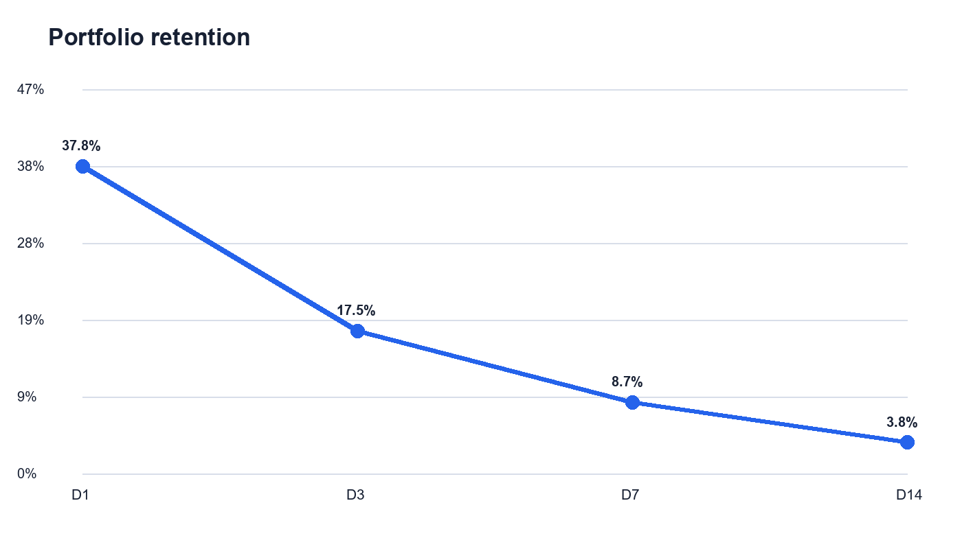
Retention uses exact return-day session activity and includes only cohorts mature enough to reach each day. Players without qualifying events remain visible in the tracking audit.

Campaign economics and player quality
Campaign | Life cycle | Players | CPI | D7 retention | D7 retained cost | ROAS
Store Intent | Active | 197 | $6.36 | 13.3% | $62.63 | 12.2%
Playable Premium | Active | 261 | $4.88 | 12.7% | $50.96 | 16.9%
Playable Broad | Active | 295 | $3.49 | 9.1% | $48.98 | 14.3%
Social Gameplay | Active | 279 | $4.05 | 8.4% | $62.83 | 10.0%
Social Lifestyle | Stopped | 96 | $5.09 | 8.3% | $61.04 | 4.0%
Search Value Global | Active | 156 | $2.76 | 5.9% | $61.57 | 20.8%
Search Value North | Active | 142 | $4.53 | 5.1% | $107.16 | 9.2%
Discovery Rewarded | Stopped | 101 | $2.54 | 2.0% | $128.39 | 18.1%

Campaign findings
Quality leaders were Store Intent, Playable Premium. The strongest return signals came from Search Value Global, Discovery Rewarded. Campaign decisions should combine scale, retained-user cost and return rather than optimize installs alone.

Creative performance
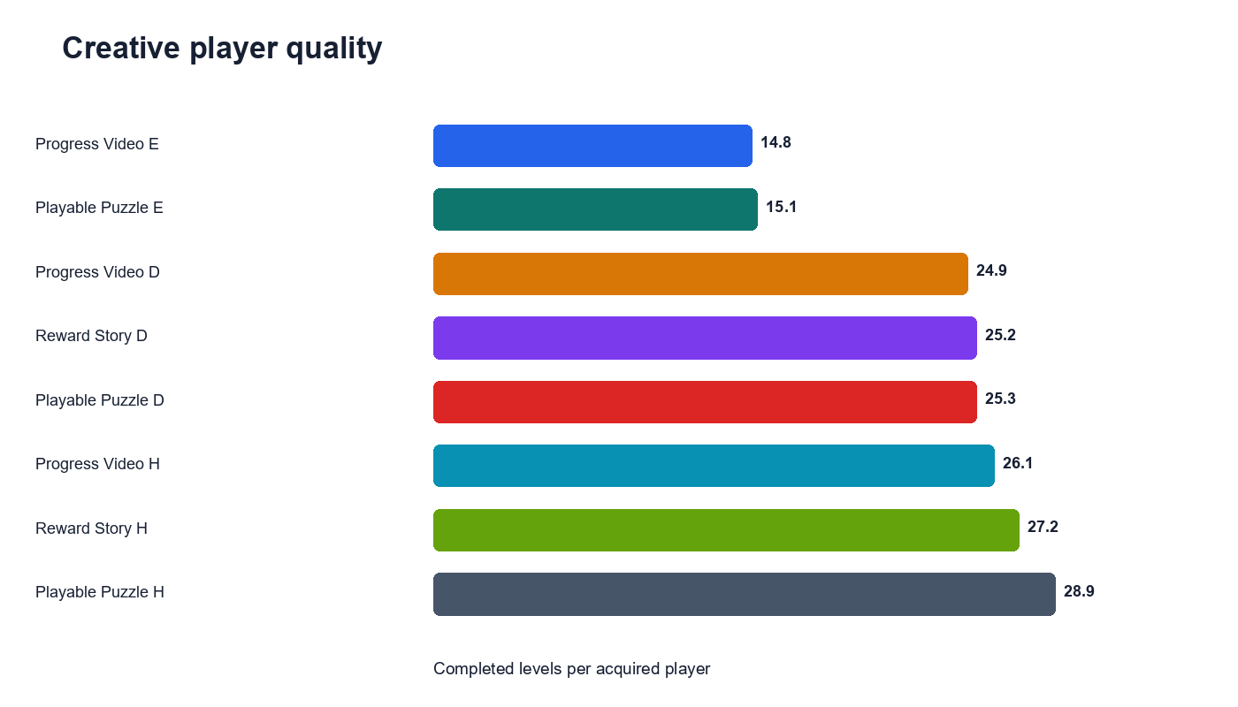
Playable Puzzle H generated the strongest completed-level signal among the synthetic creatives. Creative results should be treated as directional when eligible cohort sizes are small.

Recommended actions
- Use Store Intent as the player-quality benchmark for the next controlled test.
- Use Playable Broad as the efficiency comparison and monitor D7 retained-user cost.
- Reduce or redesign creatives with weak engagement even when their acquisition cost appears low.
- Investigate missing event coverage before making large budget changes.
- Review changes after a complete seven-day maturation window.

Data quality and methodology
Check | Result
Validation status | PASS
Synthetic players after exclusions | 1,527
Duplicate events removed | 10
Pre-install events removed | 7
Orphan event devices | 0
The pipeline joins fictional acquisition records to product events through synthetic device identifiers. It removes test-market records, duplicate event identifiers and pre-install activity before calculating engagement. ROAS equals total synthetic ad and purchase revenue divided by synthetic spend.
All data, names, findings and recommendations in this report are fictional and intended only for portfolio demonstration.

