Mobile Game Marketing Performance
Synthetic portfolio report for November 2025
This report evaluates fictional paid acquisition campaigns by cost, player quality, retention and monetization. It demonstrates the analytical method without exposing any employer, client or production data.

Executive summary
The synthetic portfolio acquired 267 players and generated 19.8% return on ad spend. D7 retention was 6.6%. Game Android E produced the strongest D7 retention, while Game Android E produced the lowest cost per D7 retained player.
Acquired players | Tracking rate | D1 retention | D7 retention | ROAS
267 | 96.6% | 26.9% | 6.6% | 19.8%

Portfolio retention
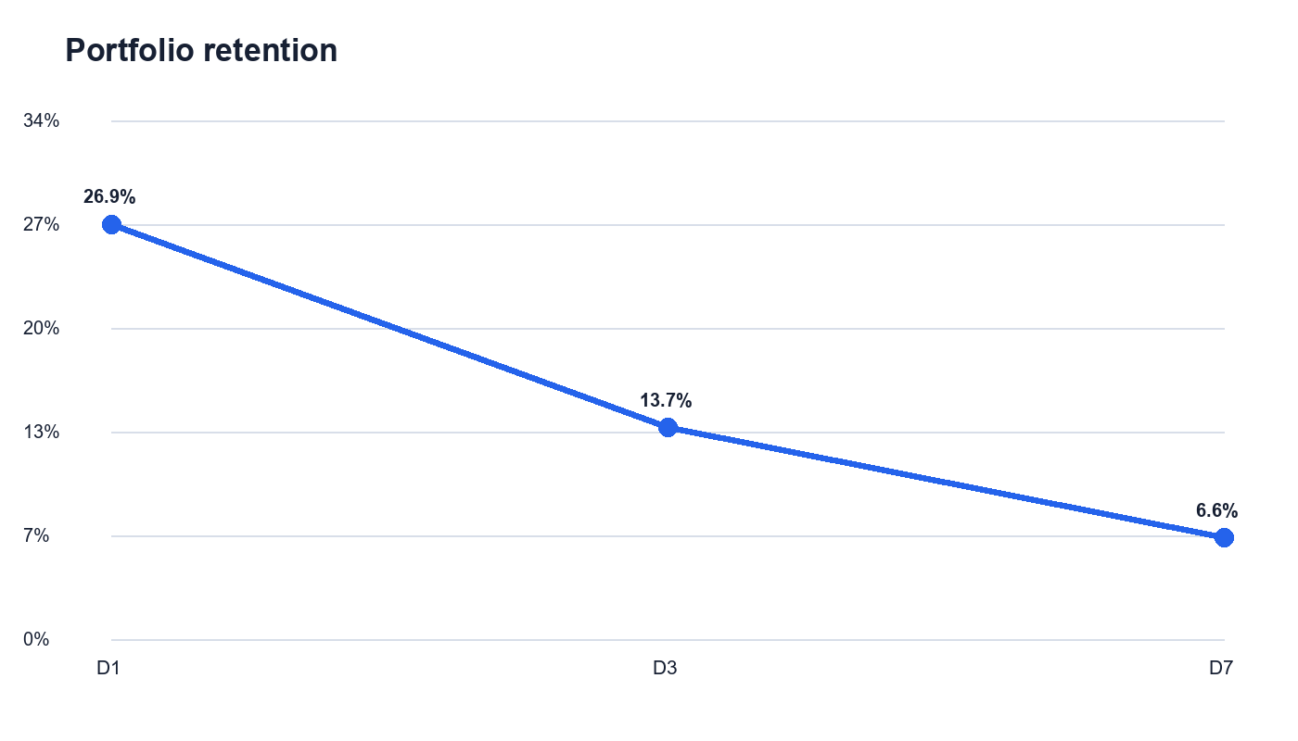
Retention uses exact return-day session activity and includes only cohorts mature enough to reach each day. Players without qualifying events remain visible in the tracking audit.

Campaign economics and player quality
Campaign | Life cycle | Players | CPI | D7 retention | D7 retained cost | ROAS
Game Android E | Active | 22 | $2.36 | 10.0% | $51.99 | 14.3%
Game iOS B | Active | 107 | $1.50 | 8.8% | $53.58 | 13.3%
Search Android A | Active | 58 | $3.49 | 5.6% | $202.21 | 28.9%
Game iOS A | Active | 78 | $2.25 | 0.0% | $n/a | 17.0%
Social iOS C | Stopped | 2 | $0.00 | 0.0% | $n/a | n/a

Campaign findings
Quality leaders were Game Android E, Game iOS B. The strongest return signals came from Search Android A, Game iOS A. Campaign decisions should combine scale, retained-user cost and return rather than optimize installs alone.

Creative performance
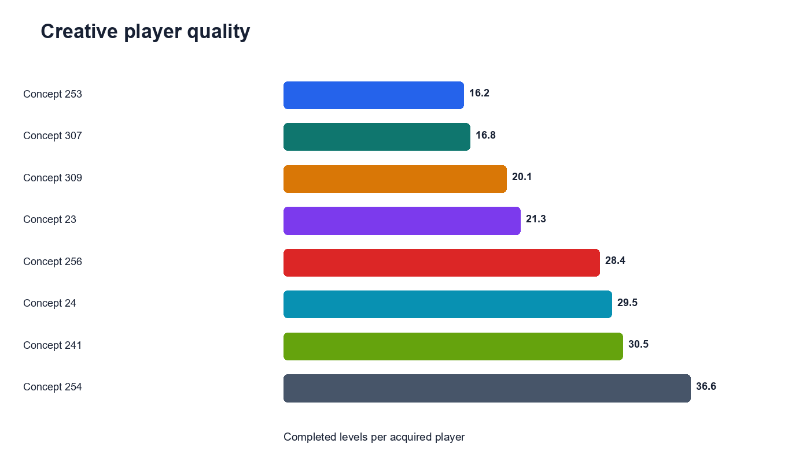
Concept 254 generated the strongest completed-level signal among the synthetic creatives. Creative results should be treated as directional when eligible cohort sizes are small.

Recommended actions
- Use Game Android E as the player-quality benchmark for the next controlled test.
- Use Game Android E as the efficiency comparison and monitor D7 retained-user cost.
- Reduce or redesign creatives with weak engagement even when their acquisition cost appears low.
- Investigate missing event coverage before making large budget changes.
- Review changes after a complete seven-day maturation window.

Data quality and methodology
Check | Result
Validation status | PASS
Synthetic players after exclusions | 267
Duplicate events removed | 0
Pre-install events removed | 0
Orphan event devices | 0
The pipeline joins fictional acquisition records to product events through synthetic device identifiers. It removes test-market records, duplicate event identifiers and pre-install activity before calculating engagement. ROAS equals total synthetic ad and purchase revenue divided by synthetic spend.
All data, names, findings and recommendations in this report are fictional and intended only for portfolio demonstration.

