**Graph Analysis Report**

1. Core Experience Implementation

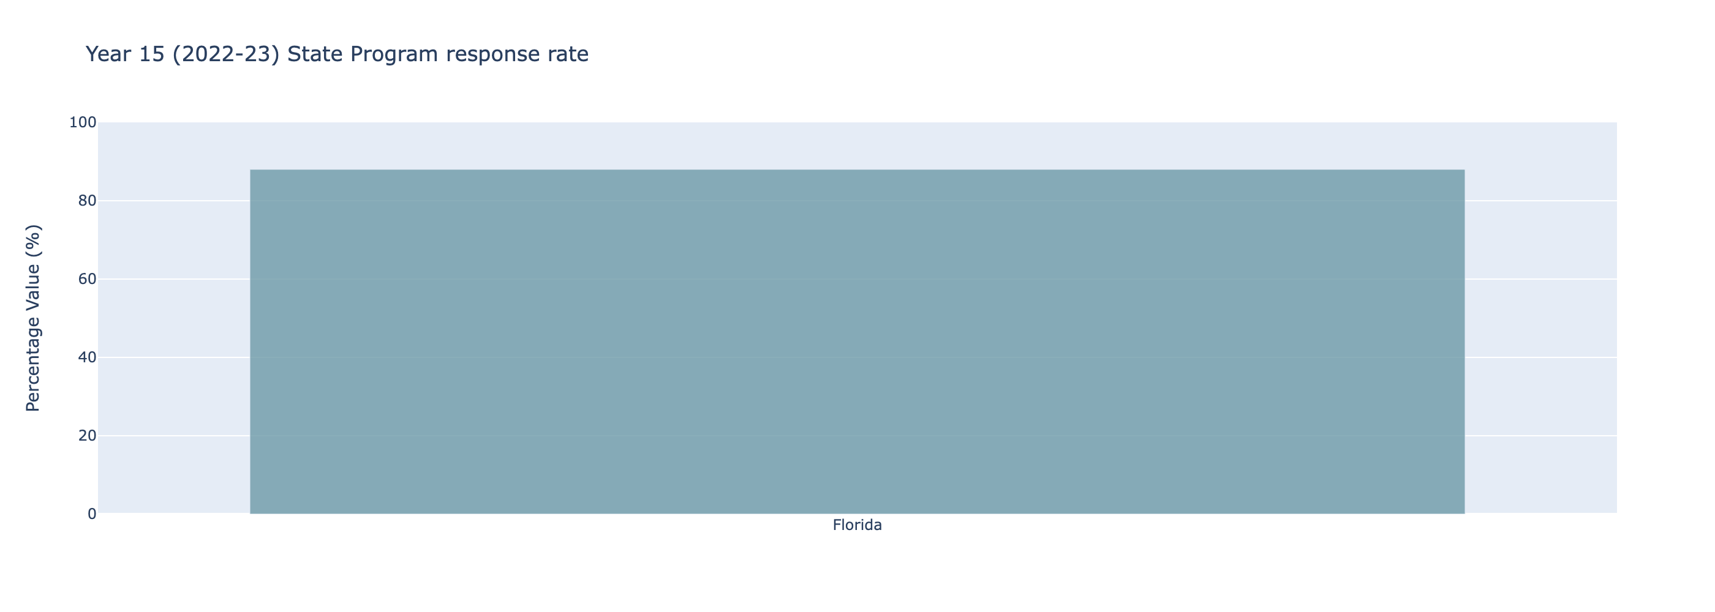The data provided in the graph pertains to the "Year 15 (2022-23) State Program response rate" for Florida. The response rate for Florida is recorded at 88%. This indicates a high level of participation in the state program for the specified academic year.  
  
In numerical terms, the data suggests that 88% of the schools have responded to the state program out of a total of 400 schools. This translates to 352 schools that have engaged with the state program in Florida.  
  
To summarize, for the 2022-23 academic year, the state of Florida achieved a commendable response rate of 88% to the state program, with 352 out of 400 schools participating.

1. Implementation Level Over Time

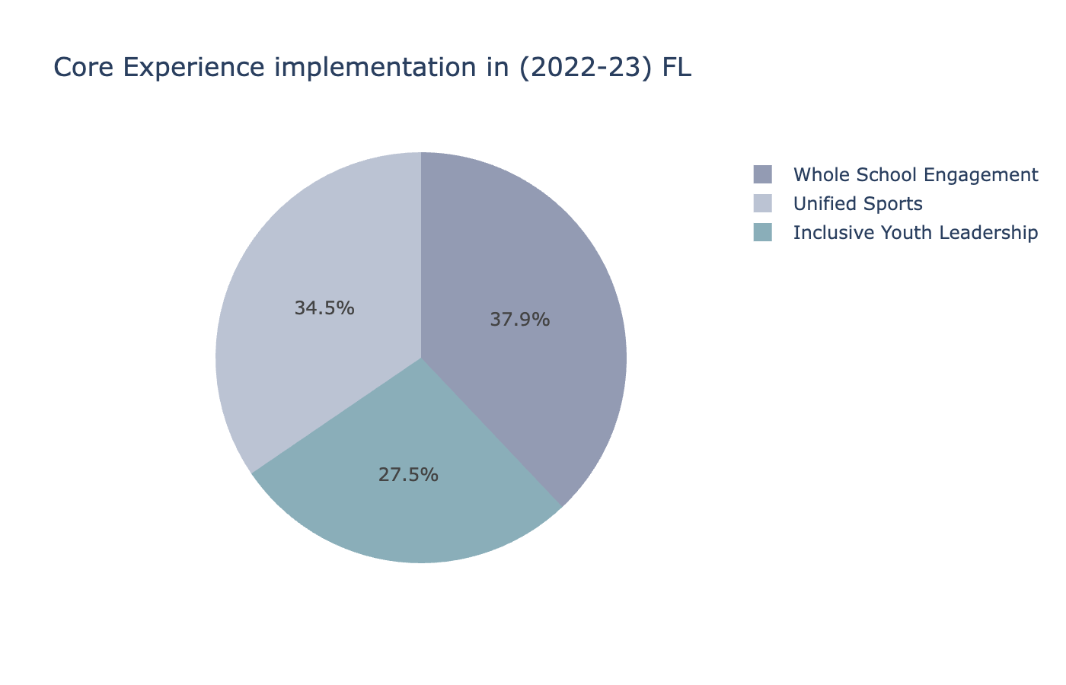The pie chart titled "Core Experience Implementation in (2022-23) FL" presents data on the number of schools implementing the Core Experience in Florida for the academic year 2022-23. The numerical data are as follows: 355 schools, 283 schools, and 390 schools.   
  
Upon analysis, the total number of schools involved is 1,028, representing the entire dataset. The individual counts for each category can be converted into percentages to provide a clearer understanding:  
  
- The segment with 355 schools constitutes approximately 34.5% of the total.  
- The segment with 283 schools accounts for about 27.5% of the total.  
- The segment with 390 schools makes up the remaining 38.0%.  
  
These figures reveal the distribution of Core Experience implementation across various groups of schools in Florida for the 2022-23 academic year, indicating varied levels of adoption across the categories.   
  
This professional assessment highlights the extent and varied distribution of Core Experience implementation, providing valuable insights for educational stakeholders and policymakers.

1. Survey Response Rate Over Time

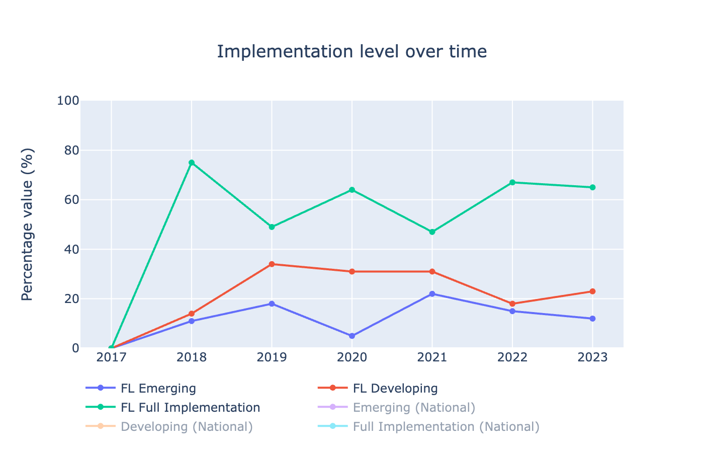### Summary Report: Implementation Level Over Time  
  
The analysis focuses on the implementation levels of different categories over time, specifically 'FL Emerging', 'FL Developing', and 'FL Full Implementation' from 2017 to 2023, ignoring the national data categories.  
  
**FL Emerging:**  
- In 2017, the implementation level was 0%.  
- This increased to 11% in 2018, where 10 schools were at this level.  
- By 2019, the percentage rose to 18%, with 22 schools implementing this level.  
- A notable decrease to 5% occurred in 2020, accounting for 7 schools.  
- The level surged again in 2021 to 22%, with 29 schools implementing this category.  
- In 2022, 15% of schools were at the FL Emerging level, equating to 41 schools.  
- In 2023, there was a slight drop to 12%, with 48 schools.  
  
**FL Developing:**  
- In 2017, the implementation level was 0%.  
- A rise to 14% in 2018 corresponded with 13 schools.  
- By 2019, this grew to 34%, involving 42 schools.  
- A slight decrease to 31% was observed in 2020, covering 40 schools.  
- The implementation level remained at 31% in 2021, with 42 schools involved.  
- In 2022, the percentage dropped to 18%, with 49 schools.  
- In 2023, a slight increase to 23% was observed, with 92 schools engaged.  
  
**FL Full Implementation:**  
- In 2017, the implementation level was 0%.  
- By 2018, it jumped to 75%, encompassing 68 schools.  
- A decrease to 49% was observed in 2019, with 61 schools at this level.  
- In 2020, there was an increase to 64%, accounting for 82 schools.  
- The level dropped to 47% in 2021, with 63 schools.  
- In 2022, the percentage rose again to 67%, involving 179 schools.  
- By 2023, the implementation level slightly decreased to 65%, covering 258 schools.  
  
Overall, 'FL Full Implementation' had the highest implementation levels throughout the years, while 'FL Emerging' fluctuated more significantly. The data indicates a dynamic change in the adoption of implementation levels with varying degrees of increase and decrease across the observed period. The numerical values reinforce that the number of schools adopting each level significantly impacts the percentage figures, indicating the overall growth and shifts in educational implementation strategies.

1. Core Experience Implementation Over Time

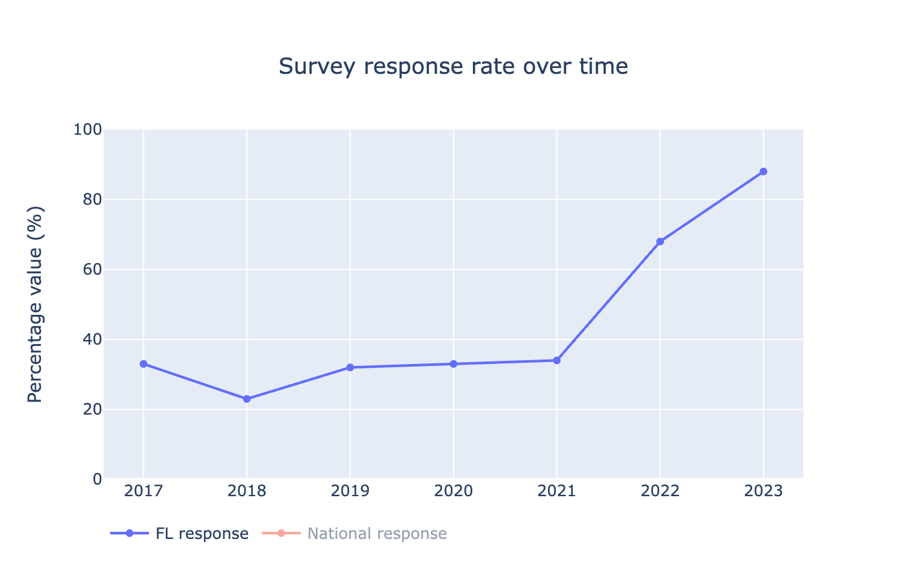Survey Response Rate Over Time  
  
The graph titled "Survey Response Rate Over Time" provides a comprehensive analysis of the response rates from Florida (FL) over the span of seven years, from 2017 to 2023. Presented in the data, the annual response rates and the corresponding number of schools participating each year offer insightful trends.  
  
In 2017, the response rate was 33%, with 83 schools contributing to the survey. The following year, 2018, saw a decline in the response rate to 23%, with 91 schools participating. The rate recovered in 2019, rising to 32% with 125 schools responding.  
  
The years 2020 and 2021 exhibited a steadier rate, with responses at 33% and 34% respectively, alongside an increase in participation, with 129 schools in 2020 and 134 schools in 2021.   
  
A significant increase in the response rate was recorded in 2022, jumping to 68% with 269 schools participating. This upward trend continued in 2023, achieving an impressive 88% response rate from 400 schools.  
  
In summary, the FL survey response rate depicted a variable trend from 2017 to 2021, followed by a substantial increase from 2022 onwards, highlighting enhanced participation and engagement in recent years.

1. State Program Response Rate

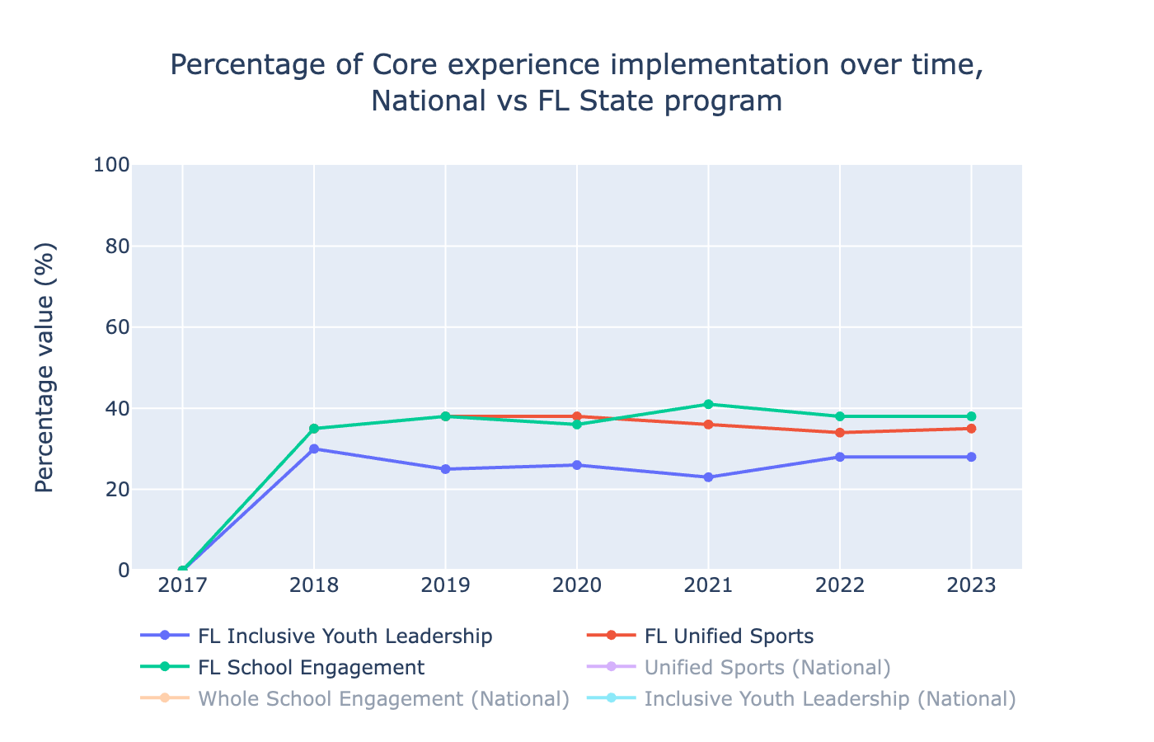The graph depicts the percentage of core experience implementation over time for various programs in the Florida State program from 2017 to 2023. The programs analyzed are FL Inclusive Youth Leadership, FL Unified Sports, and FL School Engagement. The data excludes the National programs.  
  
1. **FL Inclusive Youth Leadership**:  
 - **2017**: 0% implemented, 0 schools.  
 - **2018**: 30% implemented, 73 schools.  
 - **2019**: 25% implemented, 72 schools.  
 - **2020**: 26% implemented, 86 schools.  
 - **2021**: 23% implemented, 69 schools.  
 - **2022**: 28% implemented, 191 schools.  
 - **2023**: 28% implemented, 283 schools.  
   
 Over the period, there is a noticeable initial increase, peaking in 2018 at 30%. A slight decline follows in subsequent years, stabilizing at 28% in 2022 and 2023.   
  
2. **FL Unified Sports**:  
 - **2017**: 0% implemented, 0 schools.  
 - **2018**: 35% implemented, 84 schools.  
 - **2019**: 38% implemented, 110 schools.  
 - **2020**: 38% implemented, 126 schools.  
 - **2021**: 36% implemented, 109 schools.  
 - **2022**: 34% implemented, 234 schools.  
 - **2023**: 35% implemented, 355 schools.  
   
 The implementation percentage starts at 35% in 2018, reaches 38% in both 2019 and 2020, sees a slight decrease in 2021 to 36%, and further dips in 2022 to 34% before rebounding slightly to 35% in 2023.  
  
3. **FL School Engagement**:  
 - **2017**: 0% implemented, 0 schools.  
 - **2018**: 35% implemented, 84 schools.  
 - **2019**: 38% implemented, 111 schools.  
 - **2020**: 36% implemented, 120 schools.  
 - **2021**: 41% implemented, 122 schools.  
 - **2022**: 38% implemented, 259 schools.  
 - **2023**: 38% implemented, 390 schools.  
   
 The implementation for FL School Engagement shows a rise from 35% in 2018 to 38% in 2019, a minor decline to 36% in 2020, followed by a peak at 41% in 2021. The implementation levels at 38% in both 2022 and 2023.  
  
Overall, the data indicates gradual increases in the percentage of core experience implementations for the Florida State programs, with some fluctuations over the observed period. The numerical data reveals substantial growth in the number of schools participating in these programs, particularly notable in 2022 and 2023.

1. Youth Leadership Activity

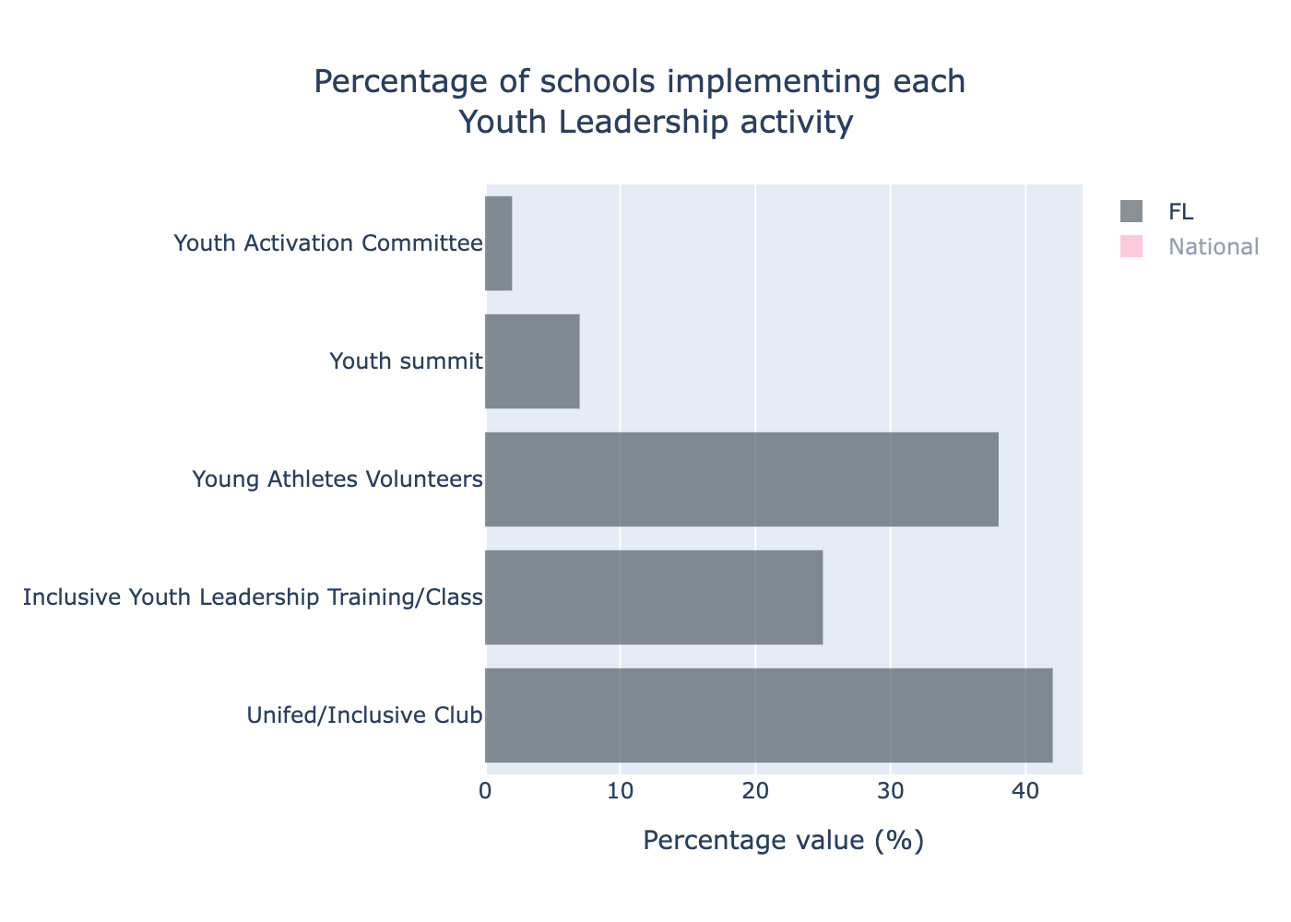The data provided details the implementation of various Youth Leadership activities across schools in Florida (FL). The following summary highlights the percentage of schools engaging in each activity along with the corresponding numerical values.  
  
Unified/Inclusive Club: 42% of schools in Florida implement Unified/Inclusive Clubs, involving a total of 166 schools. This indicates a significant level of engagement in activities that promote inclusivity within the state.  
  
Inclusive Youth Leadership Training/Class: 25% of schools in Florida offer Inclusive Youth Leadership Training or Classes, with 100 schools participating. This showcases a moderate level of involvement in leadership training programs focused on inclusivity.  
  
Young Athletes Volunteers: 38% of schools in Florida engage students as Young Athletes Volunteers, comprising 154 schools. This activity seems to have relatively high participation, highlighting the volunteers' enthusiasm and commitment to supporting young athletes.  
  
Youth Summit: Participation in Youth Summits is relatively low, with only 7% of schools in Florida engaging in this activity, corresponding to 28 schools. This suggests that Youth Summits might be less prioritized or require more promotion for broader engagement.  
  
Youth Activation Committee: Only 2% of schools in Florida have implemented Youth Activation Committees, involving just 9 schools. This indicates a minimal level of involvement, suggesting possible challenges in establishing these committees or a need for increased awareness.  
  
Overall, while certain activities like Unified/Inclusive Clubs and Young Athletes Volunteers see considerable participation, others such as Youth Summits and Youth Activation Committees are less frequently implemented. The data underscores the varying levels of engagement in different Youth Leadership activities across Florida schools.

1. Unified Sports Activity

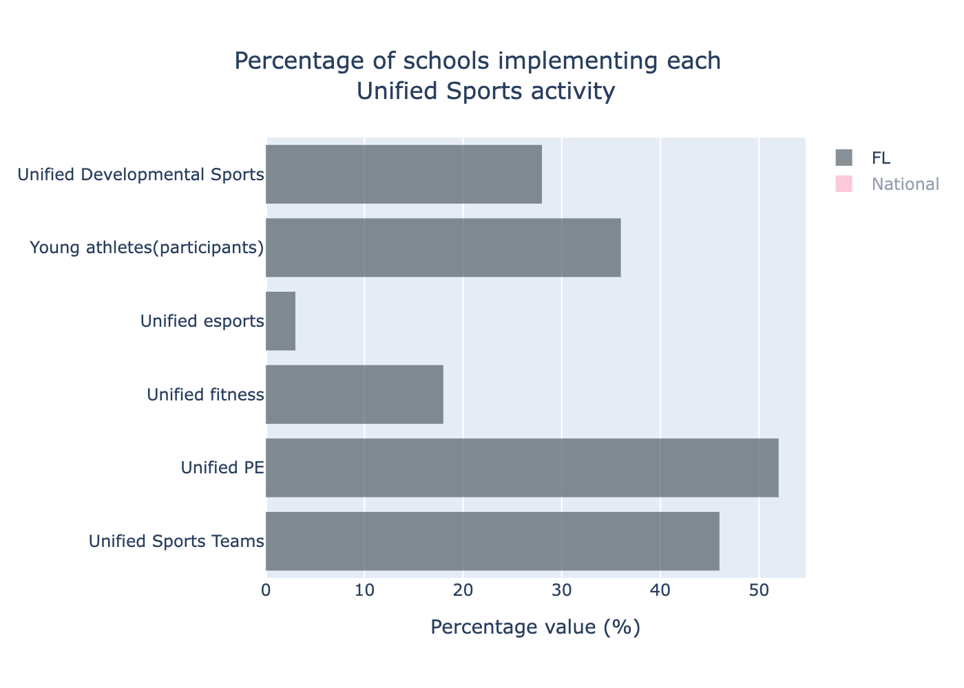The data provided focuses on the implementation of Unified Sports activities in schools. Below is a detailed analysis and summary of the data for the state of Florida:  
  
1. **Unified Sports Teams**  
 - Florida: 46% of schools implement Unified Sports Teams.  
 - Number of schools: 182.  
  
2. **Unified PE**  
 - Florida: 52% of schools implement Unified PE.  
 - Number of schools: 208.  
  
3. **Unified Fitness**  
 - Florida: 18% of schools implement Unified Fitness.  
 - Number of schools: 72.  
  
4. **Unified Esports**  
 - Florida: 3% of schools implement Unified Esports.  
 - Number of schools: 11.  
  
5. **Young Athletes (Participants)**  
 - Florida: 36% of schools have participants in the Young Athletes program.  
 - Number of schools: 143.  
  
6. **Unified Developmental Sports**  
 - Florida: 28% of schools implement Unified Developmental Sports.  
 - Number of schools: 113.  
  
In summary, Unified PE has the highest level of implementation among schools in Florida at 52%, corresponding to 208 schools. This is followed by Unified Sports Teams at 46% (182 schools) and Young Athletes (Participants) at 36% (143 schools). Unified Fitness and Unified Developmental Sports have moderate levels of implementation at 18% (72 schools) and 28% (113 schools) respectively. Unified Esports has the lowest level of adoption at just 3%, with only 11 schools participating. This data highlights the varying degrees to which different Unified Sports activities are integrated into the educational programs across Florida schools.

1. Inclusive Whole School Engagement Activity

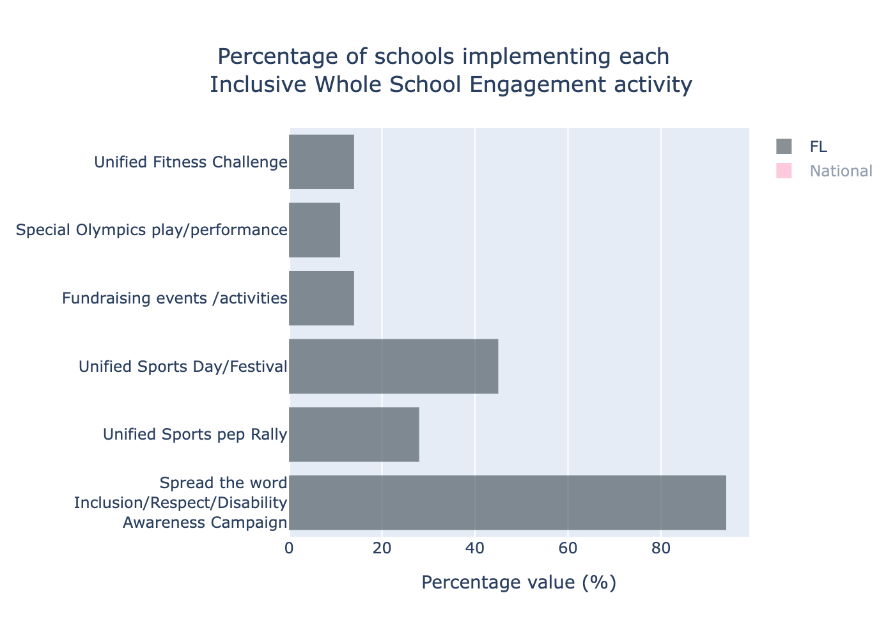The data presented provides a detailed analysis of the percentage of schools in Florida (FL) implementing various Inclusive Whole School Engagement activities, along with the corresponding numerical data values. The activities are listed below with their respective percentage values and the number of schools participating:  
  
1. Spread the word: Inclusion/Respect/Disability Awareness Campaign:  
 - 94% participation rate  
 - 376 schools  
  
2. Unified Sports pep Rally:  
 - 28% participation rate  
 - 111 schools  
  
3. Unified Sports Day/Festival:  
 - 45% participation rate  
 - 180 schools  
  
4. Fundraising events/activities:  
 - 14% participation rate  
 - 58 schools  
  
5. Special Olympics play/performance:  
 - 11% participation rate  
 - 45 schools  
  
6. Unified Fitness Challenge:  
 - 14% participation rate  
 - 57 schools  
  
This data reveals that "Spread the word: Inclusion/Respect/Disability Awareness Campaign" is the most widely implemented activity among schools in Florida, with a significant 94% participation, involving 376 schools. In contrast, "Special Olympics play/performance" is the least implemented activity, with only 11% participation, involving 45 schools. Activities such as "Unified Sports Day/Festival" and "Unified Fitness Challenge" also see moderate levels of engagement, with 45% and 14% participation respectively.   
  
This information is critical for understanding the engagement levels of schools in Florida with respect to inclusive activities and can be used to identify areas needing more support or focus.

1. SONA Resources

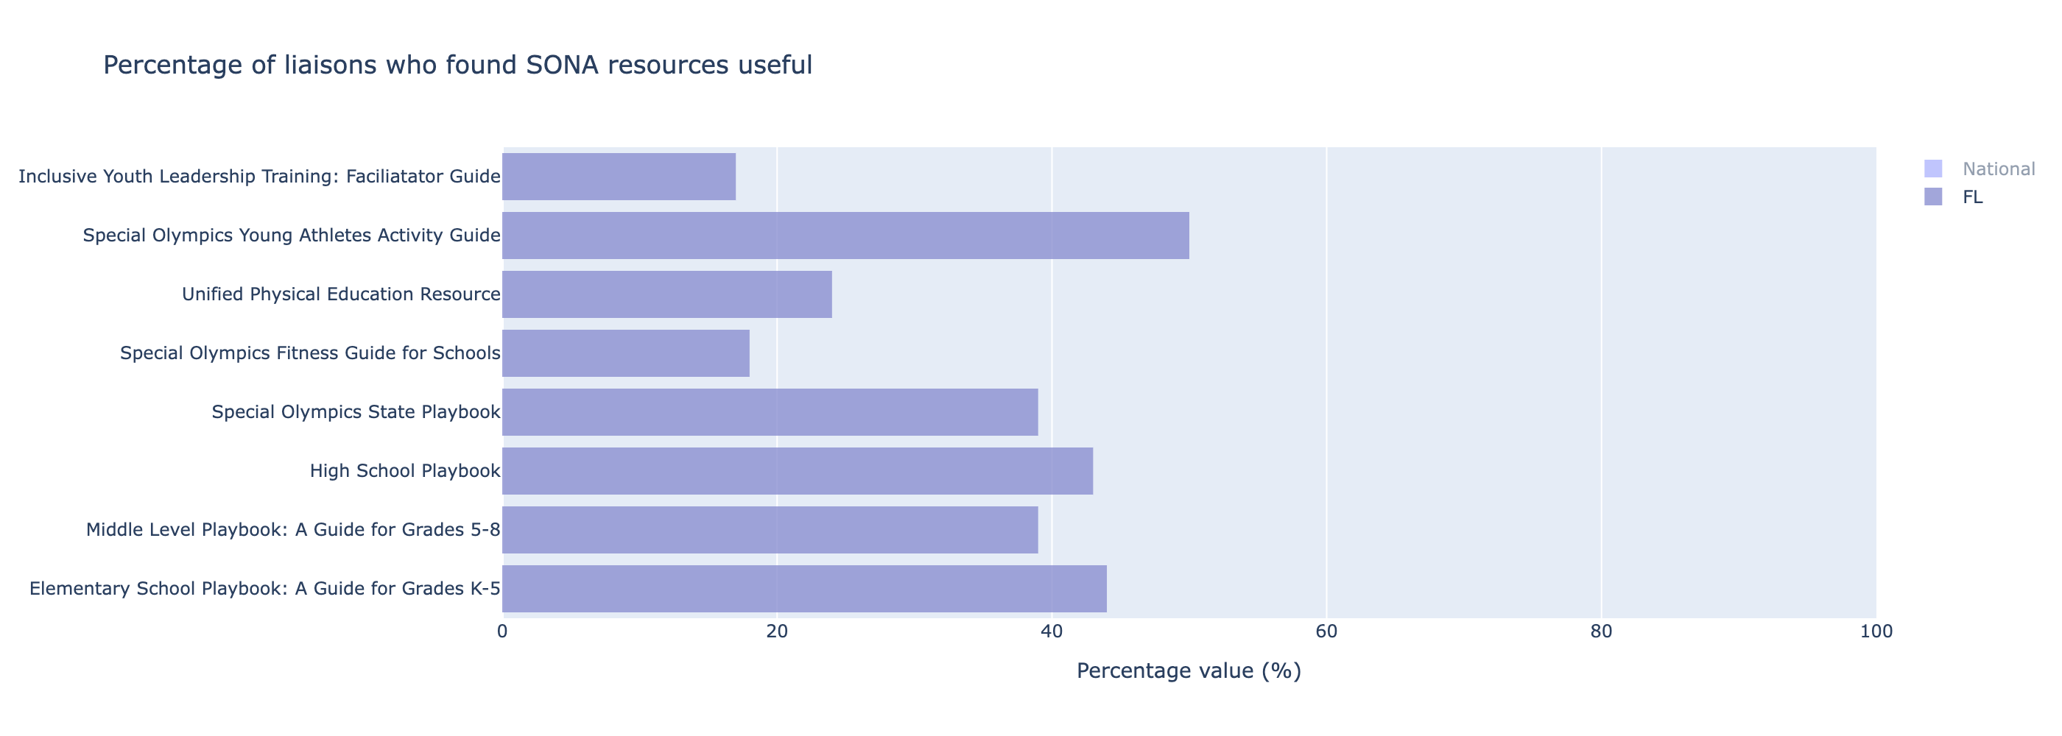The data analysis was conducted on the responses from liaisons regarding the usefulness of SONA resources, with a specific focus on the data from the region identified as "FL."  
  
1. Elementary School Playbook: A Guide for Grades K-5  
- A total of 102 schools from FL reported finding this resource useful.  
- This represents 44% of the surveyed liaisons in FL.  
  
2. Middle Level Playbook: A Guide for Grades 5-8  
- A total of 63 schools from FL found this guide useful.  
- This corresponds to 39% of the liaisons in FL.  
  
3. High School Playbook  
- This resource was found useful by 71 schools in FL.  
- The percentage of FL liaisons who found this useful stands at 43%.  
  
4. Special Olympics State Playbook  
- 39% of FL liaisons (63 schools) considered this playbook useful.  
  
5. Special Olympics Fitness Guide for Schools  
- This guide was reported as useful by 18% of FL liaisons, equating to 29 schools.  
  
6. Unified Physical Education Resource  
- 24% of FL liaisons (34 schools) found this resource useful.  
  
7. Special Olympics Young Athletes Activity Guide  
- This guide was considered useful by 50% of FL liaisons, translating to 89 schools.  
  
8. Inclusive Youth Leadership Training: Facilitator Guide  
- The guide was found useful by 17% of FL liaisons, which equals 20 schools.  
  
From the above data, it is evident that within the FL region, the "Special Olympics Young Athletes Activity Guide" had the highest reported usefulness at 50%, while the "Inclusive Youth Leadership Training: Facilitator Guide" had the lowest at 17%. This provides a clear indication of which resources are most valued and could guide future resource development and distribution strategies.