|  |  |
| --- | --- |
| Activity | Data Type |
| Number of beatings from Wife | Discrete |
| Results of rolling a dice | Discrete |
| Weight of a person | Continuous |
| Weight of Gold | Continuous |
| Distance between two places | Continuous |
| Length of a leaf | Continuous |
| Dog's weight | Continuous |
| Blue Color | Discrete |
| Number of kids | Discrete |
| Number of tickets in Indian railways | Discrete |
| Number of times married | Discrete |
| Gender (Male or Female) | Discrete |

Q1) Identify the Data type for the Following:

Q2) Identify the Data types, which were among the following

Nominal, Ordinal, Interval, Ratio.

|  |  |
| --- | --- |
| Data | Data Type |
| Gender | Nominal |
| High School Class Ranking | Nominal |
| Celsius Temperature | Interval |
| Weight | Ratio |
| Hair Color | Ratio |
| Socioeconomic Status | Interval |
| Fahrenheit Temperature | Ratio |
| Height | Ratio |
| Type of living accommodation | Ordinal |
| Level of Agreement | Interval |
| IQ(Intelligence Scale) | Interval |
| Sales Figures | Interval |
| Blood Group | Ratio |
| Time Of Day | Interval |
| Time on a Clock with Hands | Interval |
| Number of Children | Interval |
| Religious Preference | Ratio |
| Barometer Pressure | Interval |
| SAT Scores | Ratio |
| Years of Education | Nominal |

Q3) Three Coins are tossed, find the probability that two heads and one tail are obtained?

Answer: The total possible outcome = 23 =8

HHH, HHT, HTT, THT, TTH, HTH, THH, TTT

Number of favorable outcomes =3

P(two head and one tail) = 3/8 = 0.375

Q4) Two Dice are rolled, find the probability that sum is

1. Equal to 1
2. Less than or equal to 4
3. Sum is divisible by 2 and 3

Ans :

1. Total number of outcomes =36

Number of outcomes equal to 1 = 0

p(equal to 1) = 0/36

1. Total number of outcomes = 36

Number of outcomes less than or equal to 4 = 6

p(Less than 0r equal to 4) = 6/36 = 1/6

1. Total number of outcomes = 36

Number of outcomes sum is divisible by 2 and 3 = 6

p(Sum is divisible by 2 and 3) = 6/36 = 1/6

Q5) A bag contains 2 red, 3 green and 2 blue balls. Two balls are drawn at random. What is the probability that none of the balls drawn is blue?

Ans :

Total number of balls = 7 balls

N(Event ( 2 balls are drawn randomly from bag) = 7!/2!*5!

N(Event ( 2 balls are drawn randomly from bag = (7*6)/(2*1) = 21

If none of them drawn 2 balls are blue = 7-2 = 5

N ( Event ( None of the balls drawn is blue) = 5! /2! * 3! = (5*4)/(2*1) = 10

P( None of the balls drawn is blue = N(Event (None of the balls drawn is blue) /

N( Event ( 2 balls are drawn randomly from bag)

= 10/21

Q6) Calculate the Expected number of candies for a randomly selected child

Below are the probabilities of count of candies for children (ignoring the nature of the child-Generalized view)

|  |  |  |
| --- | --- | --- |
| CHILD | Candies count | Probability |
| A | 1 | 0.015 |
| B | 4 | 0.20 |
| C | 3 | 0.65 |
| D | 5 | 0.005 |
| E | 6 | 0.01 |
| F | 2 | 0.120 |

Child A – probability of having 1 candy = 0.015.

Child B – probability of having 4 candies = 0.20

Ans :

Expected no. of candies for randomly selected child = 1*0.015+ 4*0.20+3*0.65+5*0.005+6*0.01+2*0.120

=3.09

Q7) Calculate Mean, Median, Mode, Variance, Standard Deviation, Range & comment about the values / draw inferences, for the given dataset

For Points, Score, Weigh>

Find Mean, Median, Mode, Variance, Standard Deviation, and Range and also Comment about the values/ Draw some inferences.

**Use Q7.csv file**

**Ans:**

Mean for Points = 3.59, score = 3.21 and weight = 17.84

Median for Points = 3.69, Score = 3.32 and Weigh = 17.71

Mode for Points = 3.07, Score = 3.44 and Weigh = 17.02

Variance for Points = 0.28, Score = 0.95, Weigh = 3.19

Standard Deviation for Points = 0.53, Score = 0.97, Weigh = 1.78

Range [Min-Max] for Points [3.59 – 4.93], Score [3.21 – 5.42] and Weigh [17.84 – 22.9]

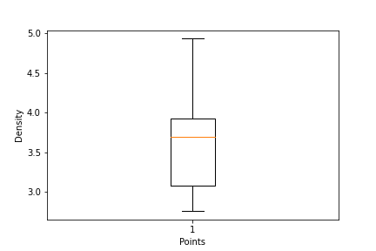

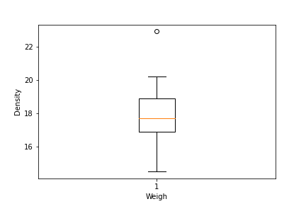

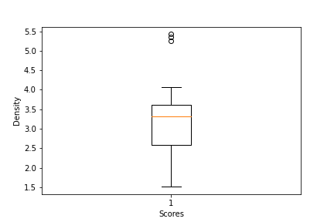

Q8) Calculate Expected Value for the problem below

1. The weights (X) of patients at a clinic (in pounds), are

108, 110, 123, 134, 135, 145, 167, 187, 199

Assume one of the patients is chosen at random. What is the Expected Value of the Weight of that patient?

Ans: mean = 1308

µ = 163.5

Expected value = ∑ [x. p(x)]

**Q9) Calculate Skewness, Kurtosis & draw inferences on the following data**

**Cars speed and distance**

**Use Q9_a.csv**

**SP and Weight(WT)**

**Use Q9_b.csv**

**Q10) Draw inferences about the following boxplot & histogram**





**Q11)** Suppose we want to estimate the average weight of an adult male in Mexico. We draw a random sample of 2,000 men from a population of 3,000,000 men and weigh them. We find that the average person in our sample weighs 200 pounds, and the standard deviation of the sample is 30 pounds. Calculate 94%,98%,96% confidence interval?

**Q12)** Below are the scores obtained by a student in tests

**34,36,36,38,38,39,39,40,40,41,41,41,41,42,42,45,49,56**

1. Find mean, median, variance, standard deviation.
2. What can we say about the student marks?

Ans: Mean= 41, Median= 40, variance= 24.11, Standard deviation= 4.91

Q13) What is the nature of skewness when mean, median of data are equal?

Ans: Symmetrical

Q14) What is the nature of skewness when mean > median?

Ans: Right skewed

Q15) What is the nature of skewness when median > mean?

Ans: left skewed

Q16) What does positive kurtosis value indicates for a data?

Ans: The data is normally distributed and kurtosis value is 0.

Q17) What does negative kurtosis value indicates for a data?

Ans: The distribution of the data has lighter tails and a flatter peak than the normal distribution.

Q18) Answer the below questions using the below boxplot visualization.



What can we say about the distribution of the data?

Ans: Let’s assume above box plot is about ages of the students in schools.

50% of the people are above 10years old and remaining are less. And students who’s age is above 15 are approx 40%.

What is nature of skewness of the data?

Ans: Left skewed median is greater than mean.

What will be the IQR of the data (approximately)?

Approximately= -8

Q19) Comment on the below Boxplot visualizations?



Draw an Inference from the distribution of data for Boxplot 1 with respect Boxplot 2.

Ans: By observing both the plots whisker’s level is high in boxplot 2, mean and median are equal hence distribution is symmetrical.

Q 20) Calculate probability from the given dataset for the below cases

Data _set: Cars.csv

Calculate the probability of MPG of Cars for the below cases.

MPG <- Cars$MPG

* 1. P(MPG>38)
  2. P(MPG<40)

c. P (20<MPG<50)

Q 21) Check whether the data follows normal distribution

1. Check whether the MPG of Cars follows Normal Distribution

Dataset: Cars.csv

1. Check Whether the Adipose Tissue (AT) and Waist Circumference(Waist) from wc-at data set follows Normal Distribution

Dataset: wc-at.csv

Q 22) Calculate the Z scores of 90% confidence interval,94% confidence interval, 60% confidence interval

Ans:

# z value for 90% confidence interval

print('Z score for 60% Conifidence Intervla =',np.round(stats.norm.ppf(.05),4))

Z score for 60% Conifidence Intervla = -1.6449

# z value for 94% confidence interval

print('Z score for 60% Conifidence Intervla =',np.round(stats.norm.ppf(.03),4))

Z score for 60% Conifidence Intervla = -1.8808

# z value for 60% confidence interval

print('Z score for 60% Conifidence Intervla =',np.round(stats.norm.ppf(.2),4))

Z score for 60% Conifidence Intervla = -0.8416

Q 23) Calculate the t scores of 95% confidence interval, 96% confidence interval, 99% confidence interval for sample size of 25

Ans:

# t score for 95% confidence interval

print('T score for 95% Confidence Interval =',np.round(stats.t.ppf(0.025,df=24),4))

T score for 95% Confidence Interval = -2.0639

# t value for 94% confidence interval

print('T score for 94% Confidence Inteval =',np.round(stats.t.ppf(0.03,df=24),4))

T score for 94% Confidence Inteval = -1.974

# t value for 99% Confidence Interval

print('T score for 95% Confidence Interval =',np.round(stats.t.ppf(0.005,df=24),4))

T score for 95% Confidence Interval = -2.7969

Q 24**)** A Government company claims that an average light bulb lasts 270 days. A researcher randomly selects 18 bulbs for testing. The sampled bulbs last an average of 260 days, with a standard deviation of 90 days. If the CEO's claim were true, what is the probability that 18 randomly selected bulbs would have an average life of no more than 260 days

Hint:

rcode 🡪 pt(tscore,df)

df 🡪 degrees of freedom

Ans: import numpy as np

Import scipy as stats

t_score = (x - pop mean) / (sample standard daviation / square root of sample size)

(260-270)/90/np.sqrt(18))

t_score = -0.471

stats.t.cdf(t_score, df = 17)

0.32 = 32%