Sales Report

Executive Summary
This report provides a comprehensive evaluation of customer demographics, purchasing behaviour, and product category performance during the Diwali festive season. The insights are derived directly from the statistical computations and visualizations contained within the project.
Core Finding: The primary consumer persona driving revenue growth consists of married women aged 26 –35 years residing in Uttar Pradesh, Maharashtra, and Karnataka. They are predominantly employed in the IT, Healthcare, and Aviation sectors and direct their purchasing power toward Food, Clothing, and Electronics.

Dataset Overview & Data Quality
- Total Transactions Analysed: 11,239 lines of clean data (after removing blank columns like Status and filtering out 12 null records).
- Total Order Volume: 27,981 units across all transactions.
- Average Order Size: approx. 2.49 (orders per transaction).
- Average Ticket Size: ₹9,453.61t (per purchase)
- Total Sales Revenue: ₹106,249,129 (approx. ₹106.25 million).

Demographics Analysis

A. Gender Insights
- Buyer Distribution: The initial count reveals that female buyers significantly outnumber male buyers, establishing them as the primary shopping demographic during the festive season.
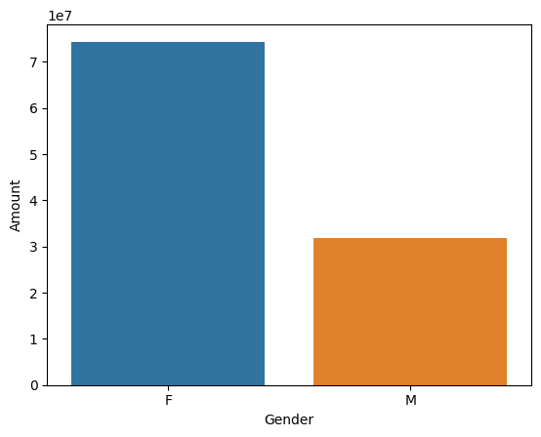
- Purchasing Power: The revenue breakdown further highlights this discrepancy. The total budget spent by female consumers is more than double that of males, proving that women hold the dominant purchasing power.
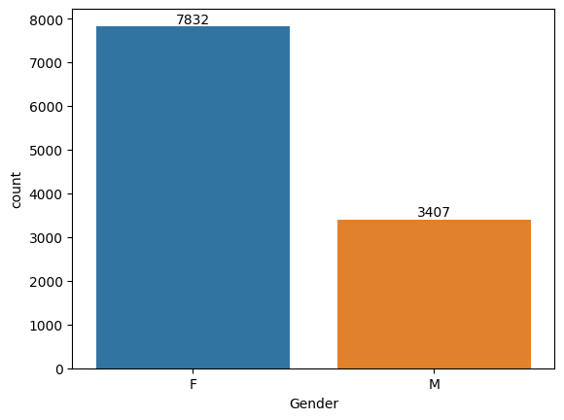

B. Age Dynamics
- Volume Distribution: When breaking down buyers into age bands and overlaying gender, the 26–35 age group emerges as the largest segment. Within this peak category, female buyers represent the highest volume.
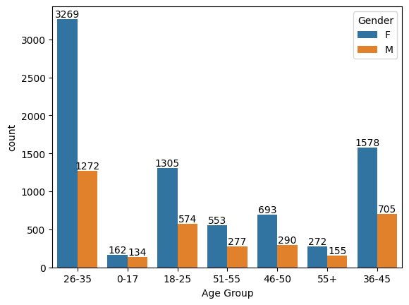

C. Marital Status Impact
- Transaction Count: Buyers classified under status 0 (unmarried/single) and status 1 (married) show a strong baseline engagement across both categories.
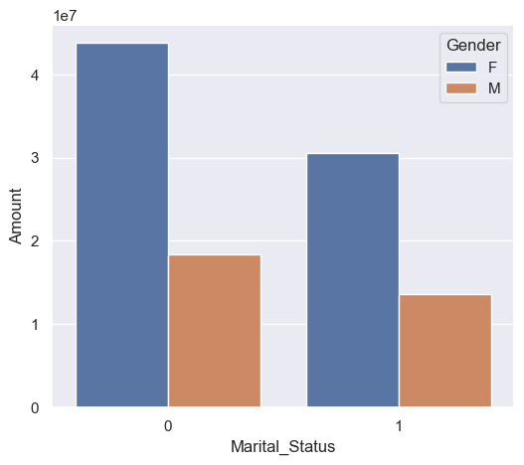
- Revenue Contribution: Grouping the financial amount by marital status and gender shows that married women generate the highest total sales value of any single demographic subgroup.
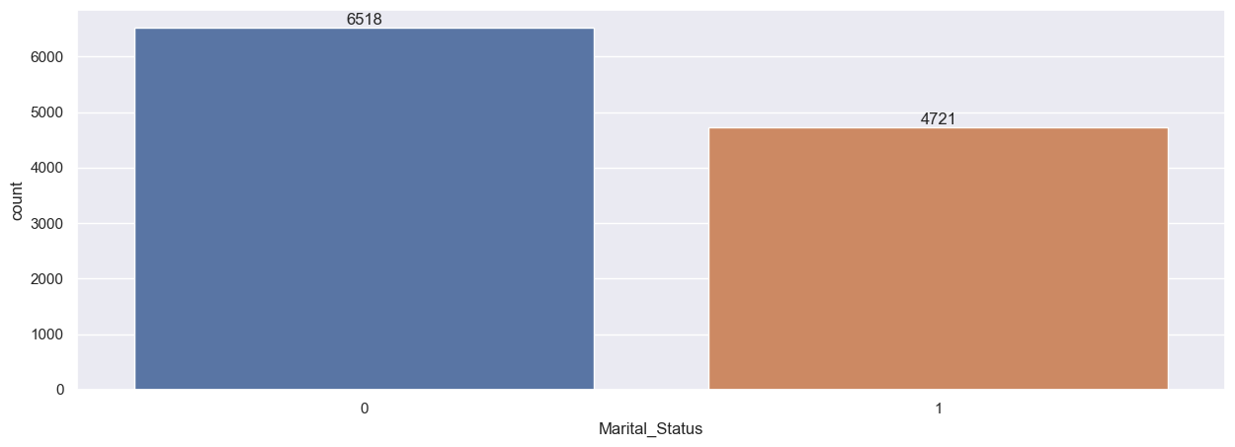

Geographic & Sector-Specific Performance

A. Regional Sales Breakdown
- Order Frequency: Analysing the top 10 states shows that Uttar Pradesh leads by a substantial margin in total number of orders placed, with Maharashtra and Karnataka securely in second and third place.
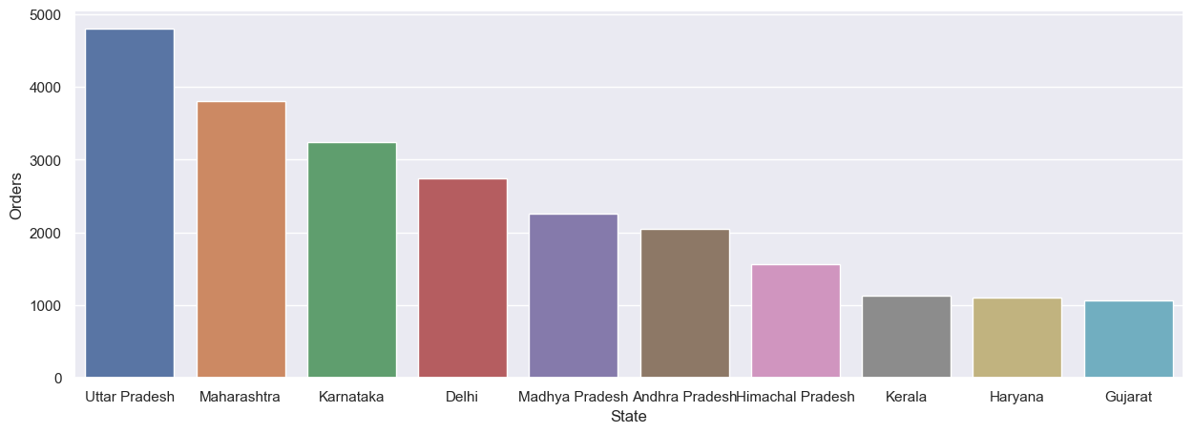

- Revenue Generation: The total sales amount chart mirrors the order frequency exactly. Uttar Pradesh, Maharashtra, and Karnataka remain the top three revenue-generating regions.
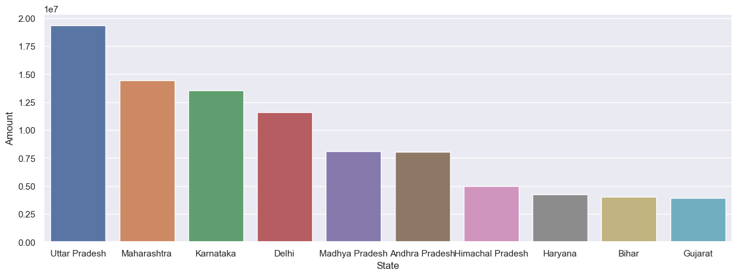

B. Professional Profiles
- Occupational Mix: The consumer base spans across 15 different industries, with notable representation from diverse employment sectors.
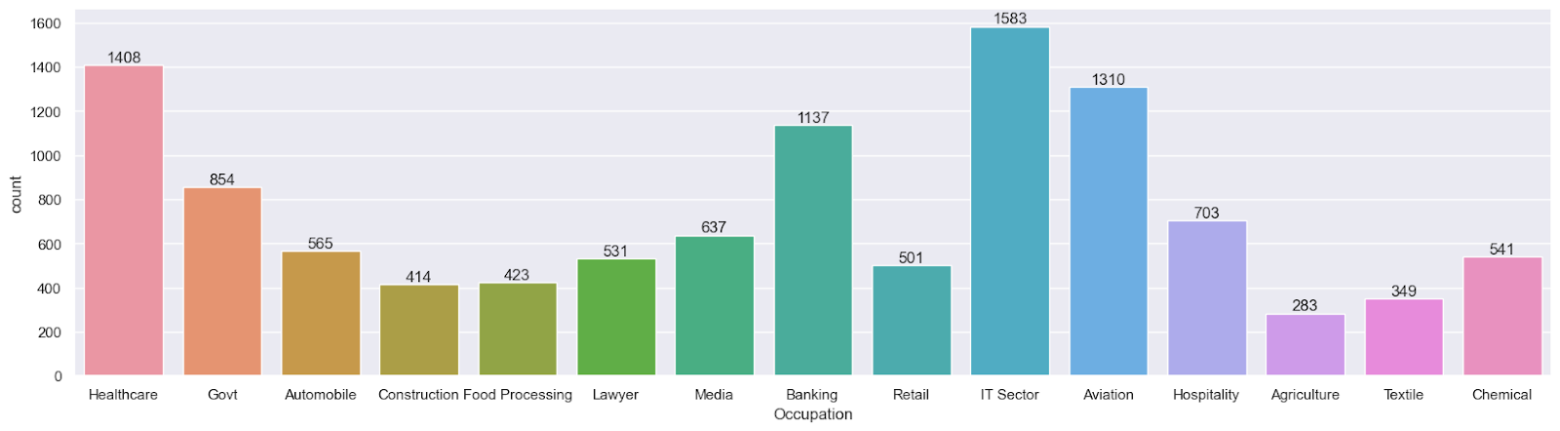
- Industry Spend: The highest cumulative monetary contribution comes from professionals working in IT Sectors, Healthcare, and Aviation, followed closely by Banking and Government employees.
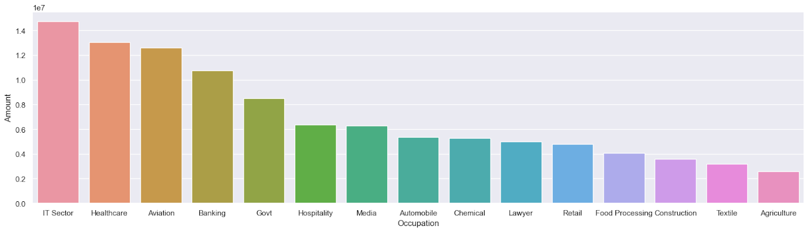

Product & Inventory Performance

A. Category Visuals
- Value Generation: In terms of absolute revenue generation, the top three categories are Food, Clothing & Apparel, and Electronics & Gadgets. While other categories may have high transaction counts, these three capture the bulk of consumer spending.
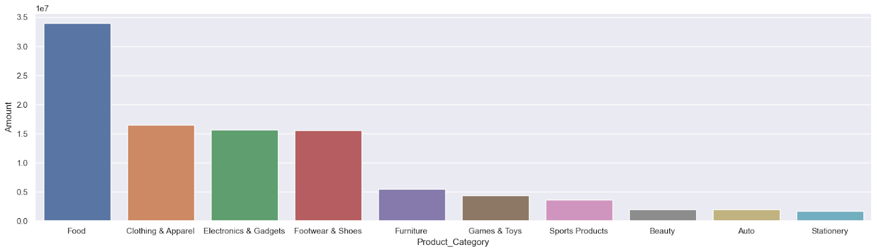

B. High-Volume Inventory
- Tracking individual product identifiers (Product ID) by order totals highlights the top 10 most frequently purchased specific products. This baseline informs supply-chain management about which items require aggressive restocking ahead of peak holiday rushes.
