

Sri Lanka Institute of Information Technology

**Classification of Breast Cancer survival**

**Using**

**Supervised Learning**

Machine Learning

(IT-4060)

Submitted by

|  |  |
| --- | --- |
| **Name** | **IT Number** |
| Nirojan.Y | IT20221928 |
| Lavaniyah.L | IT20202422 |
| Perera G.P.A.H.R | IT20175702 |

Date of Submission: 27.04.2023

**Abstract**

Breast cancer is a harmful disease which affects millions of humans. It is a kind of cancer that starts from the breast tissue and can move to other parts of the body. Early detection and accurate diagnosis of cancer are important for successful treatment and management of the disease. Now a days, machine learning plays a major role in order to find the solution for early detection of cancer. There are several supervised learning algorithms that is used for breast cancer survival classification, including logistic regression, decision trees, support vector machines and random forests. Each algorithm has its strengths and weaknesses and may be more or less appropriate depending on the specific dataset and problem at hand. The process of developing a breast cancer survival classification model using supervised learning typically involves number of steps, including data preprocessing, feature selection or extraction, model selection, and evaluation. The goal is to develop a machine learning model which can correctly classify new, unlabeled data points as to whether they can survive or not, with high precision and recall. Furthermore, Breast cancer survival classification using supervised learning has the potential to significantly improve early detection, leading to better patient outcomes and reduced healthcare costs. However, it is very important to keep in mind that these models should be used in conjunction with clinical expertise and other diagnostic tools, rather than as a replacement for them.

**Keywords:** Breast Cancer, Artificial Intelligence, Computing Methodologies, Machine Learning, Genetic Algorithm, Support Vector Machine, Decision Tree, Random Forest, Logistics regression

**Table of Contents**

1. Introduction
   1. Problem Statement……...……………………………………...................... 04
2. Methodology
   1. Data Collection…………………………………………………………...... 05
      1. Dataset………………….………………………………………….. 06
      2. Description of Dataset….………………………………………….. 06
   2. Data Mapping and Preprocessing……………………………...................... 08
   3. Supervised Learning Algorithms……………………..……………………. 10
      1. Introduction and Selection of the algorithms
      2. Implementation of Selected algorithms
3. Evaluation……………………….…………………………………………………….. 16
   1. Assessment of the project result…………………………………………… 16
   2. Future work………………………………………………………………....19
4. References……………………………………………………………………………... 20
5. Appendix……………………………………………………………………………….23
   1. Appendix A: Code Listening………………………………………………..23

**1. Introduction**

* 1. **Problem Statement**

Breast cancer is the prevalent cancer in women globally [1] and accounts for 30% of all female cancers [3]; as a result, 1.6 million women worldwide are treated with the illness each year, and 500,000 of them pass away as a result. While the fatality rate has decreased over the past 32 years, this has become more prevalent. However, it is believed that mammography screening reduces mortality by 21% and increase cancer therapy by 61% [5].

Patients with modest and undetectable malignancy indicators can have diagnostic mammography performed to evaluate aberrant breast cancer tissue. This approach can't be utilized to evaluate places where cancer may be suspected because of the sheer volume of photos. A study found that screenings of women with particularly thick breast tissue missed about 50% of breast tumors [7]. However, within two years of screening, roughly 25% of breast cancer patients receive a negative diagnosis. Therefore, it is essential to diagnose breast cancer as soon as possible [8].

The majority of mammography-based breast cancer screenings are done regularly for all women, often once a year or every two years. The "A fix screening program for everyone" may reduce the efficacy of screening programs and is ineffective in diagnosing cancer on an individual basis [9]. On the other hand, experts contend that taking into account additional risk factors in addition to mammography screening can aid in making a more precise diagnosis of women at risk [11]. Additionally, accurate risk prediction using modeling can assist radiologists in identifying high-risk patients as well as setting up personal screenings for patients and enticing them to join in programs for detection [12, 13].

Machine learning is a modeling method that has been popular in recent years for its ability to forecast various diseases by extracting information from data and uncovering hidden associations. Some research [14] simply employed demographic risk variables (lifestyle and laboratory data) to predict breast cancer survival, whereas other studies [15] relied on mammographic images or patient biopsy data to make their predictions. Others demonstrated how genetic information may be used to predict breast cancer.

The problem statement is to develop a supervised learning model that can accurately classify breast cancer survival based on their features. The model will be trained on a dataset of patients' breast tumor characteristics such as tumor size, as well as patient age and family history. According to the model the system will predict whether the patient will survive or not.

1. **Methodology**

The main aim of the ML model is to accurately predict whether a patient will survive or not, based on the features. This can help healthcare professionals to diagnose breast cancer earlier and provide more effective treatment options for patients.

Supervised learning is a popular ML technique that can be used to generate predictive ML models for breast cancer survival classification. This technique involves training a model on a labeled dataset, where each data point is assigned a class label, such as "Alive" or "Dead." The generated model can be used to make predictions of the class labels of new, unlabeled data points.

The classification task can be framed as a binary classification, where the output variable is a binary value indicating whether the patient can survive or not. A variety of supervised learning algorithms can be used to build the model, such as logistic regression, random forests decision trees, SVM, and neural networks.

Performance of the generated model by using metrics such as precision, accuracy score, F1 score and recall score, and the model can be fine-tuned by adjusting hyperparameters and feature selection techniques to maximize performance.

* 1. **Data Collection**

To classify breast cancer survival using supervised learning, system will need a dataset that includes information about patients' breast cancer diagnosis and other relevant variables such as age, Progesterone Status, and Marital Status. The dataset can be obtained from various sources such as clinical trials, medical institutions, and research studies.

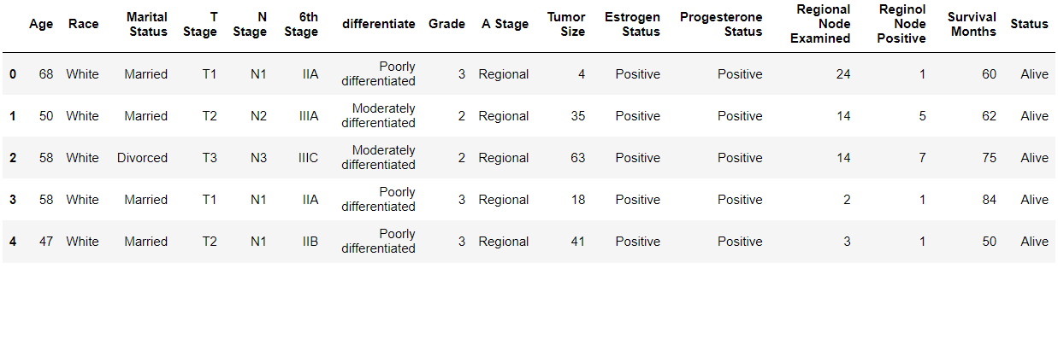Once got the dataset, supervised learning process begins. This involves splitting the data into two parts: a testing dataset and training dataset. The training dataset is used for training ML model, while the performance of the model is evaluated using testing dataset.

*First five rows of collected dataset.*

Here are the steps, which take to classify breast cancer using supervised learning:

**Data preparation:** Clean and preprocess the data, removing any missing or irrelevant data, and normalize the data.

**Feature selection**: Identify the most relevant features that contribute to breast cancer survival prediction. The techniques such as correlation analysis and principal component analysis to identify the most important features.

**Choose a supervised learning algorithm:** There are many supervised learning algorithms to choose from, such as logistic regression, SVM, and random forests. And choose an algorithm that best fits the data and problem.

Overall, classification of breast cancer survival using supervised learning is a complex process that requires careful data preparation, feature selection, algorithm selection, training, and evaluation. With the use of these steps, the accurate and reliable breast cancer survival classification model will be created.

* + 1. **Dataset**

[**https://www.kaggle.com/datasets/reihanenamdari/breast-cancer?resource=download**](https://www.kaggle.com/datasets/reihanenamdari/breast-cancer?resource=download)

* + 1. **Description of Dataset**

1. Patient Age: The age of the patient at the time of diagnosis.
2. Race: The race of the patient, which can be White, Black.
3. Marital Status: The marital status of the patient, which can be Married, Single, Divorced, Widowed, or Unknown.\
4. T Stage: The T stage of the tumor, which indicates the size of the main tumor and whether that has invaded nearby tissue. It is classified into 7 categories ranging from T0 (no evidence of tumor) to T4 (tumor with any size with direct extension to chest wall or skin).
5. N Stage: The N stage of the tumor, which indicates the presence and extent of lymph node involvement. It is classified into 4 categories ranging) to N3 (metastasis in ipsilateral supraclavicular lymph nodes) from N0 (no regional lymph node metastasis.
6. 6th Stage: The stage of the cancer is based on the sixth edition of the AJCC staging system. It is classified into 4 categories ranging from Stage 0 (carcinoma in situ) to Stage III (locally advanced cancer).
7. Differentiate: The histological grade of the tumor, which indicates how abnormal the cells appear under a microscope. It is classified into 3 categories: moderately differentiated (intermediate grade), well differentiated (low), and poorly differentiated (high).
8. A Stage: The stage of the cancer based on the TNM staging system. It combines information about the size and extent of the main tumor (T), and the presence of distant metastases (M), the existence and extent of lymph node involvement (N). It is classified into 4 categories ranging to Stage IV (metastatic cancer) from Stage 0 (carcinoma in situ).
9. Estrogen Status: The status of the tumor with respect to estrogen receptor expression. It is classified into Negative or Positive.
10. Progesterone Status: The status of the tumor with respect to progesterone receptor expression. It is classified as Negative or Positive.
11. Grade: The grade of the tumor, which indicates how much abnormal the cells appear under a microscope. It is classified into 3 categories: Grade II (moderately differentiated), Grade I (well differentiated), and Grade III (poorly differentiated).
12. Survival Months: Total number of months from the date of diagnosis to death.
13. Status: The status of the patient at the end of the study, which can be Alive or Dead.

|  |  |
| --- | --- |
| Categorical data | Numerical data |
| * + - * Race       * T stage       * Marital status       * 6th stage       * A stage       * Progesterone Status       * Grade       * N stage       * Differentiate       * Status       * Estrogen Status | * Age * Regional Node Examined * Tumor Size * Survival * Size |

* 1. **Data Mapping and Preprocessing**

**Data collection:** Collecting a dataset of breast cancer cases. This dataset should be representative of the population being studied.

**Data preprocessing:** Preprocessing the dataset to remove any missing or erroneous data, and to transform the dataset into a suitable format for machine learning algorithms. This may involve standardization, normalization, or feature scaling.



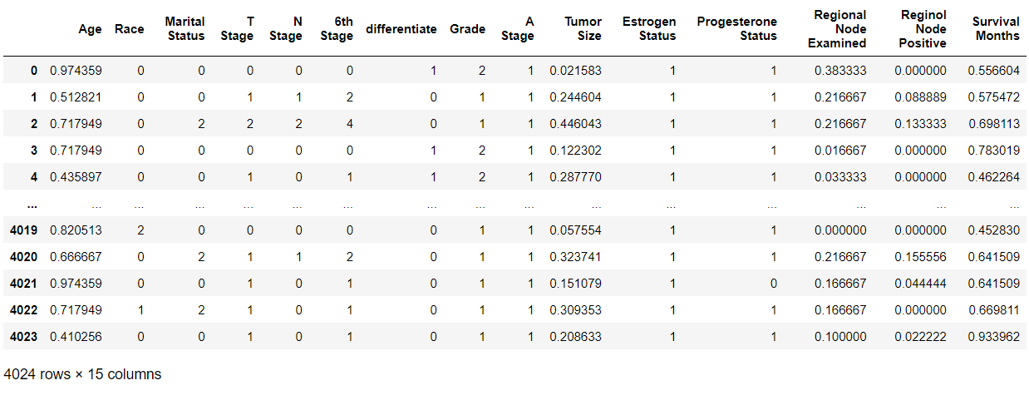

*collected dataset after data preprocessing.*

**Feature selection:** selection of the most important features from the dataset to be used in classification model. This can be done using statistical methods or ML algorithms.

**Model training:** Using a supervised learning algorithm, such as logistic regression, SVM, to train a model on the preprocessed dataset.

**Model evaluation:** measuring the performance of the generated model by the use metrics such as precision, accuracy, F1 score and recall, on a testing set or through cross-validation.

**Model testing:** Testing the final model on a separate testing set to evaluate its generalization performance.

To preprocess the data, it is important to first clean the data by removing any missing or erroneous data points. Then, the data can be transformed into a format suitable for machine learning algorithms. This may involve standardization, normalization, or feature scaling to make the features more comparable to each other.

Feature selection is also an important step in breast cancer classification. Selecting the most important features make a way to minimize the dimensionality of the data and maximize the accuracy of the model. Feature selection is done using statistical methods such as correlation analysis or using ML algorithms such as recursive feature elimination.

Once the data is preprocessed and the features are selected, the supervised learning algorithm is used to train model on the preprocessed dataset. The performance of the generated model is measured by using metrics such as precision, accuracy, F1 score and recall. such metrics help to determine the effectiveness of the model in classifying breast cancer cases.

Finally, the trained model can be tested on a separate testing set to evaluate its generalization performance. If the generated model performs good on the testing dataset, it can be used to classify surviving level of breast cancer cases in clinical settings.

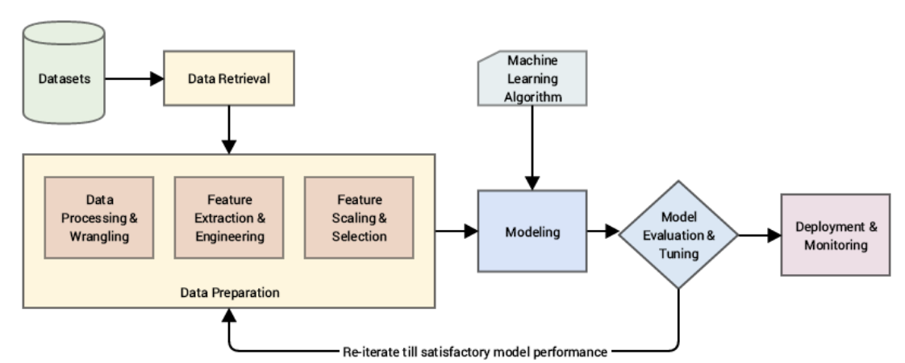

*Figure 2.2.1 Overall Diagram*

* 1. **Supervised Learning Algorithms**

Supervised learning algorithms are a type of ML algorithm where the computers are trained using labeled dataset. In this approach, algorithm is given with a set of inputs and corresponding outputs, known as the training set. The algorithm uses this training set to learn the mapping between inputs and outputs, and then applies this mapping to new, unseen inputs to make predictions or classifications.

Following are some supervised learning algorithms related for our topic:

**Logistic Regression**: it is a classification approach which uses logistic function to model the probability of a binary output.

**Decision Trees:** it is a decision-making algorithm which creates a tree-like model of decisions and their possible consequences.

**Random Forest:** it is an ensemble learning approach which uses more than one decision trees to maximize the accuracy of predictions.

**Support Vector Machines (SVMs):** it is a binary classification algorithm which calculates the hyperplane that increases the margin between two different classes.

* + 1. **Introduction and Selection of the algorithms**
* **Logistic Regression classification**

Logistic regression classification is a commonly used ML algorithm for binary classification problems, such as breast cancer survival prediction. The goal of logistic regression is to predict a binary outcome (e.g., in our case the detected patient will survive or not) based on one or more predictor variables (e.g., age, marital status, etc.).

To apply logistic regression for breast cancer survival range detection, first need to collect a dataset that includes information on patients with breast cancer in different stages, along with relevant predictor variables. This dataset could be used to train a logistic regression model, which can be used to predict the probability of breast cancer detected patients based on their predictor variables.

One example of such a dataset is the Breast Cancer Dataset, which contains information on various characteristics of breast cancer tumors, along with a binary label indicating whether the tumor is malignant or benign.

To train a logistic regression model on this dataset, first split the dataset into training set and test sets, and then the training data can be used to fit a logistic regression model. The model would then be evaluated on the test data to determine its performance.

In practice, it is important to carefully choose and preprocess the predictor variables used in the model, as well as to evaluate the generated model's performance using appropriate metrics such as precision, accuracy, f1-score and recall. It is also important to consider factors such as class imbalance and feature selection in order to build an accurate and robust model.

* **SVM**

Support Vector Machines is a popular ML algorithm which is used for binary classification such as breast cancer survival detection. SVM works by finding a hyperplane which separates the two different classes (i.e., whether the tumor is malignant or benign cells to predict the detected patient will survive or not) with maximum margin. The algorithm tries to maximize the distance between the closest points and hyperplane from each class, which are called support vectors.

To use SVM for breast cancer survival detection, we first need to prepare the data by extracting features from the medical images (such as mammograms) that are indicative of cancerous cells. Commonly used features include Age, marital status, and Race. We then train the SVM model on a labeled dataset.

if the SVM model is correctly trained, we can use it to predict whether a new patient will survive or not. To do this, we extract the same features from the new patient and feed them into the SVM model, which outputs a binary classification result.

* **Decision Tree**

A decision tree for breast cancer survival detection can be created using a dataset of patient information and outcomes. Here are the steps to create a decision tree:

* **Random Forest**

Random Forest classification is a commonly used algorithm that can be applied to various regression and classification problems, including predicting the survival of patients with breast cancer.

To use Random Forest for this purpose, system will need a dataset that includes information about patients with breast cancer, such as age, marital status, race, hormone receptor status, tumor size, and other relevant clinical factors. The dataset should also include information about whether the patient survived or not.

Once got the dataset, by using Random Forest to create a predictive model that can be used to classify new patients as either survivors or non-survivors based on their clinical factors.

* + 1. **Implementation of Selection Algorithm**
* **Logistic Regression**

**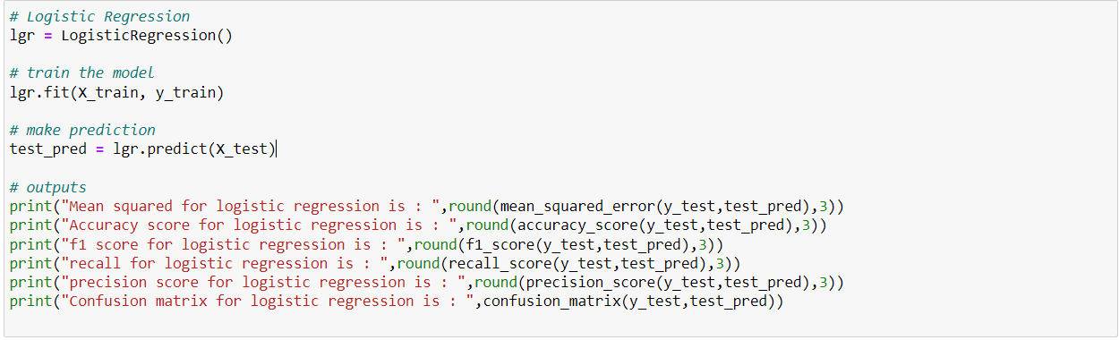**

* **A picture containing text

  Description automatically generatedSVM**
* **Decision Tree**

****

* **Random Forest**

**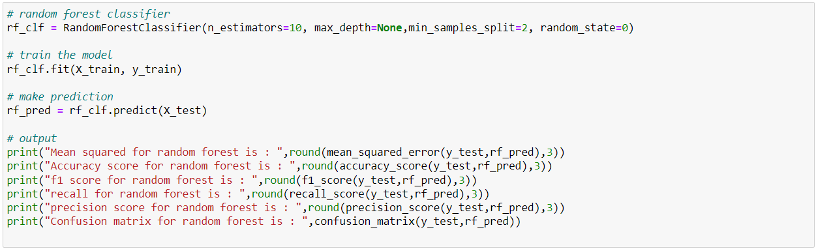**

1. **Evaluation**

To evaluate a model for detecting the survival of patients with breast cancer, there are several commonly used evaluation metrics that can be used. These include:

***Accuracy:*** This is a measurement of how often the model make correct predictions of the survival status of patients. It is measured as number of accurate predictions divided by total number of predictions.

***Precision:*** It measures the proportion of true positive predictions among all positive predictions. In the context of breast cancer survival, this would mean the proportion of patients who are correctly predicted to survive among all patients predicted to survive.

***Recall:*** Proportion of true positive predictions among all actual positive cases will give the recall. In breast cancer survival, this would mean the proportion of patients who are correctly predicted to survive among all patients who actually survived.

***F1-score:*** It is the harmonic mean of recall and precision, provides the combined measurement of both metrics. It is useful when precision and recall have different levels of importance for the problem being solved.

|  |  |  |  |  |
| --- | --- | --- | --- | --- |
|  | ***Accuracy*** | ***Precision*** | ***Recall*** | ***F1-score*** |
| ***logistic regression*** | 0.873 | 0.727 | 0.168 | 0.273 |
| ***decision tree*** | 0.779 | 0.263 | 0.308 | 0.284 |
| ***random forest*** | 0.851 | 0.443 | 0.189 | 0.265 |
| ***support vector machine*** | 0.866 | 0.667 | 0.112 | 0.192 |

*Comparison of the algorithms*

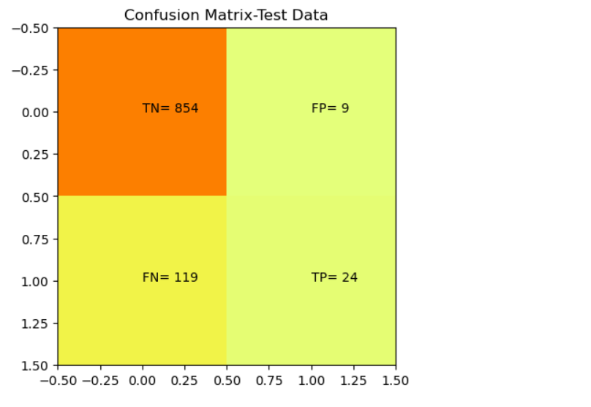

*Confusion matrix – logistic regression classification*

*Confusion matrix – decision tree classification*

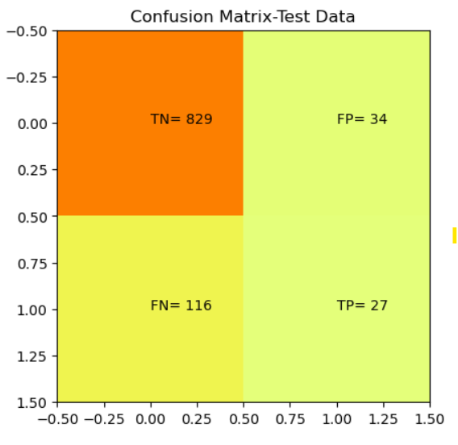

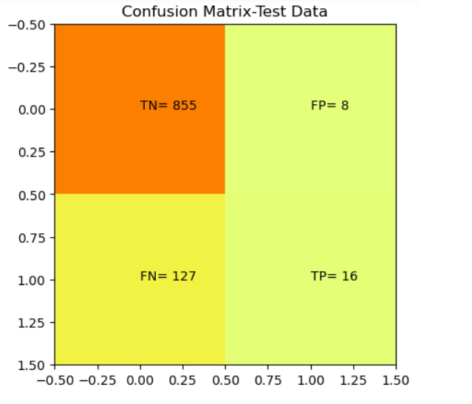*Confusion matrix – random forest classification*

*Confusion matrix – support vector machine classification*

1. **Future work**

Worldwide, the number of instances of breast cancer is increasing at an alarming rate. Worldwide, death rates are increasing and are much higher in industrialized nations. BC must be diagnosed and treated early to increase long-term survival. DL models are used to diagnose breast cancer, which considerably aids medical professionals in reaching a choice.

Notably, the information utilized was a November 2017 update from the NCI's SEER Program. If one is available, an updated dataset would be helpful in confirming the efficacy of classification systems for breast cancer detection. A fresh dataset could receive new features. Further research is required on the impact of feature selection on the predictive assessments of the approaches. To explore prediction approaches and improve accuracy, deep learning with huge data may employ additional machine learning algorithms.

The analysis of the data showcase that the combination of multidimensional data with various feature selection, dimensionality reduction, and classification approaches might offer advantageous tools for inference in this field. It is required to conduct additional studies in this area to maximize the effectiveness of classification algorithms and make them to predict on a wider range of factors. To get high accuracy, we want to parametrize our categorization systems. We are investigating several datasets and the potential application of Machine Learning methods to characterize Breast Cancer. We planning to increase accuracy while reducing mistake rate.

1. **References**
2. Zhang X, Shengli SU, Hongchao WA. Intelligent diagnosis model and method of palpation imaging breast cancer based on data mining. Big Data Research*.*2019;5(1):2019005. doi: 10.11959/j.issn.2096-0271.2019005. [[CrossRef](https://doi.org/10.11959%2Fj.issn.2096-0271.2019005" \t "_blank)] [[Google Scholar](https://scholar.google.com/scholar_lookup?journal=+Big+Data+Research&title=+Intelligent+diagnosis+model+and+method+of+palpation+imaging+breast+cancer+based+on+data+mining&author=X+Zhang&author=SU+Shengli&author=WA+Hongchao&volume=5&issue=1&publication_year=+2019&pages=2019005&doi=10.11959/j.issn.2096-0271.2019005&)]
3. Chen SI, Tseng HT, Hsieh CC. Evaluating the impact of soy compounds on breast cancer using the data mining approach. Food & function*.*2020;11(5):4561–70. doi: 10.1039/C9FO00976K. [[PubMed](https://pubmed.ncbi.nlm.nih.gov/32400770)] [[CrossRef](https://doi.org/10.1039%2FC9FO00976K" \t "_blank)] [[Google Scholar](https://scholar.google.com/scholar_lookup?journal=+Food+&+function&title=+Evaluating+the+impact+of+soy+compounds+on+breast+cancer+using+the+data+mining+approach&author=SI+Chen&author=HT+Tseng&author=CC+Hsieh&volume=11&issue=5&publication_year=+2020&pages=4561-70&pmid=32400770&doi=10.1039/C9FO00976K&)]
4. Aavula R, Bhramaramba R, Ramula US. A Comprehensive Study on Data Mining Techniques used in Bioinformatics for Breast Cancer Prognosis. Journal of Innovation in Computer Science and Engineering*.*2019;9(1):34–9. [[Google Scholar](https://scholar.google.com/scholar_lookup?journal=+Journal+of+Innovation+in+Computer+Science+and+Engineering&title=+A+Comprehensive+Study+on+Data+Mining+Techniques+used+in+Bioinformatics+for+Breast+Cancer+Prognosis&author=R+Aavula&author=R+Bhramaramba&author=US+Ramula&volume=9&issue=1&publication_year=+2019&pages=34-9&)]
5. Kaushik D, Kaur K. Application of Data Mining for high accuracy prediction of breast tissue biopsy results. 2016 Third International Conference on Digital Information Processing, Data Mining, and Wireless Communications (DIPDMWC); Moscow, Russia: IEEE; 2016. p. 40-5. doi: 10.1109/DIPDMWC.2016.7529361. [[CrossRef](https://doi.org/10.1109%2FDIPDMWC.2016.7529361" \t "_blank)] [[Google Scholar](https://scholar.google.com/scholar?q=Kaushik+D+Kaur+K+Application+of+Data+Mining+for+high+accuracy+prediction+of+breast+tissue+biopsy+results.+2016+Third+International+Conference+on+Digital+Information+Processing,+Data+Mining,+and+Wireless+Communications+(DIPDMWC);+Moscow,+Russia:+IEEE;+2016.+p.+40-5+10.1109/DIPDMWC.2016.7529361+)]
6. Mokhtar SA, Elsayad A. Predicting the severity of breast masses with data mining methods. ArXiv preprint arXiv:1305*.*7057 2013 doi: 10.48550/ARxIV.1305.7057. [[CrossRef](https://doi.org/10.48550%2FARxIV.1305.7057" \t "_blank)] [[Google Scholar](https://scholar.google.com/scholar_lookup?journal=+ArXiv+preprint+arXiv:1305&title=+Predicting+the+severity+of+breast+masses+with+data+mining+methods&author=SA+Mokhtar&author=A+Elsayad&publication_year=7057+2013&doi=10.48550/ARxIV.1305.7057&)]
7. Chaurasia V, Pal S, Tiwari BB. Prediction of benign and malignant breast cancer using data mining techniques. Journal of Algorithms & Computational Technology*.*2018;12(2):119–26.
8. Fan J, Wu Y, Yuan M, Page D, Liu J, Ong IM, Peissig P, Burnside E. Structure-leveraged methods in breast cancer risk prediction. The Journal of Machine Learning Research*.*2016;17(1):2956–70. [[PMC free article](https://www.ncbi.nlm.nih.gov/pmc/articles/PMC5446896/)] [[PubMed](https://pubmed.ncbi.nlm.nih.gov/28559747)] [[Google Scholar](https://scholar.google.com/scholar_lookup?journal=+The+Journal+of+Machine+Learning+Research&title=+Structure-leveraged+methods+in+breast+cancer+risk+prediction&author=J+Fan&author=Y+Wu&author=M+Yuan&author=D+Page&author=J+Liu&volume=17&issue=1&publication_year=+2016&pages=2956-70&)]
9. Burnside ES, Liu J, Wu Y, Onitilo AA, McCarty CA, Page CD, et al. Comparing Mammography Abnormality Features to Genetic Variants in the Prediction of Breast Cancer in Women Recommended for Breast Biopsy. Acad Radiol*.*2016;23(1):62–9. doi: 10.1016/j.acra.2015.09.007. [ [PMC Free Article](http://www.ncbi.nlm.nih.gov/pmc/articles/PMC4684977) ] [[PMC free article](https://www.ncbi.nlm.nih.gov/pmc/articles/PMC4684977/)] [[PubMed](https://pubmed.ncbi.nlm.nih.gov/26514439)] [[CrossRef](https://doi.org/10.1016%2Fj.acra.2015.09.007" \t "_blank)] [[Google Scholar](https://scholar.google.com/scholar_lookup?journal=+Acad+Radiol&title=+Comparing+Mammography+Abnormality+Features+to+Genetic+Variants+in+the+Prediction+of+Breast+Cancer+in+Women+Recommended+for+Breast+Biopsy&author=ES+Burnside&author=J+Liu&author=Y+Wu&author=AA+Onitilo&author=CA+McCarty&volume=23&issue=1&publication_year=+2016&pages=62-9&pmid=26514439&doi=10.1016/j.acra.2015.09.007&)]
10. Stephens K. New Mammogram Measures of Breast Cancer Risk Could Revolutionize Screening. AXIS Imaging News*.*2020 [[Google Scholar](https://scholar.google.com/scholar_lookup?journal=+AXIS+Imaging+News&title=+New+Mammogram+Measures+of+Breast+Cancer+Risk+Could+Revolutionize+Screening&author=K+Stephens&publication_year=+2020&)]
11. Feld SI, Fan J, Yuan M, Wu Y, Woo KM, Alexandridis R, Burnside ES. Utility of Genetic Testing in Addition to Mammography for Determining Risk of Breast Cancer Depends on Patient Age. AMIA Jt Summits Transl Sci Proc*.*2018;2017:81–90. [ [PMC Free Article](http://www.ncbi.nlm.nih.gov/pmc/articles/PMC5961791) ] [[PMC free article](https://www.ncbi.nlm.nih.gov/pmc/articles/PMC5961791/)] [[PubMed](https://pubmed.ncbi.nlm.nih.gov/29888046)] [[Google Scholar](https://scholar.google.com/scholar_lookup?journal=+AMIA+Jt+Summits+Transl+Sci+Proc&title=+Utility+of+Genetic+Testing+in+Addition+to+Mammography+for+Determining+Risk+of+Breast+Cancer+Depends+on+Patient+Age&author=SI+Feld&author=J+Fan&author=M+Yuan&author=Y+Wu&author=KM+Woo&volume=2017&publication_year=+2018&pages=81-90&pmid=29888046&)]
12. Guan Y, Nehl E, Pencea I, Condit CM, Escoffery C, Bellcross CA, McBride CM. Willingness to decrease mammogram frequency among women at low risk for hereditary breast cancer. Sci Rep*.*2019;9(1):9599. doi: 10.1038/s41598-019-45967-6. [ [PMC Free Article](http://www.ncbi.nlm.nih.gov/pmc/articles/PMC6610104) ] [[PMC free article](https://www.ncbi.nlm.nih.gov/pmc/articles/PMC6610104/)] [[PubMed](https://pubmed.ncbi.nlm.nih.gov/31270367)] [[CrossRef](https://doi.org/10.1038%2Fs41598-019-45967-6" \t "_blank)] [[Google Scholar](https://scholar.google.com/scholar_lookup?journal=+Sci+Rep&title=+Willingness+to+decrease+mammogram+frequency+among+women+at+low+risk+for+hereditary+breast+cancer&author=Y+Guan&author=E+Nehl&author=I+Pencea&author=CM+Condit&author=C+Escoffery&volume=9&issue=1&publication_year=+2019&pages=9599&pmid=31270367&doi=10.1038/s41598-019-45967-6&)]
13. American Cancer Society. Cancer facts & figures 2018*.* Atlanta: American Cancer Society; 2018. [[Google Scholar](https://scholar.google.com/scholar_lookup?title=+Cancer+facts+&+figures+2018&publication_year=2018&)]
14. Blandin Knight S, Crosbie PA, Balata H, Chudziak J, Hussell T, Dive C. Progress and prospects of early detection in lung cancer. Open Biol*.*2017;7(9):170070. doi: 10.1098/rsob.170070. [ [PMC Free Article](http://www.ncbi.nlm.nih.gov/pmc/articles/PMC5627048) ] [[PMC free article](https://www.ncbi.nlm.nih.gov/pmc/articles/PMC5627048/)] [[PubMed](https://pubmed.ncbi.nlm.nih.gov/28878044)] [[CrossRef](https://doi.org/10.1098%2Frsob.170070" \t "_blank)] [[Google Scholar](https://scholar.google.com/scholar_lookup?journal=+Open+Biol&title=+Progress+and+prospects+of+early+detection+in+lung+cancer&author=S+Blandin+Knight&author=PA+Crosbie&author=H+Balata&author=J+Chudziak&author=T+Hussell&volume=7&issue=9&publication_year=+2017&pages=170070&pmid=28878044&doi=10.1098/rsob.170070&)]
15. Ghani MU, Alam TM, Jaskani FH. Comparison of classification models for early prediction of breast cancer. 2019 International Conference on Innovative Computing (ICIC); Lahore, Pakistan: IEEE; 2019. p. 1-6. doi: 10.1109/ICIC48496.2019.8966691. [[CrossRef](https://doi.org/10.1109%2FICIC48496.2019.8966691" \t "_blank)] [[Google Scholar](https://scholar.google.com/scholar?q=Ghani+MU+Alam+TM+Jaskani+FH++Comparison+of+classification+models+for+early+prediction+of+breast+cancer.+2019+International+Conference+on+Innovative+Computing+(ICIC);+Lahore,+Pakistan:+IEEE;+2019.+p.+1-6+10.1109/ICIC48496.2019.8966691+)]
16. Ferreira P, Fonseca NA, Dutra I, Woods R, Burnside E. Predicting malignancy from mammography findings and image-guided core biopsies. International Journal of Data Mining and Bioinformatics*.*2015;11(3):257–76. doi: 10.1504/IJDMB.2015.067319. [ [PMC Free Article](http://www.ncbi.nlm.nih.gov/pmc/articles/PMC4764253) ] [[PMC free article](https://www.ncbi.nlm.nih.gov/pmc/articles/PMC4764253/)] [[PubMed](https://pubmed.ncbi.nlm.nih.gov/26333262)] [[CrossRef](https://doi.org/10.1504%2FIJDMB.2015.067319" \t "_blank)] [[Google Scholar](https://scholar.google.com/scholar_lookup?journal=+International+Journal+of+Data+Mining+and+Bioinformatics&title=+Predicting+malignancy+from+mammography+findings+and+image-guided+core+biopsies&author=P+Ferreira&author=NA+Fonseca&author=I+Dutra&author=R+Woods&author=E+Burnside&volume=11&issue=3&publication_year=+2015&pages=257-76&pmid=26333262&doi=10.1504/IJDMB.2015.067319&)]
17. **Contribution**

|  |  |
| --- | --- |
| IT Number | Contribution |
| IT20221928 | * Dataset collection * Encode the categorical columns. (preprocessing) * Train the model using Decision tree classification. * Train the model using Random Forest classification. * Report generation (abstract, data collection, evaluation) |
| IT20202422 | * Replace null values (preprocessing) * Train the model using Support vector machine classification. * Plot the data. * Report generation (problem statement, data mapping and preprocessing, future work) |
| IT20175702 | * Normalize numerical columns (preprocessing) * Plot the data. * Train the model using Logistic regression classification. * Report generation (methodology, description of dataset, selection of algorithm) |

1. **Appendix**

**7.1 Appendix A: Code Listening**

# import libraries

import pandas as pd

import numpy as np

from sklearn.model\_selection import train\_test\_split

from sklearn.preprocessing import LabelEncoder ,MinMaxScaler

from sklearn.metrics import mean\_squared\_error , accuracy\_score , confusion\_matrix ,recall\_score, f1\_score ,precision\_score

from sklearn.linear\_model import LogisticRegression

from sklearn.tree import DecisionTreeClassifier

from sklearn.ensemble import RandomForestClassifier

from sklearn.svm import SVC

import matplotlib.pyplot as plot

import seaborn as sns

# load the data into a pandas dataframe

df = pd.read\_csv("breast\_cancer\_data.csv")

# first five data

df.head()

# select all column with data type object

df\_object = df.select\_dtypes(['object'])

# remove leading or trailing white spaces

df[df\_object.columns] = df\_object.apply(lambda s: s.str.strip())

# Replacing null value columns (text) with most used value

obj\_col = df.select\_dtypes(include=['object']).isnull().sum()

for x in obj\_col.index:

    b1 = df[x].value\_counts().index.tolist()

    df[x] = df[x].fillna(b1[0])

# Replacing null value columns (int, float) with mean value

obj\_col = df.select\_dtypes(include=['integer','float']).isnull().sum()

for i in obj\_col.index:

    df[i] = df[i].fillna(df[i].mean())

# assign target column

y = df.Status

#column to be ignored

drop\_cols = ['Status']

# assign feature columns

x = df.drop(drop\_cols,axis=1)

# plot all the column

plot.figure(figsize = (25,25))

plot.subplot(6,2,1)

sns.countplot(x = 'Race', palette='Set2', data = df)

plot.subplot(6,2,2)

sns.countplot(x = 'Marital Status', palette='Set2', data = df)

plot.subplot(6,2,3)

sns.countplot(x = 'T Stage ', palette='Set2', data = df)

plot.subplot(6,2,4)

sns.countplot(x = 'N Stage', palette='Set2', data = df)

plot.subplot(6,2,5)

sns.countplot(x = '6th Stage', palette='Set2', data = df)

plot.subplot(6,2,6)

sns.countplot(x = 'differentiate', palette='Set2', data = df)

plot.subplot(6,2,7)

sns.countplot(x = 'A Stage', palette='Set2', data = df)

plot.subplot(6,2,8)

sns.countplot(x = 'Estrogen Status', palette='Set2', data = df)

plot.subplot(6,2,9)

sns.countplot(x = 'Progesterone Status', palette='Set2', data = df)

plot.subplot(6,2,9)

sns.countplot(x = 'Grade', palette='Set2', data = df)

plot.subplot(6,2,11)

sns.countplot(x = 'Status', palette='Set2', data = df)

# plot the column against target column

plot.figure(figsize = (20,20))

plot.subplot(3,2,1)

sns.countplot(x = 'Status', hue= 'Race', palette='Set2', data = df)

plot.subplot(3,2,2)

sns.countplot(x = 'Status', hue= 'Marital Status', palette='Set2', data = df)

plot.subplot(3,2,3)

sns.countplot(x = 'Status', hue= 'differentiate', palette='Set2', data = df)

plot.subplot(3,2,4)

sns.countplot(x = 'Status', hue= 'Grade', palette='Set2', data = df)

plot.subplot(3,2,5)

sns.countplot(x = 'Status', hue= 'T Stage ', palette='Set2', data = df)

plot.subplot(3,2,6)

sns.countplot(x = 'Status', hue= 'N Stage', palette='Set2', data = df)

# encoding for Race Variable

race\_encoding = {"White":0,"Black":1,"Other":2}

x["Race"] = x["Race"].replace(race\_encoding)

# encoding for Marital Status Variable

marital\_status\_encoding = {"Married":0,"Divorced":2,"Single":1,"Widowed":3,"Separated":4}

x["Marital Status"] = x["Marital Status"].replace(marital\_status\_encoding)

# encoding for T Stage Variable

t\_stage\_encoding = {"T1":0,"T3":2,"T2":1,"T4":3}

x["T Stage "] = x["T Stage "].replace(t\_stage\_encoding)

# encoding for N Stage Variable

n\_stage\_encoding = {"N1":0,"N2":1,"N3":2}

x["N Stage"] = x["N Stage"].replace(n\_stage\_encoding)

# encoding for 6th Stage Variable

label\_encoder\_x= LabelEncoder()

x["6th Stage"]=label\_encoder\_x.fit\_transform(x["6th Stage"])

# encoding for differentiate Variable

x["differentiate"]=label\_encoder\_x.fit\_transform(x["differentiate"])

# encoding for Grade Variable

x["Grade"]=label\_encoder\_x.fit\_transform(x["Grade"])

# encoding for A Stage Variable

a\_stage\_encoding = {"Distant":0,"Regional":1}

x["A Stage"] = x["A Stage"].replace(a\_stage\_encoding)

# encoding for Estrogen Status Variable

estrogen\_stage\_encoding = {"Negative":0,"Positive":1}

x["Estrogen Status"] = x["Estrogen Status"].replace(estrogen\_stage\_encoding)

# encoding for Progesterone Status Variable

progesterone\_status\_encoding = {"Negative":0,"Positive":1}

x["Progesterone Status"] = x["Progesterone Status"].replace(progesterone\_status\_encoding)

# encoding for Status Variable

status\_encoding = {"Alive":0,"Dead":1}

y = y.replace(status\_encoding)

# Normalize numerical columns

scaler = MinMaxScaler()

# Define the numerical columns

numerical\_cols = [ 'Tumor Size', 'Age', 'Reginol Node Positive', 'Regional Node Examined','Survival Months']

for col in numerical\_cols:

    encoded\_col = scaler.fit\_transform(df[[col]])

    x[col] = encoded\_col

x

# remove headers

x = x.iloc[:,:-1].values

# split data into traing and testing

X\_train, X\_test, y\_train, y\_test = train\_test\_split(x, y,test\_size=.25, random\_state=42)

# Logistic Regression

lgr = LogisticRegression()

# train the model

lgr.fit(X\_train, y\_train)

# make prediction

test\_pred = lgr.predict(X\_test)

# outputs

print("Mean squared : ",round(mean\_squared\_error(y\_test,test\_pred),3))

print("Accuracy score : ",round(accuracy\_score(y\_test,test\_pred),3))

print("f1 score : ",round(f1\_score(y\_test,test\_pred),3))

print("recall : ",round(recall\_score(y\_test,test\_pred),3))

print("precision score : ",round(precision\_score(y\_test,test\_pred),3))

print("Confusion matrix : ",confusion\_matrix(y\_test,test\_pred))

# visualize the confusion matrix

plot.clf()

cm = confusion\_matrix(y\_test,test\_pred)

plot.imshow(cm,interpolation='nearest',cmap=plot.cm.Wistia)

plot.title('Confusion Matrix-Test Data')

s = [['TN','FP'],['FN','TP']]

for k in range(2):

    for l in range(2):

        plot.text(l,k,str(s[k][l])+"= "+str(cm[k][l]))

plot.show()

# decision tree classification

dc\_clf = DecisionTreeClassifier()

# train with decision tree

dc\_clf.fit(X\_train, y\_train)

# make prediction

dc\_pred = dc\_clf.predict(X\_test)

# outputs

print("Mean squared : ",round(mean\_squared\_error(y\_test,dc\_pred),3))

print("Accuracy score : ",round(accuracy\_score(y\_test,dc\_pred),3))

print("f1 score : ",round(f1\_score(y\_test,dc\_pred),3))

print("recall  : ",round(recall\_score(y\_test,dc\_pred),3))

print("precision score  : ",round(precision\_score(y\_test,dc\_pred),3))

print("Confusion matrix  : ",confusion\_matrix(y\_test,dc\_pred))

# visualize the confusion matrix

plot.clf()

cm = confusion\_matrix(y\_test,dc\_pred)

plot.imshow(cm,interpolation='nearest',cmap=plot.cm.Wistia)

plot.title('Confusion Matrix-Test Data')

s = [['TN','FP'],['FN','TP']]

for k in range(2):

    for l in range(2):

        plot.text(l,k,str(s[k][l])+"= "+str(cm[k][l]))

plot.show()

# random forest classifier

rf\_clf = RandomForestClassifier(n\_estimators=10, max\_depth=None,min\_samples\_split=2, random\_state=0)

# train the model

rf\_clf.fit(X\_train, y\_train)

# make prediction

rf\_pred = rf\_clf.predict(X\_test)

# output

print("Mean squared  : ",round(mean\_squared\_error(y\_test,rf\_pred),3))

print("Accuracy score: ",round(accuracy\_score(y\_test,rf\_pred),3))

print("f1 score  : ",round(f1\_score(y\_test,rf\_pred),3))

print("recall  : ",round(recall\_score(y\_test,rf\_pred),3))

print("precision score  : ",round(precision\_score(y\_test,rf\_pred),3))

print("Confusion matrix  : ",confusion\_matrix(y\_test,rf\_pred))

# visualize the confusion matrix

plot.clf()

cm = confusion\_matrix(y\_test,rf\_pred)

plot.imshow(cm,interpolation='nearest',cmap=plot.cm.Wistia)

plot.title('Confusion Matrix-Test Data')

s = [['TN','FP'],['FN','TP']]

for k in range(2):

    for l in range(2):

        plot.text(l,k,str(s[k][l])+"= "+str(cm[k][l]))

plot.show()

# support vector machine

svm\_clf = SVC()

# train the model

svm\_clf.fit(X\_train, y\_train)

# make prediction

svm\_pred = svm\_clf.predict(X\_test)

# outputs

print("Mean squared : ",round(mean\_squared\_error(y\_test,svm\_pred),3))

print("Accuracy score : ",round(accuracy\_score(y\_test,svm\_pred),3))

print("f1 score : ",round(f1\_score(y\_test,svm\_pred),3))

print("recall for: ",round(recall\_score(y\_test,svm\_pred),3))

print("precision score : ",round(precision\_score(y\_test,svm\_pred),3))

print("Confusion matrix : ",confusion\_matrix(y\_test,svm\_pred))

# visualize the confusion matrix

plot.clf()

cm = confusion\_matrix(y\_test,svm\_pred)

plot.imshow(cm,interpolation='nearest',cmap=plot.cm.Wistia)

plot.title('Confusion Matrix-Test Data')

s = [['TN','FP'],['FN','TP']]

for k in range(2):

    for l in range(2):

        plot.text(l,k,str(s[k][l])+"= "+str(cm[k][l]))

plot.show()

**7.1 Appendix B: Medical report of Lavaniyah**

