--Dashboard 1
--1. Total Loan Aplication
SELECT COUNT(id) AS TOTAL_APLICATIONS FROM bank_loan_data;
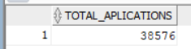
-- 1.1 Month-to-Date (MTD) Loan Applications
SELECT COUNT(id) AS MTD
FROM bank_loan_data
WHERE issue_date >= DATE '2021-12-01'
AND issue_date < DATE '2022-01-01';
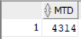
-- 2. Total Funded Amount
SELECT SUM(loan_amount) AS MTD_Total_Founded_Amount FROM bank_loan_data
WHERE issue_date >= DATE '2021-12-01'
AND issue_date <= DATE '2021-12-31';
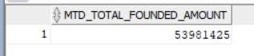
-- 2.1 Previous Month-to-Date (PMTD) Total Funded Amount
SELECT SUM(loan_amount) AS PMTD_Total_Founded_Amount FROM bank_loan_data
WHERE issue_date >= DATE '2021-11-01'
AND issue_date <= DATE '2021-11-30';
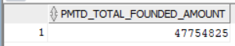
--3. Total Amount Received
SELECT SUM(total_payment) AS MTD_Total_Amount_received FROM bank_loan_data
WHERE issue_date >= DATE '2021-12-01'
AND issue_date <= DATE '2021-12-31';
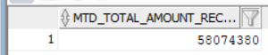

-- 3.1 Previous Month-to-Date (PMTD) Total Amount Received
SELECT SUM(total_payment) AS PMTD_Total_Amount_received FROM bank_loan_data
WHERE issue_date >= DATE '2021-11-01'
AND issue_date <= DATE '2021-11-30';
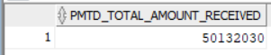
--4. Average Interest Rate
SELECT ROUND(AVG(int_rate),4) * 100 AS MTD_Avg_Interest_Rate FROM bank_loan_data
WHERE issue_date >= DATE '2021-12-01'
AND issue_date <= DATE '2021-12-31';
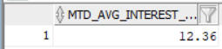
-- 4.1 Previous Month-to-Date (PMTD) Average Interest Rate
SELECT ROUND(AVG(int_rate),4) * 100 AS PMTD_Avg_Interest_Rate FROM bank_loan_data
WHERE issue_date >= DATE '2021-11-01'
AND issue_date <= DATE '2021-11-30';
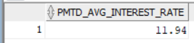
--5. Average Debt-to-Income Ratio (DTI)
SELECT ROUND(AVG(dti),4)*100 AS MTD_AVG_DTI FROM bank_loan_data
WHERE issue_date >= DATE '2021-12-01'
AND issue_date <= DATE '2021-12-31';
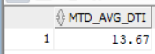
-- 5.1 Previous Month-to-Date (PMTD) Average Debt-to-Income Ratio (DTI)
SELECT ROUND(AVG(dti),4)*100 AS PMTD_AVG_DTI FROM bank_loan_data
WHERE issue_date >= DATE '2021-11-01'
AND issue_date <= DATE '2021-11-30';

------------------------------
--6. Good Loan Percentage
SELECT ROUND(
COUNT(CASE
WHEN TRIM(loan_status) IN ('Fully Paid', 'Current')
THEN id
END) * 100
/ COUNT(*)
,2) AS good_loan_percentage
FROM bank_loan_data;
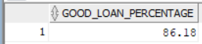
--7. Good Loan Application

SELECT COUNT(id) AS Good_Loan_Applications FROM bank_loan_data
WHERE loan_status='Fully Paid' OR loan_status='Current';
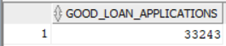
--8. Good Loan Funded Amount
SELECT SUM(loan_amount) AS Good_Loan_Founded_Amount FROM bank_loan_data
WHERE loan_status='Fully Paid' OR loan_status='Current';
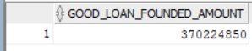
--9. Good Loan Total Received Amount
SELECT SUM(total_payment) AS Good_Loan_Received_Amount FROM bank_loan_data
WHERE loan_status='Fully Paid' OR loan_status='Current';
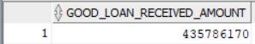
--10. Bad Loans
SELECT ROUND(
COUNT(CASE
WHEN TRIM(loan_status) IN ('Charged Off')
THEN id
END) * 100
/ COUNT(*)
,2) AS good_loan_percentage
FROM bank_loan_data;
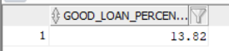
--11. Bad Loans Applications
SELECT COUNT(id) AS Bad_Loan_Applications FROM bank_loan_data
WHERE loan_status='Charged Off';
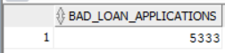
--12. Bad Total Received Amount
SELECT SUM(loan_amount) AS Bad_Loan_Founded_Amount FROM bank_loan_data
WHERE loan_status='Charged Off';
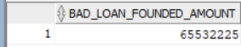
--13. Bad Loan Amount Received
SELECT SUM(total_payment) AS Bad_Loan__Amount_Received FROM bank_loan_data
WHERE loan_status='Charged Off';
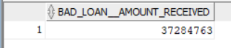
-- 14. Loan Status Overview
SELECT
loan_status,
COUNT(id) AS Total_Loan_Applications,
SUM(total_payment) AS Total_Amount_Received,
SUM(loan_amount) AS Total_Funded_Amount,
ROUND(AVG(int_rate) * 100, 2) AS Interest_Rate,
ROUND(AVG(dti) * 100, 2) AS DTI
FROM bank_loan_data
GROUP BY loan_status;
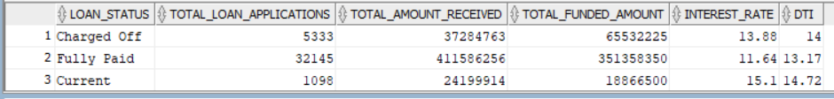
-- 14.1 Loan Status Analysis (MTD Funded & Received Amount)
SELECT
loan_status,
SUM(total_payment) AS MTD_Total_Amount_Received,
SUM(loan_amount) AS MTD_Total_Funded_Amount
FROM bank_loan_data
WHERE issue_date >= DATE '2021-12-01'
AND issue_date < DATE '2022-01-01'
GROUP BY loan_status;
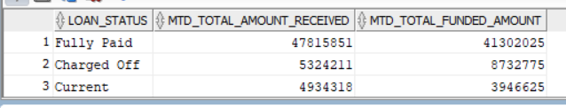
-- Dashboard 2 - Overview Analysis
-- 15. Monthly Loan Trends
SELECT
TO_CHAR(issue_date, 'Month') AS Month_name,
COUNT(id) AS total_loan_applications,
SUM(loan_amount) AS total_funded_amount,
SUM(total_payment) AS total_received_amount
FROM bank_loan_data
GROUP BY TO_CHAR(issue_date, 'Month')
ORDER BY MIN(issue_date) DESC;
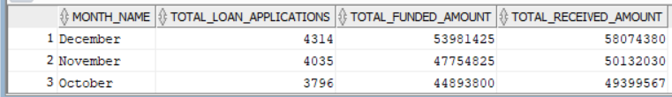

-- 16. Monthly Trends by Issue Date
SELECT
TO_CHAR(issue_date, 'MM') AS Month_number,
TO_CHAR(issue_date, 'Month') AS month_name,
COUNT(id) AS total_loan_applications,
SUM(loan_amount) AS total_funded_amount,
SUM(total_payment) AS total_received_amount
FROM bank_loan_data
GROUP BY
TO_CHAR(issue_date, 'MM'),
TO_CHAR(issue_date, 'Month')
ORDER BY
TO_CHAR(issue_date, 'MM');
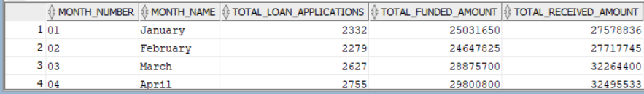
--17. Regional Analysis by State
SELECT
address_state,
COUNT(*) AS total_loan_applications,
SUM(loan_amount) AS total_funded_amount,
SUM(total_payment) AS total_received_amount,
ROUND(AVG(int_rate) * 100, 2) AS avg_interest_rate,
ROUND(AVG(dti) * 100, 2) AS avg_dti
FROM bank_loan_data
GROUP BY address_state
ORDER BY total_loan_applications DESC;
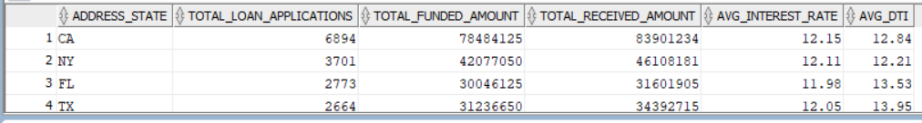
--18. Loan Term Analysis
SELECT
term,
COUNT(*) AS total_loan_applications,
SUM(loan_amount) AS total_funded_amount,
SUM(total_payment) AS total_received_amount,
ROUND(AVG(int_rate) * 100, 2) AS avg_interest_rate,
ROUND(AVG(dti) * 100, 2) AS avg_dti
FROM bank_loan_data
GROUP BY term
ORDER BY term;
--19. Employee Length Analysis
SELECT
emp_length,
COUNT(*) AS total_loan_applications,
SUM(loan_amount) AS total_funded_amount,
SUM(total_payment) AS total_received_amount,
ROUND(AVG(int_rate) * 100, 2) AS avg_interest_rate,
ROUND(AVG(dti) * 100, 2) AS avg_dti
FROM bank_loan_data
GROUP BY emp_length
ORDER BY emp_length DESC;
--Loan Purpose Breakdown
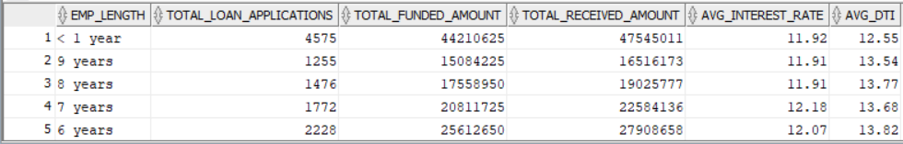

-- 20. Loan Purpose Breakdown
SELECT
purpose,
COUNT(*) AS total_loan_applications,
SUM(loan_amount) AS total_funded_amount,
SUM(total_payment) AS total_received_amount,
ROUND(AVG(int_rate) * 100, 2) AS avg_interest_rate,
ROUND(AVG(dti) * 100, 2) AS avg_dti
FROM bank_loan_data
GROUP BY purpose
ORDER BY purpose;
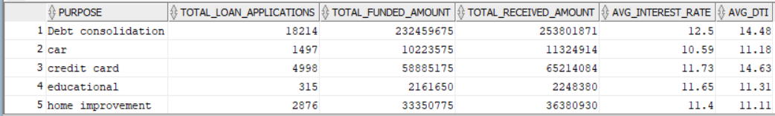
--21. Home Ownership Analysis
SELECT
home_ownership,
COUNT(*) AS total_loan_applications,
SUM(loan_amount) AS total_funded_amount,
SUM(total_payment) AS total_received_amount,
ROUND(AVG(int_rate) * 100, 2) AS avg_interest_rate,
ROUND(AVG(dti) * 100, 2) AS avg_dti
FROM bank_loan_data
GROUP BY home_ownership
ORDER BY home_ownership DESC;
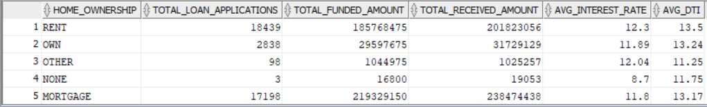

--Dashbord3
-- 22. Detailed Loan Analysis by Grade and State
SELECT
home_ownership,
COUNT(*) AS total_loan_applications,
SUM(loan_amount) AS total_funded_amount,
SUM(total_payment) AS total_received_amount,
ROUND(AVG(int_rate) * 100, 2) AS avg_interest_rate,
ROUND(AVG(dti) * 100, 2) AS avg_dti
FROM bank_loan_data
WHERE grade='A' AND address_state='CA'
GROUP BY home_ownership
ORDER BY home_ownership DESC;
--
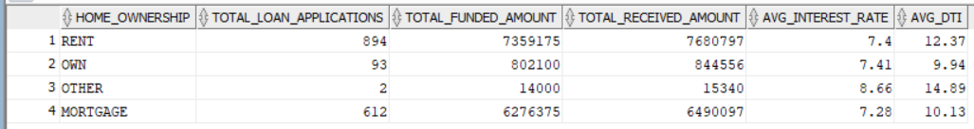
-- Dashboard 4 - Credit Risk Analysis
-- 23. Charged-Off Loan Rate
SELECT
ROUND(
COUNT(CASE
WHEN loan_status = 'Charged Off'
THEN id
END) * 100.0
/ COUNT(*)
,2) AS Charged_Off_Rate
FROM bank_loan_data;
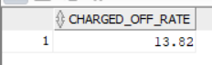
-- 24. Charged-Off Funded Amount
SELECT
SUM(loan_amount) AS Charged_Off_Funded_Amount
FROM bank_loan_data
WHERE loan_status = 'Charged Off';
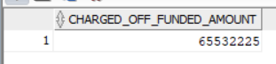
-- 25. Average Interest Rate for Charged-Off Loans
SELECT
ROUND(AVG(int_rate) * 100,2) AS Avg_Interest_Rate_Charged_Off
FROM bank_loan_data
WHERE loan_status = 'Charged Off';
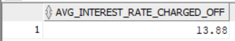
-- 26. Average DTI for Charged-Off Loans
SELECT
ROUND(AVG(dti) * 100,2) AS Avg_DTI_Charged_Off
FROM bank_loan_data
WHERE loan_status = 'Charged Off';

-- 27. Credit Risk Analysis by Grade
SELECT
grade,

COUNT(CASE
WHEN loan_status='Charged Off'
THEN id
END) AS Charged_Off_Loans,

COUNT(*) AS Total_Loans,

ROUND(
COUNT(CASE
WHEN loan_status='Charged Off'
THEN id
END) * 100.0
/ COUNT(*)
,2) AS Charged_Off_Rate
FROM bank_loan_data
GROUP BY grade
ORDER BY grade;
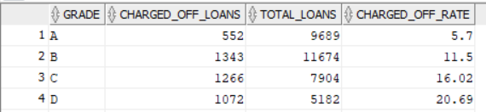
-- 28. Credit Risk Analysis by Loan Purpose
SELECT
purpose,

COUNT(CASE
WHEN loan_status='Charged Off'
THEN id
END) AS Charged_Off_Loans,

COUNT(*) AS Total_Loans,

ROUND(
COUNT(CASE
WHEN loan_status='Charged Off'
THEN id
END) * 100.0
/ COUNT(*)
,2) AS Charged_Off_Rate

FROM bank_loan_data
GROUP BY purpose
ORDER BY Charged_Off_Rate DESC;
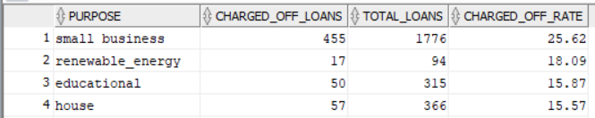
-- 29. Credit Risk Analysis by Home Ownership
SELECT
home_ownership,

COUNT(CASE
WHEN loan_status='Charged Off'
THEN id
END) AS Charged_Off_Loans,

COUNT(*) AS Total_Loans,

ROUND(
COUNT(CASE
WHEN loan_status='Charged Off'
THEN id
END) * 100.0
/ COUNT(*)
,2) AS Charged_Off_Rate

FROM bank_loan_data
GROUP BY home_ownership
ORDER BY Charged_Off_Rate DESC;
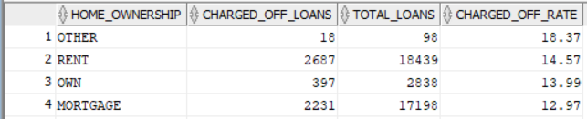
-- 30. Top Risk States Analysis
SELECT
address_state,

COUNT(CASE
WHEN loan_status='Charged Off'
THEN id
END) AS Charged_Off_Loans,

SUM(CASE
WHEN loan_status='Charged Off'
THEN loan_amount
ELSE 0
END) AS Charged_Off_Funded_Amount,

ROUND(
COUNT(CASE
WHEN loan_status='Charged Off'
THEN id
END) * 100.0
/ COUNT(*)
,2) AS Charged_Off_Rate

FROM bank_loan_data
GROUP BY address_state
ORDER BY Charged_Off_Rate DESC;
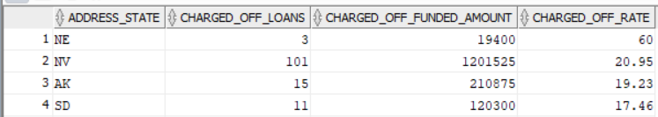
-- 31. Grade vs Purpose Risk Matrix (Heatmap)
SELECT
grade,
purpose,

COUNT(*) AS Total_Loans,

COUNT(CASE
WHEN loan_status='Charged Off'
THEN id
END) AS Charged_Off_Loans,

ROUND(
COUNT(CASE
WHEN loan_status='Charged Off'
THEN id
END) * 100.0
/ COUNT(*)
,2) AS Charged_Off_Rate

FROM bank_loan_data
GROUP BY
grade,
purpose
ORDER BY
grade,
purpose;
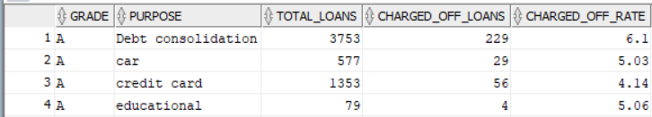
32. Top 10 Highest Risk Grade-Purpose Combinations
SELECT
grade,
purpose,

ROUND(
COUNT(CASE
WHEN loan_status='Charged Off'
THEN id
END) * 100.0
/ COUNT(*)
,2) AS Charged_Off_Rate

FROM bank_loan_data
GROUP BY grade,purpose
HAVING COUNT(*) >= 20
ORDER BY Charged_Off_Rate DESC
LIMIT 10;


