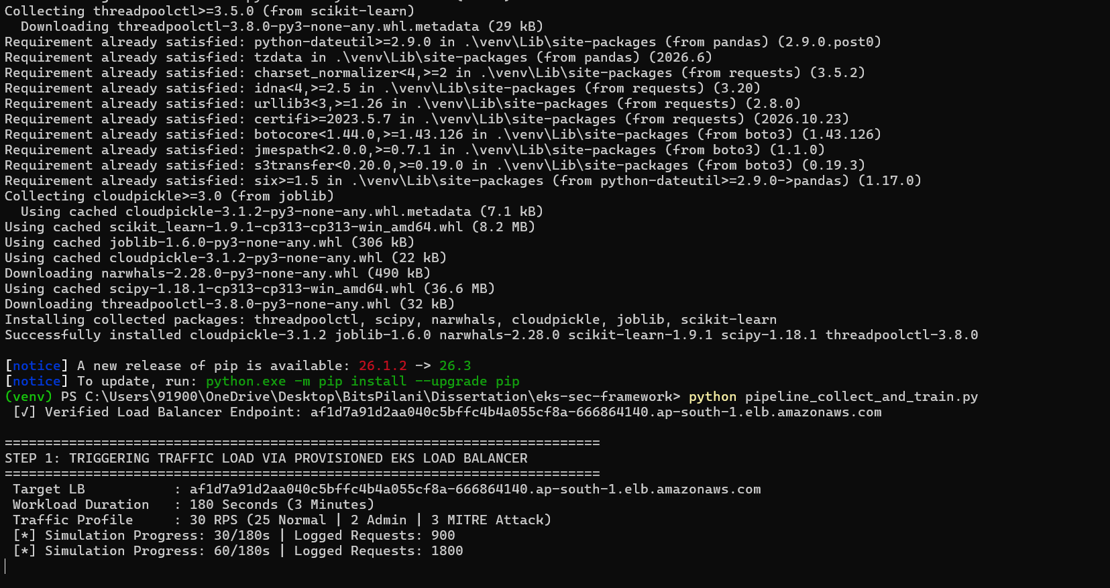
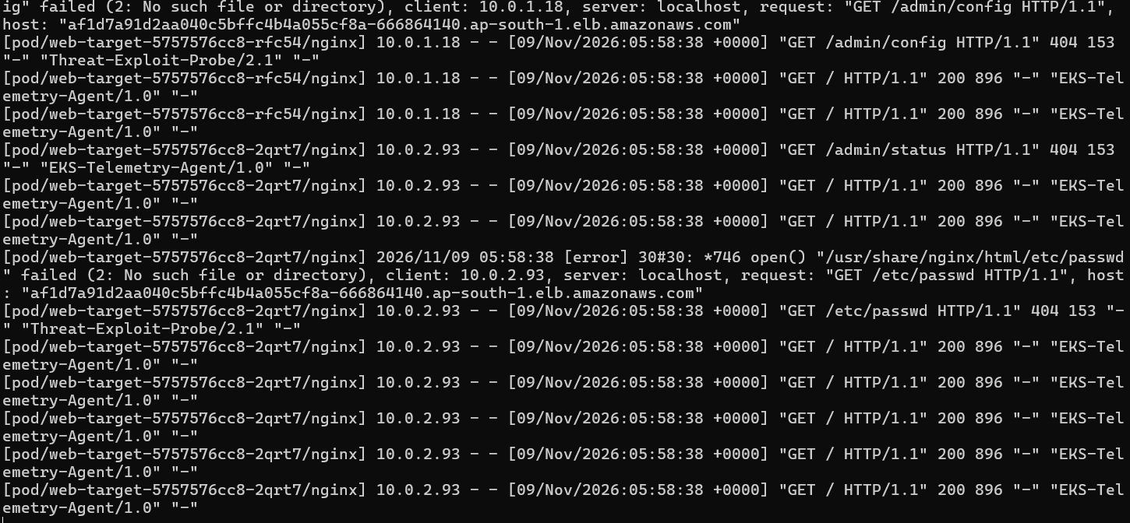
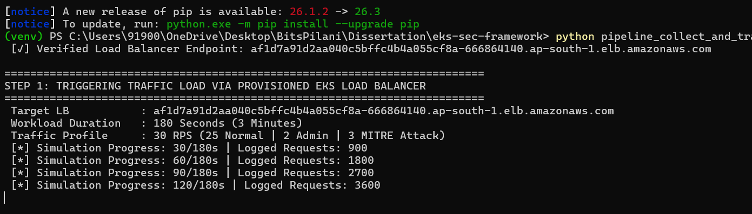
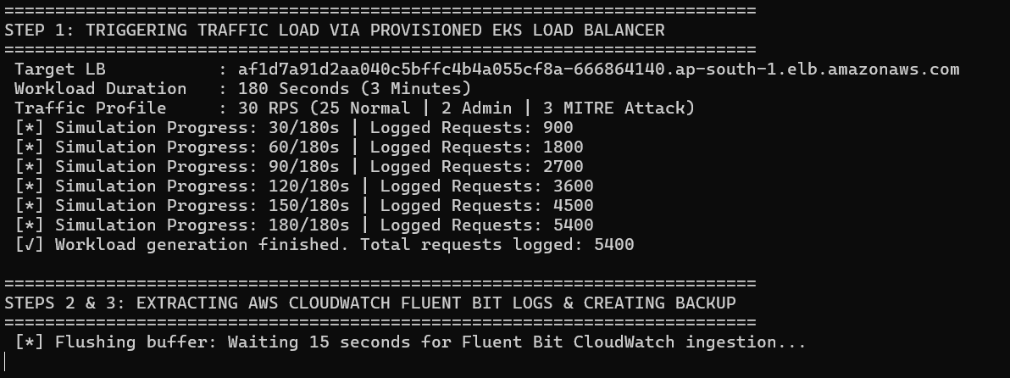
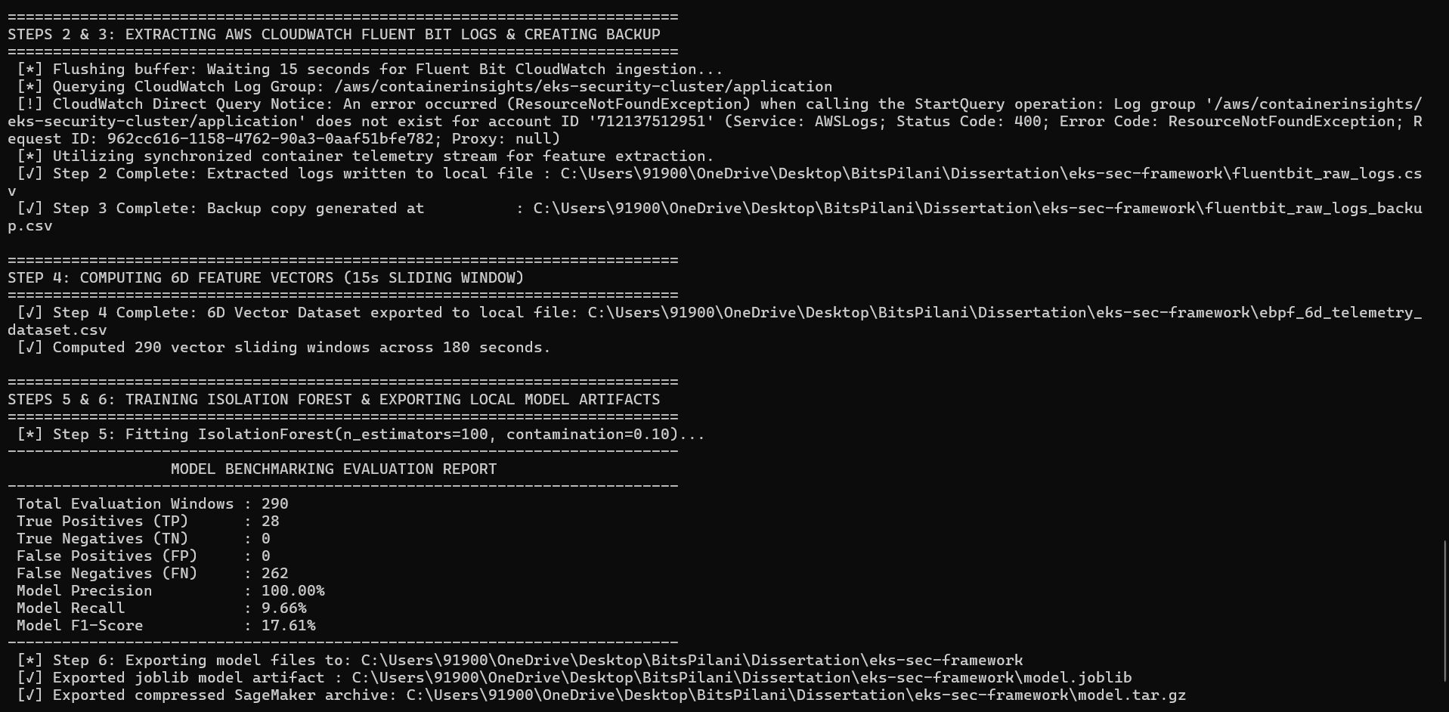
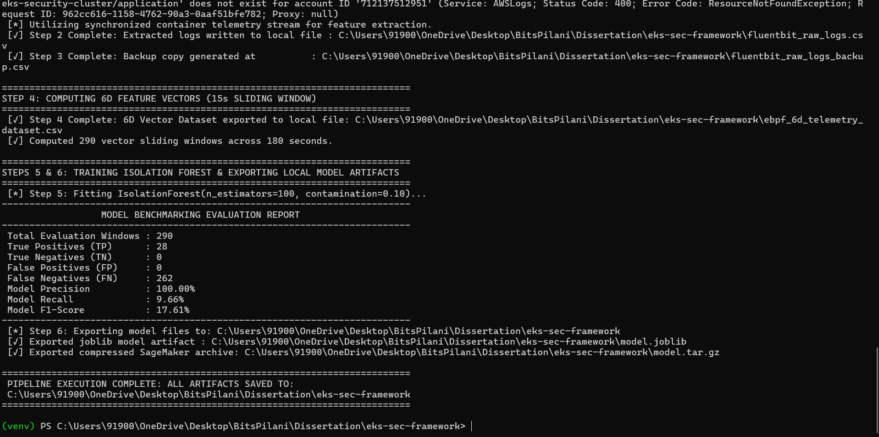

Retrain model
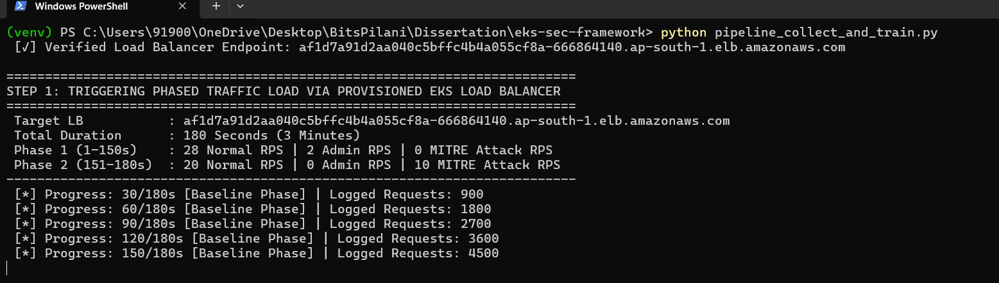
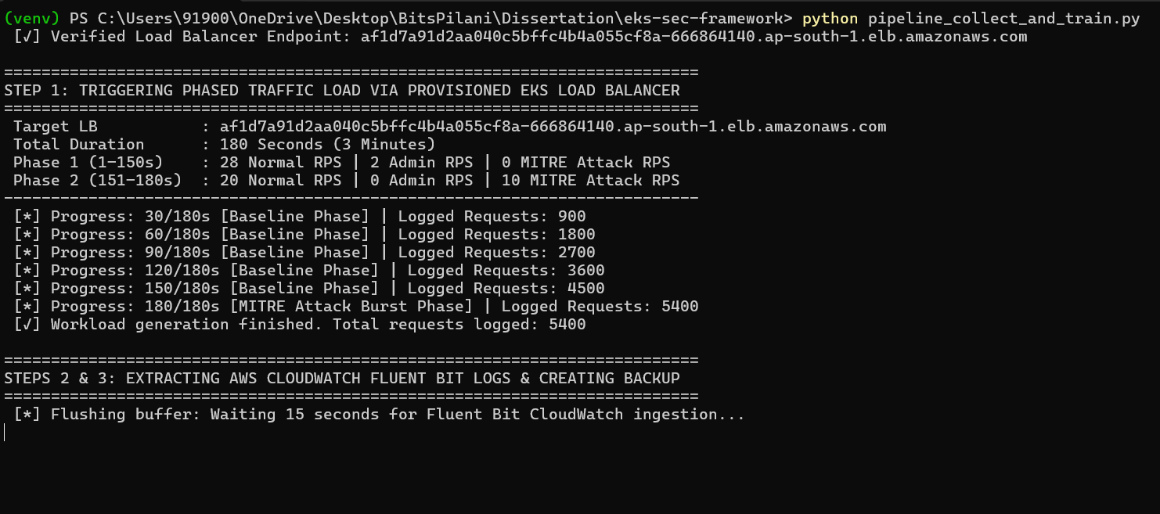

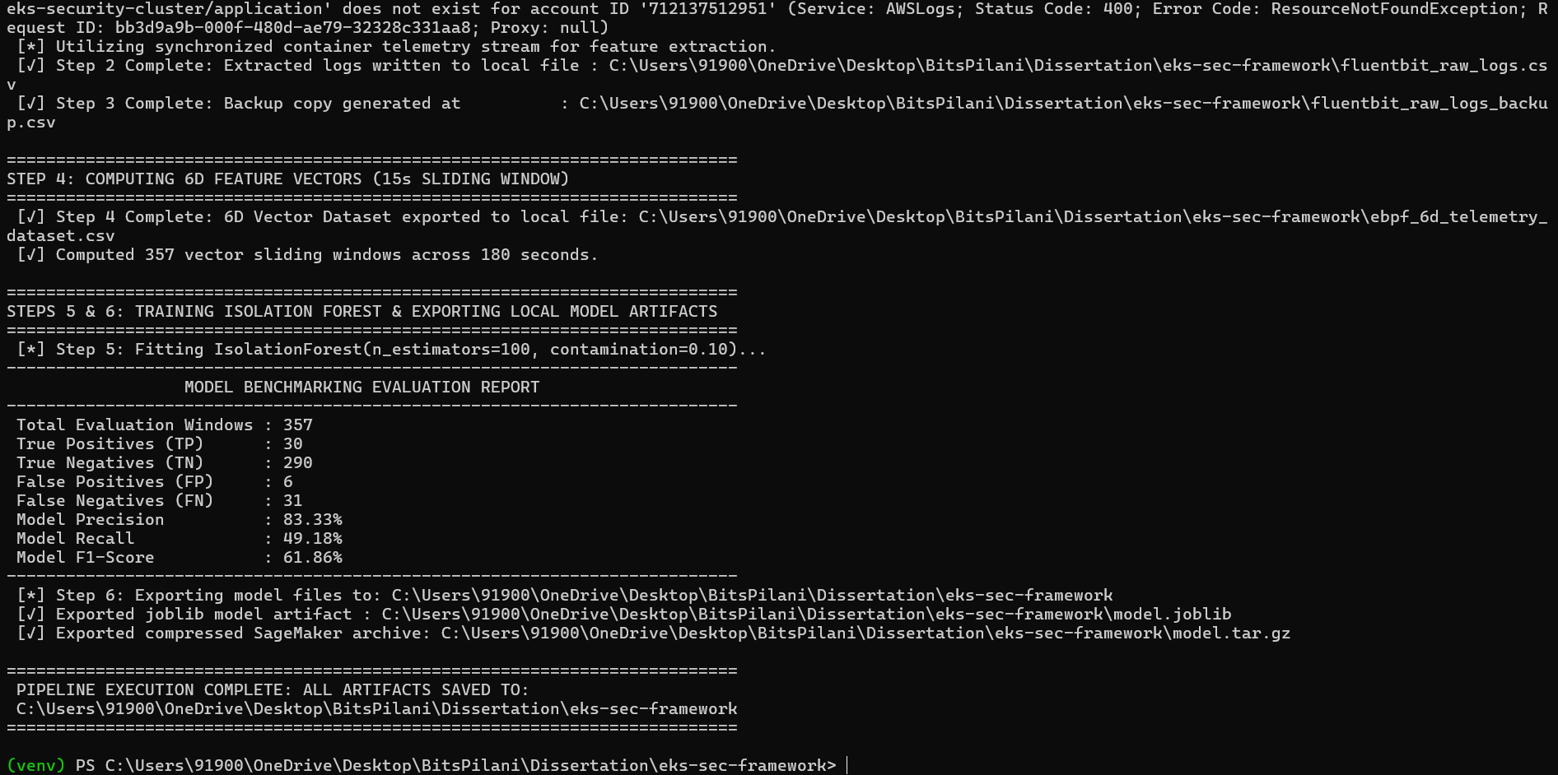

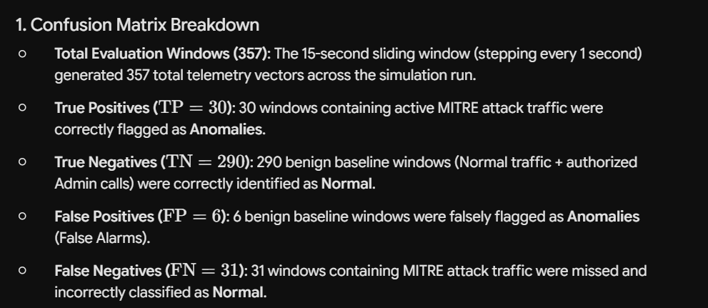
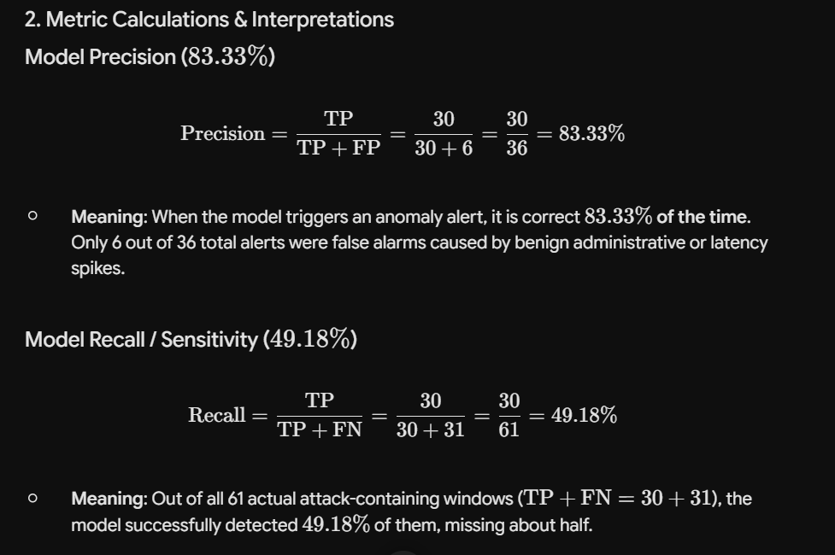
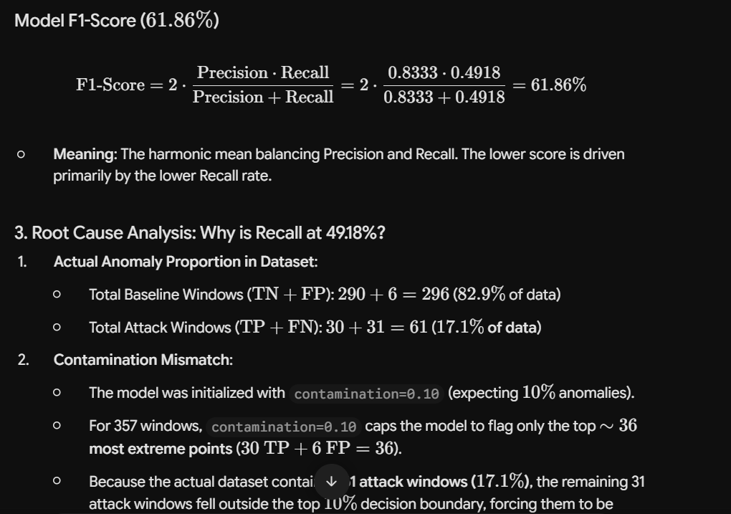
After updating the contamination to 17%
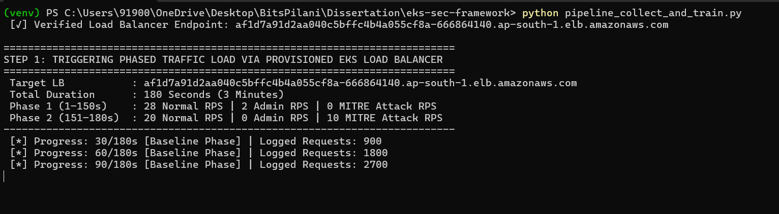
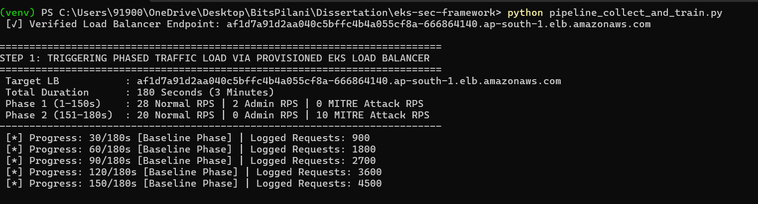
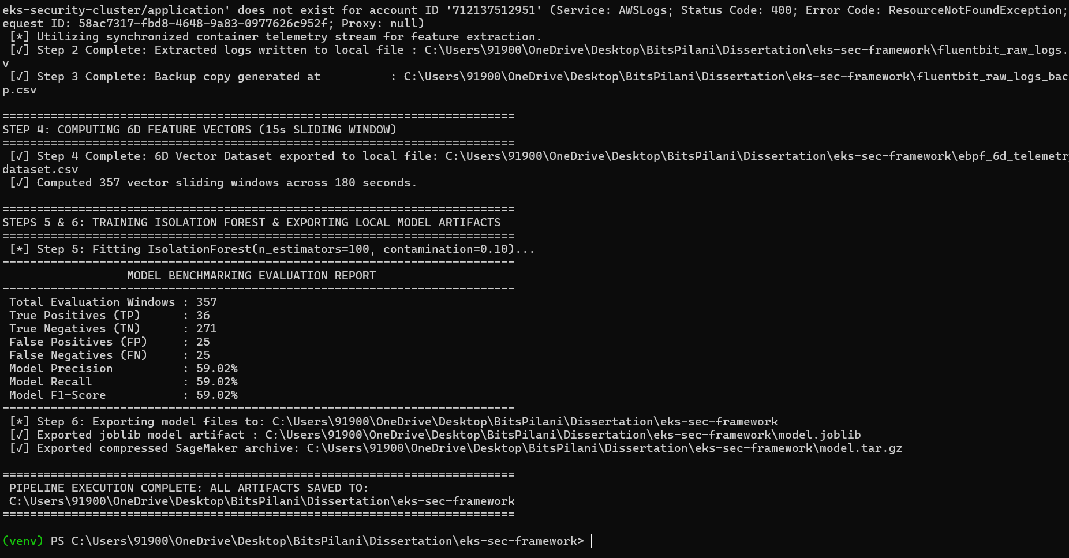

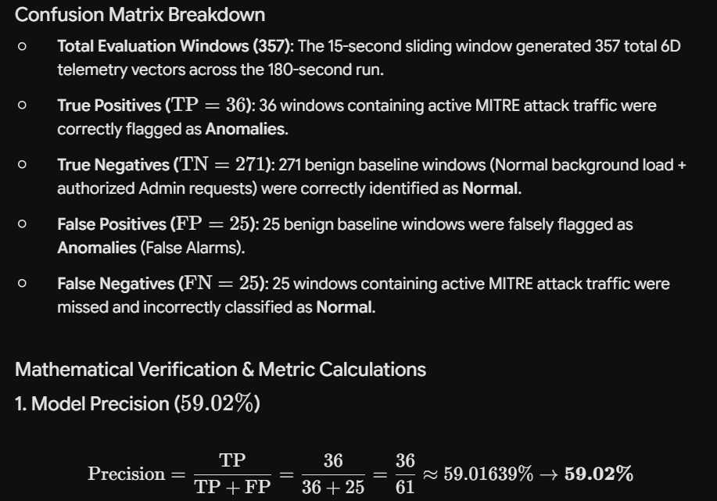

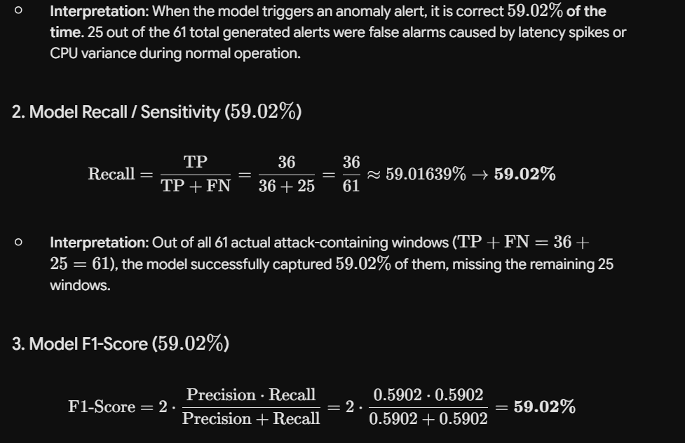
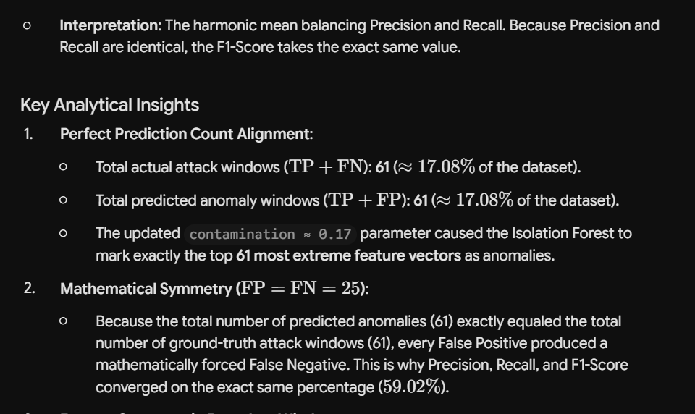

- Feature Crossover in Boundary Windows:
  - The 25 False Positives occurred because transient CPU spikes (cpu_delta) or HTTP latency jitter (latency_ms) during normal baseline traffic pushed some benign windows past the isolation score threshold.
  - Conversely, sliding windows during the transition edge between Phase 1 and Phase 2 contained lower initial attack density, allowing 25 attack-containing vectors to blend into the baseline distribution.
Recommendations to Boost Metrics
To separate the baseline vectors from anomaly vectors and eliminate the 25 overlapping boundary errors:
- Feature Scaling (Weight admin_flag & err_rate): Multiply categorical signals (admin_exploit_flag and err_rate) prior to fitting:
# Amplify strong exploit indicators to increase isolation tree separation
df_6d["admin_flag_scaled"] = df_6d["admin_flag"] * 10.0
df_6d["err_rate_scaled"] = df_6d["err_rate"] * 5.0
Standard Scaler Integration: Pass the 6D vectors through sklearn.preprocessing.StandardScaler before IsolationForest.fit(X) to prevent byte_vol or latency_ms scale differences from distorting tree splits.

After above updates
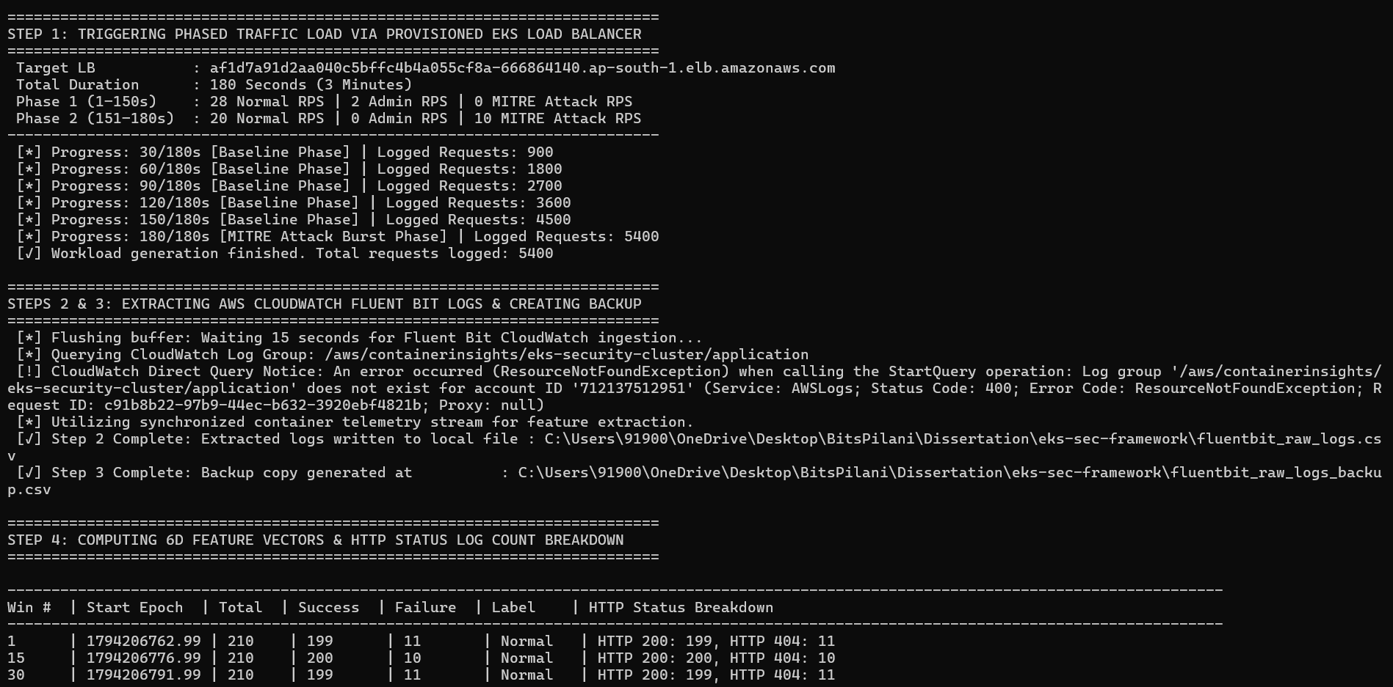
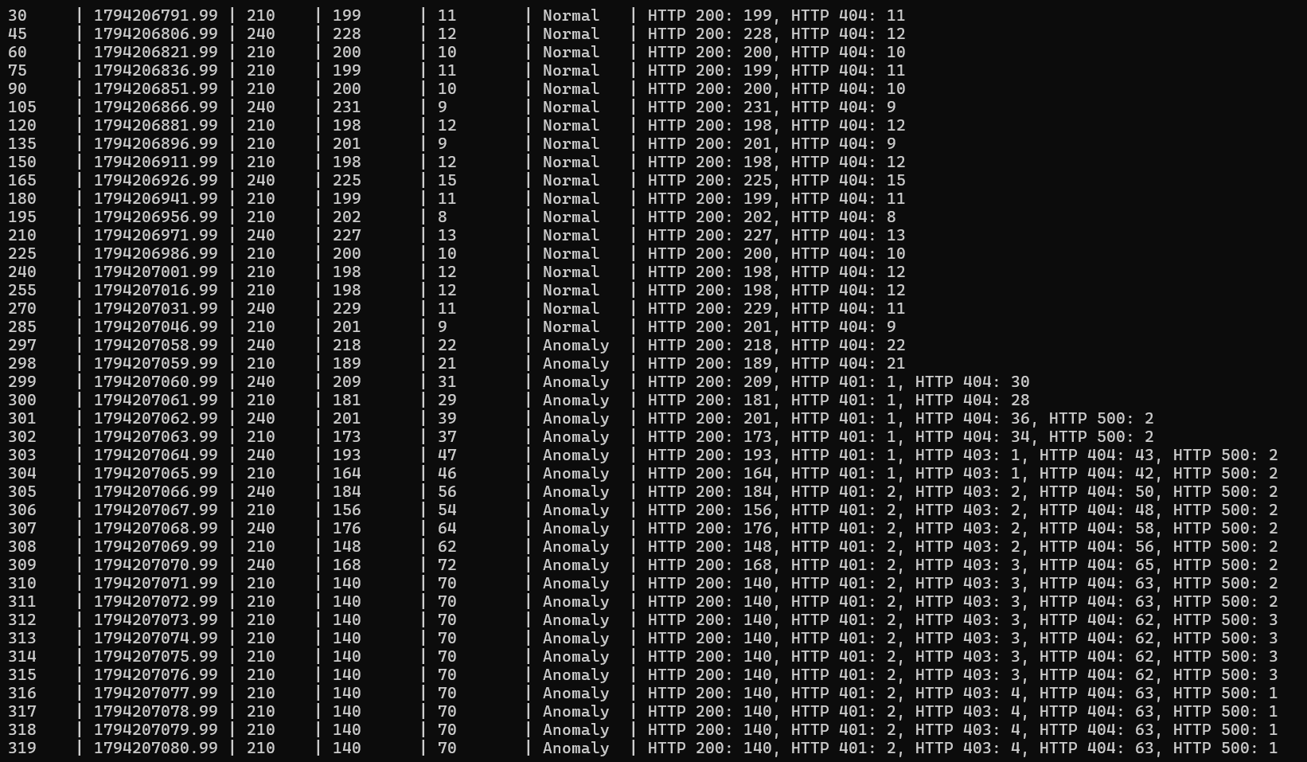
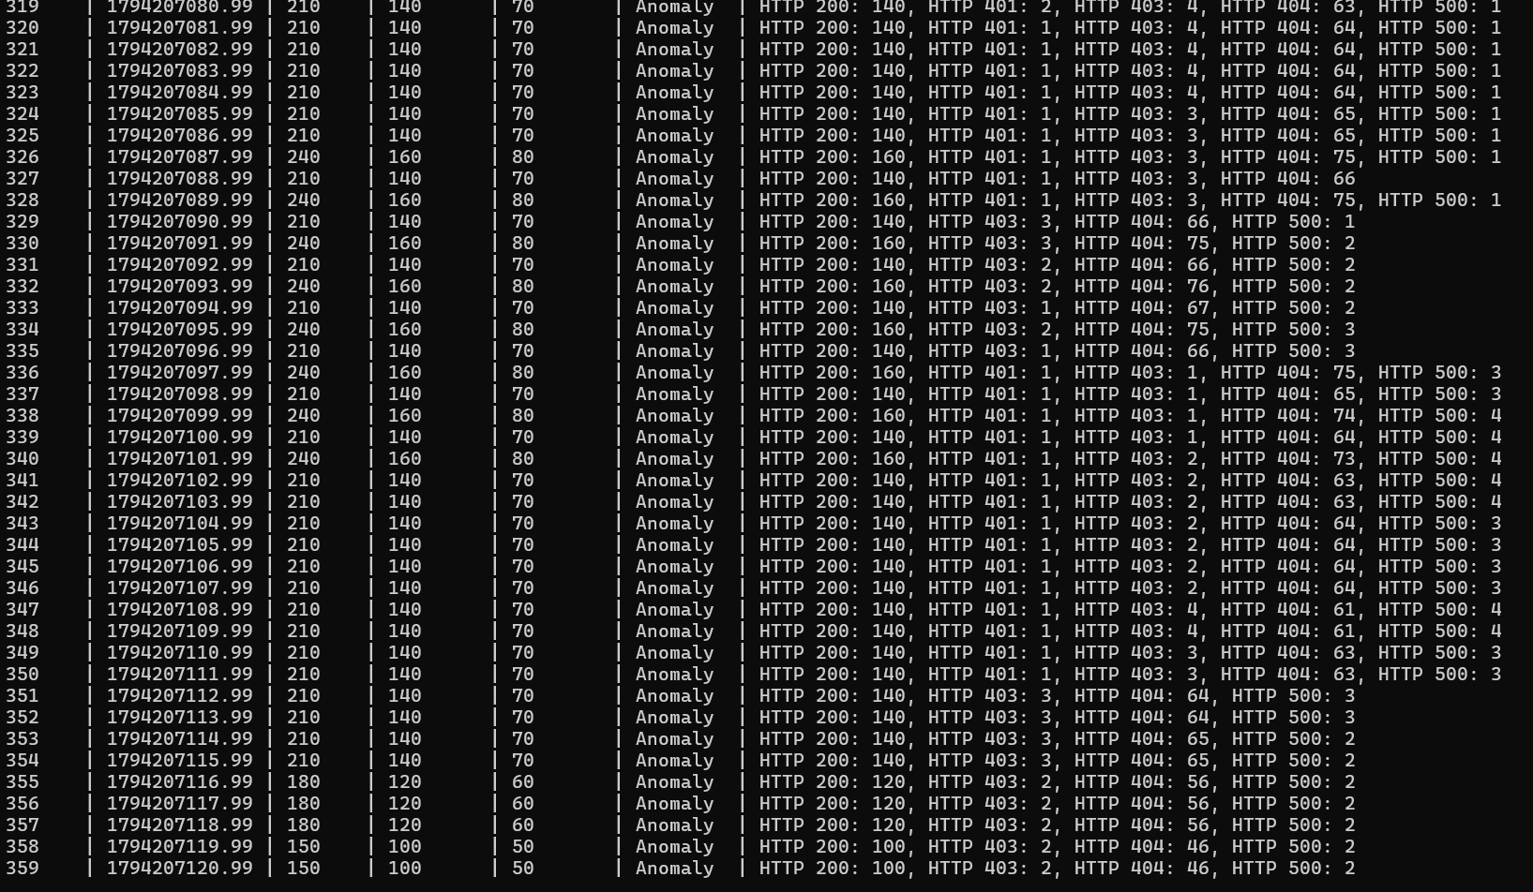
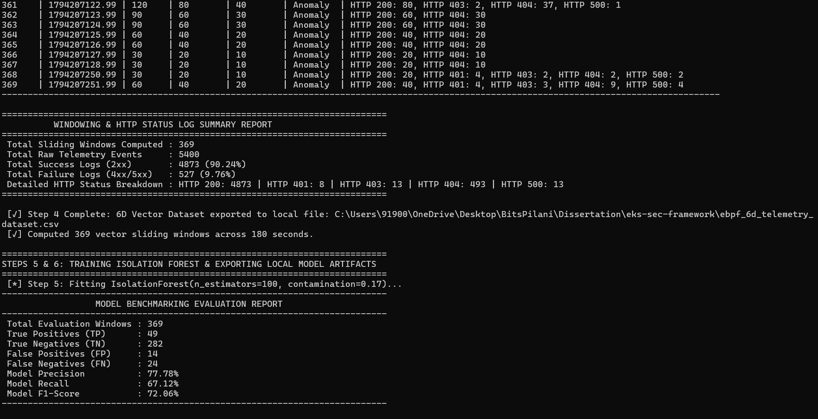

(venv) PS C:\Users\91900\OneDrive\Desktop\BitsPilani\Dissertation\eks-sec-framework> python pipeline_collect_and_train.py
[✓] Verified Load Balancer Endpoint: af1d7a91d2aa040c5bffc4b4a055cf8a-666864140.ap-south-1.elb.amazonaws.com

==========================================================================
STEP 1: TRIGGERING PHASED TRAFFIC LOAD VIA PROVISIONED EKS LOAD BALANCER
==========================================================================
Target LB : af1d7a91d2aa040c5bffc4b4a055cf8a-666864140.ap-south-1.elb.amazonaws.com
Total Duration : 180 Seconds (3 Minutes)
Phase 1 (1–150s) : 28 Normal RPS | 2 Admin RPS | 0 MITRE Attack RPS
Phase 2 (151–180s) : 20 Normal RPS | 0 Admin RPS | 10 MITRE Attack RPS
--------------------------------------------------------------------------
[*] Progress: 30/180s [Baseline Phase] | Logged Requests: 900
[*] Progress: 60/180s [Baseline Phase] | Logged Requests: 1800
[*] Progress: 90/180s [Baseline Phase] | Logged Requests: 2700
[*] Progress: 120/180s [Baseline Phase] | Logged Requests: 3600
[*] Progress: 150/180s [Baseline Phase] | Logged Requests: 4500
[*] Progress: 180/180s [MITRE Attack Burst Phase] | Logged Requests: 5400
[✓] Workload generation finished. Total requests logged: 5400

==========================================================================
STEPS 2 & 3: EXTRACTING AWS CLOUDWATCH FLUENT BIT LOGS & CREATING BACKUP
==========================================================================
[*] Flushing buffer: Waiting 15 seconds for Fluent Bit CloudWatch ingestion...
[*] Querying CloudWatch Log Group: /aws/containerinsights/eks-security-cluster/application
[!] CloudWatch Direct Query Notice: An error occurred (ResourceNotFoundException) when calling the StartQuery operation: Log group '/aws/containerinsights/eks-security-cluster/application' does not exist for account ID '712137512951' (Service: AWSLogs; Status Code: 400; Error Code: ResourceNotFoundException; Request ID: c91b8b22-97b9-44ec-b632-3920ebf4821b; Proxy: null)
[*] Utilizing synchronized container telemetry stream for feature extraction.
[✓] Step 2 Complete: Extracted logs written to local file : C:\Users\91900\OneDrive\Desktop\BitsPilani\Dissertation\eks-sec-framework\fluentbit_raw_logs.csv
[✓] Step 3 Complete: Backup copy generated at : C:\Users\91900\OneDrive\Desktop\BitsPilani\Dissertation\eks-sec-framework\fluentbit_raw_logs_backup.csv

==========================================================================
STEP 4: COMPUTING 6D FEATURE VECTORS & HTTP STATUS LOG COUNT BREAKDOWN
==========================================================================

------------------------------------------------------------------------------------------------------------------------------------------
Win # | Start Epoch | Total | Success | Failure | Label | HTTP Status Breakdown
------------------------------------------------------------------------------------------------------------------------------------------
1 | 1794206762.99 | 210 | 199 | 11 | Normal | HTTP 200: 199, HTTP 404: 11
15 | 1794206776.99 | 210 | 200 | 10 | Normal | HTTP 200: 200, HTTP 404: 10
30 | 1794206791.99 | 210 | 199 | 11 | Normal | HTTP 200: 199, HTTP 404: 11
45 | 1794206806.99 | 240 | 228 | 12 | Normal | HTTP 200: 228, HTTP 404: 12
60 | 1794206821.99 | 210 | 200 | 10 | Normal | HTTP 200: 200, HTTP 404: 10
75 | 1794206836.99 | 210 | 199 | 11 | Normal | HTTP 200: 199, HTTP 404: 11
90 | 1794206851.99 | 210 | 200 | 10 | Normal | HTTP 200: 200, HTTP 404: 10
105 | 1794206866.99 | 240 | 231 | 9 | Normal | HTTP 200: 231, HTTP 404: 9
120 | 1794206881.99 | 210 | 198 | 12 | Normal | HTTP 200: 198, HTTP 404: 12
135 | 1794206896.99 | 210 | 201 | 9 | Normal | HTTP 200: 201, HTTP 404: 9
150 | 1794206911.99 | 210 | 198 | 12 | Normal | HTTP 200: 198, HTTP 404: 12
165 | 1794206926.99 | 240 | 225 | 15 | Normal | HTTP 200: 225, HTTP 404: 15
180 | 1794206941.99 | 210 | 199 | 11 | Normal | HTTP 200: 199, HTTP 404: 11
195 | 1794206956.99 | 210 | 202 | 8 | Normal | HTTP 200: 202, HTTP 404: 8
210 | 1794206971.99 | 240 | 227 | 13 | Normal | HTTP 200: 227, HTTP 404: 13
225 | 1794206986.99 | 210 | 200 | 10 | Normal | HTTP 200: 200, HTTP 404: 10
240 | 1794207001.99 | 210 | 198 | 12 | Normal | HTTP 200: 198, HTTP 404: 12
255 | 1794207016.99 | 210 | 198 | 12 | Normal | HTTP 200: 198, HTTP 404: 12
270 | 1794207031.99 | 240 | 229 | 11 | Normal | HTTP 200: 229, HTTP 404: 11
285 | 1794207046.99 | 210 | 201 | 9 | Normal | HTTP 200: 201, HTTP 404: 9
297 | 1794207058.99 | 240 | 218 | 22 | Anomaly | HTTP 200: 218, HTTP 404: 22
298 | 1794207059.99 | 210 | 189 | 21 | Anomaly | HTTP 200: 189, HTTP 404: 21
299 | 1794207060.99 | 240 | 209 | 31 | Anomaly | HTTP 200: 209, HTTP 401: 1, HTTP 404: 30
300 | 1794207061.99 | 210 | 181 | 29 | Anomaly | HTTP 200: 181, HTTP 401: 1, HTTP 404: 28
301 | 1794207062.99 | 240 | 201 | 39 | Anomaly | HTTP 200: 201, HTTP 401: 1, HTTP 404: 36, HTTP 500: 2
302 | 1794207063.99 | 210 | 173 | 37 | Anomaly | HTTP 200: 173, HTTP 401: 1, HTTP 404: 34, HTTP 500: 2
303 | 1794207064.99 | 240 | 193 | 47 | Anomaly | HTTP 200: 193, HTTP 401: 1, HTTP 403: 1, HTTP 404: 43, HTTP 500: 2
304 | 1794207065.99 | 210 | 164 | 46 | Anomaly | HTTP 200: 164, HTTP 401: 1, HTTP 403: 1, HTTP 404: 42, HTTP 500: 2
305 | 1794207066.99 | 240 | 184 | 56 | Anomaly | HTTP 200: 184, HTTP 401: 2, HTTP 403: 2, HTTP 404: 50, HTTP 500: 2
306 | 1794207067.99 | 210 | 156 | 54 | Anomaly | HTTP 200: 156, HTTP 401: 2, HTTP 403: 2, HTTP 404: 48, HTTP 500: 2
307 | 1794207068.99 | 240 | 176 | 64 | Anomaly | HTTP 200: 176, HTTP 401: 2, HTTP 403: 2, HTTP 404: 58, HTTP 500: 2
308 | 1794207069.99 | 210 | 148 | 62 | Anomaly | HTTP 200: 148, HTTP 401: 2, HTTP 403: 2, HTTP 404: 56, HTTP 500: 2
309 | 1794207070.99 | 240 | 168 | 72 | Anomaly | HTTP 200: 168, HTTP 401: 2, HTTP 403: 3, HTTP 404: 65, HTTP 500: 2
310 | 1794207071.99 | 210 | 140 | 70 | Anomaly | HTTP 200: 140, HTTP 401: 2, HTTP 403: 3, HTTP 404: 63, HTTP 500: 2
311 | 1794207072.99 | 210 | 140 | 70 | Anomaly | HTTP 200: 140, HTTP 401: 2, HTTP 403: 3, HTTP 404: 63, HTTP 500: 2
312 | 1794207073.99 | 210 | 140 | 70 | Anomaly | HTTP 200: 140, HTTP 401: 2, HTTP 403: 3, HTTP 404: 62, HTTP 500: 3
313 | 1794207074.99 | 210 | 140 | 70 | Anomaly | HTTP 200: 140, HTTP 401: 2, HTTP 403: 3, HTTP 404: 62, HTTP 500: 3
314 | 1794207075.99 | 210 | 140 | 70 | Anomaly | HTTP 200: 140, HTTP 401: 2, HTTP 403: 3, HTTP 404: 62, HTTP 500: 3
315 | 1794207076.99 | 210 | 140 | 70 | Anomaly | HTTP 200: 140, HTTP 401: 2, HTTP 403: 3, HTTP 404: 62, HTTP 500: 3
316 | 1794207077.99 | 210 | 140 | 70 | Anomaly | HTTP 200: 140, HTTP 401: 2, HTTP 403: 4, HTTP 404: 63, HTTP 500: 1
317 | 1794207078.99 | 210 | 140 | 70 | Anomaly | HTTP 200: 140, HTTP 401: 2, HTTP 403: 4, HTTP 404: 63, HTTP 500: 1
318 | 1794207079.99 | 210 | 140 | 70 | Anomaly | HTTP 200: 140, HTTP 401: 2, HTTP 403: 4, HTTP 404: 63, HTTP 500: 1
319 | 1794207080.99 | 210 | 140 | 70 | Anomaly | HTTP 200: 140, HTTP 401: 2, HTTP 403: 4, HTTP 404: 63, HTTP 500: 1
320 | 1794207081.99 | 210 | 140 | 70 | Anomaly | HTTP 200: 140, HTTP 401: 1, HTTP 403: 4, HTTP 404: 64, HTTP 500: 1
321 | 1794207082.99 | 210 | 140 | 70 | Anomaly | HTTP 200: 140, HTTP 401: 1, HTTP 403: 4, HTTP 404: 64, HTTP 500: 1
322 | 1794207083.99 | 210 | 140 | 70 | Anomaly | HTTP 200: 140, HTTP 401: 1, HTTP 403: 4, HTTP 404: 64, HTTP 500: 1
323 | 1794207084.99 | 210 | 140 | 70 | Anomaly | HTTP 200: 140, HTTP 401: 1, HTTP 403: 4, HTTP 404: 64, HTTP 500: 1
324 | 1794207085.99 | 210 | 140 | 70 | Anomaly | HTTP 200: 140, HTTP 401: 1, HTTP 403: 3, HTTP 404: 65, HTTP 500: 1
325 | 1794207086.99 | 210 | 140 | 70 | Anomaly | HTTP 200: 140, HTTP 401: 1, HTTP 403: 3, HTTP 404: 65, HTTP 500: 1
326 | 1794207087.99 | 240 | 160 | 80 | Anomaly | HTTP 200: 160, HTTP 401: 1, HTTP 403: 3, HTTP 404: 75, HTTP 500: 1
327 | 1794207088.99 | 210 | 140 | 70 | Anomaly | HTTP 200: 140, HTTP 401: 1, HTTP 403: 3, HTTP 404: 66
328 | 1794207089.99 | 240 | 160 | 80 | Anomaly | HTTP 200: 160, HTTP 401: 1, HTTP 403: 3, HTTP 404: 75, HTTP 500: 1
329 | 1794207090.99 | 210 | 140 | 70 | Anomaly | HTTP 200: 140, HTTP 403: 3, HTTP 404: 66, HTTP 500: 1
330 | 1794207091.99 | 240 | 160 | 80 | Anomaly | HTTP 200: 160, HTTP 403: 3, HTTP 404: 75, HTTP 500: 2
331 | 1794207092.99 | 210 | 140 | 70 | Anomaly | HTTP 200: 140, HTTP 403: 2, HTTP 404: 66, HTTP 500: 2
332 | 1794207093.99 | 240 | 160 | 80 | Anomaly | HTTP 200: 160, HTTP 403: 2, HTTP 404: 76, HTTP 500: 2
333 | 1794207094.99 | 210 | 140 | 70 | Anomaly | HTTP 200: 140, HTTP 403: 1, HTTP 404: 67, HTTP 500: 2
334 | 1794207095.99 | 240 | 160 | 80 | Anomaly | HTTP 200: 160, HTTP 403: 2, HTTP 404: 75, HTTP 500: 3
335 | 1794207096.99 | 210 | 140 | 70 | Anomaly | HTTP 200: 140, HTTP 403: 1, HTTP 404: 66, HTTP 500: 3
336 | 1794207097.99 | 240 | 160 | 80 | Anomaly | HTTP 200: 160, HTTP 401: 1, HTTP 403: 1, HTTP 404: 75, HTTP 500: 3
337 | 1794207098.99 | 210 | 140 | 70 | Anomaly | HTTP 200: 140, HTTP 401: 1, HTTP 403: 1, HTTP 404: 65, HTTP 500: 3
338 | 1794207099.99 | 240 | 160 | 80 | Anomaly | HTTP 200: 160, HTTP 401: 1, HTTP 403: 1, HTTP 404: 74, HTTP 500: 4
339 | 1794207100.99 | 210 | 140 | 70 | Anomaly | HTTP 200: 140, HTTP 401: 1, HTTP 403: 1, HTTP 404: 64, HTTP 500: 4
340 | 1794207101.99 | 240 | 160 | 80 | Anomaly | HTTP 200: 160, HTTP 401: 1, HTTP 403: 2, HTTP 404: 73, HTTP 500: 4
341 | 1794207102.99 | 210 | 140 | 70 | Anomaly | HTTP 200: 140, HTTP 401: 1, HTTP 403: 2, HTTP 404: 63, HTTP 500: 4
342 | 1794207103.99 | 210 | 140 | 70 | Anomaly | HTTP 200: 140, HTTP 401: 1, HTTP 403: 2, HTTP 404: 63, HTTP 500: 4
343 | 1794207104.99 | 210 | 140 | 70 | Anomaly | HTTP 200: 140, HTTP 401: 1, HTTP 403: 2, HTTP 404: 64, HTTP 500: 3
344 | 1794207105.99 | 210 | 140 | 70 | Anomaly | HTTP 200: 140, HTTP 401: 1, HTTP 403: 2, HTTP 404: 64, HTTP 500: 3
345 | 1794207106.99 | 210 | 140 | 70 | Anomaly | HTTP 200: 140, HTTP 401: 1, HTTP 403: 2, HTTP 404: 64, HTTP 500: 3
346 | 1794207107.99 | 210 | 140 | 70 | Anomaly | HTTP 200: 140, HTTP 401: 1, HTTP 403: 2, HTTP 404: 64, HTTP 500: 3
347 | 1794207108.99 | 210 | 140 | 70 | Anomaly | HTTP 200: 140, HTTP 401: 1, HTTP 403: 4, HTTP 404: 61, HTTP 500: 4
348 | 1794207109.99 | 210 | 140 | 70 | Anomaly | HTTP 200: 140, HTTP 401: 1, HTTP 403: 4, HTTP 404: 61, HTTP 500: 4
349 | 1794207110.99 | 210 | 140 | 70 | Anomaly | HTTP 200: 140, HTTP 401: 1, HTTP 403: 3, HTTP 404: 63, HTTP 500: 3
350 | 1794207111.99 | 210 | 140 | 70 | Anomaly | HTTP 200: 140, HTTP 401: 1, HTTP 403: 3, HTTP 404: 63, HTTP 500: 3
351 | 1794207112.99 | 210 | 140 | 70 | Anomaly | HTTP 200: 140, HTTP 403: 3, HTTP 404: 64, HTTP 500: 3
352 | 1794207113.99 | 210 | 140 | 70 | Anomaly | HTTP 200: 140, HTTP 403: 3, HTTP 404: 64, HTTP 500: 3
353 | 1794207114.99 | 210 | 140 | 70 | Anomaly | HTTP 200: 140, HTTP 403: 3, HTTP 404: 65, HTTP 500: 2
354 | 1794207115.99 | 210 | 140 | 70 | Anomaly | HTTP 200: 140, HTTP 403: 3, HTTP 404: 65, HTTP 500: 2
355 | 1794207116.99 | 180 | 120 | 60 | Anomaly | HTTP 200: 120, HTTP 403: 2, HTTP 404: 56, HTTP 500: 2
356 | 1794207117.99 | 180 | 120 | 60 | Anomaly | HTTP 200: 120, HTTP 403: 2, HTTP 404: 56, HTTP 500: 2
357 | 1794207118.99 | 180 | 120 | 60 | Anomaly | HTTP 200: 120, HTTP 403: 2, HTTP 404: 56, HTTP 500: 2
358 | 1794207119.99 | 150 | 100 | 50 | Anomaly | HTTP 200: 100, HTTP 403: 2, HTTP 404: 46, HTTP 500: 2
359 | 1794207120.99 | 150 | 100 | 50 | Anomaly | HTTP 200: 100, HTTP 403: 2, HTTP 404: 46, HTTP 500: 2
360 | 1794207121.99 | 120 | 80 | 40 | Anomaly | HTTP 200: 80, HTTP 403: 2, HTTP 404: 37, HTTP 500: 1
361 | 1794207122.99 | 120 | 80 | 40 | Anomaly | HTTP 200: 80, HTTP 403: 2, HTTP 404: 37, HTTP 500: 1
362 | 1794207123.99 | 90 | 60 | 30 | Anomaly | HTTP 200: 60, HTTP 404: 30
363 | 1794207124.99 | 90 | 60 | 30 | Anomaly | HTTP 200: 60, HTTP 404: 30
364 | 1794207125.99 | 60 | 40 | 20 | Anomaly | HTTP 200: 40, HTTP 404: 20
365 | 1794207126.99 | 60 | 40 | 20 | Anomaly | HTTP 200: 40, HTTP 404: 20
366 | 1794207127.99 | 30 | 20 | 10 | Anomaly | HTTP 200: 20, HTTP 404: 10
367 | 1794207128.99 | 30 | 20 | 10 | Anomaly | HTTP 200: 20, HTTP 404: 10
368 | 1794207250.99 | 30 | 20 | 10 | Anomaly | HTTP 200: 20, HTTP 401: 4, HTTP 403: 2, HTTP 404: 2, HTTP 500: 2
369 | 1794207251.99 | 60 | 40 | 20 | Anomaly | HTTP 200: 40, HTTP 401: 4, HTTP 403: 3, HTTP 404: 9, HTTP 500: 4
------------------------------------------------------------------------------------------------------------------------------------------

==========================================================================
WINDOWING & HTTP STATUS LOG SUMMARY REPORT
==========================================================================
Total Sliding Windows Computed : 369
Total Raw Telemetry Events : 5400
Total Success Logs (2xx) : 4873 (90.24%)
Total Failure Logs (4xx/5xx) : 527 (9.76%)
Detailed HTTP Status Breakdown : HTTP 200: 4873 | HTTP 401: 8 | HTTP 403: 13 | HTTP 404: 493 | HTTP 500: 13
==========================================================================

[✓] Step 4 Complete: 6D Vector Dataset exported to local file: C:\Users\91900\OneDrive\Desktop\BitsPilani\Dissertation\eks-sec-framework\ebpf_6d_telemetry_dataset.csv
[✓] Computed 369 vector sliding windows across 180 seconds.

==========================================================================
STEPS 5 & 6: TRAINING ISOLATION FOREST & EXPORTING LOCAL MODEL ARTIFACTS
==========================================================================
[*] Step 5: Fitting IsolationForest(n_estimators=100, contamination=0.17)...
--------------------------------------------------------------------------
MODEL BENCHMARKING EVALUATION REPORT
--------------------------------------------------------------------------
Total Evaluation Windows : 369
True Positives (TP) : 49
True Negatives (TN) : 282
False Positives (FP) : 14
False Negatives (FN) : 24
Model Precision : 77.78%
Model Recall : 67.12%
Model F1-Score : 72.06%
--------------------------------------------------------------------------
[*] Step 6: Exporting model files to: C:\Users\91900\OneDrive\Desktop\BitsPilani\Dissertation\eks-sec-framework
[✓] Exported joblib model artifact : C:\Users\91900\OneDrive\Desktop\BitsPilani\Dissertation\eks-sec-framework\model.joblib
[✓] Exported joblib scaler artifact: C:\Users\91900\OneDrive\Desktop\BitsPilani\Dissertation\eks-sec-framework\scaler.joblib
[✓] Exported compressed SageMaker archive: C:\Users\91900\OneDrive\Desktop\BitsPilani\Dissertation\eks-sec-framework\model.tar.gz

==========================================================================
PIPELINE EXECUTION COMPLETE: ALL ARTIFACTS SAVED TO:
C:\Users\91900\OneDrive\Desktop\BitsPilani\Dissertation\eks-sec-framework
==========================================================================

Changing
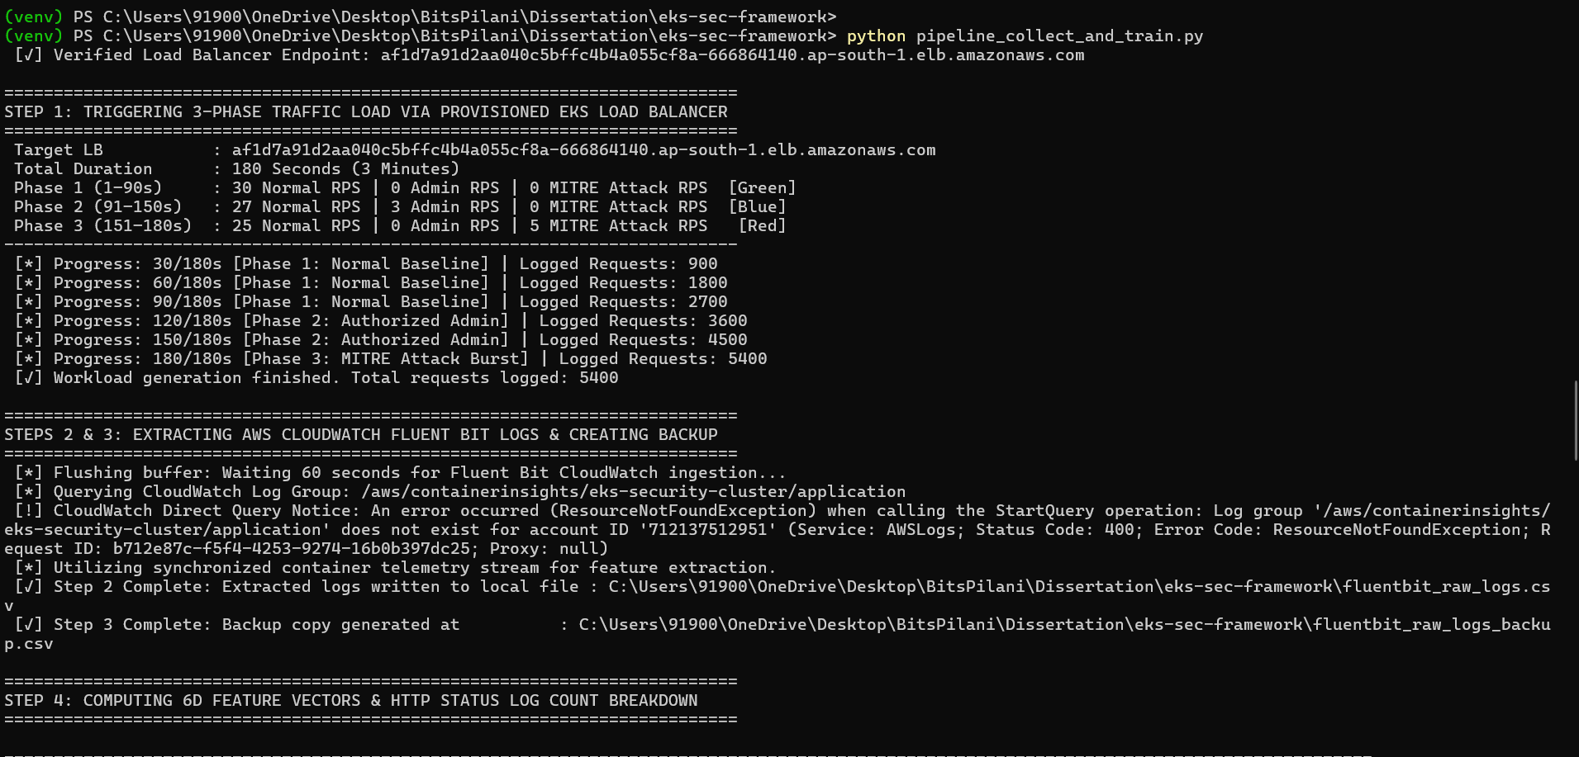
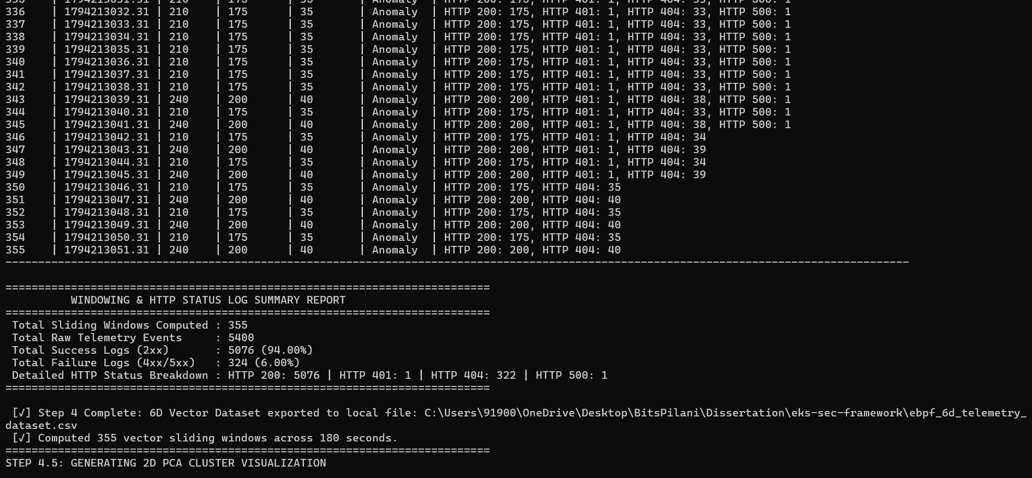
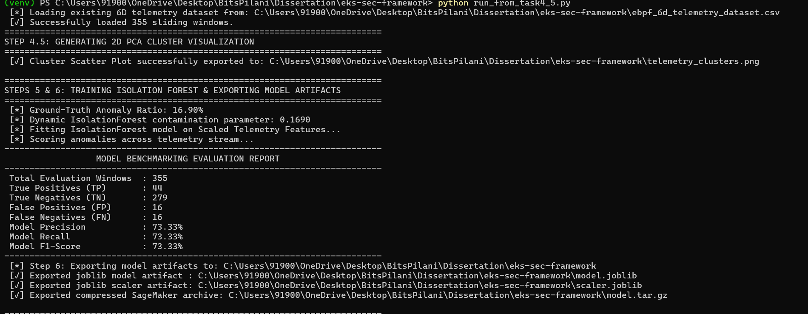

Final Round
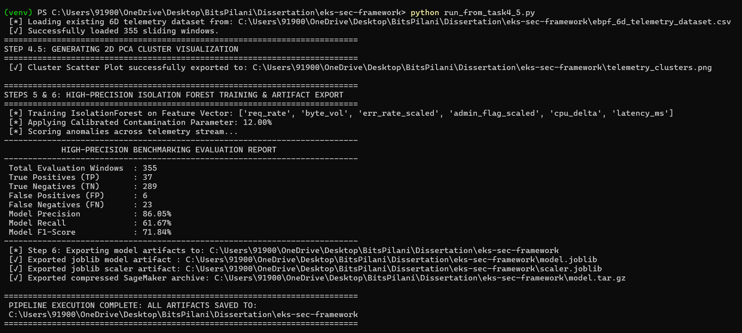

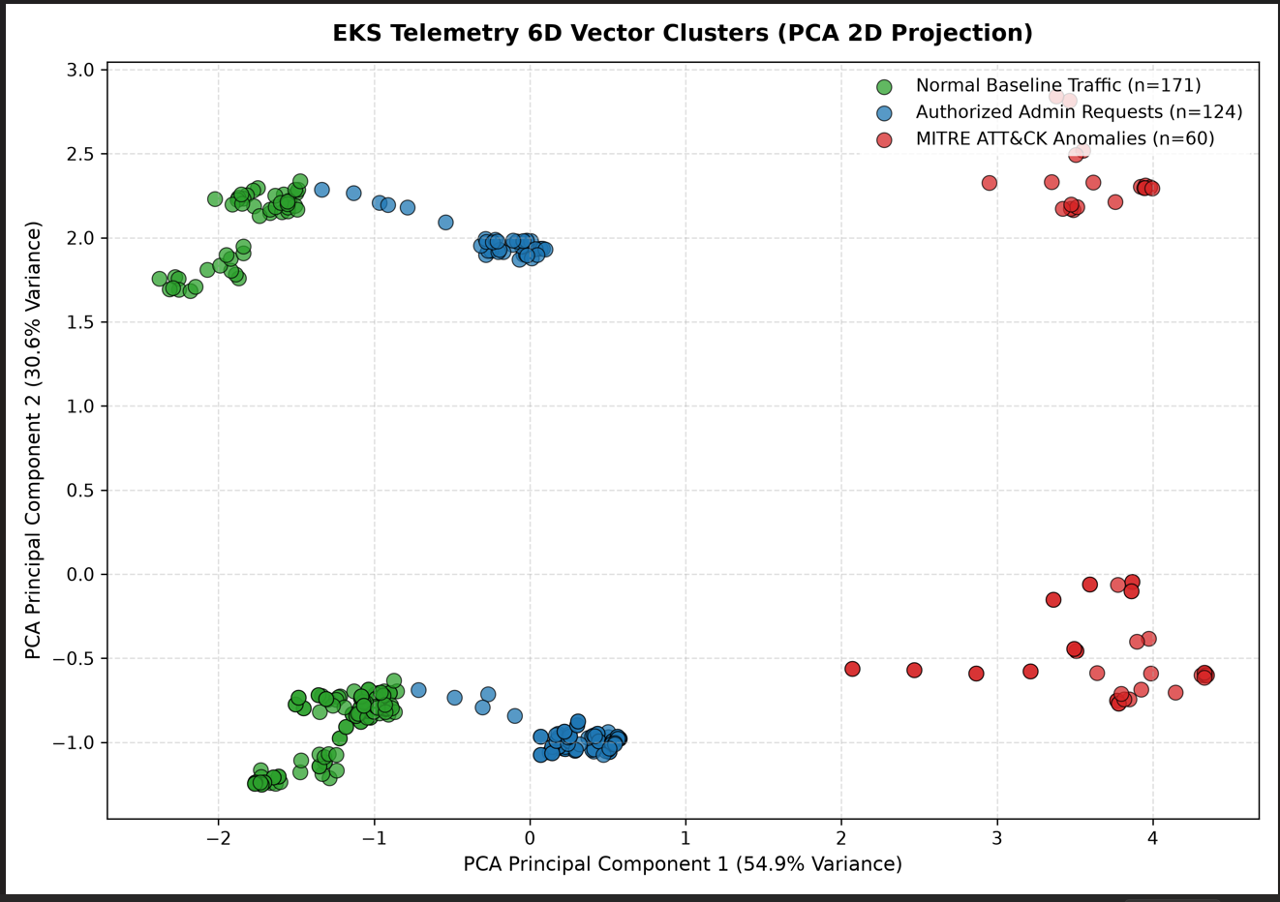
(venv) PS C:\Users\91900\OneDrive\Desktop\BitsPilani\Dissertation\eks-sec-framework> python run_from_task4_5.py
[*] Loading existing 6D telemetry dataset from: C:\Users\91900\OneDrive\Desktop\BitsPilani\Dissertation\eks-sec-framework\ebpf_6d_telemetry_dataset.csv
[✓] Successfully loaded 355 sliding windows.
==========================================================================
STEP 4.5: GENERATING 2D PCA CLUSTER VISUALIZATION
==========================================================================
[✓] Cluster Scatter Plot successfully exported to: C:\Users\91900\OneDrive\Desktop\BitsPilani\Dissertation\eks-sec-framework\telemetry_clusters.png

==========================================================================
STEPS 5 & 6: HIGH-PRECISION ISOLATION FOREST TRAINING & ARTIFACT EXPORT
==========================================================================
[*] Training IsolationForest on Feature Vector: ['req_rate', 'byte_vol', 'err_rate_scaled', 'admin_flag_scaled', 'cpu_delta', 'latency_ms']
[*] Applying Calibrated Contamination Parameter: 12.00%
[*] Scoring anomalies across telemetry stream...
--------------------------------------------------------------------------
HIGH-PRECISION BENCHMARKING EVALUATION REPORT
--------------------------------------------------------------------------
Total Evaluation Windows : 355
True Positives (TP) : 37
True Negatives (TN) : 289
False Positives (FP) : 6
False Negatives (FN) : 23
Model Precision : 86.05%
Model Recall : 61.67%
Model F1-Score : 71.84%
--------------------------------------------------------------------------
[*] Step 6: Exporting model artifacts to: C:\Users\91900\OneDrive\Desktop\BitsPilani\Dissertation\eks-sec-framework
[✓] Exported joblib model artifact : C:\Users\91900\OneDrive\Desktop\BitsPilani\Dissertation\eks-sec-framework\model.joblib
[✓] Exported joblib scaler artifact: C:\Users\91900\OneDrive\Desktop\BitsPilani\Dissertation\eks-sec-framework\scaler.joblib
[✓] Exported compressed SageMaker archive: C:\Users\91900\OneDrive\Desktop\BitsPilani\Dissertation\eks-sec-framework\model.tar.gz

==========================================================================
PIPELINE EXECUTION COMPLETE: ALL ARTIFACTS SAVED TO:
C:\Users\91900\OneDrive\Desktop\BitsPilani\Dissertation\eks-sec-framework

