CALCULATED COLUMNS :
Combines : Category Type = CONCATENATE('Order Details'[Category],"-" & 'Order Details'[Sub-Category])

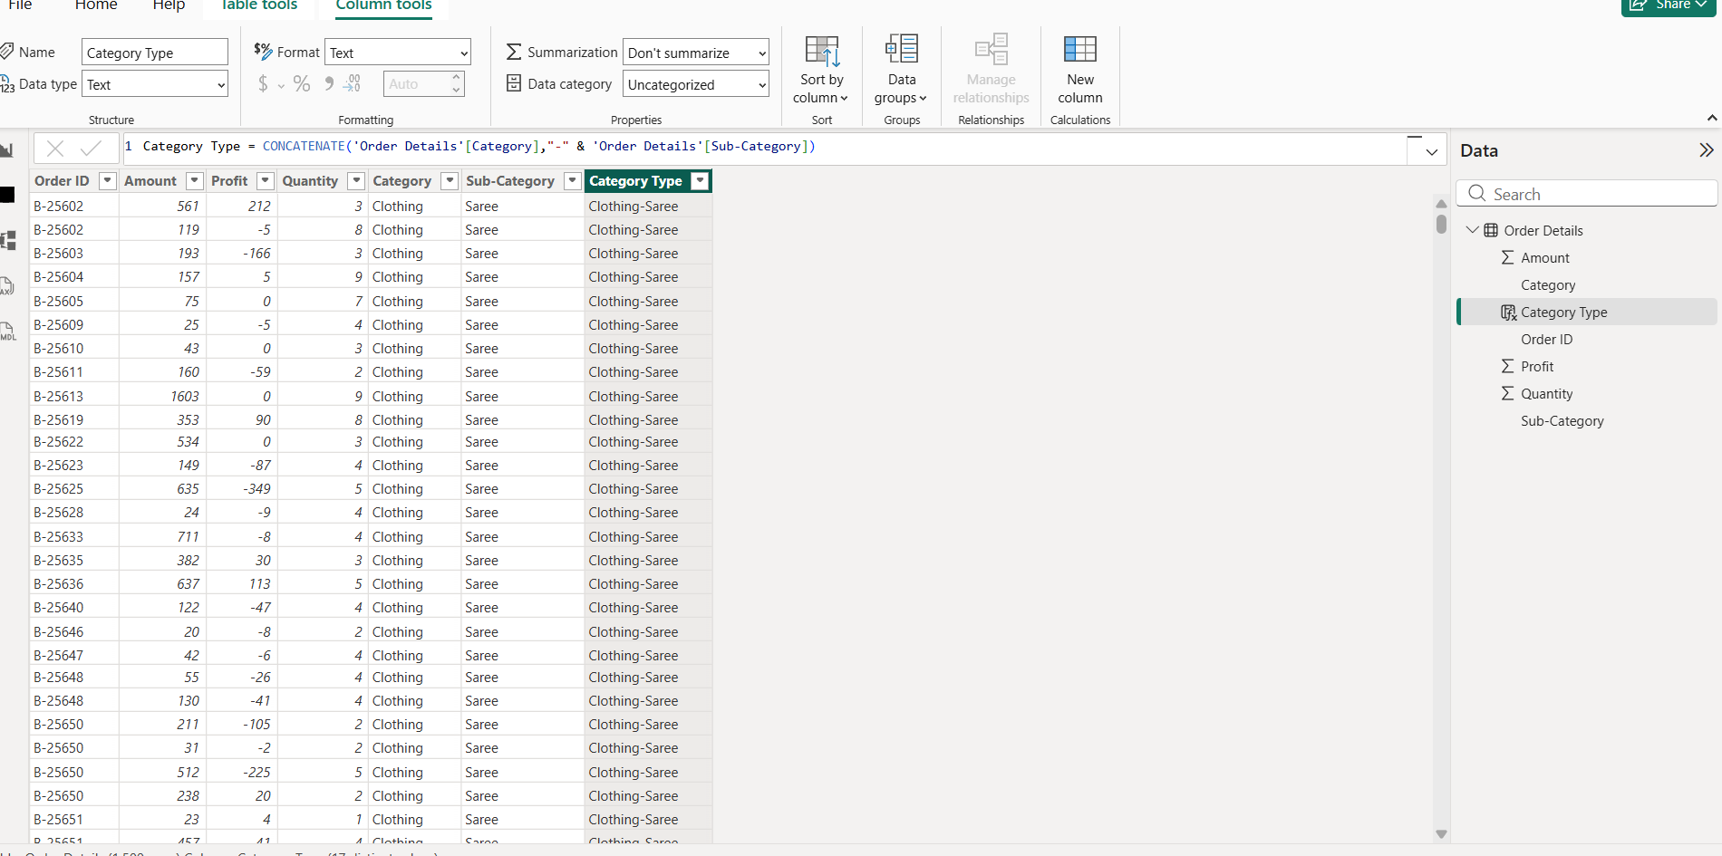
Revenue = 'Order Details (1)'[Amount] *'Order Details (1)'[Quantity]
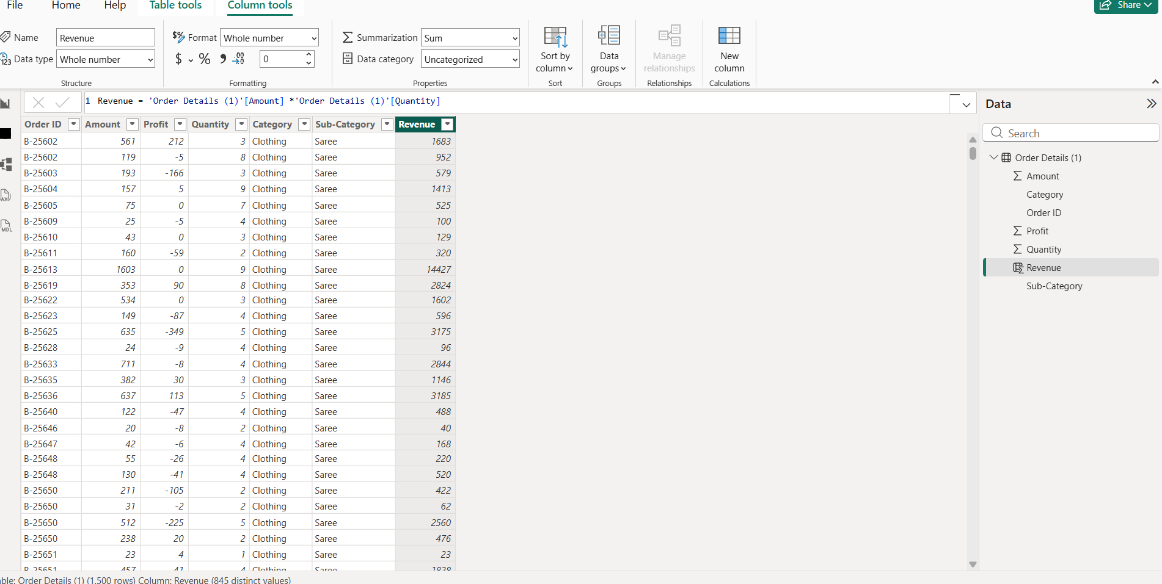

Sales Category = AVERAGE('Order Details'[Amount])

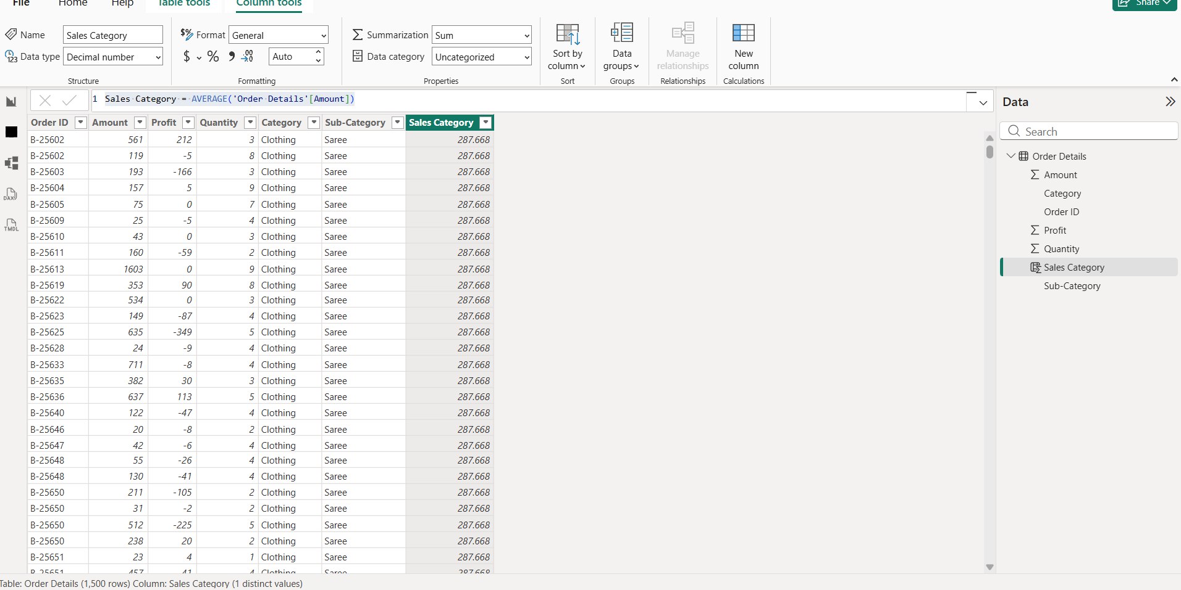

MEASURES:
Count = CALCULATE(COUNT('Order Details (1)'[Sub-Category]),'Order Details (1)'[Profit])
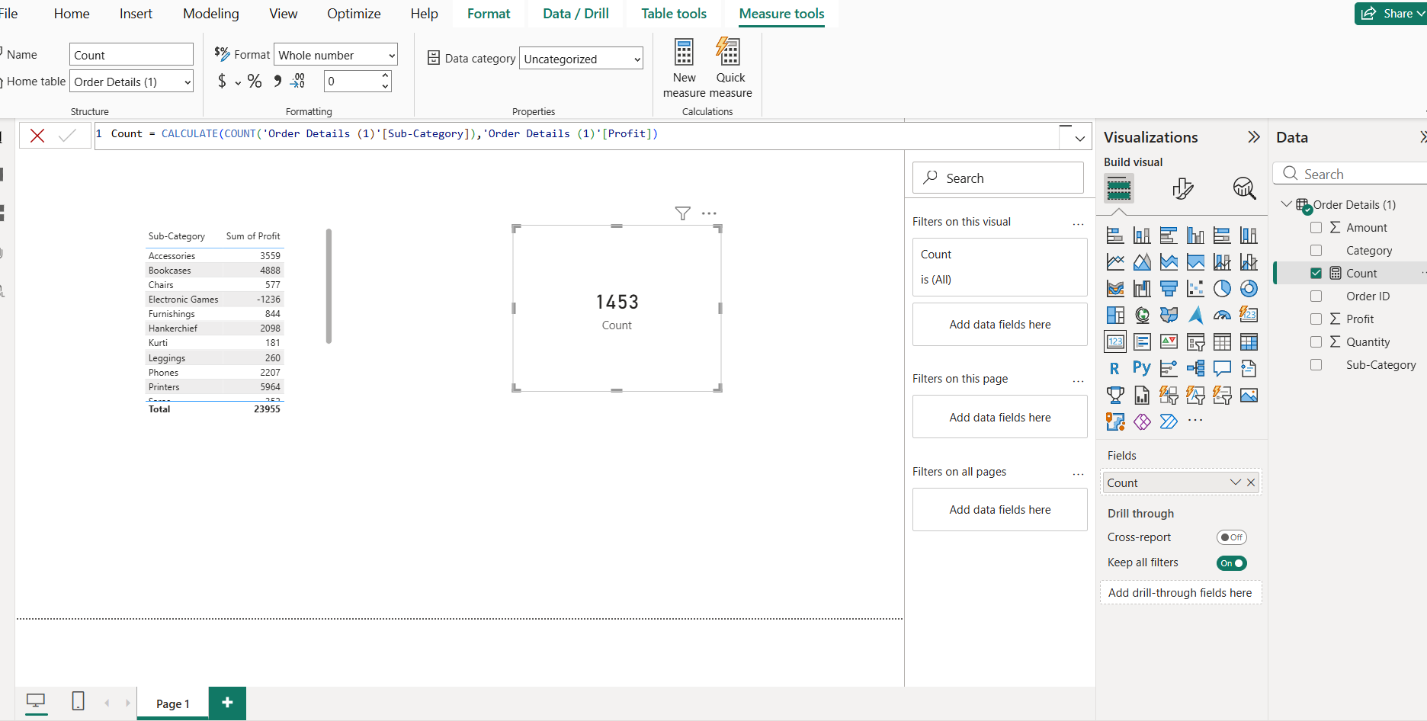
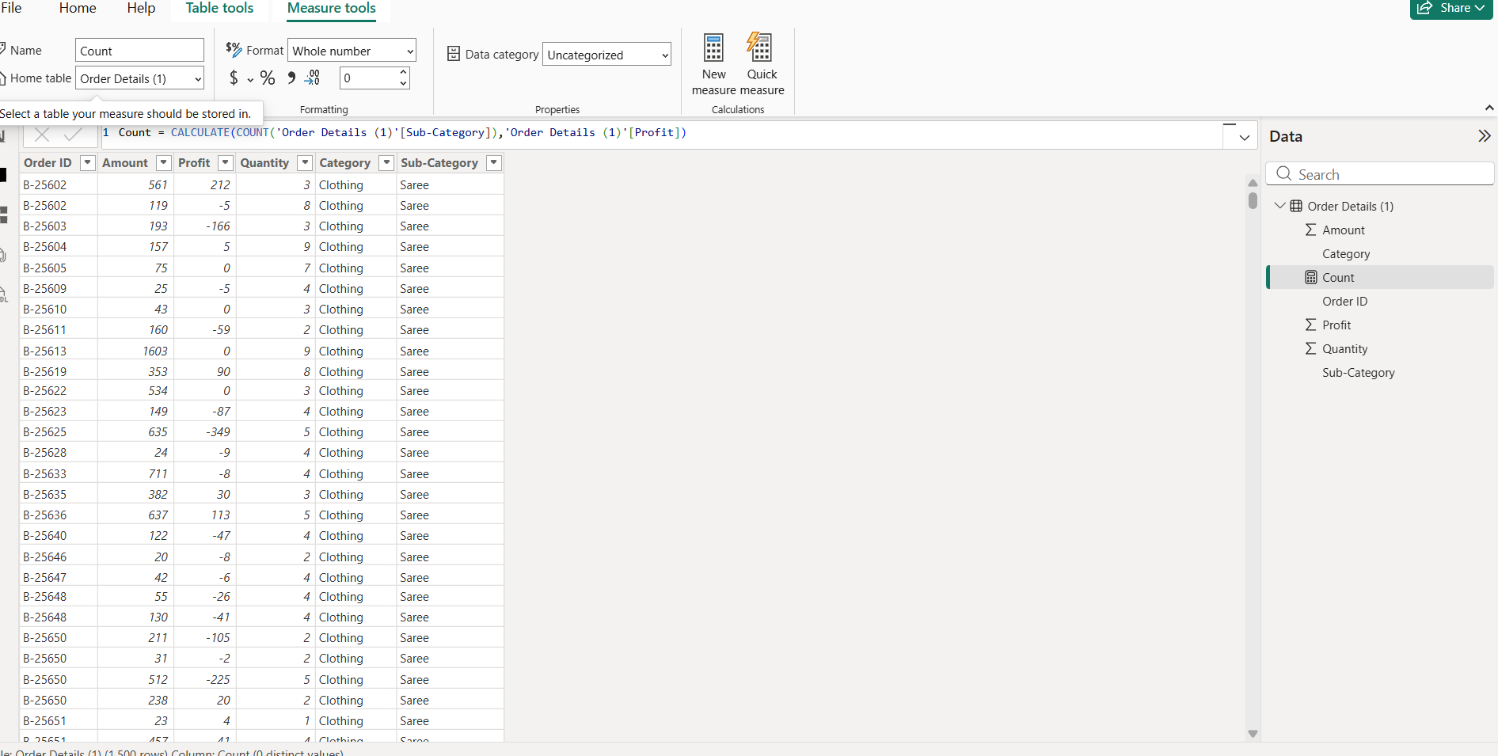
Average = CALCULATE(AVERAGE('Order Details'[Profit]),'List of Orders'[State] = "delhi")

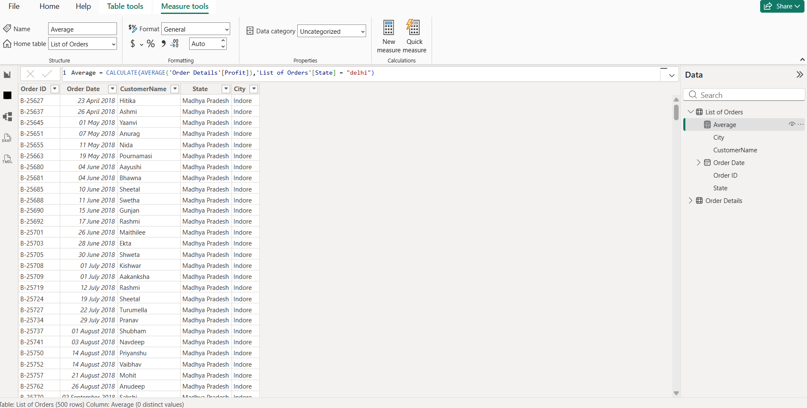
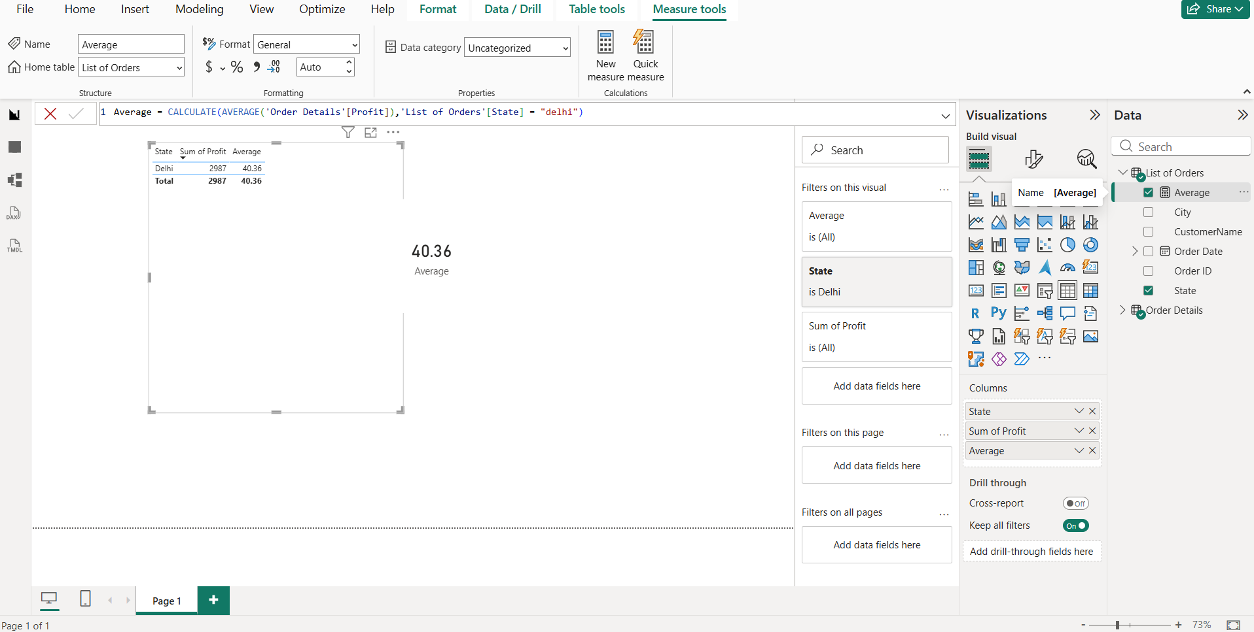

YTD = CALCULATE(SUM('Order Details (1)'[Sales]))
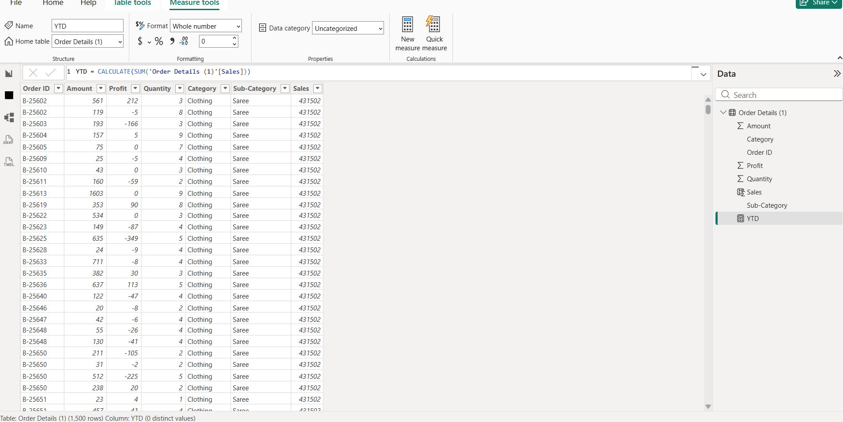
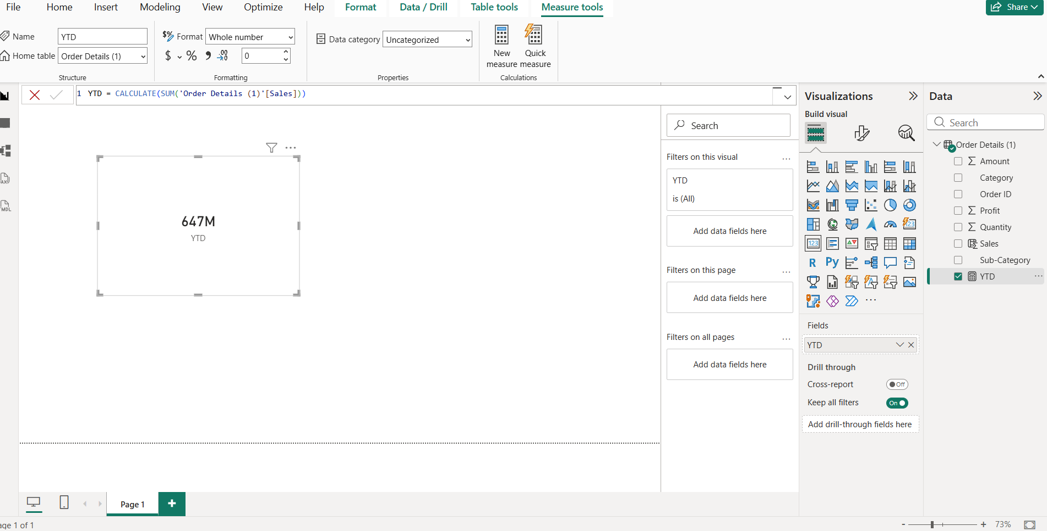

CHARTS :
Clustered Chart :

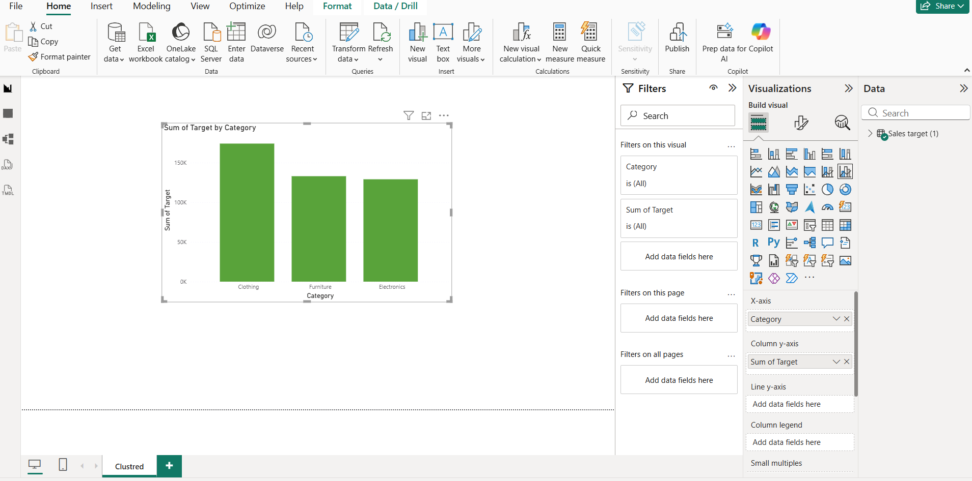

Donut Chart:
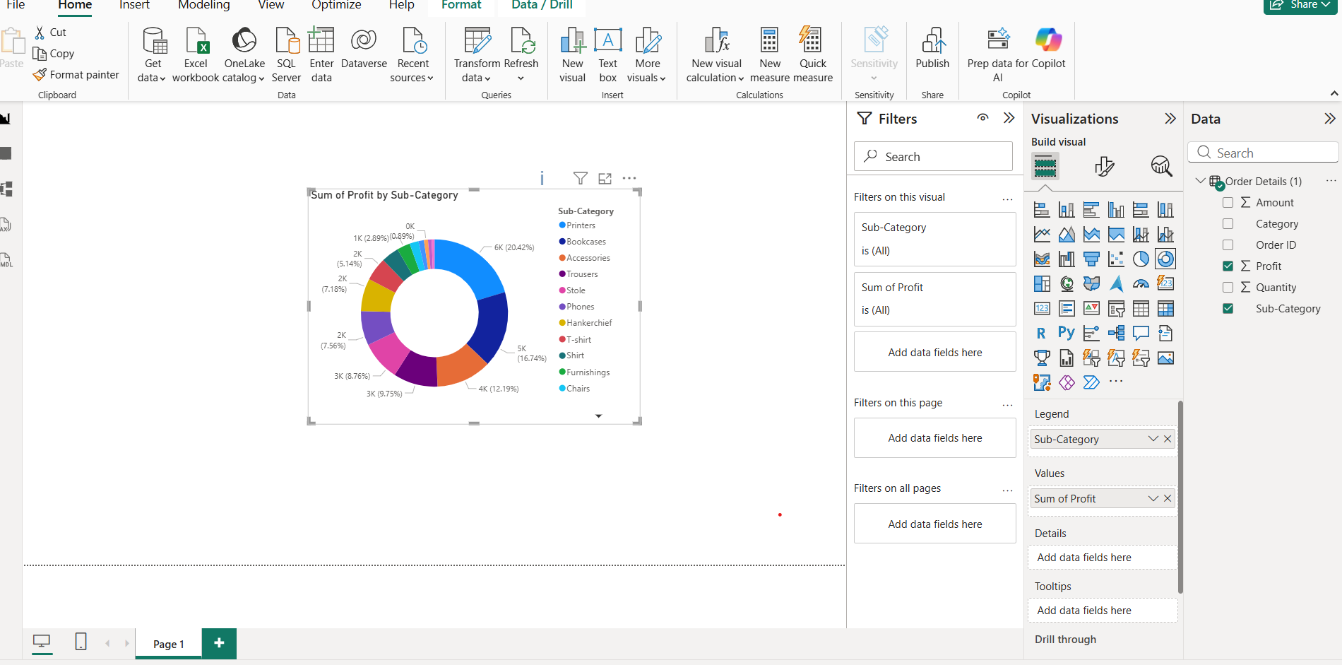

Line Chart:
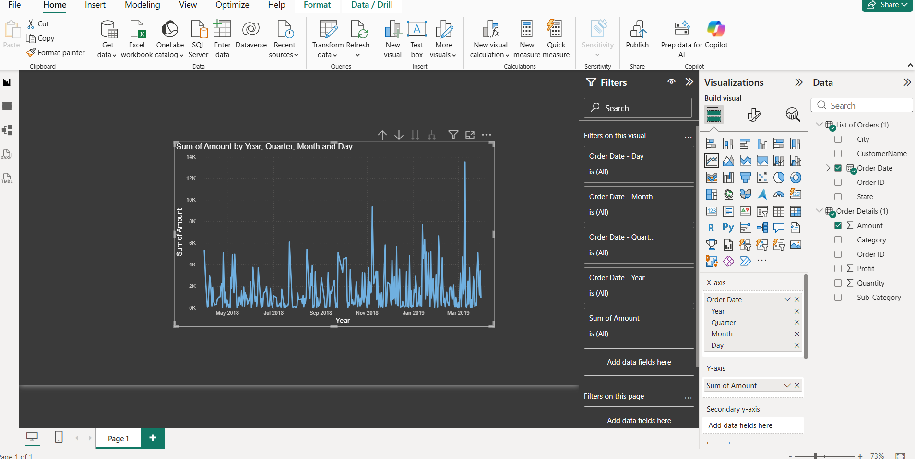

Scatter Chart :
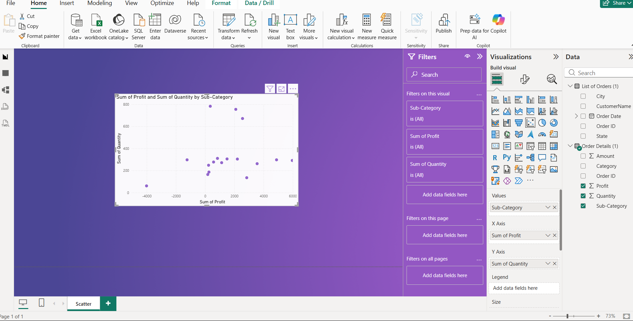

Multi-Row Card:
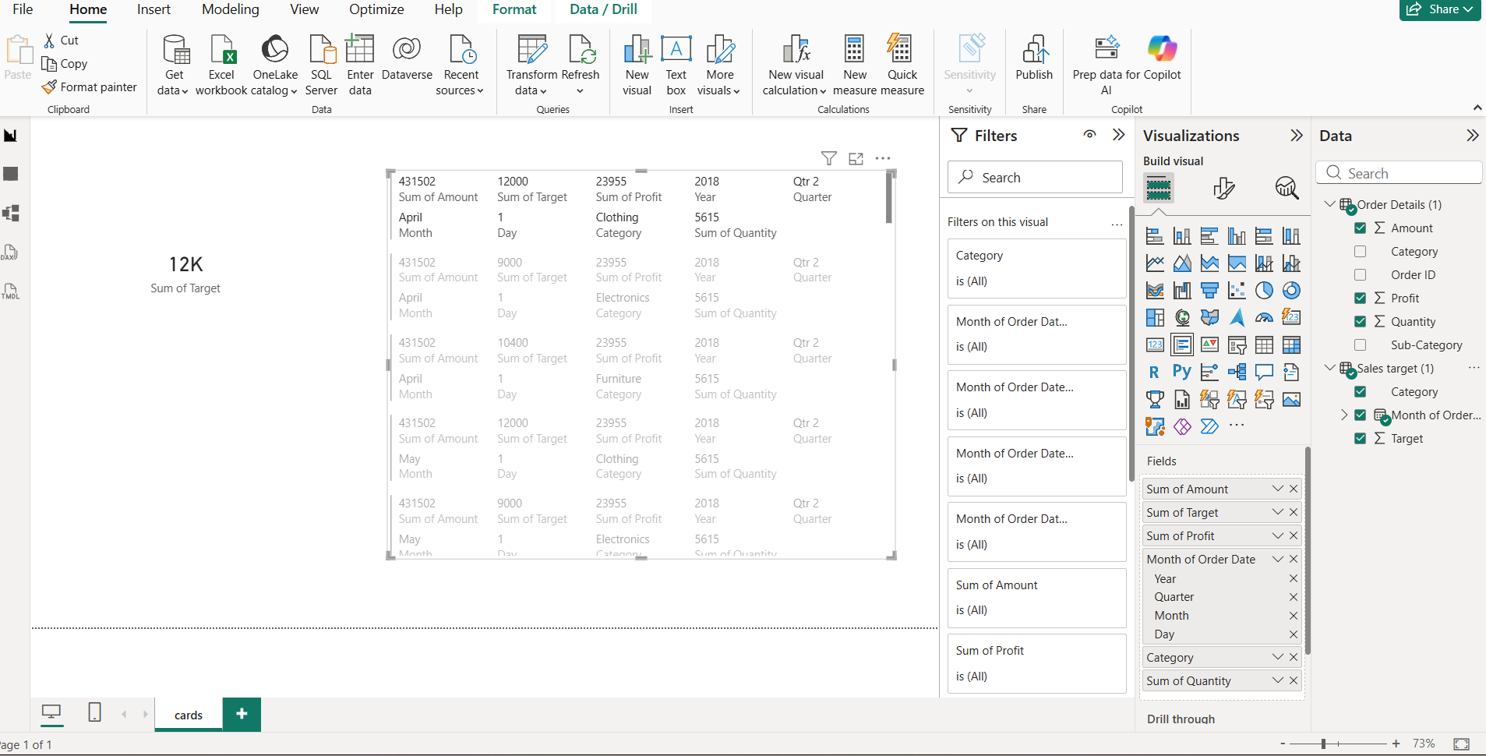

Matrix:
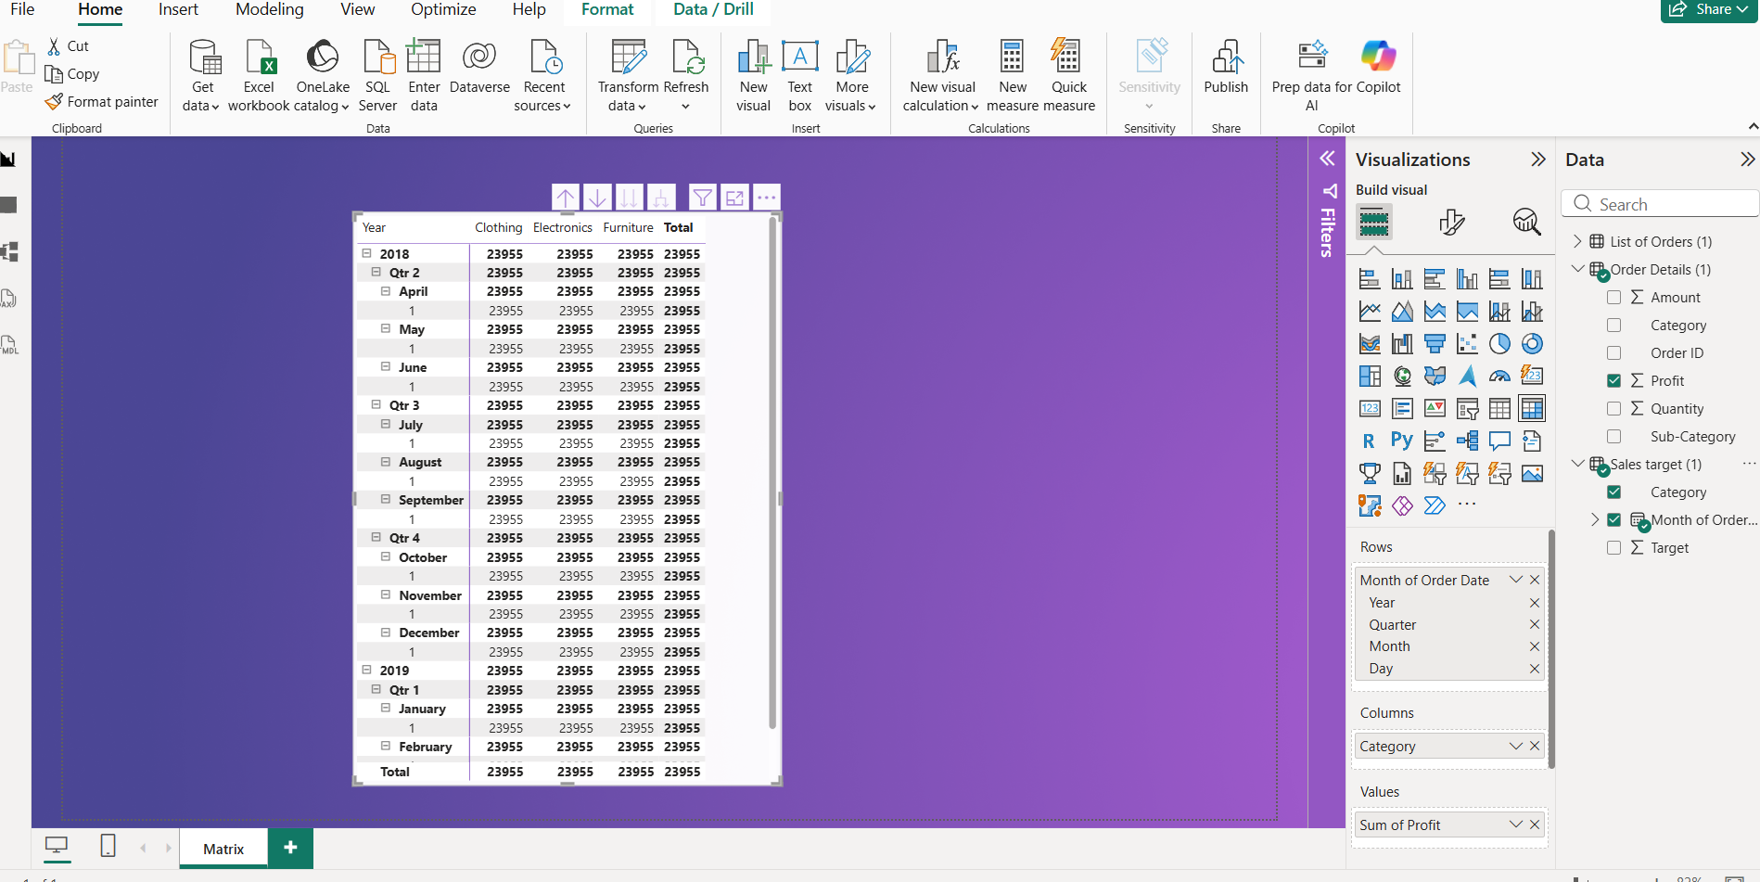

Map View:
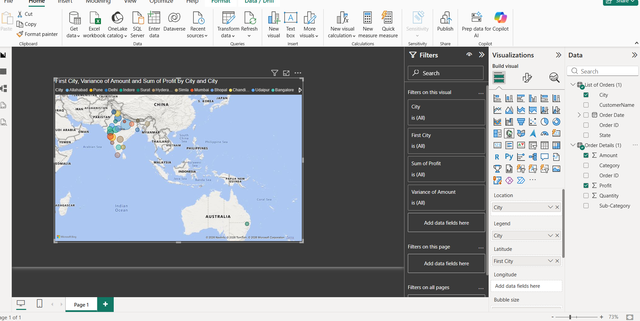

Tree Map:
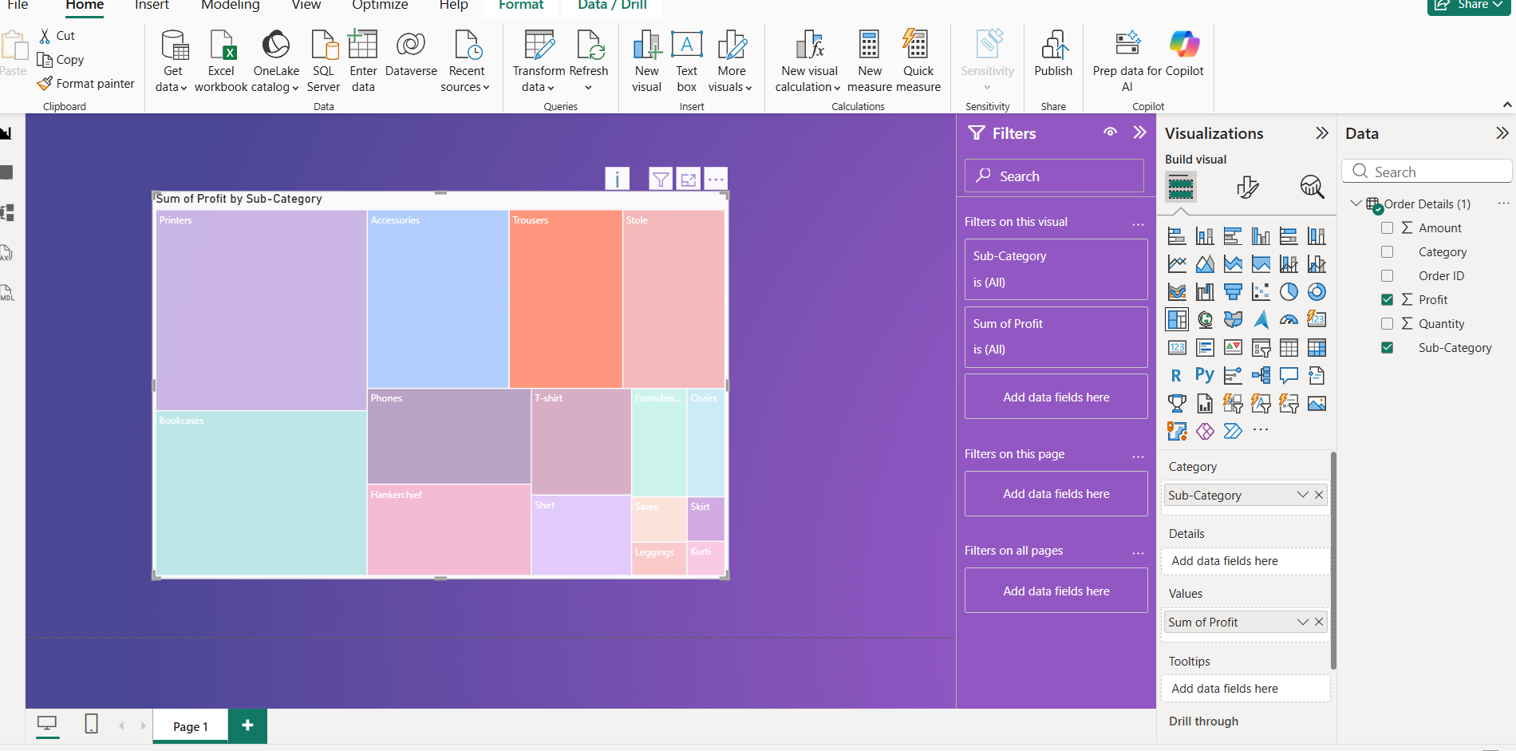

Funnel Chart :
