ALTRIA ScanData File
Version: 1.0

ALTRIA FILE SUBMISSION PROCESS

- Once you finish registration process with ALTRIA then you will receive welcome email from ALTRIA along with TEST FILE request. Please refer below screensort.
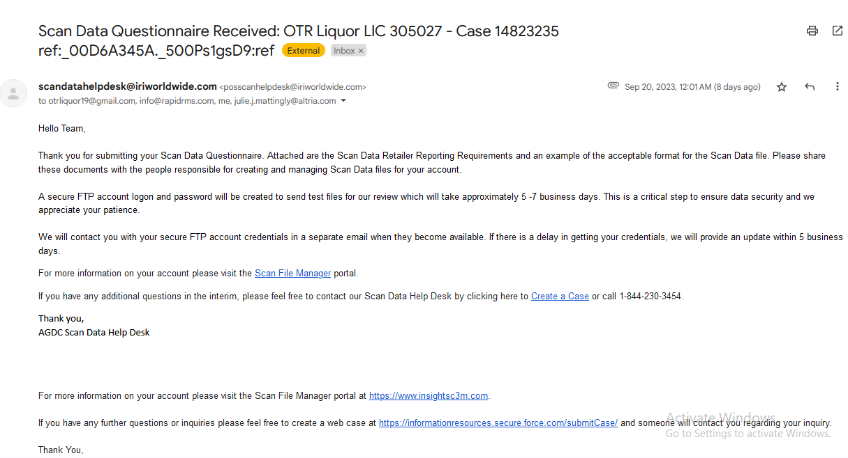
- You will receive Two additional email from ALTRIA to submitting your Scan Data file. These email contain details about FTP Credential (One email for Username & one email for Password).
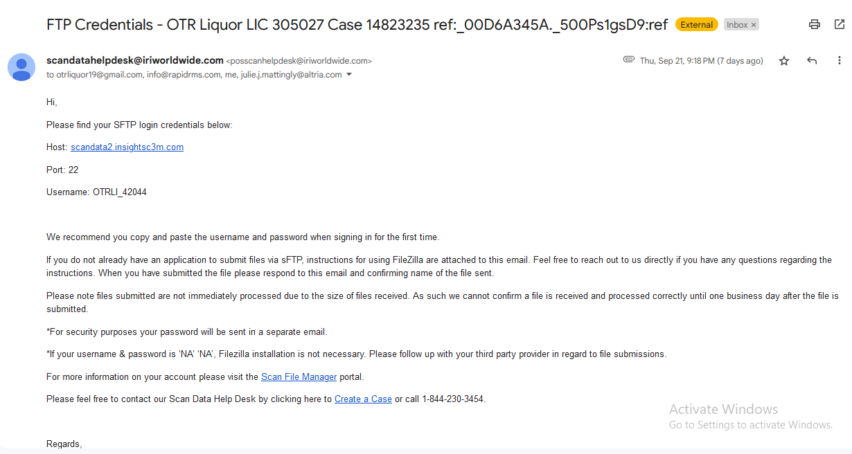
NOTE : Please share these two email with Rapid RMS team on support@rapidrms.com.
- Once Rapid RMS Team received your FTP emails then we will setup your ALTRIA account in Rapid RMS Back-Office.

- Once ALTRIA account setup is done then we will intimate you to submit your ALTRIA TEST FILE.
Please follow the below steps and screenshot to submit your ALTRIA TEST FILE.

- Login to BackOffice with your credentials.
- Tap menu  (located on the top left side).
- Click on “SCAN DATA” Module.
- Click on “ALTRIA FILE” option.
- Select Date Period.
- Click on “Upload 2022 File” Tab.
- Click on “Upload” button.
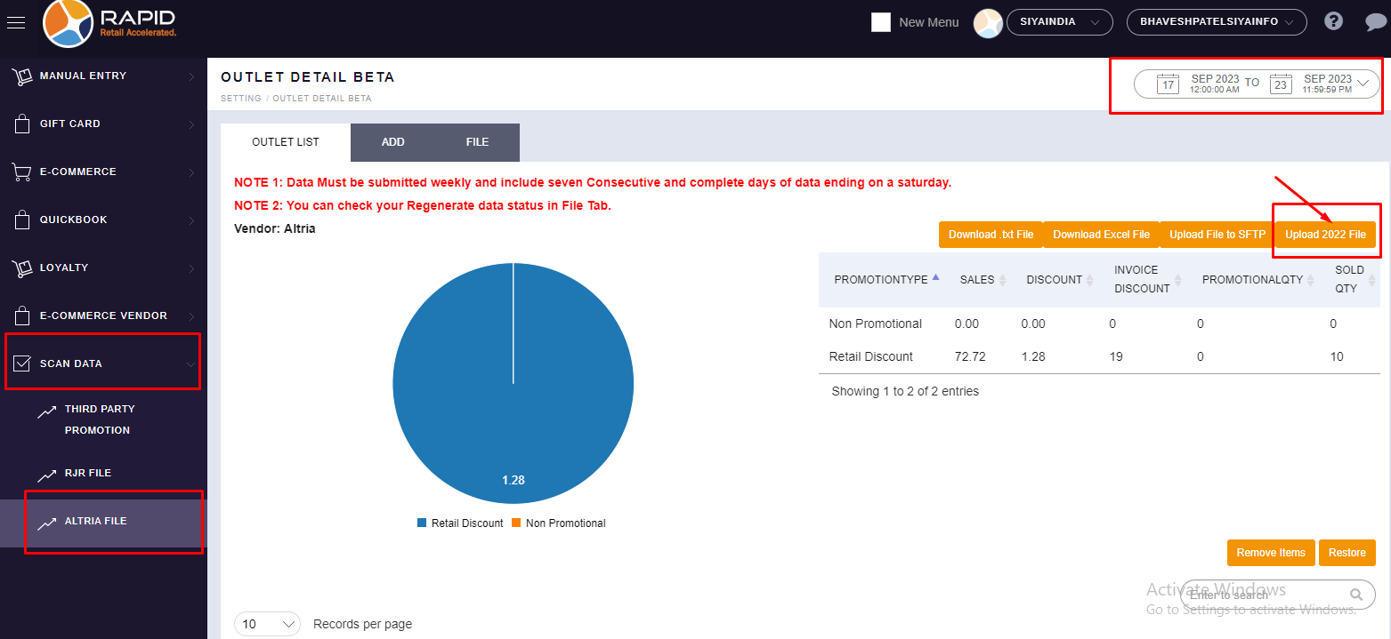

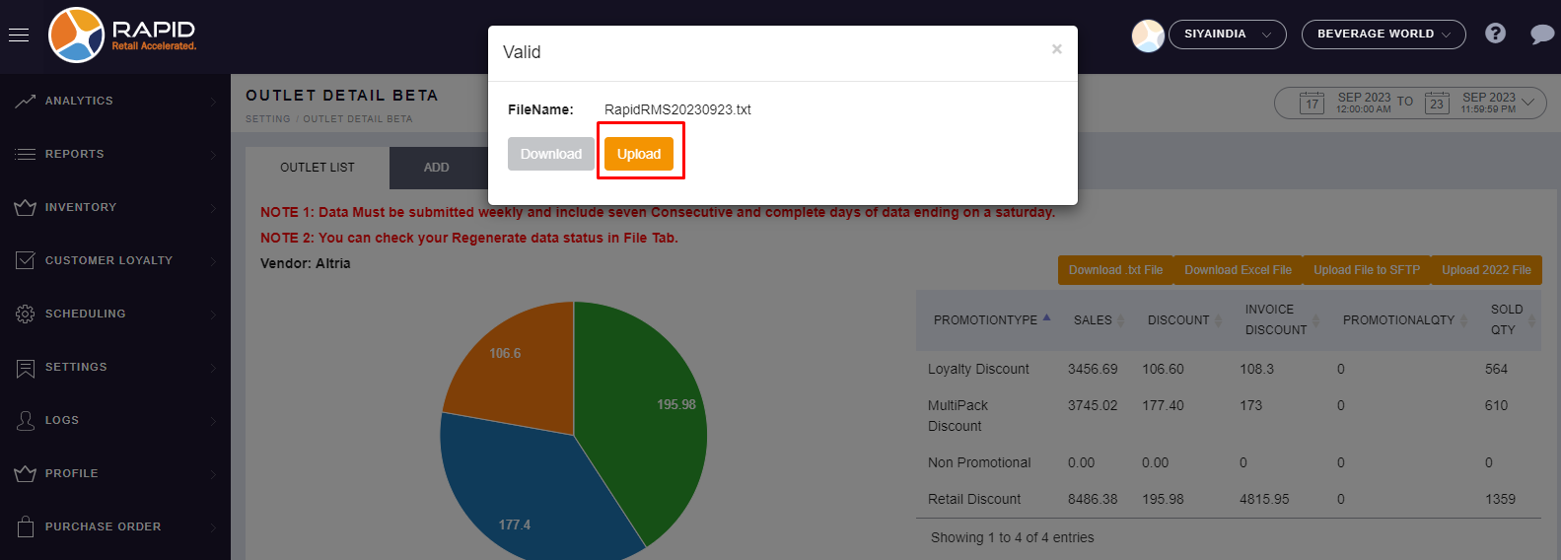

- You can check your file submitted status in FILE Section.

