Close order in Inventory Management

When from open order save invoice then it moves in close order.

- Open inventory management module.
- Go to close order.
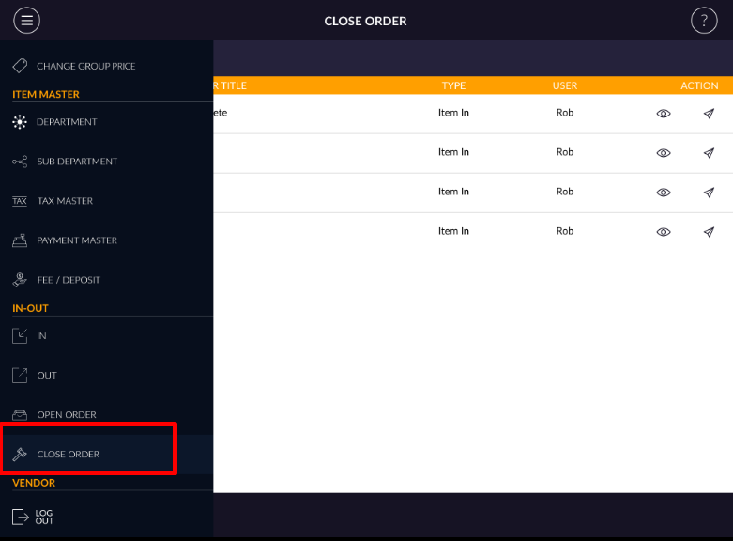

- Close order can display weekly or custom date.
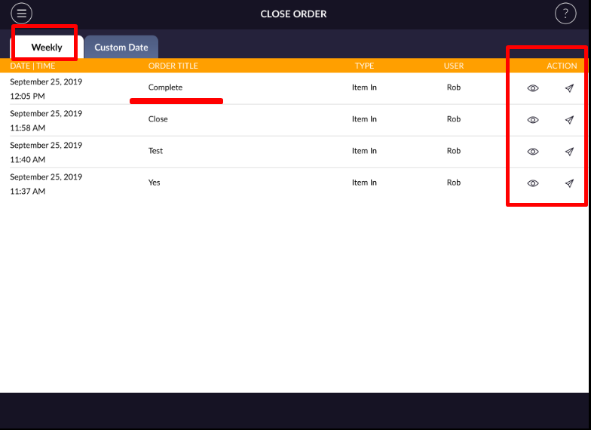

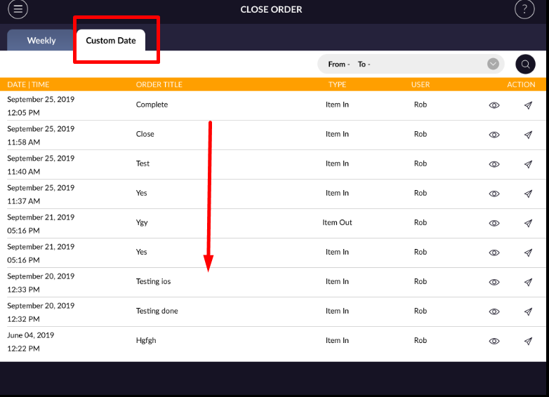

- In close order item cannot be added, delete or item qty cannot be changed.
- You can preview or email invoice.
- Close order is like in/out history.

