Application loading issue what I do?

- How to close Apps on iPad with A Home button

- Double tap the Home button to open  the app switcher. It will show your most  recently used apps. | 

- Swipe right or left to scroll through recently used apps and find the app you’re looking to close. | 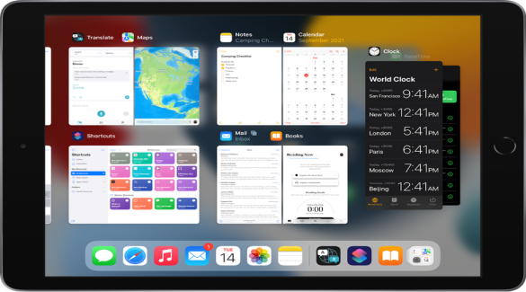

- Swipe up (without lifting your finger off the glass) to send it off the screen then select the application to restart from the home screen. | 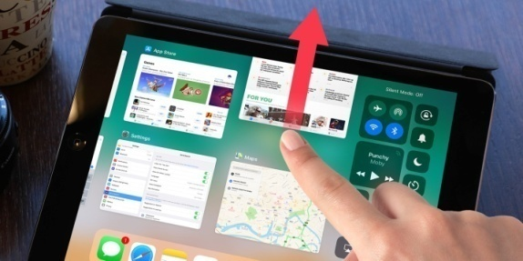

- How to close Apps on iPad with No Home Button

- On the Home screen of the iPad, or while in an app, swipe up from the bottom of the screen and pause for a moment while still pressing the screen, then let go when the App switcher appears. | 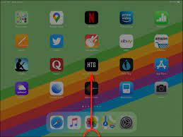

OR
You can also pinch to open App switcher. Simply place four or five fingers on the screen and bring them together to open App switcher. | 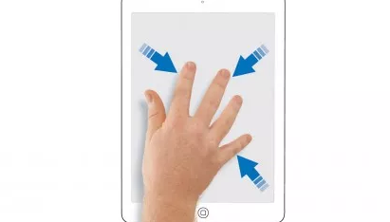

- Swipe right or left to scroll through recently used apps and find the app you’re looking to close. | 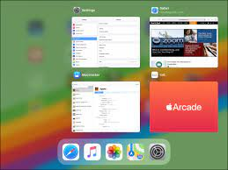

- Swipe up (without lifting your finger off the glass) to send it off the screen and select the application to restart from the home screen. | 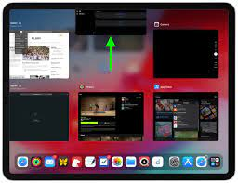
- If you are still running into issue, Please follow the below steps:-
a) If you’re running on a Wi-Fi network using a router, check your internet connectivity. To check your internet connectivity, open Safari, and type CNN.com or Google.com in the URL (located on the top)
NOTE: Follow the step below if Safari displays following message – Safari cannot open the…. or if the internet is working and the application continues to load but does not load, call 1-800-Rapid-02 or 1-800-727-4302.
b) If you’re unable to go to CNN.com in safari, find setting on your iPad, and click Wi-Fi. Make sure you’re connected to your internal network and Wi-Fi is turned on.
c) Find your router and unplug the power code for 10 seconds and then plug back in.
d) Recheck your Internet connectivity. If you still are not connected, contact your Internet Service Provider.

