How to filter items list to select items from third party promotions for RJR scan Data?
- Login to BOS with your user credentials.
- In the top right, click on three line hamburger  menu.
- Choose Third party promotion option from settings.
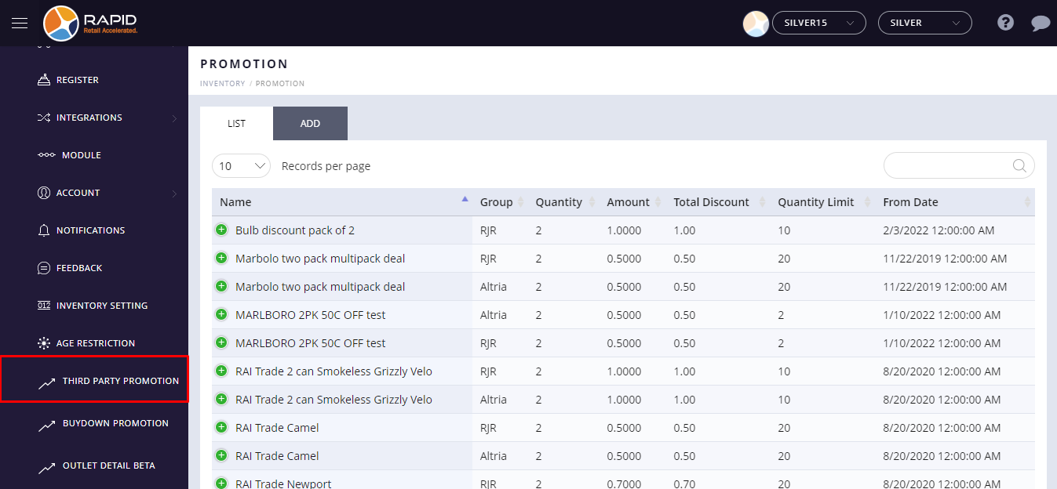

- Select the existing third party discount from the list.
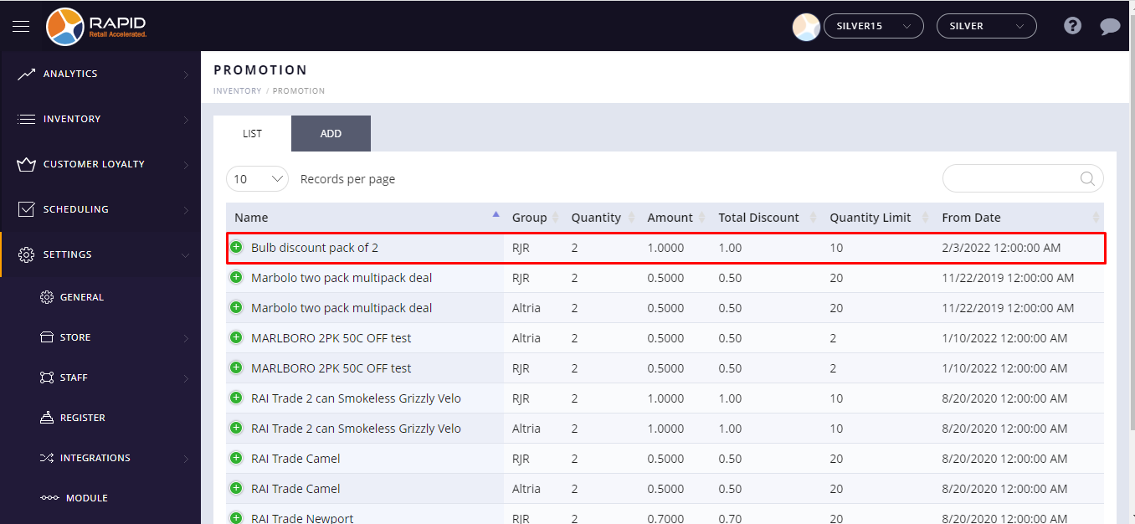
- Click on  plus button is located beside the item name.
- Click on the action button and select the Edit option from the drop down list.
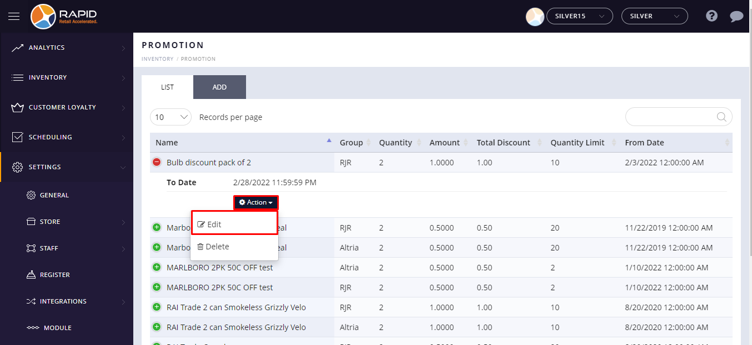

- Click on the Next button.
- At the top left side, click on the filter button.
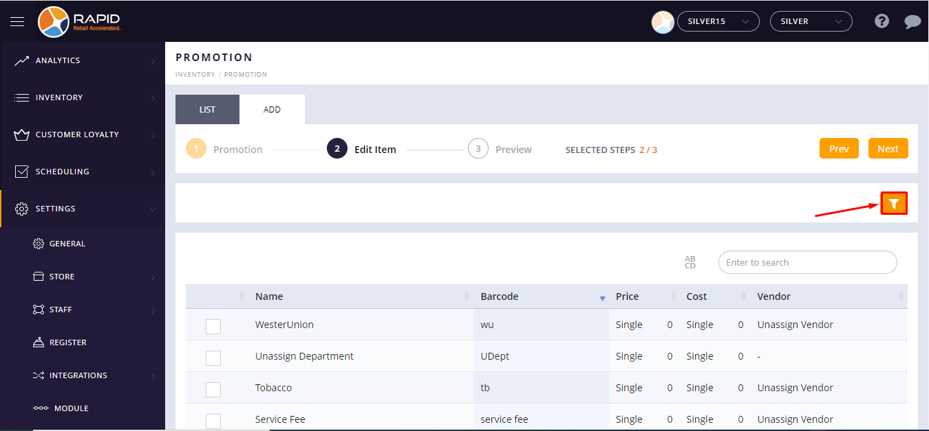
- You can filter items Department wise, Vendor wise, and Group wise.
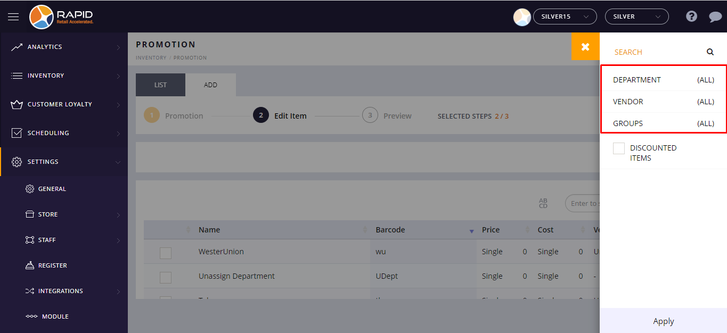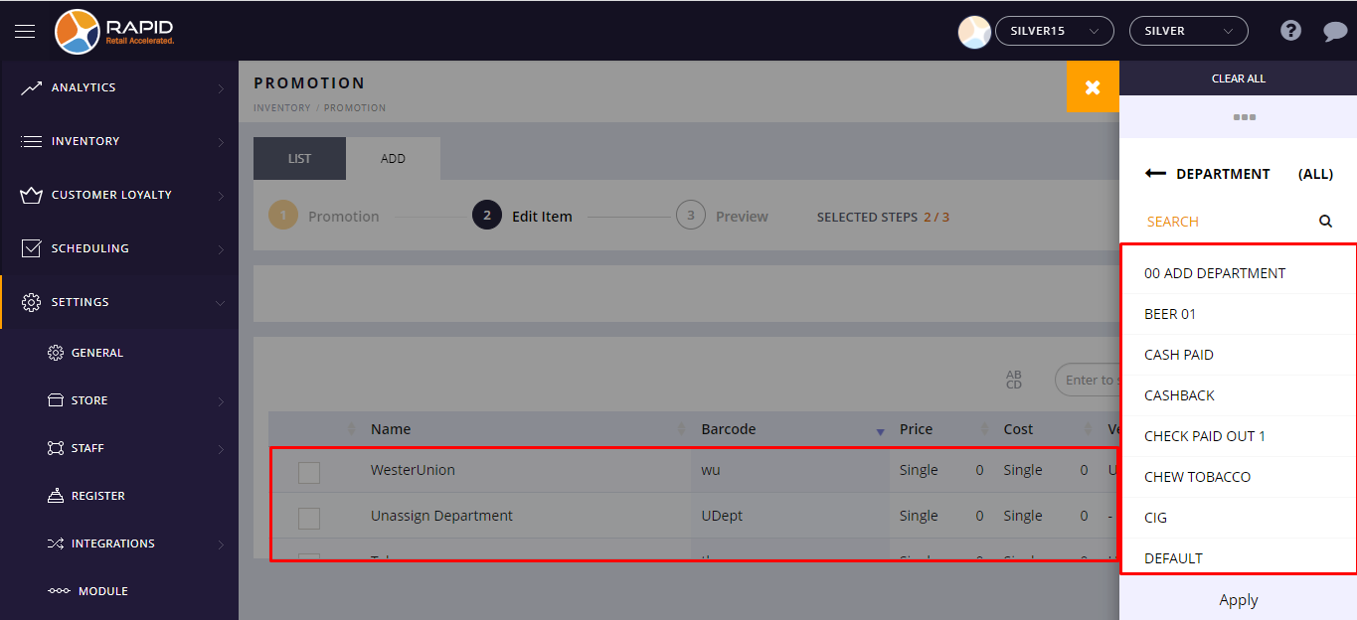

- Now, select any option of the filter.
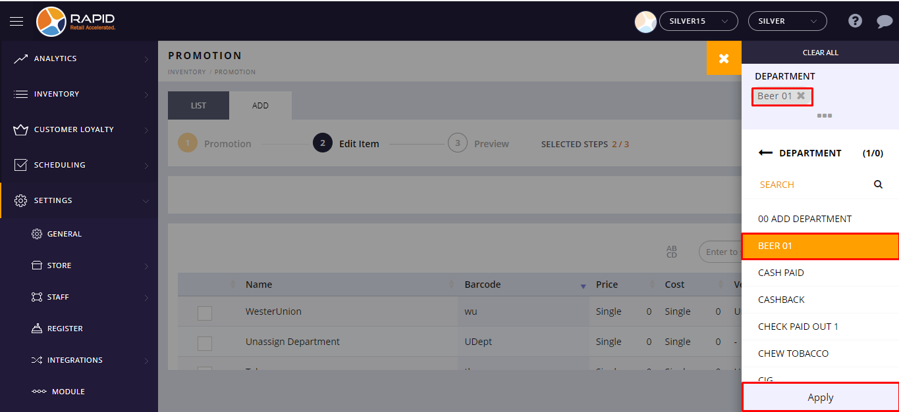
Note:- Selected filter option will appear at the top left side corner of the screen.
- You can also select the multiple filter options.
- At bottom, click on the Apply button.
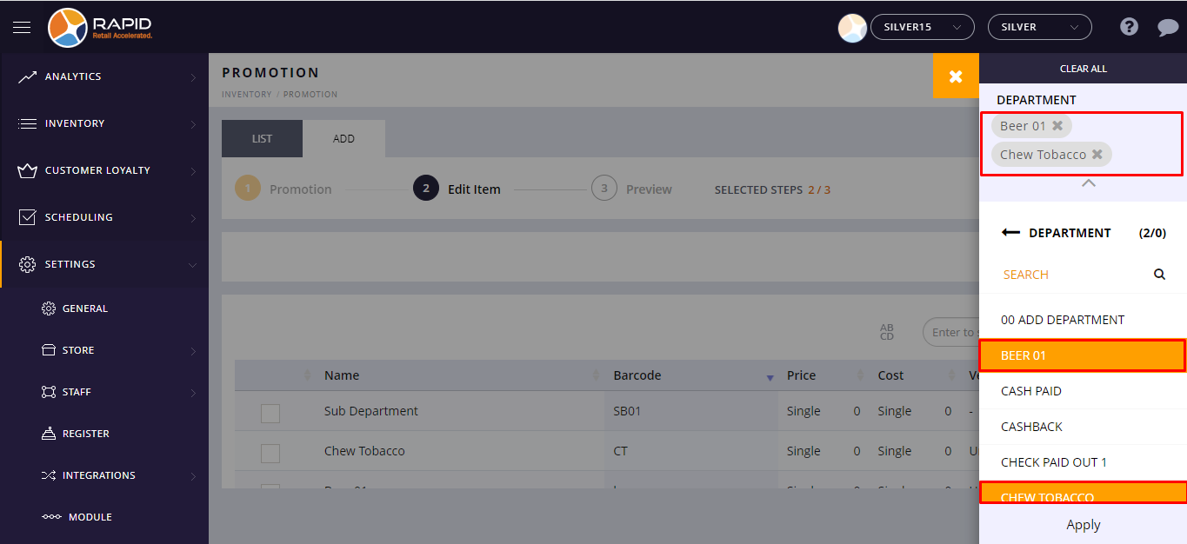
- Click on 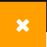 the cancel button.
- When you select any filter option, it will review items as per the selected filter option.
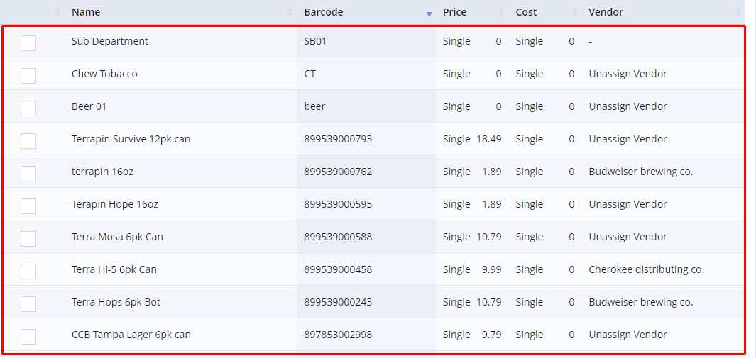

- Now, Click on the Next button.
- At the top right side, Tap on Finish.

